**COMMON LINUX COMMANDS:**

1. ls command.

A Linux shell command that lists directory contents of files and directories.

ls syntax: ls [options] [file/dir]

Some of ls command options:

-a = list all files including hidden file starting with ‘.’

-d = list directories - with ‘*/’

-l = list with long format – show permissions

-r = list in reverse order

-s = list file size

1. cd command.

A Linux command to change the directory/folder of the terminal’s shell.

Note: Pressing *tab* button will auto complete the directory name.

cd syntax: cd [directory]

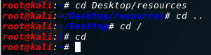

Extra: cd = will change to home directory

cd / = will change to root directory

cd .. = will change to parent directory

1. mv command.

A Linux command that is use to move files and directories.

mv syntax: mv [options] source destination



mv command options:

-f = force move by overwriting destination file without prompt

-i = interactive prompt before overwrite

-u = update-move when source is newer than destination

-v = verbose-print source and destination files

1. rm command.

A Linux command to remove files.

rm syntax: rm [options] file

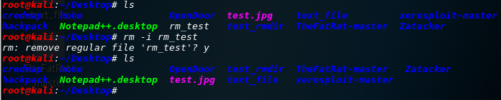

Some of rm command options:

-f, --force = ignore non-existent files, never prompt

-i = prompt before every removal

-v, --verbose = explain what is being done

1. mkdir/rmdir commands.

mkdir = create new directory

rmdir = delete directory

The syntax: mkdir filename

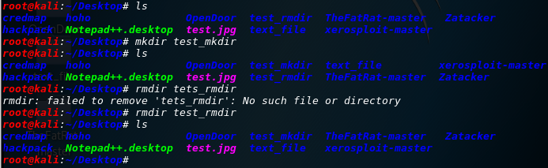 rmdir filename

Some of mkdir/rmdir command options:

-m = set file mode (as in chmod). (only for mkdir)

-p = mkdir-no error if existing, make parent directories as needed

rmdir-remove directory and its ancestors

-v = mkdir-print a message for each created directory

rmdir-output a diagnostic for every directory processed

1. touch command.

A command that change file timestamps.

touch syntax: touch [option] file

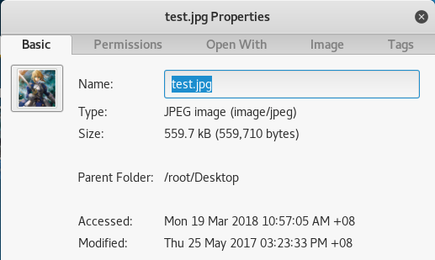



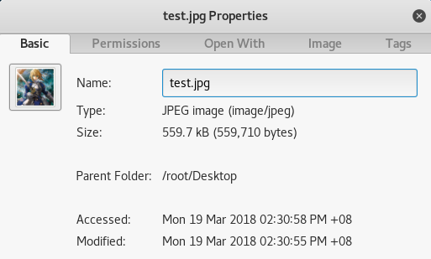

Some of touch command options:

-a = change only the access time

-c = do not create any files

-d = parse STRING and use it instead of current time

-m = change only the modification time

1. cat command.

Is used to display the content of text files and to combine several files to one file.

Note: this command does not accept directories.

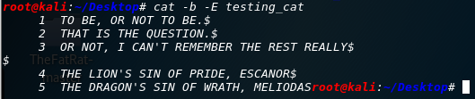cat syntax: cat [options] file1 file2…..

Some of cat command options:

-b = add line numbers to non-blank lines

-n = add line numbers to all lines

-E = show $ at the end of line

1. pwd command.

Command used to print working directory, a Linux command to get the current working directory.

pwd syntax: pwd [option] (option is not necessary)

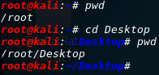

Some of pwd command options:

-h = display a brief help message and exit

-V = display version information and exit

1. file command.

Used to determine file type.

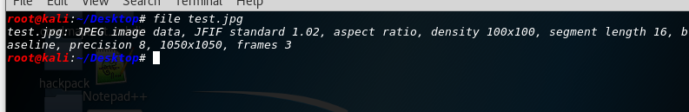file syntax: file [options] [-f namefile] [-F separator] [-m magicfiles]…….

Some of file command options:

-f = read the names of the files to be examined from namefile

-F = use the specified string as the separator between the filename and the file result returned. Defaults to “:”

-m = specify an alternate list of files containing magic numbers.

-b = do not prepend filenames to output lines (brief mode)

-N = don’t pad filenames so that they align in the output

1. ln command.

Will make links between files.

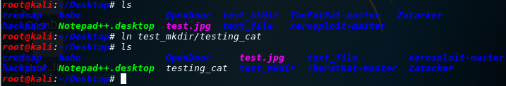ln syntax: ln [option] target (the simplest syntax form)

Some of ln command options:

--backup = make a backup of each existing destination file

-b = like –backup but does not accept an argument

-f = remove existing destination files

1. chmod/chown command.

chmod = to change access permissions, change mode.

chown = to change owner, change the user and/or group ownership of each given file to a new owner.

The syntax: chmod [options] Numeric_Mode file

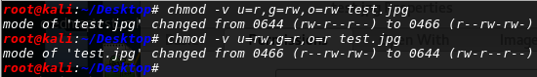 chown [options] NewOwner file

Some of chmod/chown command options:

-f = chmod-supress most error messages

chown-do not print error messages about files whose ownership cannot be changed

-v = chmod-output a diagnostic for every file processed

chown-verbosely describe the action (or non-action) taken for every file.

-c = chmod-like verbose but report only when a change is made

chown-verbosely describe the action for each file whose ownership actually changes

1. more/less command.

more = to view a text file one page at a time, press spacebar to go to the next page.

less = almost the same as more command with some exception:

1. can navigate the page up/down using less command, not possible in more command.
2. can search a string in less command.
3. more was fairly limited and any additional development has stopped.

The syntax: more [option] [-num] filename

less [option] filename (simplest form)

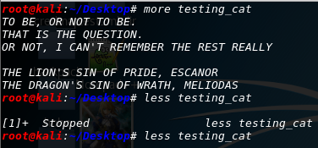

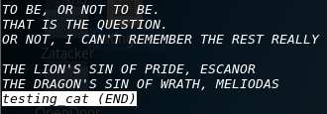

Some of more command options:

-num = specifies an integer which is the screen size (in lines)

-p = do not scroll, instead will clear the whole screen and then display the text

-s = squeeze multiple blank lines into one

Some of less command options:

-a = causes searches to start after the last line displayed on the screen

-c = causes full screen repaints to be painted from the top line down

-e = causes less to automatically exit the second time it reaches end-of-file

1. grep command.

It is use to print lines matching a pattern.

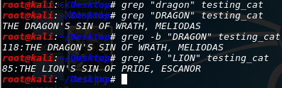grep syntax: grep [option] pattern [file]

Some of grep command options:

-a = process a binary file as if it were text

-C num = print num lines of leading context before matching lines. Place a line containing – between contiguous groups of matches.

-b = print the byte offset within the input file before each line of output

1. wc command.

Will print the number of newlines, words and bytes in files.

wc syntax: wc [option] file

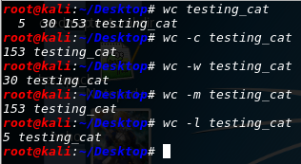

Some of wc command options:

-c = print the byte counts

-m = print the character counts

-l = print the newline counts

-w = print the word counts

1. kill command.

Used to terminate a process.

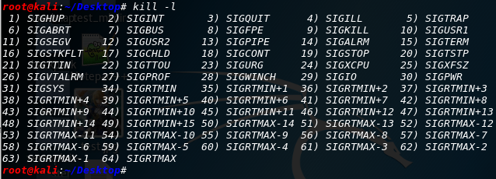kill syntax: kill -l [signal] (simplest form)

Some of kill command options:

-l = prints a list of signal names

-s signal = specify the signal to send, it may be given as a name or number

1. ps command.

Will provide information about the currently running processes.

ps syntax: ps [option]

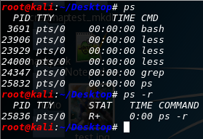

Some of ps command options:

-d = select all processes except session leaders

-e = select all processes

-r = restrict the selection to only running processes

1. top command.

Used to display Linux task.

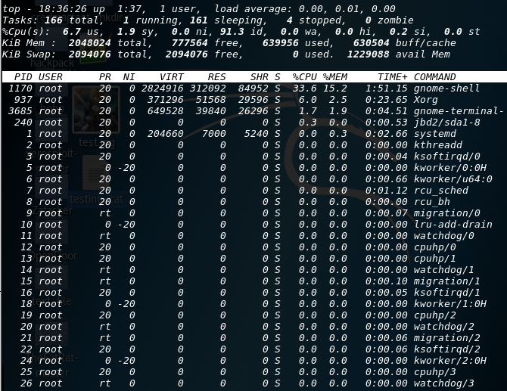top syntax: top [option] (simplest form)

Some of top command options:

-b = starts top in ‘Batch Mode’

-n = specifies the maximum number of iterations, or frames, top should produce before ending

-M = show memory units (k/M/G) and display floating point values in the memory summary

1. uname command.

The command is use to print system information.

uname syntax: uname [option]

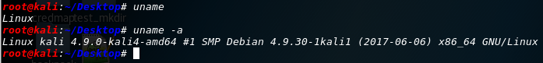

Some of uname command options:

-a = print all information in a default order, except omit -p and -i if unknown

-s = print the kernel name

-p = print the processor type or “unknown”

-i = print the hardware platform or “unknown”

1. uptime command.

Will tell how long the system has been running.

uptime syntax: uptime [option] (option is not necessary)



Some of uptime command options:

-h = display a brief help message and exit

-V = display version information and exit

1. ping command.

Send ICMP ECHO_REQUEST packets to network hosts.

ping syntax: ping [option] [option] ….. destination

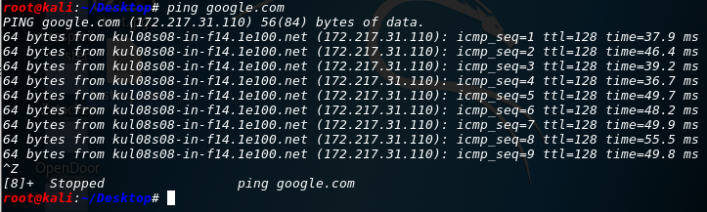Note: the syntax can be insert with multiple kinds of option if need be.

Some of ping command options:

-a = audible ping

-b = allow pinging a broadcast address

-B = do not allow ping to change source address of probes. The address is bound to one selected when ping starts

1. netstat command.

The command is use to print network connections, routing tables, interface statistics, masquerade connections and multicast memberships.

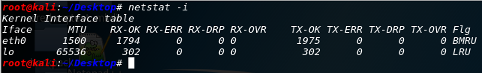netstat syntax: netstat [option] [option] …..

Some of netstat command options:

(none) = by default, netstat displays a list of open sockets with all the configured address families of the active sockets

-g = display multicast group membership information for IPv4 and IPv6

-i = display a table of all network interfaces

-s = display summary statistics for each protocol