# **Java Interview Assignment**

Spring Boot application that will be used by our candidates to implement interview assignments.

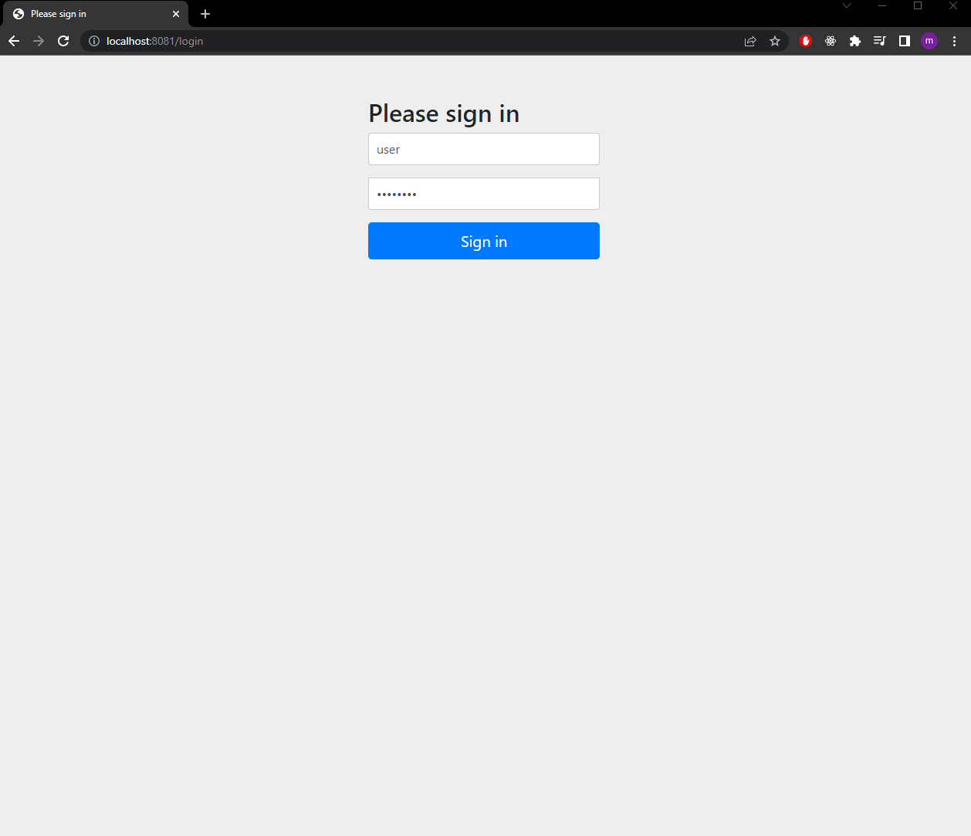

Login using credential:

User: user

Password: password

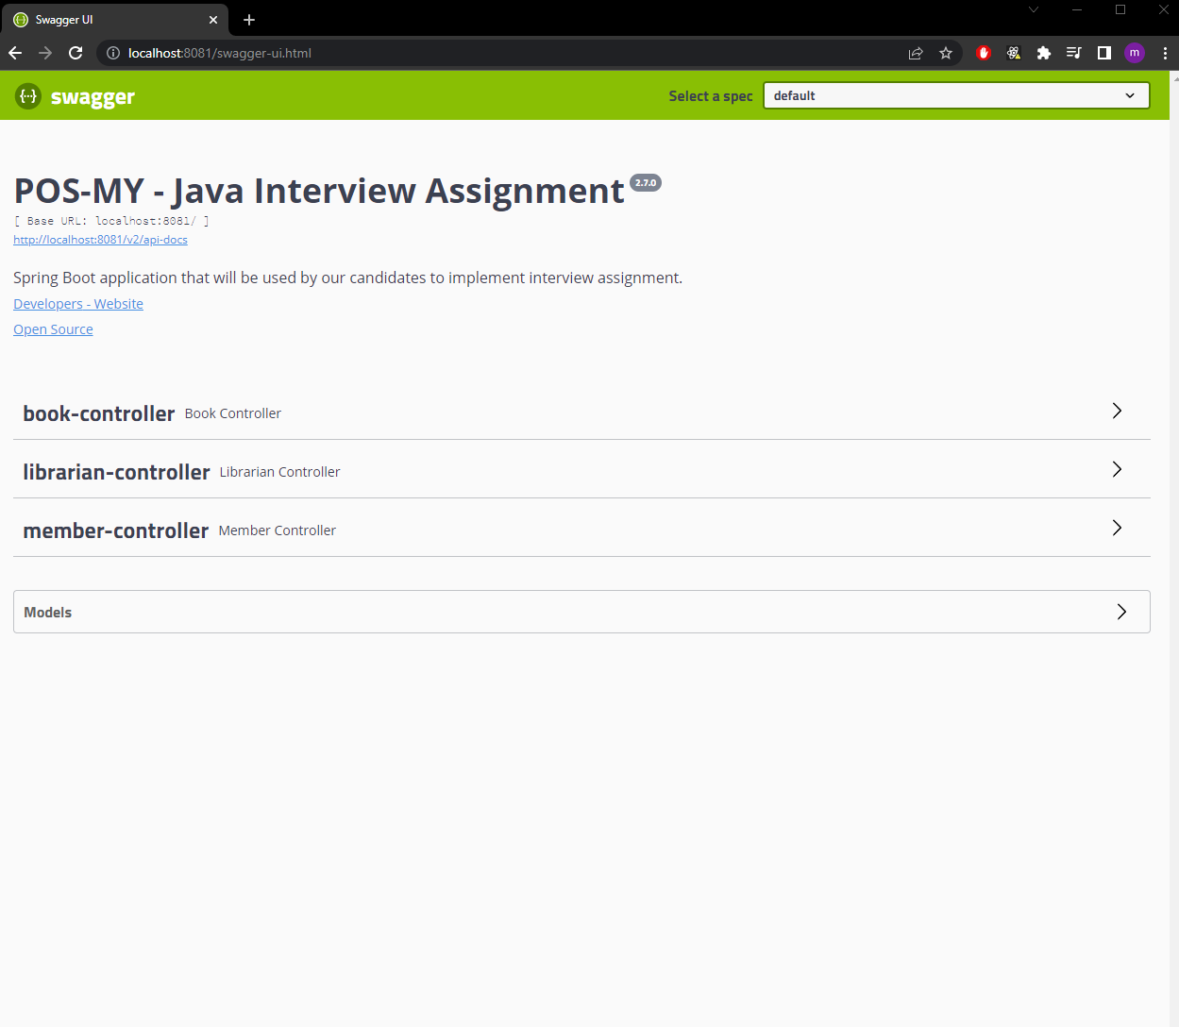

3 services - book, librarian, member

**Book**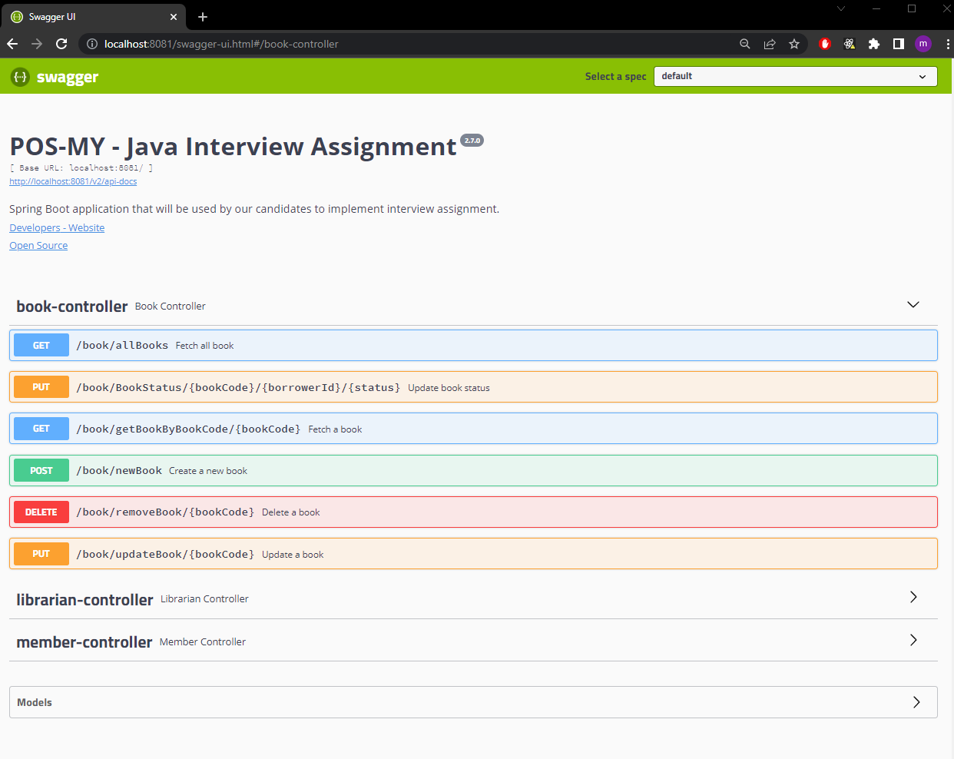

Book controller containing endpoint related to its processes

Fetch all books

Create new book

Update book

Delete book

Find book by bookCode

Update book status to BORROWED or AVAILABLE

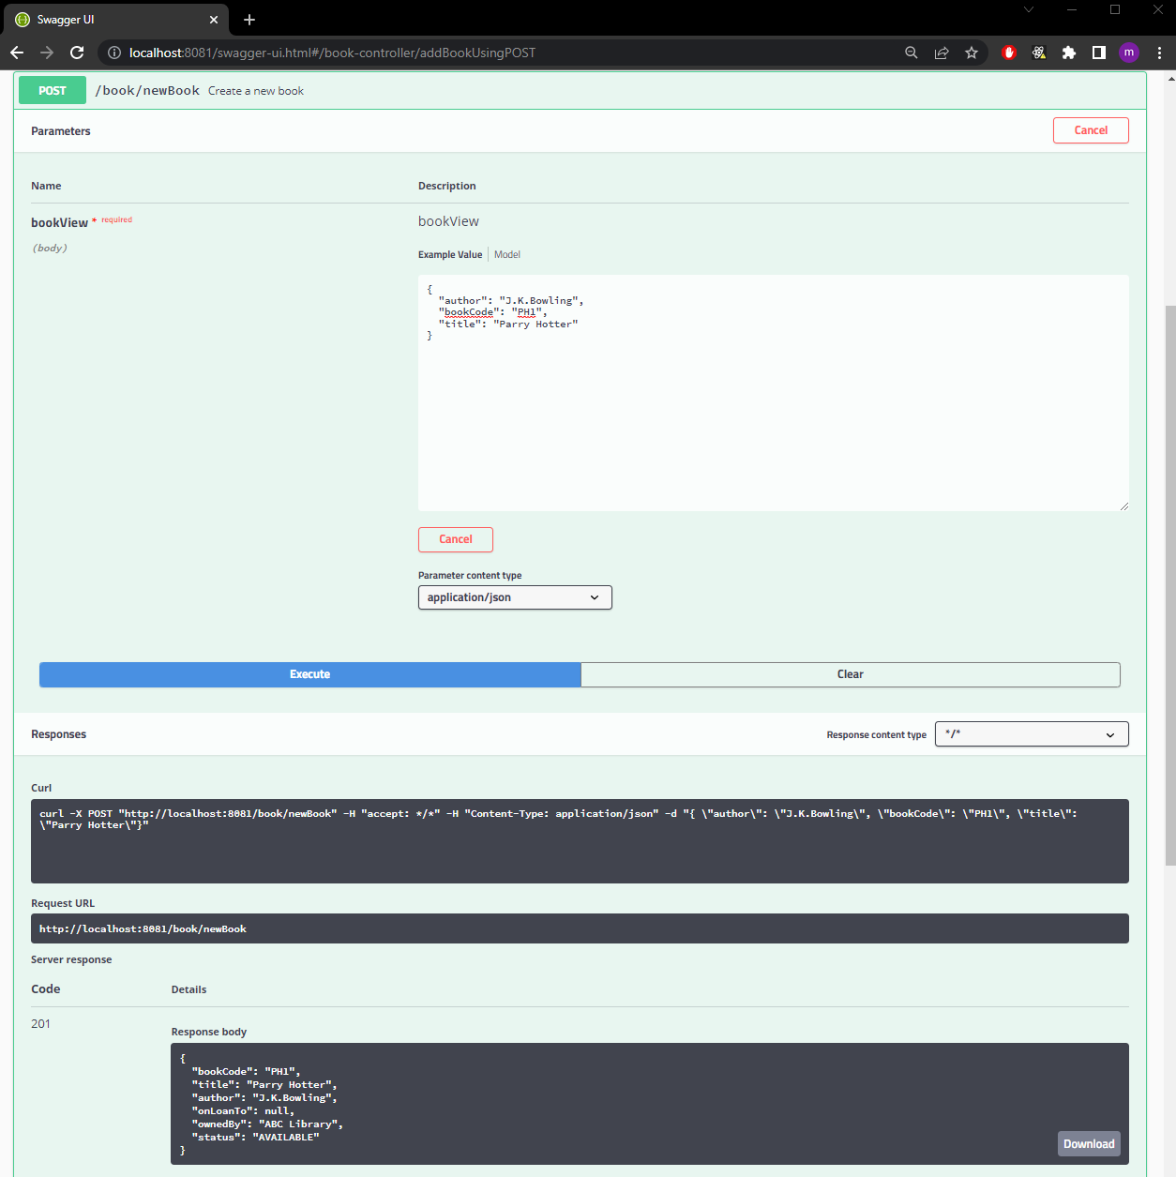

Create new book

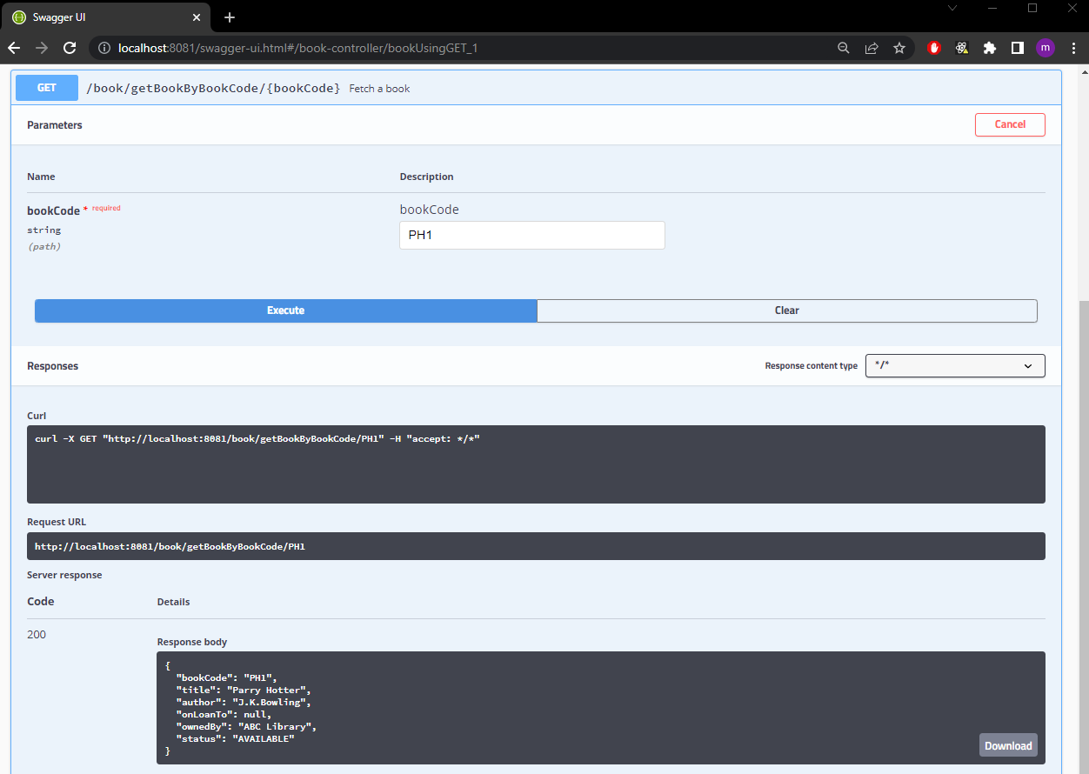

Find by bookCode

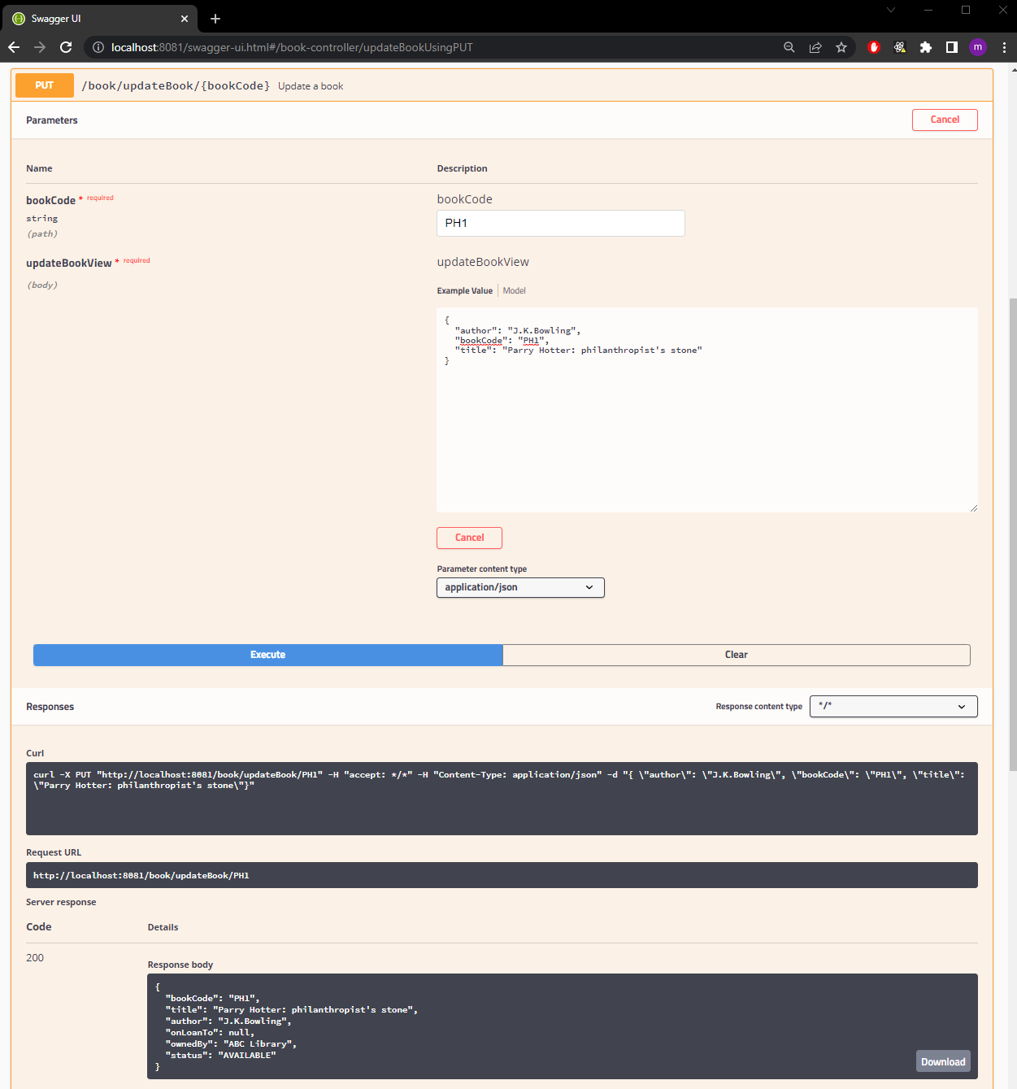Update book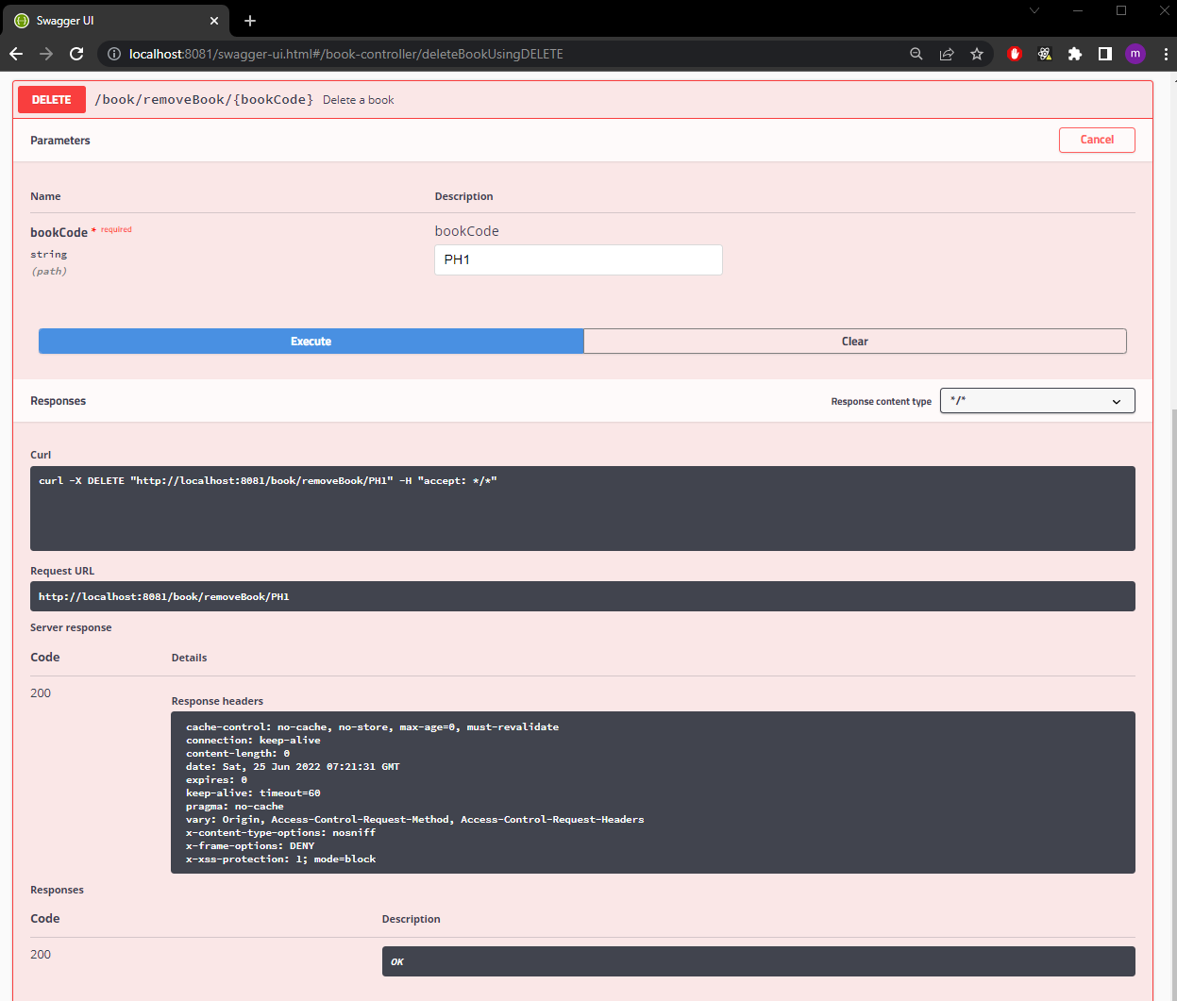

Delete book

**LIBRARIAN**

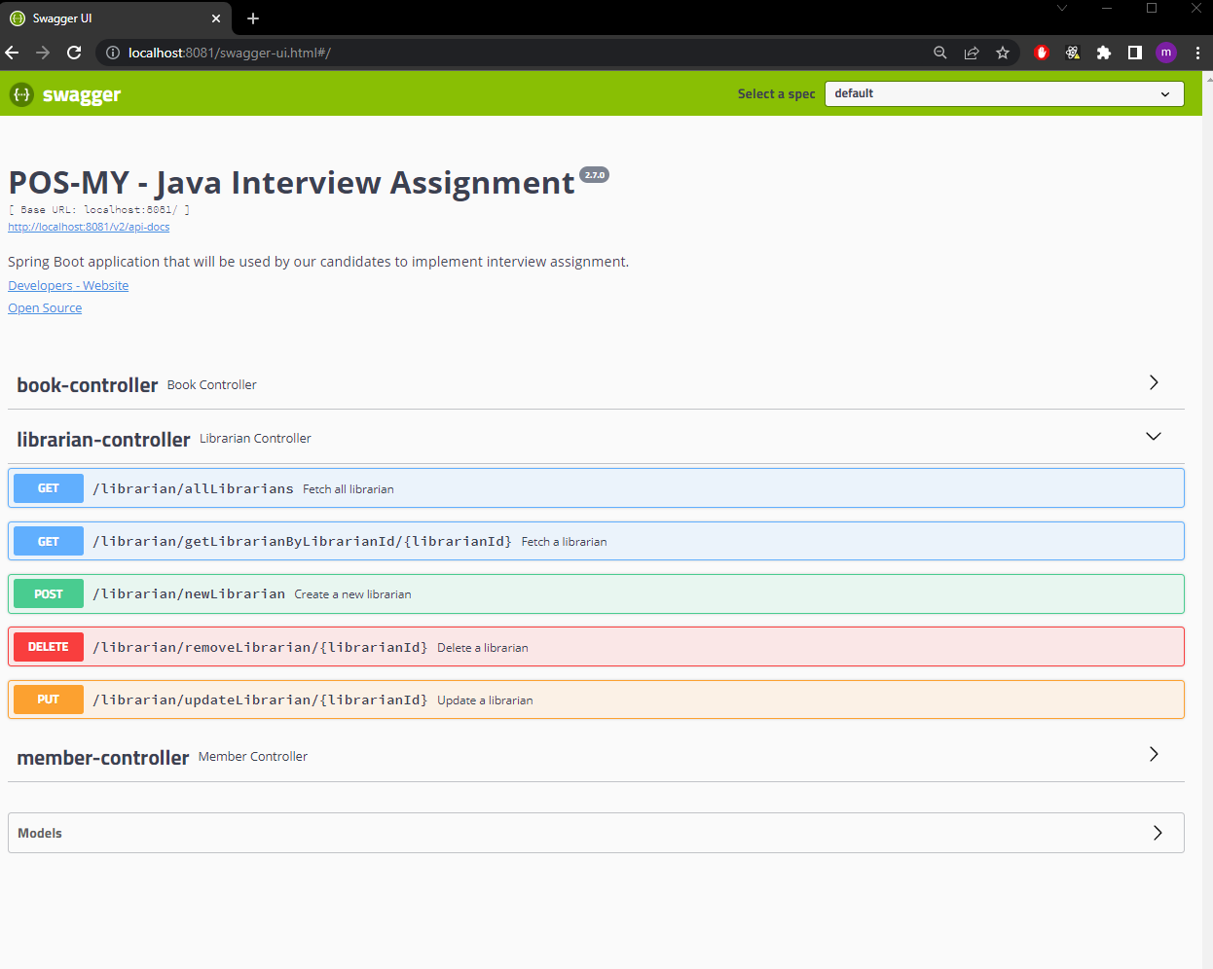Librarian controller containing endpoint related to its processes

Fetch all librarians

Create new librarian

Update librarian

Delete librarian

Find librarian by librarianId

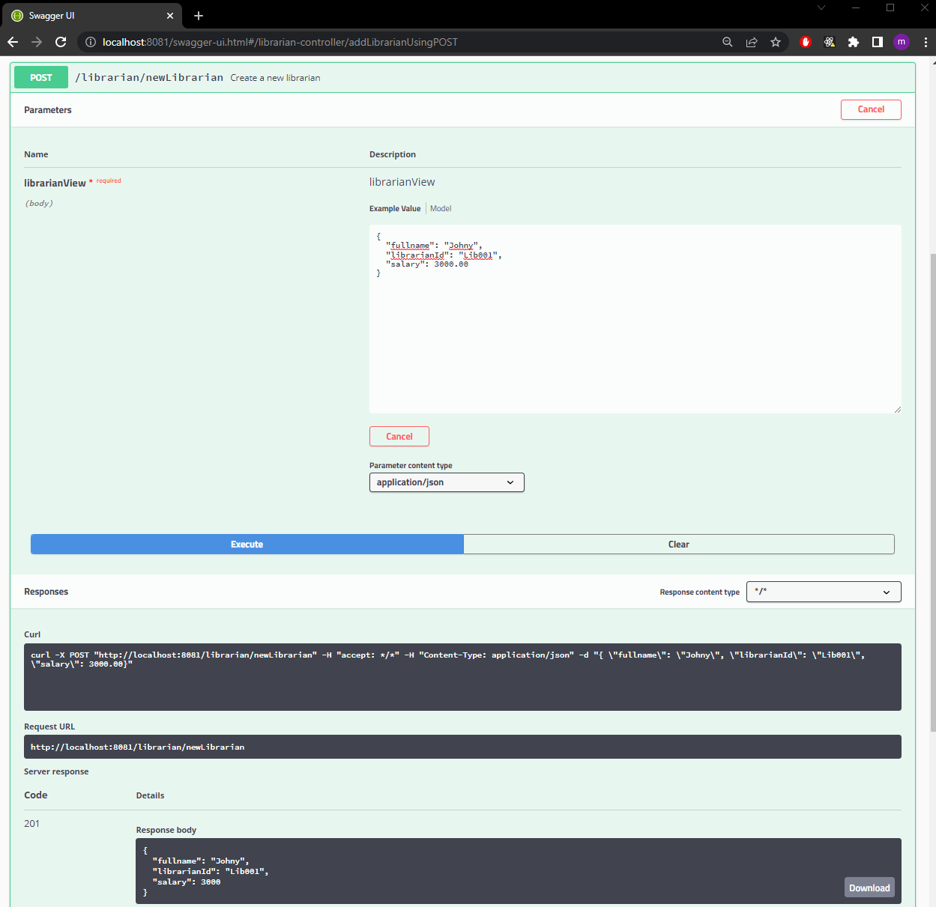

Create new librarian

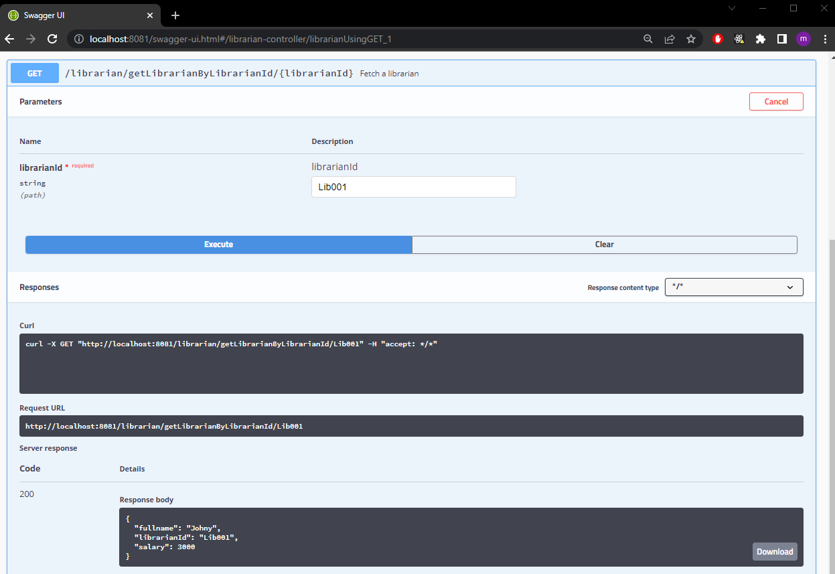Find librarian by librarianId

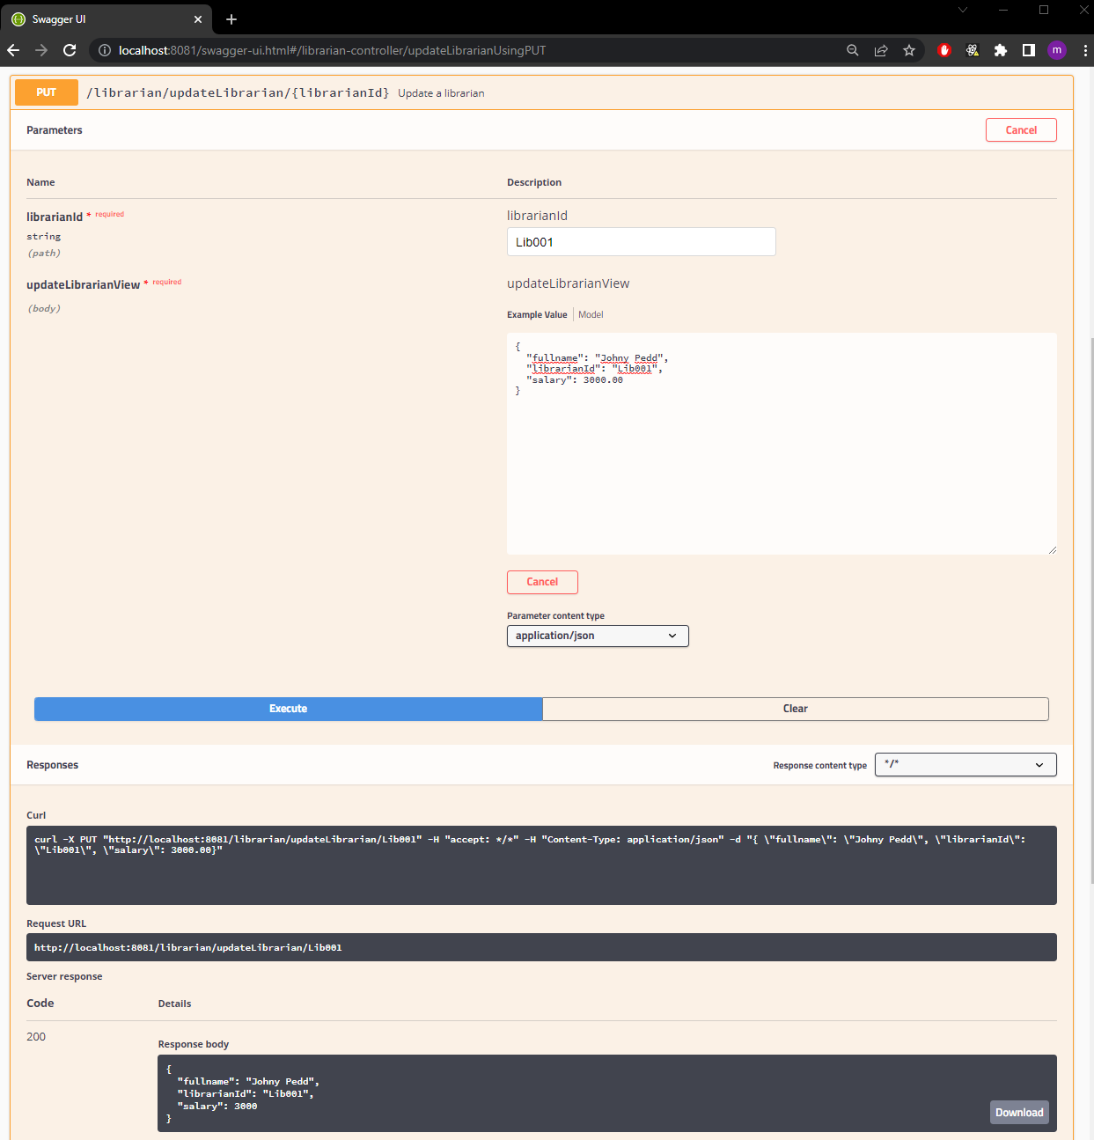Update librarian

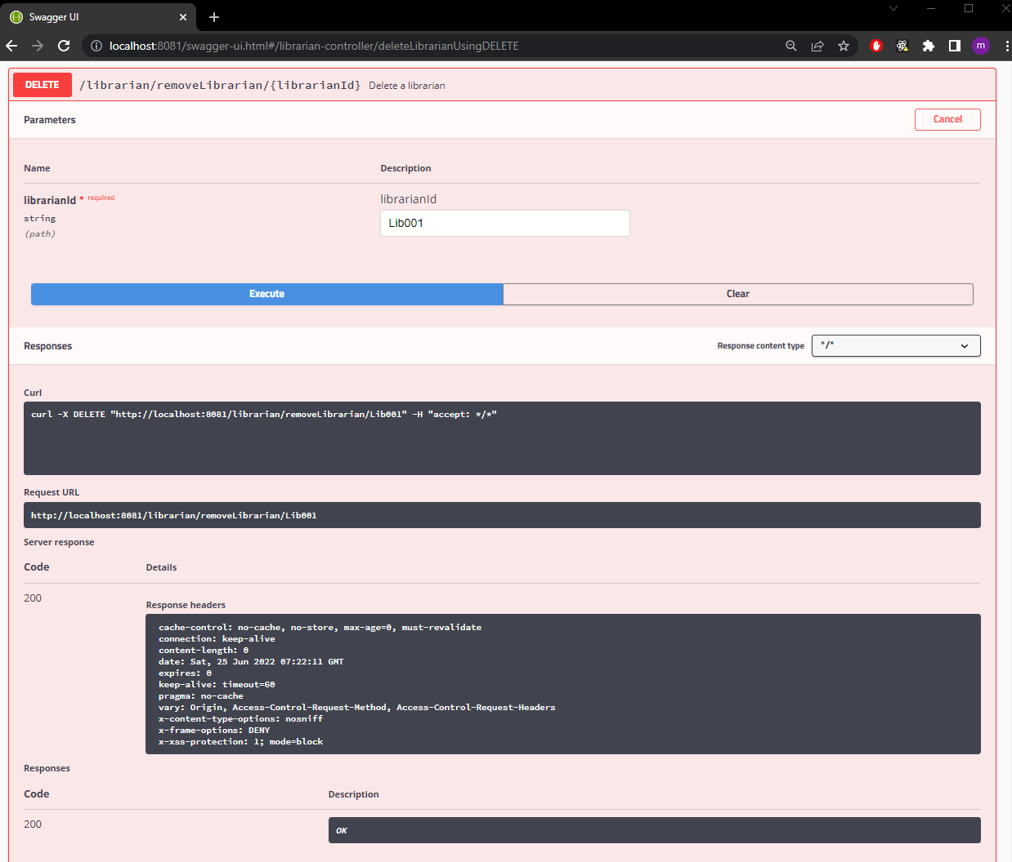Delete librarian

**MEMBER**

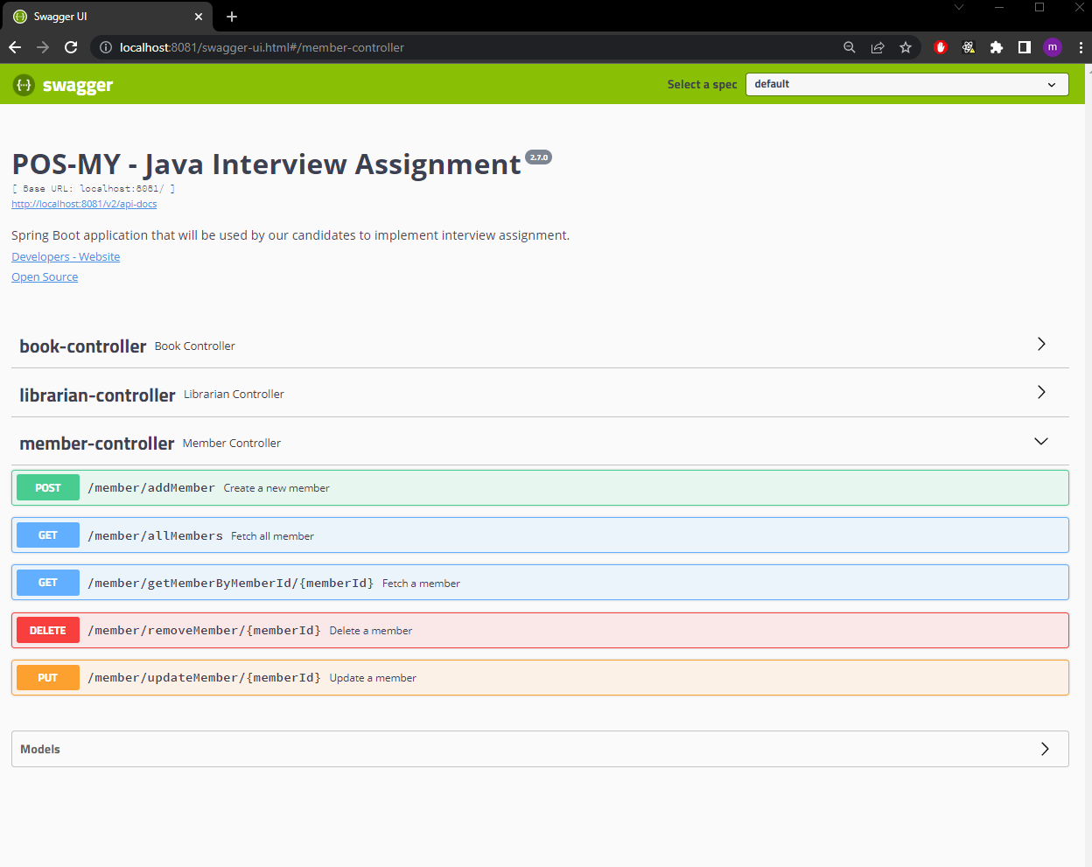Member controller containing endpoint related to its processes

Fetch all members

Create new member

Update member

Delete member

Find member by memberId

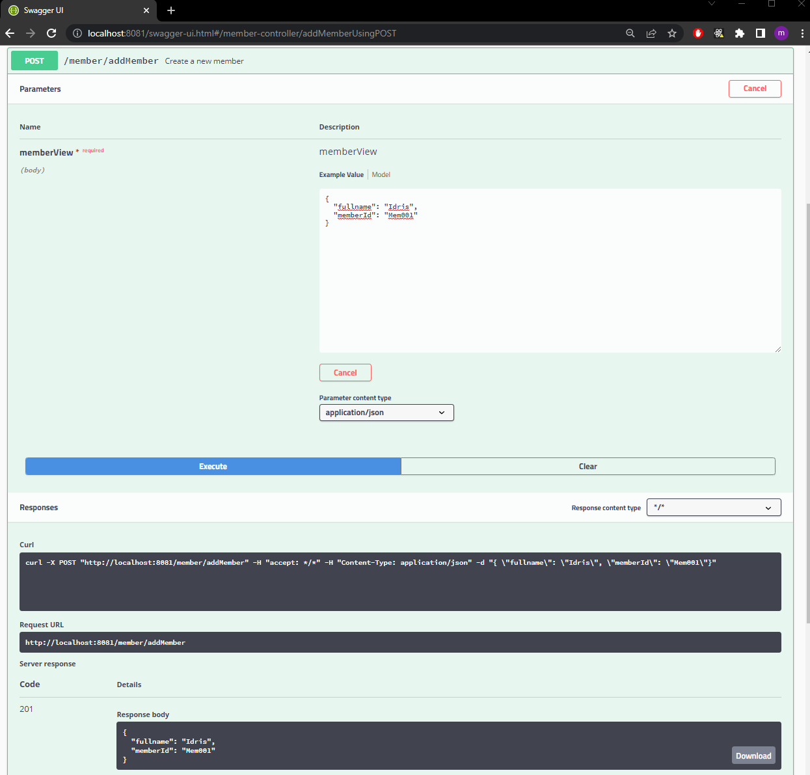Create new member

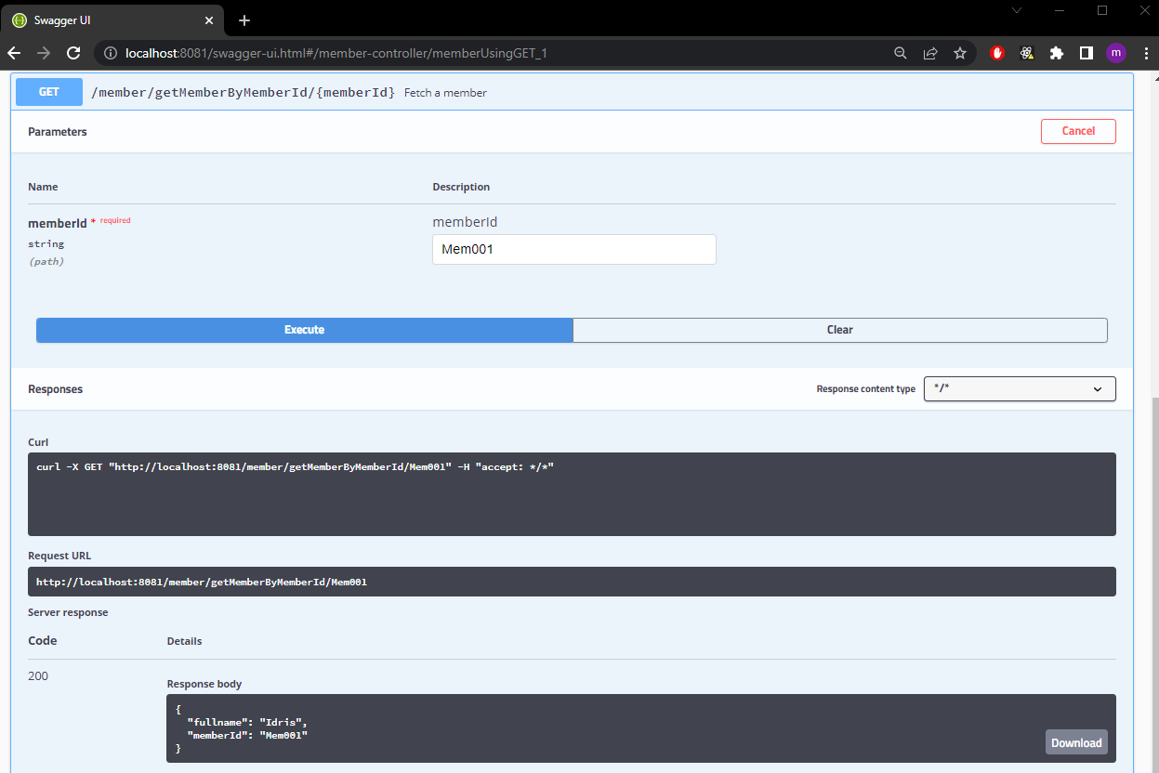Find member by memberId

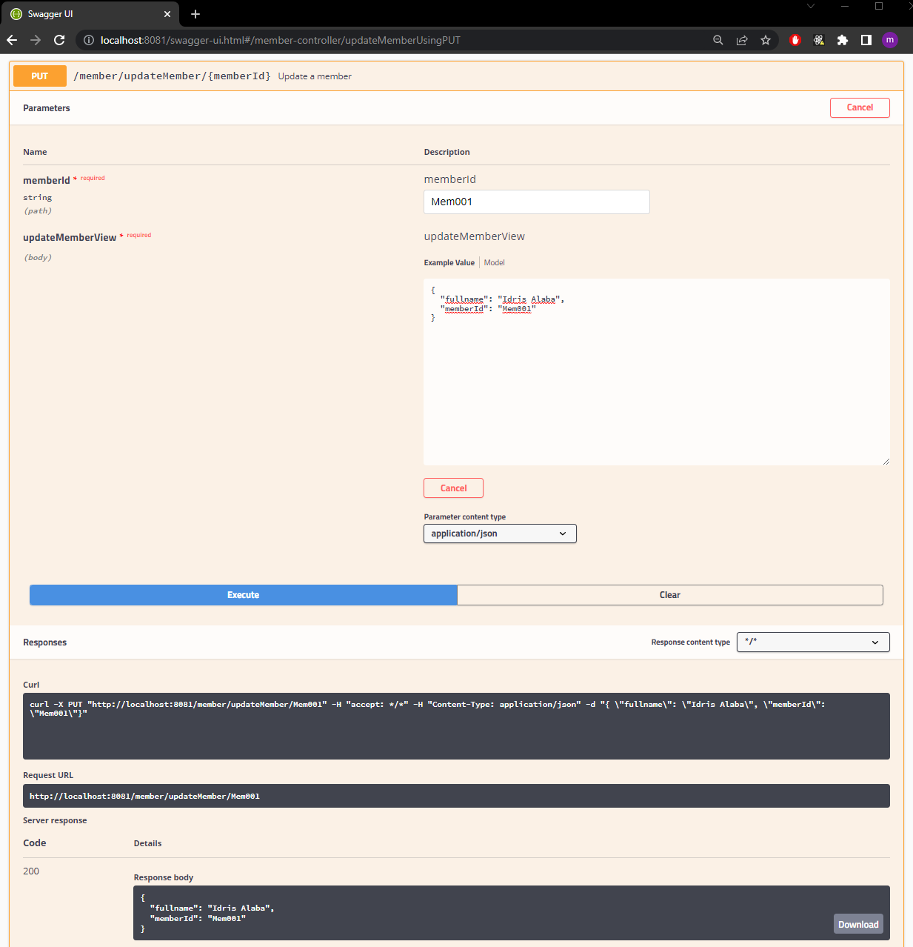Update member

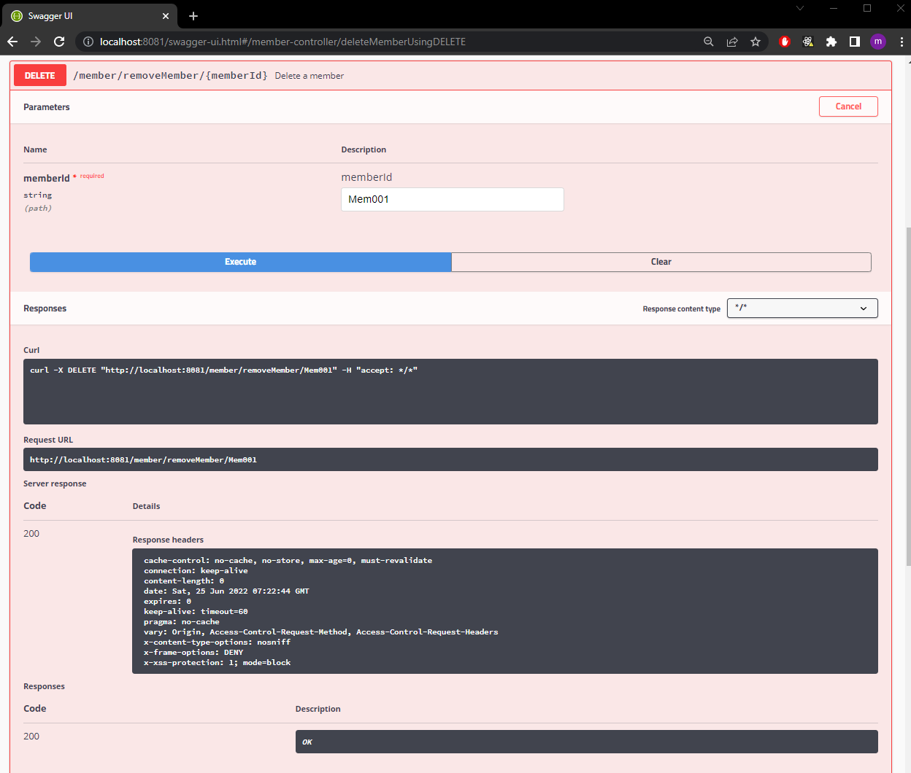Delete member

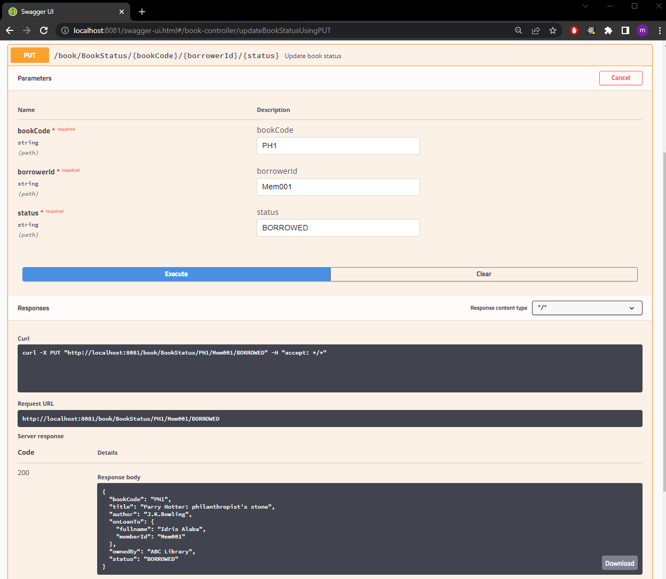

Update book status to BORROWED

Status will change to BORROWED

Book will bind to member - onLoanTo

Frontend can call this endpoint to get book record and borrower

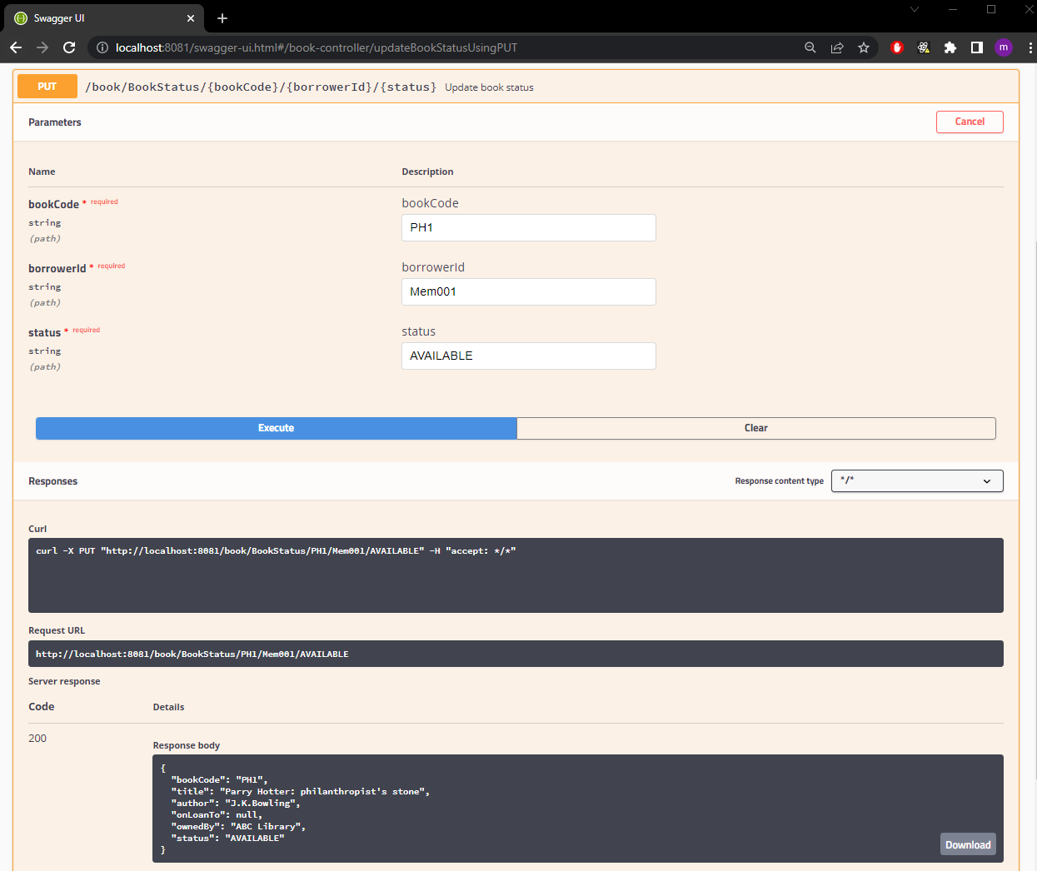

Update book status to AVAILABLE

Status will change to AVAILABLE

Once the book is returned, onLoanTo will clear and set as null

**API calling using Postman**

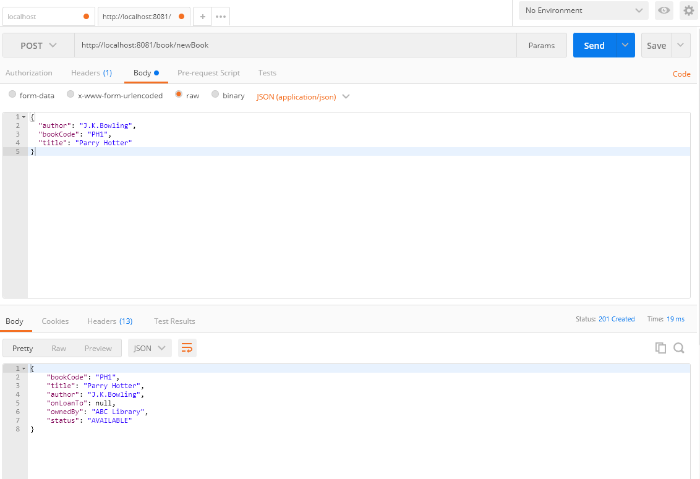add book

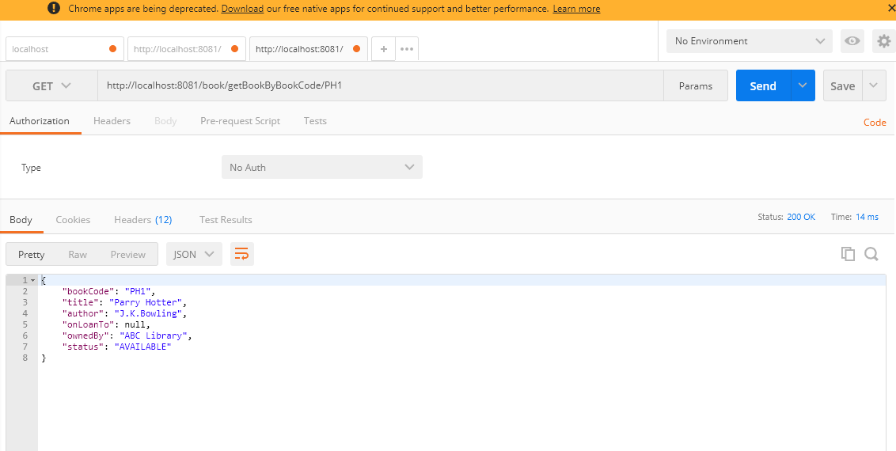find book by bookCode

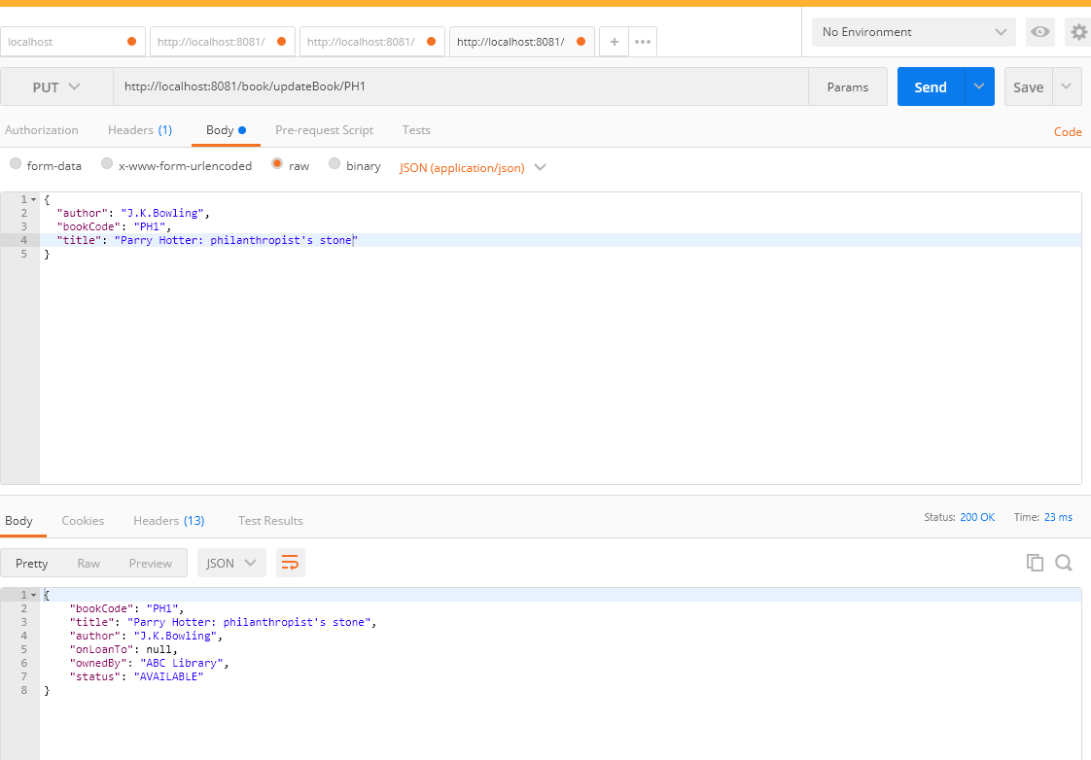Update book

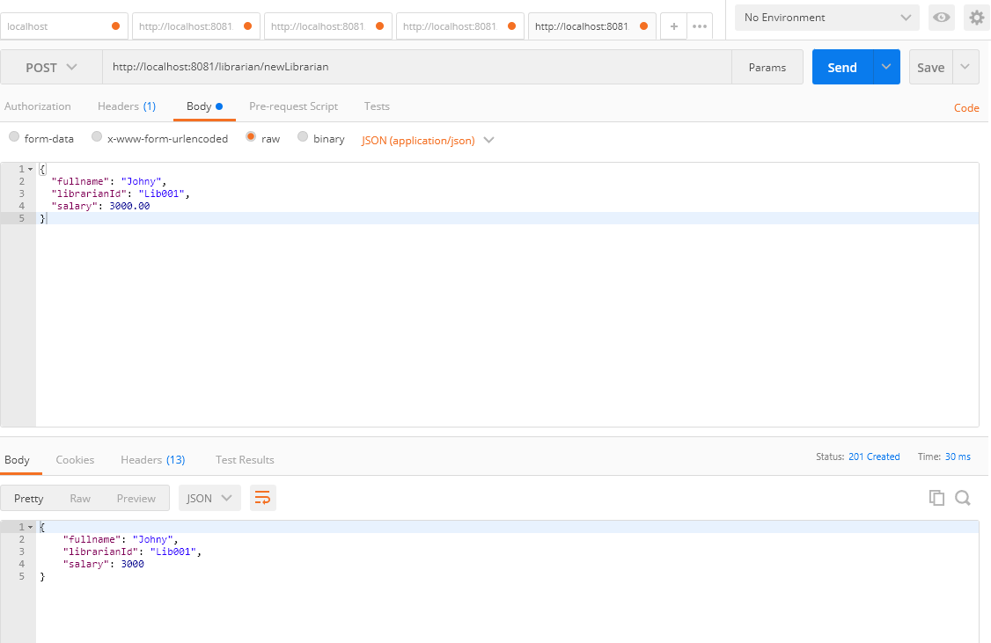add create librarian

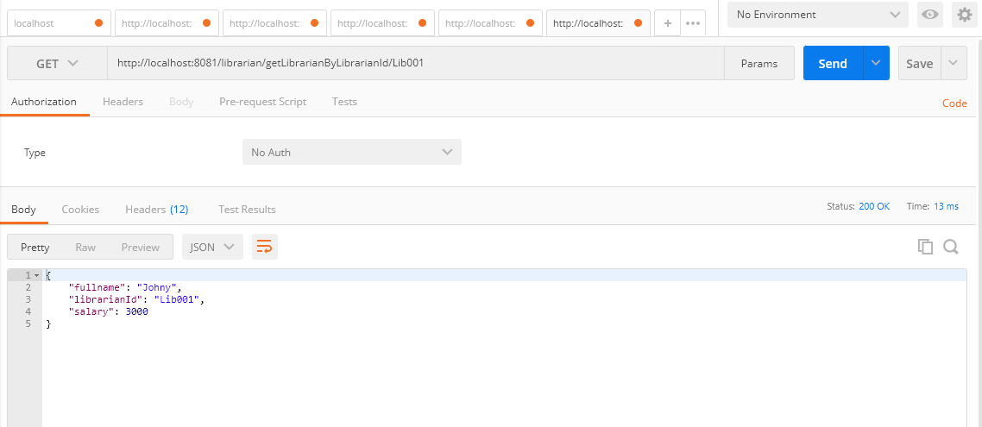find librarian by librarianId

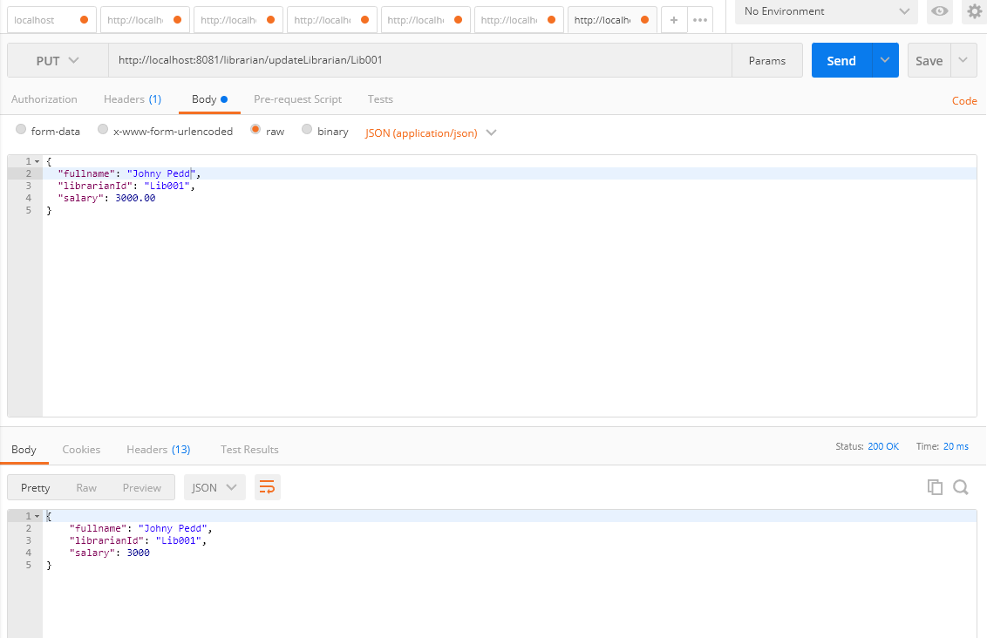Update librarian

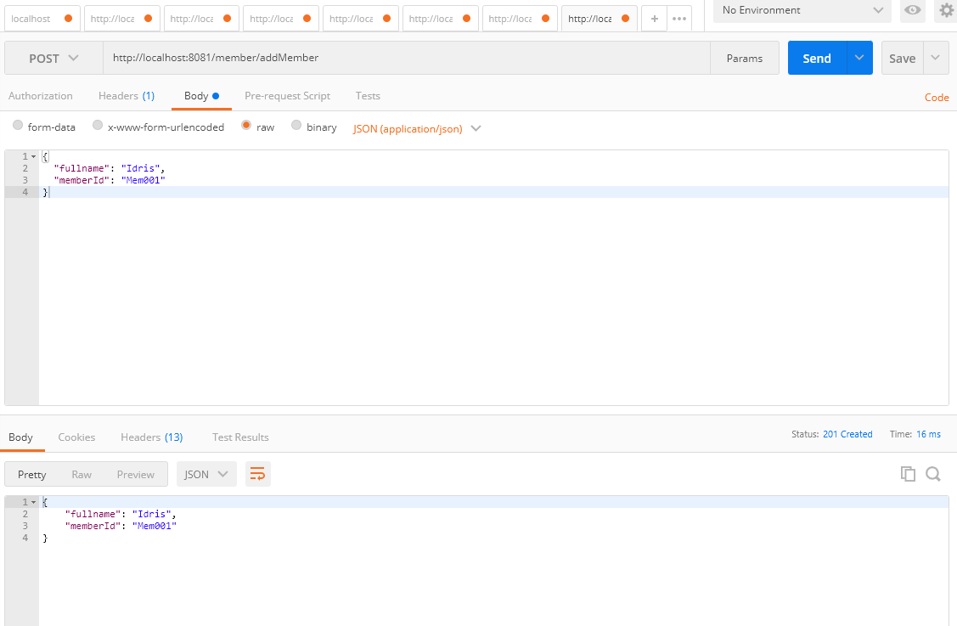add new member

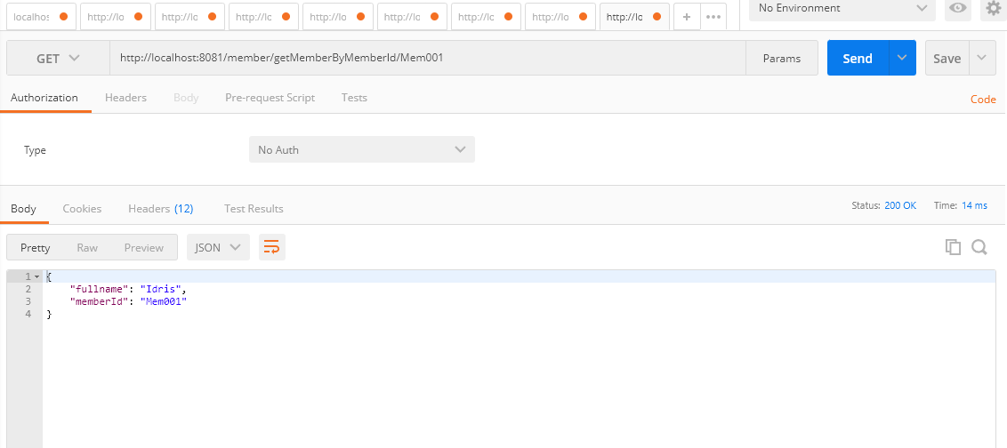find member by memberId

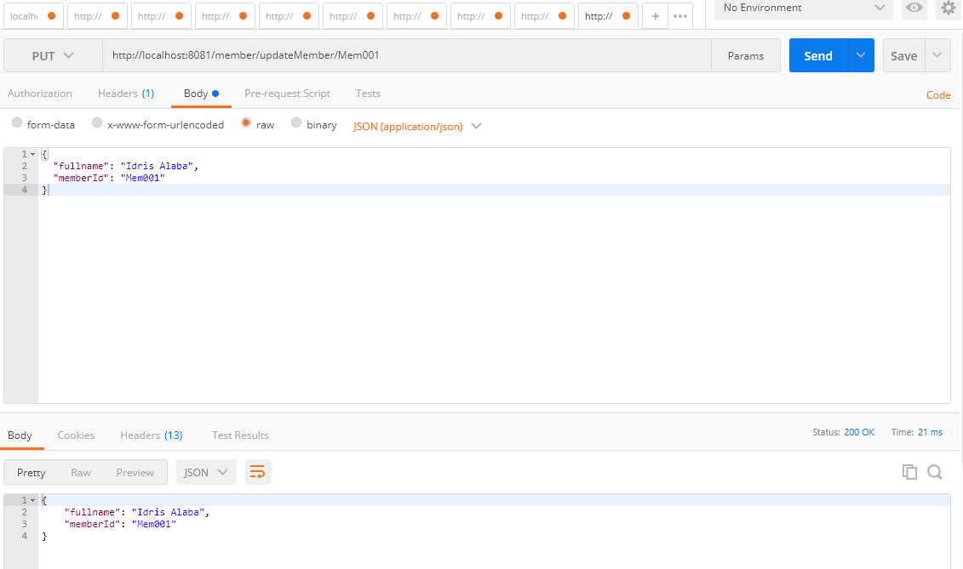update member

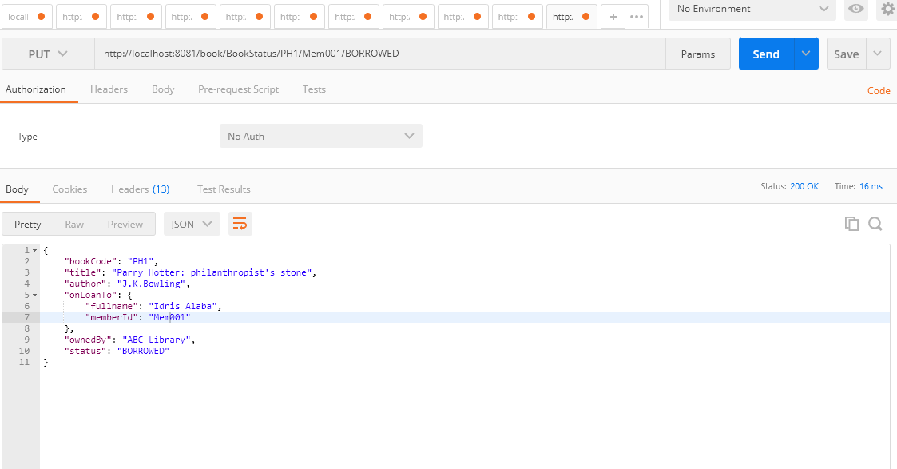

Change book status to BORROWED and bind to borrower

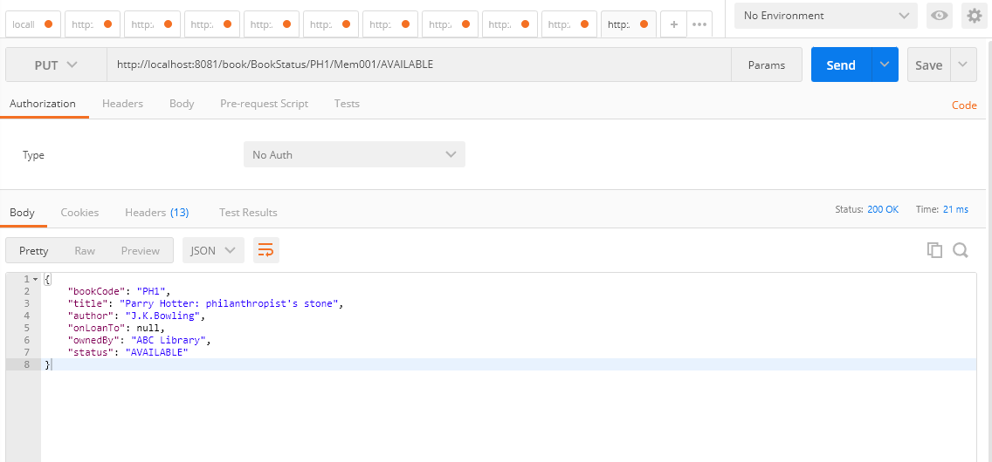

Change book status to AVAILABLE and remove borrower

**DATABASE**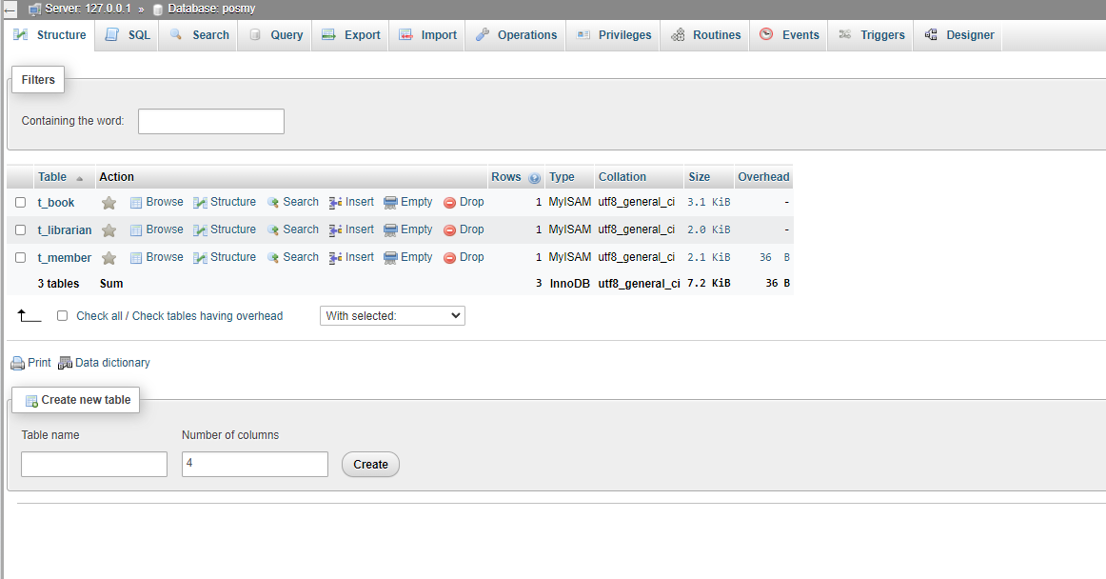3 Tables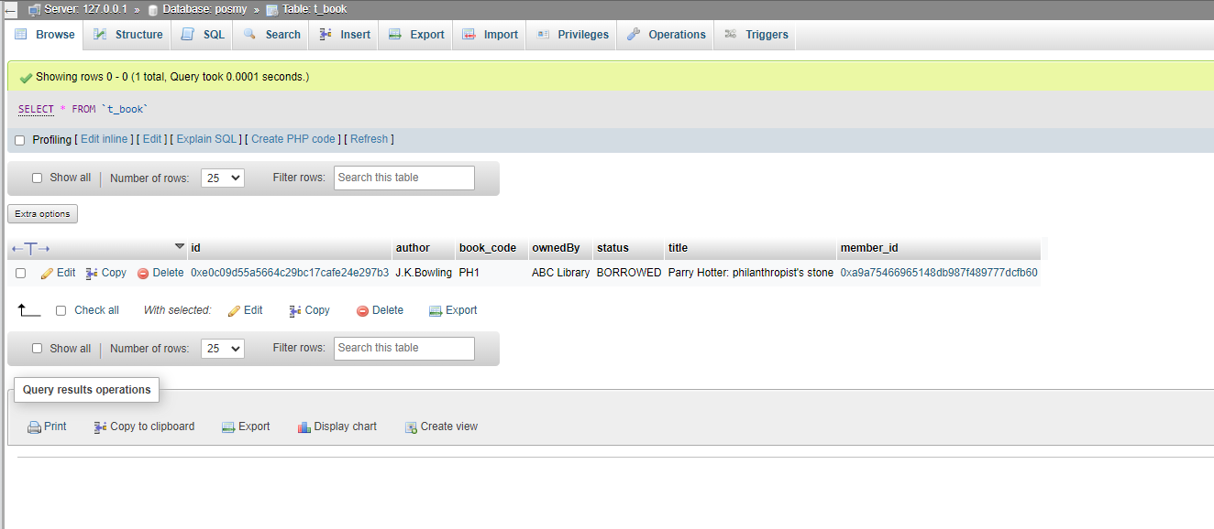Book table

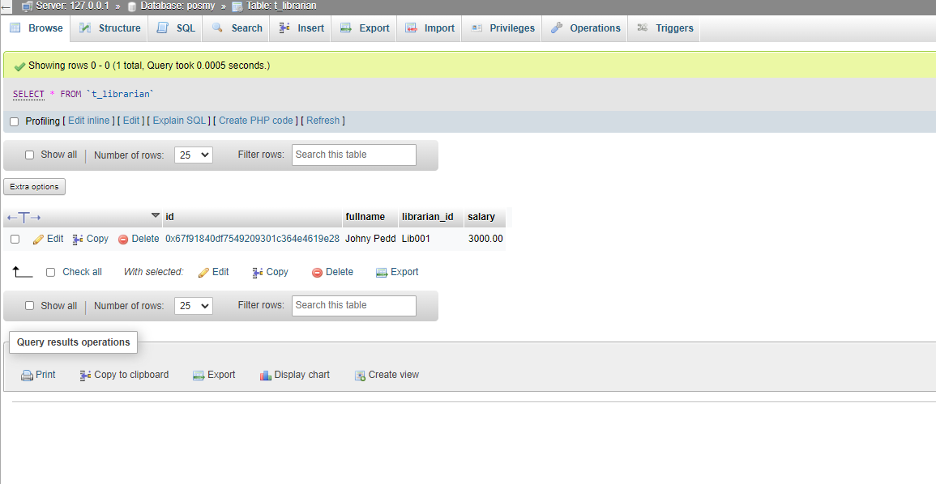Librarian table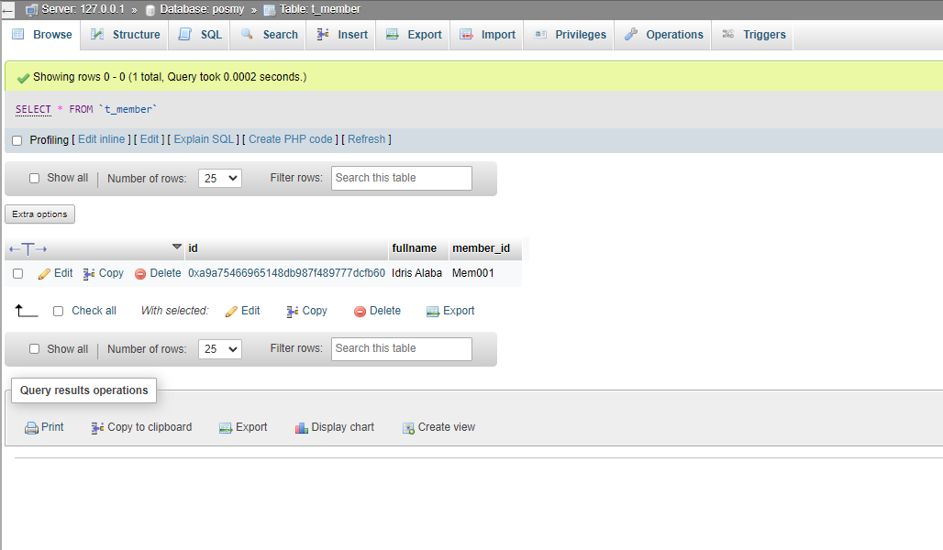Member table