BarcodeID
Comparing Machine Learning and Phylogenetic Methods for DNA Barcode-Based Species Identification
When the species is not in the reference database: Neighbor-Joining trees, k-nearest neighbours, random forests and best-close-match on European dragonflies and damselflies (Odonata, COI)
University bioinformatics research project
Project team: Data & Phylogenetics · Machine Learning · Experiments & Report
October 2026

Abstract
DNA barcoding identifies species by comparing a short gene fragment with a reference database, but reference databases are incomplete. We asked which identification method should be trusted when a query belongs to a species that is not in the database. Using 779 cleaned COI barcodes of 45 European species of Libellulidae and Coenagrionidae from BOLD Systems, we compared a Neighbor-Joining (NJ) tree with an explicit identification rule, two machine-learning classifiers on k-mer frequencies (k-nearest neighbours and random forest, each with a calibrated 'unknown' threshold), the classic best-close-match distance rule, and the same NJ tree given a calibrated tree-distance 'unknown' cut-off. With full reference coverage, all methods were equally accurate (NJ 92.4%, k-NN 93.2%, random forest 92.4%; no significant differences). When each of 39 species was removed from the reference set in turn, the NJ tree used as usual, without a cut-off, wrongly named the missing species for 67% of its queries on average and even placed two species in the wrong genus. With a calibrated 'unknown' cut-off, the same tree wrongly named only 10% and k-NN 14%. Outside a group of 10 species that share near-identical barcodes with a relative, both never named a wrong species and still reported the correct genus. Best close match, a plain distance rule, became just as safe when calibrated the same way. The safety therefore comes from the calibrated cut-off, not from machine learning; k-NN reached it about 264 times faster per query and with slightly fewer losses on known species. Barcode sharing between close relatives remains a limit that no barcode-only method overcomes.
Main finding. The calibrated 'unknown' cut-off, not the choice of method, is what makes identification safe. Without one, the NJ tree wrongly named 67% of species missing from the database. With one, the tree and k-NN were both safe (10% and 14% across 39 species held out one at a time; 0% outside barcode-sharing groups), and k-NN achieved this about 264 times faster.

1. Introduction
DNA barcoding assigns a specimen to a species by comparing a standard gene fragment, for animals usually about 650 base pairs of the mitochondrial cytochrome c oxidase I gene (COI), with sequences of identified reference specimens (Hebert et al., 2003). Public reference libraries such as the Barcode of Life Data System (BOLD; Ratnasingham & Hebert, 2007) grow quickly, but they are never complete. In practice, a query may come from a species that has no reference sequence at all.
Two families of methods are used to identify barcodes. Tree-based methods build a phylogenetic tree of reference and query sequences and read the answer from where the query lands, for example with Neighbor-Joining (NJ; Saitou & Nei, 1987). Machine-learning classifiers learn the link between sequence features and species names. Most comparisons report accuracy on species that are in the database. That is the easy case. The dangerous case is a species that is missing: a method that confidently names the wrong species produces a false record, while a method that says 'unknown', or at least points to the right genus, fails safely.
Research question. Which method should be trusted when the query species is not in the reference database: a phylogenetic tree or a machine-learning classifier?
We answer it with two experimental conditions on the same queries: full coverage (Condition A), where every test species has reference sequences, and incomplete coverage (Condition B), where some species are removed from the reference set entirely. Our contributions are:
- a head-to-head comparison of an NJ tree, k-nearest neighbours (k-NN), random forest (RF) and the classic best-close-match rule under both conditions, on identical queries;
- an explicit, reproducible identification rule for the tree, and 'unknown' cut-offs calibrated on training data only for every method, including the tree, so that all methods can be compared on equal terms;
- evidence from three independent methods that a calibrated cut-off, not machine learning as such, is what makes identification of missing species safe;
- robustness checks: species-level confidence intervals and significance tests, threshold sensitivity, three extra random splits, and holding out every eligible species once;
- an analysis of why methods fail, separating ordinary species from species that share their barcode with a close relative.

2. Data

2.1 Source and scope
We chose dragonflies and damselflies (Odonata) because a published European reference library found most species identifiable from COI alone (PeerJ, 2021). All Odonata in BOLD (2,434 named species, 25,245 COI-5P records on 9 October 2026) is far more than a project of this size can handle, so we narrowed the scope to two families with many closely related species, Libellulidae (skimmers) and Coenagrionidae (narrow-winged damselflies), from the 30 European countries with Odonata records in BOLD. Records were downloaded through the BOLD v5 public API as tab-separated files, one query per country.

2.2 Cleaning
Every filter was logged (Table 1). We kept COI-5P records of the two families that were identified to species, and removed two records whose BOLD BIN (BOLD's own sequence cluster; Ratnasingham & Hebert, 2013) was dominated by a species from a different genus, a clear mislabel. Sequences longer than 700 bp, mostly from one project that used a longer amplicon, were trimmed to the barcode region by local alignment to a reference barcode of their family. We removed sequences with more than 5% ambiguous bases, kept lengths of 600–700 bp, and kept one copy of each identical sequence per species. Seven sequences more than 10% (K2P) away from every other sequence were removed as likely contaminants: no sequence fell between 8% and 15%, so the cut-off sits in an empty gap. Finally, species with fewer than three sequences were dropped.
Table 1. Cleaning log: sequences and species left after each filter (results/tables/cleaning_log.csv).
Step | Sequences | Species | Removed
all downloaded rows (all markers, all families) | 4,477 | 120 | 0
marker_code == COI-5P | 3,365 | 118 | 1,112
family in Libellulidae, Coenagrionidae | 1,933 | 55 | 1,432
identified to species | 1,782 | 55 | 151
BIN majority species is in a different genus | 1,780 | 55 | 2
449 sequences > 700 bp trimmed to the barcode | 1,780 | 55 | 0
<= 5% non-ACGT bases | 1,776 | 55 | 4
600-700 bp | 1,592 | 54 | 184
one copy of each identical sequence per species | 798 | 54 | 794
nearest other sequence <= 0.1 K2P | 791 | 52 | 7
>= 3 sequences per species | 779 | 45 | 12

The final dataset contains 779 sequences of 45 species in 14 genera (22 Coenagrionidae, 23 Libellulidae) from 27 countries; 166 of them were trimmed. Species have between 3 and 60 sequences.

2.3 Barcode-sharing species
Some closely related species have identical or nearly identical barcodes. We defined barcode-sharing species independently of our methods as species whose specimens share a BOLD BIN with another species in our data. This gives 10 species in four groups: Coenagrion ornatum, Coenagrion puella, Coenagrion pulchellum; Ischnura elegans, Ischnura genei, Ischnura saharensis; Pyrrhosoma elisabethae, Pyrrhosoma nymphula; and Sympetrum sanguineum, Sympetrum striolatum. These species are hard for any barcode-only method and are analysed separately in Section 4.5.

3. Methods

3.1 Alignment and genetic distances
All sequences were aligned with MAFFT v7.526 (--auto; Katoh & Standley, 2013), giving an alignment of 730 columns. Pairwise distances use the Kimura two-parameter model (K2P; Kimura, 1980), the standard in DNA barcoding, skipping gaps and ambiguous bases pair by pair. Alignment uses no species labels, so aligning test sequences together with reference sequences leaks no information.

3.2 Neighbor-Joining tree
A single NJ tree (Biopython; Cock et al., 2009) was built from the K2P distances of all reference and query sequences and rooted at its midpoint. Query labels are never used. The identification rule, fixed before testing, is:
A query is assigned the species of the training sequences in the smallest clade that contains the query and at least one training sequence; if that clade holds training sequences of more than one species, the query is 'ambiguous' (with a genus if those species share one).
Used like this, as trees usually are, 'ambiguous' is the tree's only way to abstain. Building one tree per query was not feasible: Biopython's NJ takes about four minutes for 779 sequences.
To compare the tree with the classifiers on equal terms, we also evaluated the same tree with an 'unknown' cut-off ('NJ tree + cut-off'). The tree (patristic) distance from a query to its nearest training sequence is compared with a cut-off calibrated on training sequences only, inside the same tree: for every training sequence we take its tree distance to the nearest other training sequence, and the cut-off accepts 95% of these (Condition A cut-off 0.0050). A query further away is answered 'unknown', with the clade's genus. No new trees are needed. Both versions of the tree are reported throughout: plain NJ shows how trees are commonly used, and NJ + cut-off gives the fair comparison.

3.3 k-mer features and classifiers
Each unaligned sequence was converted into k-mer frequencies, the share of each possible run of k bases, for k = 4 (256 features) and k = 6 (4,096 features); each row sums to 1. We trained k-nearest neighbours (5 neighbours, closer ones weighted more) and random forests (500 trees, class weights balanced for rare species) with scikit-learn (Pedregosa et al., 2011). These settings were chosen by cross-validation on training data only. Training each model takes about one second on a laptop CPU.

3.4 'Unknown' thresholds
Without a threshold, a classifier always names one of the species it was trained on. We therefore let each classifier flag a query as 'unknown' when it is less confident than for 95% of known-species queries. The cut-off is calibrated on training data only, with two-fold cross-validation repeated five times. For random forest the confidence is the top class probability (cut-offs 0.466 for k = 4 and 0.500 for k = 6). For k-NN it is the distance to the nearest training sequence in k-mer space (cut-offs 0.0113 and 0.0124). When a query is flagged, every method still reports a genus: for k-NN the genus of the nearest training sequence, for random forest the genus of its top species, and for NJ the shared genus of the clade.

3.5 Best-close-match baseline
To test whether any advantage comes from machine learning or simply from having a cut-off, we added the classic best-close-match rule (Meier et al., 2006): take the species of the closest reference sequence by K2P distance; answer 'ambiguous' if equally close sequences belong to different species, and 'unknown' if the closest one is further than a cut-off. Following Meier et al., the cut-off is the distance below which 95% of within-species training pairs fall (2.35% in Condition A). We also report the same calibration as the classifiers and a fixed 2% cut-off.

3.6 Experimental design
- Condition A (full coverage). Within each species, 70% of sequences were used for training and 30% for testing (at least two training and one test sequence per species): 543 training and 236 test sequences, the same queries for every method. Because identical sequences were removed within species, no test sequence has an identical copy of its own species in training.
- Condition B (incomplete coverage). One species was drawn at random from each of the eight genera with at least two species (Coenagrion armatum, Erythromma viridulum, Ischnura pumilio, Leucorrhinia dubia, Libellula fulva, Orthetrum coerulescens, Pyrrhosoma elisabethae, Sympetrum sanguineum) and removed from training entirely. Queries were all 139 sequences of these species ('unknown') plus 193 Condition A test sequences of the other species ('known'). Every method was rebuilt without the held-out species, and the classifier thresholds were re-calibrated.
- Replicates. Conditions A and B were repeated with three further random seeds, each with a new split and a new set of held-out species.
- Leave-one-species-out. Each of the 39 species from multi-species genera was removed from training on its own and all its sequences were queried, with a new tree and retrained classifiers each time. This removes the luck of which species are held out.

3.7 Evaluation and statistics
For known queries we report accuracy and per-species precision and recall. For unknown queries every answer falls into exactly one class: abstained (flagged 'unknown' or 'ambiguous'; safe), a wrong species of the correct genus (wrong but close), or a wrong species of another genus (dangerous). The false-assignment rate is the share of unknown queries given any species name. 'Safe and informative' means abstaining while reporting the correct genus.
Queries of the same species are not independent, so 95% confidence intervals come from a species-level bootstrap: species are resampled with replacement, 2,000 times. Paired methods were compared with exact McNemar tests (McNemar, 1947) with Holm correction (Holm, 1979), and with a species-bootstrap interval for each difference. Runtime was measured on the same laptop for the 236 Condition A queries, from unaligned sequences, as the median of three runs. For NJ it includes alignment, distances, tree building and the rule. For best close match it includes alignment, distances and the nearest match. For the classifiers it includes k-mer extraction and prediction, excluding the one-off training.

4. Results

4.1 Known species (Condition A)
Table 2. Condition A: 236 test queries of 45 species. Accuracy without any threshold; CI = species-bootstrap interval; precision and recall are macro averages over species (results/tables/summary_A.csv, confidence_intervals.csv, runtime.csv).
Method | Accuracy | 95% CI | Precision | Recall | ms / query
NJ tree | 92.4% | 86%–98% | 94.5% | 93.9% | 868.2
k-NN (k=4) | 93.2% | 88%–98% | 91.0% | 91.3% | 3.1
k-NN (k=6) | 93.2% | 87%–98% | 93.3% | 92.2% | 3.3
RF (k=4) | 91.5% | 84%–98% | 92.8% | 93.9% | 3.9
RF (k=6) | 92.4% | 86%–98% | 93.3% | 94.2% | 4.0
Best close match | 85.6% | 72%–98% | 95.3% | 91.8% | 30.9

All four classifiers and the NJ tree identified known species with about the same accuracy (91.5–93.2%; Table 2, Figure 1). No pair differs significantly (all Holm-corrected McNemar p = 1.00), and every species-bootstrap interval of a difference between NJ and a classifier includes zero. Best close match was lower (85.6%), a significant difference (Holm p ≤ 0.015). This is because it answers 'ambiguous' for 30 queries that are identical to sequences of two species, all of them in the barcode-sharing groups. Every error of the other methods also fell inside those groups, and no method named a wrong genus.
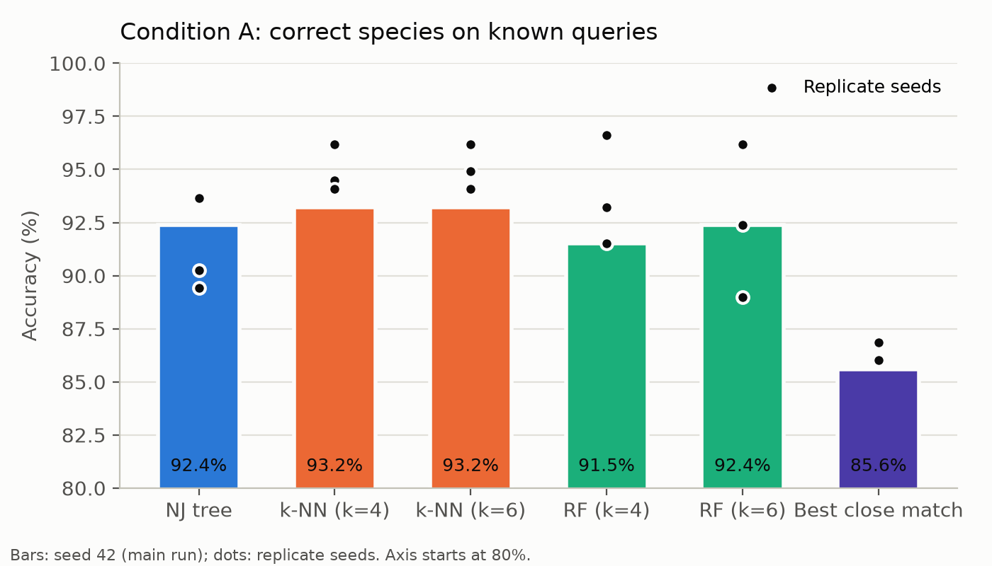
Figure 1. Accuracy on known species (Condition A). Bars: main run (seed 42); dots: three replicate seeds. The axis starts at 80%.
Across the four random splits, accuracy ranged from 89.4–93.6% for NJ, 93.2–96.2% for k-NN (k = 6) and 89.0–96.2% for random forest (k = 6). k-NN was best or tied best in three of four splits, but given the significance tests we do not claim a winner for known species.

4.2 Species missing from the database (Condition B)
Table 3. Condition B, main run: 139 unknown queries from 8 held-out species and 193 known queries. 'Known correct' counts a flagged known query as a miss (results/tables/summary_B.csv).
Method | Wrongly named | Wrong genus | Abstained | Abstained + genus | Known correct
NJ tree | 66.9% | 0.0% | 33.1% | 33.1% | 92.2%
k-NN (k=4) (cut-off) | 0.0% | 0.0% | 100.0% | 99.3% | 87.6%
k-NN (k=6) (cut-off) | 0.0% | 0.0% | 100.0% | 100.0% | 87.6%
RF (k=4) (cut-off) | 8.6% | 0.0% | 91.4% | 60.4% | 86.5%
RF (k=6) (cut-off) | 11.5% | 0.0% | 88.5% | 66.9% | 87.1%
Best close match (cut-off) | 15.8% | 0.0% | 84.2% | 84.2% | 81.9%
NJ tree + cut-off | 0.0% | 0.0% | 100.0% | 100.0% | 85.0%

For species missing from the database, the methods behaved very differently (Table 3, Figure 2). The plain NJ tree named a wrong species for 66.9% of unknown queries. It always chose a species of the correct genus and abstained only when the nearest clade mixed several species. Without a threshold, the classifiers named a known species for every unknown query, and random forest put 22–31% of them in the wrong genus. With the calibrated threshold, k-NN flagged every unknown query, and for k = 6 it reported the correct genus for all of them. Random forest flagged 88.5–91.4%, and best close match with Meier's cut-off flagged 84.2%. Given a calibrated cut-off, the NJ tree also flagged 100.0% of unknown queries, all with the correct genus: the same tree that named a wrong species two times out of three without a cut-off became as safe as k-NN.
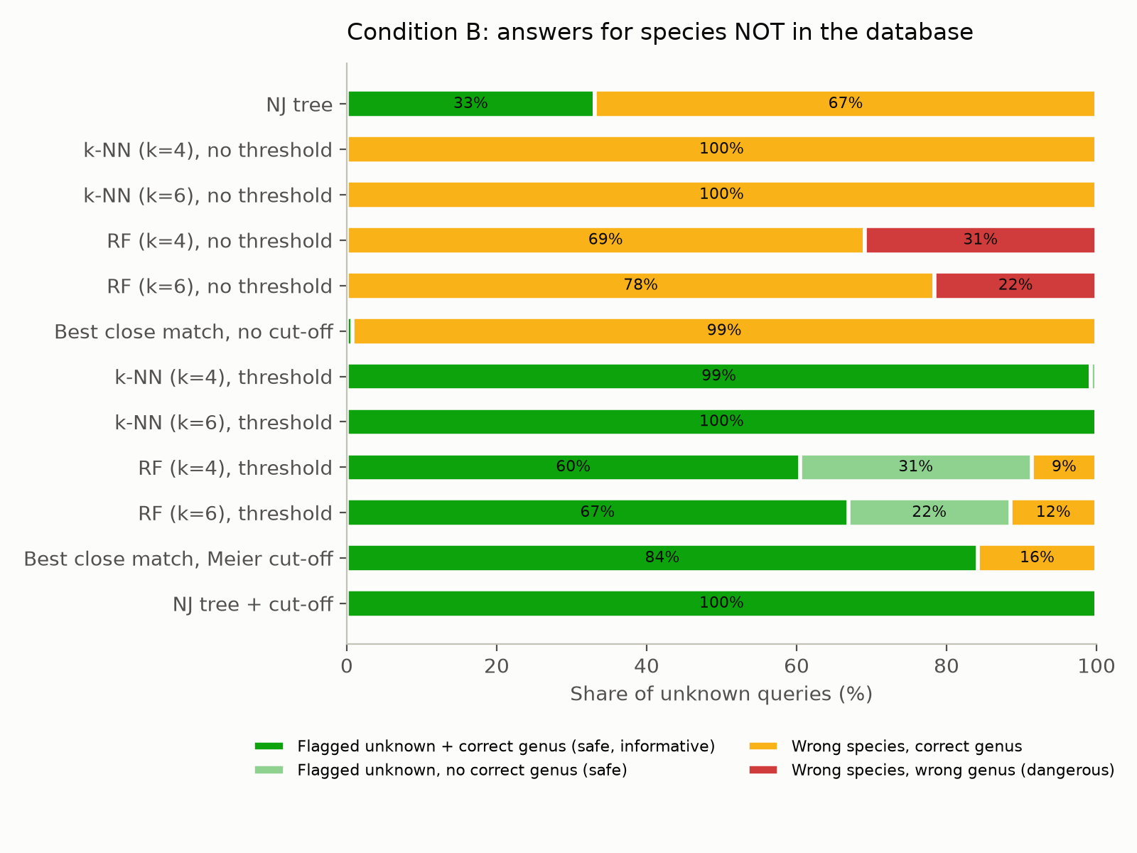
Figure 2. What each method answers for species not in the database (Condition B, main run). Green: flagged 'unknown' or abstained (dark green with the correct genus). Yellow: a wrong species of the correct genus. Red: a wrong species of another genus.
The difference between plain NJ and the thresholded classifiers is large and robust. Plain NJ named a species 55%–67% more often (Holm p < 0.0001; species-bootstrap lower bound +16%), while NJ + cut-off and k-NN did not differ at all (difference 0.0%). Safety has a price: with a cut-off on, every method rejected some known species too, reaching 85.0–87.6% correct on known queries against 92.2% for plain NJ. Figure 3 shows the same trade-off from full to incomplete coverage.
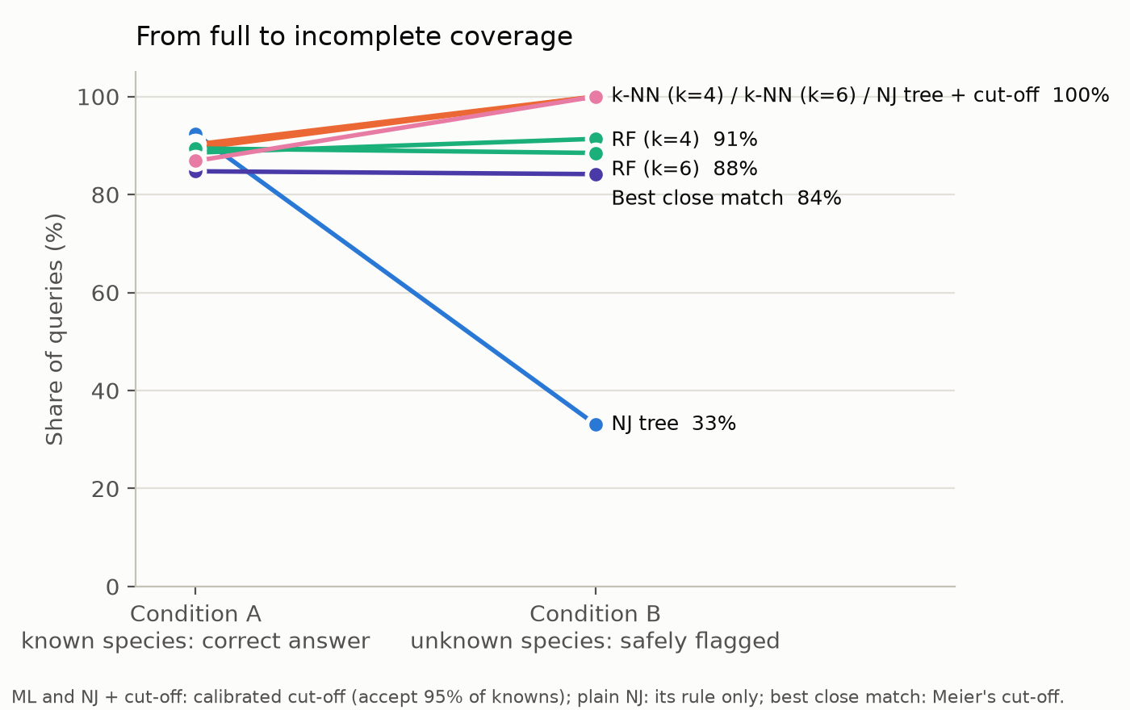
Figure 3. From full to incomplete coverage: correct answers on known species (Condition A, with each method's cut-off) against unknown species safely flagged (Condition B).

4.3 Every species held out once
Table 4. Leave-one-species-out: each of 39 species held out on its own; means over species, so each species counts equally. 29 sp. = excluding barcode-sharing species (results/tables/loso_overall.csv).
Method | Wrongly named (39 sp.) | Species never wrong | Wrongly named (29 sp.) | Abstained + genus (29 sp.) | Wrongly named (10 sharing)
NJ tree | 66.8% | 28% | 62.1% | 34.5% | 80.3%
k-NN (k=4) | 14.5% | 82% | 0.0% | 95.7% | 56.6%
k-NN (k=6) | 14.4% | 82% | 0.0% | 99.2% | 56.0%
RF (k=4) | 16.5% | 77% | 0.0% | 68.5% | 64.2%
RF (k=6) | 20.0% | 72% | 3.8% | 79.3% | 66.9%
Best close match | 18.9% | 72% | 4.2% | 89.9% | 61.8%
NJ tree + cut-off | 10.3% | 85% | 0.0% | 89.7% | 40.2%

Holding out every eligible species once confirms the result without depending on a random draw (Table 4, Figure 4). On average NJ wrongly named the missing species for 66.8% of its queries, and for 67% of species it did so for most queries. k-NN (k = 6) did so for 14.4%, never naming a wrong species for 82% of species. Among the 29 species that do not share their barcode, k-NN never named a wrong species for a single query, with either k, and reported the correct genus for 99.2%; plain NJ wrongly named 62.1%. Plain NJ also placed two species in the wrong genus, Leucorrhinia caudalis (4 queries), Libellula quadrimaculata (30 queries): each was placed next to the other. With its cut-off, the tree wrongly named 10.3% of queries overall and 0.0% outside the barcode-sharing groups, and the two wrong-genus placements were flagged 'unknown' instead. NJ + cut-off and k-NN were the two safest methods (10.3–14.4%); the tree was slightly safer on barcode-sharing species (40% against 56% wrongly named). No method with a cut-off named a wrong genus in this analysis.
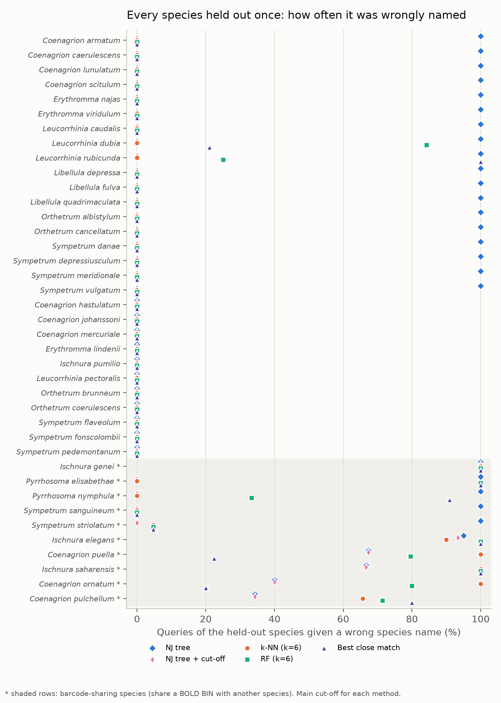
Figure 4. Every species held out once: share of its queries given a wrong species name, by method. Shaded rows (*) are barcode-sharing species.

4.4 Robustness to splits and thresholds
Across the four random Condition B draws, the share of unknown queries wrongly named ranged from 46.4–97.8% for plain NJ, 0.0–24.6% for NJ + cut-off, 0.0–33.2% for k-NN (k = 6), 11.5–41.8% for random forest (k = 6) and 15.8–40.9% for best close match. NJ + cut-off or k-NN was the safest method in every draw, and plain NJ never was. The wide ranges come from which species happen to be drawn, as Section 4.5 explains.
The threshold matters less for k-NN than for random forest (Figure 5). Even at the strictest calibration, which accepts 99% of known species, k-NN still caught 97.8% of unknown queries, while random forest fell to 84.2–85.6%. Lower thresholds catch more unknown species but reject more known ones.
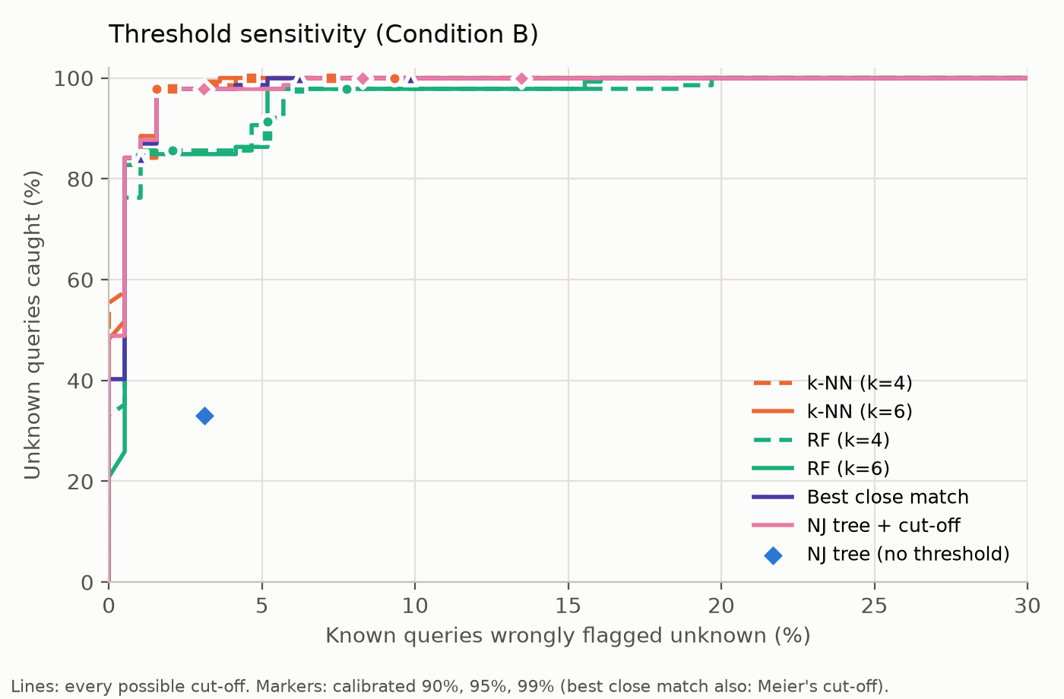
Figure 5. Threshold sensitivity (Condition B, main run). Lines: every possible cut-off; markers: cut-offs calibrated to accept 90%, 95% and 99% of known species (best close match also: Meier's cut-off). The blue diamond is plain NJ, which has no cut-off.

4.5 Why methods fail: barcode sharing
Splitting Condition B by barcode sharing explains the variation between draws (Figure 6). Without barcode-sharing species, k-NN wrongly named 0.0% of unknown queries in every draw, random forest 0.0–11.5%, best close match 0.0–16.8% and NJ 13.5–100.0%. For barcode-sharing species every method failed often, k-NN by up to 72% and NJ by up to 100%. When a missing species' barcode is identical to that of a species in the database, the barcode alone cannot reveal that it is missing.
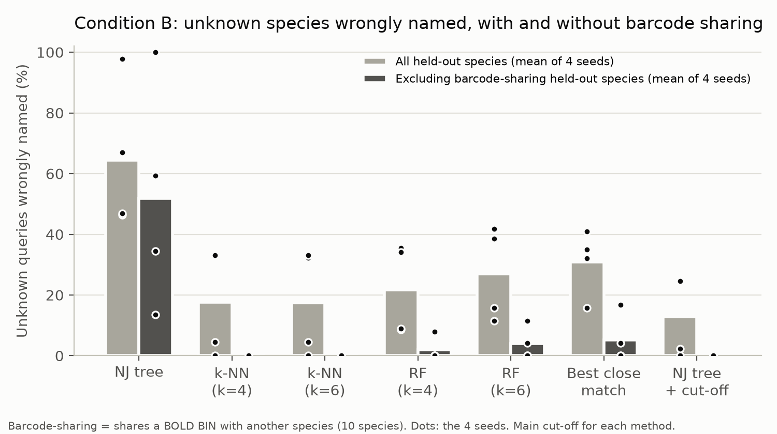
Figure 6. Unknown species wrongly named, for all held-out species and excluding barcode-sharing species (bars: mean of four seeds; dots: each seed).

4.6 Where does the safety come from?
Three independent lines of evidence point to the same answer: the safety comes from a calibrated 'unknown' cut-off, not from machine learning as such.
- A plain distance rule. Best close match has no learning. With Meier's cut-off it wrongly named 15.8% of unknown queries in the main run and 15.8–40.9% across draws. Calibrated in the same way as k-NN, it also flagged 100.0% of unknown queries.
- The same tree with a cut-off. Plain NJ wrongly named 67% of missing species across 39 species; with a calibrated tree-distance cut-off it wrongly named 10%, slightly fewer than k-NN (14%).
- The threshold curves. Across every possible cut-off, the curves of NJ + cut-off and k-NN almost overlap (Figure 5): at the same rate of wrongly rejected known species, they catch about the same share of unknown species.
What, then, does machine learning add? First, speed (Section 4.7). Second, a slightly better balance at its calibrated cut-off. With cut-offs on, k-NN kept more known species correct than NJ + cut-off in all 8 seed-and-condition comparisons, by 2.5–6.8 percentage points. These differences are not significant individually, and since the threshold curves overlap, they reflect where each calibration placed its cut-off (the in-tree calibration chose a stricter one), not a better ability to tell known from unknown. Against best close match, k-NN's advantage is clearer: at the same safety it kept 87.6% of known queries correct against 76.7%, because its vote among five neighbours resolves many queries that best close match calls ambiguous.

4.7 Speed
Per query, the NJ pipeline took 868 ms, best close match 31 ms, and the classifiers 3.1–4.0 ms, so the classifiers were 218–276 times faster than NJ (k-NN with k = 6: about 264 times; Figure 7). NJ has no training step, but it must rebuild the whole tree, including all reference sequences, every time new queries arrive. Its cost grows steeply with database size, roughly with the cube of the number of sequences.
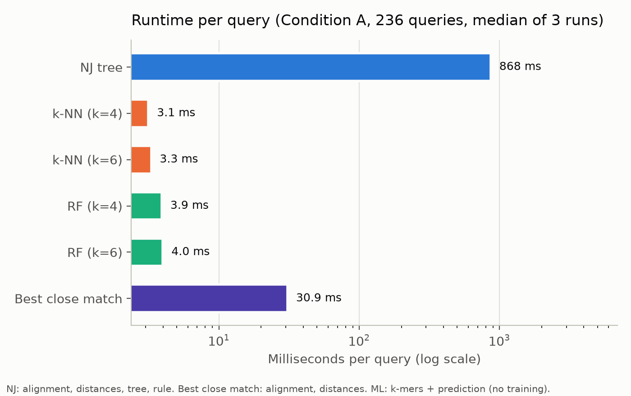
Figure 7. Runtime per query (log scale), same laptop and the same 236 queries, median of three runs.

5. Discussion
On species that are in the reference database, the choice of method hardly matters: all methods identified about nine in ten queries correctly, and their errors were the same unavoidable confusions between barcode-sharing species. When the database is incomplete, what matters is not the method but whether it has a calibrated way to say 'this species is not here'. A phylogenetic tree used as usual has none. With our rule it answered with the nearest species in most cases, twice even with a species of another genus, and abstained only when the neighbouring clade happened to contain several species. Machine-learning classifiers without a threshold are no better: they always name a known species.
Once every method is given an 'unknown' cut-off calibrated on known species, the picture changes. The tree, k-NN and even a plain distance rule all became safe, and outside the barcode-sharing groups the tree and k-NN never named a wrong species. They also kept the useful part of the tree's answer, the genus. Random forest remained somewhat less safe, because its probabilities spread over related species and do not directly measure how far a query is from the references. Methods that measure distance (k-NN, best close match and the tree) are the natural basis for an 'unknown' answer.
Our central recommendation is therefore method-independent: whichever identification method is used, add a calibrated 'unknown' cut-off. Without one, the tree named a wrong species for two thirds of missing species; with one, wrong names fell to about one in ten. If speed matters, k-NN on k-mer frequencies is the practical choice, because it reaches the same safety hundreds of times faster. Answers that fall within a barcode-sharing group should be reported at genus or species-group level.
Our results agree with earlier work on this group and on barcoding in general. The European Odonata reference study (PeerJ, 2021) found that most species are identifiable from COI alone, but not all, which matches our accuracy of about nine in ten for known species and the same problem groups. Meier et al. (2006) introduced best close match because tree-based identification overstates success. Our finding that a distance cut-off is what makes identification safe extends their argument to the case of missing species, and shows that the same fix works for the tree itself. The machine-learning studies in our reference list report high accuracy on known species. Our results suggest that such accuracy says little about behaviour on species outside the training set, which needs to be tested explicitly, and that comparisons between trees and classifiers should give both the same chance to answer 'unknown'.
A further practical difference concerns how each method scales. A classifier is trained once and then answers each new query in milliseconds, and adding reference sequences only needs retraining, which took about a second here. A tree must be rebuilt with all references every time new queries arrive. With a growing reference library, this cost rises faster than the library itself.

6. Limitations
- One group, one gene, one region. Two families of European Odonata, the COI barcode only, and data from BOLD as downloaded on 9 October 2026.
- Small dataset. 779 sequences of 45 species; some species have only three sequences, and Condition B per draw rests on eight species.
- Barcode sharing. 10 species share BINs with relatives. No barcode-only method can separate them, and they cause almost all errors.
- Calibration of the tree cut-off. The tree's cut-off was calibrated inside the same tree on training sequences, while the classifiers used cross-validation; the two procedures placed their cut-offs at slightly different points of the trade-off. We used a single NJ tree for all queries, not one tree per query, and did not test maximum-likelihood trees.
- Label quality. We trust BOLD identifications apart from two cross-genus mislabels; remaining mislabels within genera would count as method errors.
- Statistics. McNemar tests treat queries as independent, which they are not; we therefore also report species-level bootstrap intervals and prefer them where the two disagree.

7. Conclusion
Which method should be trusted when the species is not in the database? Not the method alone. Without an 'unknown' cut-off, the NJ tree wrongly named 67% of species missing from the database; with a calibrated cut-off, the tree and k-NN were both safe (10% and 14% across 39 species held out one at a time, and 0% outside barcode-sharing groups), and k-NN achieved this about 264 times faster. Whichever method is used, a calibrated 'unknown' cut-off should be part of it. Barcode sharing between close relatives remains the limit that no barcode-only method overcomes.

References
Cock P. J. A. et al. (2009). Biopython: freely available Python tools for computational molecular biology and bioinformatics. Bioinformatics 25: 1422–1423.
Coverage and quality of DNA barcode references for Central and Northern European Odonata (2021). PeerJ 9: e11192. https://peerj.com/articles/11192/
Hebert P. D. N., Cywinska A., Ball S. L., deWaard J. R. (2003). Biological identifications through DNA barcodes. Proceedings of the Royal Society B 270: 313–321.
Holm S. (1979). A simple sequentially rejective multiple test procedure. Scandinavian Journal of Statistics 6: 65–70.
Katoh K., Standley D. M. (2013). MAFFT multiple sequence alignment software version 7. Molecular Biology and Evolution 30: 772–780.
Kimura M. (1980). A simple method for estimating evolutionary rates of base substitutions through comparative studies of nucleotide sequences. Journal of Molecular Evolution 16: 111–120.
McNemar Q. (1947). Note on the sampling error of the difference between correlated proportions or percentages. Psychometrika 12: 153–157.
Meier R., Shiyang K., Vaidya G., Ng P. K. L. (2006). DNA barcoding and taxonomy in Diptera: a tale of high intraspecific variability and low identification success. Systematic Biology 55: 715–728.
Pedregosa F. et al. (2011). Scikit-learn: machine learning in Python. Journal of Machine Learning Research 12: 2825–2830.
Ratnasingham S., Hebert P. D. N. (2007). BOLD: The Barcode of Life Data System. Molecular Ecology Notes 7: 355–364.
Ratnasingham S., Hebert P. D. N. (2013). A DNA-based registry for all animal species: the Barcode Index Number (BIN) system. PLoS ONE 8: e66213.
Saitou N., Nei M. (1987). The neighbor-joining method: a new method for reconstructing phylogenetic trees. Molecular Biology and Evolution 4: 406–425.
AI-powered biodiversity assessment: species classification via DNA barcoding and deep learning (2024). Technologies 12: 240. https://www.research.unipd.it/bitstream/11577/3541838/2/technologies-12-00240-v2.pdf
A new method for species identification via protein-coding and non-coding DNA barcodes by combining machine learning with bioinformatic methods (2012). https://www.ncbi.nlm.nih.gov/pmc/articles/PMC3282726/
BOLD Systems database overview (2024). https://pmc.ncbi.nlm.nih.gov/articles/PMC11070247

Appendix: reproducibility
All code, cleaned data and results are in the project repository. One random seed (42) is used everywhere; the main splits and the held-out species list are saved once and never regenerated. Each step is a separate script that runs from cached files, in this order:
- download_bold.py: raw BOLD records (all European Odonata)
- data_cleaning.py: filters of Table 1
- alignment.py: MAFFT alignment
- splits.py: Condition A and B splits
- phylo_baseline.py, features.py, ml_classifiers.py, bcm.py: the methods
- experiment_full.py, experiment_incomplete.py: Conditions A and B
- replicates.py, leave_one_species_out.py, runtime.py: robustness and timing
- evaluate.py, significance.py: tables, figures and statistics
- report/build_report.py: this report, with every number read from results/

Appendix: supplementary tables
Table 5. Species in the final dataset, with their number of sequences, Condition A training sequences, and whether they share a BOLD BIN with another species (data/processed/metadata.csv, split_A.csv, barcode_sharing_species.csv).
Family | Species | Sequences | Training (A) | Barcode-sharing
Coenagrionidae | Ceriagrion tenellum | 6 | 4
Coenagrionidae | Coenagrion armatum | 3 | 2
Coenagrionidae | Coenagrion caerulescens | 6 | 4
Coenagrionidae | Coenagrion hastulatum | 22 | 15
Coenagrionidae | Coenagrion johanssoni | 3 | 2
Coenagrionidae | Coenagrion lunulatum | 4 | 3
Coenagrionidae | Coenagrion mercuriale | 8 | 6
Coenagrionidae | Coenagrion ornatum | 5 | 3 | yes
Coenagrionidae | Coenagrion puella | 49 | 34 | yes
Coenagrionidae | Coenagrion pulchellum | 35 | 25 | yes
Coenagrionidae | Coenagrion scitulum | 9 | 6
Coenagrionidae | Enallagma cyathigerum | 54 | 38
Coenagrionidae | Erythromma lindenii | 44 | 31
Coenagrionidae | Erythromma najas | 44 | 31
Coenagrionidae | Erythromma viridulum | 32 | 22
Coenagrionidae | Ischnura elegans | 60 | 42 | yes
Coenagrionidae | Ischnura genei | 3 | 2 | yes
Coenagrionidae | Ischnura pumilio | 10 | 7
Coenagrionidae | Ischnura saharensis | 6 | 4 | yes
Coenagrionidae | Nehalennia speciosa | 9 | 6
Coenagrionidae | Pyrrhosoma elisabethae | 3 | 2 | yes
Coenagrionidae | Pyrrhosoma nymphula | 33 | 23 | yes
Libellulidae | Crocothemis erythraea | 26 | 18
Libellulidae | Leucorrhinia caudalis | 4 | 3
Libellulidae | Leucorrhinia dubia | 19 | 13
Libellulidae | Leucorrhinia pectoralis | 5 | 3
Libellulidae | Leucorrhinia rubicunda | 4 | 3
Libellulidae | Libellula depressa | 14 | 10
Libellulidae | Libellula fulva | 13 | 9
Libellulidae | Libellula quadrimaculata | 30 | 21
Libellulidae | Orthetrum albistylum | 5 | 3
Libellulidae | Orthetrum brunneum | 14 | 10
Libellulidae | Orthetrum cancellatum | 39 | 27
Libellulidae | Orthetrum coerulescens | 36 | 25
Libellulidae | Selysiothemis nigra | 3 | 2
Libellulidae | Sympetrum danae | 10 | 7
Libellulidae | Sympetrum depressiusculum | 4 | 3
Libellulidae | Sympetrum flaveolum | 4 | 3
Libellulidae | Sympetrum fonscolombii | 11 | 8
Libellulidae | Sympetrum meridionale | 13 | 9
Libellulidae | Sympetrum pedemontanum | 6 | 4
Libellulidae | Sympetrum sanguineum | 23 | 16 | yes
Libellulidae | Sympetrum striolatum | 21 | 15 | yes
Libellulidae | Sympetrum vulgatum | 24 | 17
Libellulidae | Trithemis annulata | 3 | 2

Table 6. Paired comparisons on identical queries (main run). Difference = first minus second method; CI from the species-level bootstrap; 'only 1 / only 2' = queries where only the first or only the second method succeeded (exact McNemar test, Holm correction within each outcome; results/tables/significance_tests.csv).
Outcome | Comparison | Difference (points) | 95% CI (species) | Only 1 / only 2 | Holm p
Known (A): correct | NJ tree vs k-NN (k=4) | -0.9 | -3.0 to +1.7 | 5/7 | 1.0000
Known (A): correct | NJ tree vs k-NN (k=6) | -0.9 | -2.4 to +0.9 | 5/7 | 1.0000
Known (A): correct | NJ tree vs RF (k=4) | +0.9 | -2.8 to +5.3 | 8/6 | 1.0000
Known (A): correct | NJ tree vs RF (k=6) | +0.0 | -3.9 to +4.4 | 7/7 | 1.0000
Known (A): correct | k-NN (k=4) vs RF (k=4) | +1.7 | -1.9 to +6.8 | 8/4 | 1.0000
Known (A): correct | k-NN (k=6) vs RF (k=6) | +0.9 | -3.0 to +5.3 | 6/4 | 1.0000
Known (A): correct | Best close match vs NJ tree | -6.8 | -15.8 to +0.0 | 1/17 | 0.0019
Known (A): correct | Best close match vs k-NN (k=6) | -7.6 | -17.3 to +0.6 | 3/21 | 0.0030
Known (A): correct | Best close match vs RF (k=6) | -6.8 | -14.4 to +0.0 | 4/20 | 0.0154
Known (A): correct | NJ tree + cut-off vs NJ tree | +0.0 | +0.0 to +0.0 | 0/0 | 1.0000
Known (A): correct | NJ tree + cut-off vs k-NN (k=6) | -0.9 | -2.3 to +0.9 | 5/7 | 1.0000
Known (A): correct | NJ tree + cut-off vs RF (k=6) | +0.0 | -4.1 to +4.0 | 7/7 | 1.0000
Known (A): correct | NJ tree + cut-off vs Best close match | +6.8 | +0.0 to +15.4 | 17/1 | 0.0019
Unknown (B): wrongly named | NJ tree vs k-NN (k=4) | +66.9 | +26.5 to +100.0 | 93/0 | 0.0000
Unknown (B): wrongly named | NJ tree vs k-NN (k=6) | +66.9 | +27.1 to +100.0 | 93/0 | 0.0000
Unknown (B): wrongly named | NJ tree vs RF (k=4) | +58.3 | +19.3 to +92.4 | 81/0 | 0.0000
Unknown (B): wrongly named | NJ tree vs RF (k=6) | +55.4 | +16.4 to +91.0 | 77/0 | 0.0000
Unknown (B): wrongly named | k-NN (k=4) vs RF (k=4) | -8.6 | -26.5 to +0.0 | 0/12 | 0.0015
Unknown (B): wrongly named | k-NN (k=6) vs RF (k=6) | -11.5 | -34.9 to +0.0 | 0/16 | 0.0002
Unknown (B): wrongly named | Best close match vs NJ tree | -51.1 | -91.8 to -9.3 | 0/71 | 0.0000
Unknown (B): wrongly named | Best close match vs k-NN (k=6) | +15.8 | +0.0 to +51.3 | 22/0 | 0.0000
Unknown (B): wrongly named | Best close match vs RF (k=6) | +4.3 | +0.0 to +14.6 | 6/0 | 0.0625
Unknown (B): wrongly named | NJ tree + cut-off vs NJ tree | -66.9 | -100.0 to -25.0 | 0/93 | 0.0000
Unknown (B): wrongly named | NJ tree + cut-off vs k-NN (k=6) | +0.0 | +0.0 to +0.0 | 0/0 | 1.0000
Unknown (B): wrongly named | NJ tree + cut-off vs RF (k=6) | -11.5 | -35.6 to +0.0 | 0/16 | 0.0002
Unknown (B): wrongly named | NJ tree + cut-off vs Best close match | -15.8 | -49.4 to +0.0 | 0/22 | 0.0000
Known (B): correct | NJ tree vs k-NN (k=4) | +4.7 | +0.4 to +10.0 | 15/6 | 0.5752
Known (B): correct | NJ tree vs k-NN (k=6) | +4.7 | +0.8 to +9.7 | 15/6 | 0.5752
Known (B): correct | NJ tree vs RF (k=4) | +5.7 | +1.1 to +11.6 | 14/3 | 0.1400
Known (B): correct | NJ tree vs RF (k=6) | +5.2 | +1.0 to +10.4 | 13/3 | 0.2127
Known (B): correct | k-NN (k=4) vs RF (k=4) | +1.0 | -6.5 to +9.5 | 11/9 | 1.0000
Known (B): correct | k-NN (k=6) vs RF (k=6) | +0.5 | -6.3 to +7.6 | 9/8 | 1.0000
Known (B): correct | Best close match vs NJ tree | -10.4 | -22.4 to +0.0 | 1/21 | 0.0001
Known (B): correct | Best close match vs k-NN (k=6) | -5.7 | -17.6 to +6.3 | 10/21 | 0.5752
Known (B): correct | Best close match vs RF (k=6) | -5.2 | -14.3 to +2.1 | 7/17 | 0.5752
Known (B): correct | NJ tree + cut-off vs NJ tree | -7.2 | -12.4 to -3.4 | 0/14 | 0.0015
Known (B): correct | NJ tree + cut-off vs k-NN (k=6) | -2.6 | -7.3 to +1.8 | 8/13 | 1.0000
Known (B): correct | NJ tree + cut-off vs RF (k=6) | -2.1 | -9.4 to +5.5 | 11/15 | 1.0000
Known (B): correct | NJ tree + cut-off vs Best close match | +3.1 | -9.9 to +17.5 | 20/14 | 1.0000

Table 7. Threshold sensitivity, Condition B main run: each method at cut-offs accepting 90%, 95% and 99% of known species (calibrated on training data), plus Meier's rule and a fixed 2% cut-off for best close match (results/tables/summary_B.csv).
Method | Cut-off | Unknown flagged | Unknown wrongly named | Known correct | Known flagged
k-NN (k=4) | accept 90% | 100.0% | 0.0% | 82.9% | 9.3%
k-NN (k=4) | accept 95% | 100.0% | 0.0% | 87.6% | 4.7%
k-NN (k=4) | accept 99% | 97.8% | 2.2% | 90.7% | 1.6%
k-NN (k=6) | accept 90% | 100.0% | 0.0% | 85.0% | 7.2%
k-NN (k=6) | accept 95% | 100.0% | 0.0% | 87.6% | 4.7%
k-NN (k=6) | accept 99% | 97.8% | 2.2% | 90.2% | 2.1%
RF (k=4) | accept 90% | 97.8% | 2.2% | 84.5% | 7.8%
RF (k=4) | accept 95% | 91.4% | 8.6% | 86.5% | 5.2%
RF (k=4) | accept 99% | 85.6% | 14.4% | 89.1% | 2.1%
RF (k=6) | accept 90% | 97.8% | 2.2% | 86.0% | 6.2%
RF (k=6) | accept 95% | 88.5% | 11.5% | 87.1% | 5.2%
RF (k=6) | accept 99% | 84.2% | 15.8% | 90.2% | 1.0%
Best close match | accept 90% | 100.0% | 0.0% | 73.1% | 25.4%
Best close match | accept 95% | 100.0% | 0.0% | 76.7% | 21.8%
Best close match | accept 99% | 97.8% | 2.2% | 79.8% | 18.6%
NJ tree + cut-off | accept 90% | 100.0% | 0.0% | 79.8% | 16.1%
NJ tree + cut-off | accept 95% | 100.0% | 0.0% | 85.0% | 10.9%
NJ tree + cut-off | accept 99% | 97.8% | 2.2% | 89.6% | 6.2%
Best close match | Meier cut-off | 84.2% | 15.8% | 81.9% | 16.6%
Best close match | fixed 2% | 97.8% | 2.2% | 80.3% | 18.1%

Table 8. Held-out species for the main run (seed 42) and the three replicate seeds; one species per genus with at least two species (results/heldout_species.txt and results/replicates/).
Seed | Held-out species (Condition B)
42 | Coenagrion armatum, Erythromma viridulum, Ischnura pumilio, Leucorrhinia dubia, Libellula fulva, Orthetrum coerulescens, Pyrrhosoma elisabethae, Sympetrum sanguineum
1 | Coenagrion lunulatum, Erythromma najas, Ischnura saharensis, Leucorrhinia rubicunda, Libellula depressa, Orthetrum albistylum, Pyrrhosoma nymphula, Sympetrum vulgatum
2 | Coenagrion pulchellum, Erythromma lindenii, Ischnura elegans, Leucorrhinia dubia, Libellula fulva, Orthetrum coerulescens, Pyrrhosoma elisabethae, Sympetrum danae
3 | Coenagrion pulchellum, Erythromma lindenii, Ischnura elegans, Leucorrhinia caudalis, Libellula depressa, Orthetrum coerulescens, Pyrrhosoma nymphula, Sympetrum pedemontanum

