LocalMarket
ERD & DFD Design Document
Brief and detailed Entity-Relationship and Data Flow Diagrams
Fourth-Year DBMS — Final Project
Prepared by: Muhammad Abdullah
Companion to: LocalMarket SRS v2.0

About This Document
This document keeps all design diagrams for LocalMarket in one place, each at two levels: a brief version for quick understanding and presentations, and a detailed version with the information you need before writing the backend.
Part | Brief version | Detailed version
A. ERD | A.1 — Chen diagram: entities and relationships only | A.2 — Chen diagram with every attribute and the attribute tables (types, keys); A.3 relationships, participation and mapping to tables; A.4 normalization; A.5 business rules
B. DFD | B.1 — Level 0 context diagram | B.2 — Level 1 (5 processes, 5 data stores); B.3 — Level 2 for Process 2 and Process 4; B.4 — mapping to Express routes
C. Consistency | — | ERD tables ↔ DFD data stores ↔ processes cross-check
D. Semantic network | D.1 — concept-level network (is-a hierarchy and relations) | D.2 — instance-level example; D.3 notation; D.4 how the network maps onto the database
E. Redraw guide | — | Step-by-step for rebuilding the diagrams in draw.io yourself

Notation Key
Diagram | Symbol | Meaning
ERD | Rectangle | Entity (becomes a table)
ERD | Ellipse | Attribute of an entity or relationship; an underlined name is the primary key
ERD | Diamond | Relationship between entities, named with a verb (OWNS, POSTS, SAVES ...)
ERD | 1 / M / N on a line | Cardinality: 1 = one; M and N = many
ERD | Double line | Total participation: every instance of the entity must take part
ERD | Dashed line | Optional / redundant link (MAKES — see the design note in A.4)
DFD | Rectangle | External entity — a person or system outside LocalMarket
DFD | Circle | Process — something the system does with data
DFD | Two parallel lines | Data store — a place where data rests (here, MySQL tables)
DFD | Arrow with label | Data flow — the label names the data that moves
DFD | R/W on an arrow | The process both reads from and writes to that store
Notation note: the ERDs use Chen notation (rectangles, ellipses, diamonds). Foreign keys are deliberately not drawn — the relationship diamonds replace them, and they appear as columns only when the diagram is mapped to tables (Section A.3). The DFD symbols are explained above.

Part A — Entity-Relationship Diagram (ERD)

A.1 Brief ERD
Six entities, six relationships, and one optional link. In Chen notation, entities are rectangles, relationships are diamonds, and every line carries its cardinality. Read it as sentences: a USER OWNS at most one BUSINESS; a BUSINESS POSTS many ADs; a CATEGORY CLASSIFIES many ADs; an AD HAS many AD_IMAGEs and is PROMOTED_BY many PAYMENTs; a BUSINESS MAKES many PAYMENTs (the dashed, optional link); and USERs SAVE ADs in a many-to-many (M:N) relationship. SAVES is a diamond with its own attribute, not a separate entity — the FAVORITE table only appears when the diagram is mapped to tables.
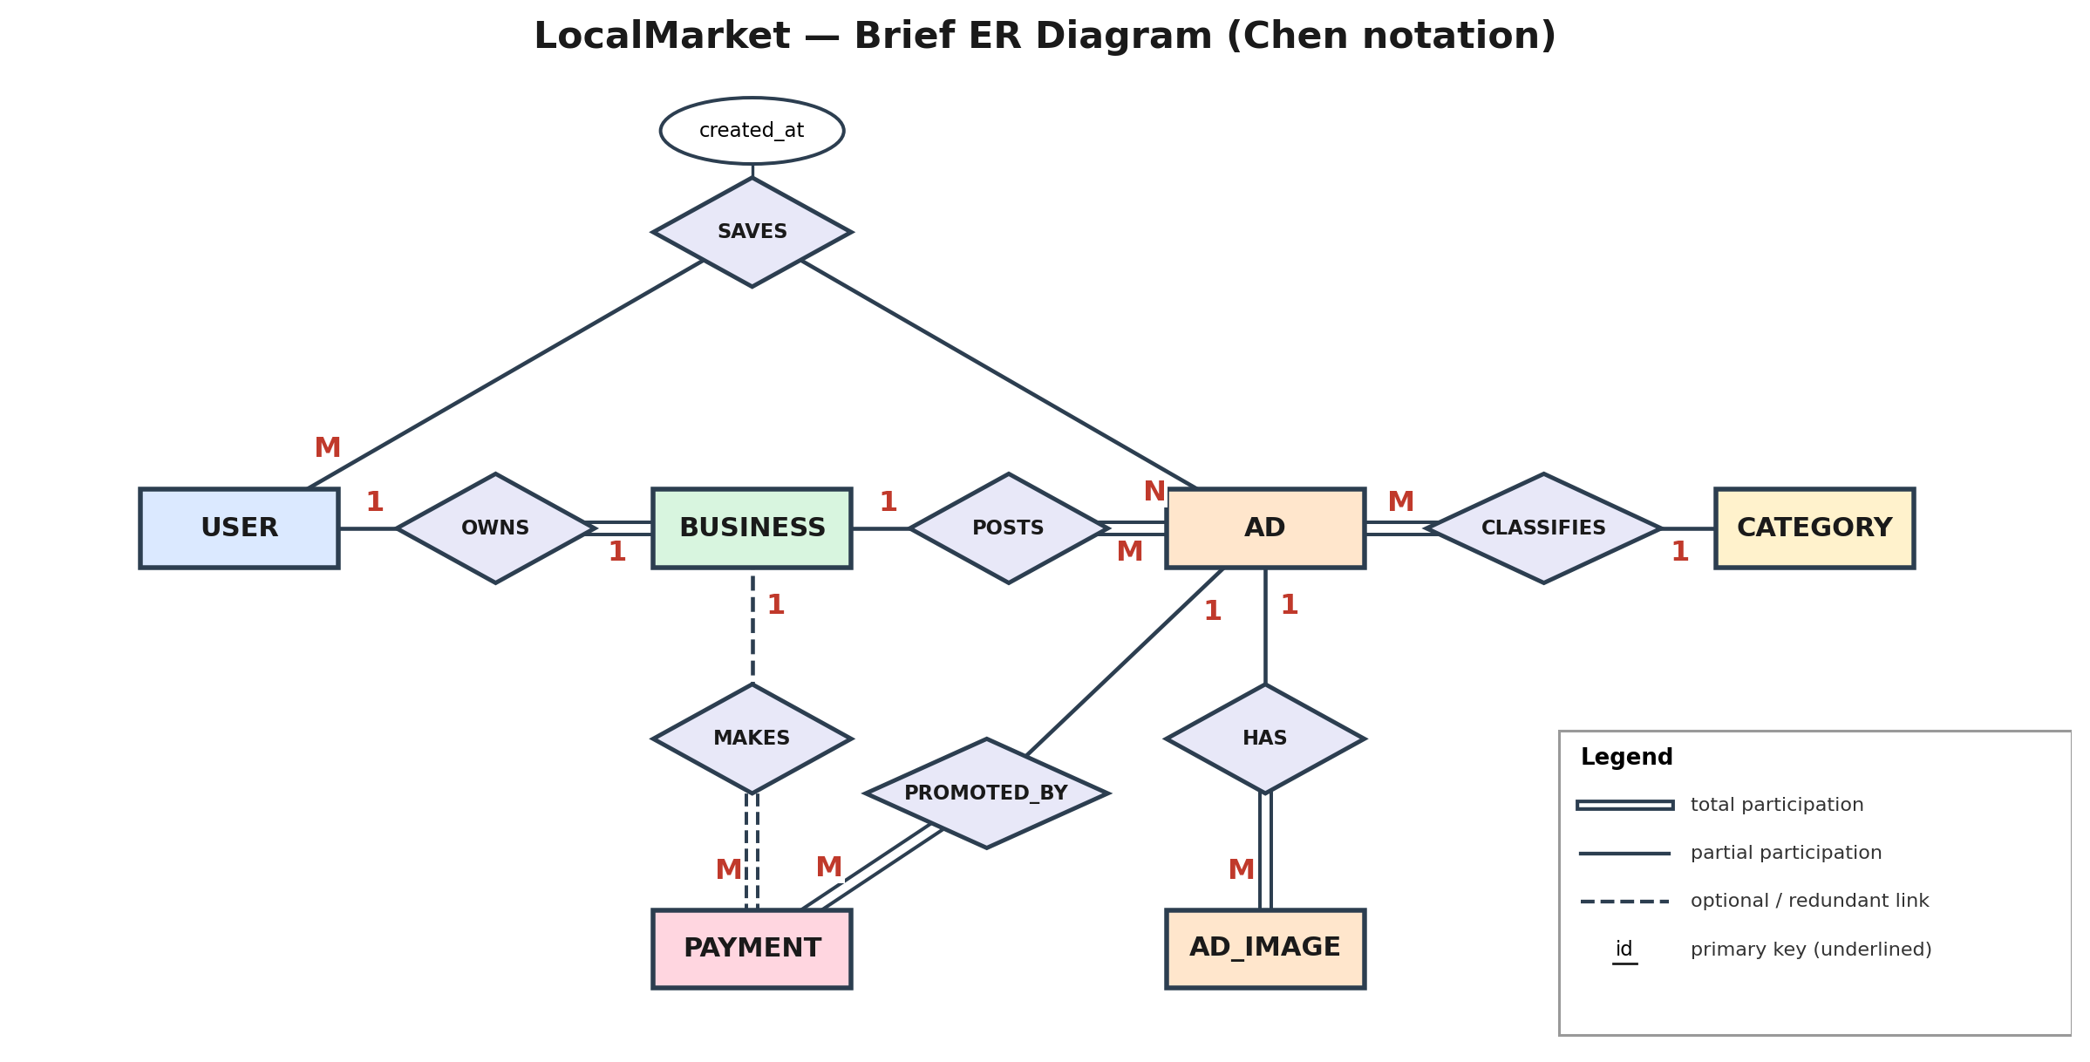
Figure A.1: Brief ER diagram in Chen notation — entities and relationships only.
Element | One-line purpose
USER | Account holder: plain user, business owner, or admin (role column)
BUSINESS | Business profile owned by one user
CATEGORY | Ad category such as Electronics, Jobs, Services, Real Estate
AD | A listing posted by a business, with a lifecycle status
AD_IMAGE | One or more images belonging to an ad
SAVES (relationship) | M:N between USER and AD; becomes the FAVORITE table when mapped
PAYMENT | Simulated payment record created when an ad is promoted

A.2 Detailed ERD
Every attribute is an ellipse; the primary key is underlined. Foreign keys are not drawn — each relationship diamond replaces them, and they return as columns when the diagram is mapped to tables (A.3). The attribute tables on the following pages give types and constraints.
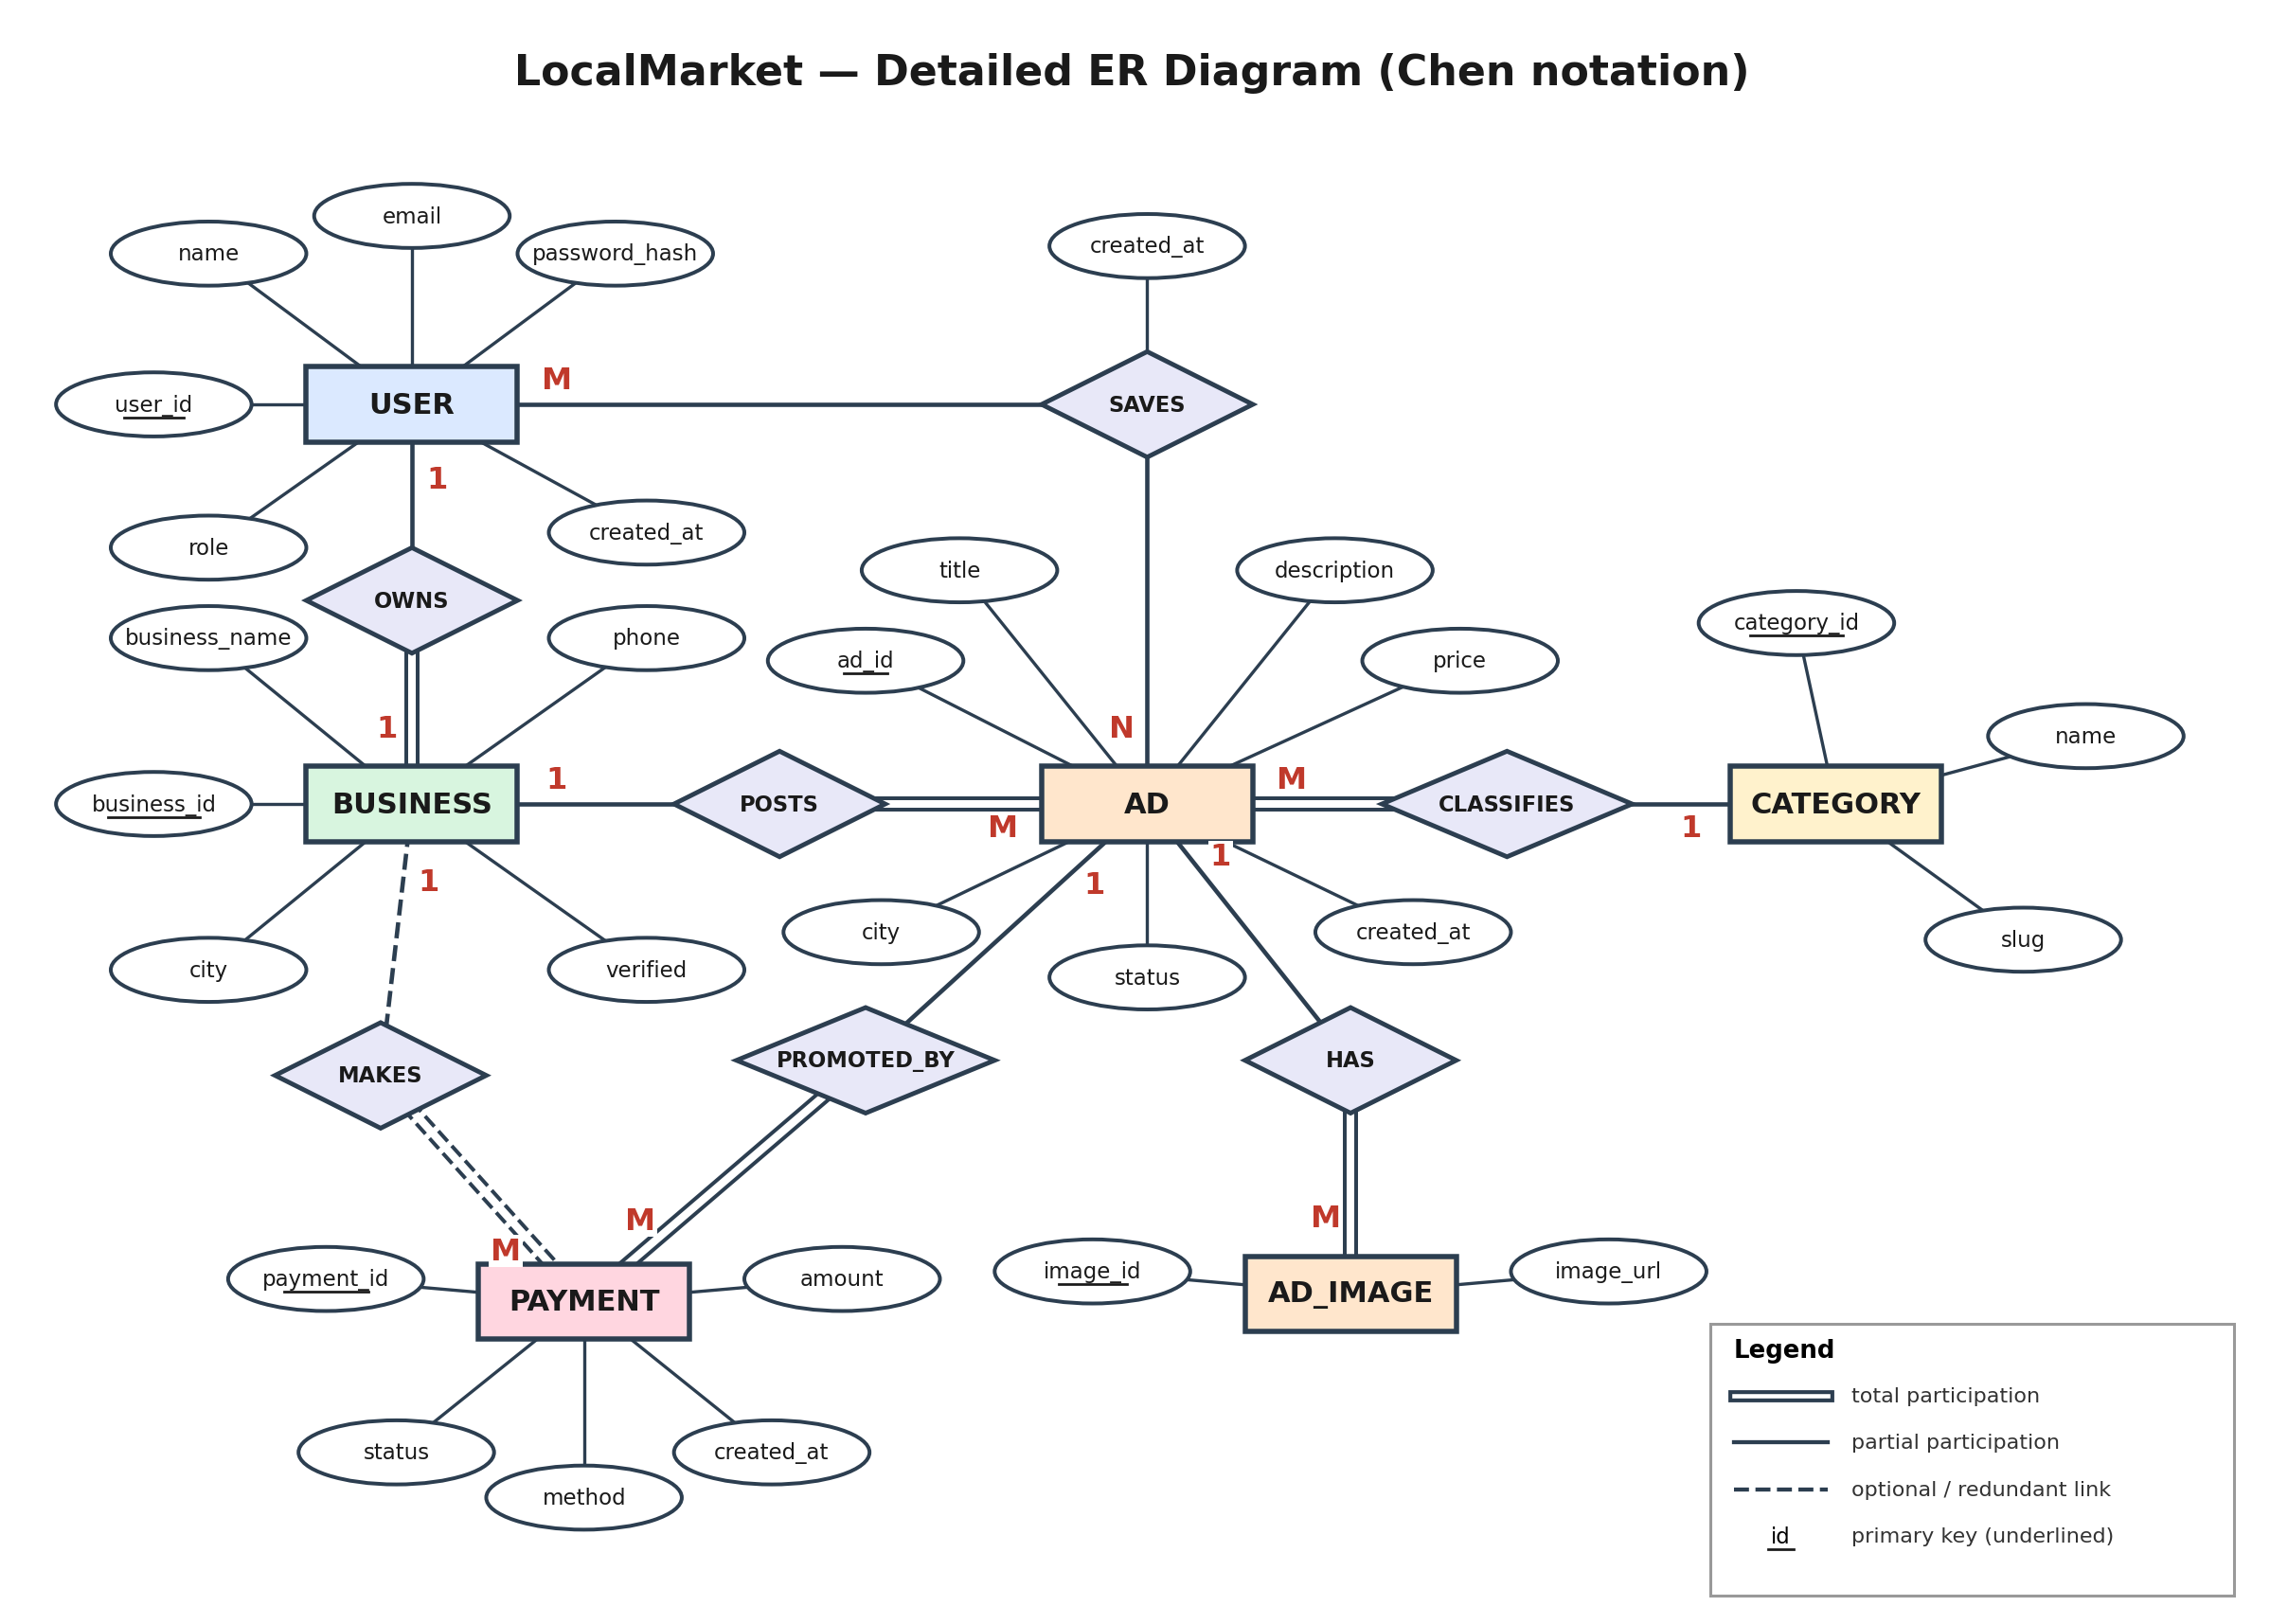
Figure A.2: Detailed ER diagram in Chen notation.

Attribute specification
These tables are the relational result of mapping the Chen diagram, so they include the foreign-key columns that the diagram itself does not show.
USER
Attribute | Type | Key | Constraints / notes
user_id | INT | PK | AUTO_INCREMENT
name | VARCHAR(100) |  | NOT NULL
email | VARCHAR(150) |  | NOT NULL, UNIQUE (no duplicate accounts)
password_hash | VARCHAR(255) |  | NOT NULL; bcrypt hash, never the plain password
role | ENUM |  | 'user' | 'business' | 'admin'; default 'user'
created_at | TIMESTAMP |  | default CURRENT_TIMESTAMP

BUSINESS
Attribute | Type | Key | Constraints / notes
business_id | INT | PK | AUTO_INCREMENT
user_id | INT | FK | NOT NULL, UNIQUE → USER(user_id); ON DELETE CASCADE (UNIQUE enforces one business per user)
business_name | VARCHAR(150) |  | NOT NULL
city | VARCHAR(100) |  | NOT NULL
phone | VARCHAR(20) |  | nullable
verified | BOOLEAN |  | default FALSE

CATEGORY
Attribute | Type | Key | Constraints / notes
category_id | INT | PK | AUTO_INCREMENT
name | VARCHAR(80) |  | NOT NULL, UNIQUE
slug | VARCHAR(80) |  | NOT NULL, UNIQUE; URL-friendly name

AD
Attribute | Type | Key | Constraints / notes
ad_id | INT | PK | AUTO_INCREMENT
business_id | INT | FK | NOT NULL → BUSINESS; ON DELETE CASCADE
category_id | INT | FK | NOT NULL → CATEGORY; INDEX idx_category
title | VARCHAR(150) |  | NOT NULL
description | TEXT |  | nullable
price | DECIMAL(10,2) |  | NOT NULL
city | VARCHAR(100) |  | NOT NULL; INDEX idx_city
status | ENUM |  | 'pending' | 'approved' | 'promoted' | 'rejected' | 'removed'; default 'pending'
created_at | TIMESTAMP |  | default CURRENT_TIMESTAMP

AD_IMAGE
Attribute | Type | Key | Constraints / notes
image_id | INT | PK | AUTO_INCREMENT
ad_id | INT | FK | NOT NULL → AD; ON DELETE CASCADE
image_url | VARCHAR(255) |  | NOT NULL

FAVORITE (table produced by mapping the M:N relationship SAVES)
Attribute | Type | Key | Constraints / notes
favorite_id | INT | PK | AUTO_INCREMENT
user_id | INT | FK | NOT NULL → USER; ON DELETE CASCADE
ad_id | INT | FK | NOT NULL → AD; ON DELETE CASCADE
created_at | TIMESTAMP |  | default CURRENT_TIMESTAMP
(user_id, ad_id) | — | UNIQUE | A user can save a given ad only once

PAYMENT
Attribute | Type | Key | Constraints / notes
payment_id | INT | PK | AUTO_INCREMENT
business_id | INT | FK | NOT NULL → BUSINESS (see design note in A.4)
ad_id | INT | FK | NOT NULL → AD
amount | DECIMAL(10,2) |  | NOT NULL
status | ENUM |  | 'pending' | 'completed' | 'failed'; default 'completed'
method | VARCHAR(50) |  | default 'simulated'
created_at | TIMESTAMP |  | default CURRENT_TIMESTAMP

A.3 Relationship Specification
# | Relationship | Cardinality | Foreign key | On delete | Meaning
1 | USER owns BUSINESS | 1 : 1 (optional on USER side) | BUSINESS.user_id (UNIQUE) | CASCADE | A user may have at most one business profile; every business belongs to a user
2 | BUSINESS posts AD | 1 : M | AD.business_id | CASCADE | Removing a business removes its ads
3 | CATEGORY classifies AD | 1 : M | AD.category_id | RESTRICT | A category in use cannot be deleted
4 | AD has AD_IMAGE | 1 : M | AD_IMAGE.ad_id | CASCADE | Images go away with their ad
5 | USER saves AD | M : N via FAVORITE | FAVORITE.user_id, FAVORITE.ad_id | CASCADE | FAVORITE resolves the many-to-many relationship
6 | AD promoted by PAYMENT | 1 : M | PAYMENT.ad_id | RESTRICT | Payment history is kept; an ad with payments cannot be silently deleted
7 | BUSINESS makes PAYMENT | 1 : M | PAYMENT.business_id | RESTRICT | Direct link used for per-business spend reports

Participation constraints
Total participation (double line) means every instance of the entity must take part in the relationship; partial participation (single line) means taking part is optional.
Relationship | Entity | Participation | Reason
OWNS | USER | Partial | Many users are plain shoppers with no business
OWNS | BUSINESS | Total | A business profile cannot exist without an owner
POSTS | BUSINESS | Partial | A new business may not have posted anything yet
POSTS | AD | Total | Every ad belongs to a business (NOT NULL foreign key)
CLASSIFIES | CATEGORY | Partial | A category can exist before any ad uses it
CLASSIFIES | AD | Total | Every ad has a category (NOT NULL foreign key)
HAS | AD | Partial | An ad may have no images
HAS | AD_IMAGE | Total | An image cannot exist without its ad
PROMOTED_BY | AD | Partial | Most ads are never promoted
PROMOTED_BY | PAYMENT | Total | A payment is always for one ad
MAKES | BUSINESS | Partial | A business may never pay for anything
MAKES | PAYMENT | Total | A payment always has a paying business
SAVES | USER and AD | Partial (both) | Users need not save ads; ads need not be saved

Mapping the Chen ERD to tables
A Chen diagram is converted to tables with a short set of rules. Applying them to Figure A.2 gives exactly the schema in the SRS (Section 4.5):
Chen element | Rule | Result in LocalMarket
Entity | One table per entity; each ellipse becomes a column; the underlined attribute becomes the PRIMARY KEY | USER, BUSINESS, CATEGORY, AD, AD_IMAGE, PAYMENT
1 : 1 relationship | Put a foreign key on one side and make it UNIQUE (prefer the side with total participation) | OWNS → BUSINESS.user_id, UNIQUE
1 : M relationship | Put a foreign key on the M side, pointing at the 1 side | POSTS → AD.business_id; CLASSIFIES → AD.category_id; HAS → AD_IMAGE.ad_id; PROMOTED_BY → PAYMENT.ad_id; MAKES → PAYMENT.business_id
M : N relationship | Create a new table holding both foreign keys plus the relationship's own attributes; the pair of keys must be unique | SAVES → FAVORITE(favorite_id, user_id, ad_id, created_at) with UNIQUE (user_id, ad_id)
Total participation | Make the foreign key NOT NULL | AD.business_id, AD.category_id, AD_IMAGE.ad_id, PAYMENT.ad_id, PAYMENT.business_id
Relationship attribute | Move it into the table that holds the relationship | SAVES.created_at → FAVORITE.created_at

A.4 Normalization Walkthrough and Design Note
Normalization is easiest to explain by starting from the flat table a beginner would draw first, then fixing one problem at a time. This is also a ready-made answer for the viva question “why is your schema in 3NF?”.
Starting point (unnormalized): AD_LISTING(ad_id, title, price, category_name, business_name, business_city, business_phone, owner_name, owner_email, image_urls, favorited_by_emails)
Step | Problem found | Fix applied | Result
1NF | image_urls and favorited_by_emails hold lists inside one cell (not atomic) | Give each image and each favorite its own row | AD_IMAGE and FAVORITE tables created
2NF | In FAVORITE-style rows keyed by (user_id, ad_id), user_name and user_email depend only on user_id, and ad_title and ad_price depend only on ad_id (partial dependencies) | Move user data to USER and ad data to AD; keep only the two keys in FAVORITE | USER, AD, FAVORITE
3NF | In AD, category_name depends on category_id, and business_name / city / phone depend on business_id, not on ad_id (transitive dependencies) | Move category data to CATEGORY and business data to BUSINESS; AD keeps only the foreign keys | CATEGORY and BUSINESS tables created
Design note on PAYMENT.business_id. A payment already identifies its business indirectly: PAYMENT.ad_id → AD.business_id. Storing business_id in PAYMENT as well is therefore a deliberate redundancy, and under a strict reading of 3NF it is a transitive dependency. You have two valid options:
- Keep it — simpler “total spend per business” query, with the cost that PAYMENT.business_id must always match the ad's business (enforce this inside the promotion transaction).
- Remove it — strictly 3NF; the aggregate query gets one extra JOIN (PAYMENT → AD → BUSINESS).
Whichever you choose, be ready to explain the trade-off in your viva. If your instructor is strict about 3NF, remove the column and update the ER diagram, the schema, and the aggregate query together.

A.5 Business Rules the ERD Must Enforce
- A user can own at most one business (UNIQUE on BUSINESS.user_id).
- Email addresses are unique across all accounts (UNIQUE on USER.email).
- An ad always belongs to exactly one business and one category (NOT NULL foreign keys).
- A user can favorite the same ad only once (UNIQUE on FAVORITE(user_id, ad_id)).
- Ad status is limited to the five defined values (ENUM).
- Only approved ads may be promoted — checked in application logic inside the promotion transaction, because a plain foreign key cannot express it.
- A payment row and the matching ad status change succeed or fail together (transaction).

Part B — Data Flow Diagrams (DFD)

B.1 Brief DFD — Context Diagram (Level 0)
The context diagram treats LocalMarket as one process and shows only what crosses its boundary: three external entities (Guest/User, Business Owner, Admin) and one data store (the MySQL database).
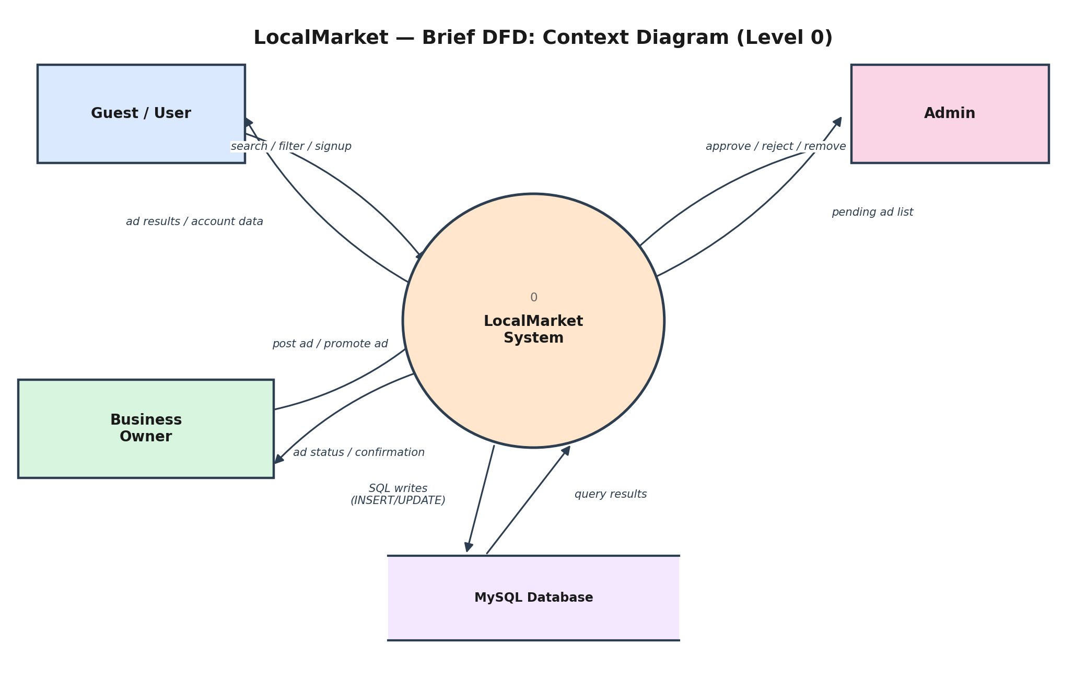
Figure B.1: Context-level DFD (Level 0).
Data flow | From → To | Contents
search / filter / signup | Guest/User → System | Keywords, category, city and price filters; registration and login details; save-to-favorites requests
ad results / account data | System → Guest/User | Matching ads, ad details, JWT token, profile, favorites list
post ad / promote ad | Business Owner → System | Ad details and images; promotion request with simulated payment details
ad status / confirmation | System → Business Owner | Ad status (pending, approved, promoted), payment confirmation
approve / reject / remove | Admin → System | Moderation decision for a given ad
pending ad list | System → Admin | Queue of ads awaiting review
SQL writes / query results | System ↔ MySQL | INSERT / UPDATE statements and result sets

B.2 Detailed DFD — Level 1
Level 1 opens the single system process into its five processes and shows which data store each one uses. The five stores map directly onto your MySQL tables (see Part C).
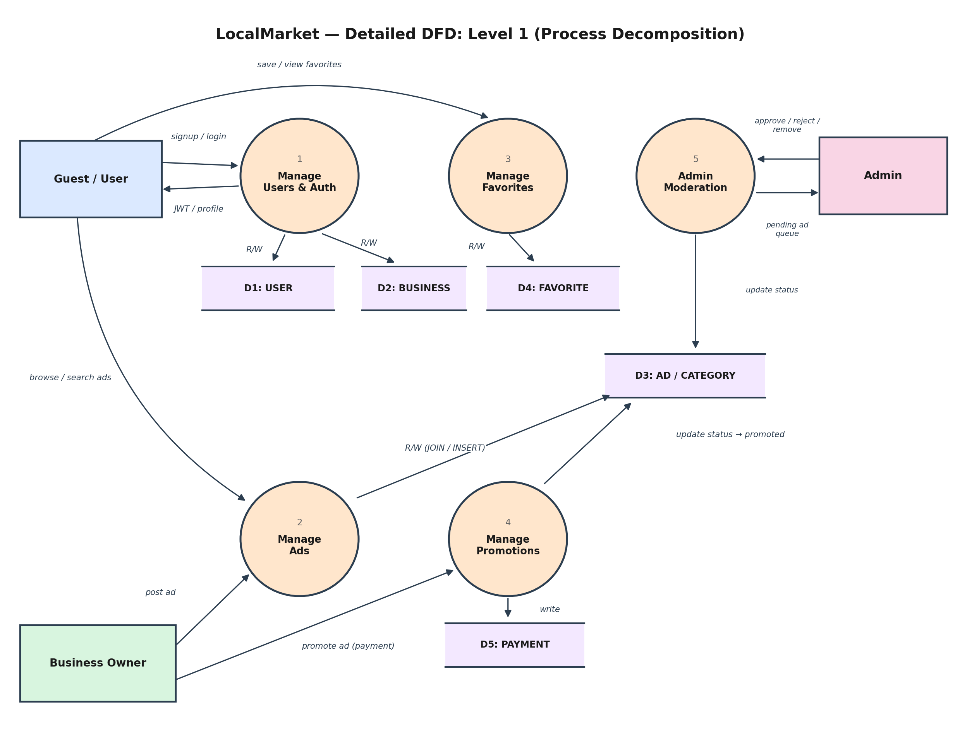
Figure B.2: Level 1 DFD — five processes and five data stores.

Process specification
ID | Process | What it does | Data stores | Routes (Express)
1 | Manage Users & Auth | Registers users, verifies login, issues JWT, creates the business profile | D1 USER (R/W), D2 BUSINESS (R/W) | POST /api/auth/register, POST /api/auth/login
2 | Manage Ads | Creates ads (status pending), lists / searches / filters approved ads, shows ad detail | D3 AD/CATEGORY (R/W), D2 BUSINESS (read) | POST /api/ads, GET /api/ads, GET /api/ads/:id
3 | Manage Favorites | Saves and removes favorites, lists a user's saved ads | D4 FAVORITE (R/W), D3 (read) | POST /api/favorites (plus GET and DELETE as you extend)
4 | Manage Promotions | Validates the request, records a simulated payment, sets ad status to promoted — inside one transaction | D5 PAYMENT (write), D3 (read/update), D2 (read) | POST /api/payments
5 | Admin Moderation | Lists pending ads; approves, rejects, or removes an ad | D3 AD/CATEGORY (R/W) | PUT /api/admin/ads/:id
Note: the diagram shows each process's primary data store to stay readable. Secondary reads (for example, Process 2 reading BUSINESS to join business names) are listed in the table above and in the Level 2 diagrams.

Data store specification
Store | MySQL table(s) | Used by
D1: USER | USER | Process 1
D2: BUSINESS | BUSINESS | Processes 1 (R/W), 2 and 4 (read)
D3: AD / CATEGORY | AD, AD_IMAGE, CATEGORY | Processes 2, 3 (read), 4, 5
D4: FAVORITE | FAVORITE | Process 3
D5: PAYMENT | PAYMENT | Process 4

B.3 Level 2 DFDs
Level 2 zooms into a single Level 1 process. Two are provided because they carry the most DBMS value: Process 4 contains the transaction, and Process 2 contains the JOIN-heavy search query.

Process 4 — Manage Promotions
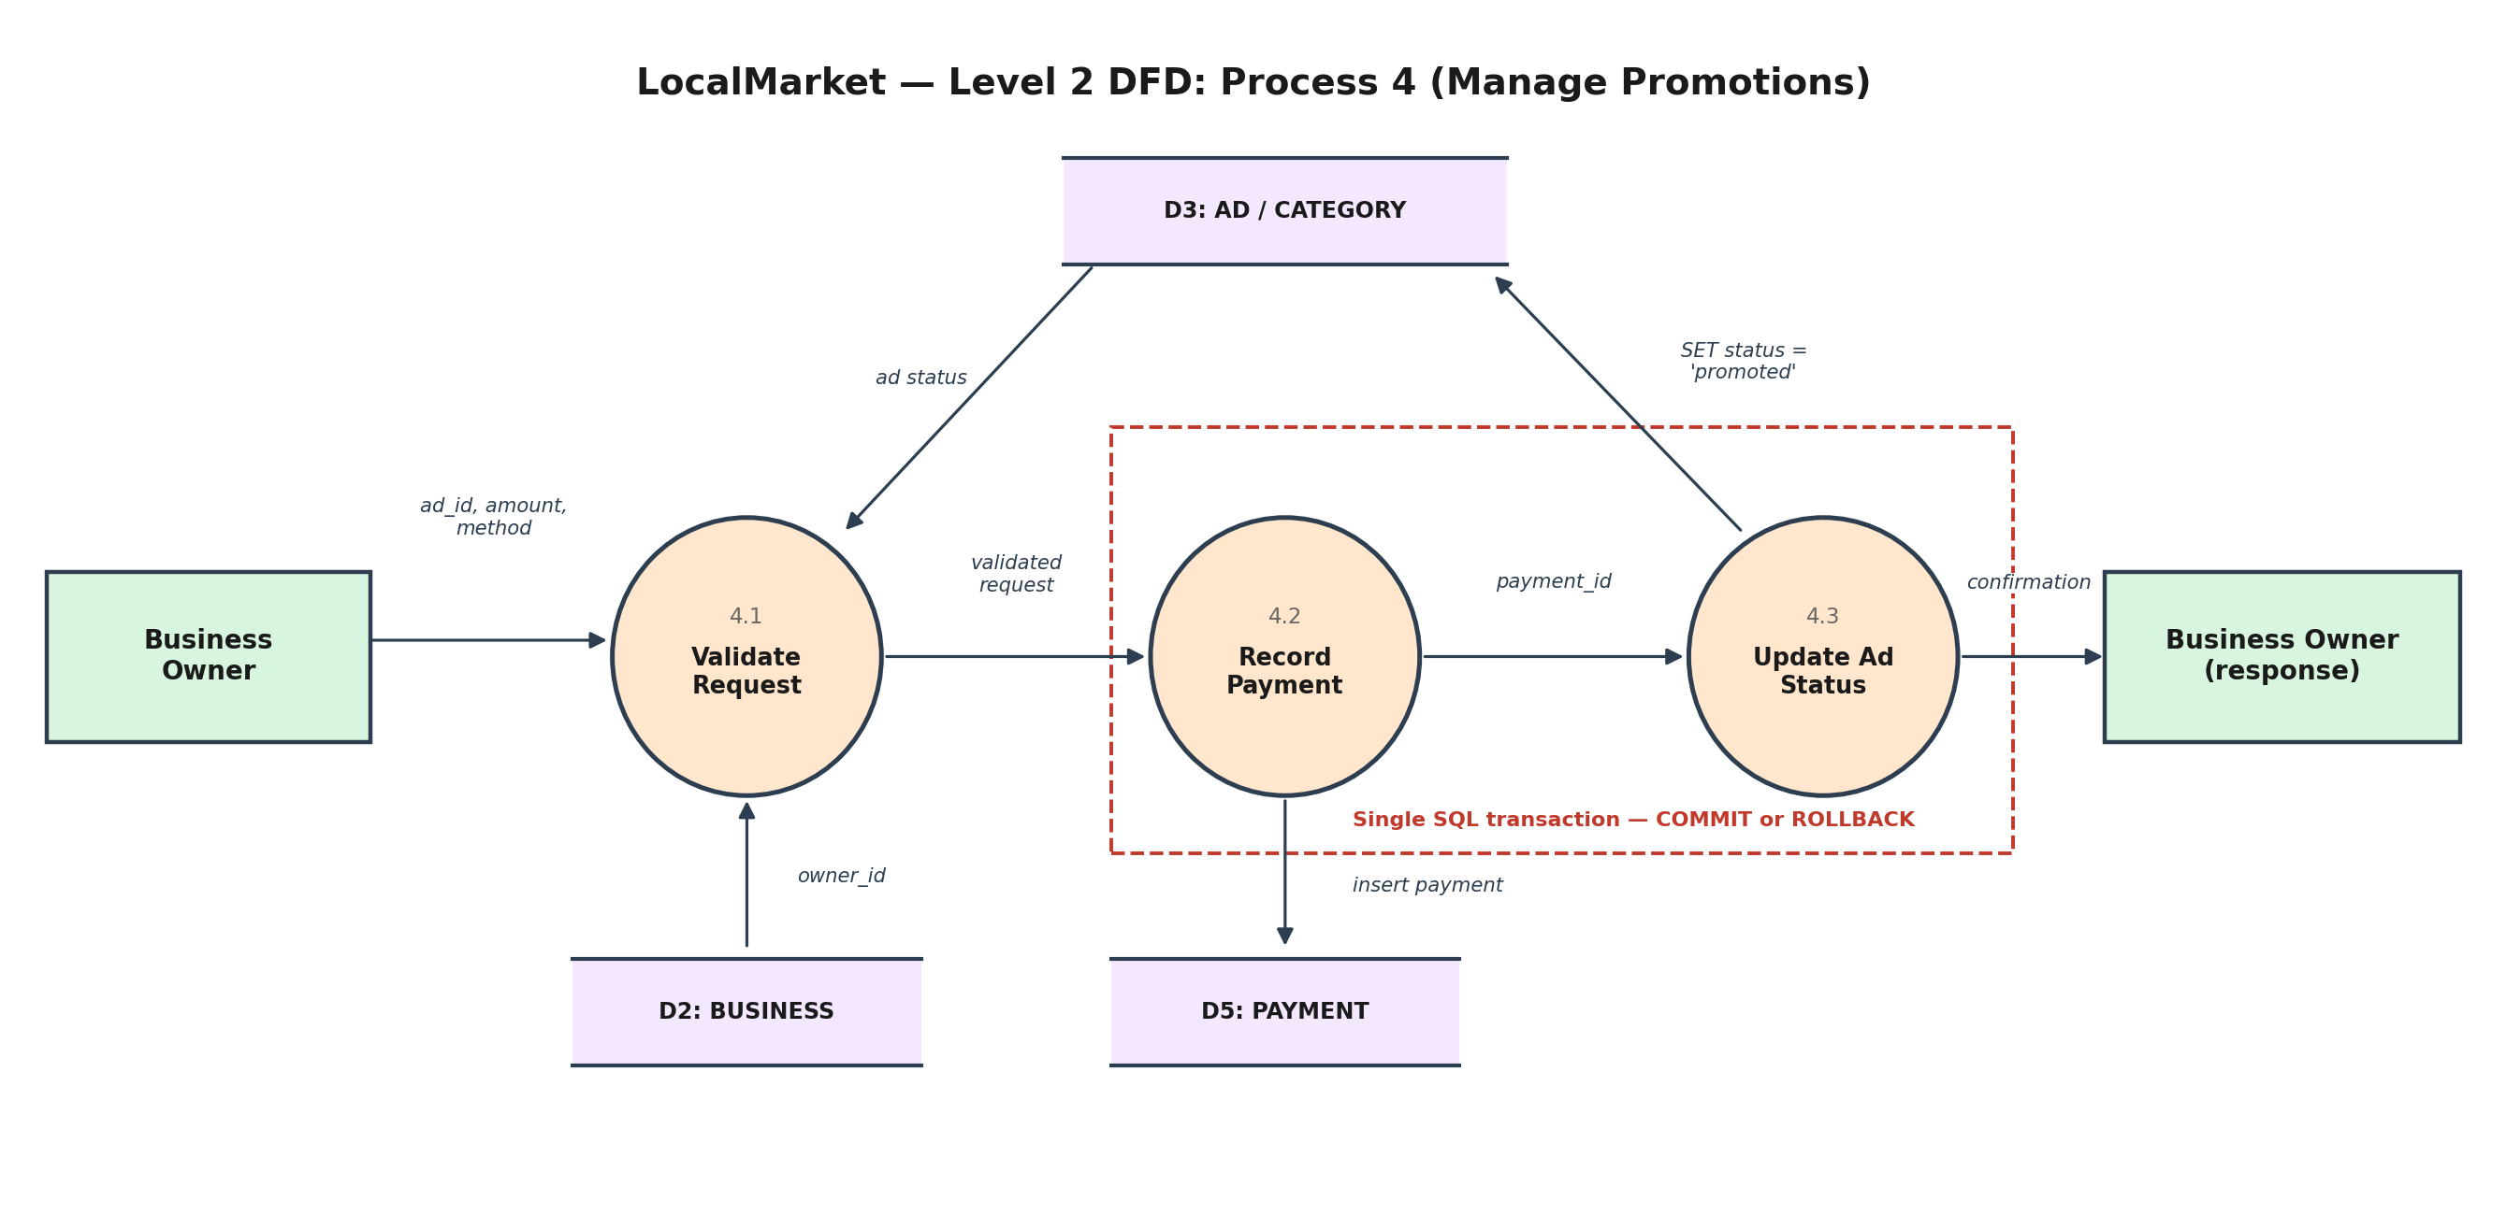
Figure B.3: Level 2 DFD for Process 4 (Manage Promotions).
ID | Sub-process | What it does
4.1 | Validate Request | Reads the ad status from D3 and the owner from D2; rejects the request unless the ad is approved and belongs to the requesting business
4.2 | Record Payment | Inserts the simulated payment row into D5 (first step of the transaction)
4.3 | Update Ad Status | Sets the ad's status to 'promoted' in D3 (second step); then commits and returns the confirmation
The dashed red box marks the atomic part: steps 4.2 and 4.3 run inside one SQL transaction, so a failure in either step rolls both back and no payment is stored without the status change.
START TRANSACTION;
INSERT INTO PAYMENT (business_id, ad_id, amount, method) VALUES (?, ?, ?, 'simulated');
UPDATE AD SET status = 'promoted' WHERE ad_id = ? AND status = 'approved';
COMMIT; -- on any error: ROLLBACK;

Process 2 — Manage Ads
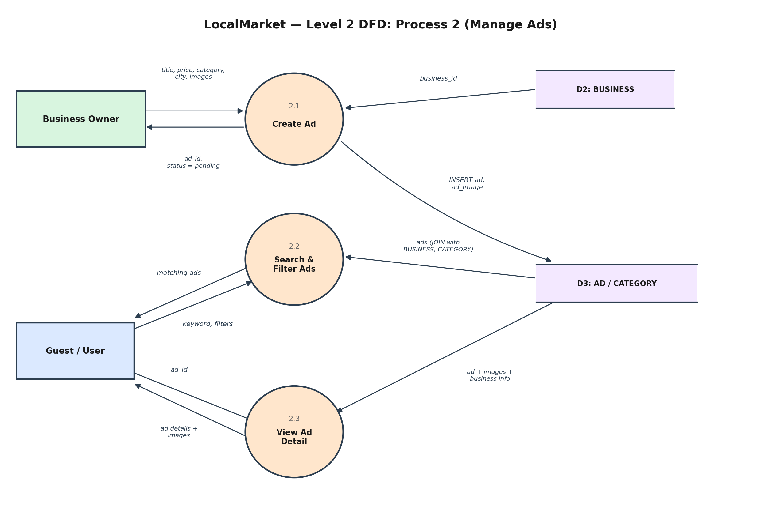
Figure B.4: Level 2 DFD for Process 2 (Manage Ads).
ID | Sub-process | What it does
2.1 | Create Ad | Reads the owner's business_id from D2, inserts the AD row (status pending) and its AD_IMAGE rows into D3, returns the new ad_id
2.2 | Search & Filter Ads | Runs the parameterized search query over D3 (JOIN with BUSINESS and CATEGORY), filtered by keyword, category, city and price, approved ads only
2.3 | View Ad Detail | Fetches one ad with its images and business information

B.4 From DFD to Backend Structure
Each Level 1 process becomes one route file and one controller, which keeps the backend organized the same way the design is. This is a suggested layout, not a requirement:
backend/
server.js // Express app, middleware, route mounting
db.js // mysql2 connection pool
middleware/
auth.js // verify JWT, check role (user / business / admin)
routes/
auth.js // Process 1 -> /api/auth/*
ads.js // Process 2 -> /api/ads/*
favorites.js // Process 3 -> /api/favorites/*
payments.js // Process 4 -> /api/payments (transaction)
admin.js // Process 5 -> /api/admin/ads/:id
sql/
schema.sql // all CREATE TABLE statements
seed.sql // categories + sample data

Part C — ERD ↔ DFD Consistency Check
A common marking point is whether the ERD and DFD agree with each other. Every data store in the DFD must correspond to table(s) in the ERD, and every table must be touched by at least one process.
ERD table | DFD data store | Created / changed by | Read by
USER | D1 | Process 1 | Process 1
BUSINESS | D2 | Process 1 | Processes 2, 4
CATEGORY | D3 | Admin seed data / Process 5 (manage categories, per FR-7) | Process 2
AD | D3 | Processes 2 (insert), 4 and 5 (status updates) | Processes 2, 3, 4, 5
AD_IMAGE | D3 | Process 2 | Process 2
FAVORITE | D4 | Process 3 | Process 3
PAYMENT | D5 | Process 4 | Process 4 (and reports)
Cross-check against the other documents: the five processes match FR-1 to FR-7 in the SRS, and the Level 2 transaction matches use case UC-3 and non-functional requirement NFR-3.

Part D — Semantic Network
A semantic network stores knowledge as a graph: nodes are concepts or individual things, and labelled arrows are the relationships between them. The ERD shows how data is stored; the semantic network shows what it means, including inheritance (is-a), which an ERD cannot express directly.

D.1 Concept-level network
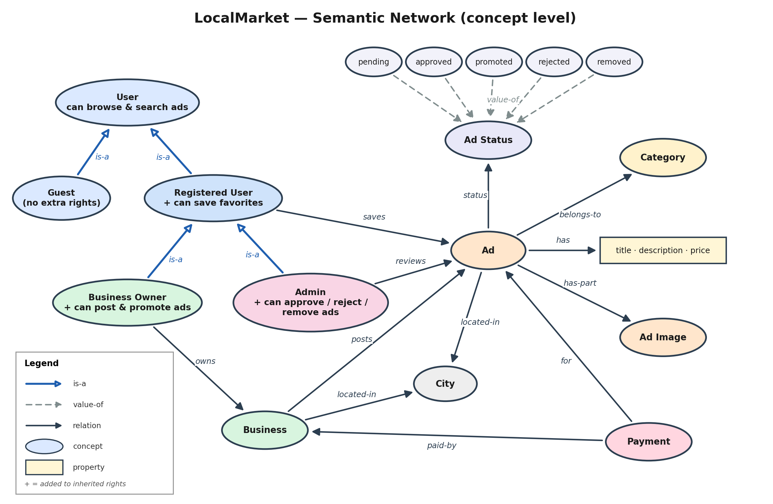
Figure D.1: Semantic network of LocalMarket concepts. Blue arrows are is-a links; a + in a role means a right added to those inherited.

D.2 Instance-level example
The same network applied to real data: one business, one ad that has been approved and then promoted, one favorite, and one simulated payment. Each node's second line names the class it is an instance of.
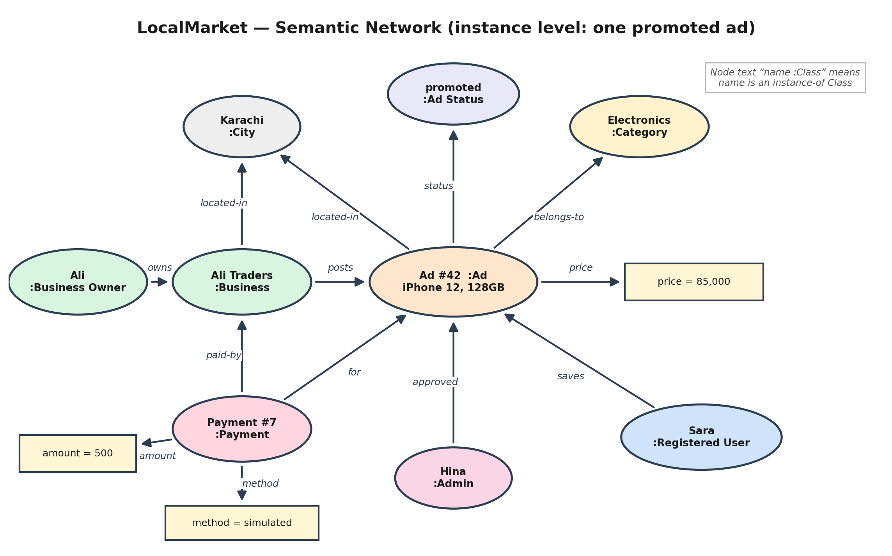
Figure D.2: Instance-level semantic network for ad #42.

D.3 Reading the Notation
Link or node | Drawn as | Meaning | Example in LocalMarket
is-a | Blue arrow, hollow head | Specialization: the child inherits everything the parent has | Business Owner is-a Registered User
value-of / instance-of | Dashed grey arrow, or “name :Class” text | An individual or value belongs to a class or domain | 'promoted' is a value-of Ad Status; Ad #42 :Ad
Labelled relation | Black arrow with a verb | Association between two concepts | Business posts Ad; Payment paid-by Business
Concept node | Ellipse | A class of things, or one individual in Figure D.2 | Ad, Category, Payment
Property node | Rectangle | A plain value or group of attribute values | title · description · price; amount = 500
Inheritance is the main reason to use a semantic network. A node inherits every right of its is-a ancestors, so Business Owner can browse and search (from User), save favorites (from Registered User), and post and promote ads (its own). Admin inherits the same first two and adds approve, reject and remove. Guest inherits only browsing.

D.4 Relating the Semantic Network to the Database
The network is a conceptual model, so not every element becomes a table. This shows where each part ends up:
Semantic network element | Where it lives in the system
Concept nodes Business, Ad, Category, Ad Image, Payment | Tables BUSINESS, AD, CATEGORY, AD_IMAGE, PAYMENT
User hierarchy (Guest, Registered User, Business Owner, Admin) | The role column in USER (ENUM). A guest has no row, because guests are not logged in.
Inherited rights (the + capabilities) | Application logic: JWT role checks in Express middleware, not database tables
Labelled relations (posts, owns, belongs-to, has-part, for, paid-by) | Foreign keys, as listed in A.3
saves | The FAVORITE table (the M:N relationship from the Chen ERD)
Ad Status and its five values | The ENUM on AD.status; the values match the lifecycle in the SRS
City node, located-in links | Plain city columns in BUSINESS and AD. Making City its own table would be a further normalization step, but it is not needed here.
Instances (Figure D.2) | Rows: one row each in USER, BUSINESS, AD, FAVORITE, PAYMENT and CATEGORY

Part E — Redraw the Diagrams Yourself in draw.io
Drawing the diagrams yourself is the fastest way to learn the notation, and instructors often ask students to explain their own diagram in the viva. Suggested order: brief ERD first, then Level 0 DFD, then the detailed versions.

ERD in draw.io (Chen notation)
- Open app.diagrams.net, choose a blank diagram, and save it to your device so the .drawio file stays editable.
- Use the General shapes: a rectangle for every entity, an ellipse for every attribute, and a diamond for every relationship.
- Place the entities first (Figure A.2 shows a workable arrangement), then add each entity's attributes around it and join every ellipse to its entity with a plain line.
- Underline the primary-key attribute: select the text and press Ctrl+U.
- Add a diamond per relationship, connect it to both entities, and write the cardinality (1, M or N) next to each line at the entity end.
- Show total participation with a double line — draw two connectors very close together — and use a dashed connector for the optional MAKES link.
- Finally check that no foreign-key attribute is drawn: in Chen notation the relationship diamonds replace them.

DFD in draw.io
- Use General shapes: rectangle for external entities, ellipse for processes, and two horizontal lines (or the “Data Store” shape if available) for data stores.
- Draw the Level 0 context diagram first: one process, three entities, one store.
- Number the processes 1 to 5 for Level 1 and 2.1, 2.2, 2.3 for Level 2, so the levels trace to each other.
- Label every arrow with the data that moves. Rule of thumb: a data flow never connects two external entities or two data stores directly — it must pass through a process.
- Export each diagram as PNG (File → Export as) for your report, and keep the .drawio file as the editable source.

Semantic network in draw.io
- Draw an ellipse for every concept and a rectangle for every plain value.
- Join nodes with arrows and type the relationship name (posts, owns, is-a) on each arrow.
- Colour the is-a arrows blue with a hollow arrowhead, and make instance-of / value-of arrows dashed, so the inheritance structure stands out.

