LocalMarket
A City-Scoped Ads & Classifieds Marketplace
Project Roadmap — DBMS Course Project
Prepared for: Fourth-Year DBMS Course — Final Project

1. Problem Statement & Scope

1.1 Problem Statement
Small and local businesses in Pakistan — shopkeepers, tutors, home-based sellers, service providers — currently advertise almost exclusively through large foreign-owned platforms (Facebook, Instagram, YouTube). This project explores a scoped-down, academic version of an alternative: a local, city-based advertising and classifieds marketplace where businesses can list ads and users can browse, search, and save them, built entirely to demonstrate core Database Management System (DBMS) concepts.
Note on scope: the original idea behind this project was a national-scale social advertising platform for Pakistan. For this course submission, the idea is intentionally scaled down to a single-city, single-team, single-semester academic project called “LocalMarket.” The academic version does not attempt to replace Facebook/Instagram or process real payments — it demonstrates the same underlying data-modeling and database skills at a manageable size.

1.2 In Scope (Academic Version)
- User registration & login (Users can be regular users or business owners)
- Business owners can create a business profile and post ads
- Ads belong to a category (e.g. Electronics, Services, Jobs, Real Estate) and a city
- Users can browse, search, and filter ads by category/city/price
- Users can save/favorite ads
- A simulated payment/transaction record when a business “promotes” an ad (no real gateway)
- An admin role that can approve/remove ads
- A relational database (MySQL) demonstrating normalization, keys, joins, and at least one transaction

1.3 Out of Scope (Academic Version)
- Real payment gateway integration (JazzCash/Easypaisa/Stripe) — simulated only
- Multi-city / national scale, high-traffic performance engineering
- Real-time chat/messaging between users and businesses
- Mobile native apps (web-responsive only)
- Advanced ad-recommendation / ML ranking algorithms
- Content moderation at scale, fraud detection, legal/compliance systems

1.4 Learning Objectives (DBMS Concepts Demonstrated)
- Entity-Relationship (ER) modeling and mapping to relational schema
- Normalization (up to 3NF) to eliminate redundancy
- Primary keys, foreign keys, and referential integrity constraints
- Joins across multiple tables (INNER, LEFT) for real query needs
- Aggregate queries (e.g. count of ads per category, total spend per business)
- Transactions (e.g. creating a payment record and updating ad status atomically)
- Basic indexing for search performance (e.g. on city, category_id)

2. Recommended Tools & Technologies
This stack is chosen specifically because it builds on what you already know (React) and keeps the number of new languages to a minimum — JavaScript is used across the whole stack, so what you learn on the frontend transfers directly to the backend.
Layer | Technology | Why this choice
Frontend | React (Create React App or Vite) | You already know this — no new language to learn
Backend / API | Node.js + Express.js | Same language (JavaScript) as the frontend; huge learning resources; simple to set up REST APIs
Database | MySQL | Most commonly taught/expected in university DBMS courses; free GUI tools (MySQL Workbench); easy to demonstrate joins, normalization, transactions
DB Access | Raw SQL via the mysql2 npm package (skip an ORM at first) | Writing raw SQL yourself is exactly what a DBMS course wants you to show — an ORM would hide the SQL
Auth | JSON Web Tokens (JWT) + bcrypt for password hashing | Industry-standard, simple to implement, well documented
ER Diagramming | draw.io (app.diagrams.net) — free, no install, browser-based | No learning curve like Figma; purpose-built for ER/flow diagrams
API Testing | Postman or Thunder Client (VS Code extension) | Lets you test backend endpoints before the frontend is ready
Version Control | Git + GitHub | You already use this for your other projects
Code Editor | VS Code | Already your primary tool
DB Admin GUI | MySQL Workbench or phpMyAdmin (via XAMPP) | Visual way to inspect tables, run queries, and export your schema for the report

2.1 What You Need to Explore First
Since you mentioned you haven't studied ER diagrams and aren't sure about the database yet, here is the minimum you should learn before writing code — in order:
# | Topic | Why it comes first | Where to learn (free)
1 | ER Diagrams (entities, attributes, relationships, cardinality) | You cannot design a schema without this — it is the blueprint | YouTube: “ER Diagram Tutorial” (freeCodeCamp / Neso Academy); draw.io's own templates
2 | Normalization (1NF, 2NF, 3NF) | Prevents duplicate/inconsistent data — heavily graded in DBMS courses | Neso Academy “Normalization” playlist on YouTube
3 | SQL fundamentals (SELECT, JOIN, GROUP BY, aggregate functions) | You'll write these queries constantly once the schema exists | W3Schools SQL, or “SQL for Beginners” on freeCodeCamp
4 | SQL transactions (COMMIT/ROLLBACK) | One of the DBMS concepts your course expects you to demonstrate | MySQL official docs — “13.3.1 START TRANSACTION Statement”
5 | REST API basics with Express.js | Connects your React frontend to MySQL | Express.js official “Getting Started” guide
6 | JWT authentication basics | Needed for login/signup and role-based access (user vs business vs admin) | jwt.io introduction + any short YouTube walkthrough

3. System Architecture
A simple 3-tier architecture is enough for this project and is the standard way to explain “how your app works” in your report and defense/viva:
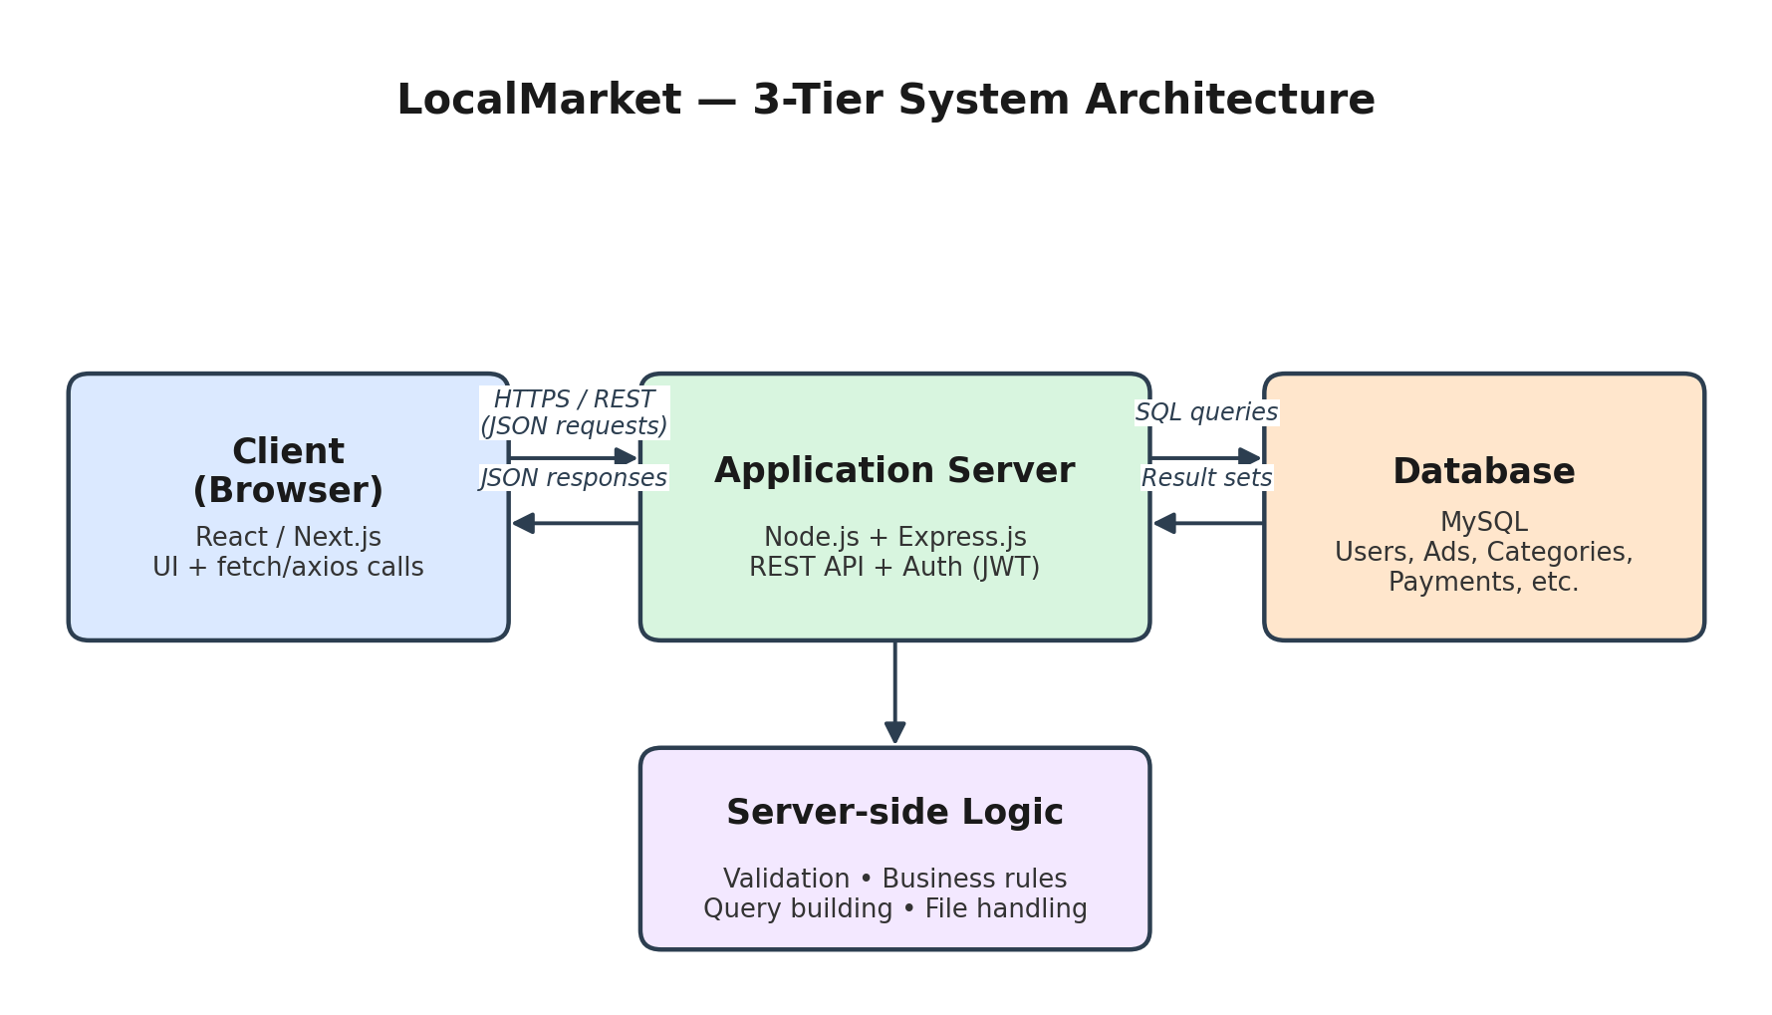
Figure 1: Client → Application Server → Database, the standard 3-tier structure.
How it works in plain terms: the React app never talks to MySQL directly. It sends HTTP requests (e.g. “get all ads in Lahore under category Electronics”) to your Express server. The server validates the request, runs the appropriate SQL query against MySQL, and sends the result back as JSON, which React then renders.

4. Entity-Relationship (ER) Diagram
Below is a draft ER diagram for LocalMarket, covering the entities you'll need for the in-scope features. Treat this as a starting point — refine it once you've studied ER modeling yourself, since redrawing it in your own words is part of demonstrating you understand it (and your instructor will likely ask you to explain it).
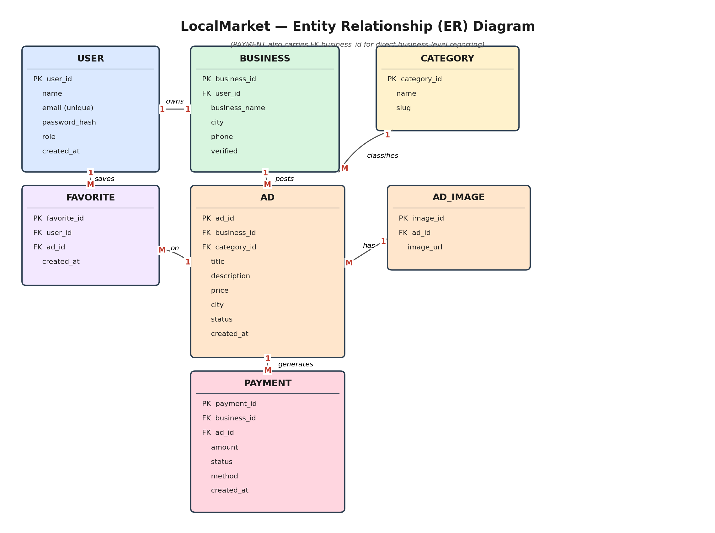
Figure 2: Draft ER diagram — 7 entities covering users, businesses, ads, categories, images, favorites, and payments.

4.1 Entity Summary
Entity | Purpose | Key Relationships
USER | Anyone with an account; can be a plain user or a business owner (via role) | 1 User → 1 Business (optional); 1 User → M Favorites
BUSINESS | A business profile created by a user | 1 Business → M Ads; 1 Business → M Payments
CATEGORY | Ad categories (Electronics, Jobs, Services, etc.) | 1 Category → M Ads
AD | A single listing posted by a business | Belongs to 1 Business, 1 Category; has M Images; generates M Payments
AD_IMAGE | One or more images attached to an ad | Belongs to 1 Ad
FAVORITE | Join table so users can save ads (many-to-many) | Links 1 User to 1 Ad per row
PAYMENT | Simulated transaction when a business promotes an ad | Belongs to 1 Business and 1 Ad

5. Development Phases & Timeline
A suggested pace for a single-semester project (adjust the week numbers to match your actual submission deadline):
Phase | Weeks | Tasks | Deliverable
1. Learn & Plan | 1–2 | Study ER diagrams, normalization, SQL basics; finalize problem statement & scope | Problem statement doc + list of entities
2. Database Design | 2–3 | Draw ER diagram in draw.io; normalize to 3NF; write CREATE TABLE SQL scripts | ER diagram + schema.sql file
3. Backend Setup | 3–5 | Set up Node/Express project; connect to MySQL; build CRUD API endpoints for each entity; add JWT auth | Working API tested in Postman
4. Frontend Build | 5–7 | Build React pages: signup/login, browse/search ads, post an ad, business dashboard | React app with static/mock data first, then wired to API
5. Integration & Testing | 7–8 | Connect React to the live API; test all user flows end-to-end; fix bugs | Fully working demo
6. Documentation & Report | 8–9 | Write final report (ER diagram, schema, normalization steps, sample queries incl. a JOIN, an aggregate, and a transaction); prepare slides/demo | Submitted report + presentation

6. Final Submission Checklist
- Problem statement & scope document (Section 1 of this roadmap can be adapted directly)
- ER diagram (finalized, in your own hand/tool once you've studied the topic)
- Normalized relational schema (table definitions up to 3NF, with PK/FK constraints)
- schema.sql — script that creates all tables
- Source code repository (frontend + backend) with a README explaining setup steps
- Sample queries document: at least one multi-table JOIN, one aggregate/GROUP BY query, and one transaction (COMMIT/ROLLBACK)
- Working demo (local run-through is fine — deployment is optional, not required for scope)
- Final report combining all of the above with screenshots

Reminder: start with the schema, not the code. Once your tables and relationships are solid, both the backend and frontend become much faster to build because you're no longer guessing what data looks like.

