Software Requirements Specification
LocalMarket
A City-Scoped Ads & Classifieds Marketplace
Version 2.0 (Enhanced)
Course: Fourth-Year DBMS — Final Project
Prepared by: Muhammad Abdullah
Date: [Insert Date]

Revision History
Version | Date | Description | Author
1.0 | [earlier draft] | Initial SRS draft covering purpose, scope, features, data requirements, interfaces, NFRs, timeline | Muhammad Abdullah
2.0 | [Insert Date] | Added: use cases, detailed FR inputs/outputs, full normalized schema with SQL, sample queries, ad lifecycle state diagram, context DFD, API examples, testing/acceptance criteria, glossary, references | Muhammad Abdullah

Table of Contents
(Right-click below and choose “Update Field” in Word to generate page numbers.)

1. Introduction

1.1 Purpose
This SRS defines the requirements for LocalMarket, a web-based, city-scoped advertising and classifieds marketplace. It is built as an academic DBMS project to demonstrate core database concepts: ER modeling, normalization (3NF), keys, joins, aggregate queries, transactions, and indexing.

1.2 Scope
LocalMarket lets local businesses (shopkeepers, tutors, home-based sellers, service providers) post ads, and lets users browse, search, filter, and save them. A simulated payment system handles ad promotion. An admin approves or removes ads. The system is a single-city, single-semester academic project — not a national-scale or production platform. It does not attempt to replace Facebook/Instagram, and it does not process real payments.
Scoping reference — OLX vs YouTube comparison: the closest real-world analogy for LocalMarket is an OLX-style classifieds marketplace (browse, search, filter, post, favorite). A YouTube-style product (video hosting, recommendation engines, subscriptions at scale) is explicitly out of scope for a single-semester DBMS project. If time remains after the core is complete, a small YouTube-like touch such as an ad view counter or a “related ads” query (same-category JOIN) can be added without causing scope creep.

1.3 Definitions, Acronyms & Abbreviations
Term | Meaning
Ad | A listing posted by a business
Business Owner | A user with role = business
Favorite | A saved ad by a user
Promotion | Simulated paid boost of an ad
3NF | Third Normal Form (a normalization level)
PK / FK | Primary Key / Foreign Key
JWT | JSON Web Token — used for authenticated sessions
DFD | Data Flow Diagram
ERD | Entity-Relationship Diagram
CRUD | Create, Read, Update, Delete
API | Application Programming Interface

1.4 References
- IEEE Std 830-1998 — IEEE Recommended Practice for Software Requirements Specifications (structure reference for this document)
- MySQL 8.0 Reference Manual — dev.mysql.com/doc
- Express.js Official Guide — expressjs.com
- JWT Introduction — jwt.io/introduction

1.5 Intended Audience
Course instructor, project evaluators, and project team member(s) implementing the system.

1.6 Document Overview
Section 2 describes the product at a high level. Section 3 lists functional requirements and use cases. Section 4 covers the data/database design. Section 5 covers external interfaces. Section 6 covers non-functional requirements. Sections 7–10 cover architecture, data flow, timeline, testing, and submission checklist.

2. Overall Description

2.1 Product Perspective
LocalMarket is a new, standalone 3-tier web application: Client (React) → Application Server (Node.js + Express) → Database (MySQL). The React app never talks to MySQL directly — it sends HTTP/REST requests (JSON) to the Express server, which runs SQL queries and returns JSON results.
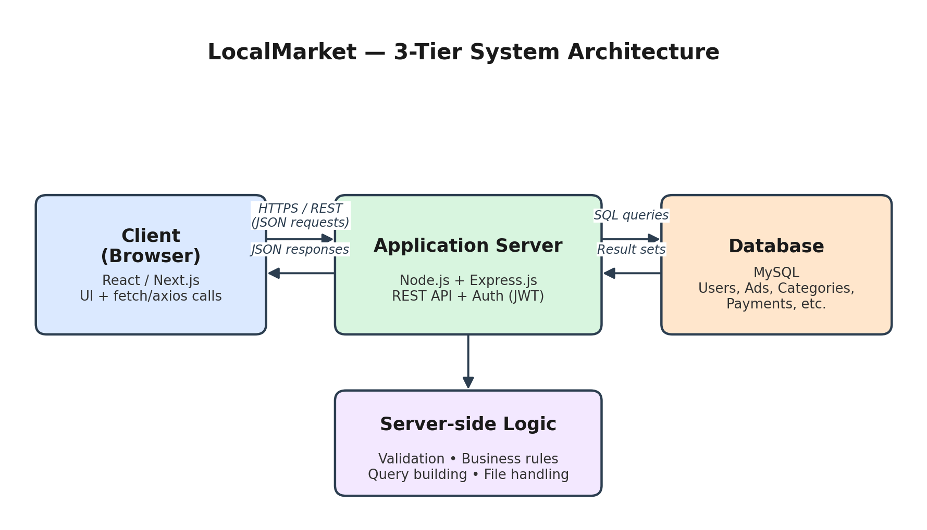
Figure 1: 3-tier system architecture.

2.2 Product Functions (Summary)
- User registration & login (JWT + bcrypt)
- Business profile creation
- Ad posting with category & city
- Browse, search, filter ads
- Save/favorite ads
- Simulated payment for ad promotion (demonstrates a DB transaction)
- Admin approval/removal of ads

2.3 User Classes and Characteristics
User Type | Description | Technical Expertise
Guest | Can browse/search ads only | None required
Registered User | Can browse, search, favorite ads | None required
Business Owner | Can create a business, post ads, promote ads | Basic web familiarity
Admin | Approves/removes ads, manages categories | Basic web familiarity

2.4 Operating Environment
- Frontend: React (Vite or CRA), any modern browser
- Backend: Node.js + Express.js
- Database: MySQL (via mysql2, raw SQL — no ORM)
- Auth: JWT + bcrypt
- Tools: draw.io, Postman/Thunder Client, Git/GitHub, VS Code, MySQL Workbench

2.5 Design and Implementation Constraints
- Simulated payments only (no real gateway)
- Single city, single semester scope
- Web-responsive only (no native mobile app)
- No real-time chat, no ML ranking, no large-scale content moderation
- Must be demonstrable on a single local machine (no cloud deployment required)

2.6 Assumptions and Dependencies
- Team has basic working knowledge of React and JavaScript
- MySQL is available locally (XAMPP/Workbench) on the development and demo machine
- Instructor evaluates DBMS concepts (schema quality, normalization, queries, transactions) rather than production polish or scale
- Project is developed and demoed within one semester by a single student/small team

3. System Features (Functional Requirements)
Each requirement below follows the pattern: description, inputs, processing, outputs, and priority — so each one can be traced directly to a test case in Section 9.

FR-1: User Registration & Login
Field | Detail
Description | Users register with name, email, password, and role (user/business); password is hashed with bcrypt; login returns a JWT.
Inputs | name, email, password, role
Processing | Validate email uniqueness → hash password → insert into USER table → on login, verify hash → issue JWT
Outputs | Success/failure message; JWT token on successful login
Priority | High

FR-2: Business Profile
Field | Detail
Description | A business owner creates one business profile (name, description, city, contact).
Inputs | business_name, city, phone, description
Processing | Verify requester role = business → insert into BUSINESS table linked to user_id
Outputs | Created business profile record
Priority | High

FR-3: Ad Management
Field | Detail
Description | Business owner creates ads with title, description, price, category, city, and images. Ads carry a status: pending, approved, promoted, rejected, or removed.
Inputs | title, description, price, category_id, city, image file(s)
Processing | Validate business owns the account → insert AD row (status = pending) → insert AD_IMAGE row(s)
Outputs | New ad record with status = pending
Priority | High

FR-4: Browse, Search, Filter
Field | Detail
Description | Anyone can browse approved ads; filter by category, city, price range; search by keyword in title/description.
Inputs | keyword, category_id (optional), city (optional), min_price/max_price (optional)
Processing | Build a parameterized SQL query with WHERE/LIKE clauses on indexed columns (city, category_id)
Outputs | List of matching ads with business and category info (via JOIN)
Priority | High

FR-5: Favorites
Field | Detail
Description | Registered users can save/unsave ads and view their list of favorites.
Inputs | user_id, ad_id
Processing | Insert/delete row in FAVORITE table (composite uniqueness on user_id + ad_id)
Outputs | Updated favorites list
Priority | Medium

FR-6: Simulated Payment / Promotion
Field | Detail
Description | A business owner “promotes” an ad via a simulated payment record. This is the primary transaction demo for the DBMS course.
Inputs | ad_id, amount, method
Processing | Within a single SQL transaction: (1) INSERT into PAYMENT, (2) UPDATE ad status to ‘promoted’. Both steps COMMIT together, or ROLLBACK together on failure.
Outputs | Payment record + updated ad status
Priority | High (core DBMS demonstration)

FR-7: Admin Moderation
Field | Detail
Description | Admin approves or removes ads, and manages categories.
Inputs | ad_id, decision (approve/reject/remove)
Processing | Verify requester role = admin → UPDATE ad status accordingly
Outputs | Updated ad status; ad becomes visible (if approved) or hidden (if rejected/removed)
Priority | Medium

3.1 Ad Status Lifecycle
The AD.status column moves through a small, well-defined set of states. Modeling this explicitly avoids inconsistent data and is a natural place to demonstrate constraints (e.g. an ENUM column) and transactions (the pending → promoted transition).
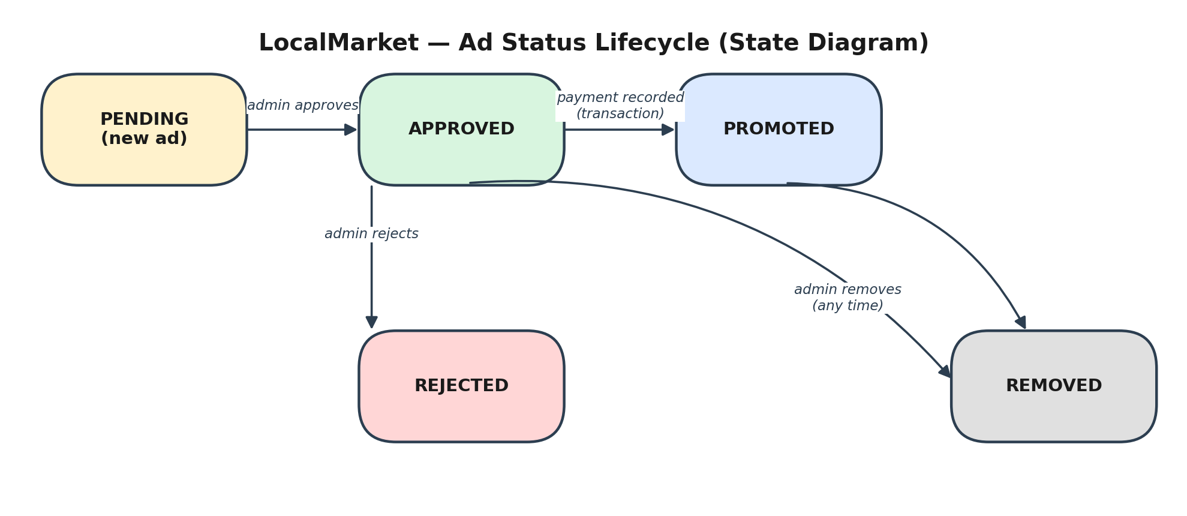
Figure 2: Ad status lifecycle.

3.2 Use Cases
Primary use cases, one per core feature, using standard actor/precondition/flow/postcondition structure:

UC-1: Post an Ad
Field | Detail
Actor | Business Owner
Precondition | User is logged in and has a business profile
Main Flow | 1) Owner opens “Post Ad” form → 2) Fills title, description, price, category, city, images → 3) Submits → 4) System validates and inserts AD row with status = pending
Postcondition | New ad exists with status = pending, awaiting admin approval
Alternate Flow | Validation fails (missing required field) → system shows inline error, no row inserted

UC-2: Search & Filter Ads
Field | Detail
Actor | Guest or Registered User
Precondition | None (public feature)
Main Flow | 1) User enters keyword and/or selects category/city/price range → 2) System queries approved ads matching filters (JOIN with BUSINESS and CATEGORY) → 3) Results displayed
Postcondition | User sees a filtered, relevant list of ads
Alternate Flow | No matches → system shows an empty-state message

UC-3: Promote an Ad (Transaction)
Field | Detail
Actor | Business Owner
Precondition | Ad exists and status = approved; owner is logged in
Main Flow | 1) Owner selects “Promote” on an ad → 2) Enters simulated payment details → 3) System starts a transaction: inserts PAYMENT row, updates AD.status to ‘promoted’ → 4) Transaction commits
Postcondition | Payment record exists; ad status = promoted; both changes are consistent (never one without the other)
Alternate Flow | Any step fails → transaction rolls back — no payment row and no status change

UC-4: Approve or Reject an Ad
Field | Detail
Actor | Admin
Precondition | Admin is logged in; at least one ad has status = pending
Main Flow | 1) Admin opens pending-ads queue → 2) Reviews an ad → 3) Approves or rejects → 4) System updates AD.status
Postcondition | Ad status reflects the admin's decision (approved/rejected)
Alternate Flow | Admin removes an already-approved ad later (policy violation) → status set to removed

UC-5: Register and Log In
Field | Detail
Actor | Guest
Precondition | Guest has a valid, unique email address
Main Flow | 1) Guest submits registration form → 2) System hashes password, creates USER row → 3) Guest logs in → 4) System verifies password hash, issues JWT
Postcondition | User account exists; user holds a valid JWT for subsequent requests
Alternate Flow | Email already registered → system rejects with a clear error, no duplicate row created

4. Data Requirements (Database Design)

4.1 Entities
Entity | Purpose
USER | Account holder (user or business owner)
BUSINESS | Business profile owned by a user
CATEGORY | Ad categories (Electronics, Jobs, Services, Real Estate)
AD | A listing posted by a business
AD_IMAGE | Images attached to an ad
FAVORITE | Join table: user saves ad (M:N)
PAYMENT | Simulated transaction for promotion

4.2 Entity-Relationship Diagram
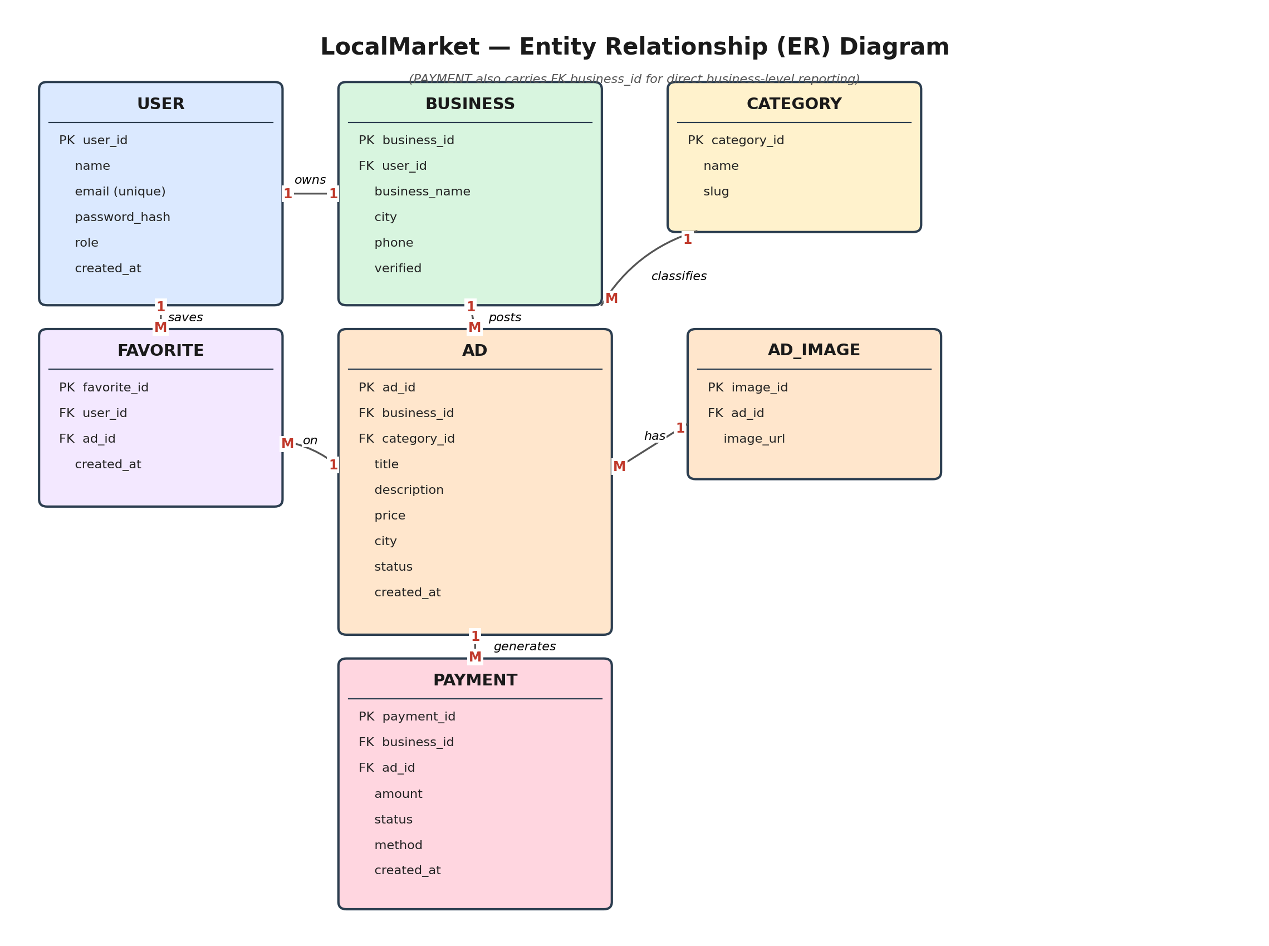
Figure 3: ER diagram — 7 entities.

4.3 Relationships
- 1 User → 0..1 Business
- 1 User → M Favorites
- 1 Business → M Ads
- 1 Business → M Payments
- 1 Category → M Ads
- 1 Ad → M Images
- 1 Ad → M Payments
- 1 Ad → M Favorites (via the Favorite join table)

4.4 Normalization Notes
The schema below is normalized to 3NF: every non-key attribute depends on the whole primary key (2NF) and only on the primary key, not on another non-key attribute (3NF). For example, business_name and city are not repeated on every AD row — they live once in BUSINESS and are reached via business_id, which removes the update-anomaly risk of storing business details redundantly on each ad.

4.5 Full Table Schema (DDL)
The following CREATE TABLE statements define the complete normalized schema. This is the schema.sql deliverable referenced in Section 10.
CREATE TABLE USER (
user_id INT AUTO_INCREMENT PRIMARY KEY,
name VARCHAR(100) NOT NULL,
email VARCHAR(150) NOT NULL UNIQUE,
password_hash VARCHAR(255) NOT NULL,
role ENUM('user','business','admin') NOT NULL DEFAULT 'user',
created_at TIMESTAMP DEFAULT CURRENT_TIMESTAMP
);
CREATE TABLE BUSINESS (
business_id INT AUTO_INCREMENT PRIMARY KEY,
user_id INT NOT NULL UNIQUE,
business_name VARCHAR(150) NOT NULL,
city VARCHAR(100) NOT NULL,
phone VARCHAR(20),
verified BOOLEAN DEFAULT FALSE,
FOREIGN KEY (user_id) REFERENCES USER(user_id) ON DELETE CASCADE
);
CREATE TABLE CATEGORY (
category_id INT AUTO_INCREMENT PRIMARY KEY,
name VARCHAR(80) NOT NULL UNIQUE,
slug VARCHAR(80) NOT NULL UNIQUE
);
CREATE TABLE AD (
ad_id INT AUTO_INCREMENT PRIMARY KEY,
business_id INT NOT NULL,
category_id INT NOT NULL,
title VARCHAR(150) NOT NULL,
description TEXT,
price DECIMAL(10,2) NOT NULL,
city VARCHAR(100) NOT NULL,
status ENUM('pending','approved','promoted','rejected','removed')
NOT NULL DEFAULT 'pending',
created_at TIMESTAMP DEFAULT CURRENT_TIMESTAMP,
FOREIGN KEY (business_id) REFERENCES BUSINESS(business_id) ON DELETE CASCADE,
FOREIGN KEY (category_id) REFERENCES CATEGORY(category_id),
INDEX idx_city (city),
INDEX idx_category (category_id)
);
CREATE TABLE AD_IMAGE (
image_id INT AUTO_INCREMENT PRIMARY KEY,
ad_id INT NOT NULL,
image_url VARCHAR(255) NOT NULL,
FOREIGN KEY (ad_id) REFERENCES AD(ad_id) ON DELETE CASCADE
);
CREATE TABLE FAVORITE (
favorite_id INT AUTO_INCREMENT PRIMARY KEY,
user_id INT NOT NULL,
ad_id INT NOT NULL,
created_at TIMESTAMP DEFAULT CURRENT_TIMESTAMP,
UNIQUE KEY uq_user_ad (user_id, ad_id),
FOREIGN KEY (user_id) REFERENCES USER(user_id) ON DELETE CASCADE,
FOREIGN KEY (ad_id) REFERENCES AD(ad_id) ON DELETE CASCADE
);
CREATE TABLE PAYMENT (
payment_id INT AUTO_INCREMENT PRIMARY KEY,
business_id INT NOT NULL,
ad_id INT NOT NULL,
amount DECIMAL(10,2) NOT NULL,
status ENUM('pending','completed','failed') NOT NULL DEFAULT 'completed',
method VARCHAR(50) DEFAULT 'simulated',
created_at TIMESTAMP DEFAULT CURRENT_TIMESTAMP,
FOREIGN KEY (business_id) REFERENCES BUSINESS(business_id),
FOREIGN KEY (ad_id) REFERENCES AD(ad_id)
);

4.6 Sample Queries
These three queries are the minimum the course expects (a JOIN, an aggregate, and a transaction) and should appear — with real output screenshots — in the final report.

A — Multi-table JOIN: approved ads with business and category names
SELECT a.title, a.price, a.city, b.business_name, c.name AS category
FROM AD a
JOIN BUSINESS b ON a.business_id = b.business_id
JOIN CATEGORY c ON a.category_id = c.category_id
WHERE a.status = 'approved'
ORDER BY a.created_at DESC;

B — Aggregate: number of ads per category
SELECT c.name AS category, COUNT(a.ad_id) AS total_ads
FROM CATEGORY c
LEFT JOIN AD a ON a.category_id = c.category_id AND a.status = 'approved'
GROUP BY c.category_id
ORDER BY total_ads DESC;

C — Transaction: promote an ad (payment + status update atomically)
START TRANSACTION;
INSERT INTO PAYMENT (business_id, ad_id, amount, method)
VALUES (?, ?, ?, 'simulated');
UPDATE AD SET status = 'promoted' WHERE ad_id = ?;
COMMIT;
-- On any error in either step: ROLLBACK;

5. External Interface Requirements

5.1 User Interfaces
- Signup/Login page
- Home (browse ads)
- Search/Filter page
- Ad detail page
- Post Ad page (business)
- Business Dashboard
- Admin Panel
- Favorites page

5.2 API Interfaces (REST)
Method | Endpoint | Purpose
POST | /api/auth/register | Register a new user
POST | /api/auth/login | Log in, receive JWT
GET | /api/ads | List/search/filter ads
GET | /api/ads/:id | Ad detail
POST | /api/ads | Create ad (business, auth required)
POST | /api/favorites | Save an ad (auth required)
POST | /api/payments | Promote ad — runs the transaction (auth required)
PUT | /api/admin/ads/:id | Approve/reject/remove ad (admin only)

Example: POST /api/ads (request/response)
Request body:
{
"title": "iPhone 12, 128GB",
"description": "Excellent condition, box included",
"price": 85000,
"category_id": 3,
"city": "Karachi"
}
Response (201 Created):
{
"ad_id": 42,
"status": "pending",
"message": "Ad submitted for admin approval"
}

5.3 Database Interface
MySQL, accessed via the mysql2 npm package using raw parameterized SQL (no ORM), so that every query written is visible and gradable as a DBMS artifact.

6. Non-Functional Requirements
ID | Category | Requirement
NFR-1 | Security | Passwords hashed with bcrypt; JWT for sessions; parameterized queries to prevent SQL injection
NFR-2 | Performance | Search by city/category should use indexes; typical query should return in well under 1 second on the demo dataset
NFR-3 | Reliability | Payment + ad status update must be atomic (transaction) — never a partial write
NFR-4 | Usability | UI must be responsive (desktop + mobile browser) and usable without training
NFR-5 | Maintainability | Code must be in a Git repo with a README documenting setup steps and environment variables
NFR-6 | Portability | System runs locally via XAMPP/Node without cloud dependency; deployment optional
NFR-7 | Legal / Ethical | Payments are clearly simulated; UI must label promotion as a demo transaction, not a real charge

7. System Architecture
See Figure 1 (Section 2.1) for the 3-tier architecture. In short: the React client never talks to MySQL directly — all data access is mediated by the Express API layer, which enforces validation, authentication, and transaction boundaries before touching the database.

8. Data Flow Diagram (Context Level)
The context-level DFD (Level 0) shows LocalMarket as a single process exchanging data with its three external entities and its one data store. Lower-level DFDs (Level 1) can decompose the central process into Auth, Ads, Favorites, and Payments sub-processes if your course requires that depth — the entities and data store stay the same.
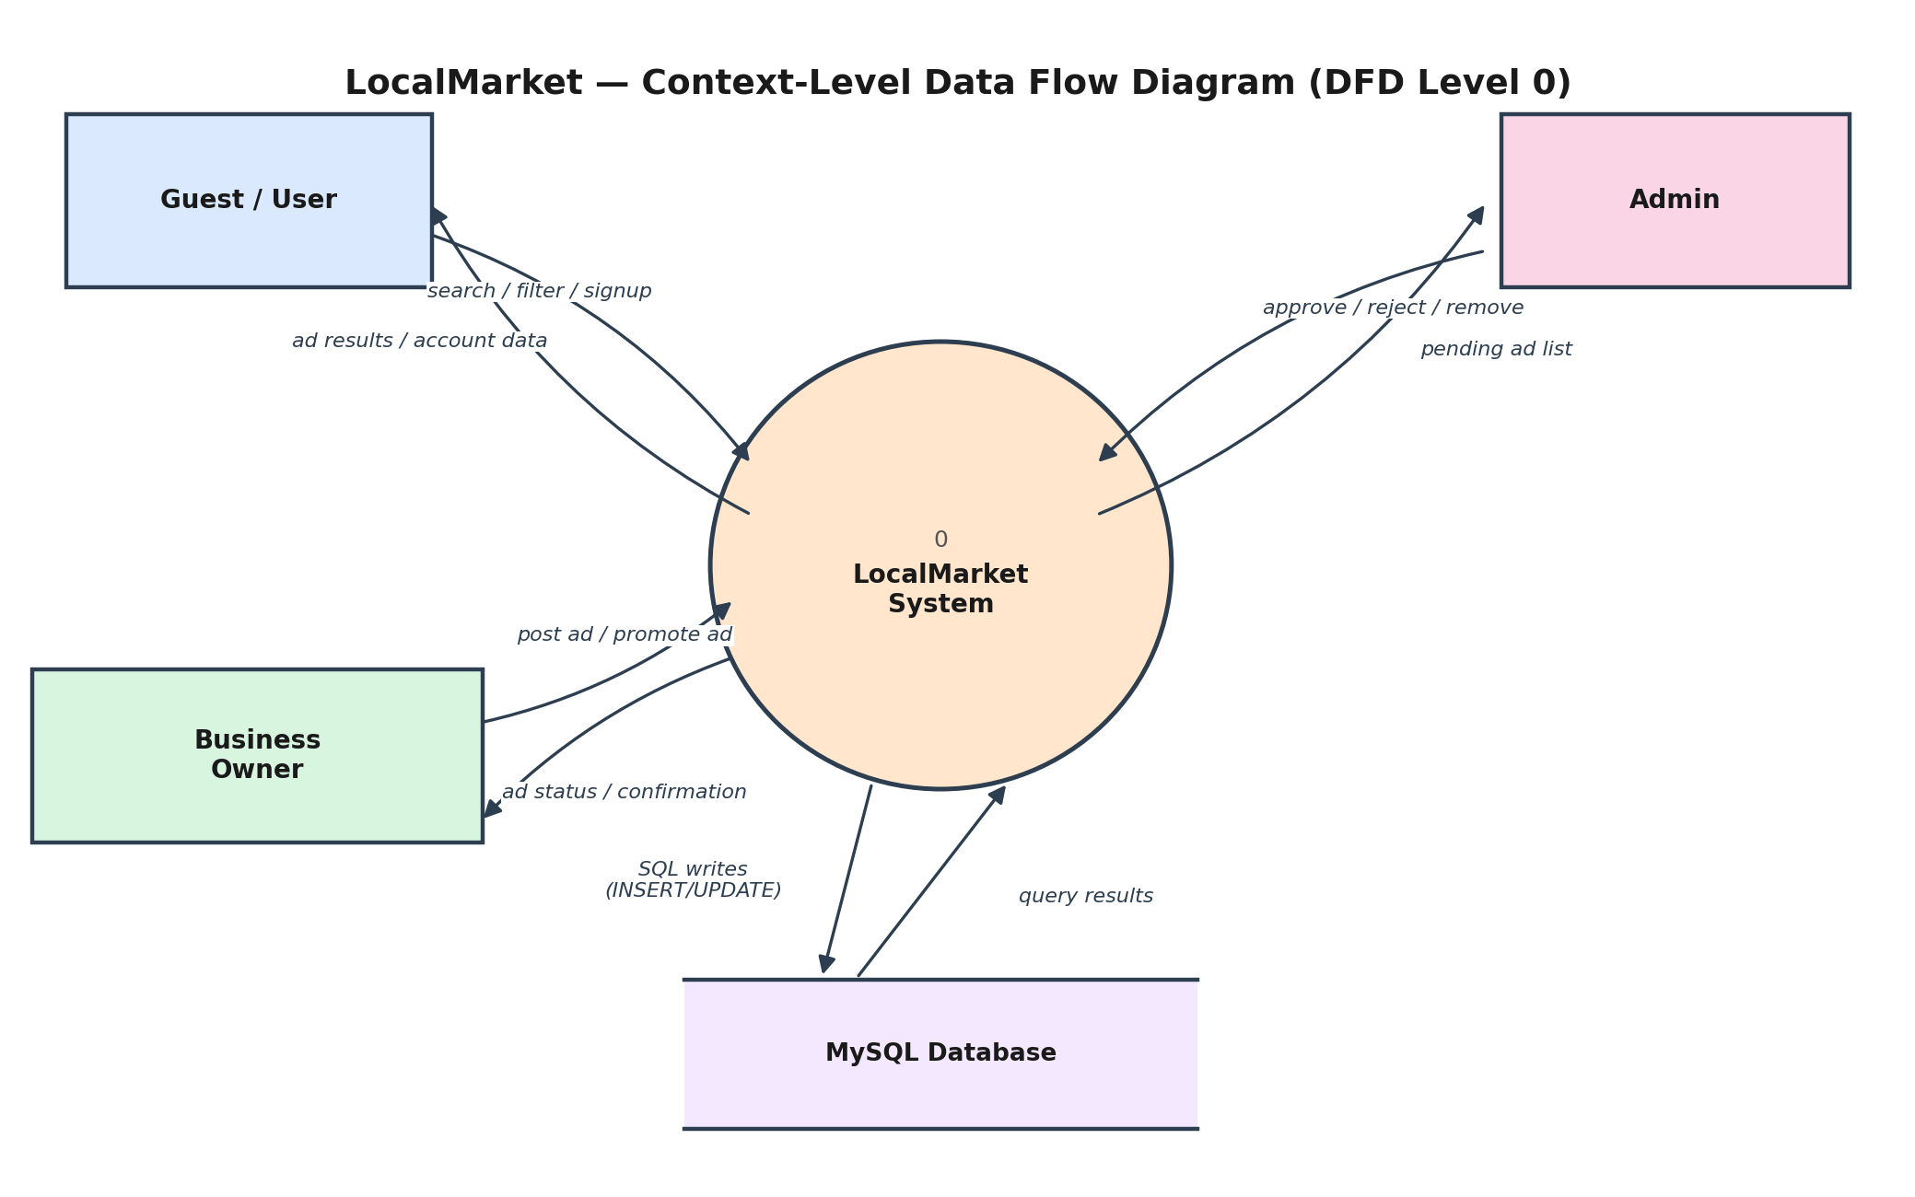
Figure 4: Context-level Data Flow Diagram.

9. Testing & Acceptance Criteria
Minimum test scenarios to validate before the demo, mapped to their functional requirement:
FR | Test Scenario | Expected Result
FR-1 | Register with an email already in use | System rejects with a clear error; no duplicate row created
FR-1 | Log in with correct credentials | JWT returned; subsequent authenticated requests succeed
FR-3 | Business owner posts an ad with all required fields | Ad created with status = pending
FR-4 | Search for a keyword that matches no ad | Empty result set returned, no server error
FR-4 | Filter by city + category together | Only ads matching both filters are returned
FR-6 | Promote an ad, then force a failure mid-transaction (e.g. invalid ad_id) | No PAYMENT row is created and AD.status is unchanged (ROLLBACK verified)
FR-7 | Admin approves a pending ad | Ad becomes visible in public search results
NFR-1 | Attempt SQL injection in the search keyword field | Query is safely parameterized; no unintended data exposure

10. Development Phases & Timeline
Phase | Weeks | Tasks | Deliverable
1. Learn & Plan | 1–2 | Study ER, normalization, SQL; finalize scope | Problem statement + entity list
2. Database Design | 2–3 | Draw ER, normalize to 3NF, write schema.sql | ER diagram + schema.sql
3. Backend Setup | 3–5 | Express + MySQL, CRUD APIs, JWT auth | Working API (Postman tested)
4. Frontend Build | 5–7 | React pages (auth, browse, post, dashboard) | React app wired to API
5. Integration & Testing | 7–8 | End-to-end testing per Section 9, bug fixes | Working demo
6. Documentation | 8–9 | Report, slides, sample queries with screenshots | Submitted report + demo

11. Final Submission Checklist
- Problem statement & scope document
- ER diagram (finalized)
- Normalized schema (3NF, PK/FK constraints) — Section 4.5
- schema.sql — script that creates all tables
- Source code repo (frontend + backend) with README
- Sample queries: 1 JOIN, 1 aggregate/GROUP BY, 1 transaction — Section 4.6
- Working demo covering all use cases in Section 3.2
- Final report with screenshots and test results from Section 9

12. Appendix A: Glossary
Term | Meaning
Atomicity | A transaction's guarantee that all its steps succeed together or none do
Index | A database structure that speeds up lookups on specific columns (e.g. city, category_id)
Referential Integrity | The guarantee that a foreign key always points to a valid existing row
Parameterized Query | A SQL query with placeholders for values, preventing SQL injection

End of document.

