**NAMA : HAFIZ AULIA RAKHMAN**

**NIM : 16090089**

**KELAS : 6A**

**WEB PROFIL**

1. **White Box**
2. FlowChart
3. Admin

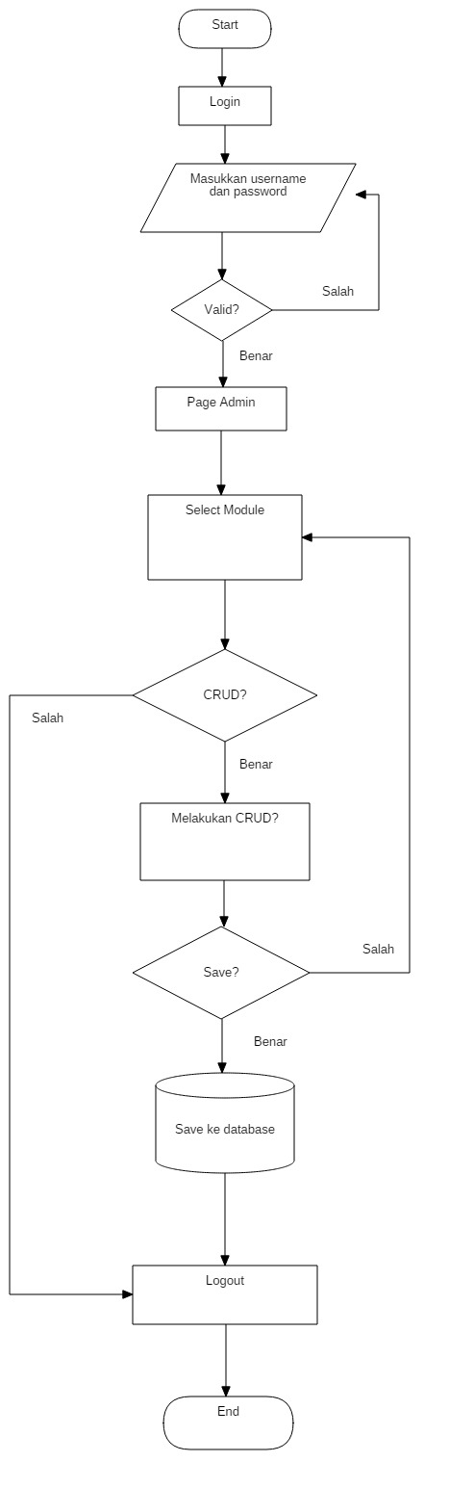

1. User

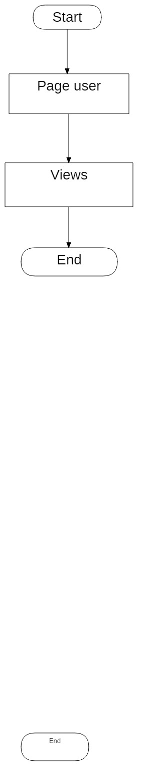

1. CFG (Control Flow Graph)
2. Admin

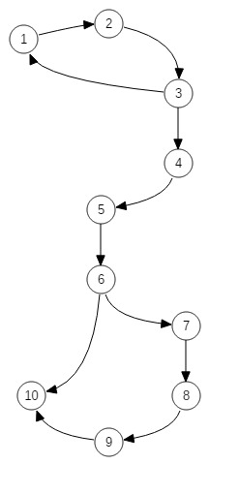

1. User

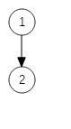

1. Cyclomatic Complexity

Rumus = Decision + 1

* Admin

2 + 1 = 3

* User

0 + 1 = 1

1. Basic Path

* Admin

1. : 1-2-3-1
2. : 2-1-2-3-4-5-6-7-8-9-10-1
3. : 1-2-3-4-5-6-7-8-5-6-10-1

* User

1. : 1-2
2. **Black Box**
3. Equivslence Partitioning
4. Modul Sejarah

* Validasi untuk Judul

|  |  |  |
| --- | --- | --- |
| Invalid | Valid | Invalid |
| …,-1,0 | 1,2,3,...,100 | 101,102,…. |

* Validasi untuk Artikel

|  |  |  |
| --- | --- | --- |
| Invalid | Valid | Invalid |
| …-1,0 | 1,2,3,…255 | 256,257,… |

* Validasi untuk foto(dalam mb)

|  |  |  |
| --- | --- | --- |
| Invalid | Valid | Invalid |
| …,-1,0 | 1,2 | 3,4…. |

1. Tabel Kebenaran

* Validasi Untuk Login Admin

|  |  |  |  |  |
| --- | --- | --- | --- | --- |
| Email | F | F | T | T |
| Password | F | T | F | T |
|  | error | Error | error | Berhasil |

* Validasi Untuk Tambah Sejarah (admin)

|  |  |  |  |
| --- | --- | --- | --- |
| Judul | Artikel | Foto |  |
| T | T | T | Berhasil |
| T | T | F | Error |
| T | - | - | Error |

* Validasi Untuk Edit Sejarah (admin)

|  |  |  |  |
| --- | --- | --- | --- |
| Judul | Artikel | Foto |  |
| T | T | T | Berhasil |
| T | T | F | Berhasil |
| T | - | - | Error |

Tampilan Admin

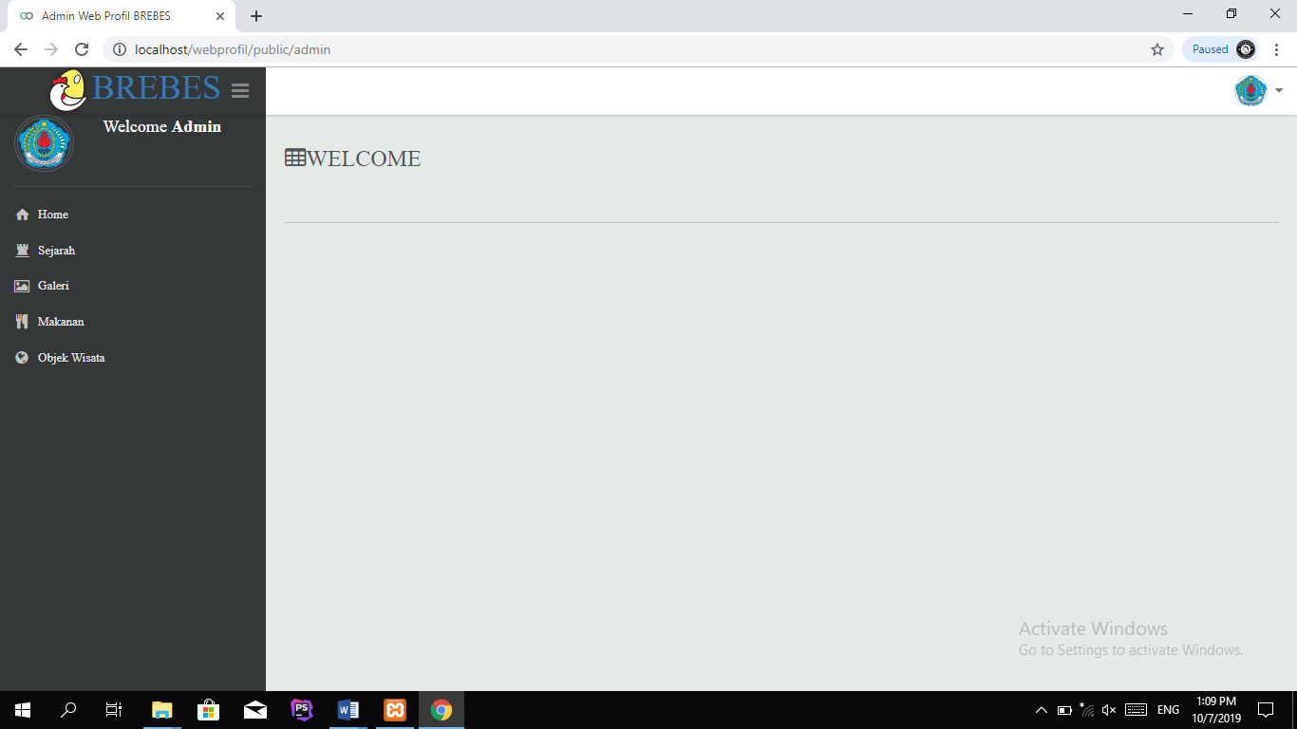

Tampilan Tambah Sejarah, Galeri, Makanan, dan Wisata

