Project Title:
Mobile Game Monetization Analysis: Insights into Player Segmentation and In-App Purchase Behavior
Dataset: “Mobile Game In-App Purchases Dataset 2025” (3,024 users, 13 columns)
Tools: Google Sheets, BigQuery (SQL), Tableau
Step 1 — Business Problem
The mobile game team wants to understand which types of players are most valuable, how they spend, and what behaviors predict higher in-app purchases.
Your goal: analyze spending patterns, segment users, and provide actionable insights to optimize monetization and retention.
##Write a short “Business Questions & Impact” section at the top of your project ####
##Your business insights section with real-world tone#####
##Your “Executive Summary” section (very important for hiring managers) ######

Step 2 — Key Analysis Questions
- Player Segmentation & Revenue
  - How much revenue comes from whales, dolphins, and minnows?
  - What percentage of users belong to each segment?
- Demographics & Spending
  - Does age, gender, or country correlate with spending?
  - Which device generates the most revenue?
- Gameplay & Monetization
  - Do more sessions or longer average session length correlate with spending?
  - How quickly do players make their first purchase after install?
- Payment Preferences
  - Which payment methods are most popular for each spending segment?
- Game Genre Insights
  - Which genres attract high-value players (whales)?

Data Cleanup:
- UserID
- Data > Data cleanup > Trim whitespace
- Data > Data cleanup > Remove duplicates
- Format > Number > Plain text
- I create a new helper column to check the length of the id using formula =LEN(A2) and filter the id for the length that is not 36
- I create a new helper column and use formula =LOWER(A2), then Paste Special > Values only back into Column A to overwrite the original IDs with the standardized version
- Age
- Format > Number > Number
- Remove Decimals/Rounding
- Filter tool on the Age column to find any cells that are (Blanks)
- calculate the Median age of the dataset (using the formula =MEDIAN(Age)), and replace the missing data with the Median Age (33)
- check statistical range (Min/Max) using =MIN(AGE) and =MAX(AGE) formulas
- Edit > Find and replace to remove any stray characters and then re-convert the column to a number
- Gender
- Data > Data cleanup > Trim whitespace
- Use =PROPER(C2) formula on helper column, and Paste Special > Values only
- using filter to check for gender types, and update every spelling mistake, variation, placeholder, or unexpected entry using Edit > Find and replace
- filter out blanks and replace it with UNKNOWN
- Country
- Data > Data cleanup > Trim whitespace
- Use the Filter tool to get a complete list of unique entries
- Fix all obvious misspellings using Edit > Find and replace
- Use the Filter tool and select the (Blanks) and replace with UNKNOWN
- use helper column and apply formula =UPPER(D2) and Copy Paste Special > Values only
- Device
- Data > Data cleanup > Trim whitespace
- Formula (in Helper Column): =UPPER(E2), Copy & Paste Special > Values only
- Edit > Find and replace to map known variations to the standard
- Use the Filter tool and select the (Blanks) and replace with UNKNOWN
- GameGenre
- Data > Data cleanup > Trim whitespace
- Use the Filter tool and select the (Blanks) and replace with UNCATEGORIZED
- Use =PROPER(F2) formula on helper column, and Paste Special > Values only
- Use Edit > Find and replace repeatedly for each genre to map inconsistencies

- SessionCount
- Format > Number > Number & Remove Decimals
- Edit > Find and replace to remove any non-numeric symbols
- Calc Min, Max, Median value to check statistical range
- Check for blanks and replace with 0
- AverageSessionLenght
- Format > Number > Number
- Edit > Find and replace to remove any non-numeric symbols
- Calc Min, Max, Median value to check statistical range
- Use the Filter tool to isolate values significantly above plausible limit
- Check for blanks and replace with 0
- SpendingSegment
- Data > Data cleanup > Trim whitespace
- Use =PROPER(I2) formula on helper column, and Paste Special > Values only
- Use the Filter tool to get a complete list of unique entries
- Map and Correct Invalid Values using Edit > Find and replace
- Check for blanks and replace with UNCLASSIFIED
- InAppPurchaseAmount
- Format > Number > Currency
- Edit > Find and replace to remove non-numeric characters
- Calc Min, Max, Median value to check statistical range
- Check for blanks and replace all empty cells in the column with 0
- FirstPurchaseDaysAfterInstall
- Format > Number > Number
- Use Edit > Find and replace to remove any non-numeric symbols or text residues
- Calc Min, Max, Median value to check statistical range
- Use the Filter tool to isolate values significantly higher than the expected
- Check for blanks and leave it with Blanks
- PaymentMethod
- Data > Data cleanup > Trim whitespace
- Use =PROPER(L2) formula on helper column, and Paste Special > Values only
- Use the Filter tool to get a complete list of unique entries
- Use Edit > Find and replace to replace all empty cells in the column with UNKNOWN
- LastPurchaseDate
- Format > Number > Date
- check for any cells failed the conversion and fix it
- Calc Min, Max, Median value to check statistical range
- Check for blanks and leave it as Blanks

#USE CONDITIONAL FORMATING

BIGQUERY
Phase 1: The Core Revenue Picture (The "What & Where")
- Spending Segment Distribution
This query answers the most important question in game monetization: where does the revenue come from? You'll see the power law distribution (the 80/20 rule) in action.
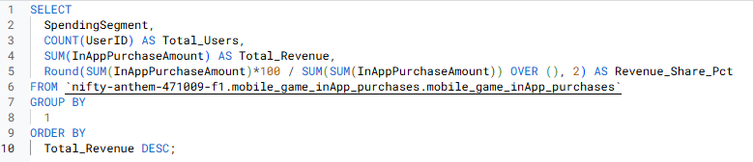

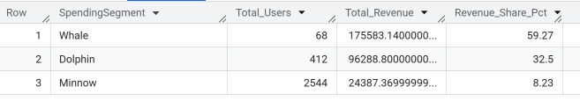

- Top Countries by Revenue
This query identifies the geographical markets that deliver the highest returns.
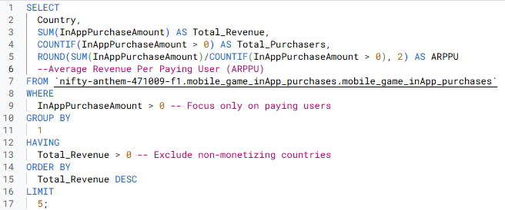

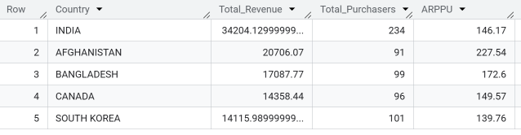

- Revenue by Game Genre
This query links revenue directly to the content type, showing which games/genres are most successful monetarily.
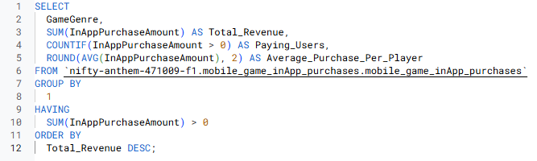

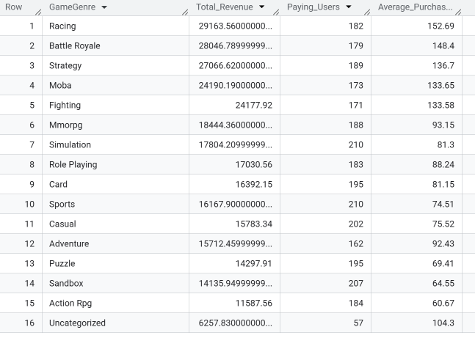
Phase 2: Behavioral Insights (The "How & When")
- Device Comparison
This query compares your core monetization metrics between your two main platforms to see if iOS or Android users are more valuable.
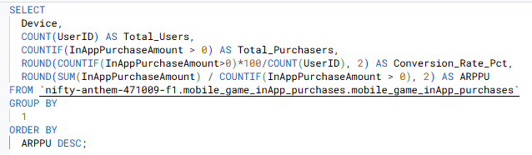

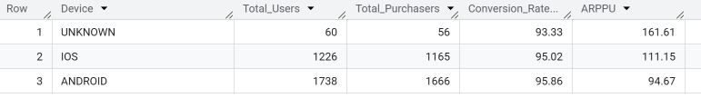

- First Purchase Timing
This query analyzes the distribution of time until the first purchase, identifying the crucial Day 0 conversion rate and the median delay for the rest of your payers.
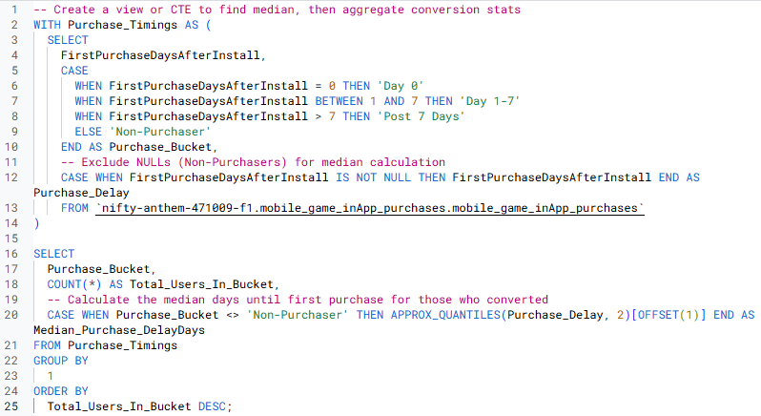

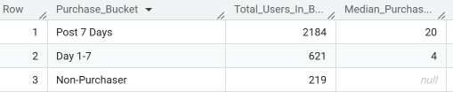

- Gameplay vs Spending
This query links the Total Playtime (a proxy for engagement) to the actual revenue generated.
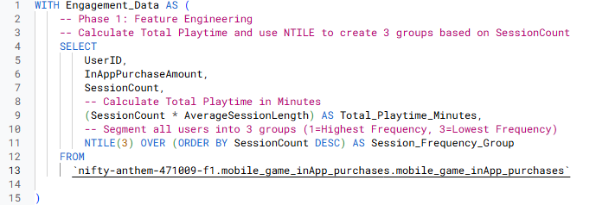

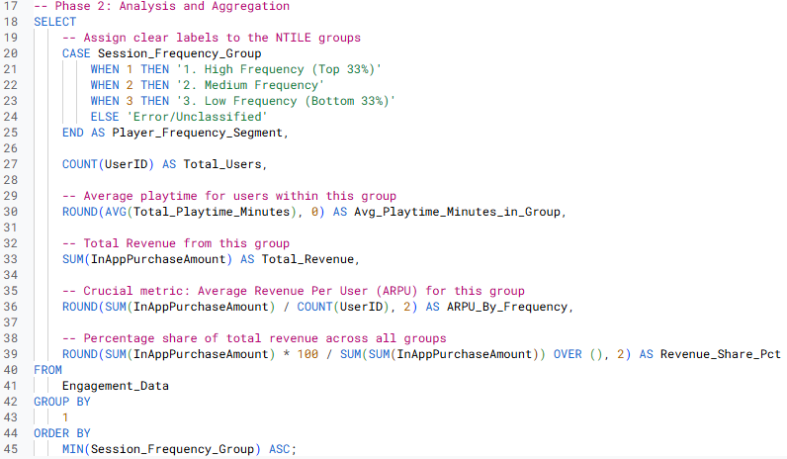

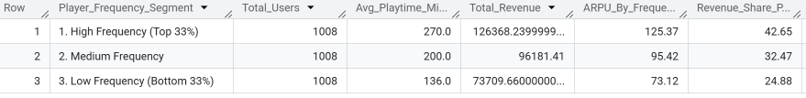

Phase 3: Actionable Deep Dive (The "Why")
- Payment Methods by Spending Segment
This query groups your payers by their spending tier and reports which payment methods are most popular within each group.
