­

|  |
| --- |
| ***Computer Engineering Department*** |
| ***CE302L: Database Management Systems*** |

|  |  |
| --- | --- |
| ***Course Instructor: Umer Farooq*** | ***Dated: January 17, 2022*** |
| ***Lab Engineer: Muhammad Usama Riaz*** | ***Semester: 5th*** |
| ***Session: 2019-2023*** | ***Batch: BSCE2019*** |

# Lab. 11 Introduction to Data Modeling (ER Diagrams)

|  |  |  |  |
| --- | --- | --- | --- |
| **Name** | **Roll No** | **Lab Report Marks/100** | **Total Marks**  **(Scaled out of 10)** |
|  |  |  |  |

Checked on:

Signature:

## 10.1 Objective

## The object of this manual is to give an overview and hands on practice to Data modeling using ERDPlus online DBMS tool.

## 10.2 Equipment and Component

|  |  |  |
| --- | --- | --- |
| **Component Description/Software** | **Value** | **Quantity** |
| Computer, ERDPlus | On Campus | 1 |

## 10.3 Conduct of Lab

* + 1. Students are required to perform this experiment individually.
    2. In case the lab experiment is not understood, the students are advised to seek help from the course instructor, lab engineers, assigned teaching assistants (TA) and lab attendants.

## 10.4 Theory and Background

ERDPlus is a popular data modeling tool. The product supports a variety of aspects of database design, including data modeling, forward engineering (the creation of a database schema and physical database based on a data model), and reverse engineering (the creation of a data model on the basis of an existing database) for a wide variety of relational DBMS.

## 10.5 Lab Task:

Make ER diagram for the following Schema. Kindly Follow the IE Notation.

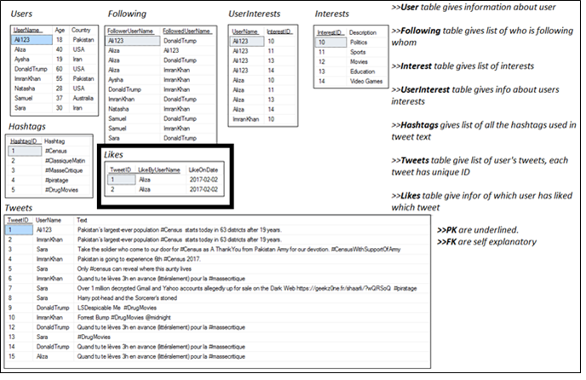

#### Assessment Rubrics for Lab

Method:Lab reports and instructor observation during lab sessions.

**Outcome assessed:**

a. Ability to conduct experiments, as well as to analyze and interpret data (P)

b. Ability to function on multi-disciplinary teams (A)

c. Ability to use the techniques, skills, and modern engineering tools necessary for engineering practice (P)

|  |  |  |  |  |  |  |  |
| --- | --- | --- | --- | --- | --- | --- | --- |
| Performance metric | Mapping (task no. and description) | | Max marks | Exceeds expectation | Meets expectation | Does not meet expectation | Obtained marks |
| 1. Realization of experiment (a) | 1 | Functionality | 40 | Executes without errors excellent user prompts, good use of symbols, spacing in output. Through testing has been completed (45-41) | Executes without errors, user prompts are understandable, minimum use of symbols or spacing in output. Some testing has been completed (40-21) | Does not execute due to syntax errors, runtime errors, user prompts are misleading or non-existent. No testing has been completed (20-0) |  |
| 2. Teamwork (b) | 1 | Group Performance | 5 | Actively engages and cooperates with other group member(s) in effective manner (5-4) | Cooperates with other group member(s) in a reasonable manner but conduct can be improved (3-2) | Distracts or discourages other group members from conducting the experiment (1-0) |  |
| 3. Conducting experiment (a, c) | 1 | On Spot Changes | 10 | Able to make changes (5-4) | Partially able to make changes (3-2) | Unable to make changes (1-0) |  |
| 2 | Viva | 10 | Answered all questions (5-4) | Few incorrect answers (3-2) | Unable to answer all questions (1-0) |  |
| 4. Laboratory safety and disciplinary rules (a) | 1 | Code commenting | 5 | Observes lab safety rules; adheres to the lab disciplinary guidelines aptly (5-4) | Generally, observes safety rules and disciplinary guidelines with minor lapses (3-2) | Disregards lab safety and disciplinary rules (1-0) |  |
| 5. Data collection (c) | 1 | Code Structure | 5 | Excellent use of white space, creatively organized work, excellent use of variables and constants, correct identifiers for constants, No line-wrap (5-4) | Includes name, and assignment, white space makes the program fairly easy to read. Title, organized work, good use of variables (3-2) | Poor use of white space (indentation, blank lines) making code hard to read, disorganized and messy (1-0) |  |
| 6. Data analysis (a, c) | 1 | Algorithm | 20 | Solution is efficient, easy to understand, and maintain (5-4) | A logical solution that is easy to follow but it is not the most efficient (3-2) | A difficult and inefficient solution (1-0) |  |
| 7. Computer use (c) | 1 | Documentation | 5 | Timely documented (5-4) | Late documented (3-2) | Not documented (1-0) |  |
|  | Max Marks (total): | | 100 | Obtained Marks (Total): | | |  |

Lab Engineer Signature: ________________________