

Submitted by:
Fatima Saeed-2026-CYS-15
Assignment:
Lab No.2
Submitted To:
Sir Mujtaba Kamal
For the fulfillment of,
Programming Fundamental Lab
Department of Computer Engineering
University of Engineering and Technology, Lahore

Task 1:
def binary_to_decimal(binary):
if not all(bit in "01" for bit in binary):
return "Invalid binary number. Please enter a binary number (0s and 1s only)."
return int(binary, 2)
def main():
binary = input("Enter a binary number: ")
result = binary_to_decimal(binary)
print(f"The decimal equivalent of {binary} is {result}.")
if __name__ == "__main__":
main()

Output:
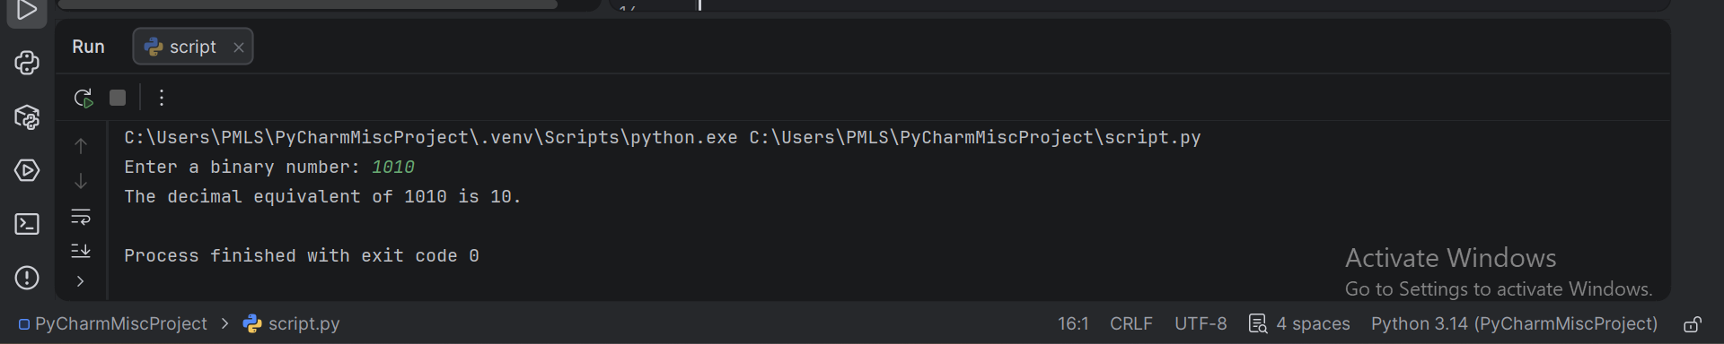
Task 2:
def count_vowels_consonants(sentence):
vowels = "aeiouAEIOU"
vowel_count = 0
consonant_count = 0
for char in sentence:
if char.isalpha():
if char in vowels:
vowel_count += 1
else:
consonant_count += 1
return vowel_count, consonant_count
#Get input from user
sentence = input("Enter a sentence: ")
# Calculate counts
vowel_count, consonant_count = count_vowels_consonants(sentence)
#Display results
print(f"Number of vowels: {vowel_count}")
print(f"Number of consonants: {consonant_count}")

Output:
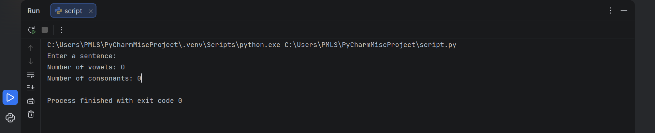
Task 3:
def is_prime(n):
"""Check if a number is prime."""
if n <= 1:
return False
for i in range(2, int(n**0.5) + 1):
if n % i == 0:
return False
return True
def prime_numbers_in_range(start, end):
"""Find prime numbers in given range and calculate their sum."""
primes = []
for num in range(start, end + 1):
if is_prime(num):
primes.append(num)
return primes, sum(primes)
def main():
# Take range from user
start = int(input("Enter the start of range: "))
end = int(input("Enter the end of range: "))
# Get primes and their sum
primes, total_sum = prime_numbers_in_range(start, end)
#Display results
print("Prime numbers between", start, "and", end, "are:")
print(primes)
print("Sum of prime numbers:", total_sum)
if __name__ == "__main__":
main()

Output:
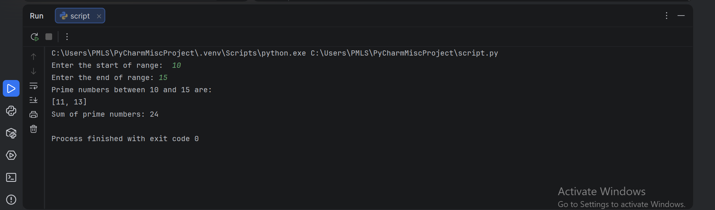
Task 4:
import random
import string
def generate_password(length, use_upper, use_lower, use_digits, use_special):
"""Generate a random password based on your preferences."""
char_pool = "Orange"
if use_lower:
char_pool += string.ascii_lowercase
if use_upper:
char_pool += string.ascii_uppercase
if use_digits:
char_pool += string.digits
if use_special:
char_pool += string.punctuation
# Ensure at least one character from each selected set is in the password
password = []
if use_lower:
password.append(random.choice(string.ascii_lowercase))
if use_upper:
password.append(random.choice(string.ascii_uppercase))
if use_digits:
password.append(random.choice(string.digits))
if use_special:
password.append(random.choice(string.punctuation))
# Fill the rest of password length with random characters from the pool
for _ in range(length - len(password)):
password.append(random.choice(char_pool))
# Shuffle the password to avoid predictable patterns
random.shuffle(password)
return ''.join(password)
def main():
print("Welcome to the password generator!")
#Get user preferences
length = int(input("Enter password length: "))
use_upper = input("Include uppercase letters? (y/n): ").lower() == 'y'
use_lower = input("Include lowercase letters? (y/n): ").lower() == 'y'
use_digits = input("Include digits? (y/n): ").lower() == 'y'
use_special = input("Include special characters? (y/n): ").lower() == 'y'
#Generate and display password
password = generate_password(length, use_upper, use_lower, use_digits, use_special)
print(f"Your generated password is: {password}")
if __name__ == "__main__":
main()

Output:
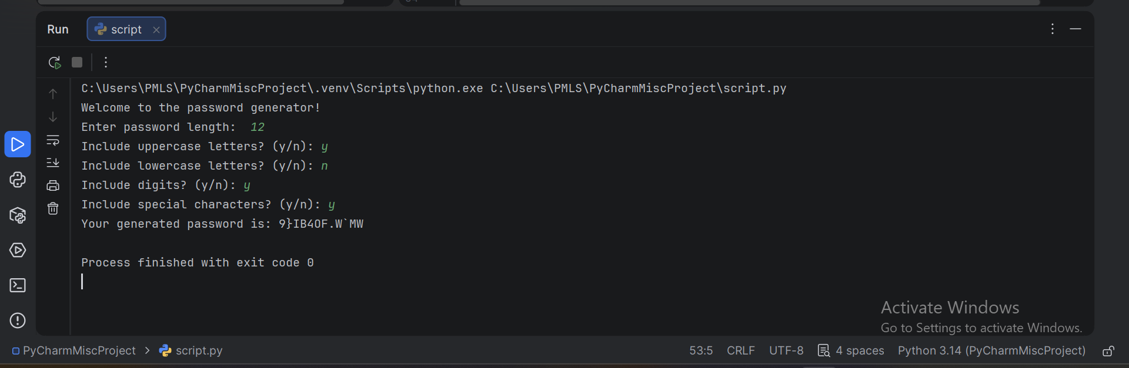
Task 5:
for i in range(1, 6):
if i <= 3:
print('* ' * i)
else:
print('* ' *

Output:
