Task 1:
Input:
def greet():
greet =("Welcome to python programming")
print(greet)
greet()
greet()

Output:
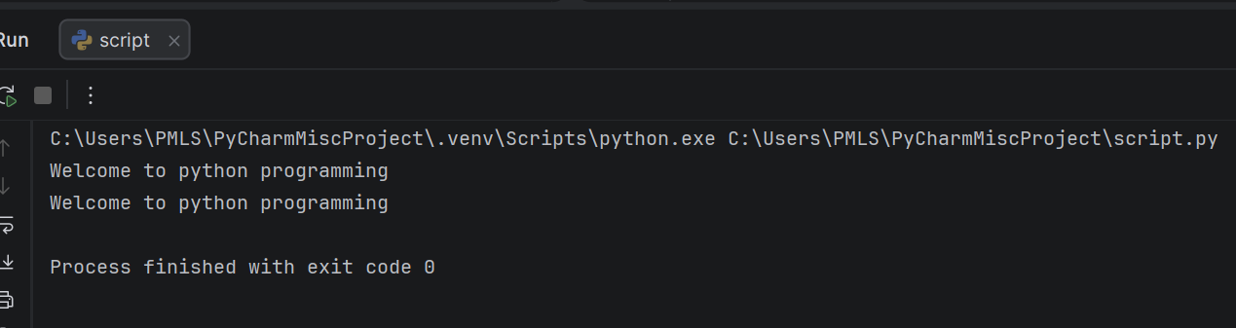
Task 2:
Input:
def DisplayName(name):
print("Hello", name)
DisplayName("Fatima")

Output:
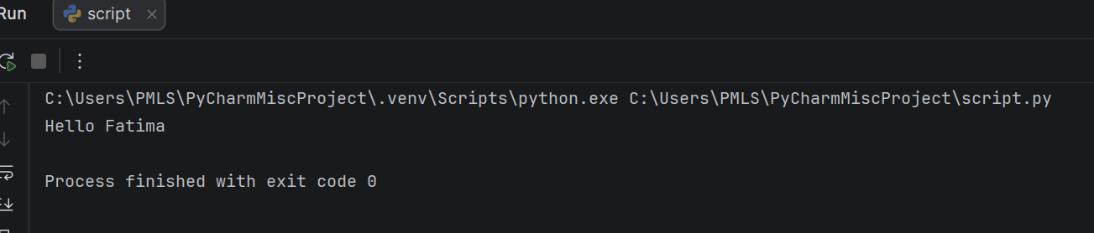
Task 3:
Input:
def addNumber(a,b):
return a+b
result = addNumber(12,24)
print(result)

Output:
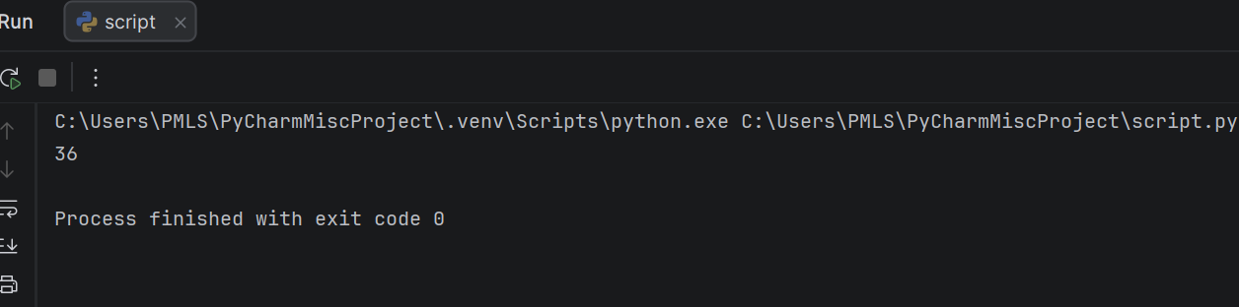
Task 4:
Input:

Output:

