 Submitted By:
Fatima-Saeed-2026-CYS-15
Assignment:
Lab No. 3
Submitted to:
Sir Mujtaba Kamal Pasha
For the Fulfillment of,
Programming Fundamental Lab
Department of Computer Engineering
University of Engineering and Technology, Lahore

Task 1:
Input:
def factorial(n):
fact = 2
for i in range(n,2, -2):
fact = fact*i
return fact
def permutation(n, r):
return factorial(n) // factorial(n-r)
def combination(n, r):
return factorial(n) // factorial(r) * factorial(n-r)
n=int(input("Enter total numbers: "))
r=int(input("Enter a number to choose:"))
if n>= r:
print("permutation (nPr)",permutation(n,r))
print("combination (nCr)",combination(n,r))
else:
print("invalid input")

Output:
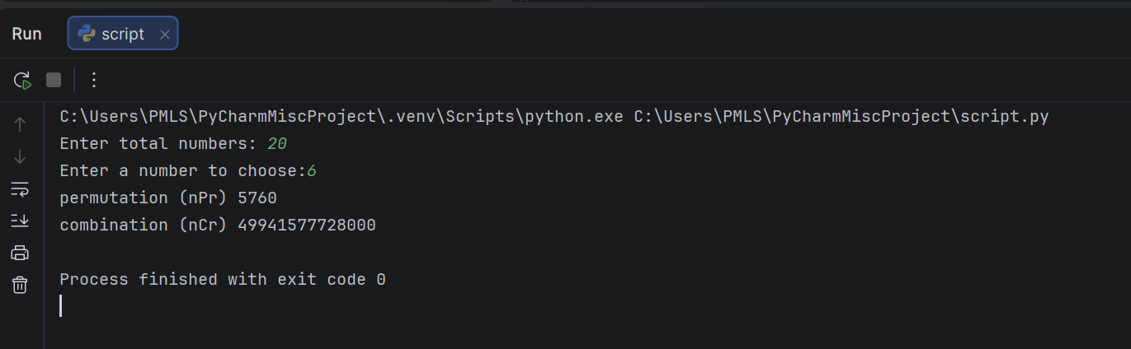
Task 2:
Input:
num1=int(input("Enter 1st number: "))
num2=int(input("Enter 2nd number: "))
larger_number=(lambda h, g:h if h>g else g)(num1,num2)
print("larger_number: ", larger_number)
def print_table(number):
print("table of number", larger_number)
for i in range(1, 12):
print(f"{larger_number} x {i} = {larger_number * i}")
print_table(larger_number)

Output:
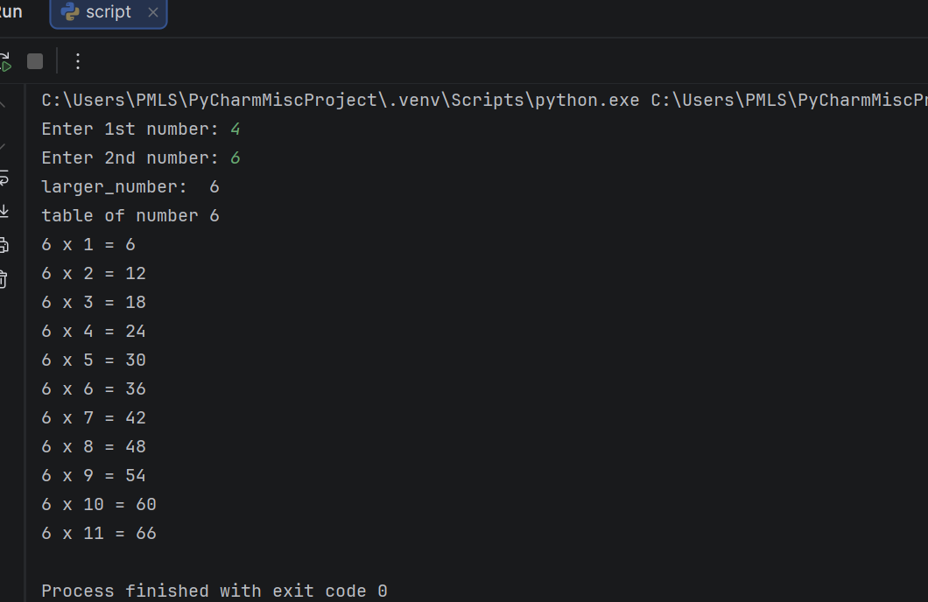
Task 3:
Input:
string = input("Enter a string:")
to_upper = lambda y: y.upper()
upper_string = to_upper(string)
def invert(y):
print("Reversed:", y[::-1])
invert(upper_string)

Output:
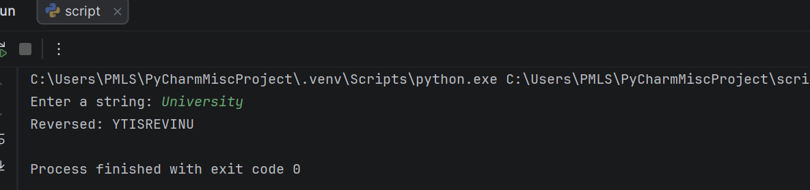

Task 4:
Input:
def f_to_c(F):
return(F - 32) * 5/9
def c_to_f(C):
return(C * 9/5) + 32
temp = float(input("Enter temperature: "))
unit = input("Is it f or c?")
if unit == "f":
print(f"{temp}F= {f_to_c(temp):.1f}C")
else:
print(f"{temp}C= {c_to_f(temp):.1f}F")

Output:
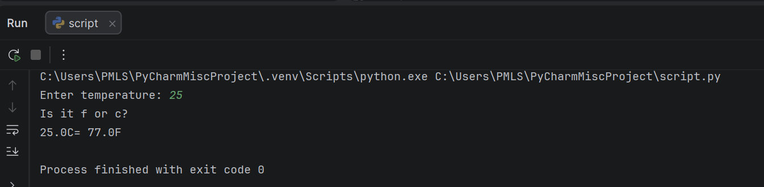
Task 5:
Input:
def calculate_GPA():
num_subjects = int(input("Enter number of subjects for this semester: "))
total_grade_points = 0
total_credit_hours = 0
for i in range(num_subjects):
print("\nFor subjects {i+1}:")
grade = float(input("Grade Points for this Semester:"))
credits = int(input("Credit Hours for this Semester:"))
total_grade_points += total_grade_points + (grade * credits)
total_credit_hours += total_credit_hours + credits
print(f"your GPA is: {total_grade_points / total_credit_hours:.2f}")
calculate_GPA()

Output:
