THESIS FIGURES — COMPLETE COLLECTION WITH DESCRIPTIONS
Task-Oriented DeepJSCC for UAV Navigation
Final Year Project — Figure Companion
Name | Roll Number
Areesha Sohail | 1005
Amna Shahid | 1004
Hafiza Laiba Faisal | 1015

Supervisor: Ismat Hira
Date: October 2026
Table of Contents
How to Use This Document 4
Figure Index 4
Part 1 — Main Results: M1 and M2 6
Figure 1 — M1 Success Rate vs SNR (k = 1, 2, 3) 7
Figure 2 — M2 Three-Way Comparison on AWGN 8
Figure 3 — M2 Three-Way Comparison on Rayleigh Fading 9
Figure 4 — Bandwidth Crossover at 0 and 20 dB 10
Figure 5 — Full Bandwidth Axis at 0 dB 11
Part 2 — Supporting Metrics 12
Figure 6 — Final Distance to Goal 13
Figure 7 — Control Effort 14
Figure 8 — Time-to-Goal 15
Figure 9 — Success-Rate Heatmaps 16
Figure 10 — Frozen-Protocol Training Curves 17
Figure 11 — CDF of Final Distance 18
Figure 12 — Sample Closed-Loop Trajectories 19
Figure 13 — Trajectory MSE vs SNR 21
Figure 14 — Rate-Distortion View 22
Figure 15 — Learned Encoder Constellations 23
Part 3 — Statistical Validation 24
Figure 16 — Per-Seed Agreement 25
Figure 17 — McNemar Significance Heatmap 26
Figure 18 — Seed Spread Bars 27
Figure 19 — Full M1 Success-Rate Table 28
Part 4 — Wave-A and the Mechanism 29
Figure 20 — Wave-A Arm Comparison 30
Figure 21 — Gradient-Conditioning Mechanism 31
Part 5 — Wave-B: CSI Robustness 32
Figure 22 — Wave-B Success Rate vs Bandwidth with CSI Bands 33
Figure 23 — Wave-B Reconstruction MSE vs CSI Sigma 34
Figure 24 — Wave-B Success Rate vs SNR at k = 12 35
Figure 25 — Wave-B CSI Sweep Summary 36
Figure 26 — Wave-B Success Rate vs Bandwidth Bars 37
Figure 27 — Wave-B Success Rate vs SNR at the Extremes 38
Part 6 — Wave-C: Lambda-Shaping Generalisation 39
Figure 28 — Wave-C Success Rate vs SNR 40
Figure 29 — Wave-C Combined k Axis 41
Figure 30 — Wave-C Comparison Table 42
Figure 31 — Wave-C Success vs Bandwidth 43
Part 7 — Extensions A-10, A-11, A-12/A-13 44
Figure 32 — A-10 Required Transmit SNR on the Aerial Link 45
Figure 33 — A-12 vs A-13 Training under 3GPP Dispersion 46
Figure 34 — A-11 Polar vs Convolutional Baseline 47
Part 8 — M3, M4, the 3GPP Model, and the Experiment Matrix 48
Figure 35 — M3 Digital Infeasibility Boundary 49
Figure 36 — M4 B = 8 Bandwidth Reference 50
Figure 37 — 3GPP UMa-Aerial Channel Model 51
Figure 38 — Experiment Matrix Actually Executed 52
Figure-to-Chapter Map 53

How to Use This Document
This companion contains all 38 figures generated for the project. Each figure gets its own page: the image, a short description of what it shows, the points to notice, and the best place to use it in the thesis.
- All images are 200 DPI and are embedded at 5.9 inches wide.
- The figure numbers in this document are sequential and are for this companion only. The Best placement line maps each figure to the thesis chapter or section.
- Where two figures show the same result in different ways, the entry is marked alternate view.
- Figures 35–38 (M3, M4, the 3GPP model, and the experiment matrix) are generated from the stored JSON artifacts by tools/make_figures_m3_m4.py; the older figures are generated by the scripts in tools/.
- The Markdown source is fyp_md_files/FIGURES_DOCUMENT.md. Regenerate the Word file with:
python tools/build_thesis_docx.py --md fyp_md_files/FIGURES_DOCUMENT.md --out FIGURES_DOCUMENT.docx --header "Thesis Figures"

Figure Index
# | Figure | File | Best placement
1 | M1 success rate vs SNR (k = 1, 2, 3) | fig1_m1_sr_vs_snr.png | Ch 5.1
2 | M2 three-way comparison, AWGN | fig2_m2_awgn.png | Ch 5.2
3 | M2 three-way comparison, Rayleigh | fig3_m2_rayleigh.png | Ch 5.2
4 | Bandwidth crossover at 0 and 20 dB | fig4_bandwidth_crossover.png | Ch 5.2
5 | Full bandwidth axis, 0 dB | fig5_full_bandwidth_axis.png | Ch 5.2
6 | Final distance to goal | fig6_final_distance.png | Ch 5 / Appendix
7 | Control effort | fig7_control_effort.png | Ch 5 / Appendix
8 | Time-to-goal | fig8_time_to_goal.png | Ch 5 / Appendix
9 | Success-rate heatmaps | fig9_sr_heatmaps.png | Ch 5 / Appendix
10 | Frozen-protocol training curves | fig10_training_curves.png | Ch 5.4 / Appendix
11 | CDF of final distance | fig11_cdf_final_dist.png | Ch 5 / Appendix
12 | Sample closed-loop trajectories | fig12_trajectories.png | Ch 3 / Ch 5
13 | Trajectory MSE vs SNR | fig13_mse_vs_snr.png | Appendix (caveat)
14 | Rate-distortion view | fig14_rate_distortion.png | Ch 5 / Appendix
15 | Learned encoder constellations | fig15_constellation.png | Ch 3 / Appendix
16 | Per-seed agreement | fig_new1_per_seed_agreement.png | Ch 4 / Ch 5
17 | McNemar significance heatmap | fig_new2_mcnemar_heatmap.png | Ch 4 / Appendix
18 | Seed spread bars | fig_new3_seed_spread_bars.png | Ch 4 / Ch 5
19 | Full M1 success-rate table | fig_new4_sr_table.png | Appendix
20 | Wave-A arm comparison | fig_wave_a_arms.png | Ch 5.3
21 | Gradient-conditioning mechanism | fig_training_stability.png | Ch 5.4
22 | Wave-B SR vs k with CSI bands | fig_waveb1_sr_vs_k_csi_bands.png | Ch 5.5
23 | Wave-B MSE vs CSI sigma | fig_waveb2_mse_vs_csi_sigma.png | Ch 5.5
24 | Wave-B SR vs SNR at k = 12 | fig_waveb3_sr_vs_snr_csi.png | Ch 5.5
25 | Wave-B CSI sweep summary | fig_wave_b_csi_sweep.png | Ch 5.5 (alternate)
26 | Wave-B SR vs bandwidth bars | fig_wave_b_sr_vs_k.png | Ch 5.2/5.5 (alternate)
27 | Wave-B SR vs SNR extremes | fig_wave_b_sr_vs_snr.png | Ch 5.2/5.5 (alternate)
28 | Wave-C SR vs SNR | fig_wavec1_sr_vs_snr.png | Ch 5.6
29 | Wave-C combined k axis | fig_wavec2_sr_vs_k.png | Ch 5.6
30 | Wave-C comparison table | fig_wavec3_comparison_table.png | Ch 5.6 / Appendix
31 | Wave-C success vs bandwidth | fig_wave_c_success.png | Ch 5.6
32 | A-10 required transmit SNR | fig_aerial_required_snr.png | Ch 5.8
33 | A-12 vs A-13 training | fig_aerial_training.png | Ch 5.10
34 | A-11 polar vs convolutional | fig_polar_vs_conv.png | Ch 5.9
35 | M3 digital infeasibility boundary | fig_m3_infeasibility.png | Ch 5.2.1
36 | M4 B = 8 bandwidth reference | fig_m4_bandwidth_reference.png | Ch 5.2.2
37 | 3GPP UMa-aerial channel model | fig_3gpp_channel_model.png | Ch 3.8
38 | Experiment matrix actually executed | fig_experiment_matrix.png | Ch 4.3

Part 1 — Main Results: M1 and M2

Figure 1 — M1 Success Rate vs SNR (k = 1, 2, 3)
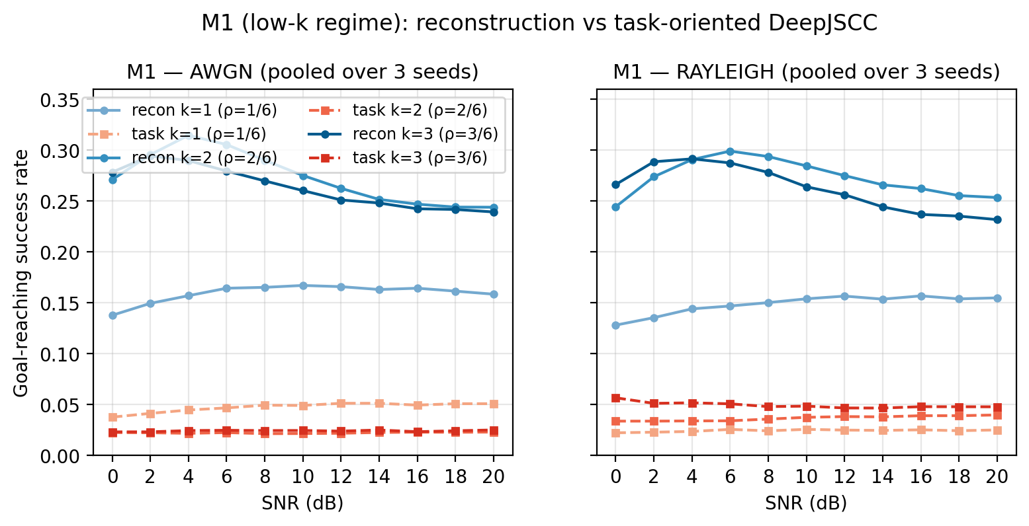
Figure 1 — M1 success rate vs SNR for k = 1, 2, 3.
What it shows. M1 evaluates the severe-bandwidth regime at k = 1, 2, and 3. The panel plots goal-reaching success rate against SNR for the reconstruction-oriented and task-oriented DeepJSCC arms, on both AWGN and Rayleigh fading. The reconstruction arm learns a usable representation and reaches roughly 24–31% success; the frozen task arm stays at 2–5% and is almost flat across SNR.
What to notice.
- The task arm is not merely worse than reconstruction; it is almost unresponsive to SNR. That points to an optimisation/objective failure rather than a channel limitation.
- Reconstruction is the stronger neural baseline in this regime.
- This is the observation that motivated the Wave-A diagnosis in Chapter 5.3.
Best placement. Chapter 5.1 (M1 results); optionally Chapter 4 as the first baseline.
File. fig1_m1_sr_vs_snr.png

Figure 2 — M2 Three-Way Comparison on AWGN
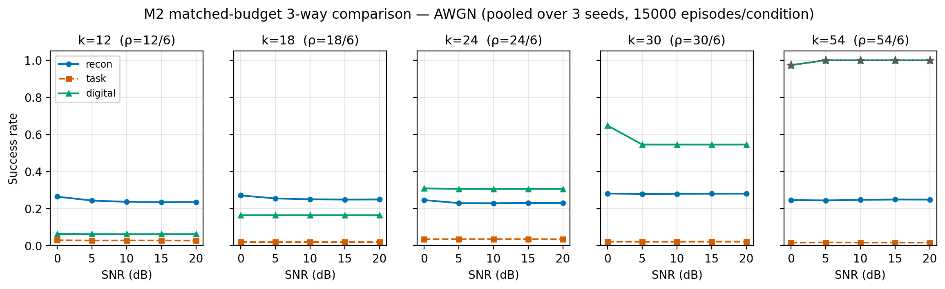
Figure 2 — M2 three-way comparison on AWGN, k = 12 to 54.
What it shows. M2 is the main matched-budget comparison at k = 12, 18, 24, 30, and 54 on AWGN. Each panel shows success rate versus SNR for the reconstruction, task, and digital methods. The digital budget is matched exactly through the frozen (k, B) pairs, which satisfy 6B + 6 = k.
What to notice.
- At k = 12 and 18, reconstruction is the best method; the digital link is payload-limited.
- At k = 24 the digital link overtakes; at k = 30 and 54 it dominates.
- The frozen task arm remains low at every k, so the crossover is between reconstruction and digital, not the task arm.
- This is the strongest single figure for the thesis; use it first when presenting the main result.
Best placement. Chapter 5.2 (M2 main result).
File. fig2_m2_awgn.png

Figure 3 — M2 Three-Way Comparison on Rayleigh Fading
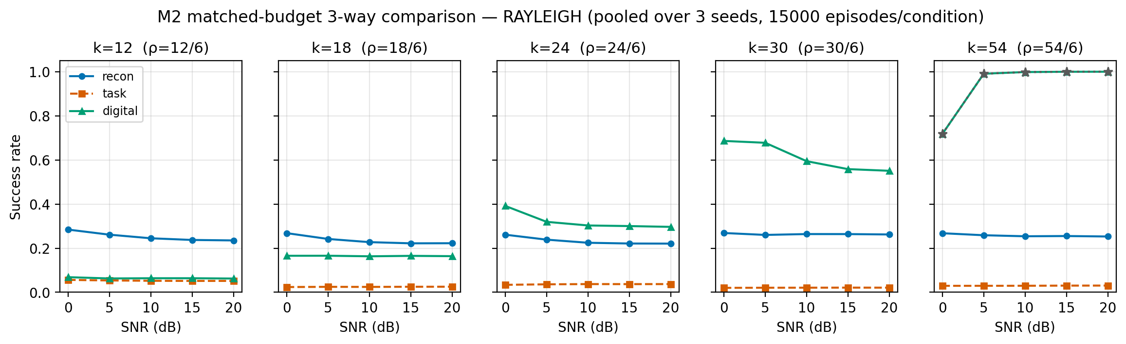
Figure 3 — M2 three-way comparison on Rayleigh fading.
What it shows. The same comparison as Figure 2, but on slow Rayleigh fading. The qualitative ordering is preserved: reconstruction wins at low k, digital wins at high k, and the digital link loses more at low SNR because of fading.
What to notice.
- The crossover survives fading.
- Digital at k = 54 still reaches near 1.0 at high SNR; reconstruction stays near 0.25.
- The task arm is again flat and low.
- Use this next to Figure 2 to show that the result is not an AWGN-only artefact.
Best placement. Chapter 5.2 (channel robustness).
File. fig3_m2_rayleigh.png

Figure 4 — Bandwidth Crossover at 0 and 20 dB
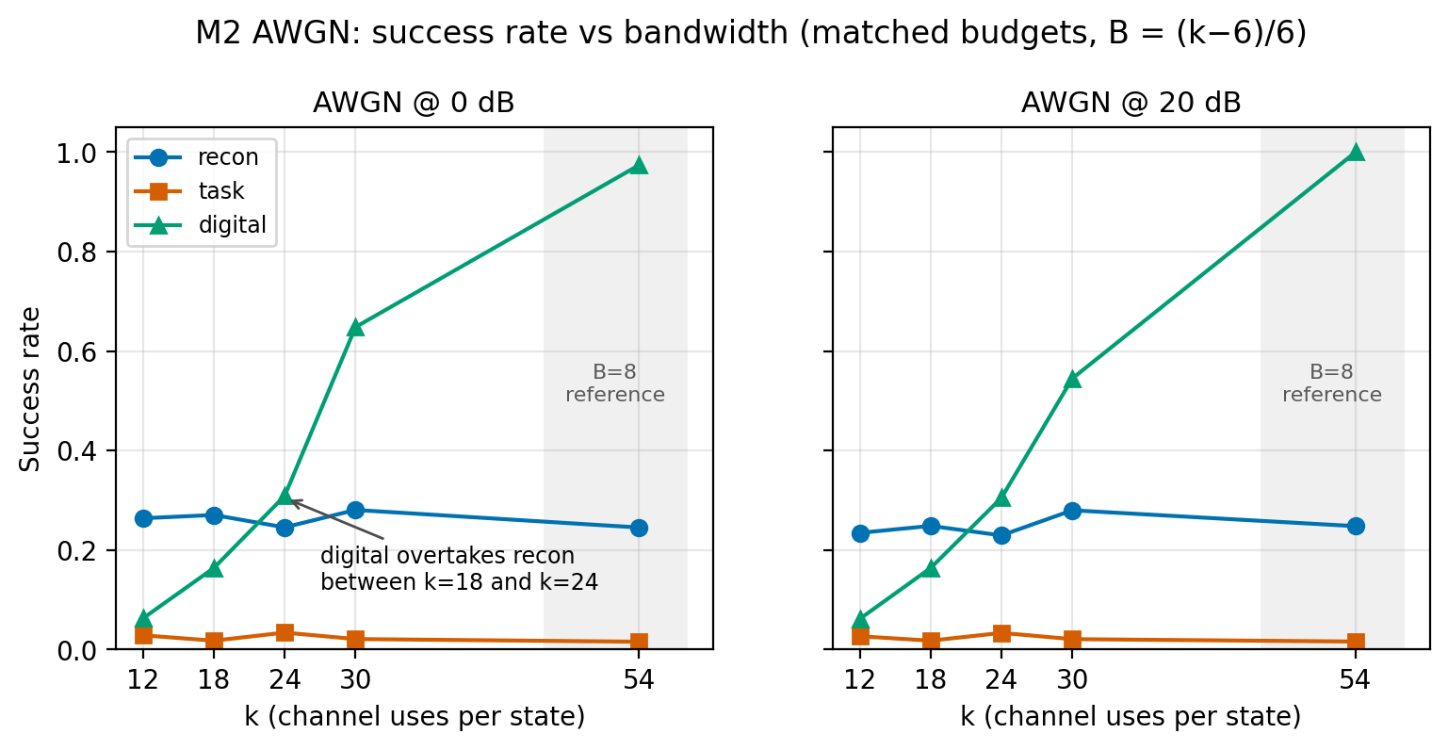
Figure 4 — Success rate vs bandwidth with the crossover annotated.
What it shows. Success rate versus bandwidth k at 0 dB and 20 dB on AWGN, with the crossover annotated. This is the cleanest visual statement of the main result.
What to notice.
- The crossover sits between k = 18 and k = 24.
- At 0 dB the neural link is far ahead at low k; at 20 dB the digital link catches up earlier.
- Use this figure when the supervisor asks “where exactly does the crossover happen?”
Best placement. Chapter 5.2 (primary crossover figure).
File. fig4_bandwidth_crossover.png

Figure 5 — Full Bandwidth Axis at 0 dB
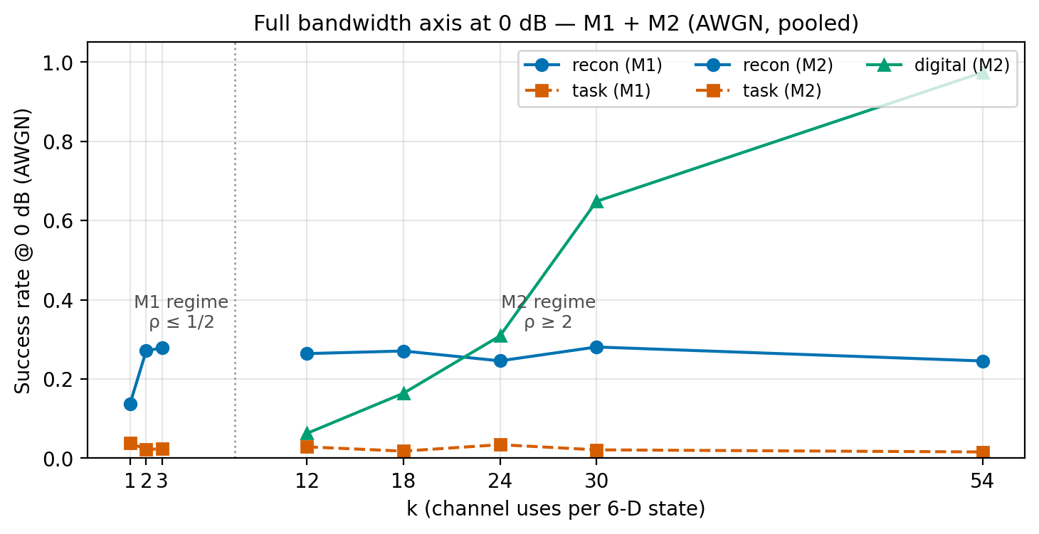
Figure 5 — M1 and M2 combined on a single bandwidth axis.
What it shows. Combines M1 (k = 1, 2, 3) and M2 (k = 12–54) at 0 dB on a single bandwidth axis. It tells the whole story in one figure.
What to notice.
- Neural JSCC wins at the low-k end; digital wins at the high-k end.
- The gap is largest at k = 12–18.
- The task arm is low across the whole axis because the frozen loss does not learn the task.
Best placement. Chapter 5.2 (overview) or the results introduction.
File. fig5_full_bandwidth_axis.png

Part 2 — Supporting Metrics

Figure 6 — Final Distance to Goal
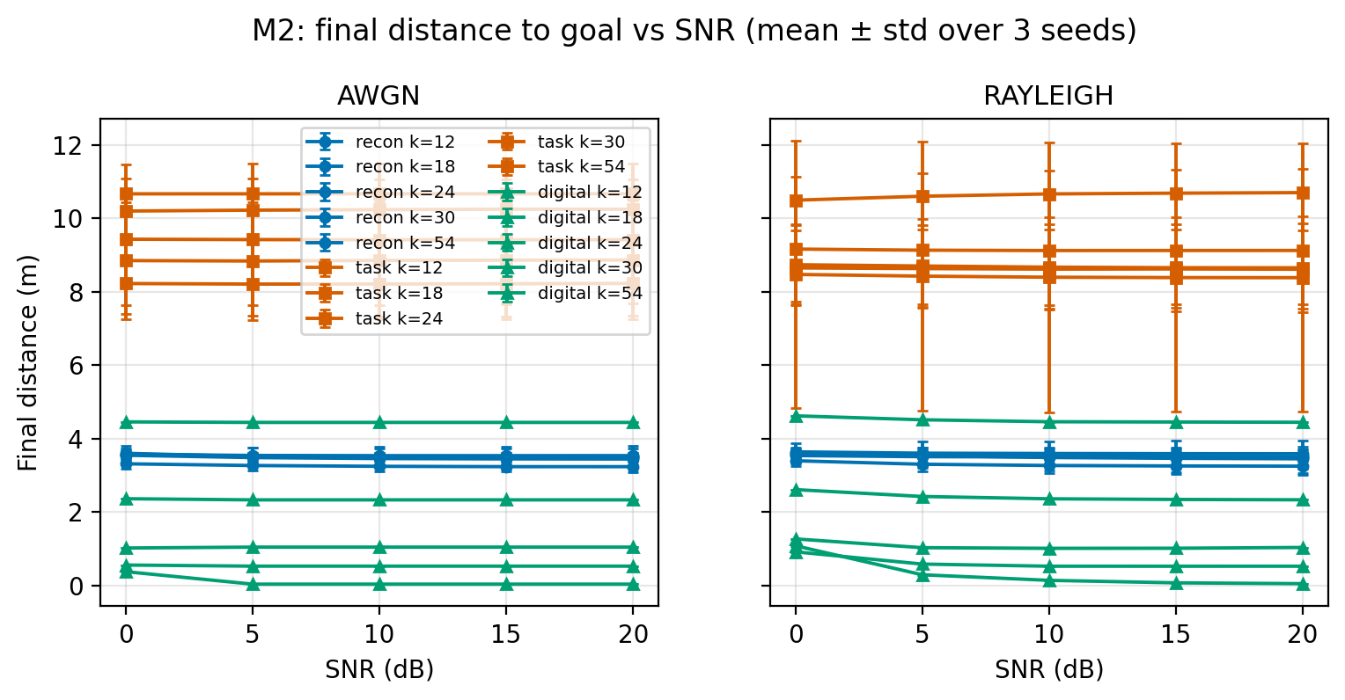
Figure 6 — Mean final distance to goal vs SNR.
What it shows. Mean final distance to goal versus SNR for all methods and k, on AWGN and Rayleigh. Lower is better. The task arm sits around 8–11 m, reconstruction around 3.4 m, and digital improves as k and SNR increase.
What to notice.
- Final distance separates the methods even when success rate is coarse.
- The task arm's failure is visible as a large final distance.
- Digital at k = 54 is the closest to the goal.
- Use with Figure 7 to show that the task arm is not succeeding by idling.
Best placement. Chapter 5 supporting metrics, or the appendix.
File. fig6_final_distance.png

Figure 7 — Control Effort
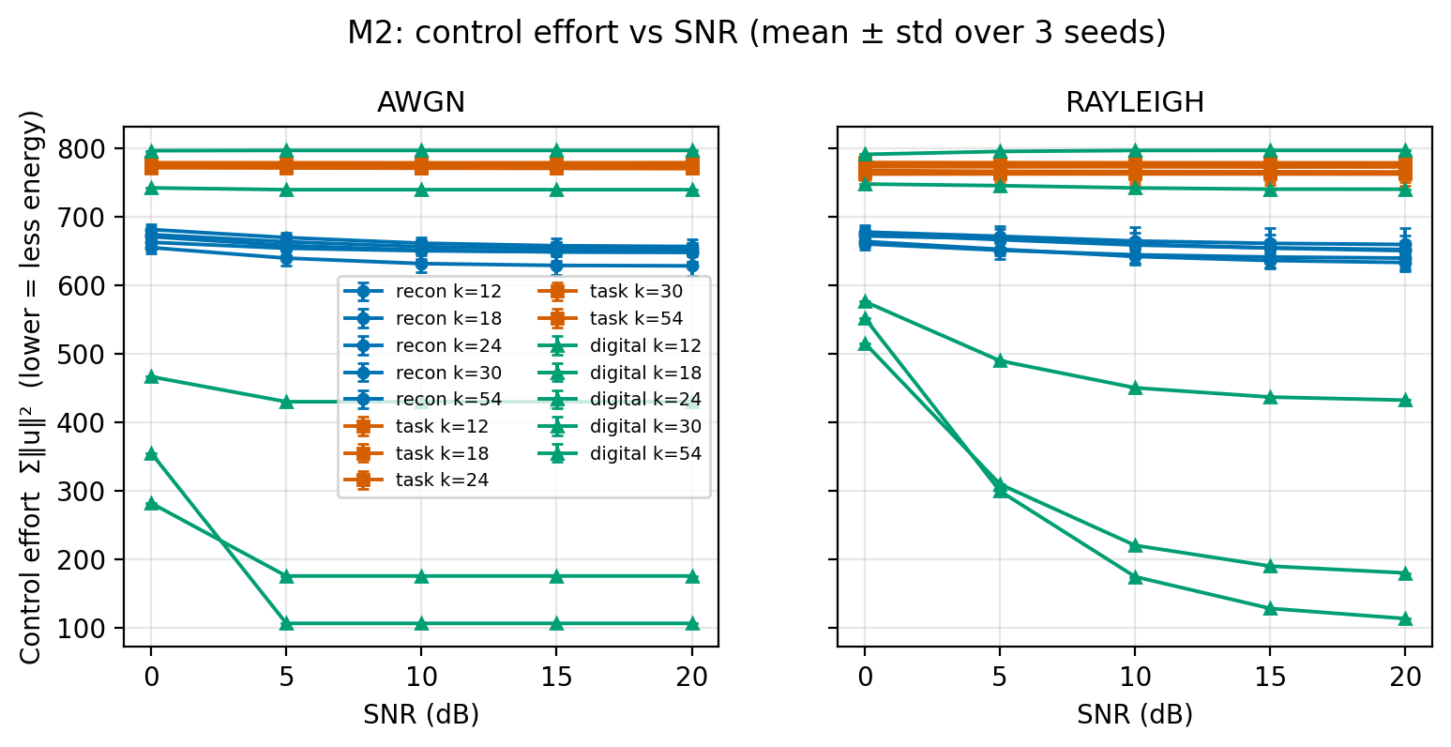
Figure 7 — Control effort vs SNR.
What it shows. Control effort, measured as the sum of squared control inputs, versus SNR. Lower is less energy. Reconstruction is around 620–680, the frozen task arm around 740–800, and digital decreases with SNR and k.
What to notice.
- The task arm spends high effort because it fails to reach the goal.
- Digital at high k is the most energy-efficient.
- Use with Figure 6 to show that success is not bought by doing nothing.
Best placement. Chapter 5 supporting metrics, or the appendix.
File. fig7_control_effort.png

Figure 8 — Time-to-Goal
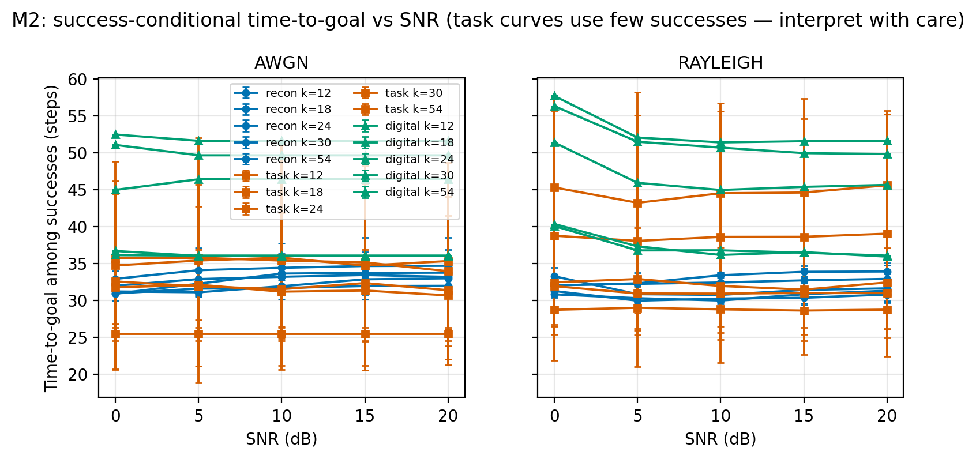
Figure 8 — Success-conditional time-to-goal vs SNR.
What it shows. Success-conditional time-to-goal versus SNR. Only successful episodes are included, so the task curves rest on very few successes and must be interpreted with care.
What to notice.
- Reconstruction reaches the goal in roughly 30–34 steps; digital takes 45–52 steps when it succeeds.
- The task arm's apparent short time is based on a handful of lucky successes.
- Do not present this figure without the caveat.
Best placement. Chapter 5 supporting metrics, or the appendix (with the caveat in the caption).
File. fig8_time_to_goal.png

Figure 9 — Success-Rate Heatmaps
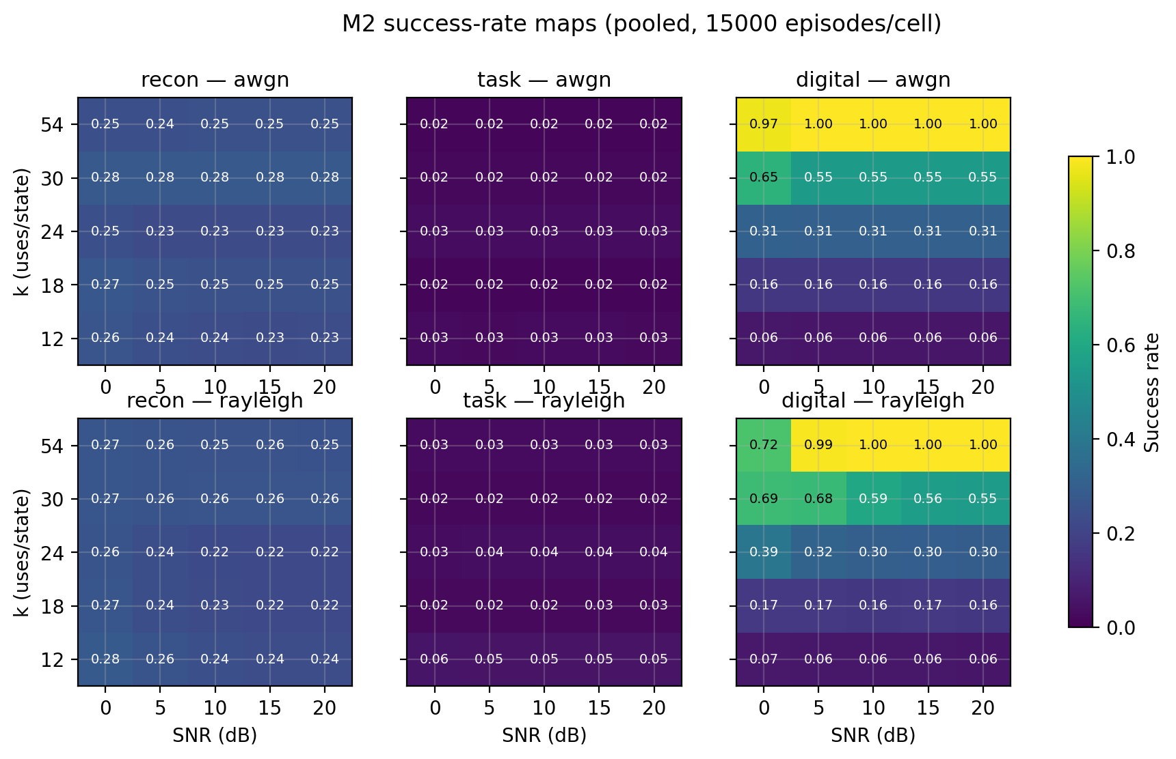
Figure 9 — Success-rate heatmaps across the (k, SNR) grid.
What it shows. Six heatmaps of success rate across the (k, SNR) grid: reconstruction, task, and digital, each on AWGN and Rayleigh. The colour scale runs from 0 to 1.
What to notice.
- Digital is bright at high k and high SNR, dark at low k.
- Reconstruction is a flat mid-blue band; it does not improve with k.
- The task arm is dark everywhere.
- The crossover is visible as the digital row overtaking reconstruction above k = 18.
Best placement. Chapter 5.2 (compact overview), or the appendix.
File. fig9_sr_heatmaps.png

Figure 10 — Frozen-Protocol Training Curves
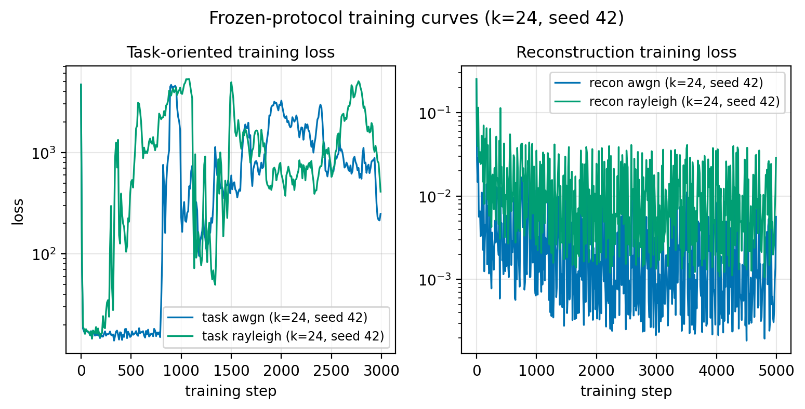
Figure 10 — Frozen-protocol training curves at k = 24, seed 42.
What it shows. Frozen-protocol training curves at k = 24, seed 42. The left panel shows task loss; the right panel shows reconstruction loss. The task loss oscillates over orders of magnitude (roughly 10²–10⁴), while reconstruction loss is stable around 10⁻³–10⁻².
What to notice.
- The task loss does not converge; this is the optimisation pathology behind the frozen task arm.
- Reconstruction training is stable, so the architecture and data are not the problem.
- This is a diagnostic figure, not a performance result.
Best placement. Chapter 5.4 (mechanism/diagnosis), or the appendix.
File. fig10_training_curves.png

Figure 11 — CDF of Final Distance
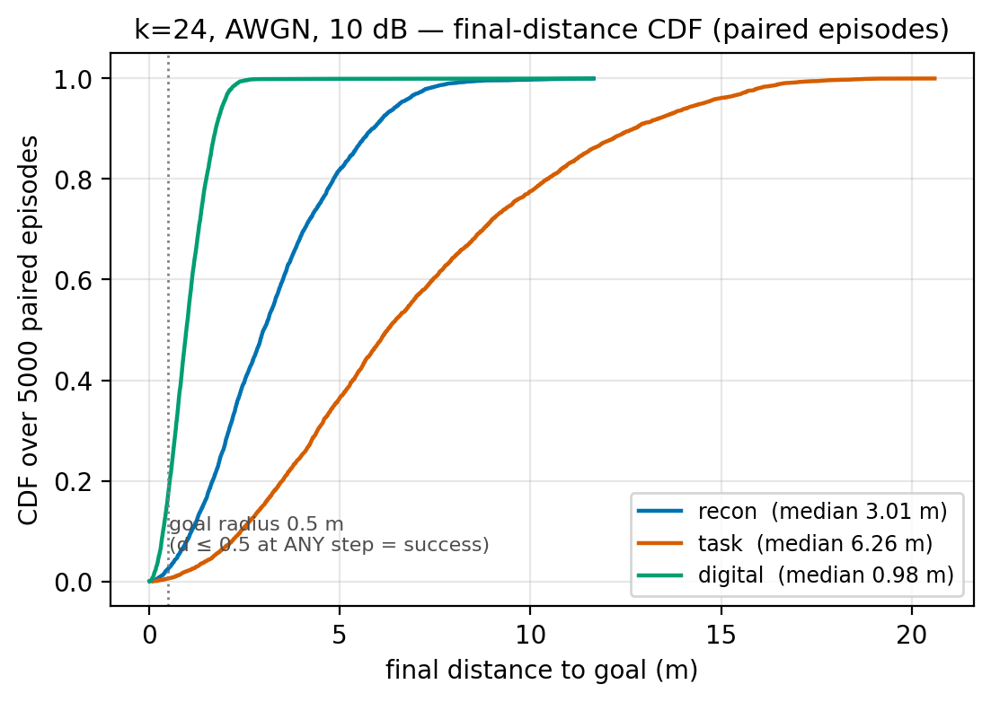
Figure 11 — CDF of final distance at k = 24, AWGN, 10 dB.
What it shows. CDF of final distance at k = 24, AWGN, 10 dB, over 5,000 paired episodes. The dotted line marks the 0.5 m goal radius. Digital has median 0.98 m, reconstruction 3.01 m, and task 6.26 m.
What to notice.
- Digital reaches the goal radius for most episodes.
- Reconstruction's distribution is shifted right; task is furthest right.
- A CDF shows the whole distribution, not just the mean.
Best placement. Chapter 5 supporting metrics, or the appendix.
File. fig11_cdf_final_dist.png

Figure 12 — Sample Closed-Loop Trajectories
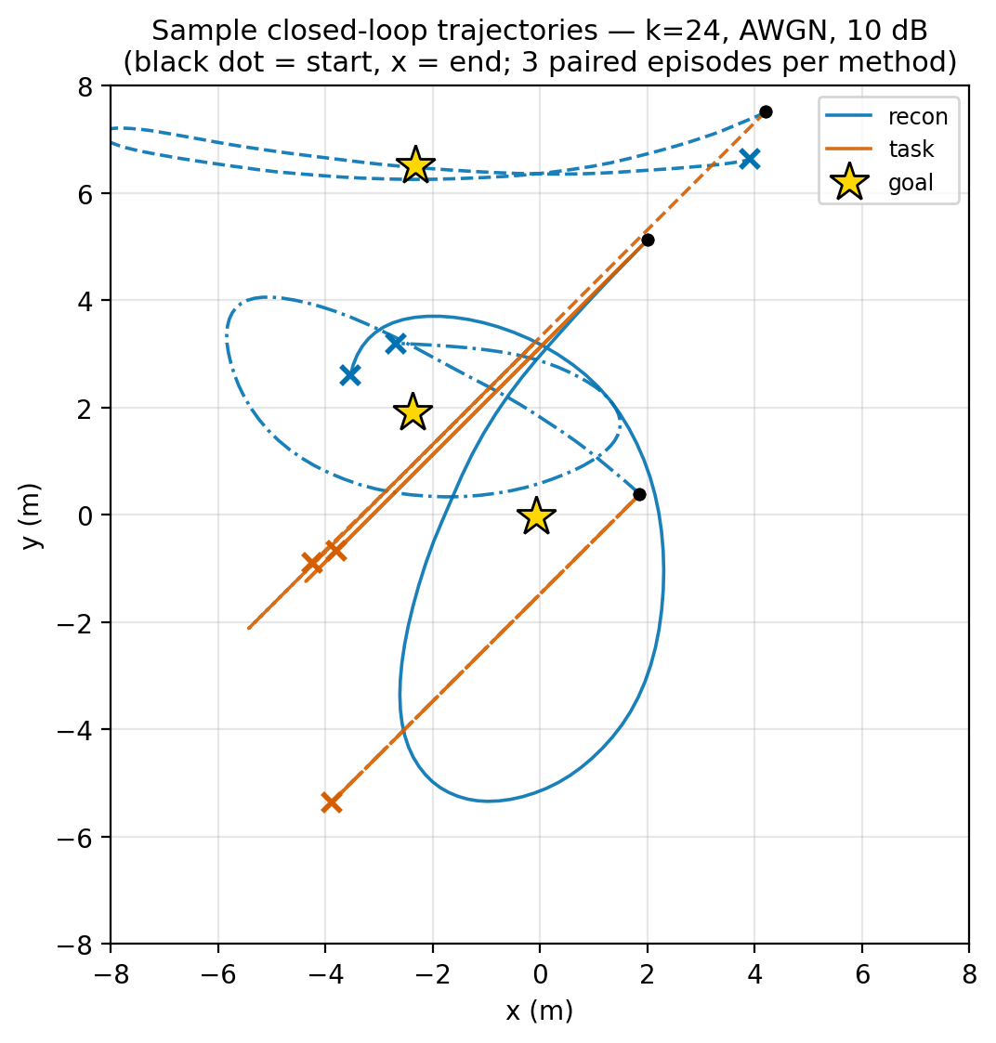
Figure 12 — Sample closed-loop trajectories at k = 24, AWGN, 10 dB.
What it shows. Sample closed-loop trajectories at k = 24, AWGN, 10 dB, with three paired episodes per method. Black dots are starts, crosses are ends, and stars are goals.
What to notice.
- Reconstruction trajectories are smooth but can loop or miss the goal; this is the objective issue.
- Task trajectories often go straight past or stop short.
- Digital trajectories are shorter and more direct.
- Use this figure to explain why a smooth trajectory is not the same as a successful one.
Best placement. Chapter 3 (system model illustration) or Chapter 5 (qualitative behaviour).
File. fig12_trajectories.png

Figure 13 — Trajectory MSE vs SNR
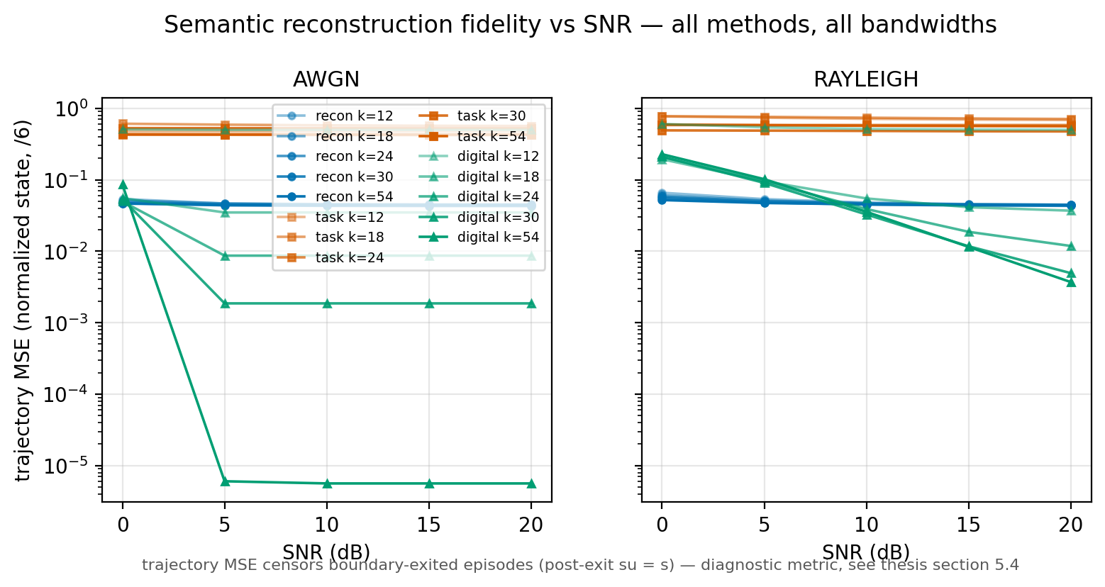
Figure 13 — Trajectory MSE vs SNR, with the post-exit caveat.
What it shows. Trajectory MSE versus SNR for all methods and k, on AWGN and Rayleigh. The metric censors boundary-exited episodes (post-exit su = s), so a low MSE does not necessarily mean successful navigation.
What to notice.
- Digital MSE falls sharply with SNR; reconstruction stays around 0.05; task stays high.
- The post-exit bypass can make MSE look artificially small.
- Use only with the caveat; success rate is the primary metric.
Best placement. Appendix, with the caveat in the caption.
File. fig13_mse_vs_snr.png

Figure 14 — Rate-Distortion View
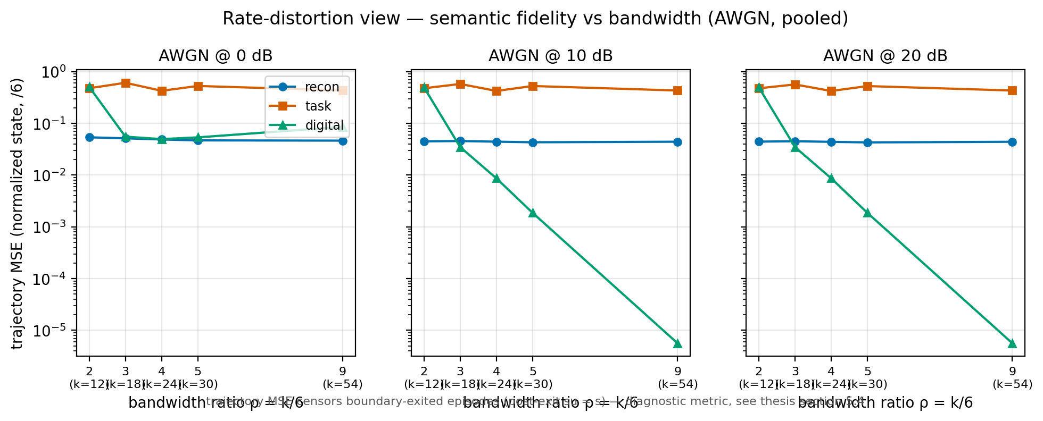
Figure 14 — Trajectory MSE vs bandwidth ratio at 0, 10, and 20 dB.
What it shows. Rate-distortion view: trajectory MSE versus bandwidth ratio ρ = k/6 at 0, 10, and 20 dB on AWGN. Digital improves monotonically with bandwidth; reconstruction is flat; task is high.
What to notice.
- Digital's distortion falls as bandwidth increases, which is the classical rate-distortion behaviour.
- Reconstruction does not exploit extra bandwidth; its MSE is flat.
- Task is high because the frozen objective does not learn the task.
- This figure explains why digital wins at high k.
Best placement. Chapter 5 (interpretation of the crossover), or the appendix.
File. fig14_rate_distortion.png

Figure 15 — Learned Encoder Constellations
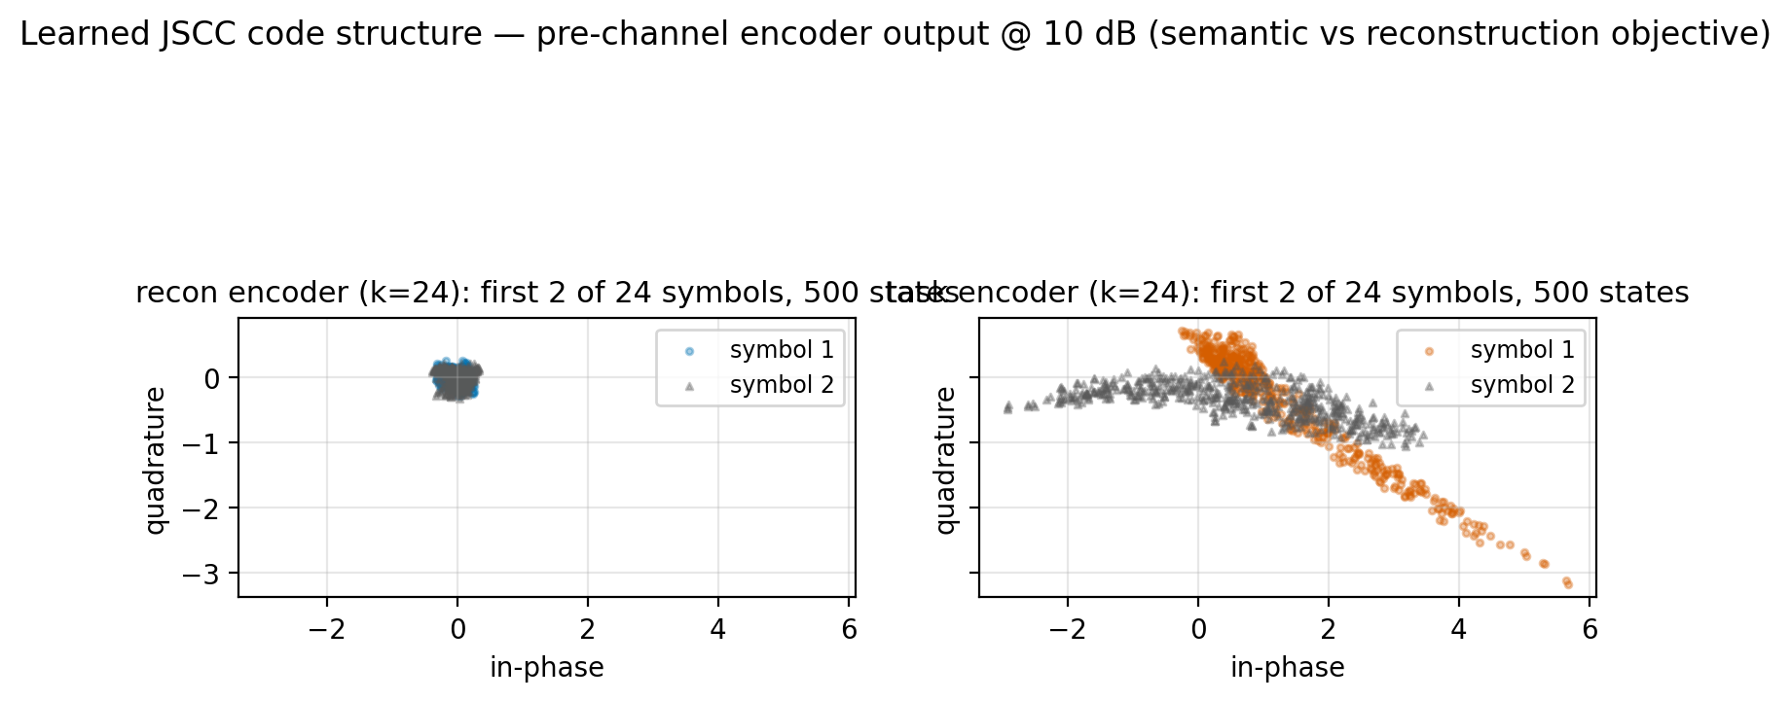
Figure 15 — Learned JSCC code structure at 10 dB.
What it shows. Learned JSCC code structure at 10 dB: the first two of 24 symbols for 500 states, reconstruction versus task encoder. The reconstruction constellation is compact around the origin; the task constellation is spread along a diagonal.
What to notice.
- The two objectives learn visibly different code structures.
- The task encoder uses a wider, correlated constellation; the reconstruction encoder clusters.
- The panel titles overlap in the current layout; fix the spacing before using it in the thesis.
- Use as a qualitative system-model figure, not as a performance claim.
Best placement. Chapter 3 (system model) or the appendix.
File. fig15_constellation.png

Part 3 — Statistical Validation

Figure 16 — Per-Seed Agreement
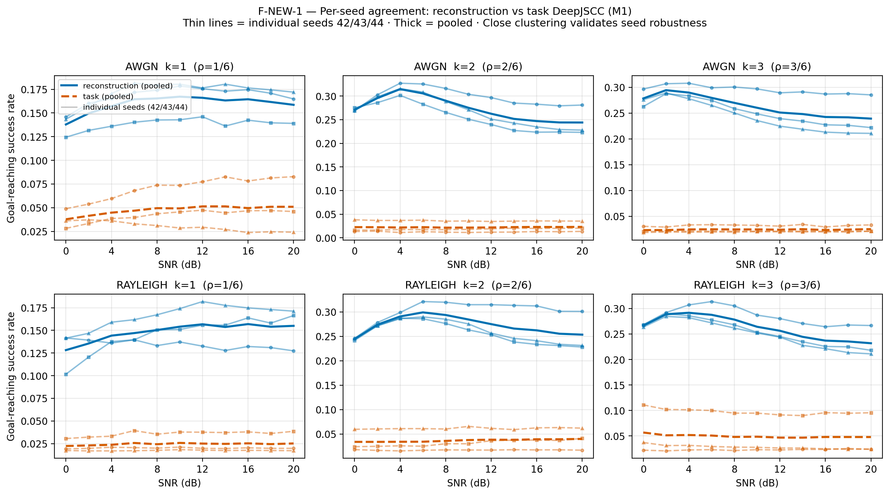
Figure 16 — Per-seed success rate for seeds 42, 43, and 44.
What it shows. Per-seed success rate for seeds 42, 43, and 44, overlaid. It answers the “lucky seed?” objection by showing that the three training replicas agree.
What to notice.
- The curves are close across seeds.
- Seed spread is small relative to the method gaps.
- Use in Chapter 4 to justify the three-seed protocol.
Best placement. Chapter 4 (methodology) or Chapter 5 (reproducibility).
File. fig_new1_per_seed_agreement.png

Figure 17 — McNemar Significance Heatmap
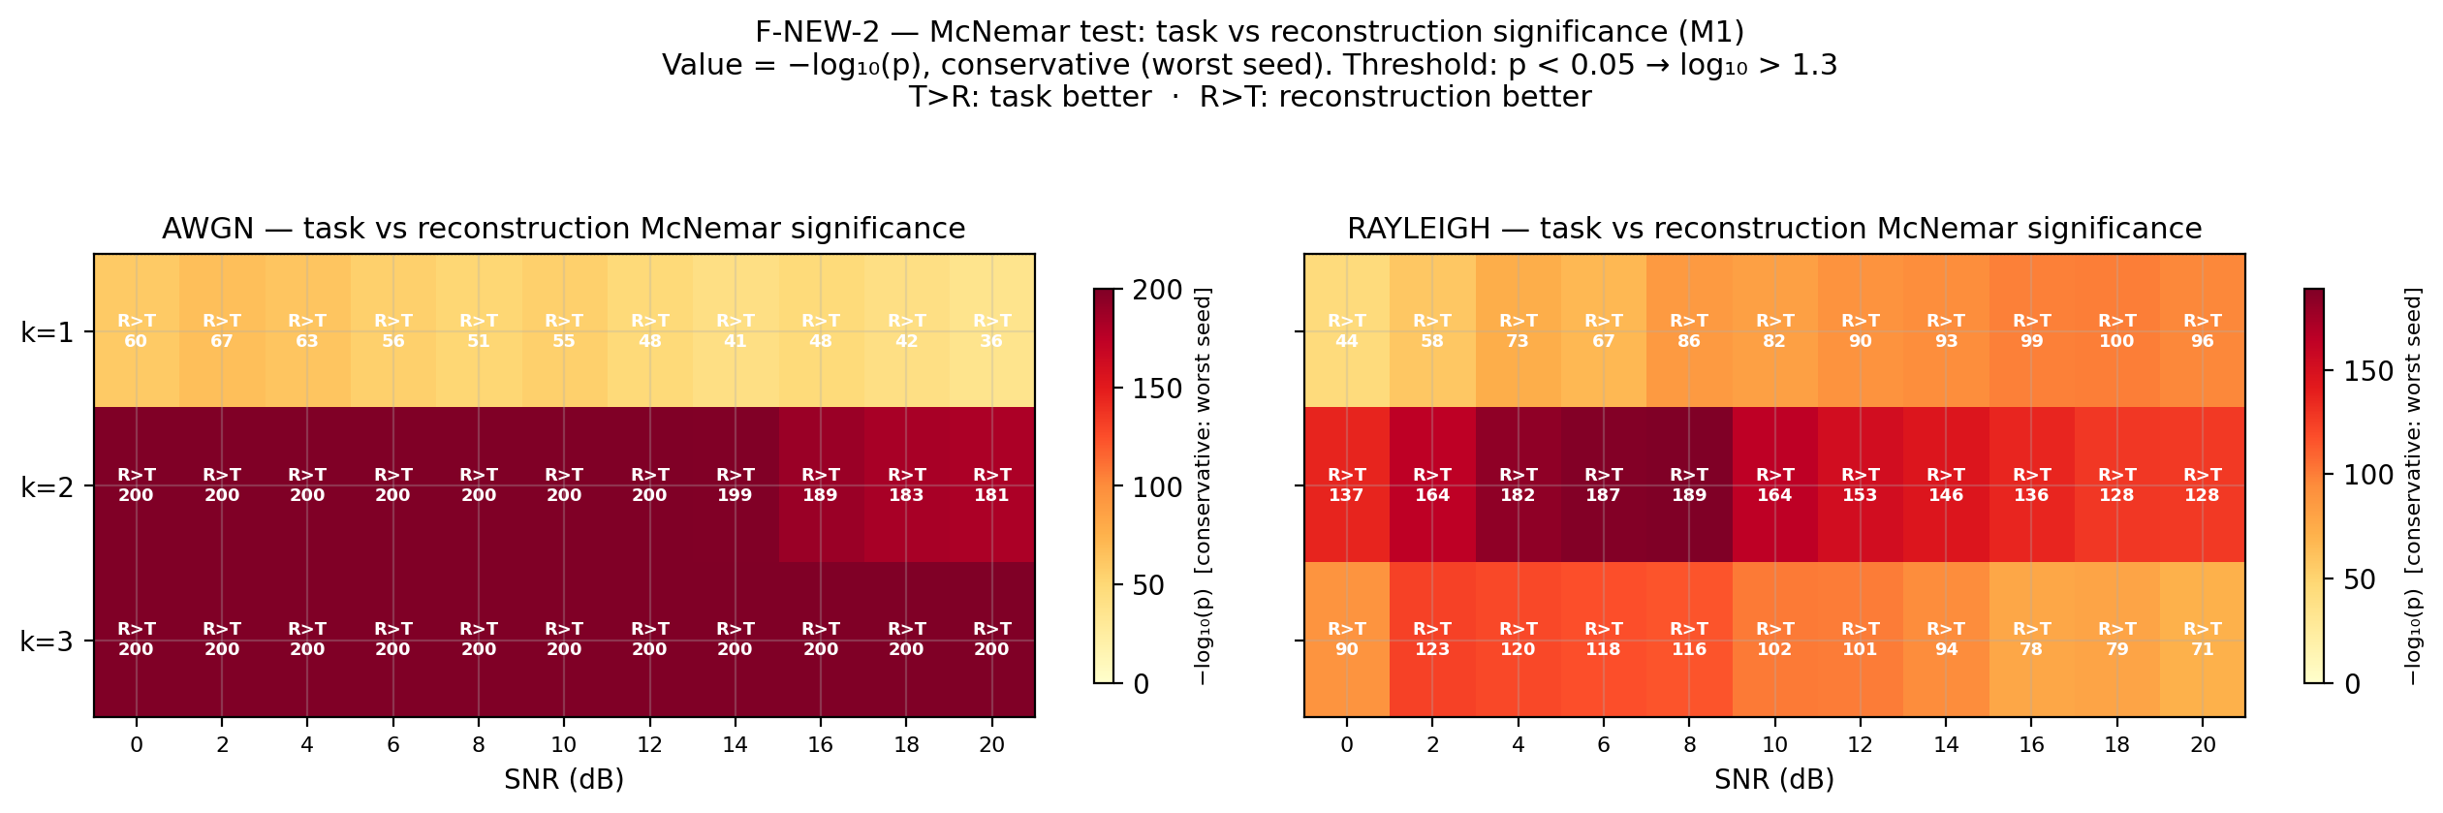
Figure 17 — McNemar −log10(p) heatmap across the M1 matrix.
What it shows. McNemar test heatmap: −log10(p) for every paired cell in the M1 matrix (198 cells). Higher values mean stronger evidence that the two methods differ.
What to notice.
- Most cells show strong evidence of a difference.
- The heatmap is a statistical-significance visual, not an effect-size visual.
- Use in Chapter 4 or the appendix.
Best placement. Chapter 4 (statistics) or the appendix.
File. fig_new2_mcnemar_heatmap.png

Figure 18 — Seed Spread Bars
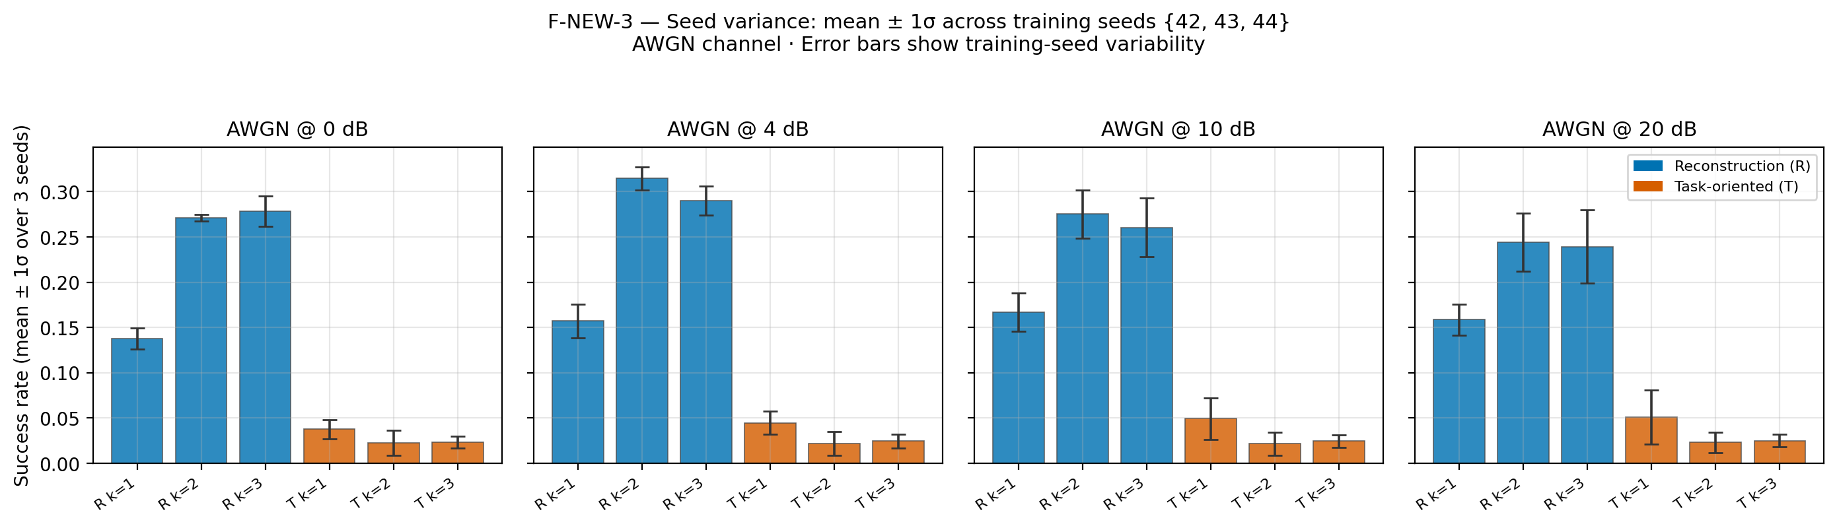
Figure 18 — Mean success rate with ±1 SD bars across seeds.
What it shows. Mean success rate with ±1 SD bars across the three seeds, for each method and condition. It makes seed variance explicit.
What to notice.
- The error bars are small compared with the between-method gaps.
- The task arm is low with small variance; it is consistently failing, not randomly failing.
- Use in Chapter 4/5 to support reproducibility.
Best placement. Chapter 4 (methodology) or Chapter 5 (reproducibility).
File. fig_new3_seed_spread_bars.png

Figure 19 — Full M1 Success-Rate Table
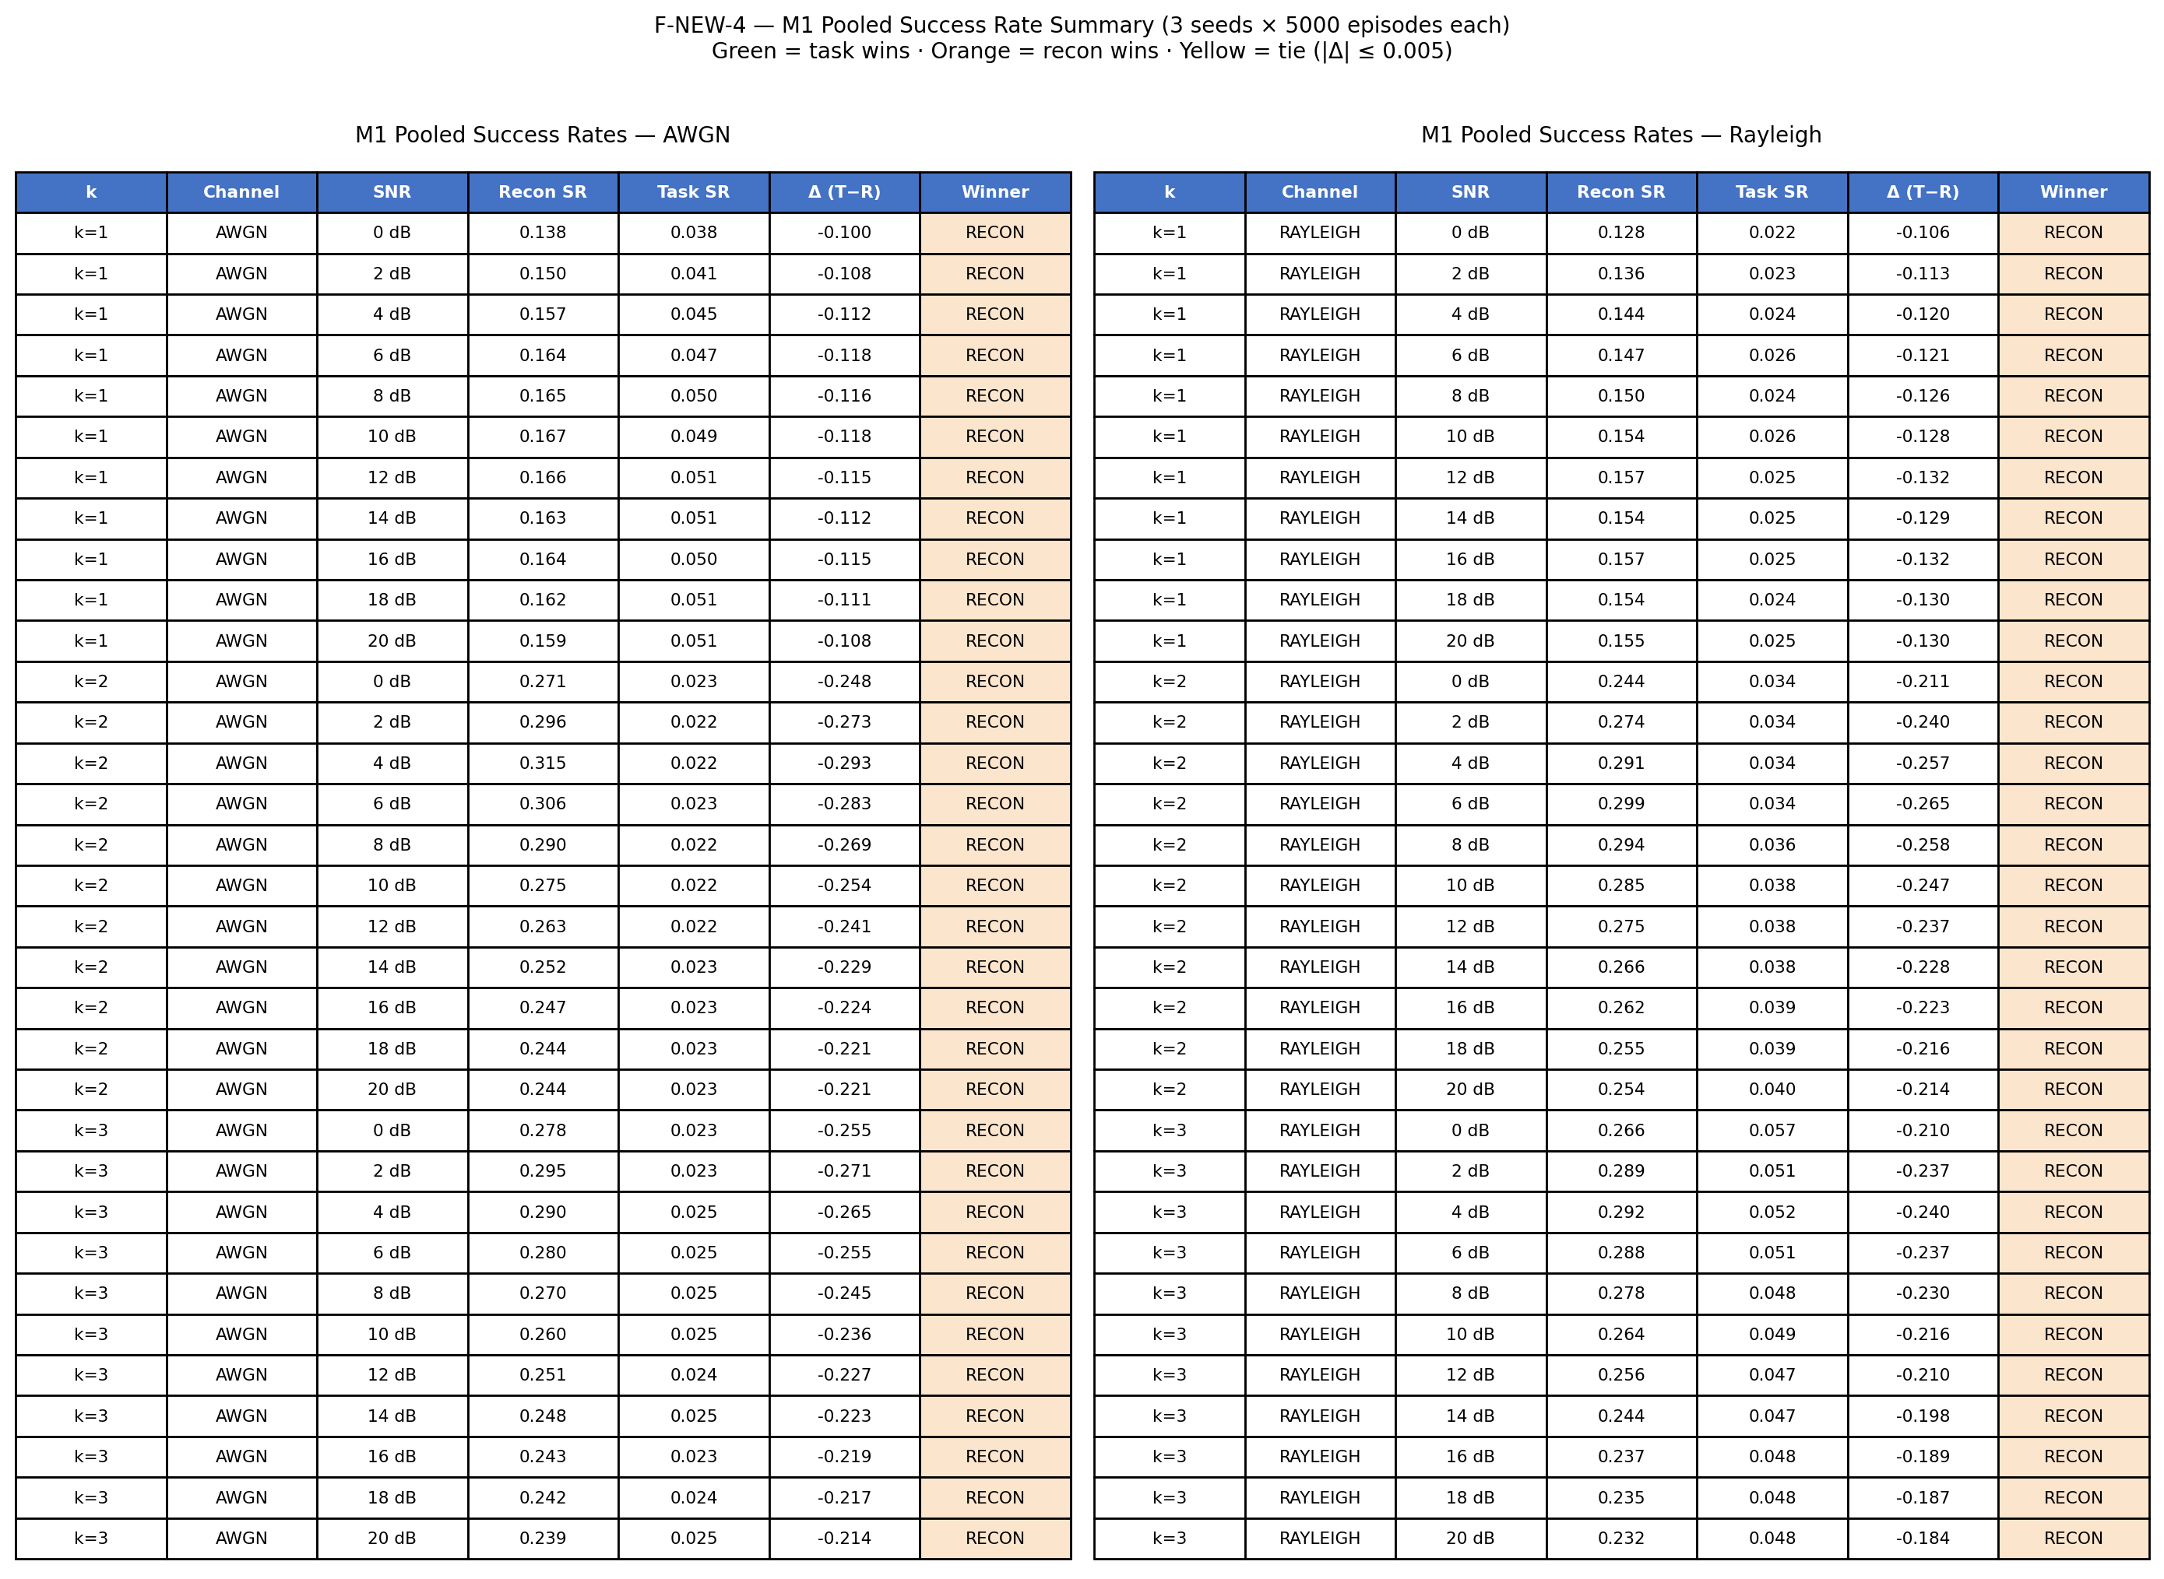
Figure 19 — Full M1 success-rate table as a figure.
What it shows. The full M1 success-rate table rendered as a figure. It is useful as an appendix plate when the exact numbers are needed.
What to notice.
- All 198 cells are visible.
- Use the Markdown/JSON tables for exact values; this figure is for visual reference.
- Appendix placement.
Best placement. Appendix.
File. fig_new4_sr_table.png

Part 4 — Wave-A and the Mechanism

Figure 20 — Wave-A Arm Comparison
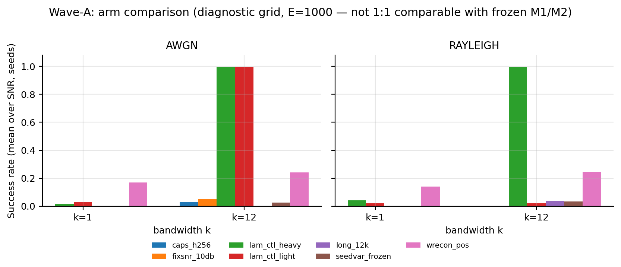
Figure 20 — Wave-A arm comparison at k = 1 and k = 12.
What it shows. Wave-A arm comparison at k = 1 and k = 12, on AWGN and Rayleigh. The arms are the frozen task loss, λ-light (0.01), λ-heavy (0.1), capacity 256, fixed-SNR training, longer training, reconstruction auxiliary, and the seed-variance control.
What to notice.
- Only λ-heavy reaches about 1.0 on both channels at k = 12.
- λ-light works on AWGN (0.995) but collapses on Rayleigh (0.019), so the strength of the shaping matters.
- Capacity 256, fixed-SNR training, longer training, and the reconstruction auxiliary do not fix the task arm.
- The seed-variance control stays low, so the metric is not trivially exploitable.
Best placement. Chapter 5.3 (Wave-A diagnosis).
File. fig_wave_a_arms.png

Figure 21 — Gradient-Conditioning Mechanism
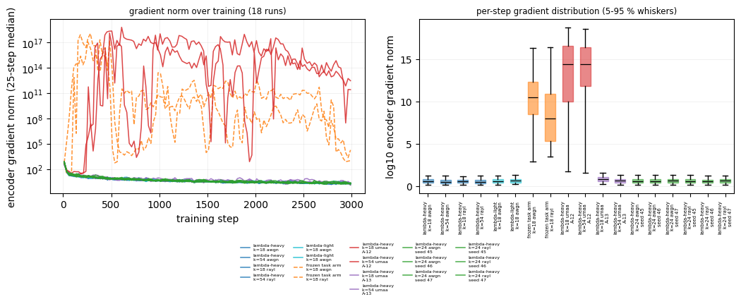
Figure 21 — Encoder gradient norm and per-step distribution.
What it shows. Gradient-conditioning mechanism. Left: encoder gradient norm over training for 18 runs on a log scale. Right: per-step gradient distribution with 5–95% whiskers. Frozen and A-12 runs reach roughly 10¹⁴–10¹⁷; λ-heavy runs stay at O(1).
What to notice.
- The separation is about fourteen orders of magnitude.
- λ-heavy runs have zero non-finite gradient steps; frozen runs have many.
- A-12 full-dispersion training explodes even with λ; A-13 resampling restores stability.
- This is the mechanism figure; it explains why λ-shaping works.
Best placement. Chapter 5.4 (mechanism).
File. fig_training_stability.png

Part 5 — Wave-B: CSI Robustness

Figure 22 — Wave-B Success Rate vs Bandwidth with CSI Bands
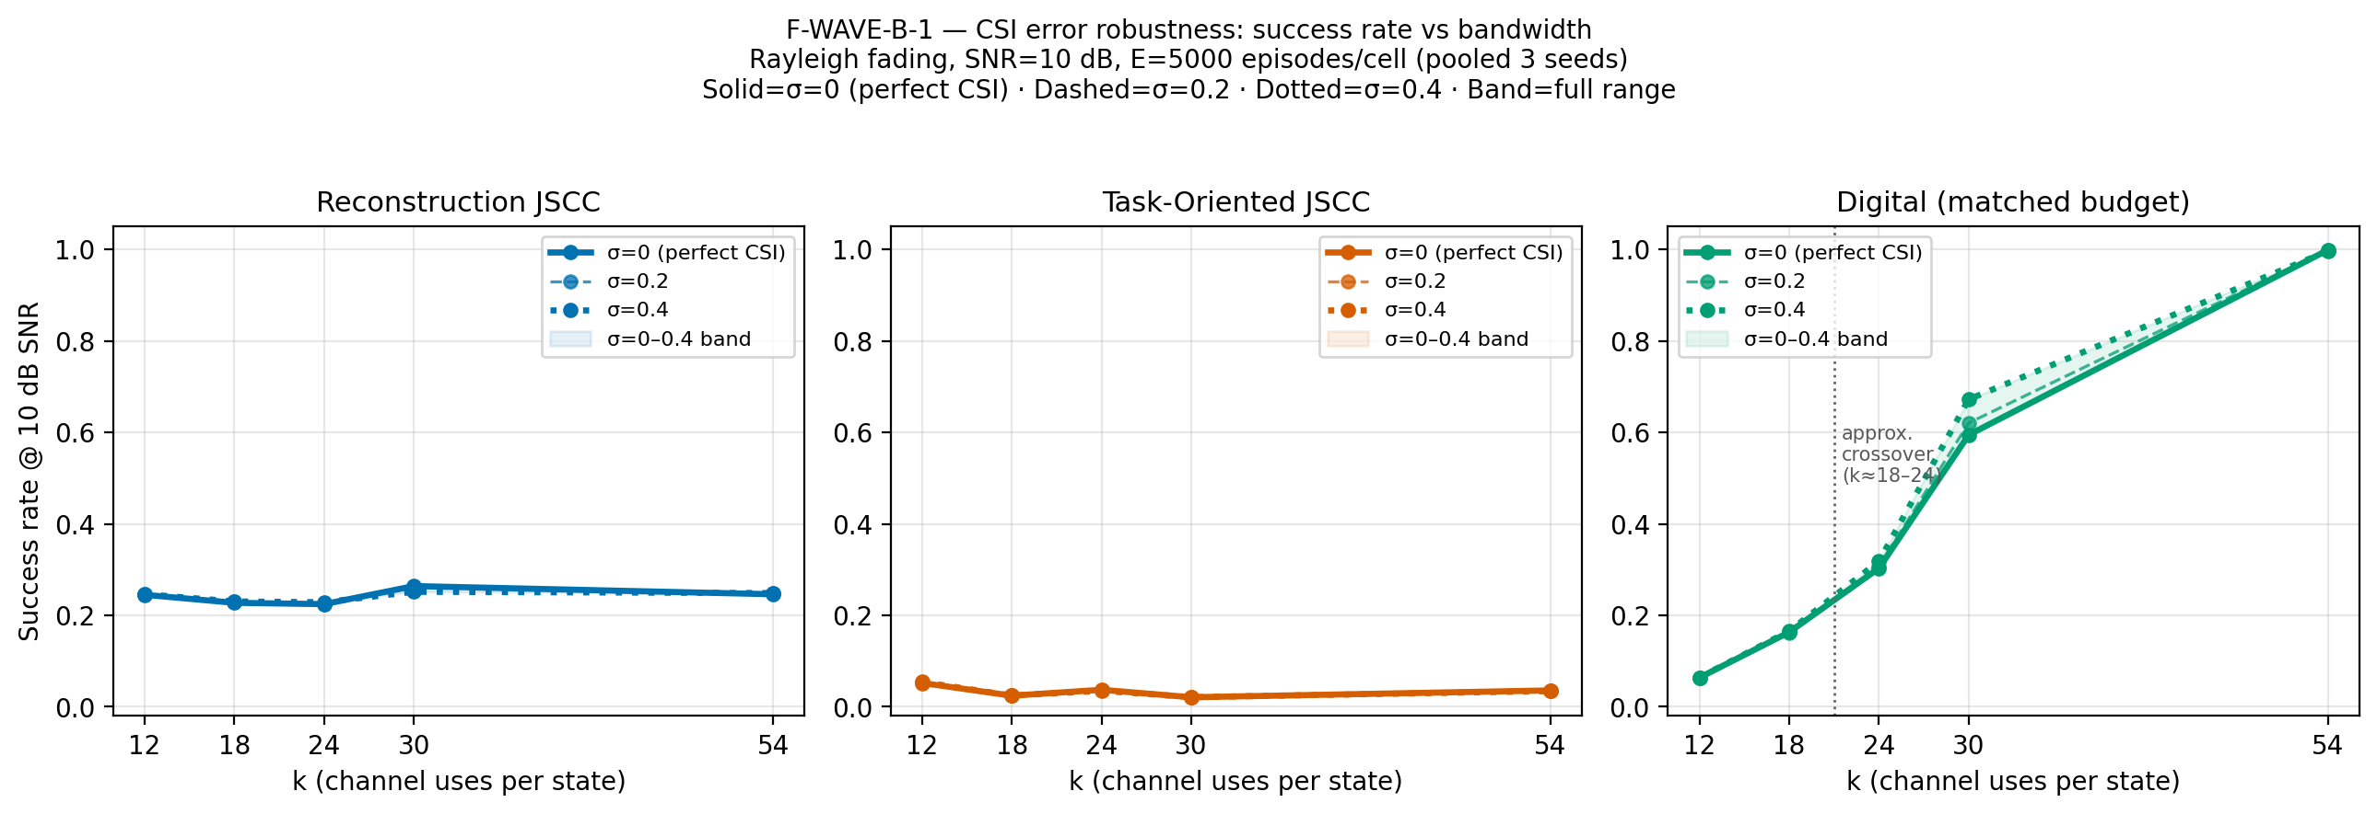
Figure 22 — Wave-B success rate vs bandwidth with CSI-error bands.
What it shows. Wave-B success rate versus bandwidth with CSI-error bands σ = 0, 0.2, and 0.4. The three methods are reconstruction, task, and digital.
What to notice.
- Success rate is essentially flat across σ for every method.
- The task arm is the frozen arm (about 0.034), not the λ-heavy arm.
- The digital link is highest at high k; reconstruction is flat.
- Use with Figure 23, which shows the MSE degradation that success rate hides.
Best placement. Chapter 5.5 (Wave-B).
File. fig_waveb1_sr_vs_k_csi_bands.png

Figure 23 — Wave-B Reconstruction MSE vs CSI Sigma
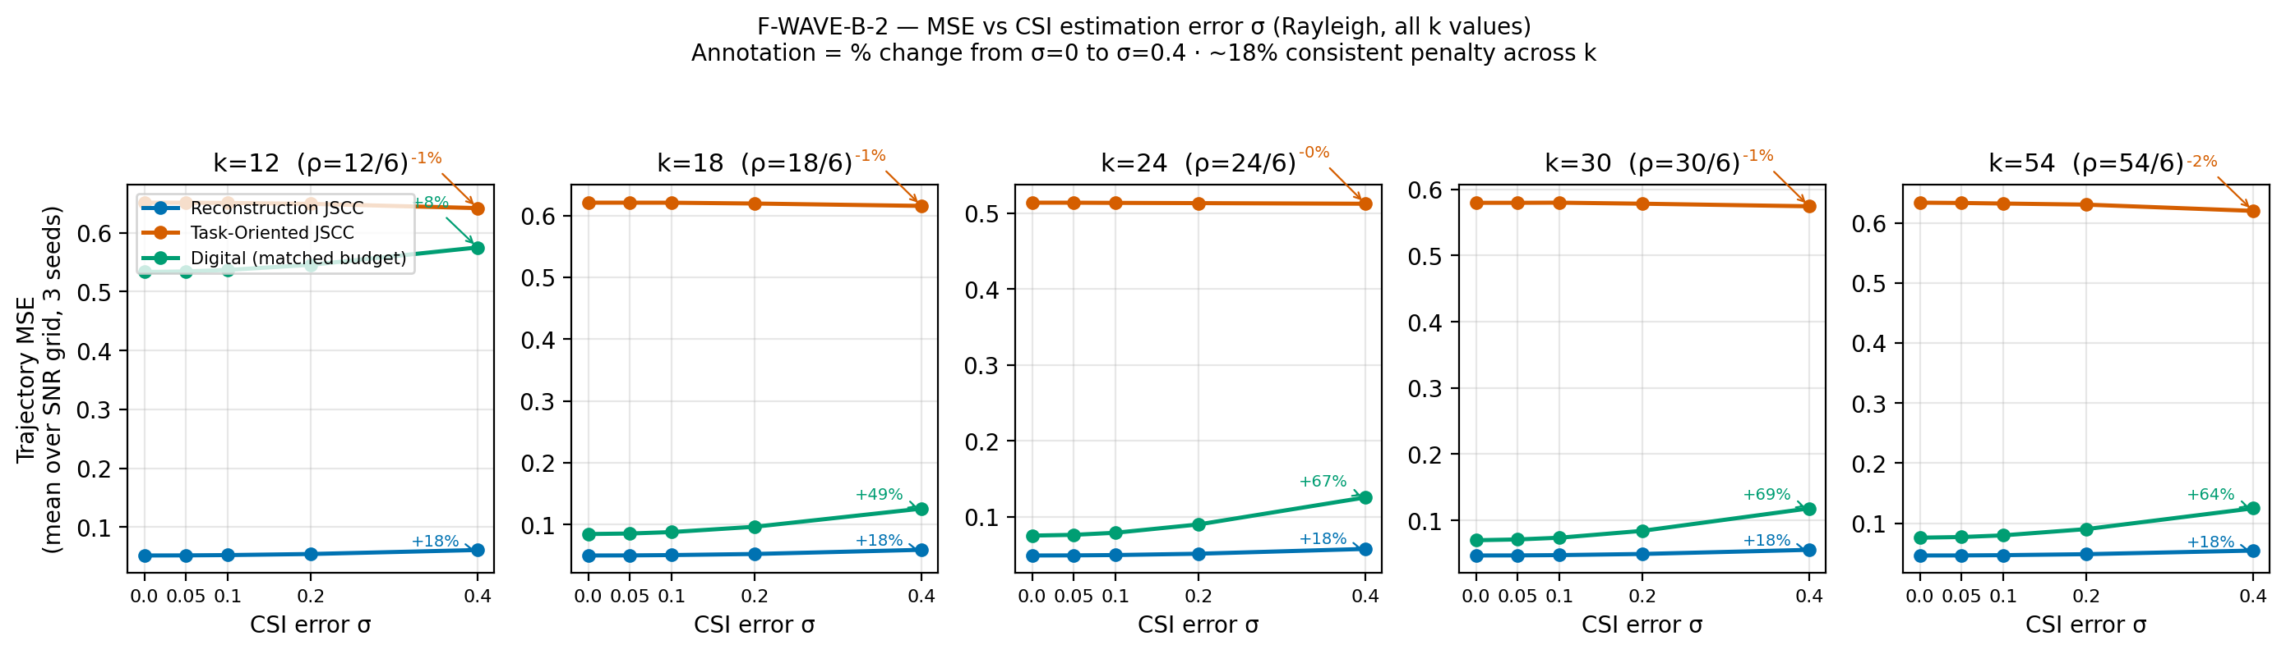
Figure 23 — Reconstruction MSE vs CSI-error sigma.
What it shows. Reconstruction MSE versus CSI-error σ for each k. The annotation shows the percentage penalty; at σ = 0.4 the penalty is about +18%.
What to notice.
- MSE degrades monotonically with σ.
- The penalty is similar across k (+17.6% to +18.5%).
- Success rate is too coarse to reveal this degradation.
- Use this figure to make the “SR flat, MSE worse” point.
Best placement. Chapter 5.5 (Wave-B).
File. fig_waveb2_mse_vs_csi_sigma.png

Figure 24 — Wave-B Success Rate vs SNR at k = 12
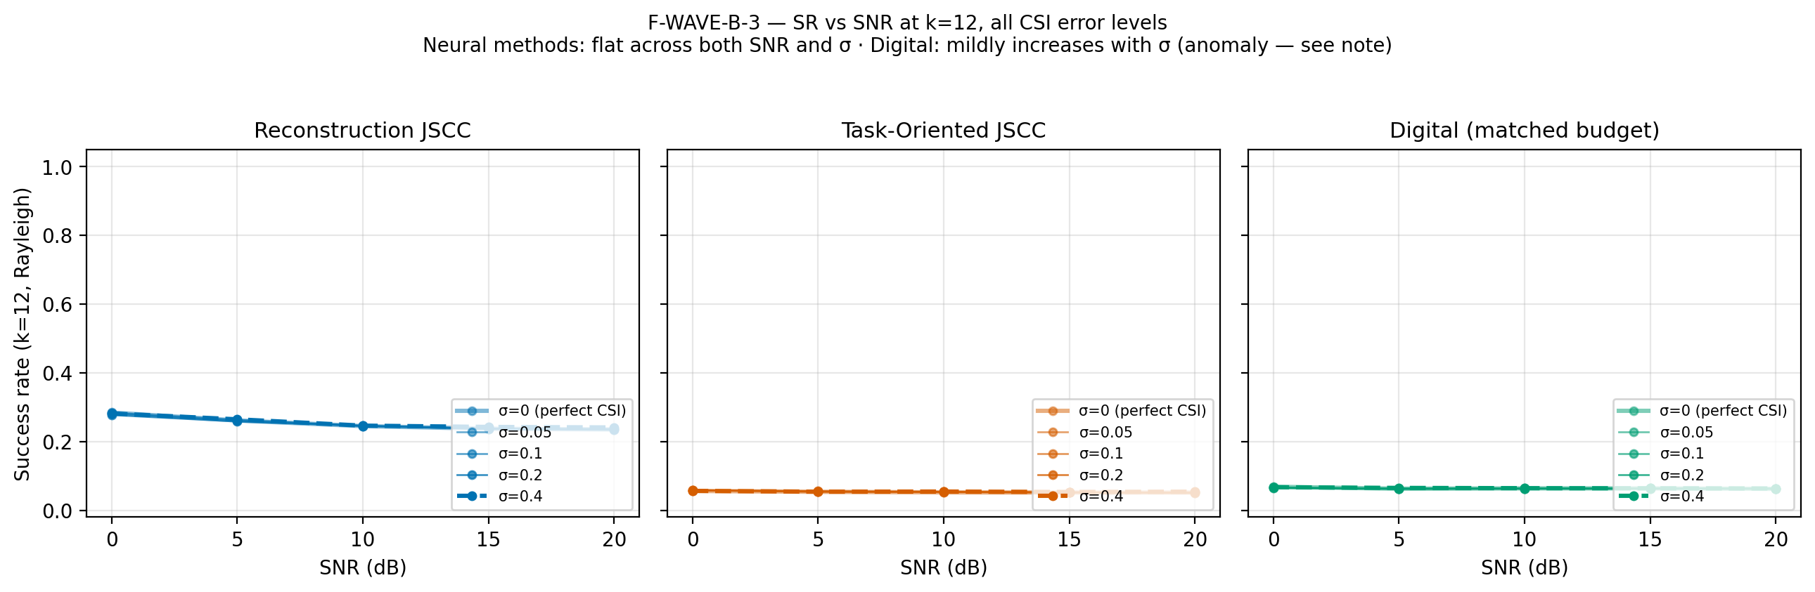
Figure 24 — Wave-B success rate vs SNR at k = 12 for all CSI levels.
What it shows. Success rate versus SNR at k = 12 for all CSI-error levels. The curves are flat across both SNR and σ.
What to notice.
- CSI magnitude error does not change the success ordering.
- The task arm remains low; reconstruction is about 0.25; digital is about 0.38.
- Use as a compact Wave-B summary.
Best placement. Chapter 5.5 (Wave-B).
File. fig_waveb3_sr_vs_snr_csi.png

Figure 25 — Wave-B CSI Sweep Summary
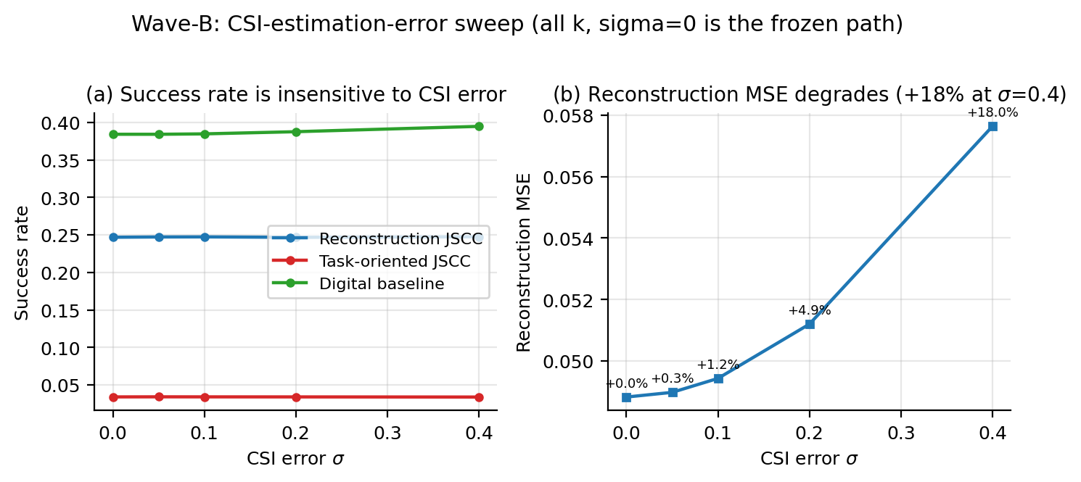
Figure 25 — Wave-B summary: success rate and reconstruction MSE vs CSI error.
What it shows. Wave-B summary in two panels: (a) success rate versus σ for the three methods, flat; (b) reconstruction MSE versus σ, rising by +18% at σ = 0.4. This is an alternate view that combines Figures 22–24.
What to notice.
- Panel (a) is the null result; panel (b) is the hidden cost.
- Use it if you have space for only one Wave-B figure.
- The success-rate panel is deliberately coarse; do not read it as “CSI does not matter”.
Best placement. Chapter 5.5 (alternate summary).
File. fig_wave_b_csi_sweep.png

Figure 26 — Wave-B Success Rate vs Bandwidth Bars
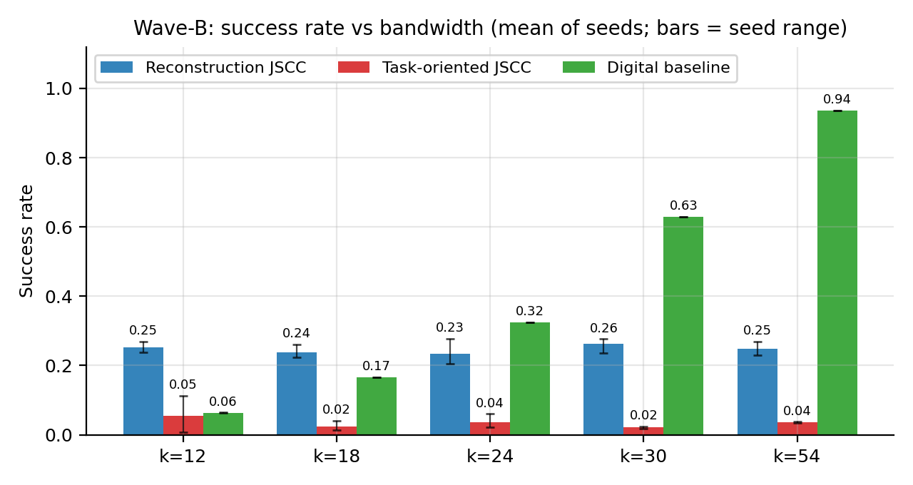
Figure 26 — Wave-B success rate vs bandwidth with seed-range bars.
What it shows. Wave-B success rate versus bandwidth, mean of seeds with bars showing the seed range. Reconstruction is 0.23–0.26, task is 0.02–0.05, and digital rises to 0.94 at k = 54. This is an alternate view of the M2 result.
What to notice.
- The crossover is visible at k = 24.
- Seed ranges are small.
- This is a compact way to show both the crossover and the seed spread in one panel.
Best placement. Chapter 5.2/5.5 (alternate view).
File. fig_wave_b_sr_vs_k.png

Figure 27 — Wave-B Success Rate vs SNR at the Extremes
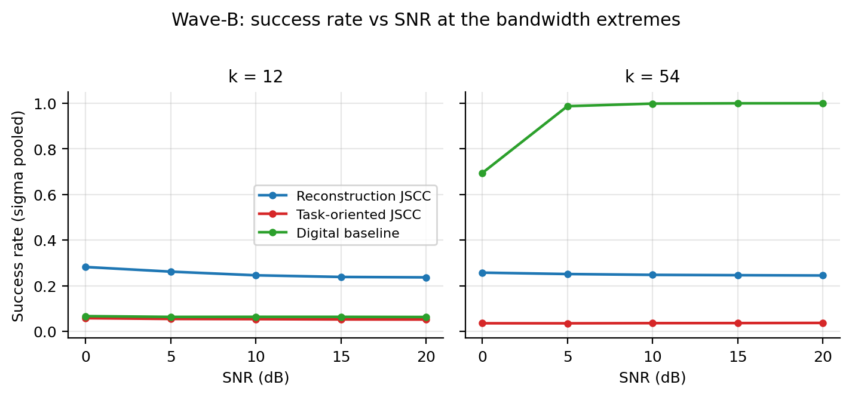
Figure 27 — Wave-B success rate vs SNR at k = 12 and k = 54.
What it shows. Wave-B success rate versus SNR at the bandwidth extremes k = 12 and k = 54, with σ pooled. Reconstruction and task are flat; digital rises to 1.0 at k = 54. This is an alternate view of the SNR behaviour.
What to notice.
- At k = 12 digital is payload-limited and stays low.
- At k = 54 digital saturates at 1.0 by 5 dB.
- Reconstruction is flat in both panels; extra bandwidth does not help its objective.
Best placement. Chapter 5.2/5.5 (alternate view).
File. fig_wave_b_sr_vs_snr.png

Part 6 — Wave-C: Lambda-Shaping Generalisation

Figure 28 — Wave-C Success Rate vs SNR
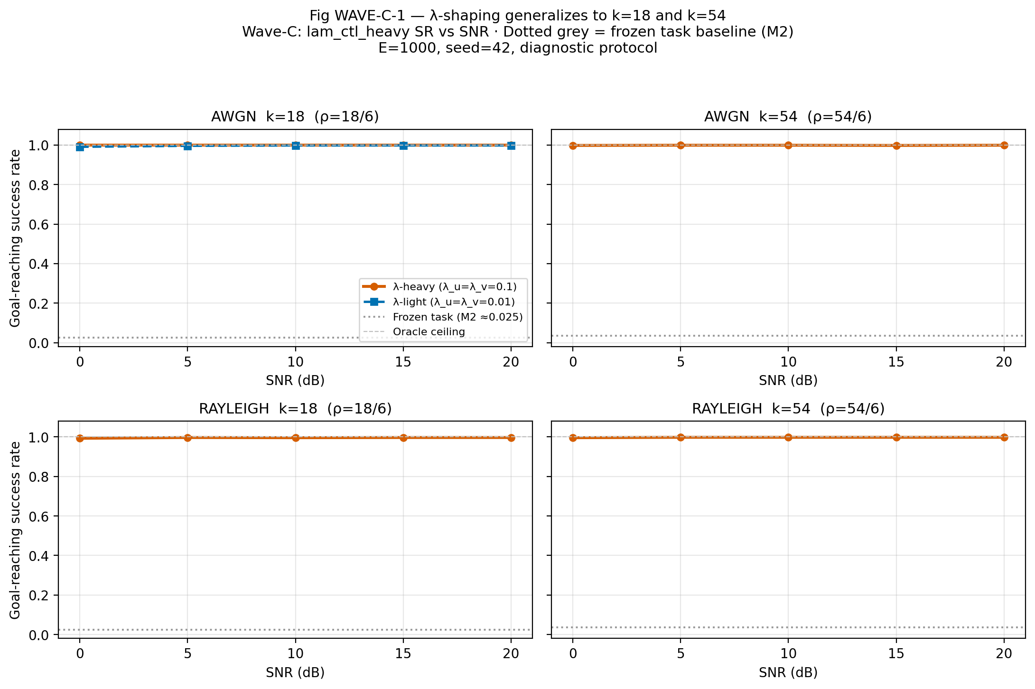
Figure 28 — Wave-C lambda-heavy vs lambda-light success rate vs SNR.
What it shows. Wave-C λ-heavy versus λ-light success rate versus SNR at k = 18 and k = 54, on AWGN and Rayleigh. The λ-heavy curves are at 0.99+ at every SNR point.
What to notice.
- The fix generalises from k = 12 to k = 18 and 54.
- λ-light is not a robust alternative; the heavy penalty is the reliable setting.
- Both channels are covered.
Best placement. Chapter 5.6 (Wave-C).
File. fig_wavec1_sr_vs_snr.png

Figure 29 — Wave-C Combined k Axis
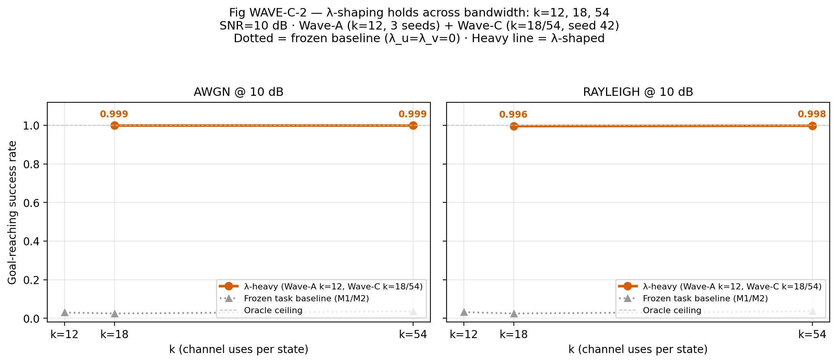
Figure 29 — Combined k axis: Wave-A k = 12 and Wave-C k = 18/54.
What it shows. Combined k axis: k = 12 from Wave-A and k = 18/54 from Wave-C. It shows that λ-shaping generalises across bandwidth.
What to notice.
- The λ-heavy curve is at the task ceiling across the axis.
- The frozen task curve is low at every k.
- This is the key Wave-C figure.
Best placement. Chapter 5.6 (key figure).
File. fig_wavec2_sr_vs_k.png

Figure 30 — Wave-C Comparison Table
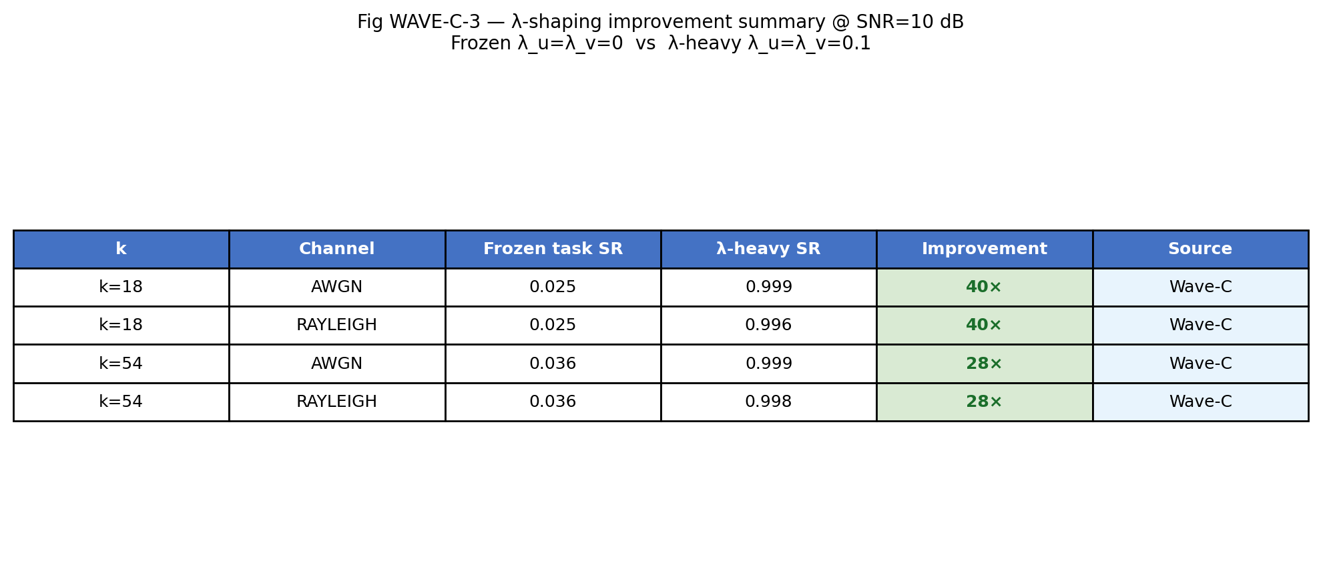
Figure 30 — Wave-C summary comparison table.
What it shows. Summary comparison table as a figure: frozen versus λ-heavy, with the improvement factor (roughly 30–40×).
What to notice.
- The improvement is large and consistent.
- The table is a convenient appendix plate.
- Use the Markdown table for exact values.
Best placement. Chapter 5.6 or the appendix.
File. fig_wavec3_comparison_table.png

Figure 31 — Wave-C Success vs Bandwidth
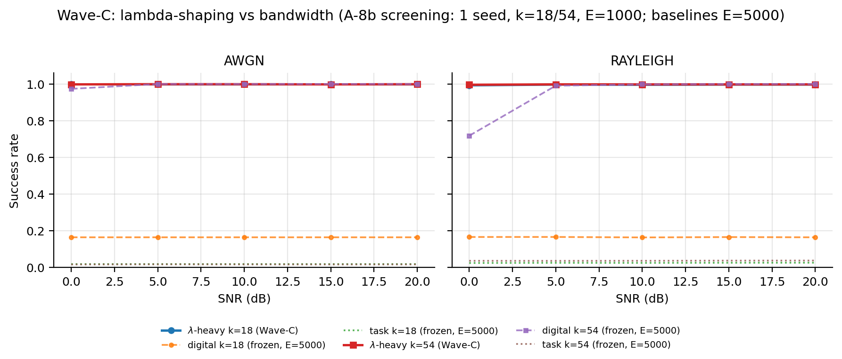
Figure 31 — Wave-C success vs bandwidth with baselines.
What it shows. Wave-C success versus bandwidth at k = 18 and 54, on AWGN and Rayleigh, with baselines. λ-heavy is at 0.99+; digital k = 54 Rayleigh is 0.72 at 0 dB and reaches 1.0 by 5 dB.
What to notice.
- λ-heavy wins at low SNR and under fading.
- At k = 54 and high SNR, digital reaches 1.0; λ-heavy ties at 0.998.
- The advantage is regime-specific, not universal.
Best placement. Chapter 5.6 (Wave-C).
File. fig_wave_c_success.png

Part 7 — Extensions A-10, A-11, A-12/A-13

Figure 32 — A-10 Required Transmit SNR on the Aerial Link
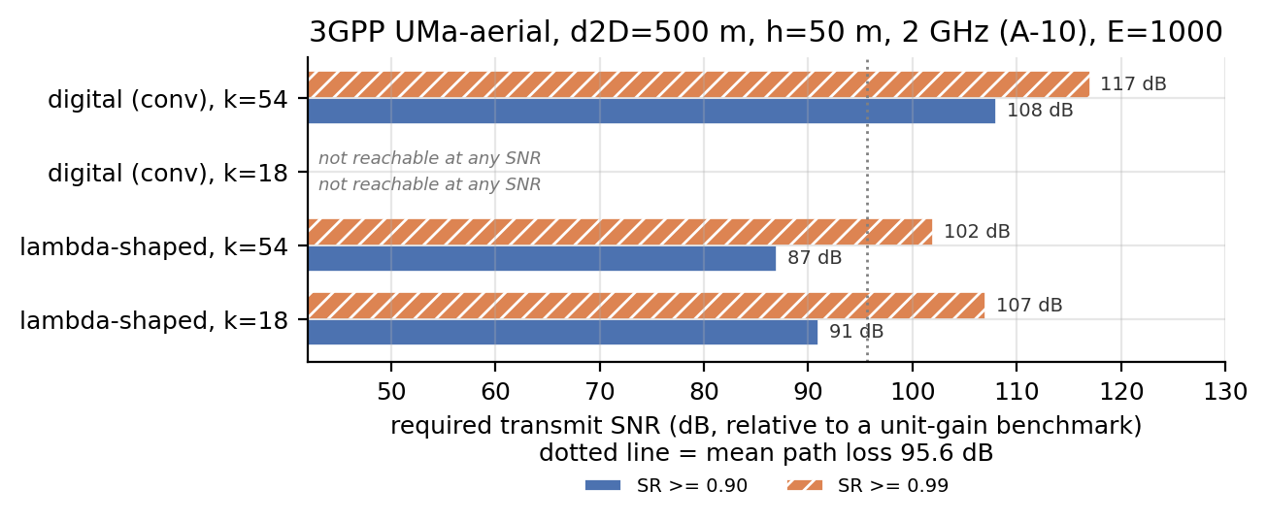
Figure 32 — A-10 required transmit SNR on the 3GPP UMa-aerial link.
What it shows. A-10 required transmit SNR on the 3GPP UMa-aerial link (d₂D = 500 m, h = 50 m, 2 GHz). Horizontal bars show the transmit SNR needed for SR ≥ 0.90 (solid) and ≥ 0.99 (hatched).
What to notice.
- λ-heavy k = 18 needs 91 dB for 0.90 and 107 dB for 0.99.
- λ-heavy k = 54 needs 87 dB and 102 dB.
- Digital k = 54 needs 108 dB and 117 dB.
- Digital k = 18 is not reachable at any SNR because it is payload-limited.
- The dotted line is the mean path loss of 95.6 dB.
Best placement. Chapter 5.8 (A-10).
File. fig_aerial_required_snr.png

Figure 33 — A-12 vs A-13 Training under 3GPP Dispersion
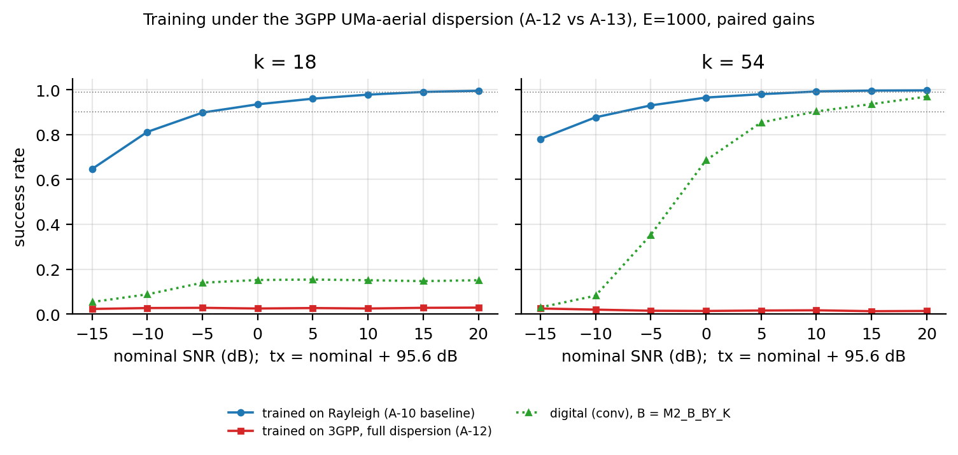
Figure 33 — A-12 full-dispersion training vs the Rayleigh-trained baseline.
What it shows. A-12 versus the Rayleigh-trained baseline under the 3GPP UMa-aerial dispersion at k = 18 and 54. The full-dispersion A-12 run stays near 0.02–0.03; the Rayleigh-trained policy remains high; digital is shown for reference. The A-13 resampled variant is reported in the results table; this figure is the A-12 diagnostic.
What to notice.
- Full-dispersion training collapses even with λ-shaping.
- The Rayleigh-trained policy transfers well to the dispersion at evaluation.
- Use this to explain the negative result honestly.
- Do not claim that A-13 is plotted here; it is not.
Best placement. Chapter 5.10 (A-12/A-13).
File. fig_aerial_training.png

Figure 34 — A-11 Polar vs Convolutional Baseline
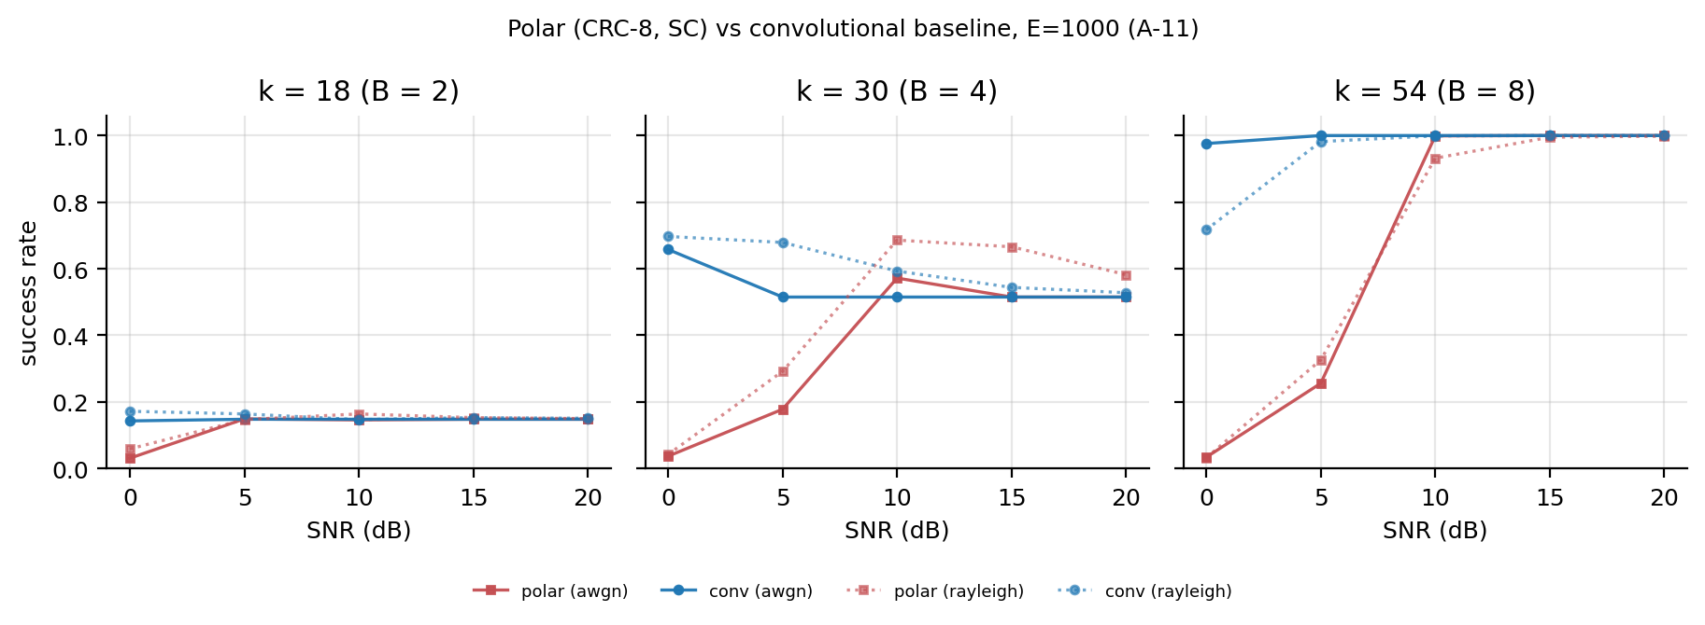
Figure 34 — A-11 SC polar vs convolutional baseline.
What it shows. A-11: SC polar (CRC-8, no rate matching) versus the convolutional baseline at k = 18, 30, and 54, on AWGN and Rayleigh.
What to notice.
- At k = 18 both are payload-limited; the curves are close.
- At k = 30 polar is better at high SNR.
- At k = 54 polar is worse at low SNR and reaches parity at 10–15 dB.
- The crossover does not depend on the convolutional code being uniquely weak; A-15 adds the full 5G NR chain.
Best placement. Chapter 5.9 (A-11/A-15).
File. fig_polar_vs_conv.png

Part 8 — M3, M4, the 3GPP Model, and the Experiment Matrix

Figure 35 — M3 Digital Infeasibility Boundary
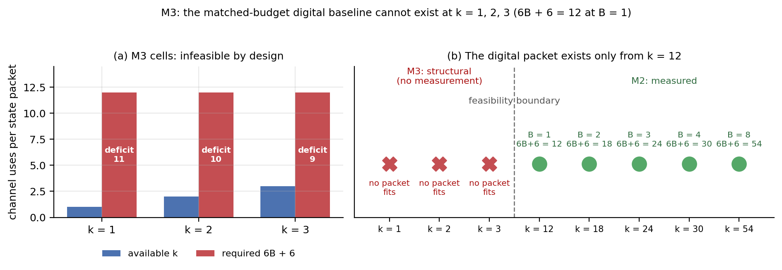
Figure 35 — M3: the matched-budget digital baseline cannot exist at k = 1, 2, 3.
What it shows. M3 is a structural display, not a measured performance result. At k = 1, 2, and 3 the smallest matched-budget digital packet would need 6B + 6 = 12 channel uses at B = 1, while only 1, 2, or 3 uses are available. The deficits are therefore 11, 10, and 9 channel uses. Panel (b) places the three M3 cells beside the five measured M2 points and shows the first feasible packet at k = 12 (B = 1, 6B + 6 = 12).
What to notice.
- The digital baseline is infeasible by construction at k = 1–3; it is not missing because it was forgotten or because it lost.
- This is why M1 has only the reconstruction and task arms: there is no matched-budget digital cell to run at those bandwidths.
- The neural arms have no equivalent packet constraint, so they can operate at k = 1–3. That is a structural property of the comparison, not a coding gain.
- M3 is a feasibility boundary, not an empirical result. Never quote it as a success rate.
Best placement. Chapter 5.2.1 (M3); also Chapter 4.5.1 for the design explanation.
File. fig_m3_infeasibility.png

Figure 36 — M4 B = 8 Bandwidth Reference
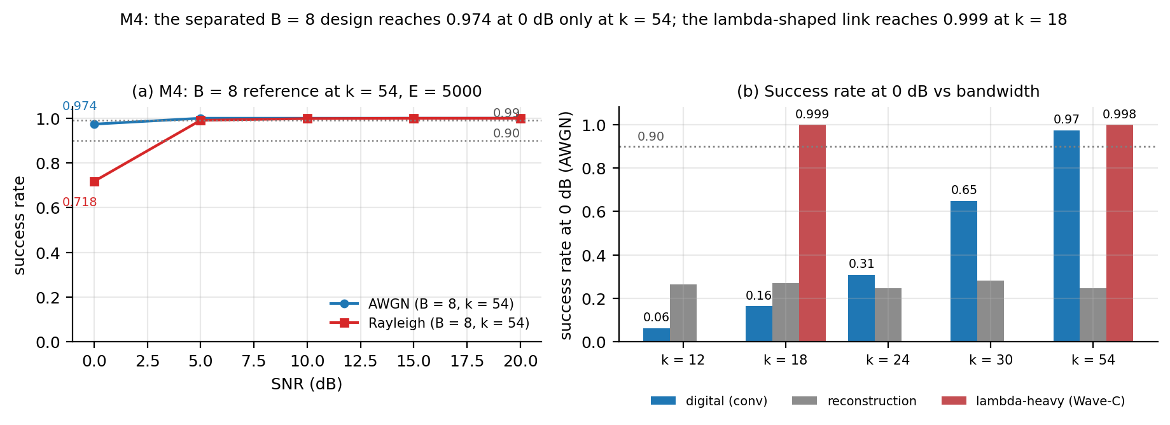
Figure 36 — M4: B = 8 digital reference at k = 54 and the bandwidth cost of separation.
What it shows. M4 is the secondary digital reference at B = 8, k = 54, E = 5,000, on AWGN and Rayleigh. The left panel gives the success-rate curves: at 0 dB the AWGN link reaches 0.974 and the Rayleigh link 0.718; by 5 dB they reach 1.000 and 0.991. The right panel compares success at 0 dB across bandwidth for the digital, reconstruction, and λ-heavy arms. The digital link crosses 0.90 only at k = 54; the λ-heavy link is already at 0.999 at k = 18; reconstruction never crosses 0.90.
What to notice.
- M4 is secondary: it duplicates the matched-budget M2 k = 54, B = 8 cell as a clearly labelled reference. It is not a new primary result.
- The bandwidth cost of separation is the point: at 0 dB AWGN the digital design needs k = 54 to pass 0.90, while the λ-shaped neural design is at 0.999 with k = 18.
- The λ-heavy points use E = 1,000 (Wave-C) while the digital points use E = 5,000 (M2/M4). Treat the comparison as an order-of-magnitude bandwidth statement, not a precise dB gain.
- On Rayleigh at 0 dB the digital link is only 0.718, so it needs roughly 5 dB more to reach 0.90; the AWGN bar is the cleaner illustration of the bandwidth gap.
Best placement. Chapter 5.2.2 (M4); use next to the M2 crossover table.
File. fig_m4_bandwidth_reference.png

Figure 37 — 3GPP UMa-Aerial Channel Model
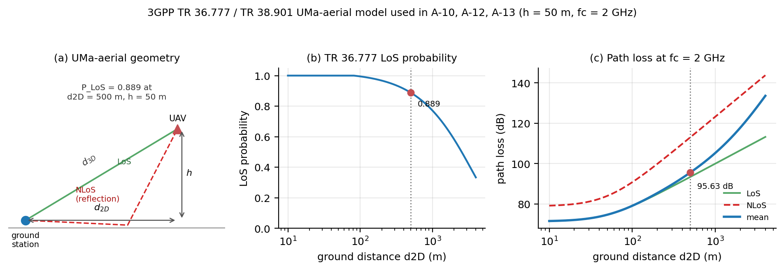
Figure 37 — 3GPP TR 36.777 / TR 38.901 UMa-aerial model used in A-10, A-12, and A-13.
What it shows. The 3GPP UMa-aerial model is a first-class channel model in this thesis, not only an appendix note. Panel (a) defines the geometry: a UAV at height h = 50 m and ground distance d₂D from the ground station, with 3-D distance d₃D. Panel (b) plots the TR 36.777 LoS probability against ground distance. Panel (c) plots the LoS, NLoS, and mean path loss at f_c = 2 GHz. At the pinned geometry d₂D = 500 m, the model gives P_LoS = 0.889, PL_LoS = 93.45 dB, PL_NLoS = 113.09 dB, and PL_mean = 95.63 dB.
What to notice.
- A-10 uses the large-scale layer: a deterministic gain shifts the effective SNR, and the LoS/NLoS curves are mixed with P_LoS.
- A-12 and A-13 add the per-episode dispersion: one LoS/NLoS draw per episode, TR 38.901 shadowing (4 dB LoS, 6 dB NLoS), and block fading over the episode.
- The model does not include Doppler, time-correlated shadowing, altitude-dependent small-scale fading, antenna patterns, noise figure, or bandwidth. Those are stated limits, not hidden assumptions.
- The mean path loss of about 95.6 dB is why the A-10 transmit-SNR numbers are in the 87–108 dB range; they are relative to a unit-gain benchmark, not a hardware budget.
Best placement. Chapter 3.8 (system model); refer back from Chapter 5.10 (A-10/A-12/A-13).
File. fig_3gpp_channel_model.png

Figure 38 — Experiment Matrix Actually Executed
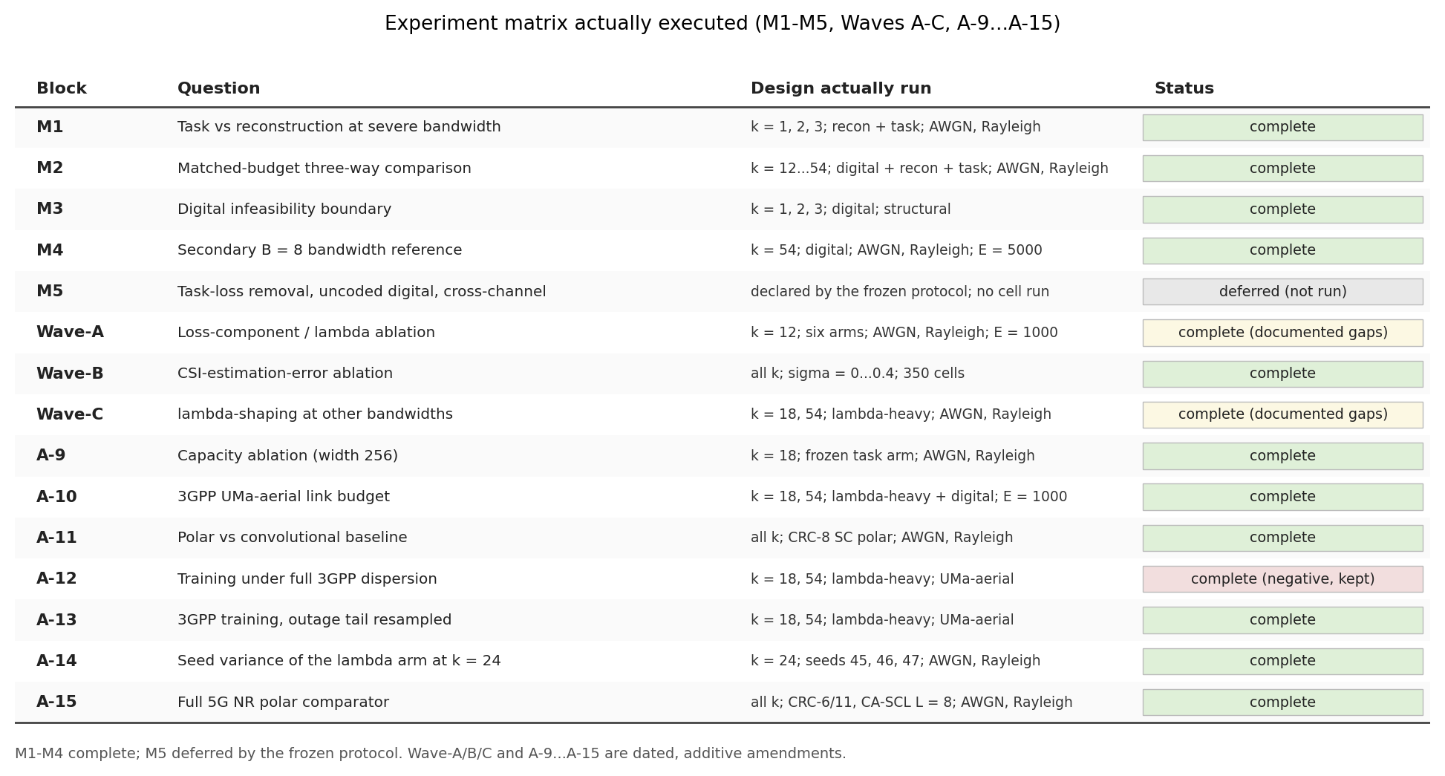
Figure 38 — Experiment matrix: M1–M5, Waves A–C, and A-9…A-15.
What it shows. A single-page map of every experiment block in the project: M1–M5, Waves A–C, and extensions A-9…A-15. Each row gives the question, the design actually run, and the status. M1–M4 are complete; M5 is deferred by the frozen protocol and was not run; Wave-A is complete with two documented failures (85/90 slots); Wave-C is the pre-registered screening subset; A-12 is a kept negative result.
What to notice.
- This is the completeness map to use when checking that nothing was silently dropped.
- M3 is structural, M4 is secondary, and M5 is deferred; those three labels must travel with any description of the matrix.
- Wave-A and Wave-C have documented gaps; they are marked “complete (documented gaps)” rather than being presented as full grids.
- A-12 is marked “complete (negative, kept)”; it is not retrained or hidden.
Best placement. Chapter 4.3 (experimental matrix); also Appendix B.
File. fig_experiment_matrix.png

Figure-to-Chapter Map
Chapter / section | Figures to use
Chapter 3 — System Model | 12, 15, 37
Chapter 4 — Methodology | 16, 17, 18, 38
Chapter 5.1 — M1 | 1, 19
Chapter 5.2 — M2 | 2, 3, 4, 5, 9, 26, 27
Chapter 5.2.1 — M3 | 35
Chapter 5.2.2 — M4 | 36
Chapter 5.3 — Wave-A | 20
Chapter 5.4 — Mechanism | 10, 21
Chapter 5.5 — Wave-B | 22, 23, 24, 25
Chapter 5.6 — Wave-C | 28, 29, 30, 31
Chapter 5.8 — A-10 | 32, 37
Chapter 5.9 — A-11/A-15 | 34
Chapter 5.10 — A-12/A-13 | 33
Appendix | 6, 7, 8, 11, 13, 14, 19, 38

Recommended minimum set for the main thesis: Figures 1, 2, 3, 4, 9, 20, 21, 22, 23, 29, 32, 34, 35, 36, 37, 38. The rest are supporting material or alternate views.
End of figures companion.

