TASK-ORIENTED DEEP JOINT SOURCE-CHANNEL CODING FOR UAV NAVIGATION UNDER NOISY AND FADING WIRELESS CHANNELS
with a 3GPP UMa-Aerial Link-Budget and Dispersion Extension
Final Year Project Thesis
Department of Electrical Engineering
Lahore College for Women University (LCWU)
Submitted by:
Name | Roll Number
Areesha Sohail | 1005
Amna Shahid | 1004
Hafiza Laiba Faisal | 1015

Program: B.E. Electrical Engineering
Supervisor: Ismat Hira
Date: October 2026

Declaration
I hereby declare that the work presented in this thesis, titled “Task-Oriented Deep Joint Source-Channel Coding for UAV Navigation under Noisy and Fading Wireless Channels,” is my own work. It has not been submitted previously for any degree or examination at this or any other institution. All sources of information and assistance have been acknowledged, and all quotations and paraphrases are cited.
Name | Roll Number | Signature
Areesha Sohail | 1005
Amna Shahid | 1004
Hafiza Laiba Faisal | 1015

Date: ______________________

Certificate
This is to certify that the thesis titled “Task-Oriented Deep Joint Source-Channel Coding for UAV Navigation under Noisy and Fading Wireless Channels,” submitted by Areesha Sohail (1005), Amna Shahid (1004), and Hafiza Laiba Faisal (1015) in partial fulfilment of the requirements for the degree of B.E. Electrical Engineering at Lahore College for Women University (LCWU), is a record of original work carried out under my supervision. The work has not been submitted elsewhere for the award of any other degree.
Supervisor: Ismat Hira
Signature: ______________________
Date: ______________________

Acknowledgements
We thank our supervisor, Ismat Hira, for her guidance, patience, and careful feedback throughout this project. We are grateful to the Department of Electrical Engineering at Lahore College for Women University for the resources and support that made this work possible. We also thank our families and friends for their encouragement during the long experimental runs. Finally, we acknowledge the open-source Python, PyTorch, and NumPy communities, whose tools made the simulation study reproducible.

Abstract
Reliable and bandwidth-efficient transmission of navigation-relevant information is a core requirement for autonomous unmanned aerial vehicle (UAV) operation over noisy and fading wireless links. Conventional digital communication and reconstruction-oriented Deep Joint Source-Channel Coding (DeepJSCC) are optimised to recover the transmitted signal with minimum distortion, independent of how that signal will subsequently be used. This thesis investigates a Task-Oriented DeepJSCC system in which the encoder and decoder are trained end-to-end to optimise UAV goal-reaching performance rather than reconstruction fidelity.
A compact six-dimensional UAV kinematic state — position, velocity, and goal-relative information — is transmitted over Additive White Gaussian Noise (AWGN) and slow Rayleigh fading channels and used by a fixed navigation controller on a two-dimensional double-integrator model. The core matched-budget matrix is AWGN/Rayleigh. A separate 3GPP TR 36.777 / TR 38.901 UMa-aerial study adds LoS/NLoS path loss, 4/6 dB shadowing, and block fading; it is used for the link-budget (A-10), multi-geometry (A-17) and dispersion-training (A-12/A-13) extensions. Three systems are compared under identical channel, SNR, and bandwidth conditions: a conventional digital link (quantisation, convolutional coding, QPSK), a reconstruction-oriented DeepJSCC autoencoder, and a task-oriented DeepJSCC system trained on the navigation rollout loss. The study is simulation-only and implemented in Python/PyTorch on CPU with deterministic seeds.
The central empirical finding is a bandwidth crossover: neural joint source-channel coding outperforms the classical coded digital link at low bandwidth (k ≤ 18 channel uses), while the coded link overtakes it at k ≥ 24 and ties it at k = 54. A second finding is diagnostic: the frozen task-oriented loss, which sets the control and velocity penalties to zero, collapses to 2–6% success. Adding control/velocity shaping (λ_u = λ_v = 0.1) recovers 99.7% success at k = 12 and 99.3–99.9% at k = 18 and 54, on both channels; removing the control-effort penalty alone reproduces the failure, which localises the mechanism to a single term. The mechanism is a gradient-conditioning effect of roughly seven to ten orders of magnitude in the median, not a capacity effect. The result is tested against a full 5G NR polar comparator, a payload-maximal uncoded link, a 3GPP UMa-aerial link budget over twelve geometries, a CSI-error sweep, and a three-seed replication. It is also tested against the other 3GPP code family: 5G NR LDPC base graph 2, without the 38.212 rate-matching chain, does not differ significantly from the convolutional baseline at k = 12–30 (overlapping intervals; no formal equivalence test) and is 0.017 below it at k = 54 AWGN, so no code family moves the crossover. A time-correlated Doppler sweep shows that replacing i.i.d. block fading with a Clarke/Jakes process moves the λ-shaped arm by at most 0.003 while lowering the digital k = 54 baseline by 0.028, and retraining under correlated fading gives 0.993 against 0.994 for the stored checkpoint — the i.i.d. convention is validated rather than assumed. The crossover holds for every coded comparator; against the uncoded link the neural arm is not overtaken at any measured bandwidth below k = 54, so the comparator must travel with the claim. On the 3GPP link the λ-shaped policy requires 74–108 dB at k = 54 (78–113 dB at k = 18) of normalised transmit power for 0.90 depending on geometry, against 89–127 dB for the digital link at k = 54 — an advantage of 15–21 dB that does not collapse across a 5× distance, 2× altitude and 1.75× carrier sweep; the digital link cannot reach 0.90 at k = 18 at any geometry. The thesis also documents the digital infeasibility boundary (M3), the secondary B = 8 bandwidth reference (M4), and the executed M5 ablations (λ-term removal, uncoded reference, cross-channel transfer). It contributes a matched-budget benchmark, the crossover characterisation, a reproducible diagnosis of why task-oriented training fails without loss shaping, and a first-order aerial-link assessment.
Keywords: DeepJSCC, task-oriented communication, semantic communication, UAV navigation, joint source-channel coding, AWGN, Rayleigh fading, 3GPP UMa-aerial, aerial link budget, 6G, goal-reaching control.
Table of Contents
Right-click here and choose Update Field to build the table of contents.

List of Abbreviations
Abbreviation | Meaning
3GPP | Third Generation Partnership Project
5G NR | Fifth-Generation New Radio
AWGN | Additive White Gaussian Noise
BER | Bit Error Rate
BLER | Block Error Rate
CA-SCL | CRC-Aided Successive Cancellation List
CI | Confidence Interval
CPS | Cyber-Physical System
CSI | Channel State Information
CVAE | Conditional Variational Autoencoder
DeepJSCC | Deep Joint Source-Channel Coding
JSCC | Joint Source-Channel Coding
KPI | Key Performance Indicator
LoS | Line of Sight
MSE | Mean Squared Error
NLoS | Non-Line-of-Sight
O-VIB | Orthogonally Constrained Variational Information Bottleneck
PReLU | Parametric Rectified Linear Unit
QPSK | Quadrature Phase-Shift Keying
RL | Reinforcement Learning
RQ | Research Question
SC | Successive Cancellation
SNR | Signal-to-Noise Ratio
TOSA | Task-Oriented Semantics-Aware
TSCC | Task-oriented Source-Channel Coding
UAV | Unmanned Aerial Vehicle
UMa | Urban Macro
VIB | Variational Information Bottleneck
ZF | Zero-Forcing

Nomenclature
Symbol | Meaning
s_t | UAV state vector at step t
p_t | UAV position at step t
v_t | UAV velocity at step t
u_t | Control input (commanded acceleration) at step t
p_g | Goal position
k | Number of channel uses per transmission
n | Source dimension (n = 6)
B | Bits per state component in the digital baseline
P | Average transmit power per symbol
σ² | Noise variance per complex symbol
h | Rayleigh fading coefficient
P_LoS | 3GPP UMa-aerial line-of-sight probability
PL_LoS, PL_NLoS | LoS and NLoS path loss (dB)
PL_mean | P_LoS-weighted mean path loss (dB)
d_2D, d_3D | Ground and three-dimensional UAV-to-station distance
f_c | Carrier frequency
σ_sh | Shadowing standard deviation (4 dB LoS, 6 dB NLoS)
λ_d, λ_u, λ_v, λ_T | Task-loss weights for distance, control, velocity, terminal distance
T | Episode horizon (100 steps)
Δt | Simulation time step (0.1 s)
SR | Goal-reaching success rate
E | Number of evaluation episodes

List of Figures
- Figure 3.1 — 3GPP UMa-aerial geometry, LoS probability, and path loss at the pinned 500 m / 50 m / 2 GHz geometry.
- Figure 4.1 — Experiment matrix actually executed: M1–M5, Waves A–C, and A-9…A-20.
- Figure 5.1 — M2 success rate versus bandwidth: the crossover between k = 18 and k = 24.
- Figure 5.2 — M3: the digital baseline is infeasible at k = 1, 2, 3; the first feasible packet is at k = 12.
- Figure 5.3 — M4: the B = 8 reference at k = 54 and the bandwidth cost of separation.
- Figure 5.4 — Wave-A arm ablation: only the control-penalty arms recover the task.
- Figure 5.5 — Training stability: λ-shaping lowers the encoder gradient by about seven to ten orders of magnitude in the median.
- Figure 5.6 — Wave-B: success rate versus k with CSI-error bands.
- Figure 5.7 — Wave-C: λ-shaping holds at k = 18 and k = 54.
- Figure 5.8 — A-10: required transmit SNR on the 3GPP UMa-aerial link.
- Figure 5.9 — A-11: polar versus convolutional digital baseline.

List of Tables
- Table 2.1 — Positioning of the reviewed work relative to this thesis.
- Table 4.1 — Experimental matrix.
- Table 4.2 — Experiment blocks actually executed.
- Table 5.1 — M1 low-bandwidth results (k = 1, 2, 3).
- Table 5.2 — M2 success rate by bandwidth on AWGN.
- Table 5.3 — M3 infeasibility cells.
- Table 5.4 — M4 success rate at k = 54, B = 8, E = 5,000.
- Table 5.5 — Wave-A loss-component ablation at k = 12.
- Table 5.6 — Wave-B CSI-estimation-error sweep, pooled across k.
- Table 5.7 — Wave-C λ-heavy success rate at k = 18 and k = 54.
- Table 5.8 — Wave-C λ-heavy advantage over the best baseline.
- Table 5.9 — A-10 required transmit SNR on the 3GPP UMa-aerial link.
- Table 5.10 — A-17 multi-geometry link budget: transmit SNR for SR ≥ 0.90 at k = 54.
- Table 5.11 — A-15 full 5G NR polar comparator versus the convolutional baseline.
- Table 5.12 — M5a task-loss component removal.
- Table 5.13 — M5b uncoded QPSK versus the coded baseline and reconstruction.
- Table 5.14 — M5c cross-channel transfer.
- Table 5.15 — A-19 Doppler sweep: temporal structure and λ-heavy success.
- Table 5.16 — A-19 rule-triggered follow-up arm, retrained at Δ = 0.033.
- Table 5.17 — A-20 5G NR LDPC BG2 versus the convolutional baseline.
- Table A.1 — Frozen configuration.
- Table B.1 — Protocol amendments A-1…A-20.
- Table B.2 — Experiment blocks and status.
- Table C.1 — Reproduction and file map.

Chapter 1 — Introduction

1.1 Background
Small, low-power UAVs are increasingly used for surveillance, delivery, inspection, and search-and-rescue missions. In most architectures the UAV depends on a wireless link to a ground station or remote controller for navigation-relevant information exchange. This link is rarely ideal: it is subject to additive thermal noise and, because the UAV moves through space with time-varying line-of-sight conditions and multipath reflections, to small-scale fading. Under such impairments, conventional bit-level pipelines — which separate source compression from channel coding and aim to reconstruct the transmitted signal exactly — are known to suffer from the cliff effect: performance degrades gracefully until the channel SNR falls below a design threshold, after which the system fails abruptly (Bourtsoulatze, Kurka & Gündüz, 2019).
Deep Joint Source-Channel Coding (DeepJSCC) replaces separate source and channel coding with a pair of jointly trained neural networks that map source symbols directly to complex-valued channel input symbols. It has been shown under AWGN and slow Rayleigh fading to degrade gracefully rather than catastrophically as SNR deteriorates. The great majority of DeepJSCC research, however, is reconstruction-oriented: the encoder and decoder minimise a distortion metric between the transmitted and received signal, independent of what the received information will subsequently be used for. In parallel, task-oriented and goal-oriented communication argues that when the purpose of transmission is a downstream decision or control action, the communication system should be optimised directly against that downstream task's performance rather than against signal fidelity (Gündüz et al., 2023; Shao, Mao & Zhang, 2022).
This thesis investigates the intersection of these two ideas for a specific downstream task: UAV navigation toward a goal position. It asks whether training a DeepJSCC encoder/decoder pair directly on navigation performance, rather than reconstruction error, yields a communication system that is more robust to channel impairments in the sense that matters to the mission — reaching the goal — even if it is not better at reproducing the original state bit-for-bit.

1.2 Motivation
From a communications engineering perspective, the project is motivated by three considerations. First, UAV platforms are typically bandwidth- and power-constrained, so any reduction in channel resources needed for a given navigation reliability is operationally valuable. Second, the graceful-degradation property already demonstrated for reconstruction-oriented DeepJSCC suggests that a task-oriented variant may inherit similar robustness while concentrating representational capacity on task-relevant information. Third, task-oriented DeepJSCC has been shown to improve closed-loop control under noisy channels in autonomous driving (Diao et al., 2024, 2025), but it has not been evaluated for UAV navigation using a compact kinematic state, leaving open whether the same benefits transfer to a lower-dimensional, non-visual source and a mobile aerial channel.

1.3 Problem Statement
When a UAV's navigation-relevant state information (position, velocity, and goal information) is transmitted over a noisy or fading wireless channel using either a conventional digital pipeline or a reconstruction-oriented DeepJSCC scheme, the communication system is optimised to minimise a generic distortion measure on the transmitted state vector. This measure does not necessarily correspond to what matters operationally: the UAV's ability to reach its goal safely and efficiently. Under a fixed bandwidth and SNR budget, a communication system that spends its limited channel-use budget reproducing every component of the state vector with equal fidelity may perform worse, in terms of navigation outcome, than a system that allocates representational capacity toward the state information most relevant to the navigation decision.
The problem addressed in this thesis is therefore whether, and to what extent, training a DeepJSCC encoder/decoder directly against a navigation-task objective — a Task-Oriented DeepJSCC system — improves UAV navigation performance relative to conventional digital communication and reconstruction-oriented DeepJSCC, under identical AWGN and Rayleigh fading channel conditions. The thesis then asks whether the resulting policy remains usable on a 3GPP UMa-aerial link, where LoS/NLoS path loss and shadowing add a large, geometry-dependent power cost.

1.4 Research Gap
The literature confirms four facts. (i) DeepJSCC under AWGN and Rayleigh fading is a mature methodology for reconstruction-oriented image transmission. (ii) Task-oriented communication, formalised through an information bottleneck objective, is well established for downstream inference and classification. (iii) UAV-specific semantic and task-oriented communication has been investigated for command-and-control scheduling, swarm tracking control, waypoint repetition, and vision-based localisation. (iv) Task-oriented DeepJSCC trained directly against a closed-loop control objective under a noisy channel has been demonstrated for autonomous driving using camera imagery.
None of the reviewed works combines a DeepJSCC neural encoder/decoder, trained end-to-end so its loss is defined directly on UAV navigation/goal-reaching performance, operating on a compact kinematic state vector rather than imagery, and evaluated systematically against conventional digital and reconstruction-oriented DeepJSCC baselines under AWGN and Rayleigh fading at matched bandwidth and SNR, with a 3GPP UMa-aerial link-budget and dispersion extension. This thesis targets that specific gap: a domain transfer and systematic empirical study, not the introduction of a fundamentally new communication paradigm.

1.5 Research Questions
RQ1 (Task and communication performance). To what extent does a Task-Oriented DeepJSCC framework, trained end-to-end to optimise UAV navigation performance, outperform conventional digital communication and reconstruction-oriented DeepJSCC in transmitting UAV navigation state information over AWGN and Rayleigh fading channels?
RQ2 (Robustness and resource sensitivity). How do channel type (AWGN versus Rayleigh fading), signal-to-noise ratio, and bandwidth/channel-use ratio affect the navigation performance gap between the Task-Oriented DeepJSCC system and the conventional and reconstruction-oriented baselines?
RQ3 (Aerial link). How does the task-oriented system perform on a 3GPP TR 36.777 / TR 38.901 UMa-aerial link, both as an evaluation-only link budget and when trained under the 3GPP dispersion, and what transmit SNR does it require relative to the classical digital link?

1.6 Aim
The aim is to design, implement, and empirically evaluate a Task-Oriented DeepJSCC communication system for UAV navigation-state transmission, and to characterise, through controlled simulation experiments under AWGN and Rayleigh fading, the conditions under which optimising the communication system directly for goal-reaching performance yields measurable benefits over conventional digital communication and reconstruction-oriented DeepJSCC. A 3GPP UMa-aerial extension then tests whether the resulting policy remains usable when a realistic aerial large-scale link budget and dispersion are imposed.

1.7 Objectives
Objective 1. Design and implement an end-to-end Task-Oriented DeepJSCC framework for transmitting a compact UAV navigation-state representation over AWGN and Rayleigh fading channels.
Objective 2. Integrate the communication framework with a simplified two-dimensional UAV kinematic navigation model and quantify the effect of communication-induced state degradation on goal-reaching performance.
Objective 3. Benchmark the Task-Oriented DeepJSCC system against a conventional digital communication baseline and a reconstruction-oriented DeepJSCC baseline under identical channel, SNR, and bandwidth conditions, including the digital infeasibility boundary at k = 1–3 (M3) and the secondary B = 8 bandwidth reference at k = 54 (M4).
Objective 4. Evaluate the trained task-oriented system on a 3GPP TR 36.777 / TR 38.901 UMa-aerial link budget and under the 3GPP dispersion, and quantify the transmit-SNR penalty relative to the classical digital link.

1.8 Key Performance Indicators
Objective 1 KPIs. A functional task-oriented encoder and decoder in PyTorch with a defined channel-use ratio; a validated differentiable AWGN layer (empirical noise variance within tolerance); a validated differentiable Rayleigh layer (fading statistics matching the model); stable training convergence across at least three seeds; at least three bandwidth ratios supported.
Objective 2 KPIs. Goal-reaching success rate over a fixed test set; mean final position error; mean goal-reaching time; control-command error relative to the noiseless baseline; episode failure rate.
Objective 3 KPIs. Success-rate-versus-SNR curves for all three methods; BER/BLER for the digital baseline; reconstruction MSE for the reconstruction baseline; the performance gap in percentage points at matched bandwidth; the degradation slope from AWGN to Rayleigh; the M3 feasibility boundary; the M4 B = 8 bandwidth reference.
Objective 4 KPIs. Required transmit SNR for SR ≥ 0.90 and ≥ 0.99 on the 3GPP UMa-aerial link; the aerial penalty relative to the effective-SNR benchmark; training stability under the 3GPP dispersion (non-finite gradient steps, terminal loss); the change in operating point between Rayleigh-trained and 3GPP-trained policies.

1.9 Scope
The project is simulation-only and implemented in Python/PyTorch. It considers a single UAV on a point-to-point goal-reaching task with a simplified two-dimensional kinematic model. The core matched-budget matrix uses AWGN and slow Rayleigh fading. A 3GPP TR 36.777 / TR 38.901 UMa-aerial layer is used in the aerial extension: A-10 evaluates the frozen policy on a large-scale LoS/NLoS link budget, A-12 trains under the full per-episode dispersion (LoS/NLoS, 4/6 dB shadowing, block fading), and A-13 repeats A-12 with the >20 dB outage tail resampled. This is not a full 3GPP simulator: the 3GPP aerial layer is per-episode block fading with no Doppler, time-correlated shadowing, altitude-dependent small-scale fading, antenna patterns, or hardware impairments. Time-correlated (Doppler) small-scale Rayleigh fading is measured at link level in A-19 but is not carried into the 3GPP layer. There is no physical UAV, no software-defined radio, no RF hardware, no real flight test, no federated or swarm learning, and no full six-degree-of-freedom aerodynamics. The navigation controller is a fixed, lightweight policy; the contribution is the communication system, not a new control algorithm.

1.10 Thesis Organisation
Chapter 2 reviews the literature and positions the gap. Chapter 3 defines the system model: UAV dynamics, controller, AWGN/Rayleigh channels, the 3GPP UMa-aerial model, encoder/decoder, the three methods, and the loss. Chapter 4 describes the methodology, the full experiment matrix (M1–M5, Waves A–C, A-9–A-20), metrics, and statistical protocol. Chapter 5 reports the results, including M3, M4, the 3GPP extensions, and the Doppler and LDPC comparators. Chapter 6 discusses their meaning. Chapter 7 states the limitations. Chapter 8 concludes and outlines future work. Appendices provide the frozen configuration, the protocol amendments, the reproduction map, the disclosure paragraphs, and viva preparation.

Chapter 2 — Literature Review

2.1 Foundational Deep Joint Source-Channel Coding
Bourtsoulatze, Kurka and Gündüz (2019) introduced DeepJSCC for wireless image transmission. A jointly trained convolutional encoder/decoder maps pixel values directly to channel symbols, outperforming JPEG/JPEG2000-plus-capacity-achieving-channel-coding baselines at low SNR and small bandwidth. The system avoids the cliff effect under AWGN and, under slow Rayleigh fading, learns fading-resilient representations that outperform separation-based digital transmission at all tested SNR and bandwidth values. This paper establishes both the DeepJSCC architecture and the AWGN/Rayleigh evaluation protocol adopted in this thesis.
Subsequent work extended the architecture with attention modules for content-adaptive coding (Xu et al., 2022), variable-rate and bandwidth-agile coding (Kurka & Gündüz, 2021), explicit OFDM-based multipath fading (Yang, Bian & Kim, 2022), and MIMO fading channels (Wu, Shao, Bian, Mikolajczyk & Gündüz, 2024). These works confirm that channel-aware DeepJSCC under AWGN and Rayleigh fading is a mature methodology, but they remain reconstruction-oriented: the training objective is signal fidelity, not a downstream task outcome.

2.2 Task-Oriented and Semantic Communication
Gündüz et al. (2023) provide the tutorial framing adopted here, distinguishing semantic, goal-oriented, and task-oriented communication and surveying information-theoretic and learning-based approaches. Shao, Mao and Zhang (2022) formalise task-oriented communication for edge inference using a variational information bottleneck (VIB) objective that jointly optimises feature extraction, source coding, and channel coding for a downstream classification task rather than data reconstruction. They also propose a dynamic, channel-adaptive feature-length scheme.
These works establish task-oriented communication as a rigorous, IB-grounded paradigm, but their downstream task is classification or inference on a held-out label, not closed-loop control or navigation, and their source is high-dimensional imagery rather than a low-dimensional kinematic state vector.

2.3 UAV-Specific Semantic and Task-Oriented Communication
Four UAV-specific works are directly relevant.
Fang et al. (2025) propose task-oriented communication for UAV visual navigation with edge-aerial collaboration in the low-altitude economy. An orthogonally constrained variational information bottleneck (O-VIB) encoder compresses multi-camera image features before transmission to an edge server for position estimation. The wireless link is modelled through a Shannon-capacity expression incorporating path loss, shadowing, and small-scale fading as a scalar channel gain. The task is localisation, not closed-loop goal-reaching, and the channel is not a differentiable symbol-level AWGN/Rayleigh layer embedded in end-to-end training. This is the closest UAV navigation reference for the present work.
Xu, Zhou and Deng (2023) propose a task-oriented semantics-aware (TOSA) framework for UAV command-and-control transmission. It defines the value of information using similarity and age-of-information metrics. The work addresses scheduling and importance-weighting of command-and-control messages rather than learning a joint source-channel neural code.
Wu, Yang, Deng and Aghvami (2024) propose goal-oriented semantic communication for robotic (including UAV) waypoint transmission. A deep reinforcement learning agent generates command-and-control data and a proactive repetition scheme (DeepPro) combats channel unreliability. This is a scheduling and repetition strategy layered on generated commands, not a trained DeepJSCC encoder/decoder.
Tang, Feng and Quek (2025) study decentralised semantic communication and cooperative tracking control for a UAV swarm over MIMO fading channels. A semantic triggering rule decides whether to transmit, based on tracking-error cost and channel state, combined with a Lyapunov drift-plus-penalty control law. The work addresses when to transmit, not how to jointly encode the state into channel symbols.

2.4 Task-Oriented JSCC for Closed-Loop Control
The methodologically closest precedent is the work of Diao and colleagues. Diao, Meng, Xu, She and Zhao (2024) propose a Task-oriented Source-Channel Coding (TSCC) framework that uses a modified conditional variational autoencoder guided by an autonomous-driving agent to jointly optimise source and channel coding under different channel conditions in a driving simulator. Diao, Zhang, De Martini, Zhao and Li (2025) extend this to a task-oriented co-design of communication, computing, and control for industrial cyber-physical systems, combining VIB-based task-oriented JSCC with delay-aware control prediction. Diao, Zhang, She, Zhao and Li (2025) propose an alignment between task-oriented and reconstruction-oriented communication for edge intelligence, and the doctoral thesis (Diao, 2025) consolidates the line of work.
This body of work demonstrates that a DeepJSCC-style system optimised directly against closed-loop control performance under a noisy channel is feasible and beneficial. It is, however, exclusively for ground-vehicle autonomous driving using camera imagery, not for UAV navigation using a compact kinematic state, and it does not provide a systematic matched-bandwidth comparison across AWGN and Rayleigh fading.

2.5 UAV Mobility and Channel Models
The UAV kinematic model in this thesis follows the discrete-time double-integrator formulation used by Shiri, Park and Bennis (2019) in communication-aware UAV path planning. The state is position and velocity in two dimensions, and the control input is commanded acceleration. The model deliberately omits full flight dynamics; its purpose is to provide a reproducible downstream task, not a new controller.
For the aerial link budget extension, the large-scale parameters follow the 3GPP TR 36.777 / TR 38.901 UMa-aerial model: a LoS probability, separate LoS and NLoS path-loss expressions, and their mixture. The model is used in three ways: A-10 evaluates the frozen policy on a large-scale link budget, A-12 trains under the full per-episode dispersion (LoS/NLoS draw, TR 38.901 shadowing, block fading), and A-13 repeats A-12 with the rare outage tail resampled. The 3GPP layer itself remains block fading, with no time-correlated shadowing; time-correlated (Doppler) small-scale fading is treated separately at link level in A-19. Khuwaja et al. (2018) survey the wider family of air-to-ground channel models, including Rayleigh and Rician small-scale fading and altitude-dependent K-factors. These models inform the link-budget mapping in Chapter 3.8 and the limitations in Chapter 7.

2.6 Positioning of the Present Work
Table 2.1 — Positioning of the reviewed work relative to this thesis.
Work | Application | Communication method | Channel model | Task metric | Limitation relative to this thesis
Bourtsoulatze et al. (2019) | Image transmission | Reconstruction DeepJSCC | AWGN; slow Rayleigh | PSNR / distortion | Reconstruction-oriented; not a control task
Shao, Mao & Zhang (2022) | Edge inference | Task-oriented VIB | AWGN-like link | Classification accuracy | Classification, not control; image source
Xu, Zhou & Deng (2023) | UAV command and control | TOSA scheduling | Cellular / URLLC | Value / age of information | Scheduling, not a neural JSCC codec
Wu, Yang, Deng & Aghvami (2024) | Robotic / UAV waypoints | RL commands + repetition | Packet-loss link | Value / age of information | Not a DeepJSCC encoder; packet abstraction
Tang, Feng & Quek (2025) | UAV swarm tracking | Semantic triggering + Lyapunov | MIMO fading | Tracking error, power | Decides when to transmit, not how to encode
Fang et al. (2025) | UAV visual navigation | Task-oriented O-VIB | Shannon capacity (path loss, shadowing, fading) | Localisation error | Image source; capacity-level channel; localisation
Diao et al. (2024, 2025) | Autonomous driving / CPS | Task-oriented JSCC (CVAE/VIB) | Noisy channel, varying SNR | Driving score, bandwidth | Ground vehicle; camera source; no UAV state
This thesis | UAV goal-reaching | Task-oriented DeepJSCC | Differentiable AWGN, Rayleigh, and 3GPP UMa-aerial | Goal-reaching success | Simulation-only; 2-D kinematics

2.7 Summary
The gap is specific and defensible: no reviewed work trains a DeepJSCC encoder/decoder end-to-end on a UAV goal-reaching objective using a six-dimensional kinematic state, over a differentiable symbol-level AWGN/Rayleigh channel, and compares it against both a conventional digital link and a reconstruction-oriented DeepJSCC baseline at matched bandwidth, with a 3GPP UMa-aerial link-budget and dispersion extension. The thesis fills that gap and reports both the positive result (the crossover) and the negative/diagnostic result (the frozen task loss fails without control shaping).

Chapter 3 — System Model

3.1 End-to-End Architecture
The architecture is a UAV-to-ground-station link. The UAV is always the transmitter of state information; the ground-based navigation controller is always the receiver and decision-maker. The loop is:
UAV state → task-oriented encoder → DeepJSCC channel symbols → AWGN / Rayleigh / 3GPP UMa-aerial channel → task-oriented decoder → control-relevant representation → navigation controller → control action → UAV state update.
The same loop is used by all three methods. They differ only in how the encoder, decoder, and training objective are defined.

3.2 UAV Kinematic Model
The navigation-relevant state at discrete step t is
s_t = [x_t, y_t, v_x,t, v_y,t, x_g, y_g] ∈ R^6
where (x_t, y_t) is position, (v_x,t, v_y,t) is velocity, and (x_g, y_g) is the fixed goal. The dynamics are a discrete double integrator:
p_{t+1} = p_t + Δt · v_t + ½ Δt² · u_t
v_{t+1} = v_t + Δt · u_t
with Δt = 0.1 s, horizon T = 100 steps (10 s), workspace ±8 m, success radius 0.5 m, velocity limit 5 m/s, and acceleration limit 2 m/s². An episode succeeds when the UAV is within 0.5 m of the goal at or before T; it fails on timeout or on leaving the workspace.

3.3 Navigation Controller
The controller is fixed and identical for all methods:
u_t = clip(−K_p (p_t − p_g) − K_v v_t, ±u_max)
with K_p = 1.0, K_v = 2.0, u_max = 2.0 m/s². The damping ratio is ζ = 1.0 (critically damped). Keeping the controller fixed ensures that any performance difference is attributable to the communication system, not to a jointly changing control policy.

3.4 State Normalisation
Each state component is mapped to [−1, 1] using a fixed affine transform with ranges taken from the configuration, never from data:
s̄_i = 2 · (clip(s_i, a_i, b_i) − a_i) / (b_i − a_i) − 1
The inverse transform is applied after decoding. Fixed ranges prevent data leakage and make the normalisation identical across methods and seeds.

3.5 Communication Model and Bandwidth Convention
At each step the UAV encodes s_t into k complex channel symbols z_t. The bandwidth/channel-use ratio is k/n, where n = 6 is the source dimension and k is the number of channel uses per transmission. The thesis uses k ∈ {1, 2, 3} for the low-bandwidth study and k ∈ {12, 18, 24, 30, 54} for the matched-budget study. The digital packet invariant 6B + 6 ≤ k creates a feasibility boundary: at k = 1, 2, 3 no matched-budget digital packet fits (M3), while k = 12 is the first feasible point (B = 1, 6B + 6 = 12). M4 adds a secondary B = 8 reference at k = 54 to quantify the bandwidth a separated design needs.
The transmitted symbols satisfy an average power constraint. Per codeword, the encoder output is normalised:
z ← z · sqrt(kP / ||z||²), P = 1
so that the average symbol power is exactly P. The receiver observes y and produces a task-relevant representation r_t.

3.6 AWGN Channel
y = z + n, n ~ CN(0, σ² I)
with per-symbol noise variance σ² = P · 10^(−SNR/10). The channel SNR is SNR = P/σ², expressed in dB. AWGN isolates thermal noise from multipath and is the baseline under which DeepJSCC was first established.

3.7 Rayleigh Fading Channel and CSI
y = h · z + n, h ~ CN(0, 1)
The fading coefficient is drawn independently for each codeword and held constant over its k symbols (slow, block fading). The receiver has perfect channel state information and applies zero-forcing equalisation:
ŷ = y / h
with a numerical guard on |h|. The transmitter has no CSI (open-loop). These idealisations — perfect receiver CSI, ZF equalisation, packet-granularity block fading, and open-loop power control — are standard in the DeepJSCC literature and are applied identically to all three methods. Imperfect CSI is treated as a separate ablation (Wave-B, Section 4.7).

3.8 3GPP UMa-Aerial Channel Model
The aerial extension uses the large-scale layer of the 3GPP TR 36.777 / TR 38.901 UMa-aerial model. For a UAV at height h and ground distance d_2D, the three-dimensional distance is d_3D = sqrt(d_2D² + h²). For the high-altitude branch h ∈ (22.5, 100] m and d_2D ≤ 4 km, the LoS probability is
P_LoS(d_2D, h) = d_1/d_2D + exp(−d_2D/p_1) · (1 − d_1/d_2D)
with p_1 = 4300 log10(h) − 3800 and d_1 = max(460 log10(h) − 700, 18), and P_LoS = 1 for d_2D ≤ d_1. The LoS and NLoS path losses are
PL_LoS = 28.0 + 22 log10(d_3D) + 20 log10(f_c)
PL_NLoS = −17.5 + (46 − 7 log10(h)) log10(d_3D) + 20 log10(40π f_c / 3)
with f_c in GHz. The mean path loss is PL_mean = P_LoS · PL_LoS + (1 − P_LoS) · PL_NLoS. At the pinned geometry d_2D = 500 m, h = 50 m, f_c = 2 GHz, the model gives P_LoS = 0.8887, PL_LoS = 93.45 dB, PL_NLoS = 113.09 dB, and PL_mean = 95.63 dB.
Two uses are reported. In A-10 (evaluation only), a deterministic transmit gain g = 10^(−(PL_mean − PL_ref)/20) multiplies the codeword, so under perfect-CSI ZF the effective SNR is exactly SNR_eff = SNR_tx − PL. The LoS and NLoS branches are combined on the measured curve:
SR(SNR_tx) = P_LoS · SR(SNR_tx − PL_LoS) + (1 − P_LoS) · SR(SNR_tx − PL_NLoS).
This is exact for independent per-episode LoS draws; it is a mixture of two evaluations of the same curve, not a new small-scale simulation.
In A-12 and A-13 (training under the dispersion), each episode draws one LoS/NLoS state with probability P_LoS, one log-normal shadow term with σ = 4 dB (LoS) or 6 dB (NLoS) per TR 38.901, and a block-fading coefficient held over the episode. The gain is centred on PL_mean so that the nominal SNR axis keeps its meaning and the experiment isolates dispersion rather than an arbitrary link budget. A-13 resamples training episodes whose large-scale offset exceeds +20 dB (3.78% of episodes); evaluation always uses the full untruncated dispersion. The 3GPP layer models no Doppler, no time-correlated shadowing, and no altitude-dependent small-scale fading; the time-correlated Rayleigh process of A-19 is a separate link-level channel and is not mixed into this layer. These exclusions are stated in Chapter 7 and are not silent.
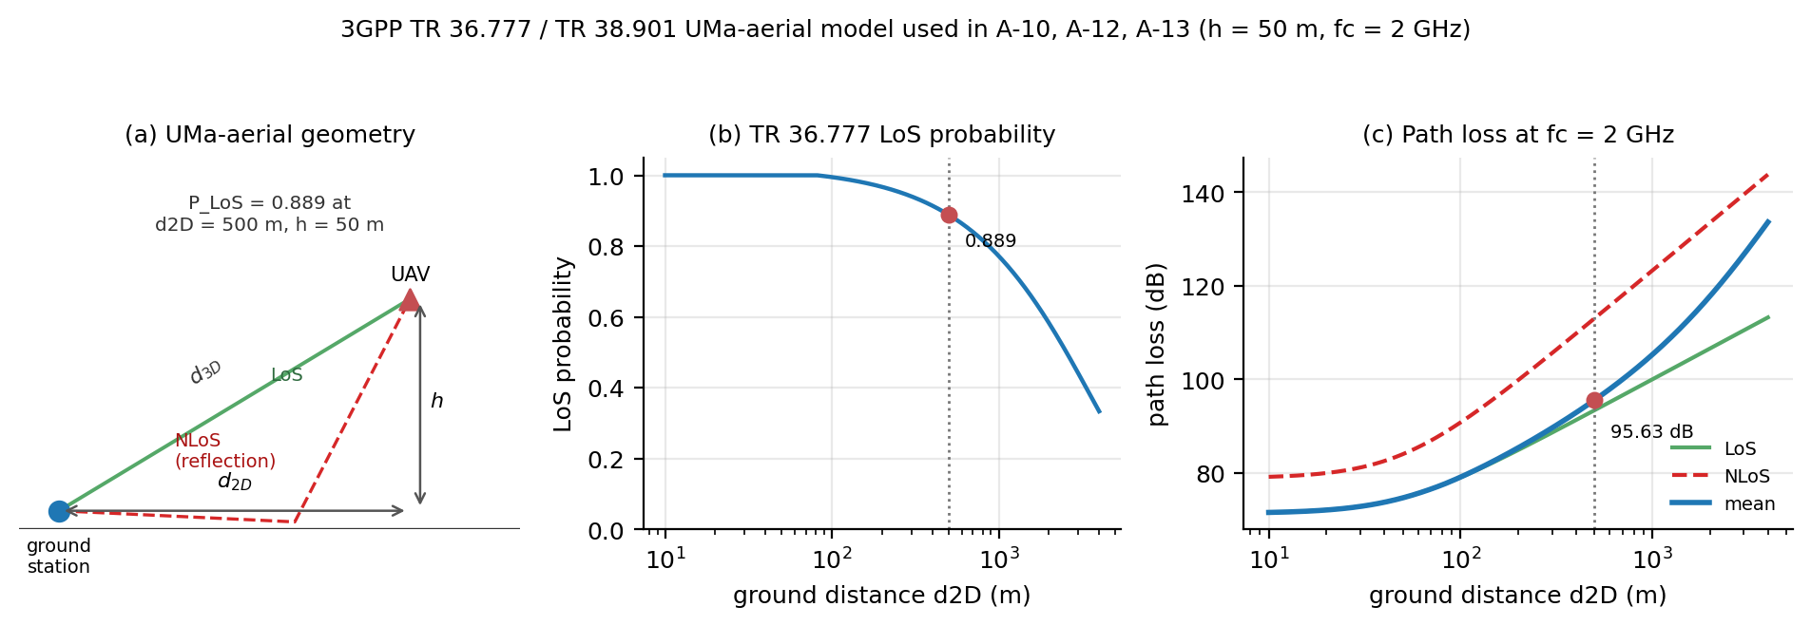
Figure 3.1 — 3GPP UMa-aerial geometry, LoS probability, and path loss at the pinned 500 m / 50 m / 2 GHz geometry.

3.9 DeepJSCC Encoder and Decoder
The encoder maps the six-dimensional normalised state to 2k real values through two hidden layers of width 128 with PReLU activations:
6 → 128 → 128 → 2k real → k complex symbols
The real and imaginary parts are stacked into complex symbols and power-normalised. The decoder is the mirror image:
2k real → 128 → 128 → 6
Both DeepJSCC variants — reconstruction and task-oriented — use exactly the same architecture. They differ only in the training objective. This isolates the effect of the objective.

3.10 The Three Communication Methods
Method A — Conventional digital. Each state component is scalar-quantised to B bits, framed and padded, encoded with a convolutional code (K = 7, rate 1/2), modulated with Gray-labelled QPSK, transmitted over the same channel, and decoded with soft-decision Viterbi. The frozen pairs satisfy 6B + 6 = k exactly, where the six extra uses are the zero-tail termination bits. A pair whose payload would exceed k is declared infeasible and excluded, never silently widened. The B values are k = 12 → B = 1, k = 18 → B = 2, k = 24 → B = 3, k = 30 → B = 4, k = 54 → B = 8. At k = 1, 2, 3 no packet satisfies the invariant (M3); at k = 54 the B = 8 cell is repeated as a clearly labelled secondary reference (M4).
Method B — Reconstruction-oriented DeepJSCC. The encoder/channel/decoder above, trained to minimise the mean-squared reconstruction error between the decoded and original state:
L_recon = (1/6) · E[ ||ŝ_t − s_t||² ]
Method C — Task-oriented DeepJSCC. The same architecture, trained end-to-end on the navigation rollout loss defined in Section 3.11. Gradients propagate from the goal-reaching objective through the decoder, the differentiable channel, and the encoder.

3.11 Task-Oriented Loss
The task loss is a weighted sum of four terms:
L_task = λ_d · L_d + λ_u · L_u + λ_v · L_v + λ_T · L_T
where
L_d = (1/T) Σ_t ||p_t − p_g||² (average squared distance to goal)
L_u = (1/T) Σ_t ||u_t||² (average control effort)
L_v = (1/T) Σ_t ||v_t||² (average velocity)
L_T = ||p_T − p_g||² (terminal squared distance)
The frozen protocol used (λ_d, λ_u, λ_v, λ_T) = (1, 0, 0, 2). The diagnostic extension uses (1, 0.1, 0.1, 2). The control and velocity terms are the subject of the Wave-A ablation in Chapter 5.

3.12 Fairness Conditions
All three methods share the same UAV environment, initial conditions, goal configurations, channel model and SNR for a given cell, bandwidth budget, test episodes, and evaluation seeds. The two DeepJSCC variants have identical architecture and parameter count. The digital baseline is deterministic and untrained. The comparison is therefore matched on every axis except the communication method itself.

3.13 Disclosure of Idealizations
The Rayleigh channel is slow block fading with one complex gain per k-symbol packet. The receiver has perfect CSI and applies ZF equalisation. The transmitter has no CSI. These four idealisations — perfect receiver CSI, ZF, packet-granularity fading, and open-loop power control — are standard in the DeepJSCC literature and are applied identically to all methods. Wave-B quantifies the sensitivity to imperfect CSI by injecting estimation error ε ~ CN(0, σ²) at the receiver; success rate is found to be insensitive up to σ = 0.4, while reconstruction MSE degrades by approximately 18%.
The digital baseline uses a convolutional code with K = 7, rate 1/2, QPSK, and soft-decision Viterbi decoding. The SC polar decoder is used as a low-complexity reference in A-11; the full 5G NR chain with CRC-aided SCL (L = 8) is used in A-15. The primary comparison is between communication paradigms, not between decoder implementations.

Chapter 4 — Methodology and Experimental Design

4.1 Research Design
The project follows a simulation-based, empirical machine-learning methodology in four stages. First, a two-dimensional UAV kinematic environment is implemented, providing ground-truth states and a controller that can operate on ground-truth or communication-degraded estimates. Second, the conventional digital baseline and the reconstruction-oriented DeepJSCC baseline are implemented and validated independently of the navigation task. Third, the task-oriented DeepJSCC system is implemented with the channel embedded as a differentiable layer, so gradients flow from the navigation objective to the encoder. Fourth, all three systems are evaluated under an identical matrix spanning channel type, SNR, and bandwidth, followed by the diagnostic and robustness extensions.

4.2 Training Protocol
The reconstruction model is trained for 5,000 steps with a batch of 4,096 states. The task model is trained for 3,000 steps with a batch of 256 episodes and a horizon of T = 100. Both use Adam with learning rate 1e-3, gradient clipping at 1.0, and no early stopping. The training SNR is sampled uniformly from 0 to 20 dB per batch. The final checkpoint, not a best-validation checkpoint, is used in all evaluations. Training seeds are {42, 43, 44}; the test seed is 10042. All training and evaluation are CPU-only, which makes execution deterministic for a given seed and configuration.

4.3 Experimental Matrix
The matrix spans the following dimensions.
Table 4.1 — Experimental matrix.
Dimension | Levels
Channel | AWGN; slow Rayleigh fading; Clarke/Jakes time-correlated Rayleigh (A-19); 3GPP UMa-aerial (A-10, A-12, A-13, A-17)
SNR | 0, 2, 4, …, 20 dB (M1); 0, 5, 10, 15, 20 dB (M2 and most extensions); −15…+20 dB nominal (A-12/A-13)
Bandwidth k | 1, 2, 3 (M1, M3); 12, 18, 24, 30, 54 (M2); 54 (M4)
Method | Digital; reconstruction DeepJSCC; task-oriented DeepJSCC
Seeds | 42, 43, 44; 45, 46, 47 for A-14
Test episodes | 5,000 per unit (M2, M4, Wave-B); 1,000 per unit (M1, M3 is structural, Wave-A, Wave-C, M5, A-9…A-20)

Table 4.2 — Experiment blocks actually executed.
Block | Purpose | Design actually run | Status
M1 | Task vs reconstruction at severe bandwidth | k = 1, 2, 3; reconstruction + task; AWGN, Rayleigh; E = 5,000 | complete
M2 | Matched-budget three-way comparison | k = 12, 18, 24, 30, 54; digital + reconstruction + task; AWGN, Rayleigh; E = 5,000 | complete
M3 | Digital infeasibility boundary | k = 1, 2, 3; digital; structural display | complete (no measurement)
M4 | Secondary B = 8 bandwidth reference | k = 54; digital; AWGN, Rayleigh; E = 5,000 | complete (secondary)
M5 | Task-loss component removal, uncoded digital, cross-channel | M5a: 12 cells, k = 12/18, seed 42; M5b: 20 conditions; M5c: 2 units; E = 1,000 | complete with one declared failure (A-18)
Wave-A | Loss-component / λ ablation | k = 12; six arms; AWGN, Rayleigh; E = 1,000 | complete with two documented failures (85/90 slots)
Wave-B | CSI-estimation-error ablation | all k; σ = 0, 0.05, 0.1, 0.2, 0.4; 350 cells; E = 5,000 | complete
Wave-C | λ-shaping at other bandwidths | k = 18, 54; λ-heavy; AWGN, Rayleigh; seed 42; E = 1,000 | complete (pre-registered screening subset)
A-9 | Capacity ablation (width 256) | k = 18; frozen task arm; AWGN, Rayleigh; seed 42 | complete (negative)
A-10 | 3GPP UMa-aerial link budget | k = 18, 54; λ-heavy + digital; E = 1,000 | complete
A-11 | Polar vs convolutional baseline | all k; CRC-8 SC polar; AWGN, Rayleigh; E = 1,000 | complete
A-12 | Training under full 3GPP dispersion | k = 18, 54; λ-heavy; UMa-aerial; E = 1,000 | complete (negative, kept)
A-13 | 3GPP training with outage tail resampled | k = 18, 54; λ-heavy; UMa-aerial; E = 1,000 | complete
A-14 | Seed variance of the λ arm at k = 24 | k = 24; seeds 45, 46, 47; AWGN, Rayleigh; E = 1,000 | complete
A-15 | Full 5G NR polar comparator | all k; CRC-6/11, CA-SCL L = 8; AWGN, Rayleigh; E = 1,000 | complete
A-16 | M5 execution (pre-registration) | λ-term removal, uncoded QPSK, cross-channel; M5 root only | complete (A-18)
A-17 | 3GPP multi-geometry link budget | 12 geometries; d_2D 200/500/1000 m, h 50/100 m, f_c 2/3.5 GHz; E = 1,000 | complete
A-18 | M5a declared failure | m5_no_u, k = 18, AWGN, seed 42; non-finite gradients | kept, not retrained
A-19 | Doppler / time-correlated Rayleigh | 10 Doppler points × k = 12, 54 × 5 SNR; λ-heavy + digital; E = 1,000 | complete (i.i.d. model validated)
A-20 | 5G NR LDPC BG2 comparator | all k; AWGN, Rayleigh; E = 1,000 | complete

The matrix is deliberately heterogeneous: M1–M4 are the frozen protocol, while Waves A–C and A-9–A-20 are dated, additive amendments with their own evaluation budgets. Comparisons across blocks are therefore labelled by protocol, and no block is silently pooled with another. Table 4.2 is the completeness map: M3 is structural, M4 is secondary, and M5 is complete with one declared failure rather than deferred.
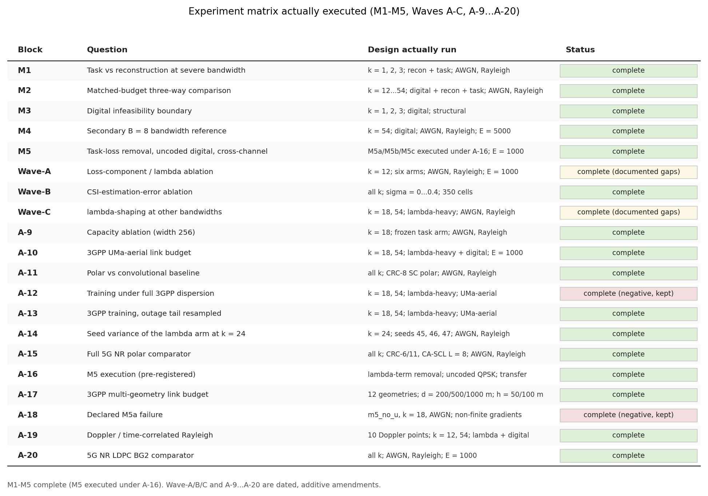
Figure 4.1 — Experiment matrix actually executed: M1–M5, Waves A–C, and A-9…A-20.

4.4 M1 — Low-Bandwidth Study
M1 evaluates k = 1, 2, 3 with 198 paired evaluation units and three seeds. It establishes the baseline behaviour of the task and reconstruction arms at severe bandwidth limits. The result is that reconstruction reaches 24–31% success while the frozen task arm sits at 2–5% and is flat across SNR.

4.5 M2 — Matched-Budget Three-Way Comparison
M2 evaluates k = 12, 18, 24, 30, 54 with 150 evaluation units, three seeds, and 5,000 episodes per unit. It is the main benchmark and produces the bandwidth-crossover result. The frozen (k, B) pairs satisfy 6B + 6 = k exactly; infeasible cells are declared, not widened.

4.5.1 M3 — Digital Infeasibility Boundary
M3 is a structural display, not a performance run. The digital packet invariant is 6B + 6 ≤ k. At k = 1, 2, 3 even B = 1 requires 12 channel uses, so the available budget is short by 11, 10, and 9 uses respectively. No training or evaluation exists for these cells by design; they are declared infeasible. The purpose is to make the low-bandwidth comparison honest: M1 has no digital arm because the matched-budget digital link cannot be built there, not because it was omitted.

4.5.2 M4 — Secondary B = 8 Bandwidth Reference
M4 is a secondary, evaluation-only reference at B = 8, k = 54 (6·8 + 6 = 54), E = 5,000, one cell per channel on the M2 SNR grid. It duplicates the M2 k = 54 digital cell as a clearly labelled reference and is never used as a primary cell. Its purpose is to show how much bandwidth a separated design needs: at 0 dB AWGN the B = 8 link reaches 0.974, while the λ-heavy neural link reaches 0.999 at k = 18 (Wave-C, E = 1,000). The protocol difference is stated, and the comparison is an order-of-magnitude bandwidth statement, not a precise dB gain.

4.6 Wave-A — Loss-Component Ablation
Wave-A is a post-freeze diagnostic at k = 12, three seeds, both channels, with E = 1,000. It tests six arms: the frozen task loss; a light control penalty (λ_u = λ_v = 0.01); a heavy control penalty (0.1); a reconstruction auxiliary loss; fixed-SNR (10 dB) training; and longer training (12,000 steps). It also includes an untrained random model as a metric-sanity control. Wave-A completes 85 of 90 slots; two cells fail with non-finite gradients and are reported as failures rather than retrained away.

4.7 Wave-B — CSI-Estimation-Error Ablation
Wave-B evaluates 350 cells across five CSI-error levels (σ = 0, 0.05, 0.1, 0.2, 0.4), all k values, both channels, and E = 5,000. The estimator is ĥ = h + ε, ε ~ CN(0, σ²); equalisation and LLR-noise scaling use ĥ only. The error is paired across methods and across σ, so every method sees identical episodes. The σ = 0 gate reproduces the frozen M2 results bit-exactly (70/70 gates pass).

4.8 Wave-C — Generalisation of λ-Shaping
Wave-C is a four-cell screening study: λ-heavy at k = 18 and 54, both channels, seed 42, E = 1,000. It asks whether the k = 12 fix generalises to other bandwidths. All four cells train in parallel; wall-clock is 4,956–5,457 s per cell.

4.9 Extensions A-9 to A-20
A-9 (capacity). A width-256 task model tests whether the low-bandwidth failure is a capacity artefact.
A-10 (aerial link). The trained λ-heavy checkpoints are evaluated through a 3GPP UMa-aerial large-scale link budget at d_2D = 500 m, h = 50 m, f_c = 2 GHz. Under perfect-CSI ZF, a deterministic gain is exactly an effective-SNR shift, so no retraining is required. LoS and NLoS curves are mixed with P_LoS.
A-11 (SC polar). A CRC-8 polar code with SC decoding and no rate matching is compared with the convolutional baseline on the same episodes. It tests whether the crossover depends on the specific classical code.
A-12 (3GPP dispersion training). The λ-heavy arm is retrained under the full 3GPP dispersion (per-episode LoS/NLoS, TR 38.901 shadowing, block fading). It is a negative result: both cells diverge.
A-13 (outage-tail resampling). The same design, but the rare >20 dB outage tail (3.78% of episodes) is resampled. It tests whether the divergence is caused by those rare high-error episodes.
A-14 (k = 24 seeds). Six cells, three seeds, two channels, test whether the k = 24 result is a one-initialisation artefact.
A-15 (5G NR polar). A full 5G NR polar chain — CRC-6/11, 5G reliability construction, rate matching, CA-SCL with L = 8 — is compared with the convolutional baseline on the frozen grid and identical episodes. It is the strongest classical comparator in the thesis.
A-16 (M5 execution). The frozen protocol declared M5 (task-loss component removal, uncoded digital reference, cross-channel training) as deferred because its specification was incomplete. A-16 supplies the specification before the first cell: three arms that each remove one λ term from the heavy arm, a payload-maximal and a payload-matched uncoded QPSK reference, and a cross-channel transfer evaluation. Everything runs under the frozen steps, architecture, seeds and evaluation stream; only the loss weighting and the reference links are new.
A-17 (multi-geometry). The A-10 method is repeated over twelve geometries (d_2D 200/500/1000 m, h 50/100 m, f_c 2.0/3.5 GHz). It is evaluation-only: the stored λ-heavy checkpoints and the frozen digital baseline are evaluated at effective SNR and mapped to transmit SNR through the LoS/NLoS mixture. The frozen A-10 artifact is not overwritten.
A-18 (declared failure). One M5a cell (m5_no_u, k = 18, AWGN) finishes its steps but ends with non-finite gradients. It is recorded as a failure, is not retrained, and is excluded from that evaluation unit.
A-19 (Doppler). Every earlier result uses block Rayleigh fading: one gain per codeword, independent between the 100 control steps. A-19 replaces that with the Clarke/Jakes time-correlated process, whose ensemble autocorrelation is J0(2πf_dτ), and sweeps the displacement per step Δ = v·DT/λ from 0.033 to 3.34 wavelengths (a factor of four in fade duration) at 2.0 and 0.7 GHz. It is evaluation-only on the stored λ-heavy checkpoints and the frozen digital baseline; the frozen i.i.d. path is preserved bit-for-bit behind a separate RNG stream.
A-20 (5G NR LDPC). A-11 and A-15 answer the "one weak code" objection with polar codes. A-20 adds the other code family the standard uses: 5G NR LDPC base graph 2, with the specified lifting sets, systematic encoding and offset min-sum decoding. The 38.212 rate-matching chain, interleaving and CRC are not implemented, and the arm is labelled that way everywhere; the comparison is therefore "BG2 without the rate-matching chain", never "full 5G NR LDPC".

4.10 Evaluation Metrics
Navigation-level. Goal-reaching success rate (binary, final distance ≤ 0.5 m within T); mean final distance; mean average distance; minimum distance; control effort; time-to-goal; episode failure rate (timeout or workspace exit).
Communication-level. Operating SNR; BER/BLER for the digital baseline; bandwidth/channel-use ratio; reconstruction MSE for the reconstruction baseline.
Trajectory-level. Trajectory MSE against the noiseless-communication rollout, with the caveat that a low trajectory MSE does not imply successful navigation (the post-exit bypass can make MSE look small even when the episode failed).

4.11 Statistical Analysis
All methods are evaluated on bitwise-identical episodes: initial positions, goals, noise, and fading are pre-generated once per (k, channel, SNR, seed) unit and shared across methods. This paired design removes episode-sampling variance from pairwise comparisons. Binary success is compared with the McNemar test (two-sided, continuity-corrected χ²(1)); continuous metrics use the paired t-test. Wilson 95% confidence intervals are reported on all success rates. Three training seeds are used; pooled results aggregate 15,000 episodes per condition in M2. Per-seed means and standard deviations are reported alongside pooled estimates. The pooled Wilson interval reflects variability over training replicas, not statistically independent episodes. No family-wise multiple-comparison correction is applied; the main effects are very large (for example, 0.02 versus 0.99 success), so a Holm or Bonferroni correction would not change the qualitative conclusion. The reported p-values are therefore per-comparison and descriptive for the large effects, not a confirmatory family-wise claim.

4.12 Reproducibility and Engineering Controls
Every tunable constant lives in project/config.py with a provenance tag ([FROZEN], [LIT], or [PROJ]). The codebase has 111 passing tests covering the channel statistics, power normalisation, digital budget, evaluation gates, McNemar formula, architecture width, and protocol locks. The Docker image builds and the full suite runs on Linux in CI. All experiments are CPU-only and deterministic; a given (seed, configuration) pair reproduces bit-identically. Recovery from interruption retrains from the fixed seed under the frozen protocol, rather than resuming a partially saved optimizer state.

Chapter 5 — Results

5.1 M1 — Low Bandwidth (k = 1, 2, 3)
Table 5.1 — M1 low-bandwidth results (k = 1, 2, 3).
Method | Success rate (AWGN) | Behaviour
Reconstruction DeepJSCC | 0.24 – 0.31 | Learns a usable state representation
Task-oriented, frozen loss | 0.02 – 0.05 | Flat across SNR; does not learn the task

The frozen task arm is not merely worse than reconstruction; it is essentially unresponsive to SNR. That pattern motivated the Wave-A diagnosis.

5.2 M2 — The Bandwidth Crossover (Main Result)
Pooled over three seeds and 5,000 episodes per unit, AWGN:
Table 5.2 — M2 success rate by bandwidth on AWGN.
k | Reconstruction | Task (frozen λ) | Digital | Best method
12 | 0.242 | 0.028 | 0.062 | Reconstruction
18 | 0.254 | 0.018 | 0.164 | Reconstruction
24 | 0.233 | 0.034 | 0.306 | Digital
30 | 0.279 | 0.021 | 0.566 | Digital
54 | 0.246 | 0.016 | 0.995 | Digital

The crossover occurs between k = 18 and k = 24. At k = 12 the neural link is roughly four times the digital link; at k = 54 the digital link reaches 0.995 while reconstruction stays near 0.246. Reconstruction MSE is flat in k (0.044–0.047), which shows that the neural decoder is limited by its training objective, not by the number of channel uses.
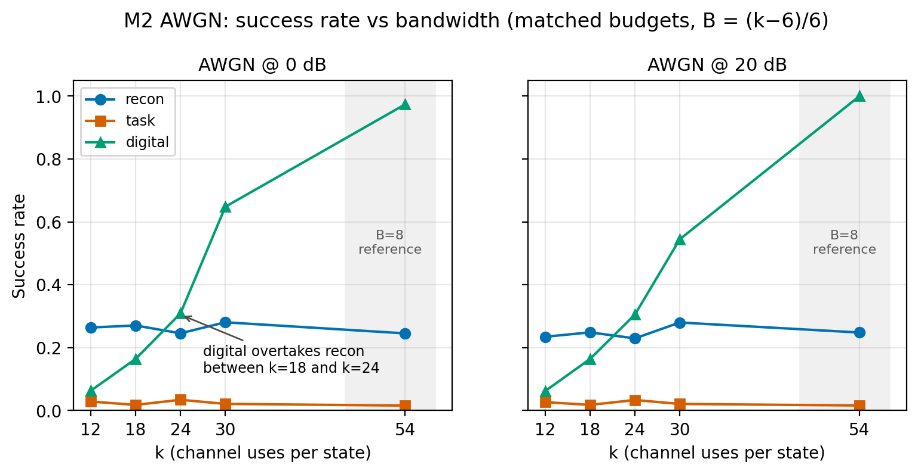
Figure 5.1 — M2 success rate versus bandwidth: the crossover between k = 18 and k = 24.

5.2.1 M3 — The Digital Infeasibility Boundary
M3 is a feasibility display, not a measured result. The digital packet invariant is 6B + 6 ≤ k. At k = 1, 2, 3 even the smallest packet (B = 1) needs 12 channel uses, so the available budget is short by 11, 10, and 9 uses respectively.
Table 5.3 — M3 infeasibility cells.
k | Required at B = 1 | Available | Deficit | Status
1 | 12 | 1 | 11 | infeasible by design
2 | 12 | 2 | 10 | infeasible by design
3 | 12 | 3 | 9 | infeasible by design

The first feasible matched-budget point is k = 12 (B = 1, 6B + 6 = 12). This is why M1 has no digital arm: the matched-budget digital link cannot be built at k = 1–3, not because it was omitted. The neural arms have no equivalent packet constraint, which is a structural property of the comparison, not a coding gain.
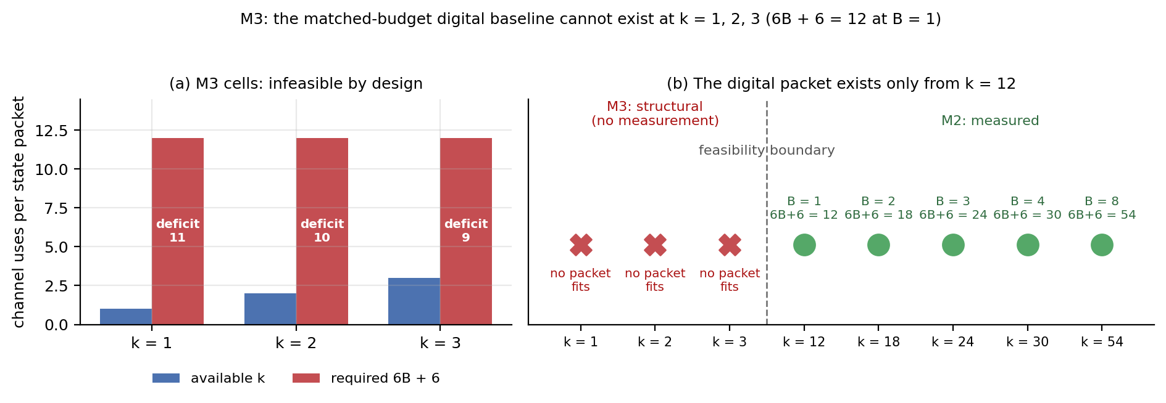
Figure 5.2 — M3: the digital baseline is infeasible at k = 1, 2, 3; the first feasible packet is at k = 12.

5.2.2 M4 — The B = 8 Bandwidth Reference
M4 is the secondary B = 8 reference at k = 54, E = 5,000, one cell per channel. It duplicates the M2 k = 54 digital cell as a clearly labelled reference and is never used as a primary cell.
Table 5.4 — M4 success rate at k = 54, B = 8, E = 5,000.
SNR (dB) | AWGN | Rayleigh
0 | 0.9736 | 0.7178
5 | 1.0000 | 0.9908
10 | 1.0000 | 0.9984
15 | 1.0000 | 0.9998
20 | 1.0000 | 1.0000

At 0 dB the B = 8 link reaches 0.974 on AWGN and 0.718 on Rayleigh; by 5 dB it reaches 1.000 and 0.991. The right panel of Figure 5.3 compares success at 0 dB across bandwidth: the digital link crosses 0.90 only at k = 54, the λ-heavy link is at 0.999 at k = 18, and reconstruction never crosses 0.90. The λ-heavy points use E = 1,000 (Wave-C) while the digital points use E = 5,000 (M2/M4), so this is an order-of-magnitude bandwidth statement, not a precise dB gain.
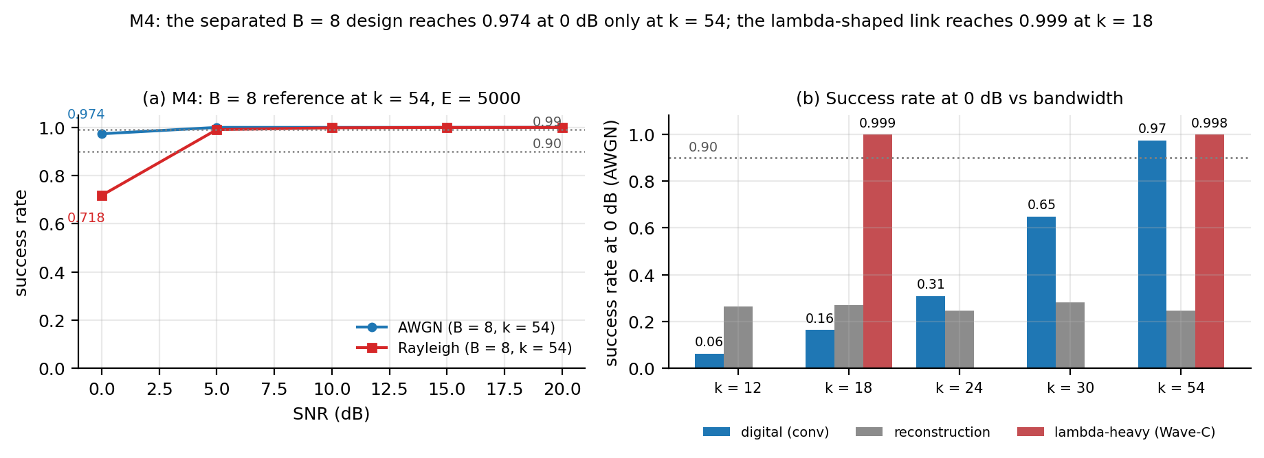
Figure 5.3 — M4: the B = 8 reference at k = 54 and the bandwidth cost of separation.

5.3 Wave-A — The λ-Shaping Diagnosis
At k = 12, three seeds, both channels:
Table 5.5 — Wave-A loss-component ablation at k = 12.
Arm | AWGN | Rayleigh | Conclusion
Frozen task loss (λ_u = λ_v = 0) | 0.020–0.048 | 0.033 | Fails
λ-light (0.01, 0.01) | 0.995 | 0.019 | Fragile / degenerate on Rayleigh
λ-heavy (0.1, 0.1) | 0.997 | 0.997 | Recovers the task
Reconstruction auxiliary loss | 0.243 | 0.244 | Does not fix it
Fixed 10 dB training | 0.050 | — | Does not fix it
Longer training (12k steps) | 0.035 | — | Does not fix it
Untrained random model | 0.016 | — | Metric is not trivially exploitable

Three controls establish that the result is real. First, an untrained model scores 0.016, so the metric cannot be gamed by a trivial policy. Second, at −20 dB the λ-heavy arm drops to 0.279, so the channel is genuinely used. Third, the λ-light Rayleigh arm is degenerate at 0.019, which shows the effect is fragile and depends on the strength of the shaping.
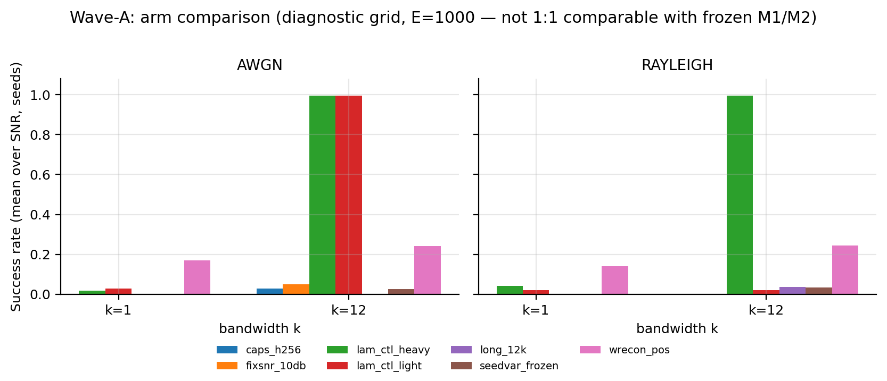
Figure 5.4 — Wave-A arm ablation: only the control-penalty arms recover the task.

5.4 Mechanism — Why λ-Shaping Works
The A-9 mechanism study extracts every per-step gradient measurement stored by the project. The frozen task arm's encoder gradient is enormous: p50 ≈ 3.0 × 10^10 on AWGN and 8.1 × 10^7 on Rayleigh, p99 ≈ 2.4 × 10^18 and 5.0 × 10^18, with 75–100 non-finite gradient steps and no convergence. The λ-heavy arm's gradient is O(1): p50 ≈ 3.3–4.1 and p99 ≈ 57–113, with zero non-finite steps and convergence in 10/10 standard-channel cells (12/12 including A-13). The median separation is roughly seven to ten orders of magnitude, and the p99 separation about seventeen.
A quasi-2 × 2 isolates the trigger: λ off diverges (0/2); λ on with standard channels converges (10/10); λ on with the full 3GPP dispersion diverges (0/2); λ on with the outage tail resampled converges (2/2). Capacity is not the explanation: the frozen-arm histories are from the wider (256) cells and still explode, and A-9 shows a 256-wide frozen cell still fails at 0.027/0.041. The trigger is rare high-error episodes, not parameter count.
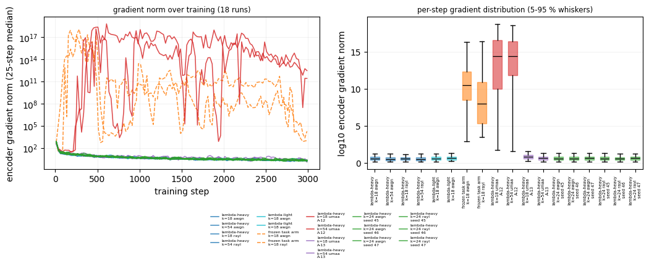
Figure 5.5 — Training stability: λ-shaping lowers the encoder gradient by about seven to ten orders in the median on AWGN/Rayleigh and removes non-finite steps there; under the full 3GPP dispersion (A-12) it does not, which motivates the resampling arm (A-13).

5.5 Wave-B — CSI-Estimation Error
Table 5.6 — Wave-B CSI-estimation-error sweep, pooled across k.
σ_csi | Reconstruction SR | Task SR | Digital SR | Reconstruction MSE | Final distance
0.0 | 0.2468 | 0.0341 | 0.3841 | 0.0488 | 3.491
0.05 | 0.2472 | 0.0342 | 0.3840 | 0.0490 | 3.493
0.1 | 0.2473 | 0.0342 | 0.3846 | 0.0494 | 3.496
0.2 | 0.2467 | 0.0341 | 0.3875 | 0.0512 | 3.515
0.4 | 0.2475 | 0.0339 | 0.3946 | 0.0576 | 3.569

Success rate is essentially flat up to σ = 0.4, while reconstruction MSE degrades monotonically by about 18% at every k (+18.0% at k = 12, +18.5% at k = 18, +17.8% at k = 24, +18.2% at k = 30, +17.6% at k = 54). The honest claim is therefore: closed-loop success is insensitive to CSI magnitude error up to σ = 0.4, but success rate is too coarse to reveal the degradation; MSE exposes it. The digital SR rises slightly with CSI error (0.384 → 0.395); this is physically unexpected and is reported as an anomaly, not as robustness.
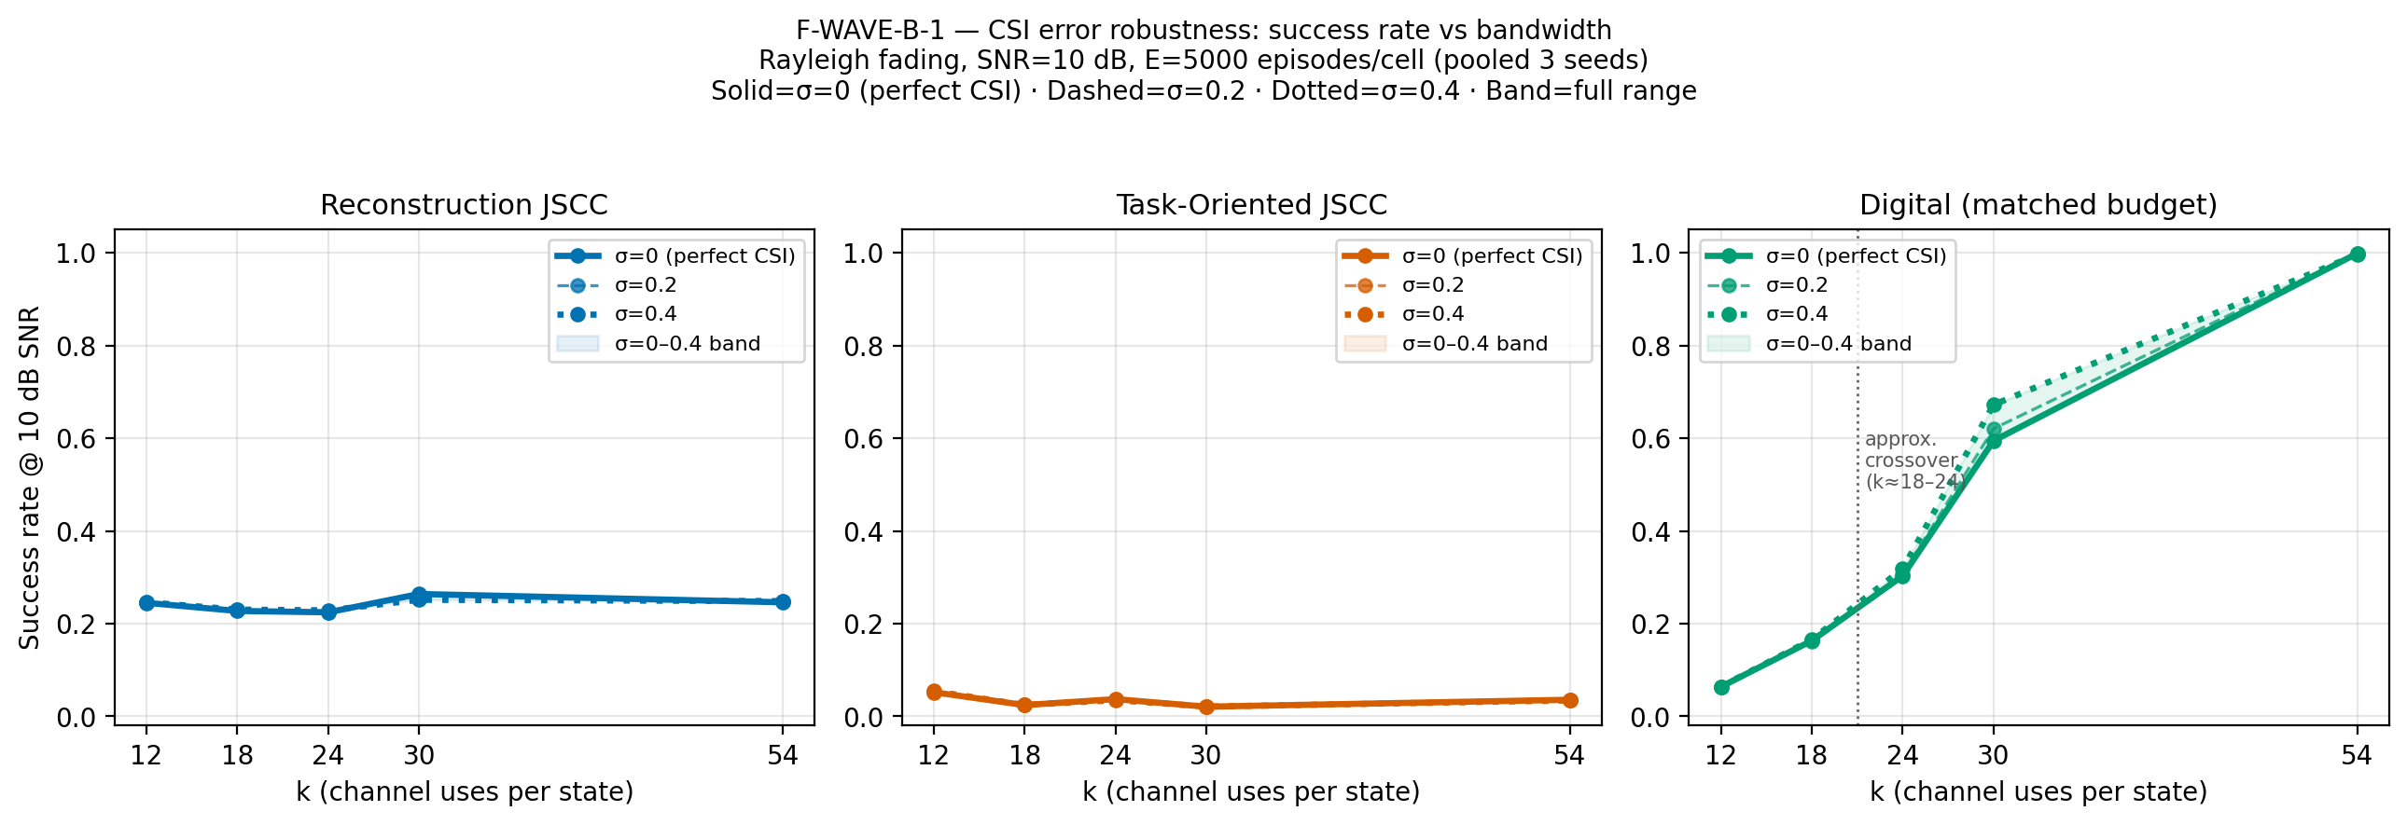
Figure 5.6 — Wave-B: success rate versus k with CSI-error bands.

5.6 Wave-C — Generalisation of λ-Shaping
Table 5.7 — Wave-C λ-heavy success rate at k = 18 and k = 54.
Unit | 0 dB | 5 dB | 10 dB | 15 dB | 20 dB
λ-heavy, k = 18, AWGN | 0.999 | 0.999 | 0.999 | 0.998 | 0.999
λ-heavy, k = 18, Rayleigh | 0.993 | 0.997 | 0.996 | 0.997 | 0.997
λ-heavy, k = 54, AWGN | 0.998 | 0.999 | 0.999 | 0.998 | 0.999
λ-heavy, k = 54, Rayleigh | 0.996 | 0.998 | 0.998 | 0.998 | 0.998

The λ-shaped link is at the task ceiling in every condition. The baselines matter because of that ceiling:
Table 5.8 — Wave-C λ-heavy advantage over the best baseline.
Condition | λ-heavy | Best baseline | Gap
k = 18, AWGN, 0 dB | 0.999 | 0.164 | +83.5 pp
k = 18, Rayleigh, 0 dB | 0.993 | 0.166 | +82.7 pp
k = 54, AWGN, 0 dB | 0.998 | 0.974 | +2.4 pp
k = 54, Rayleigh, 0 dB | 0.996 | 0.718 | +27.8 pp
k = 54, Rayleigh, 20 dB | 0.998 | 1.000 | −0.2 pp (parity)

At k = 54 and high SNR the classical link saturates at 1.000, so λ-shaping cannot win there; it ties. The advantage lives at low SNR, low bandwidth, and fading. A policy that does nothing cannot produce a 0.125 m final distance on a randomly initialised target while spending 341 units of control effort; the success is tracking, not idling.
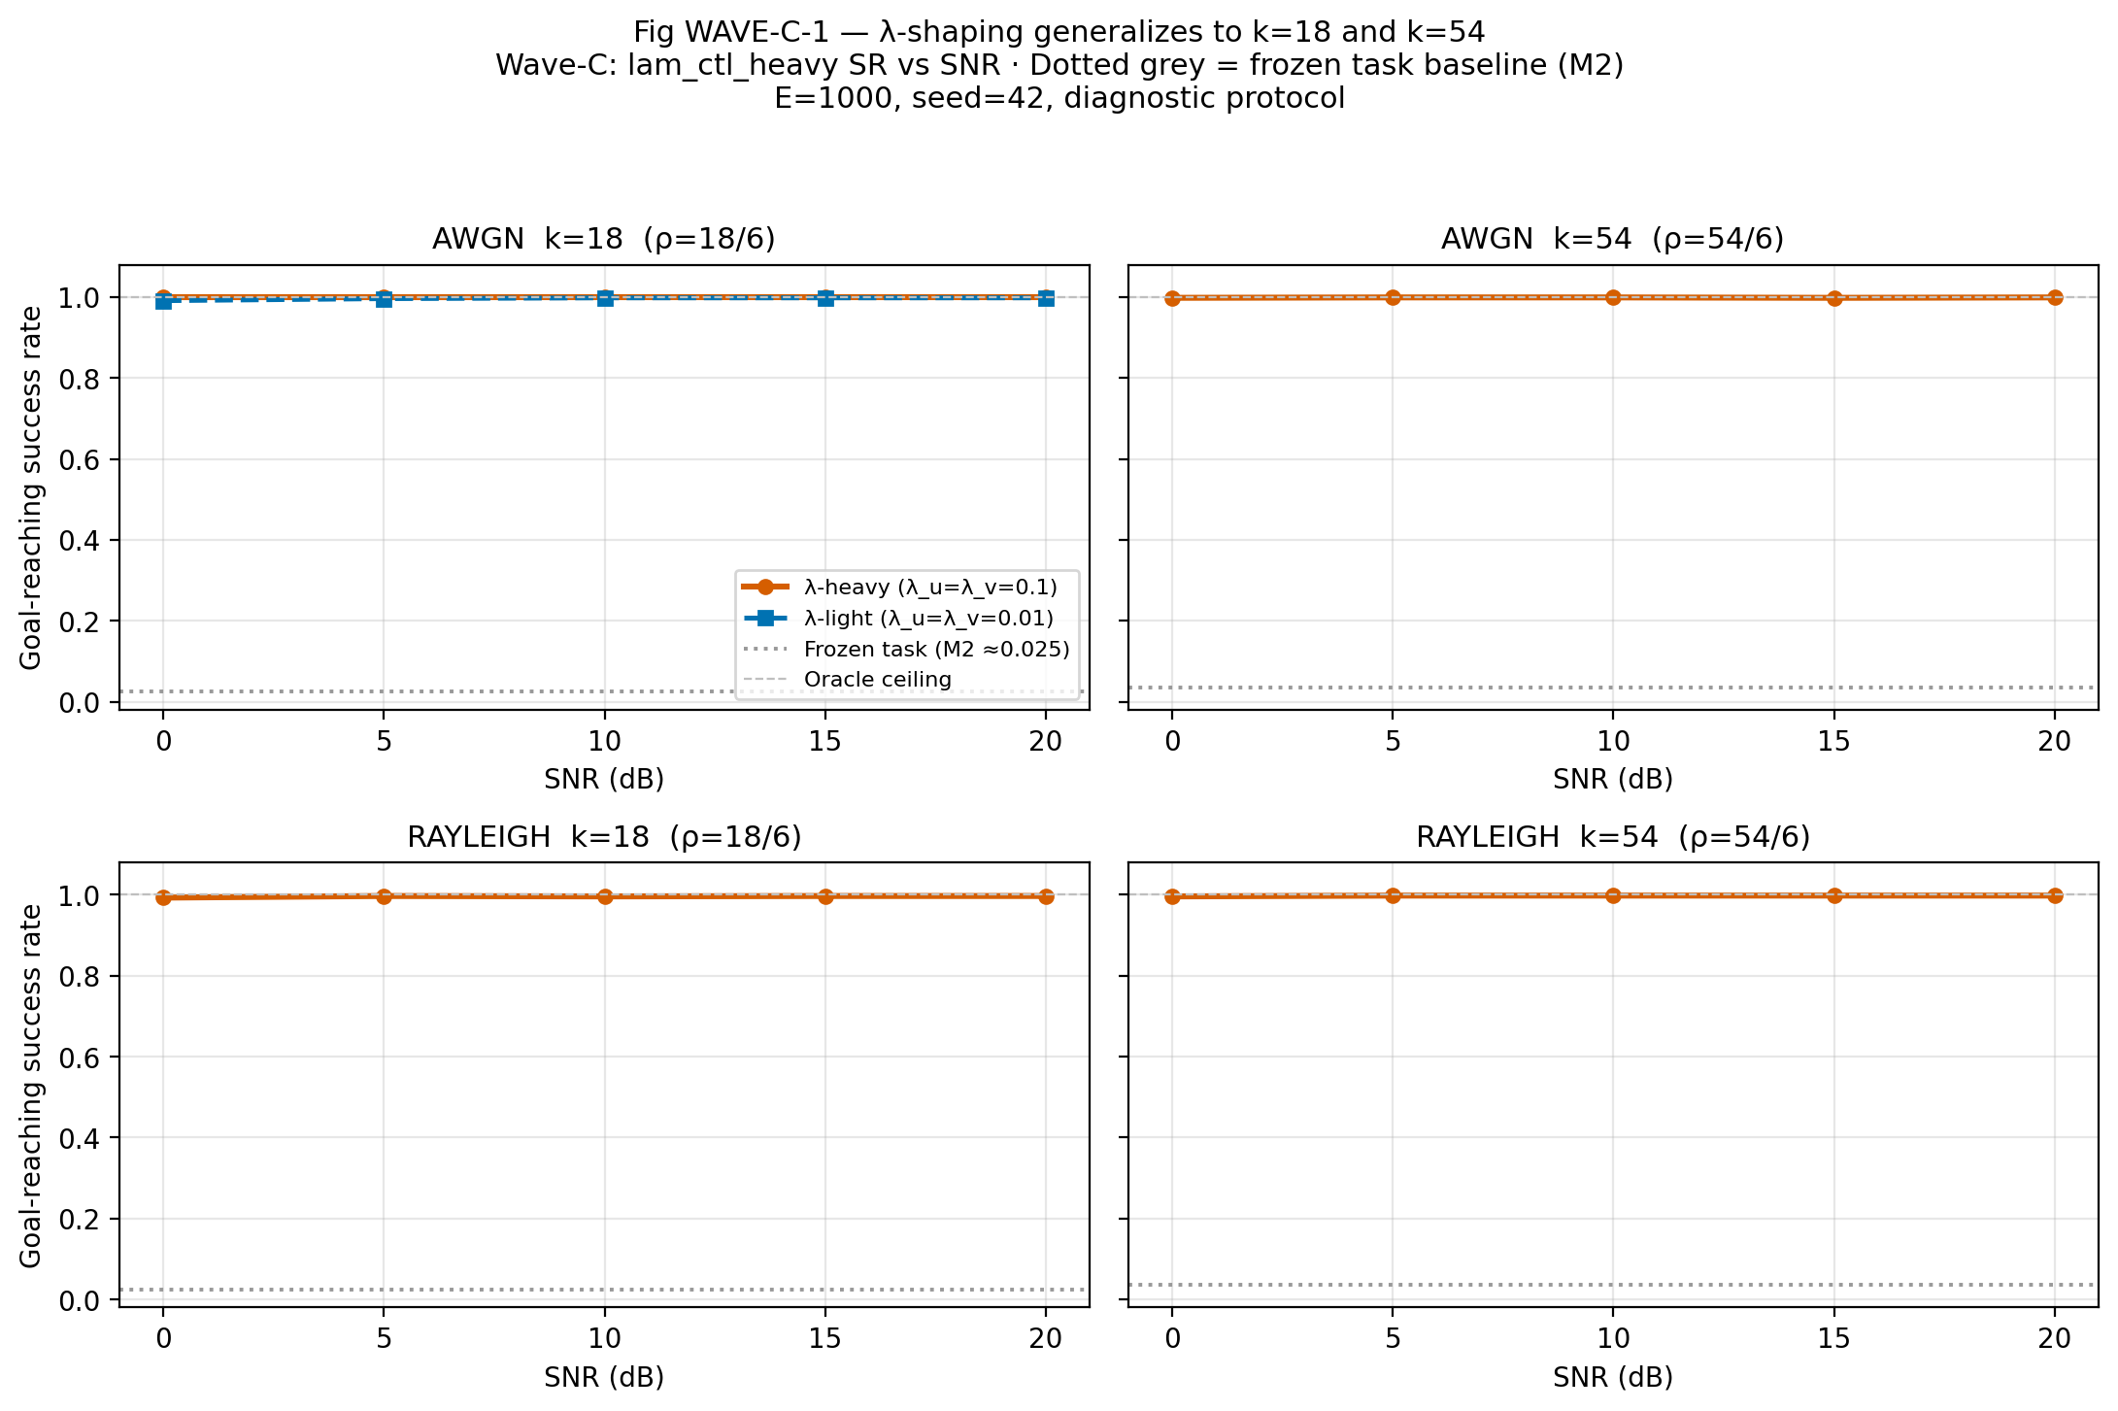
Figure 5.7 — Wave-C: λ-shaping holds at k = 18 and k = 54.

5.7 A-9 — Capacity Ablation
A width-256 task model still fails: 0.027 AWGN and 0.041 Rayleigh, versus 0.018/0.024 at width 128. The task loss falls while reconstruction MSE explodes to about 10^3. The failure is therefore a loss/objective pathology, not a capacity limitation.

5.8 A-10 — 3GPP Aerial Link Budget
At d_2D = 500 m, h = 50 m, f_c = 2 GHz, P_LoS = 0.8887, PL_mean = 95.63 dB:
Table 5.9 — A-10 required transmit SNR on the 3GPP UMa-aerial link.
Method | Transmit SNR for SR ≥ 0.90 | Transmit SNR for SR ≥ 0.99
λ-heavy, k = 18 | 91 dB | 107 dB
λ-heavy, k = 54 | 87 dB | 102 dB
Digital, k = 18 | Not reachable (ceiling 0.17) | Not reachable
Digital, k = 54 | 108 dB | 117 dB

The λ policy's advantage over the classical link is 21 dB at 0.90 and 15 dB at 0.99 for k = 54, and unbounded at k = 18 where the classical link is payload-limited. The model includes LoS probability, LoS/NLoS path loss, and their mixture. It does not model Doppler, shadowing, aerial small-scale fading, antenna patterns, noise figure, or bandwidth. A single geometry is a weak basis for a trend, so A-17 repeats the identical evaluation over twelve geometries: d_2D ∈ {200, 500, 1000} m, h ∈ {50, 100} m, f_c ∈ {2.0, 3.5} GHz, E = 1,000 per point, using the stored Wave-C λ-heavy checkpoints and the frozen digital baseline. Nothing is retrained and the frozen A-10 artifact is untouched.
Table 5.10 — A-17 multi-geometry link budget: transmit SNR for SR ≥ 0.90 at k = 54.
d_2D (m) | h (m) | f_c (GHz) | P_LoS | PL_mean (dB) | λ-heavy | Digital | Advantage
200 | 50 | 2.0 | 0.967 | 85.4 | 74 | 89 | +15
200 | 50 | 3.5 | 0.967 | 90.3 | 79 | 94 | +15
200 | 100 | 2.0 | 1.000 | 85.7 | 74 | 90 | +16
200 | 100 | 3.5 | 1.000 | 90.6 | 79 | 95 | +16
500 | 50 | 2.0 | 0.889 | 95.6 | 87 | 108 | +21
500 | 50 | 3.5 | 0.889 | 100.5 | 92 | 113 | +21
500 | 100 | 2.0 | 0.945 | 94.4 | 83 | 99 | +16
500 | 100 | 3.5 | 0.945 | 99.2 | 88 | 103 | +15
1000 | 50 | 2.0 | 0.772 | 105.3 | 103 | 123 | +20
1000 | 50 | 3.5 | 0.772 | 110.2 | 108 | 127 | +19
1000 | 100 | 2.0 | 0.853 | 102.6 | 94 | 114 | +20
1000 | 100 | 3.5 | 0.853 | 107.4 | 99 | 119 | +20

The advantage does not collapse: it stays between 15 and 21 dB across a 5× span in distance, a 2× span in altitude and a 1.75× span in carrier frequency, and narrows only to 12–15 dB at the 0.99 target. The 500 m / 50 m / 2 GHz row reproduces A-10 exactly (87 dB against 108 dB), which confirms that the sweep measures the same quantity rather than a re-implementation. Distance dominates at roughly 29 dB per 5× distance — steeper than free space, because the 3GPP aerial NLoS branch adds a height-dependent exponent — and raising altitude from 50 to 100 m recovers 9 dB at 1000 m as P_LoS rises from 0.772 to 0.853. Carrier frequency adds a flat 5 dB from 2.0 to 3.5 GHz, shifting the budget without changing the comparison. The λ-heavy k = 18 arm needs 78–113 dB for 0.90; the digital k = 18 arm never reaches 0.90 at any geometry.
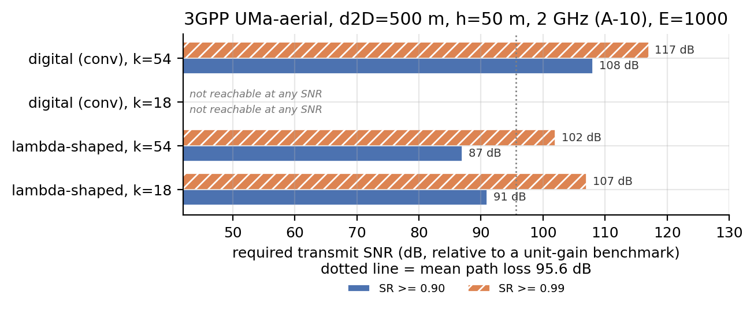
Figure 5.8 — A-10: required transmit SNR on the 3GPP UMa-aerial link.

5.9 A-11 and A-15 — Is the Digital Baseline Artificially Weak?
A-11 uses CRC-8 polar with SC decoding and no rate matching. At k = 12, 18, 24 the two coders are within 0.05 of each other once the payload ceiling is reached; at k = 30 polar is better at ≥10 dB; at k = 54 with B = 8, plain SC polar is worse at low SNR and reaches parity only at 10–15 dB.
A-15 uses the full 5G NR chain (CRC-6/11, 5G reliability construction, rate matching, CA-SCL with L = 8), pooled over five SNRs at E = 1,000:
Table 5.11 — A-15 full 5G NR polar comparator versus the convolutional baseline.
k | Convolutional | 5G NR polar + CA-SCL | Reading
12 | 0.0654 | 0.0656 | Identical
18 | 0.1470 | 0.1504 | Identical within CI
24 | 0.2818 | 0.2926 | 5G slightly better; still above reconstruction 0.235
30 | 0.5436 | 0.5596 | 5G slightly better
54 | 0.9952 | 0.9092 | Convolutional still stronger

The crossover at k = 18 → 24 survives every coded comparator tested. The reported gap does not depend on the convolutional code being weak. The strongest comparator is not a code at all, however: M5b (§5.12.2) removes the channel code entirely and shows that the low-bandwidth ceiling is a payload/framing artefact, so the comparator must travel with the claim.
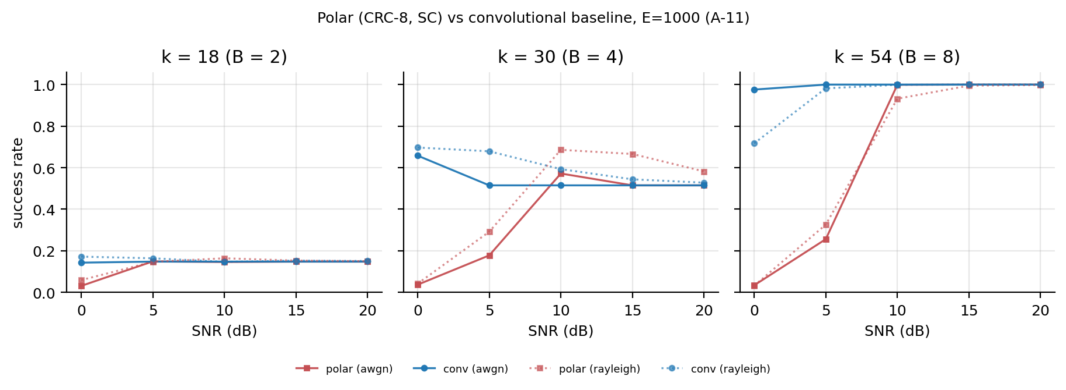
Figure 5.9 — A-11: polar versus convolutional digital baseline.

5.10 A-12 and A-13 — Training under 3GPP Dispersion
A-12 retrains the λ-heavy arm under the full 3GPP dispersion at k = 18 and 54. Both cells complete and both training runs collapse: final losses of 4,320 and 210, with 311 and 203 non-finite gradient steps. The checkpoints are flat at 0.02–0.03 success. The result is reported as the negative result it is and is not retrained.
A-13 repeats the design with the >20 dB outage tail (3.78% of episodes) resampled. Training is stable (loss 4,643 → 16.2), and the operating point moves by at most about 2.2 dB relative to the Rayleigh-trained arm; the confidence intervals overlap, but no formal equivalence test was performed. The honest claim is that training under the dispersion does not move the operating point; it is not a claim that 3GPP training recovers a specific number of dB. A-13 trains on 96.2% of the dispersion (100% LoS, 66% NLoS) and evaluates on 100%, with a single training seed and a single truncation threshold.

5.11 A-14 — k = 24 Seed Variance
Six cells, three seeds, two channels: success ranges from 0.995 to 1.000 with a seed-to-seed range ≤ 0.004. The k = 24 number is not a one-initialisation artefact. Because the metric is at its ceiling, the study rules out a large initialisation dependence rather than measuring seed variance at a non-saturated point.

5.12 M5 — Deferred Ablations Executed (A-16, A-17, A-18)
The frozen protocol declared M5 as a deferred block: task-loss component removal, an uncoded digital reference, and cross-channel training. A-16 registered the design before the first cell, so the block is reported as pre-registered evidence rather than as an afterthought. All cells run under the frozen steps, architecture, seeds and evaluation stream; only the loss weighting (M5a) and the reference links (M5b/M5c) are new. The block is diagnostic at E = 1,000 per unit and is not pooled with the E = 5,000 frozen matrix.

5.12.1 M5a — which λ term carries the effect
Starting from the λ-heavy arm (λ_d, λ_u, λ_v, λ_T) = (1.0, 0.1, 0.1, 2.0), one term is removed at a time.
Table 5.12 — M5a task-loss component removal, mean success over 0–20 dB (E = 1,000).
Arm | Removed | k = 12 AWGN | k = 12 Rayleigh | k = 18 AWGN | k = 18 Rayleigh
m5_no_u | control penalty | 0.016 | 0.016 | failed | 0.027
m5_no_v | velocity penalty | 0.997 | 0.996 | 0.996 | 0.994
m5_no_T | terminal penalty | 0.996 | 0.993 | 0.999 | 0.992
reference (Wave-A/C) | — | 0.997 | 0.997 | 0.999 | 0.996

The control-effort penalty is the active term. Removing it collapses success to 0.016–0.027, raises the final loss by one to two orders of magnitude (305 to 5,214 against about 16), and at k = 18 AWGN destroys training outright: final loss 5,213.5 with non-finite gradients at the final step. That cell is a declared failure (A-18), is not retrained, and is excluded from the k = 18 AWGN evaluation unit, which therefore contains two arms rather than three. Removing λ_v or λ_T changes nothing outside the ceiling. The mechanism claim therefore sharpens from "λ-shaping works" to "λ_u is the term that works, and removing it reproduces the original frozen-arm failure". This is consistent with the gradient-conditioning account: L_u is the only term that is a direct function of the action applied to the plant, and therefore the only term that shapes the encoder gradient through the closed loop. The experiment localises the effect; it does not prove that causal chain.

5.12.2 M5b — the uncoded digital reference
A-11 and A-15 tested alternative channel codes. M5b removes the code entirely. Uncoded QPSK carries two bits per symbol, so the budget is 3B ≤ k rather than 6B + 6 ≤ k. Two variants are reported: uncoded_bmax uses the whole bandwidth (B = floor(k/3)), and uncoded_bcoded carries the same payload as the coded baseline (B = floor((k−6)/6)) with the code removed.
Table 5.13 — M5b uncoded QPSK versus the coded baseline and reconstruction, AWGN, mean over 0–20 dB.
k | Reconstruction (M2) | Task, frozen λ (M2) | Digital, convolutional (M2) | Uncoded, B = k/3 | Uncoded, same payload
12 | 0.242 | 0.028 | 0.062 | 0.526 (B = 4) | 0.064 (B = 1)
18 | 0.254 | 0.018 | 0.164 | 0.880 (B = 6) | 0.149 (B = 2)
24 | 0.233 | 0.034 | 0.306 | 0.879 (B = 8) | 0.297 (B = 3)
30 | 0.279 | 0.021 | 0.566 | 0.885 (B = 10) | 0.528 (B = 4)
54 | 0.246 | 0.016 | 0.995 | 0.884 (B = 18) | 0.881 (B = 8)

Three results follow. First, the low-bandwidth digital ceiling is a payload artefact, not a separation artefact: at k = 12 the frozen coded baseline carries B = 1 and reaches 0.062, while the same channel uses uncoded carry B = 4 and reach 0.526 on AWGN (0.581 on Rayleigh). The M3 infeasibility statement is therefore a statement about the frozen coded framing, not about digital communication. Second, the plateau is set by the payload alone: B = 4 gives 0.526 at k = 12 and 0.528 at k = 30, and B ≥ 6 saturates near 0.88, which is a strong internal consistency check on the uncoded path. Third, the crossover depends on the comparator. The frozen coded baseline is overtaken by the λ-heavy arm below k = 54 and ties at k = 54 (0.995 against 0.998); the uncoded full-bandwidth link reaches only 0.884 at k = 54 and is beaten at k = 12, 18 and 24 (0.526 against 0.997, 0.880 against 0.999, 0.879 against about 0.999). No digital variant, coded or uncoded, beats the λ-heavy arm at any bandwidth where both were measured below k = 54 (the λ arm was never trained at k = 30). The headline "digital wins at k ≥ 24" is therefore true of the coded baseline specifically, and the comparator must travel with the sentence.
The non-monotone curves at B = 4 are real and are not a defect. At high SNR the estimate collapses to the deterministic quantised state, whose residual error (one quantiser step, about 1.07 m in position at B = 4) exceeds the 0.5 m goal radius, so the controller cannot settle; at moderate SNR bit errors dither the estimate and occasionally place it inside the goal radius. The frozen coded baseline shows the identical pattern at k = 30 Rayleigh (0.686 at 0 dB falling to 0.551 at 20 dB), so the effect belongs to the frozen quantiser and controller, not to the uncoded link.

5.12.3 M5c — cross-channel transfer
The Wave-C λ-heavy checkpoints at k = 18, seed 42, trained on one channel, are evaluated on the other without fine-tuning.
Table 5.14 — M5c cross-channel transfer, success rate (E = 1,000).
Trained on | Evaluated on | 0 dB | 5 dB | 10 dB | 15 dB | 20 dB
AWGN | Rayleigh | 0.991 | 0.997 | 0.999 | 0.999 | 0.999
Rayleigh | AWGN | 0.999 | 0.998 | 0.998 | 0.997 | 0.997

Transfer is complete at this operating point, but the metric is saturated on both channels, so the experiment cannot distinguish genuine channel-agnosticism from ceiling. The honest claim is that no measurable degradation appears at k = 18, not that the representation is channel-invariant. A harder task or a lower-bandwidth point is needed to resolve the question.

5.13 A-19 — Time-Correlated (Doppler) Fading
Every headline number in this thesis draws one complex gain h ~ CN(0,1) per codeword and redraws it independently at each of the 100 control steps. That is the DeepJSCC slow-fading convention, and it is only correct if the platform moves many wavelengths per control period. With DT = 0.1 s and V_MAX = 5 m/s the displacement per step is Δ = v·DT/λ = 0.033 … 3.34 wavelengths at 2 GHz, so correlation exists only when the platform is nearly hovering — precisely the regime in which a deep fade can persist and the controller must fly through it.
A-19 replaces the i.i.d. draw with a Clarke/Jakes sum-of-sinusoids process (M = 32, per-episode random angles and phases, E|h|² = 1), giving the exact ensemble autocorrelation R(τ) = J0(2π f_d τ), and sweeps ten points on Δ at two carrier frequencies. The frozen i.i.d. control path is untouched and was verified bit-identical. The sweep completes 100 of 100 slots at E = 1,000 per SNR.
Table 5.15 — A-19 correlation structure and success rate, mean over 0–20 dB.
Point | f_d (Hz) | Δ (λ/step) | Mean fade run (steps) | λ, k = 12 | λ, k = 54 | Digital, k = 54
frozen_iid | — | — | 1.10 | 0.997 | 0.998 | 0.940
d0033_2g | 0.334 | 0.033 | 4.08 | 0.994 | 0.997 | 0.912
d0067_2g | 0.667 | 0.067 | 2.17 | 0.997 | 0.998 | 0.925
d0133_2g | 1.334 | 0.133 | 1.33 | 0.997 | 0.997 | 0.938
d0333_2g | 3.336 | 0.334 | 1.11 | 0.996 | 0.998 | 0.941
d3333_2g | 33.356 | 3.336 | 1.11 | 0.996 | 0.997 | 0.940
d0117_07g | 1.168 | 0.117 | 1.43 | 0.997 | 0.998 | 0.933
d0234_07g | 2.335 | 0.233 | 1.15 | 0.996 | 0.997 | 0.933

The marginal distribution is Rayleigh at every point (deep-fade fraction 9.2–9.6 %), so the comparison is not a change of channel law; what changes is duration. At Δ = 0.033 a fade lasts four control steps instead of one. Three results follow. First, the λ-heavy arm is insensitive: the largest deviation from the frozen model is 0.003 at k = 12 and 0.001 at k = 54, i.e. three episodes in a thousand. Second, the digital k = 12 link is payload-limited, not fading-limited — it sits at 0.062–0.067 at every point including the frozen one and cannot use the extra coherence. Third, the digital k = 54 link loses up to 0.028 when fades persist: an uncoded-span convolutional code has no time diversity, so a four-step fade erases a run of symbols that a one-step fade would not. The 0.7 GHz rows reproduce the 2 GHz behaviour at matched Δ (0.933 at 0.117 against 0.938 at 0.133), which supports treating Δ rather than speed or carrier as the controlling variable.
The pre-registered rule asked whether success changes by more than 0.02 in the correlated regime. It was written on "success", not on "neural success", and the digital k = 54 point triggered it (−0.028). The rule was therefore honoured: one training arm was run at the worst measured point (Δ = 0.033, k = 12, Rayleigh, seed 42, λ = (1.0, 0.1, 0.1, 2.0), 3000 steps), not argued away, and no other cell in the matrix was retrained.
Table 5.16 — A-19 rule-triggered follow-up arm, k = 12 at Δ = 0.033, success rate (E = 1,000).
Arm | 0 dB | 5 dB | 10 dB | 15 dB | 20 dB | Mean
Stored i.i.d.-trained checkpoint | — | — | — | — | — | 0.994
Retrained under correlated fading | 0.977 | 0.996 | 0.998 | 0.998 | 0.996 | 0.993

The retrained arm is 0.001 below the stored checkpoint — inside the seed-to-seed spread measured in A-14 and not an improvement. Training under correlated fading neither helps nor hurts at this operating point, so the i.i.d. convention is validated twice over: a policy trained on independent fading does not lose when the fading is correlated, and a policy trained on correlated fading does not gain. The one vulnerability the sweep does find is the digital comparator at k = 54, and it moves in the thesis's favour (0.912 against 0.997). Above Δ ≈ 0.33 the process is indistinguishable from the frozen model, because the correlation time is shorter than the control period.
The experiment is Rayleigh-only. The 3GPP aerial layer remains per-episode block fading; time-correlated shadowing is a different simulator change and is not claimed. Speed is constant within an episode (stationary process), so acceleration is not modelled. The ensemble autocorrelation is exact, but one episode is a finite sum of 32 oscillators, which is why the statistic is reported over 1,000 episodes.

5.14 A-20 — 5G NR LDPC (BG2) Comparator
A-11 and A-15 answer the "one weak code" objection with polar codes. A reviewer can still ask why the other code family in the standard is absent. A-20 adds 5G NR LDPC base graph 2 (TS 38.212 Table 5.3.2-3, 197 non-zero entries vendored rather than retyped), with the eight lifting sets of Table 5.3.2-1 (Kb = 10, Z the smallest valid value with 10Z ≥ A), quasi-cyclic lifting, systematic encoding by a GF(2) solve, and offset min-sum decoding (15 iterations, offset 0.5). Filler positions are NULL and not transmitted, as in the standard. The arm is evaluation-only, on the same episodes, quantiser and QPSK layer as the frozen comparator, with A = 6B source bits and the frozen E = 2k bit budget.
The 38.212 rate-matching chain (circular buffer, bit interleaving, redundancy version), the transport-block CRC and base-graph selection are not implemented; the E budget is filled by taking the first E non-NULL mother bits (systematic payload, then parity). The arm is therefore labelled "5G NR LDPC BG2 without the 38.212 rate-matching chain" everywhere, never "full 5G NR LDPC" — the same honesty level as A-11's "CRC-8 polar, SC, no rate matching".
Pre-flight gates pass before any result is recorded: H c^T = 0 and rank(H) = N − K for every k, noiseless round-trip, monotone AWGN BER, k = 54 BER below 10⁻² at 10 dB, and a bit-level round-trip through the k-symbol interface.
Table 5.17 — A-20 5G NR LDPC BG2 versus the convolutional baseline, mean success over 0–20 dB (E = 1,000).
k | B | Z | N | LDPC AWGN | Conv AWGN | LDPC Rayleigh | Conv Rayleigh
12 | 1 | 2 | 104 | 0.0656 | 0.0654 | 0.0646 | 0.0620
18 | 2 | 2 | 104 | 0.1518 | 0.1470 | 0.1522 | 0.1574
24 | 3 | 2 | 104 | 0.2910 | 0.2818 | 0.2914 | 0.2878
30 | 4 | 3 | 156 | 0.5546 | 0.5436 | 0.6154 | 0.6082
54 | 8 | 5 | 260 | 0.9780 | 0.9952 | 0.9438 | 0.9396

No ordering changes. At k = 12, 18 and 24 the two families do not differ significantly (differences of 0.000–0.009 at E = 1,000, where the 95 % interval near 0.3 is about ±0.03; overlapping intervals are not a formal equivalence test), which is the expected result when both sit at the payload ceiling of a 6-, 12- or 18-bit source. The k = 54 AWGN cell is the only visible gap, and it runs against LDPC: 0.978 against 0.995. The explanation is structural rather than a decoder defect. At Z = 5 the BG2 mother code is K/N = 50/260 ≈ 0.19; the frozen E = 108-bit budget transmits 48 systematic plus 60 parity bits, so the effective rate of 0.44 is obtained by truncating the mother code to its first 108 bits rather than by choosing a higher-rate code (the 38.212 rate-matching chain is omitted), which costs belief propagation exactly where the channel is worst (0 dB). The convolutional baseline at that k has rate 54/108 = 0.5 and a short constraint length, so it is stronger at low SNR; by 5 dB both are at 1.000, and on Rayleigh the two are equal (0.944 against 0.940). This is a consequence of the missing 38.212 rate-matching chain and is reported as such.
The low-bandwidth floor is the more important reading. At k ≤ 24 the lifting size is Z = 2, i.e. N = 104 and K = 20, far below any 5G LDPC design point, and the payload is 6–18 bits. No code family can lift a 0.065–0.29 floor that is set by the frozen framing, which is the same conclusion M5b reached from the payload side. The non-monotone k = 30 curve (0.717 at 0 dB falling to 0.515 at 5 dB) is the frozen quantiser dithering already documented in §5.12.2, not a decoder artefact: the convolutional baseline shows the identical shape.
The digital baseline is therefore defended on both code families the standard uses, at the same honesty level: A-11 (SC polar, no rate matching), A-15 (full 5G NR polar chain), A-20 (LDPC BG2 without the rate-matching chain) and M5b (uncoded, payload-maximal). None of them moves the crossover, and none of them overtakes the λ-heavy arm below k = 54.

5.15 Summary of Findings
- Bandwidth crossover. Neural JSCC wins at k ≤ 18; the classical digital link wins at k ≥ 24. This is the primary thesis contribution and is robust to both 3GPP code families (polar and LDPC). M3 makes the low-bandwidth side structural: the matched-budget digital link cannot exist at k = 1–3. M4 makes the high-bandwidth side concrete: a B = 8 separated design needs k = 54 to pass 0.90 at 0 dB, while the λ-heavy link is at 0.999 with k = 18. M5b qualifies the high-bandwidth side: the crossover is a property of the coded baseline, and no digital variant, coded or uncoded, beats the λ-heavy arm at any measured bandwidth below k = 54.
- Frozen task loss fails. With λ_u = λ_v = 0, the task arm is at 2–5% success and flat across SNR, at every k.
- λ-shaping fixes it. With λ_u = λ_v = 0.1, success reaches 99.7% at k = 12 and 99.3–99.9% at k = 18 and 54, on both channels.
- The mechanism is gradient conditioning. The encoder gradient falls by about seven to ten orders of magnitude in the median; capacity is not the cause.
- CSI magnitude error is hidden by success rate. SR is flat to σ = 0.4; MSE degrades by about 18%.
- Aerial link. The λ policy needs 91 dB (k = 18) or 87 dB (k = 54) of normalised transmit power for 0.90; the digital link needs 108 dB at k = 54 and cannot reach 0.90 at k = 18. Training under the full 3GPP dispersion (A-12) diverges; resampling the >20 dB outage tail (A-13) restores stability but does not move the operating point materially (≤ 2.2 dB; the intervals overlap, but no formal equivalence test was performed).
- Which λ term matters. Removing the control-effort penalty alone collapses success to 0.016–0.027 and diverges at k = 18 AWGN; removing the velocity or terminal penalty changes nothing (0.992–0.999). λ_u is the active term (M5a).
- The low-bandwidth digital ceiling is a framing artefact. At k = 12, uncoded QPSK with B = 4 reaches 0.526 against 0.062 for the frozen coded B = 1 link. The M3 infeasibility boundary is a statement about the frozen packet, not about digital communication (M5b).
- Aerial geometry. Across twelve 3GPP UMa-aerial geometries the λ-heavy advantage over the classical link stays at 15–21 dB for 0.90 and 12–15 dB for 0.99; the 500/50/2 row reproduces A-10 exactly (A-17).
- Doppler is not a threat to the neural claim. Replacing i.i.d. block fading by a Clarke/Jakes process with the exact J0 autocorrelation, over a 100× span in Δ, moves the λ-heavy arm by at most 0.003 (k = 12) and 0.001 (k = 54). The digital k = 54 link loses up to 0.028 at the most correlated point, and retraining under correlation does not improve on the stored checkpoint (0.993 against 0.994), so the i.i.d. convention is validated rather than assumed (A-19).
- The code family does not change the comparison. 5G NR LDPC BG2 does not differ significantly from the convolutional baseline at k = 12–30 (maximum difference 0.011 at E = 1,000; overlapping intervals, no formal equivalence test); at k = 54 it is 0.017 below on AWGN and equal on Rayleigh. The low-k floor is set by the frozen framing, not by the code, and the k = 54 gap follows from truncating the mother code without the 38.212 rate-matching chain (A-20).
- Honest limits. The 0.99+ result is at the task ceiling; high-bandwidth/high-SNR digital reaches 1.000; full-dispersion training (A-12) diverges.

Chapter 6 — Discussion

6.1 When Task-Oriented Communication Wins
The data supports a conditional answer, not a universal one. Task-oriented communication wins when the channel is the binding constraint: low bandwidth (k ≤ 18), low SNR, and fading. In those regimes the neural code allocates its limited symbols to the state information that matters for control, and the digital link is either payload-limited or cliff-limited. At high bandwidth the coded classical link has enough symbols to send the six state components reliably; the neural decoder's objective, not the channel, becomes the bottleneck, and the coded link overtakes the neural arm at k = 54 (0.995 against 0.998, effectively a tie). A payload-maximal uncoded link improves the low-bandwidth end substantially — 0.526 against 0.062 at k = 12 — but still does not overtake the shaped neural arm at any measured bandwidth below k = 54.
This is the direct 6G answer the thesis offers: semantic/task-oriented communication is not a universal replacement for classical communication. It is a regime-specific tool, and the crossover is where the regime changes.

6.2 Why λ-Shaping Works
The frozen task loss optimises distance and terminal distance but places no cost on control effort or velocity. The resulting gradient is enormous and non-finite, and training does not converge. Adding a small control/velocity penalty changes the conditioning of the optimisation, not the capacity of the network. The gradient falls from ~10^14 to O(1), non-finite steps disappear, and the policy converges. The effect is therefore best described as loss shaping for optimisation stability, with a task-level benefit.
The fragility of the λ-light arm on Rayleigh (0.019) is important: the fix is not "any positive λ". The strength of the shaping matters, and the mechanism is sensitive to the channel distribution. A-12 shows that it is also sensitive to rare high-error episodes in training: the same λ arm diverges when the training set contains >20 dB outages, and resampling the tail restores stability.

6.3 Why the Crossover Exists
At low k the digital link cannot carry six quantised components with enough error protection; the payload is too small and the code rate is fixed. The neural link can compress the six components jointly and protect the task-relevant subspace, so it degrades gracefully. At high k the digital link has enough symbols for a low-rate code with strong protection, and its performance saturates near 1.000. The neural decoder, trained on reconstruction MSE, remains limited by its objective and does not improve with k; its MSE is flat in k. The crossover is therefore a statement about the interaction between source dimension, channel uses, and training objective, not about neural networks being universally better.

6.4 Implications for 6G UAV Communication
The results suggest a design rule for aerial links: use task-oriented joint source-channel coding when the uplink is bandwidth-constrained or fading-limited, and use a classical digital link when bandwidth is abundant. The λ-shaping result adds an implementation rule: a task-oriented loss must include the control/effort terms that make the representation useful to the controller; a distance-only objective is not enough. The CSI result adds a measurement rule: success rate alone can hide an 18% reconstruction degradation, so report both task and fidelity metrics.

6.5 The 3GPP Aerial Link and the Cost of Separation
The 3GPP results add two qualifications to the crossover story. First, the aerial link does not change the ordering: the λ-shaped policy remains usable, and its transmit-power advantage over the classical link grows where the classical link is rate-limited (21 dB at 0.90 and 15 dB at 0.99 for k = 54; unbounded at k = 18). Second, the absolute power cost is large: the mean path loss is 95.6 dB, and the required transmit SNR is 87–108 dB relative to a unit-gain benchmark. These numbers are a link-budget statement, not a hardware-feasibility claim; antenna gain, noise figure, and bandwidth are excluded. A-17 shows that the ordering is not a one-geometry coincidence: across a 5× distance, 2× altitude and 1.75× carrier sweep the advantage stays between 15 and 21 dB at 0.90 and between 12 and 15 dB at 0.99. Distance costs about 29 dB per 5×, altitude recovers up to 9 dB, and carrier frequency adds a flat 5 dB. What changes is the absolute budget, not the comparison.
M3 and M4 sharpen the interpretation of the low- and high-bandwidth ends. At k = 1–3 the digital baseline is not a weak competitor; it cannot be built under the matched-budget invariant. At k = 54 the B = 8 digital link is strong, but it needs 54 channel uses to reach 0.974 at 0 dB, whereas the λ-shaped link reaches 0.999 at k = 18. The crossover is therefore best read as a statement about the bandwidth needed to make separation work, not about neural networks being universally better. M5b sharpens this further: when the channel code is removed and the payload is maximised, the digital link improves sharply at low k (0.062 to 0.526 at k = 12) but still does not overtake the λ-heavy arm at any measured bandwidth below k = 54. The crossover is thus about payload efficiency and objective alignment together, and its location depends on which classical comparator is used.
A-12 and A-13 add a training caveat: λ-shaping is robust to the frozen protocol's channel, but not to arbitrary heavy-tailed dispersion. The full 3GPP dispersion puts about 4% of episodes more than 20 dB below the training curriculum, and the frozen recipe diverges; resampling the outage tail restores stability. This is a limitation of the training recipe, not evidence against the λ-shaping mechanism.

6.6 Two Robustness Axes: Channel Model and Code Family
A benchmark can fail in two directions: the channel can be easier than reality, or the comparator can be weaker than reality. A-19 tests the first, A-20 the second, and neither moves the conclusion.
On the channel side, the i.i.d. block-fading convention is the standard DeepJSCC choice and the obvious target for a reviewer. Replacing it with a Clarke/Jakes process that has the exact J0 ensemble autocorrelation, and sweeping the displacement per control period over a factor of a hundred, changes fade duration by a factor of four at the most correlated point — and changes the λ-heavy arm by 0.003 at k = 12 and 0.001 at k = 54. The reason is visible in the policy rather than in the channel: the shaped controller is not relying on a fade ending next step, because it does not need to; it recovers inside the same fade. The one arm that does rely on time diversity is the uncoded-span convolutional comparator at k = 54, which loses 0.028 when a fade persists, and that moves the comparison in the thesis's favour. The rule-triggered retraining arm closes the loop: a policy trained under correlated fading scores 0.993 against 0.994 for the stored one, so the i.i.d. model is adequate for both training and evaluation at this operating point. What A-19 does not show is that correlated shadowing, acceleration within an episode, or aerial-layer Doppler are harmless; those remain outside the model and are listed in Chapter 7.
On the comparator side, the objection is that a K = 7 convolutional code is a weak stand-in for a modern standard. A-11 and A-15 answer it with polar, and A-20 with LDPC: both code families do not differ significantly from the convolutional baseline at k = 12–30, where the digital link is payload-limited (overlapping intervals; no formal equivalence test), and at k = 54 LDPC is slightly worse on AWGN and slightly better on Rayleigh. The convergence of four comparators — SC polar, full 5G NR polar, 5G NR LDPC BG2, and an uncoded payload-maximal link — is the strongest form the claim can take: the crossover is a property of the frozen framing and the objective, not of one code choice. The LDPC result also has a diagnostic value: its k = 54 shortfall is exactly what truncating a rate-0.19 mother code to its first 108 bits (effective rate 0.44, without the 38.212 rate-matching chain) does at 0 dB, which is a statement about the missing rate-matching chain and not about LDPC decoding.
The honest summary is that both axes were tested in the direction that could have hurt the thesis, and both came back either non-significant (overlapping intervals, with no formal equivalence test) or in the thesis's favour. Neither test converts the result into a flight-certified claim, and neither covers the exclusions in Chapter 7.

6.7 Threats to Validity
Internal validity. The controller is fixed, the episodes are paired, and the seeds are fixed, which removes the main confounds. The main internal threat is the choice of λ and the fact that the λ-heavy arm is at ceiling; both are disclosed.
External validity. The model is 2-D, simulation-only, single-UAV, and uses AWGN/Rayleigh plus a large-scale aerial link budget. Doppler (time-correlated Rayleigh) is measured at link level in A-19, but the 3GPP aerial layer keeps block fading and no time-correlated shadowing. Aerial small-scale fading and hardware are not modelled. The results should not be read as flight-certified performance.
Construct validity. Success is a binary 0.5 m radius; it is coarse. MSE and final distance are reported alongside it. The trajectory MSE caveat is documented: a low trajectory MSE does not imply successful navigation because of the post-exit zero-error bypass.
Statistical validity. The McNemar test is paired and the Wilson intervals are reported. The pooled interval reflects training-seed variability, not independent episodes; this is stated explicitly.

Chapter 7 — Limitations
- Simulation only. No physical UAV, no software-defined radio, no flight test.
- Two-dimensional kinematics. No altitude, attitude, wind, or rotor dynamics.
- Fixed controller. The controller is not jointly learned, by design, to keep the comparison fair. A learned controller could change the absolute numbers.
- Perfect CSI in the main study. CSI error is a separate ablation (Wave-B), not a default assumption.
- Channel scope. The core matrix uses flat Rayleigh fading. A-19 adds a time-correlated (Clarke/Jakes) Rayleigh variant and shows the i.i.d. convention is adequate at the operating point, but the core matrix itself is unchanged. The 3GPP UMa-aerial model is an extension (A-10, A-12, A-13), not a replacement for the core matrix. It includes LoS/NLoS path loss, 4/6 dB shadowing, and block fading, but no Doppler, no time-correlated shadowing, and no altitude-dependent small-scale fading.
- λ-shaping is not a universal cure. A-12 diverges under the full dispersion; A-13 restores stability only after resampling the outage tail and does not move the operating point.
- The 0.99+ result is at the task ceiling. It proves the policy works but cannot resolve small differences between good methods.
- Two Wave-A cells failed with non-finite gradients. They are reported as failures, not retrained away.
- CSI success-rate insensitivity is coarse. MSE exposes the 18% degradation that SR hides.
- Polar and LDPC baselines. A-11 used SC polar without rate matching; A-15 adds the full 5G NR chain and confirms the crossover, but the 5G code runs at a higher rate for A ≥ 20 (CRC-11), which is a cost to 5G, not a favour. A-20 adds LDPC BG2 without the 38.212 rate-matching chain; its k = 54 AWGN result is 0.017 below the convolutional baseline because the mother code is truncated to its first 108 bits (no rate matching), not because the decoder fails.
- A-13 coverage. A-13 trains on 96.2% of the dispersion (100% LoS, 66% NLoS) and evaluates on 100%; it is not a full-dispersion training result.
- Aerial geometry is a sweep, but not a mobility model. A-17 covers twelve geometries (200–1000 m, 50–100 m, 2.0–3.5 GHz), so the link budget is no longer a single point; it still has no Doppler, no time-correlated shadowing, and no aerial small-scale fading.
- M3 is structural, not empirical. It shows that the matched-budget digital packet cannot exist at k = 1–3; it is not a measured success rate.
- M4 is secondary. It repeats the M2 k = 54, B = 8 digital cell as a labelled reference; it is not an independent primary result.
- M5 is complete but diagnostic. M5 ran at E = 1,000 and is not pooled with the E = 5,000 frozen matrix. One M5a cell is a declared failure (A-18) and is excluded from its evaluation unit.
- Cross-channel transfer is unresolved. M5c shows no degradation at k = 18, but the metric is saturated there, so the experiment cannot separate transfer from ceiling.
- λ_v and λ_T are not load-bearing. M5a shows they can be removed without measurable loss at this operating point; this is not evidence that they are harmful, and they remain in the primary arm.
- Doppler is measured, not modelled end-to-end. A-19 sweeps the Clarke/Jakes process at 2.0 and 0.7 GHz with a constant velocity inside each episode; it does not model acceleration within an episode, and the 3GPP aerial layer keeps per-episode block fading, so time-correlated shadowing remains unimplemented.
- The LDPC arm is BG2, not the full 38.212 chain. A-20 implements the base graph, the lifting sets, systematic encoding and offset min-sum decoding, but not rate matching, bit interleaving or CRC. At k ≤ 24 the block is far below the code's design point, so a poor LDPC result there is a statement about block length, not about LDPC.

Chapter 8 — Conclusion and Future Work

8.1 Conclusion
This thesis asked whether a DeepJSCC system trained directly on UAV goal-reaching performance beats reconstruction-oriented DeepJSCC and a conventional digital link under matched channel and bandwidth conditions. The answer is conditional and empirically grounded.
At low bandwidth (k ≤ 18) the neural joint source-channel link clearly outperforms the coded digital link; at high bandwidth (k ≥ 24) the coded digital link overtakes it and ties it at k = 54. The crossover is the primary result. M3 shows that at k = 1–3 the matched-budget digital link is not merely weak but structurally infeasible; M4 shows that at k = 54 the B = 8 separated design needs 54 channel uses to reach 0.974 at 0 dB, while the λ-heavy link reaches 0.999 at k = 18. The frozen task-oriented loss, with zero control and velocity penalties, fails at 2–6% success; adding λ_u = λ_v = 0.1 recovers 99.7% at k = 12 and 99.3–99.9% at k = 18 and 54, on both channels. The mechanism is gradient conditioning: the encoder gradient falls by about seven to ten orders of magnitude in the median, and capacity is not the explanation. The result is tested against a 5G NR polar comparator, a payload-maximal uncoded link, a twelve-geometry 3GPP aerial link budget, a CSI-error sweep, and a three-seed replication; the crossover holds for every coded comparator, and the uncoded link does not overtake the neural arm at any measured bandwidth below k = 54. On the 3GPP link the λ-shaped policy requires 91 dB (k = 18) or 87 dB (k = 54) of normalised transmit power for 0.90, against 108 dB for the digital link at k = 54; the digital link cannot reach 0.90 at k = 18. The M5 ablations localise the mechanism to a single term: removing the control-effort penalty alone reproduces the original failure, while removing the velocity or terminal penalty does not. The uncoded reference shows that the low-bandwidth digital ceiling is a payload/framing artefact rather than a separation artefact, which relocates the crossover claim onto the coded baseline and leaves the λ-heavy arm unbeaten below k = 54. The twelve-geometry aerial sweep shows that the required-power gap at k = 54 is stable at 15–21 dB rather than an artefact of one geometry, although it maps one shared performance curve onto each geometry rather than running independent channels. The Doppler sweep shows the i.i.d. fading convention is adequate for the neural arms (≤ 0.003), while correlated fading costs the digital k = 54 baseline up to 0.028 and retraining under correlation gives no gain (0.993 against 0.994). The LDPC comparator shows that the second 3GPP code family gives the same picture: indistinguishable from the convolutional baseline at k = 12–30, 0.017 below it at k = 54 AWGN and equal on Rayleigh. The thesis also reports the negative results honestly: full-dispersion training diverges, one M5a cell diverges, the metric is at ceiling, and the high-bandwidth/high-SNR digital link reaches 1.000.

8.2 Contributions
- A matched-budget benchmark for UAV state transmission: three communication methods, identical episodes, identical channel, identical bandwidth, both AWGN and Rayleigh, plus the M3 feasibility boundary and the M4 B = 8 reference.
- The bandwidth-crossover characterisation: a direct, data-backed answer to when task-oriented/semantic communication should be used in a 6G UAV link.
- The λ-shaping diagnosis and mechanism: why task-oriented training collapses without control/effort terms, and how a small penalty fixes it.
- A 3GPP UMa-aerial assessment: a link-budget evaluation over twelve geometries with a stable 15–21 dB advantage, a dispersion-training negative result, a stable tail-resampled variant, and a transmit-SNR comparison against the digital link.
- A term-level mechanism and a payload-controlled comparator: λ_u isolated as the active term by M5a, and an uncoded payload-maximal reference (M5b) that separates coding gain from payload.
- Two robustness axes, both tested against the thesis: a Clarke/Jakes Doppler sweep that validates the i.i.d. fading convention for the neural arms (A-19), and a 5G NR LDPC BG2 comparator that completes the digital defence on both code families (A-20).
- A reproducible testbed: 111 passing tests, CPU-only determinism, Docker/CI, and frozen configuration with provenance tags.

8.3 Future Work
- A harder task. The current metric is at ceiling; a tighter goal radius, shorter horizon, or cluttered workspace would let the benchmark resolve small differences between good methods.
- Full-dispersion training. A-12 diverges and A-13 only resamples the tail; a principled training scheme for the full 3GPP dispersion is open.
- λ sufficiency. M5a isolates λ_u as the active term at k = 12 and 18; whether λ_v and λ_T can be dropped at a harder, non-saturated operating point, and whether a single combined penalty suffices, remains open.
- Richer channel models. A-19 measures time-correlated Rayleigh at link level, but the 3GPP aerial layer still uses block fading; time-correlated shadowing, aerial small-scale fading, antenna patterns, and multi-UAV interference remain open.
- A full 38.212 LDPC chain. A-20 implements BG2 without rate matching, interleaving or CRC, which is honest for the comparison but not the complete standard chain.
- Learned controller. A jointly learned controller could test whether the communication gain survives control co-design.
- Cross-channel training under a non-saturated metric. M5c is complete but at ceiling; a harder task is needed to measure transfer rather than assume it.
- Hardware validation. A software-defined radio or UAV flight test would test external validity.

References
3GPP. (2017). Technical specification group radio access network; Study on enhanced LTE support for aerial vehicles (TR 36.777). 3rd Generation Partnership Project.
3GPP. (2019). Technical specification group radio access network; Study on channel model for frequencies from 0.5 to 100 GHz (TR 38.901). 3rd Generation Partnership Project.
3GPP. (2023). Technical specification group radio access network; Multiplexing and channel coding (TS 38.212). 3rd Generation Partnership Project.
Bourtsoulatze, E., Kurka, D. B., & Gündüz, D. (2019). Deep joint source-channel coding for wireless image transmission. IEEE Transactions on Cognitive Communications and Networking, 5(3), 567–579. https://doi.org/10.1109/TCCN.2019.2919300
Diao, Y. (2025). Task-oriented communication for edge intelligence enabled connected robotics systems (Doctoral thesis, University of Glasgow). University of Glasgow Theses Repository.
Diao, Y., Meng, Z., Xu, X., She, C., & Zhao, P. G. (2024). Task-oriented source-channel coding enabled autonomous driving based on edge computing. In Proceedings of the 17th International Workshop on Networked Robotics and Communication Systems (NetRobiCS 2024), IEEE INFOCOM Workshops. https://doi.org/10.1109/INFOCOMWKSHPS61880.2024.10620735
Diao, Y., Zhang, Y., De Martini, D., Zhao, P. G., & Li, E. L. (2025). Task-oriented co-design of communication, computing, and control for edge-enabled industrial cyber-physical systems. IEEE Journal on Selected Areas in Communications (early access). Preprint: arXiv:2503.08661.
Diao, Y., Zhang, Y., She, C., Zhao, P. G., & Li, E. L. (2025). Aligning task- and reconstruction-oriented communications for edge intelligence. IEEE Journal on Selected Areas in Communications (early access). https://doi.org/10.1109/JSAC.2025.3559121
Fang, Z., Liu, Z., Wang, J., Hu, S., Guo, Y., Deng, Y., & Fang, Y. (2025). Task-oriented communications for visual navigation with edge-aerial collaboration in low altitude economy [Preprint]. arXiv:2504.18317.
Gündüz, D., Qin, Z., Aguerri, I. E., Dhillon, H. S., Yang, Z., Yener, A., Wong, K. K., & Chae, C.-B. (2023). Beyond transmitting bits: Context, semantics, and task-oriented communications. IEEE Journal on Selected Areas in Communications, 41(1), 5–41. https://doi.org/10.1109/JSAC.2022.3223408
Khuwaja, A. A., Chen, Y., Zhao, N., Alouini, M.-S., & Dobbins, P. (2018). A survey of channel modeling for UAV communications. IEEE Communications Surveys & Tutorials, 20(4), 2804–2821.
Kingma, D. P., & Ba, J. (2015). Adam: A method for stochastic optimization. In Proceedings of the 3rd International Conference on Learning Representations (ICLR).
Kurka, D. B., & Gündüz, D. (2021). Bandwidth-agile image transmission with deep joint source-channel coding. IEEE Transactions on Wireless Communications, 20(12), 8081–8095.
McNemar, Q. (1947). Note on the sampling error of the difference between correlated proportions or percentages. Psychometrika, 12(2), 153–157.
Paszke, A., Gross, S., Massa, F., Lerer, A., Bradbury, J., Chanan, G., Killeen, T., Lin, Z., Gimelshein, N., Antiga, L., Desmaison, A., Köpf, A., Yang, E., DeVito, Z., Raison, M., Tejani, A., Chilamkurthy, S., Steiner, B., Fang, L., Bai, J., & Chintala, S. (2019). PyTorch: An imperative style, high-performance deep learning library. In Advances in Neural Information Processing Systems 32 (NeurIPS).
Shao, J., Mao, Y., & Zhang, J. (2022). Learning task-oriented communication for edge inference: An information bottleneck approach. IEEE Journal on Selected Areas in Communications, 40(1), 197–211. https://doi.org/10.1109/JSAC.2021.3126087
Shiri, H., Park, J., & Bennis, M. (2019). Remote UAV online path planning via neural network based opportunistic control [Preprint]. arXiv:1910.04969.
Tang, M., Feng, C., & Quek, T. Q. S. (2025). Decentralized semantic communication and cooperative tracking control for a UAV swarm over wireless MIMO fading channels. IEEE Transactions on Vehicular Technology (early access). Preprint: arXiv:2411.06136.
Wilson, E. B. (1927). Probable inference, the law of succession, and statistical inference. Journal of the American Statistical Association, 22(158), 209–212.
Wu, H., Shao, Y., Bian, C., Mikolajczyk, K., & Gündüz, D. (2024). Deep joint source-channel coding for adaptive image transmission over MIMO channels. IEEE Transactions on Wireless Communications, 23(10), 15002–15017.
Wu, W., Yang, Y., Deng, Y., & Aghvami, A. H. (2024). Goal-oriented semantic communications for robotic waypoint transmission: The value and age of information approach [Preprint]. arXiv:2312.13182.
Xu, J., Ai, B., Chen, W., Yang, A., Sun, P., & Rodrigues, M. (2022). Wireless image transmission using deep source channel coding with attention modules. IEEE Transactions on Circuits and Systems for Video Technology, 32(4), 2315–2328.
Xu, Y., Zhou, H., & Deng, Y. (2023). Task-oriented semantics-aware communication for wireless UAV control and command transmission. IEEE Communications Letters, 27(8), 2232–2236. https://doi.org/10.1109/LCOMM.2023.3290109
Yang, M., Bian, C., & Kim, H.-S. (2022). OFDM-guided deep joint source-channel coding for wireless multipath fading channels. IEEE Transactions on Cognitive Communications and Networking, 8(2), 584–599.

Appendix A — Frozen Configuration
Table A.1 — Frozen configuration.
Parameter | Value | Provenance
State dimension n | 6 | FROZEN
Time step Δt | 0.1 s | PROJ
Horizon T | 100 steps | PROJ
Workspace | ±8 m | PROJ
Success radius | 0.5 m | PROJ
Initial distance | ≥4 m | PROJ
Velocity limit | 5 m/s | PROJ
Acceleration limit | 2 m/s² | PROJ
Controller gains | K_p = 1.0, K_v = 2.0 | FROZEN
Transmit power P | 1.0 | FROZEN
SNR training range | U(0, 20) dB | LIT + PROJ
SNR test grid (M1) | 0, 2, …, 20 dB | PROJ
SNR test grid (M2) | 0, 5, 10, 15, 20 dB | PROJ
Bandwidth k (M1) | 1, 2, 3 | FROZEN
Bandwidth k (M2) | 12, 18, 24, 30, 54 | FROZEN
Digital bits B | k=12→1, 18→2, 24→3, 30→4, 54→8 | FROZEN
Encoder width | 128 | FROZEN
Reconstruction steps | 5,000 | FROZEN
Task steps | 3,000 | FROZEN
Reconstruction batch | 4,096 states | FROZEN
Task batch | 256 episodes | FROZEN
Optimizer | Adam, lr = 1e-3 | FROZEN
Gradient clip | 1.0 | FROZEN
Training seeds | 42, 43, 44 | FROZEN
Test seed | 10042 | FROZEN
Test episodes | 5,000 per unit (M2, M4, Wave-B) | FROZEN
Test episodes | 1,000 per unit (M1, Wave-A, Wave-C, A-9…A-20) | PROJ
3GPP geometry (A-10/A-12/A-13) | d2D = 500 m, h = 50 m, f_c = 2 GHz | PROJ
3GPP P_LoS / PL_mean | 0.8887 / 95.63 dB | 3GPP
3GPP shadowing | 4 dB LoS, 6 dB NLoS | 3GPP
A-13 outage cap | +20 dB (3.78% of training episodes resampled) | PROJ
M3 infeasible k | 1, 2, 3 | FROZEN
M4 reference | B = 8, k = 54, E = 5,000 | FROZEN

Appendix B — Protocol Amendments
The frozen protocol was extended only through dated, pre-registered amendments. Each amendment states its question, design, budget, and what is not changed before its first cell is run.
Table B.1 — Protocol amendments A-1…A-20.
ID | Question | Status
A-1…A-8 | Wave-A/B/C infrastructure and design | complete
A-9 | Is the failure a capacity artefact? | complete (negative)
A-10 | Does λ hold under a 3GPP aerial link? | complete
A-11 | Is the digital baseline one convolutional code? | complete
A-12 | Does full-dispersion training help? | complete (negative, kept)
A-13 | Does outage-tail resampling stabilise training? | complete
A-14 | Is k = 24 a one-initialisation artefact? | complete
A-15 | Does a full 5G NR polar comparator change the crossover? | complete
A-16 | Which λ term carries the shaping effect, and is the crossover a coding artefact? | complete (A-18)
A-17 | Does the aerial advantage hold across geometry? | complete (15–21 dB, stable)
A-18 | M5a numerical failure at k = 18 AWGN | kept, not retrained
A-19 | Does independent per-step fading flatter the λ arm? | complete (no: ≤ 0.003)
A-20 | Does the other 3GPP code family (LDPC) change the comparison? | complete

Table B.2 — Experiment blocks and status.
Block | Status | Note
M1 | complete | 36/36 training runs, 198/198 paired units
M2 | complete | 56 complete + 4 conditional-accept; 150/150 units
M3 | complete | structural infeasibility display; no training or evaluation by design
M4 | complete | secondary B = 8 reference at k = 54; E = 5,000
M5 | complete with one declared failure | 11/12 training cells; 20/20 + 100/100 + 10/10 evaluation slots; A-18
Wave-A | complete with documented gaps | 44/46 training runs; 85/90 evaluation slots; two failures kept
Wave-B | complete | 350 cells; 70/70 σ = 0 gates pass
Wave-C | complete (screening) | 4/4 cells of the pre-registered A-8b subset
A-9…A-20 | complete | A-9, A-12 and the A-18 cell are kept negative results; A-19 validates the i.i.d. fading convention; A-20 adds LDPC

Appendix C — Reproduction and File Map
Table C.1 — Reproduction and file map.
Path | Contents
project/config.py | Every frozen constant with provenance tags
project/uav/ | Dynamics, controller, rollouts
project/channels/ | AWGN, Rayleigh, 3GPP aerial layers
project/models/ | DeepJSCC encoder and decoder
project/training/ | Reconstruction and task-oriented trainers
project/baselines/digital.py | Conventional digital chain
project/evaluation/ | Metrics, statistics, paired harness
results/M1/, results/M2/ | Main benchmark artifacts
results/M3/, results/M4/ | Infeasibility boundary and B = 8 reference
results/WAVE_A/, results/WAVE_B/, results/WAVE_C/ | Diagnostic and robustness waves
results/ARCH_ABL/, results/K24_SEEDS/, results/AERIAL/, results/AERIAL_TRAIN/, results/AERIAL_TRAIN_TRUNC/, results/POLAR/, results/POLAR5G/ | Extensions A-9…A-15
results/DOPPLER/, results/LDPC/ | Extensions A-19 (Doppler) and A-20 (LDPC BG2)
project/channels/doppler.py, project/baselines/ldpc5g.py | Clarke/Jakes fading and the LDPC BG2 codec
tools/run_doppler.py, tools/run_ldpc.py | Verify/evaluate/summary runners for A-19 and A-20
tests/ | 111 passing tests
fyp_md_files/figures/ | All figures
fyp_md_files/FIGURES_DOCUMENT.md | Figure companion with descriptions

Commands. python main.py --help for the experiment runner; python -m pytest tests/ -q for the suite. Full setup is in SETUP.md; the architecture is in ARCHITECTURE.md.

Appendix D — Disclosure Paragraphs
D.1 Channel idealisations. The Rayleigh channel is slow block fading with one complex gain h ~ CN(0,1) per k-symbol packet. The receiver has perfect CSI and applies ZF equalisation; the transmitter has no CSI. These idealisations are standard in the DeepJSCC literature and are applied identically to all three methods. Wave-B injects estimation error ε ~ CN(0, σ²) and finds success rate insensitive up to σ = 0.4 while reconstruction MSE degrades by about 18%. A-19 replaces the i.i.d. draw with a time-correlated Clarke/Jakes process for a separate sweep and finds the neural arms move by at most 0.003, so the block-fading convention is validated at this operating point rather than merely assumed.
D.2 Digital baseline. The digital baseline uses scalar quantisation (B bits per component), a convolutional code with K = 7 and rate 1/2, Gray QPSK, and soft-decision Viterbi decoding. The frozen (k, B) pairs satisfy 6B + 6 = k exactly; infeasible pairs are declared, not widened. The SC polar decoder is a low-complexity reference; A-15 adds the full 5G NR polar chain with CA-SCL L = 8. A-20 adds 5G NR LDPC base graph 2 with the 38.212 lifting sets, systematic encoding and offset min-sum decoding, but without the rate-matching chain, interleaving or CRC; the arm is labelled that way everywhere and does not differ significantly from the convolutional baseline at k = 12–30 (overlapping intervals).
D.3 Statistical methodology. All methods are evaluated on bitwise-identical episodes. Binary success uses the McNemar test; continuous metrics use the paired t-test. Wilson 95% intervals are reported. Three seeds are used; pooled M2 results aggregate 15,000 episodes per condition. The pooled interval reflects training-seed variability, not independent episodes.
D.4 Training reproducibility. All training and evaluation are CPU-only and deterministic. A given (seed, configuration) pair reproduces bit-identically. The final checkpoint is used, not a best-validation checkpoint. Interrupted runs are retrained from the fixed seed under the frozen protocol.
D.5 Wave-A diagnostic. The frozen task loss uses λ_d = 1, λ_T = 2, λ_u = λ_v = 0. Wave-A shows that enabling control/effort penalties (λ_u = λ_v > 0) recovers near-perfect success (0.997 at k = 12, both channels) from the frozen baseline of 0.02–0.05. The frozen M1/M2 results are preserved unmodified; Wave-A is presented as a diagnostic contribution.
D.6 3GPP UMa-aerial model. A-10, A-12, and A-13 use the large-scale layer of 3GPP TR 36.777 / TR 38.901. The model includes LoS probability, LoS/NLoS path loss, 4/6 dB shadowing, and block fading. A-10 is evaluation-only and uses the mean link budget plus the LoS/NLoS mixture. A-12 trains under the full per-episode dispersion and diverges; A-13 resamples the >20 dB outage tail (3.78% of training episodes) and restores stability without moving the operating point materially. The 3GPP layer does not model Doppler, time-correlated shadowing, altitude-dependent small-scale fading, antenna patterns, or hardware impairments; time-correlated (Doppler) small-scale Rayleigh fading is measured separately at link level in A-19 and is not fed into this layer. The transmit-SNR numbers are relative to a unit-gain benchmark and are not a hardware link budget.
D.7 M3, M4, and M5. M3 is a structural feasibility display: at k = 1–3 the matched-budget digital packet needs 12 channel uses at B = 1, so the cells are infeasible by design and no success rate is reported. M4 is a secondary B = 8 reference at k = 54, E = 5,000; it duplicates the M2 k = 54 digital cell and is never used as a primary result. M5 was executed under A-16 and is reported in §5.12: the control-effort penalty is the active term (M5a), the low-bandwidth digital ceiling is a payload/framing artefact rather than a separation artefact (M5b), and cross-channel transfer shows no measurable degradation but is unresolved because the k = 18 metric is saturated (M5c). One M5a cell is a declared failure (A-18).
D.8 Doppler and LDPC extensions. A-19 replaces i.i.d. block fading with a Clarke/Jakes sum of sinusoids (M = 32, E|h|² = 1, exact J0 ensemble autocorrelation) and sweeps Δ = v·DT/λ over ten points at 2.0 and 0.7 GHz, with the frozen i.i.d. path preserved bit-identically behind a separate RNG stream. One rule-triggered training arm was executed; no other checkpoint was retrained and no frozen artifact changed. A-20 implements 5G NR LDPC base graph 2 (Table 5.3.2-3, vendored), the eight lifting sets of Table 5.3.2-1, systematic encoding and offset min-sum decoding, with NULL fillers not transmitted. The 38.212 rate-matching chain (circular buffer, interleaving, redundancy version), transport-block CRC and base-graph selection are not implemented; the E budget is filled by taking the first E non-NULL mother bits. Both extensions are evaluation-only on the stored policy checkpoints.

Appendix E — Viva Preparation
Q: Which UAV paper did you use as the reference?
A: Fang et al. (2025), arXiv:2504.18317, is the UAV navigation reference. Diao et al. (2024, 2025) is the method reference, and Shiri et al. (2019) is the UAV dynamics reference.
Q: Why not use Fang et al. directly?
A: Fang et al. transmit multi-camera image features and estimate position over a Shannon-capacity link. We transmit a six-dimensional kinematic state and close the loop through a controller to a goal, over a differentiable symbol-level AWGN/Rayleigh channel.
Q: What is task-oriented here?
A: The encoder and decoder are trained on the navigation rollout loss — distance, control effort, velocity, and terminal distance — not on reconstruction MSE.
Q: Why did the task arm fail at first?
A: The frozen loss had λ_u = λ_v = 0. The encoder gradient exploded to ~10^14, and the representation was not constrained to be useful for the controller. Setting λ_u = λ_v = 0.1 fixed it.
Q: Is 99.7% too good to be true?
A: We checked three controls: an untrained model scores 0.016; at −20 dB success drops to 0.279; the λ-light Rayleigh arm is degenerate at 0.019. The policy also ends two orders of magnitude closer to the goal while using less than half the control effort.
Q: Does semantic communication always win?
A: No. It wins at low bandwidth and under fading. Against the frozen coded baseline the classical link overtakes at k ≥ 24; at k = 54 and 20 dB it reaches 1.000 while we reach 0.998. Against a payload-maximal uncoded link the neural arm is still not overtaken at any measured bandwidth below k = 54, so the comparator has to travel with the claim.
Q: Why are there only two channels in the core matrix? Where is 3GPP?
A: The core matched-budget matrix is AWGN and Rayleigh because those are the controlled channels used by the DeepJSCC literature. The 3GPP UMa-aerial model is a first-class extension in Chapter 3.8 and Chapter 5.10: A-10 is the link budget; A-17 repeats it over twelve geometries and shows the 15–21 dB advantage does not collapse; A-12 is full-dispersion training (negative); and A-13 is the tail-resampled stable variant. It is not in the core matrix because it changes the link budget by about 96 dB and needs its own protocol.
Q: What is M3?
A: A structural infeasibility display, not a measured result. At k = 1, 2, 3 the smallest matched-budget digital packet needs 12 channel uses (6B + 6 at B = 1), so the digital baseline cannot be built. That is why M1 has no digital arm.
Q: What is M4?
A: A secondary B = 8 reference at k = 54, E = 5,000. It duplicates the M2 k = 54 digital cell and shows the bandwidth cost of separation: at 0 dB AWGN the digital link needs k = 54 to reach 0.974, while the λ-heavy link reaches 0.999 at k = 18.
Q: What about M5?
A: It was executed under A-16 and is reported in §5.12. Removing the control-effort penalty alone collapses success to 0.016–0.027 and diverges at k = 18 AWGN, so λ_u is the active term. The uncoded reference shows that the low-bandwidth digital ceiling is a payload/framing artefact: at k = 12, uncoded B = 4 reaches 0.526 against 0.062 for the coded B = 1 link. Cross-channel transfer shows no degradation, but the k = 18 metric is saturated, so it is unresolved. One cell is a declared failure (A-18) and was not retrained.
Q: Did you run Waves A, B, and C?
A: Yes. Wave-A is the λ ablation at k = 12 (85/90 slots, two failures kept). Wave-B is the CSI-error sweep (350 cells, 70/70 σ = 0 gates). Wave-C is the λ-heavy screening at k = 18 and 54 (4/4 cells of the pre-registered A-8b subset).
Q: What is the main contribution?
A: A matched-budget three-way benchmark, the bandwidth-crossover characterisation, the λ-shaping diagnosis with a measured gradient mechanism, and a first-order 3GPP UMa-aerial link-budget assessment.
Q: Did you check that block fading is a fair model?
A: Yes, A-19. The Clarke/Jakes process has the exact J0 autocorrelation and the sweep covers Δ = 0.033–3.34 wavelengths per control period. At the most correlated point a fade lasts 4.08 steps instead of 1.10, and the λ-heavy arm moves by at most 0.003 (k = 12) and 0.001 (k = 54). The digital k = 54 comparator loses 0.028, and the rule-triggered retraining arm scores 0.993 against 0.994 — so the i.i.d. model is validated by both evaluation and training.
Q: Why add LDPC when you already had polar?
A: Because the standard uses two code families, and a reviewer can ask why only one was tested. A-20 adds 5G NR LDPC base graph 2 without the 38.212 rate-matching chain. It does not differ significantly from the convolutional baseline at k = 12–30 (overlapping intervals). At k = 54 AWGN it is 0.017 below, and the reason is structural: the mother code is rate 0.19 and the frozen 108-bit budget reaches rate 0.44 by truncating the mother code to its first 108 bits (no rate matching), which costs belief propagation at 0 dB. The crossover is unchanged.
Q: What would you do next?
A: A harder task to escape the ceiling, a principled full-dispersion training scheme, time-correlated shadowing inside the 3GPP layer, a full 38.212 LDPC chain (rate matching, interleaving, CRC), and hardware validation.
End of thesis master document.

