**Directory:**

I have made the directory on git bash and then through **“cd”** command I get into it. Then I have provided the path of my GitHub repository to keep track of all my work. I have made my repository through atom editor as it is my default editor for git bash.



**Atom Editor:**

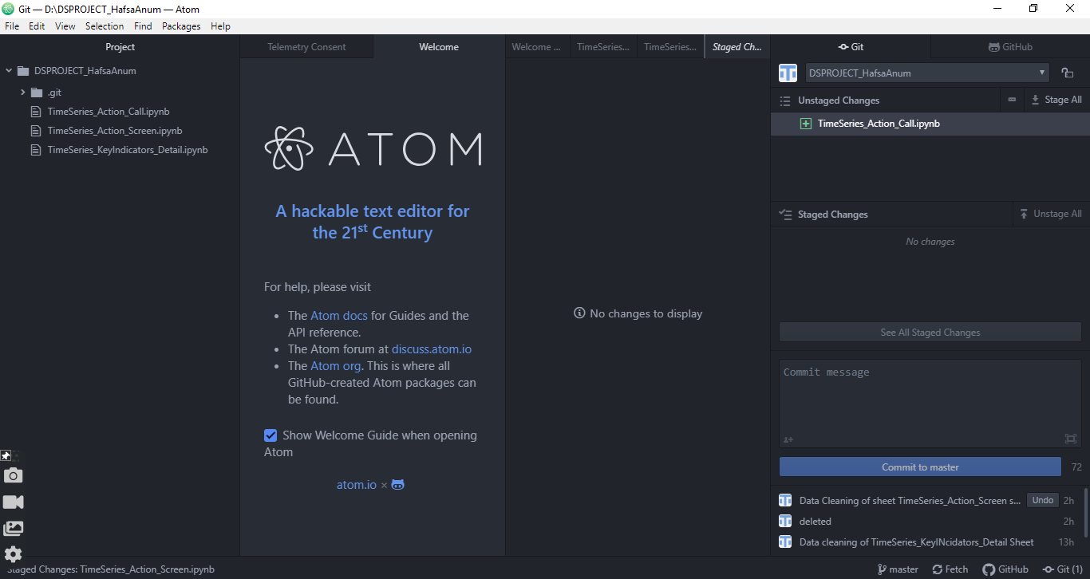Here is the atom editor with my repository and showing files which, I have added till now and then I committed those files through atom editor.

**Staging Files:**

After uploading the files, I am committing my files in the repository.

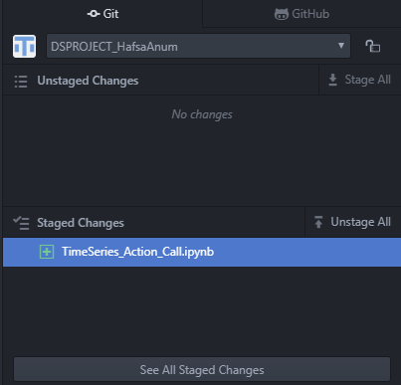

**Commits:**

Through **“Git Log”** command it is showing my commits that I have made.

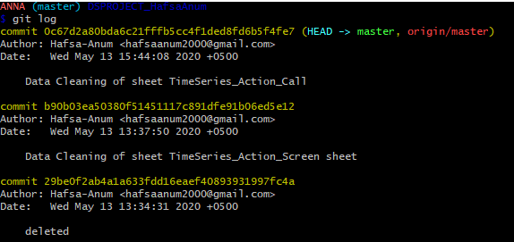

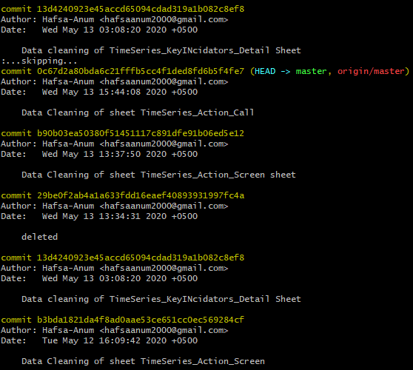

**Commits in Atom Editor and Pushing of Files:**

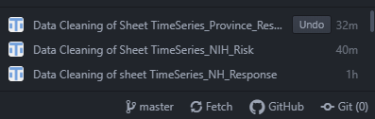

Showing committed files.

**GitHub Repository in Atom Editor:**

For keeping track of all my work, I have joined my repository with atom editor.

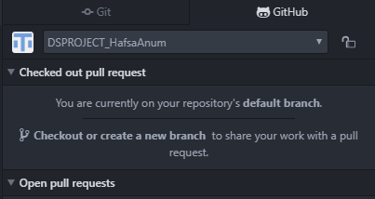

**We can also push the files through git bas only:**

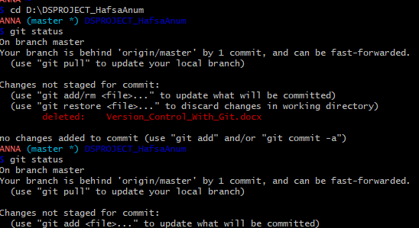

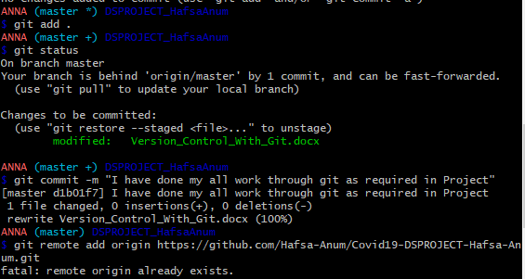

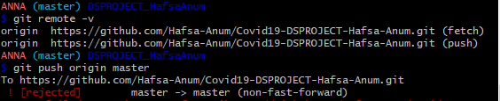

As I have done it already so I cannot push the files from here but through these commands we can push files on Git Hub.

**Pushing File on GitHub Through Commands Only:**

Displaying file that I have added today.

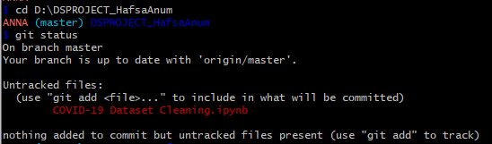

**I have pushed the file through this command:**

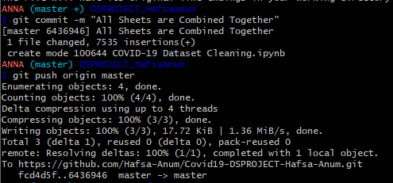

Now the file is pushed on GitHub.

My last commit updation.

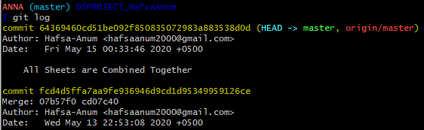

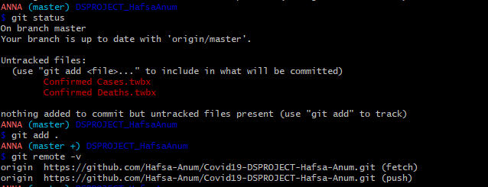**Adding my Visuals:**

**I Committed Files through Atom Editor:**

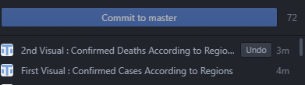

Files has been Pushed on GitHub.

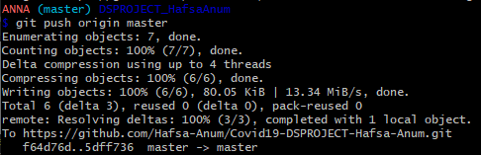

Showing Commits through **Git Log** Command.

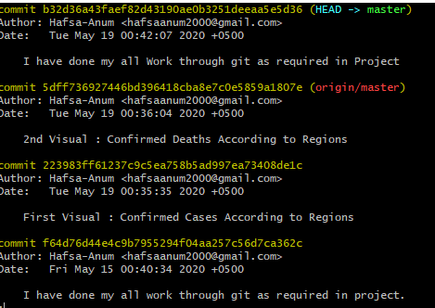

**More Commits:**

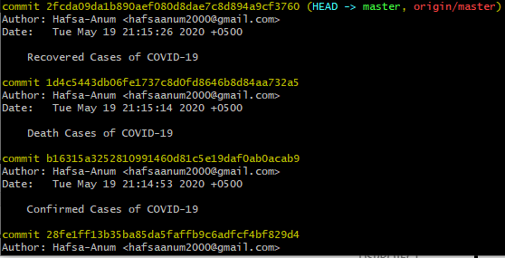

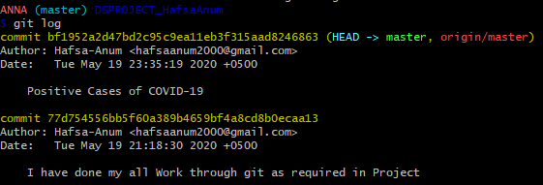

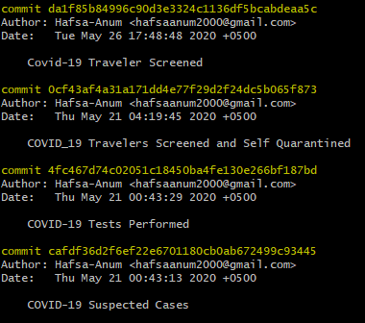

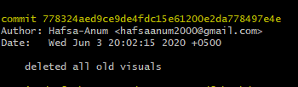

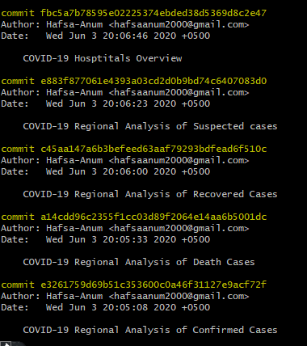

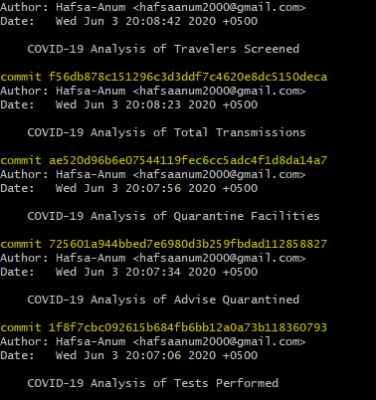

**Note: I have done my all work through git, as required in the project.**