  Database Proposal | HAFSA KHURRAM(FA22-BCS-058)  ZAINAB ASIF (FA22-BCS-068) SYEDA HUMAIMA (FA22-BCS-066)

1. Introduction
The Travel Agency DB database system is designed to streamline travel agency operations, ensuring efficient management of admins, customers, employees, travel packages, bookings, payments, and feedback. Its primary goal is to simplify workflows, enhance customer experience, and provide robust reporting capabilities.

2. Proposed Solution
- A relational database to manage core operations of the travel agency.
- Seamless integration of customers, travel packages, bookings, payments, and feedback.
- Role-based access control via the Admins table for secure management.
- Inclusion of additional tables such as Transport Options, Accommodations, and Itineraries for detailed travel planning.

3. Working
- Admins manage packages, employees, and operations.
- Customers can view and book travel packages.
- Bookings are linked to payments, ensuring financial tracking.
- Transport Options and Accommodations enhance the service offerings by providing detailed package components.
- Feedback helps in improving services based on customer experiences.

4. Diagrams
EERD
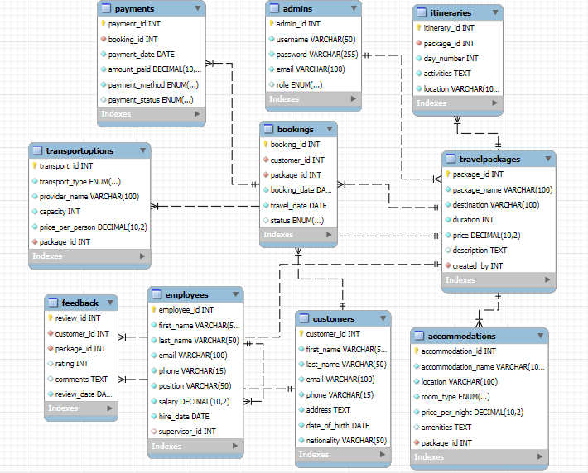

a. Conceptual Data Model
Illustrates high-level entities such as Admins, Customers, Travel Packages, Bookings, and Payments, along with their relationships.

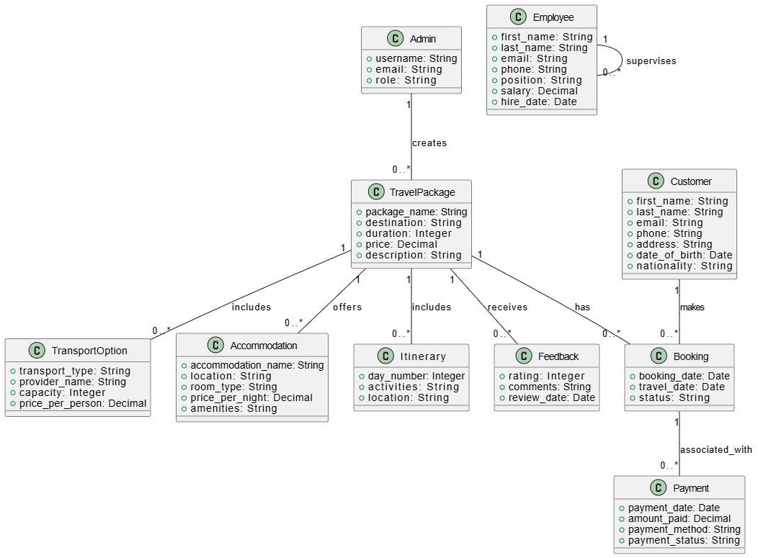
b. Logical Data Model
Details entities, their attributes, and relationships, enforcing normalization rules.
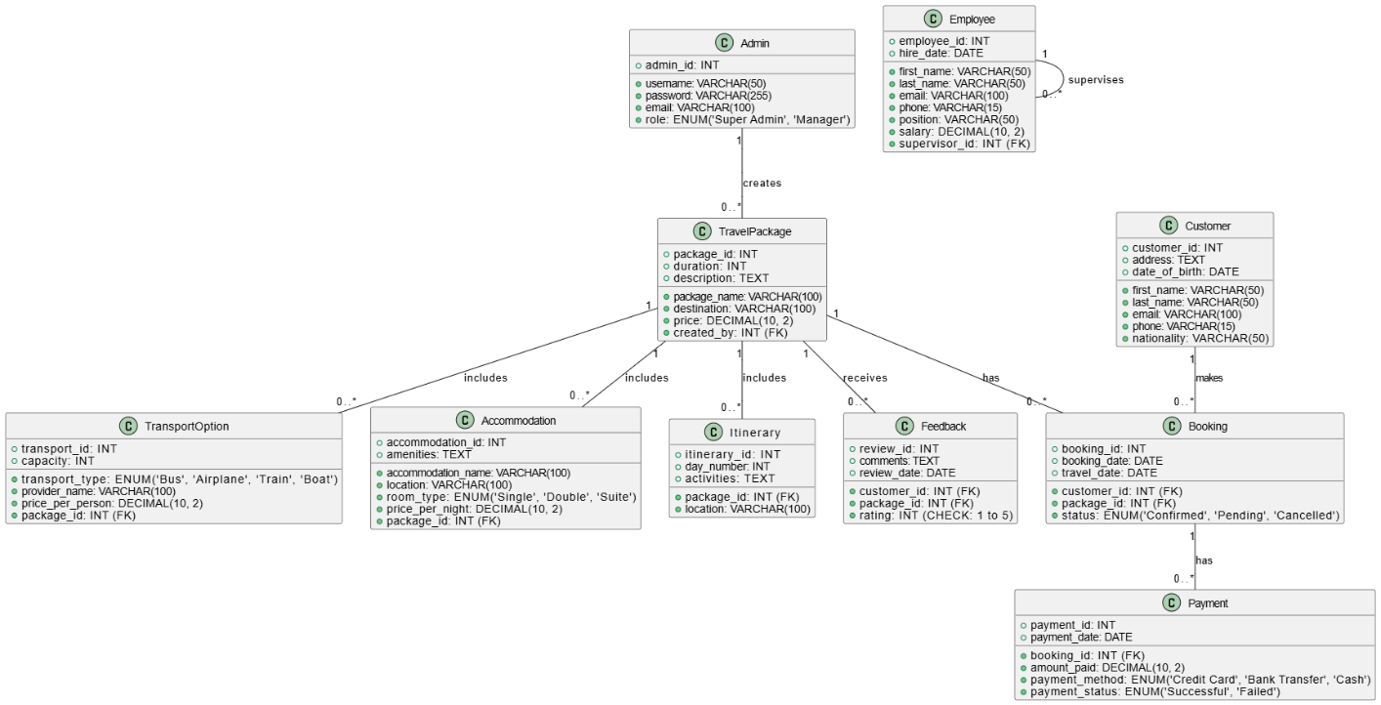

c. Physical Data Model
Implements logical entities into actual database tables with columns, constraints, and indexes.
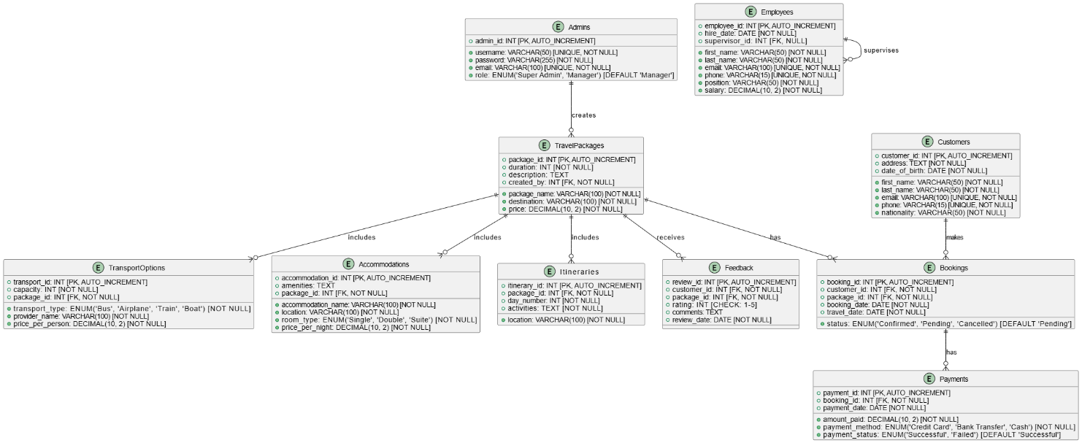

5. Conceptual Data Model
- Entities: Admins, Customers, Employees, Travel Packages, Bookings, Payments, Transport Options, Accommodations, Feedback, and Itineraries.
- Relationships: One-to-many relationships between Admins and Travel Packages, Customers and Bookings, Bookings and Payments, etc.

6. Logical Data Model
- Entities Attributes:
  - Admins: admin_id, username, password, email, role
  - Customers: customer_id, first_name, last_name, email, etc.
  - Bookings: booking_id, customer_id, package_id, status, etc.
- Primary and Foreign Keys: Define relationships, e.g., package_id in Bookings referencing Travel Packages.

7. Physical Data Model
Implemented using SQL as described in your schema. Tables have been normalized to avoid redundancy and ensure data integrity. Constraints such as primary keys, foreign keys, and CHECK conditions are applied.

8. Conclusion
The Travel Agency DB provides a comprehensive database design to address travel agency needs, ensuring scalability and ease of maintenance. The detailed relationships between entities enable efficient tracking and reporting of operations.

