**Webinar Course Management System Free Bootstrap Template**

**Registration Form**

* First name
* Middle name
* Last name
* Date of birth
* Email Address
* Contact Number
* Username
* Password

**Login**

**Admin Dashboard**

* Number of webinars
* Number of members
* Number of certificates released

**Webinar Information**

* Webinar name
* Description
* Speaker
* Date
* Time
* Meeting Link Information

**Member Information**

* First name
* Middle name
* Last name
* Date of birth
* Email Address
* Contact Number
* Profile Image
* Username
* Password
* Account Status – pending, approved

**Test Management**

* Webinar name
* Test code
* Question
* Choice 1
* Choice 2
* Choice 3
* Choice 4
* Correct Answer

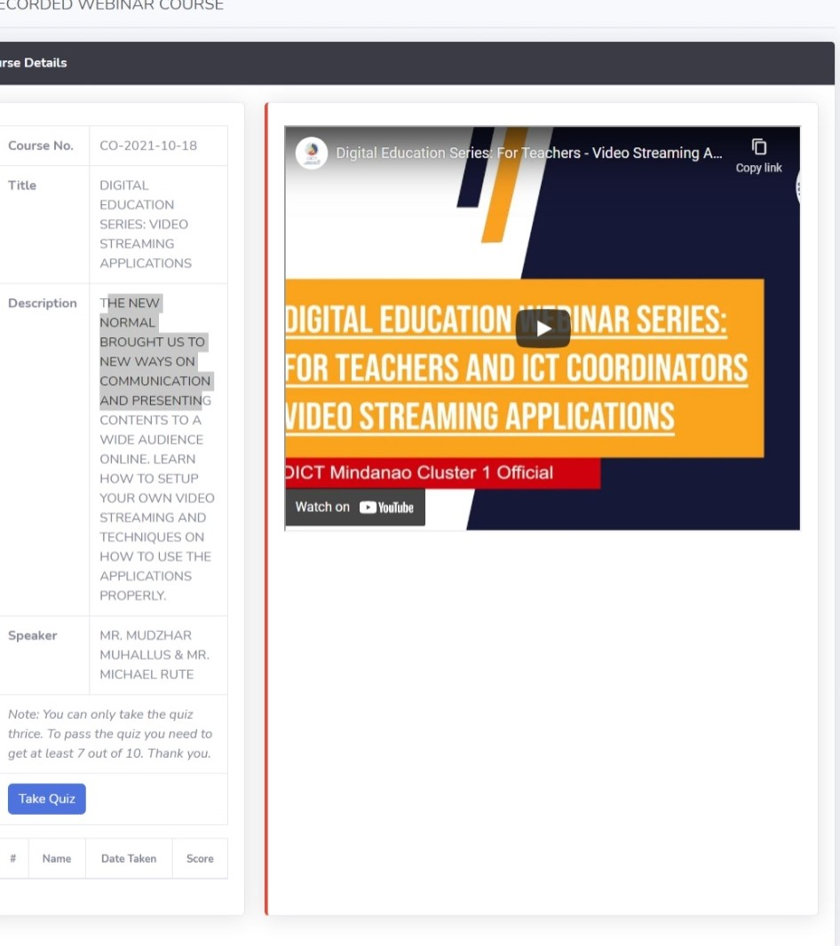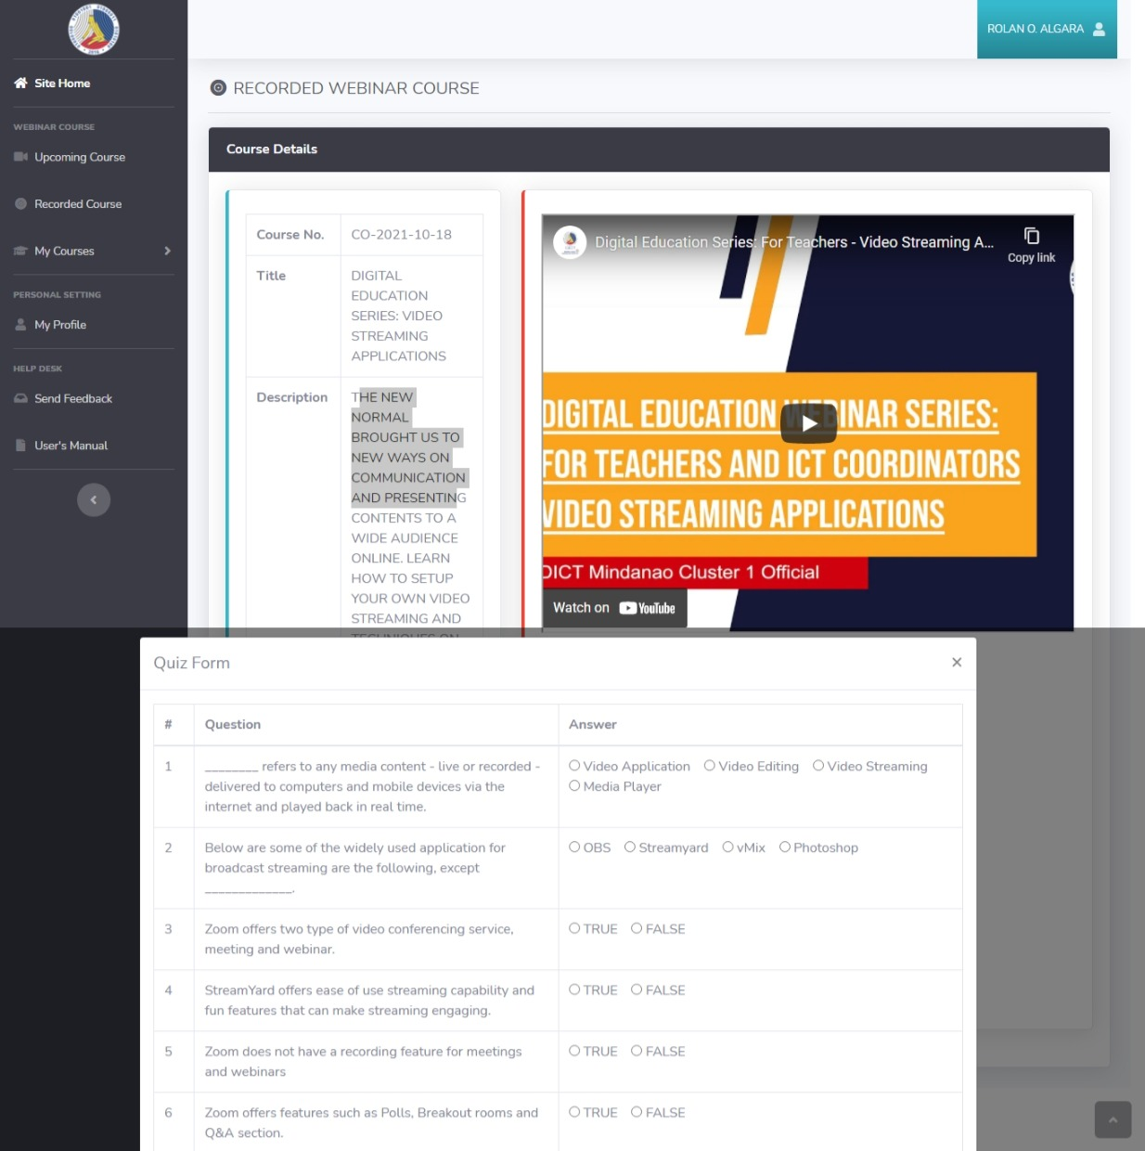

**Test Result**

* Test Code
* Member Name
* Score
* Passing Score
* Status – Passed, Failed

**Upload Certificate**

* Test Code
* Member Name
* Upload Certificate

**Feedback and Messages**

* Member name
* Message

**Member Account**

**Member Dashboard**

* Number of webinars attended
* Number of Certificates

**List of Available Webinars**

* Webinar name
* Description
* Speaker
* Date
* Time
* Meeting Link Information
* Register Button

**Take Exam – list and multiple choice**

* Webinar name
* Test code
* Question
* Choice 1
* Choice 2
* Choice 3
* Choice 4
* Correct Answer

**List of Certificates**

* Webinar name
* Download Certificate

**Send Message/FeedBack**