using System;

using System.Collections.Generic;

using System.Linq;

using System.Text;

using System.Threading.Tasks;

namespace Javeria_Q1

{

internal class Program

{

static void Main(string[] args)

{

string[] patientNames = new string[10];

for (int i = 0; i < 10; i++)

{

Console.Write("Enter Patient Name " + (i + 1) + ": ");

patientNames[i] = Console.ReadLine();

}

Array.Sort(patientNames);

Console.WriteLine("\nAlphabetical Names:");

foreach (string name in patientNames)

{

Console.WriteLine(name);

}

}

}

}

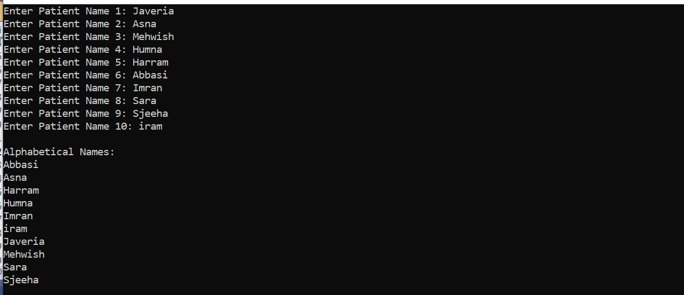

using System;

using System.Collections.Generic;

using System.ComponentModel;

using System.Data;

using System.Drawing;

using System.Linq;

using System.Text;

using System.Threading.Tasks;

using System.Windows.Forms;

namespace Qno2_Ali

{

public partial class Form1 : Form

{

public Form1()

{

InitializeComponent();

}

private void label1_Click(object sender, EventArgs e)

{

}

private void button1_Click(object sender, EventArgs e)

{

if (int.TryParse(textBox1.Text, out int number))

{

if (number >= 0)

{

long factorial = Factorial(number);

MessageBox.Show($"Factorial of {number} is {factorial}", "Factorial Calculation");

}

else

{

MessageBox.Show("Please enter a non-negative number.", "Input Error");

}

}

else

{

MessageBox.Show("Please enter a valid integer.", "Input Error");

}

}

private long Factorial(int n)

{

if (n == 0)

return 1;

long result = 1;

for (int i = 1; i <= n; i++)

{

result *= i;

}

return result;

}

private void textBox1_TextChanged(object sender, EventArgs e)

{

}

}

}

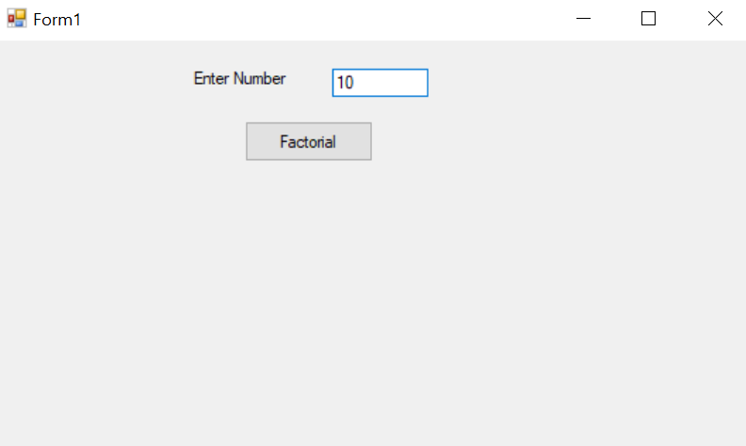

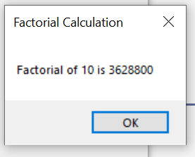

using System;

using System.Collections.Generic;

using System.ComponentModel;

using System.Data;

using System.Drawing;

using System.Linq;

using System.Text;

using System.Threading.Tasks;

using System.Windows.Forms;

namespace Qno2_Ali

{

public partial class Form1 : Form

{

public Form1()

{

InitializeComponent();

}

private void button1_Click(object sender, EventArgs e)

{

if (int.TryParse(textBox1.Text, out int num1) && int.TryParse(textBox2.Text, out int num2))

{

int sum = num1 + num2;

MessageBox.Show($"Sum of {num1} and {num2} is {sum}", "Sum Calculation");

}

else

{

MessageBox.Show("Please enter valid integers in both textboxes.");

}

}

}

}

