**RIPHAH INTERNATIONAL UNIVERSITY, ISLAMABAD**



**Lab # 3**

**Bachelor of Computer Science – 6th Semester**

**Subject: Operating System**

**Submitted to: Ms. Kausar**

**Submitted by: Hafsa Maqsood-40880**

**Date of Submission: 08- Sep -2024**

**Task#1**

Make directory with name books and in this directory we made three directories (maths,physics,computer) these directories we made in Books dircetory

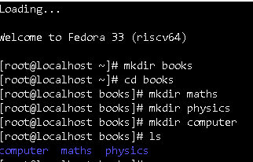

Access the maths directory that is present in the books directory and in the maths directory we made two directories (tignomatric, calculus) these directories we made in maths directory

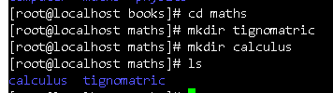

Access the physics directory that is present in the books directory and in the physics directory we made three directories (quantum, classical,nuclear) these directories we made in physics directory.

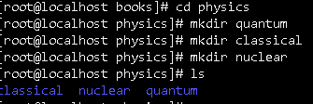

**Task#2**

**Directories Command:**

**mkdir (Make Directory):**The command makes a new directory.

**rmdir (Remove Directory):**Remove directory which you want to remove

**pwd** **(Print Working Directory):** It shows the current directory.

**ls (List):** Displays the contents of a directory. ls will show the files and folders in the current directory

**cd (Change Directory):**A switch in the current directory.

**rm -r (Remove Recursive):** Removes a directory and the files inside.

**Bash:**

BASH is a program that provides a terminal to users for interacting with an operating system via commands. It enables the execution of commands, the running of programs, and the management of files.

**Task#3**

Make directory with name D1 and in this directory we made four directories (D11,D12,D13,D14) these directories we made in D1 dircetory

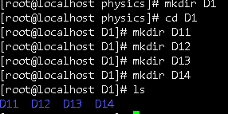

In D11 directory we made three file f1,f2,f3 file make in this direrctory.

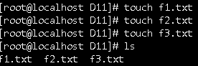

In D12 directory we made one file s .f4 file make in this direrctory

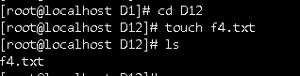

In D13 directory we made two files .f5.f6 file make in this direrctory.

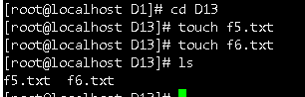

In D14 directory we made three files. f7,f8,f9 file make in this direrctory.

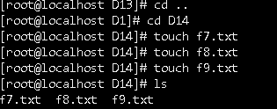

**Task#4**

Make directory with name D1 and in this directory we made four directories (D11,D12,D13,D14) these directories we made in D1 dircetory



In D11 directory we made two files .f1,f2, file make in this direrctory.

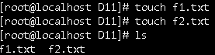

In D12 directory we made one file s .f3 file make in this direrctory



In D13 directory we made two files .f4,f5 file make in this direrctory

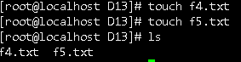

In D14 directory we made one files .f6 file make in this direrctory

