**RIPHAH INTERNATIONAL UNIVERSITY, ISLAMABAD**



**Lab # 4**

**Bachelor of Computer Science – 6th Semester**

**Subject: Operating System**

**Submitted to: Ms. Kausar**

**Submitted by: Hafsa Maqsood-40880**

**Date of Submission: 08- Sep -2024**

**Task#1**

Create LINIXOS directory and change user permission give execution permission.

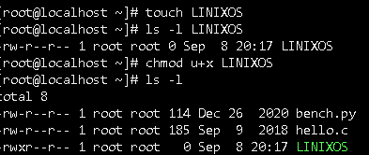

change group permission give read and write permission.

change others permission give write permission.

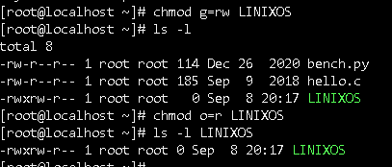

**TASK#2**

Create Lab4 directory and make three files in this directory.

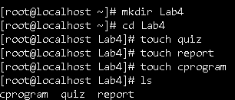

change user permission give read,write permission in quiz file.

change group permission give read ,write permission in report file.

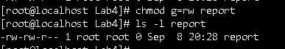

change user permission give read,write,execute permission in cprogram file.



change group permission give read,write,execute permission in cprogram file

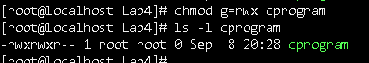

change others permission give execution permission in cprogram file



**Task#3**

Make oslab and ostheory directories

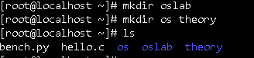

In oslab directory make overview file and wite text in this file



Make detail file and write text in this file



Make application file and write text in this file



Noe combined three files in one new combinedtext file

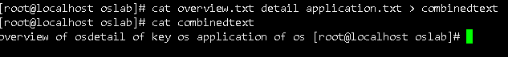

**TASK#4**

**Make directory name A and create two file in this directory**

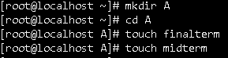

Make B name directory and create two file here



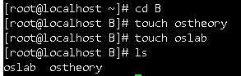

Move midterm file in diretory A to directory B with rename Tasks





**Task#5**

C++ code for circle

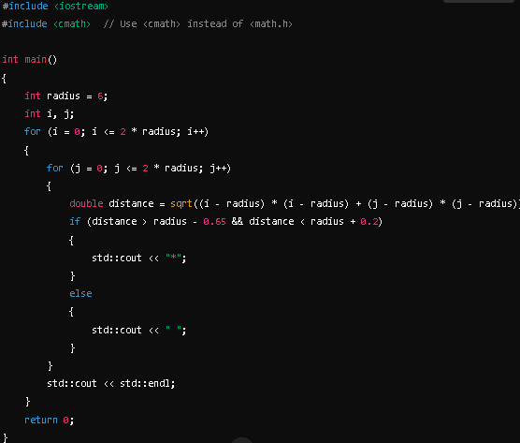

Command for ouput





