

COMPLEX COMPUTING ACTIVITY
COMPUTER VISION

NAME: HAFSA NAZ
ROLL No: 23-AI-56
BATCH 2023

DEPARTMENT: ARTIFICIAL INTELLIGENCE SECTION: A2

Pose Estimation for Activity Detection (Standing vs Squatting)

1. Code Implementation Overview

The project was implemented in Python using OpenCV and MediaPipe. It consists of three main tasks:

Task 1: Real-time pose detection with skeleton overlay and angle extraction

Task 2: Joint angle smoothing and visualization using plots

Task 3: Accuracy evaluation using ground truth comparison

The system processes a video frame-by-frame, detects human pose landmarks, computes joint angles, classifies activity, and displays results in real time.

2. Angle Computation Approach

Pose landmarks were extracted using MediaPipe. Three joint angles were calculated:

Knee (Hip–Knee–Ankle)

Hip (Shoulder–Hip–Knee)

Elbow (Shoulder–Elbow–Wrist)

Key Feature Selection

The knee angle was selected as the main feature because it shows clear variation between standing and squatting postures.

3. Rule-Based Classification Logic

A simple threshold-based rule was designed:

If knee angle > 140° → STANDING

If knee angle ≤ 140° → SQUATTING

This threshold was chosen based on observed joint behavior in the dataset:

Standing → straight leg → high angle

Squatting → bent knee → low angle

4. Signal Smoothing

Joint angle data was noisy due to detection fluctuations. To stabilize results:

Savitzky–Golay filter was applied

Window size = 15, Polynomial order = 3

This improved smoothness of angle curves and reduced false transitions.

5. Accuracy Results

The predicted labels were compared with ground truth annotations.

Total evaluated frames: 32

Correct predictions: 29

Incorrect predictions: 3

Final Accuracy: 90.6%

Error Analysis

Misclassifications occurred mainly during transition frames where the subject was moving between standing and squatting.

6. Observations

MediaPipe successfully detected pose in all frames

Knee angle was the most reliable feature for classification

Rule-based approach worked well for binary activity detection

Smoothing significantly reduced prediction instability

Errors mostly occurred during movement transitions

7. Demo Outputs

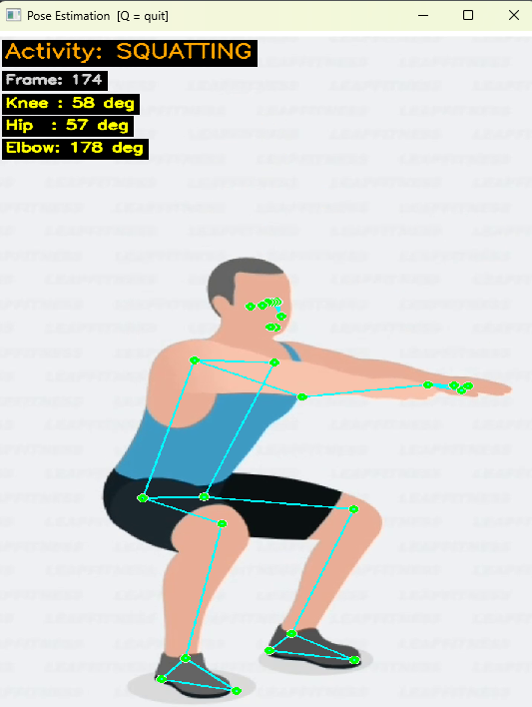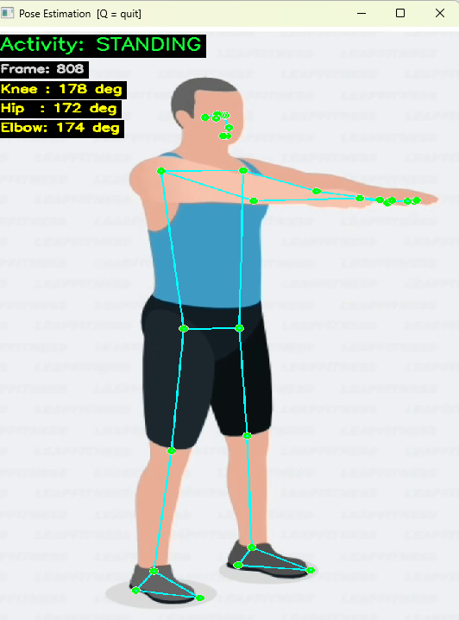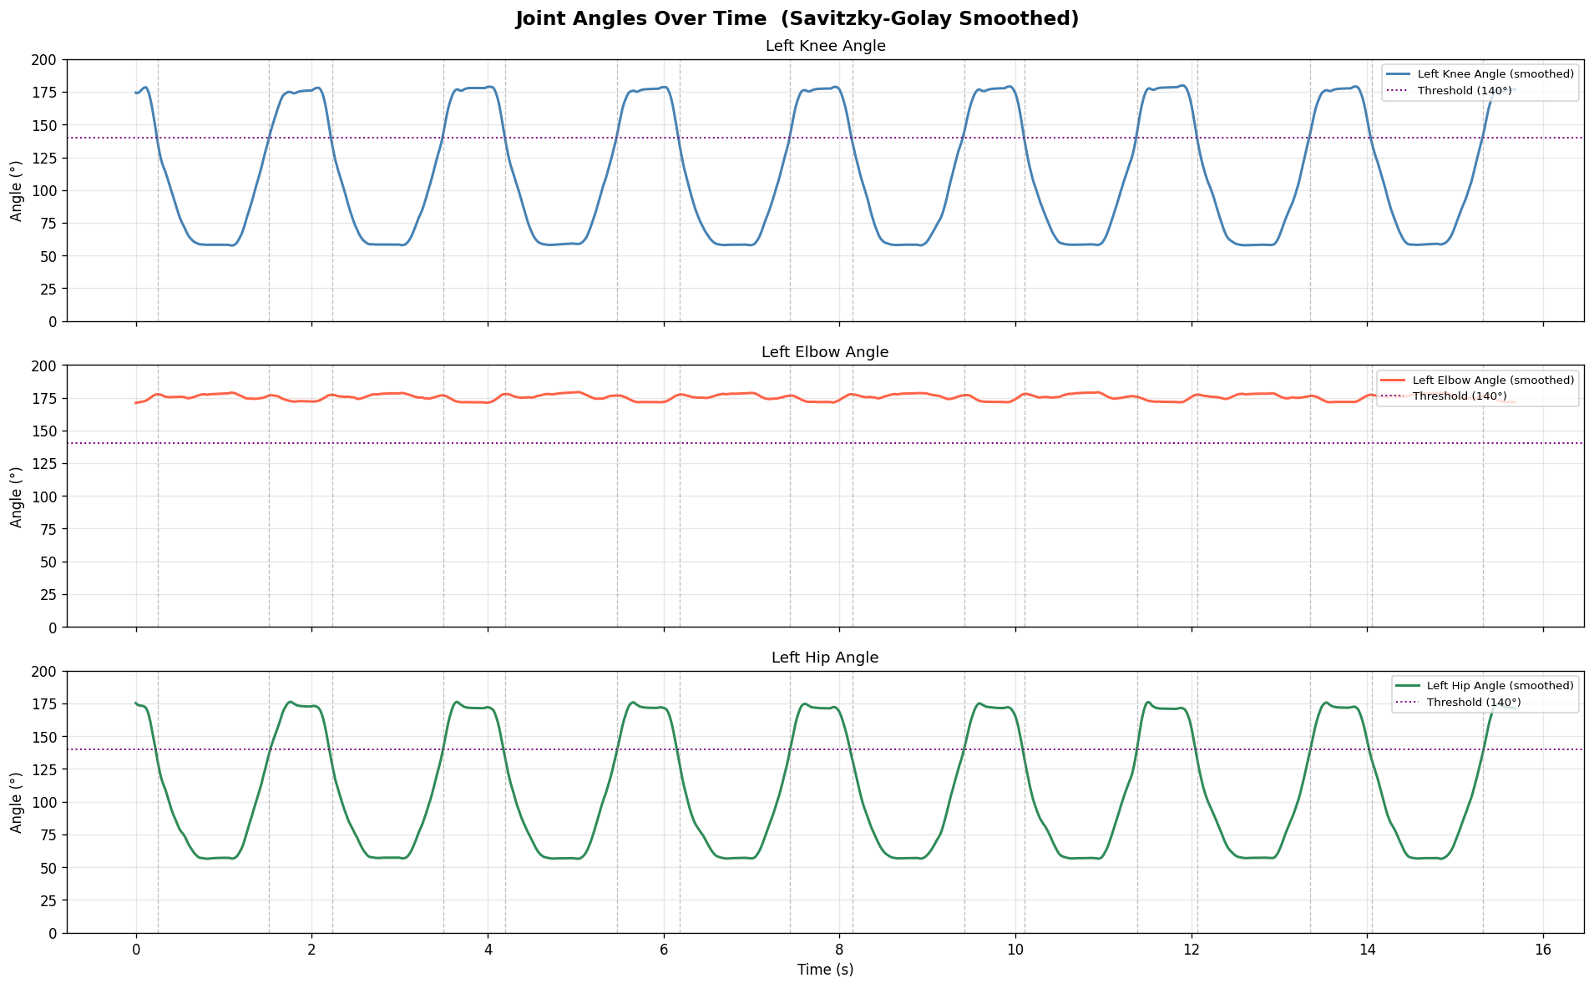

8. Conclusion

This project demonstrates an efficient pose-based activity recognition system using simple geometric features. A rule-based classifier using knee angle achieved 90.6% accuracy, proving that lightweight approaches can effectively solve basic human activity recognition tasks.

