Lab Session 01
Objective:
Introduction to Cloud Computing and types of cloud computing. Also choose the best cloud types for banking system.
Theory:
Cloud Computing:
Cloud computing is a method for delivering information technology (IT) services in which resources are retrieved from the Internet through web-based tools and applications, as opposed to a direct connection to a server. Rather than keeping files on a hard drive or local storage device, cloud-based storage makes it possible to save them to a remote database. If an electronic device has access to the web, it has access to the data and the software programs to run it.
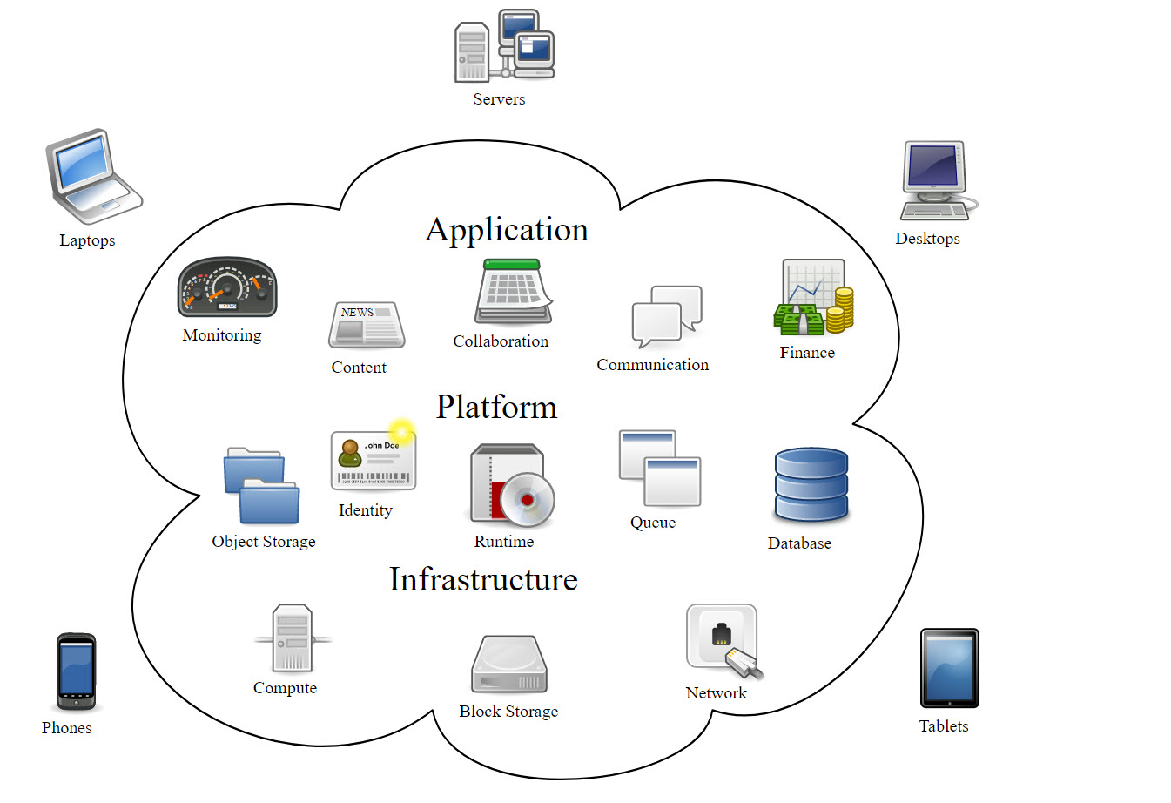
Figure 1 Cloud Computing
Cloud Computing – Types of Cloud:
Cloud computing is usually described in one of two ways. Either based on the deployment model, or on the service that the cloud is offering. Based on a deployment model, we can classify cloud as
• Public
• Private
• Hybrid
• Community cloud
Based on a service the cloud model is offering; we are speaking of either:
• IaaS (Infrastructure-as-a-Service)
• PaaS (Platform-as-a-Service)
• SaaS (Software-as-a-Service)
• or, Storage, Database, Information, Process, Application, Integration, Security, Management, Testing-as-a-service
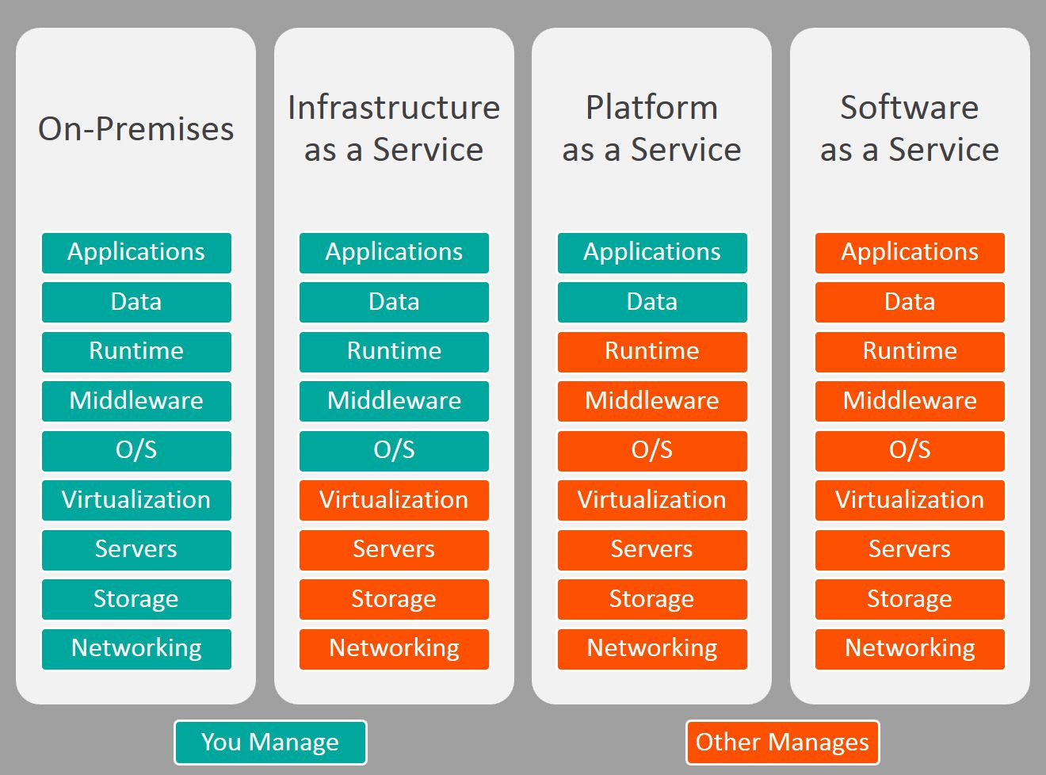
Basically, programs that are needed to run a certain application are now more popularly located on a remote machine, owned by another company. This is done in order not to lose on the quality performance due to processing power of your own computer, to save money on IT support, and yet remain advantageous on the market. These computers that run the applications, store the data, and use a server system, are basically what we call “the cloud”.
Public Cloud
When we talk about public cloud, we mean that the whole computing infrastructure is located on the premises of a cloud computing company that offers the cloud service. The location remains, thus, separate from the customer and he has no physical control over the infrastructure.
As public clouds use shared resources, they do excel mostly in performance, but are also most vulnerable to various attacks.
GlobalDots offers worldwide Public Cloud service in leading data centers.
Private Cloud
Private Cloud provides the same benefits of Public Cloud, but uses dedicated, private hardware. Private cloud means using a cloud infrastructure (network) solely by one customer/organization. It is not shared with others, yet it is remotely located. The companies have an option of choosing an on-premise private cloud as well, which is more expensive, but they do have a physical control over the infrastructure.
The security and control level is highest while using a private network. Yet, the cost reduction can be minimal, if the company needs to invest in an on-premise cloud infrastructure. GlobalDots offers worldwide private cloud service in leading data centers. With our Private Cloud you‟ll get:
Increased redundancy
Decreased provisioning time for new servers
Saved capital by eliminating hardware support contracts
Quicker expendability compared to hosting your own physical servers
Use of dedicated, private hardware
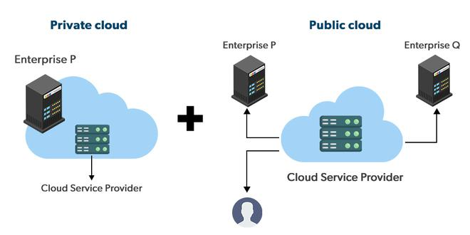
Figure 2 Public and Private Cloud
Hybrid Cloud
Hybrid cloud, of course, means, using both private and public clouds, depending on their purpose. For example, public cloud can be used to interact with customers, while keeping their data secured through a private cloud. Most people associate traditional public cloud service with elastic scalability and the ability to handle constant shifts in demand. However, performance issues can arise for certain data-intensive or high-availability workloads.
GlobalDots offer combines hybrid cloud with bare-metal and virtualized clouds into a unified environment allowing your business to optimize for scale performance and cost simultaneously.
Community Cloud
It implies an infrastructure that is shared between organizations, usually with the shared data and data management concerns. For example, a community cloud can belong to a government of a single country. Community clouds can be located both on and off the premises. The most popular services of the cloud are that of either infrastructure, platform, software, or storage.
Cloud Service Models:
As explained before, the most common cloud service is that one offering data storage disks and virtual servers, i.e. infrastructure. Examples of Infrastructure-as-a-Service (IaaS) companies are Amazon, Rackspace, Flexiscale.
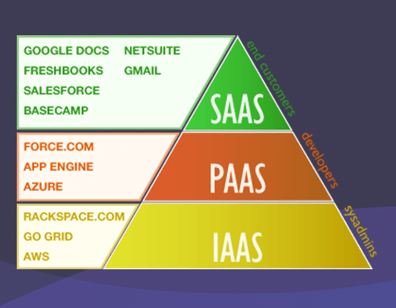
Figure 3 Cloud Service Models
If the cloud offers a development platform, and this includes operating system, programming language execution environment, database, and web server, the model is known as Platform-as a-Service (PaaS), examples of which are Google App Engine, Microsoft Azure, Salesforce. Operating system can be frequently upgraded and developed with PaaS, services can be obtained from diverse sources, and programming can be worked in teams (geographically distributed).
Software-as-a-Service (SaaS) users can access various software applications on a pay-per-use basis. As opposed to buying licensed programs, often very expensive. Examples of such services include widely used GMail, or Google Docs.
Advantages of Cloud Computing:
Less Costs
The services are free from capital expenditure. There are no huge costs of hardware in cloud computing. You just have to pay as you operate it and enjoy the model based on your subscription plan.
24 X 7 Availability
Most of the cloud providers are truly reliable in offering their services, with most of them maintaining an uptime of 99.9%. The workers can get onto the applications needed basically from anywhere. Some of the applications even function off-line.
Flexibility in Capacity
It offers flexible facility which could be turned off, up or down as per the circumstances of the user. For instance, a promotion of sales is very popular, capacity can be immediately and quickly added to it for the avoidance of losing sales and crashing servers. When those sales are done, the capacity can also be shrunk for the reduction of costs.
All over Functioning
Cloud computing offers yet another advantage of working from anywhere across the globe, as long as you have an internet connection. Even while using the critical cloud services that offer mobile apps, there is no limitation of the device used.
Automated Updates on Software
In cloud computing, the server suppliers regularly update your software including the updates on security, so that you do not need to agonize on wasting your crucial time on maintaining the system. You find extra time to focus on the important things like “How to grow your businesses”.
Security
Cloud computing offers great security when any sensitive data has been lost. As the data is stored in the system, it can be easily accessed even if something happens to your computer. You can even remotely wipe out data from the lost machines for avoiding it getting in the wrong hands.
Carbon Footprint
Cloud computing is helping out organizations to reduce their carbon footprint. Organizations utilize only the amount of resources they need, which helps them to avoid any over-provisioning. Hence, no waste of resources and thus energy.
Enhanced Collaboration
Cloud applications enhance collaboration by authorizing diverse groups of people virtually meet and exchange information with the help of shared storage. Such capability helps in improving the customer service and product development and also reducing the marketing time.
Control on the Documents
Before cloud came into being, workers needed to send files in and out as the email attachments for being worked on by a single user at one time ultimately ending up with a mess of contrary titles, formats, and file content. Moving to cloud computing has facilitated central file storage.
Easily Manageable
Cloud computing offers simplified and enhanced IT maintenance and management capacities by agreements backed by SLA, central resource administration and managed infrastructure. You get to enjoy a basic user interface without any requirement for installation. Plus you are assured guaranteed and timely management, maintenance, and delivery of the IT services.
Applications of Cloud Computing:
1. Online File storage
2. Photo editing software
3. Digital video software
4. Twitter-related applications
5. Creating image-album
6. Web application for antivirus
7. Word processing application
8. Spreadsheets
9. Presentation software
10. Finding a way on the map
11. E-commerce software
Exercise:
Task1
A famous bank at Khuzdar is considering a cloud environment to improve the operating efficiency for their data and applications services provided to the customers. At the bank strict security and data privacy issues are the highest importance. In your opinion, which type of cloud would be a good choice and why?
Task2
Top 10 cloud service providers globally in 2025.
Top 10 Cloud Service Providers Globally in 2025 - Dgtl Infra

