Lab Session 02
Objective:
To Try Linux Environment using Terminal (Installation and Configuration of Cygwin).
Theory:
Cygwin
Cygwin is free and open-source software with tons of optional packages which let you run and execute the age-old Unix-like commands right in your Windows system. Do note that it can’t be used to run any Linux/Unix software though.
Installing Cygwin
To install Cygwin, head to the official site of Cygwin and download the executable depending on your system preference (32-bit or 64-bit). The executable itself is small as it downloads all the required packages while installing the software.
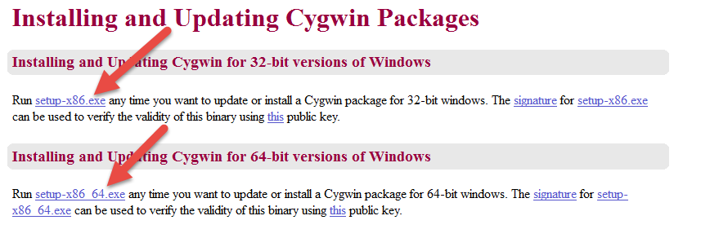
Once you have downloaded the Cygwin installer, launch the installer as the Administrator. You will be greeted with the welcome screen,; just click on the “Next” button to continue. Here in this screen, select the radio button “Install from Internet” and click on the “Next” button. This option will download all the required packages for the installation and will store them in the local directory for future use.
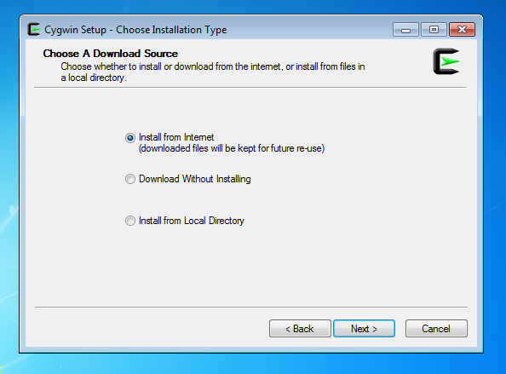
Here you can select the root directory for the Cygwin installation. The default settings are fine unless you want to customize the installation directory and user access. Click on the “Next” button to continue.
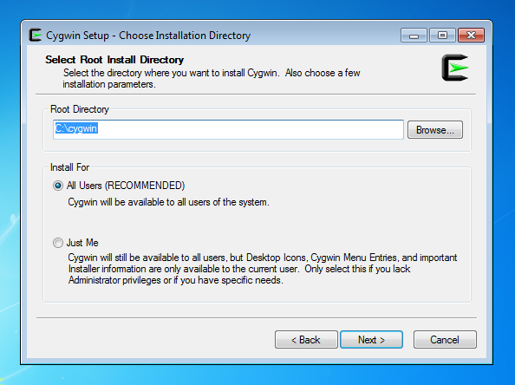
In this screen, you can select the local package directory where the downloaded files are stored. If you want to change it, go ahead and change the directory location by click on the “browser” button. Otherwise, click on the “Next” button to continue.
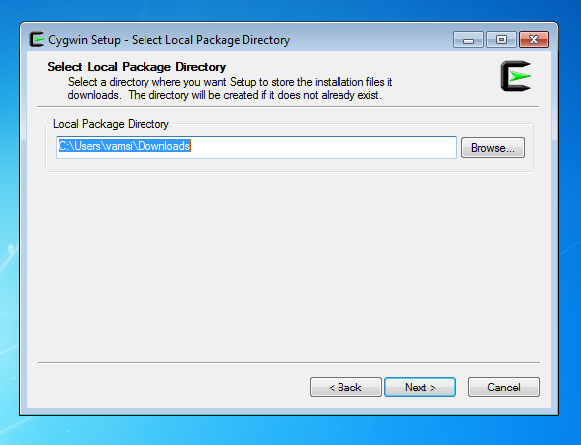
Unless you are using some sort of HTTP proxy to access the internet, just leave the default option and click on the “Next” button to continue.
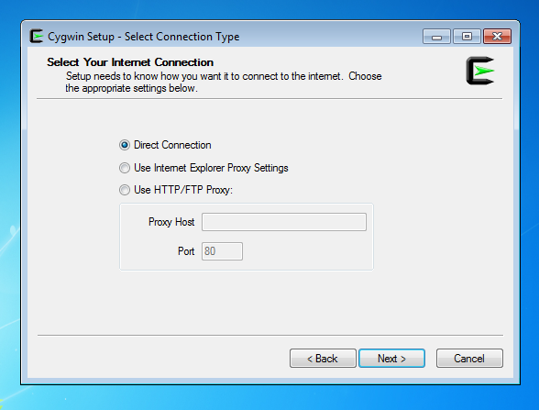
Here you can select the download site from which you wish to download the required packages. Unfortunately, Cygwin doesn’t provide any additional details like site location. So just select a random site and click on the “Next” button.
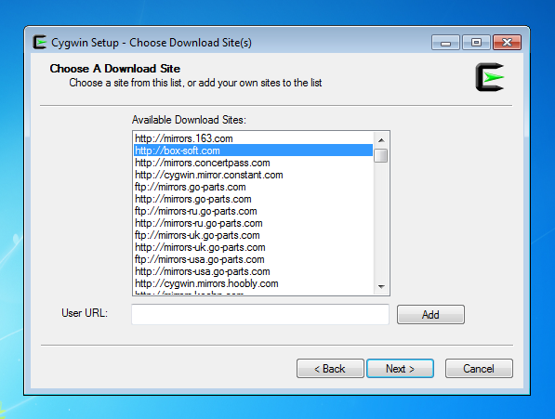
As soon as you click on the “Next” button, Cygwin will show you all the available packages in categories. At this point, you can keep them at the default settings and click the “Next” button. If you ever want to add packages to your Cygwin installation, you can do so by running the installer as needed.
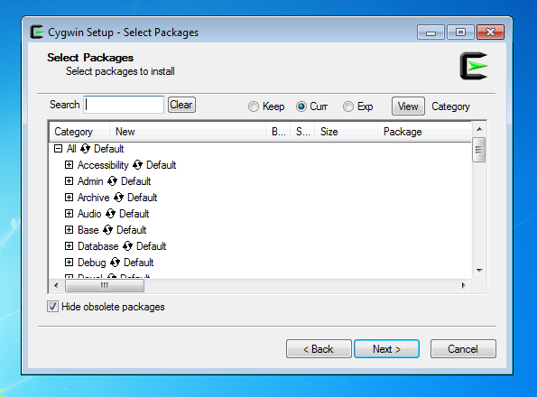
Now Cygwin will download all the default packages and install them. The downloading and installing may take some time depending on your Internet speed and the selected server speed.
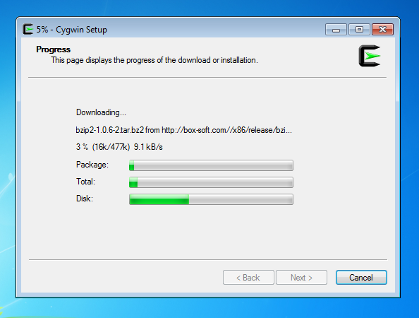
Once the installation is complete, you can start using Cygwin by launching it using the desktop shortcut or from the start menu.
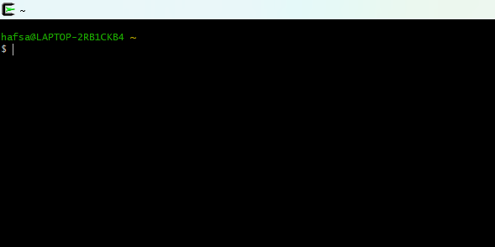
Alternatively, you can configure Cygwin to work with the normal Windows command prompt, so you don’t have to launch Cygwin specifically. To do that, open up your Start menu, type “system” and select the option “System” in the control panel section. If you are using Windows 8, you can access the same section by pressing “Win + X” and selecting “System” from the power user menu.
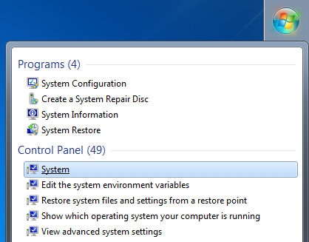
Click on the “Advanced System Settings” located on the left pane to open “System properties.”
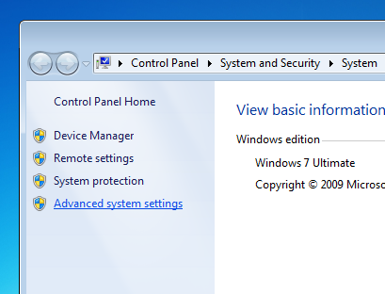
Click on the “Environmental Variables” button.
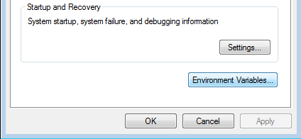

Scroll down and select the variable “path” under the “system variables” and click on the “Edit” button.
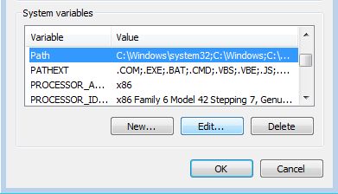
Now add the below location (variable value) at the end of the line. Don’t forget to separate it from using. If you have chosen a different installation directory while installing Cygwin, then change the location below variable accordingly. Once you have added it, click on the “Ok” button to save the changes.
C:\Cygwin\bin
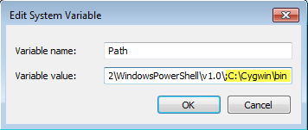

B.E (Software Engineering)
Semester: 5th
Course: Cloud Computing
Course Code: SWE-313
Credit Hours: 3+1
Lab Credit Hours: 01
Lab CLO: Demonstrate the basic service delivery models of cloud and distributed computing: Software as a Service (SaaS), Platform as a Service (PaaS), Infrastructure as a service (IaaS)
Bloom’s Taxonomy Level: C3
Linked PLO: 05 (Modern Tool Usage)
Max Marks: 20
Marks Distribution
Semester Work: 10
Final Lab Examination: 10
Lab Examination Rubrics

Attribute | Attainment Extent (Marks) |  |  |  |  | Marks Obtained (out of 2)
 | 0 | 0.5 | 1 | 1.5 | 2
Software Installation and configuration  (Knowledge about how to access Cloud /Distributed software) | Not able to recognize cloud/Distributed computing-based software | Knows a little bit about software but unable to access | Knows about software but cannot access it without detailed help | Knows about cloud based /Distribution computing software and able to access it with minor help | Able to recognize cloud based /distributed computing-based software and access it independently
Use of Software Knowledge and environment setting  (Knowledge about using Cloud based /distributed computing-based software and its environment) | Not able to work on cloud based /distributed computing-based software | Very limited work on Cloud based /distributed computing-based software with complete dependance on external help | Able to use Cloud based /distributed computing-based software with major external support | Able to use Cloud based /distributed computing-based software components with minor errors | Able to use Cloud based /distributed computing-based software properly with no errors
Procedural Skills  (Procedural skills of students using programming codes for the lab/or algorithm given is assessed) | Not able to follow procedure given to perform lab | Rarely follows procedure and mainly asks others | Follows procedure on large parts with some errors | Follows procedures as given with minimal errors | Follow correct procedure as provided independently
Accuracy of Completion of task  (Student assessment of completing the given task as per requirement is assessed) | Completely wrong or fundamental level errors indicating student is completely unaware about completion of task | Very few things of task as per requirement correct | Some tasks completed correctly but major portion inaccurate | Major parts of task completely accurate with minor mistakes | Accurate completion of tasks with no errors
Responding to questions about Lab work  (Student will be assessed for having confidence while answering questions asked about cloud based/distributed computing-based software and given task) | Completely confused and not able to respond | Confused but able to respond a few questions | Middle level confidence and able to respond | Good confidence except minor level confusion and ability to respond | Completely confident and responding well to questions asked
CLO Score in Lab Examination (Out of 10)
Notes:
- There shall be a 10 marks final examination on Rubrics
- Students not getting 50% KPI shall be given additional chance to repeat and improve in CQI

