Lab Session 03
Objective:
Demonstrate the Linux commands and script writing using Cygwin.
Working with directories
This lab includes a brief overview of the most common commands to work with directories:
pwd, cd, ls, mkdir and rmdir. These commands are available on any Linux (or Unix) system.
This module also discusses absolute and relative paths and path completion in the bash shell.
- pwd
The you are here sign can be displayed with the pwd command (Print Working Directory).
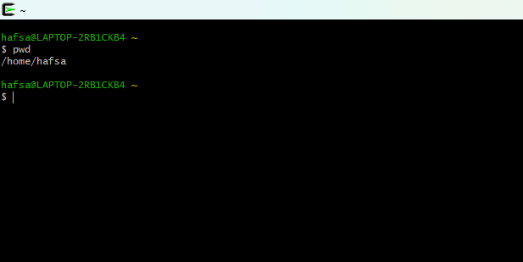
- cd
You can change your current directory with the cd command (Change Directory).
- cd ~ (tilde)
The cd is also a shortcut to get back into your home directory. Just typing cd without a target
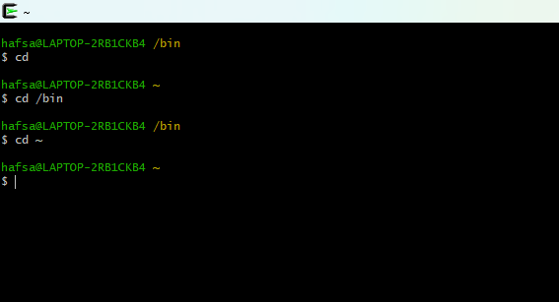
directory, will put you in your home directory. Typing cd ~ has the same effect.

- cd ..
To go to the parent directory (the one just above your current directory in the directory
tree), type cd .. .
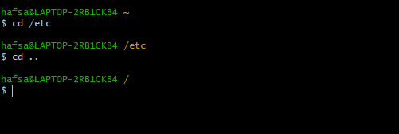
- cd -
Another useful shortcut with cd is to just type cd - to go to the previous directory.
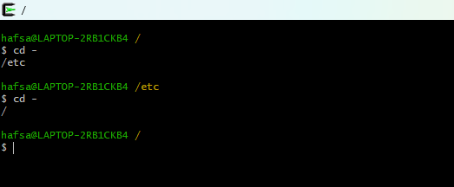

Absolute and relative paths
You should be aware of absolute and relative paths in the file tree. When you type a path starting with a slash (/), then the root of the file tree is assumed. If you don't start your path with a slash, then the current directory is the assumed starting point.
The screenshot below first shows the current directory /home/hafsa. From within this directory, you have to type cd /home instead of cd home to go to the /home directory.
When inside /home, you must type cd hafsa instead of cd /hafsa to enter the subdirectory hafsa of the current directory /home.
In case your current directory is the root directory /, then both cd /home and cd home will get you in the /home directory.
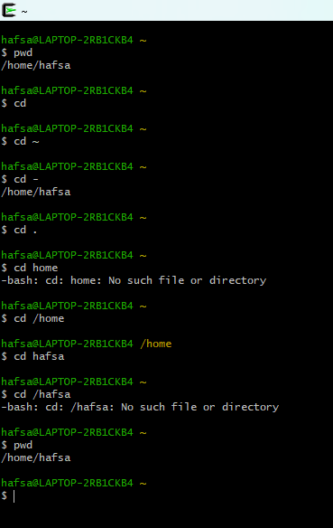

Path completion
The tab key can help you in typing a path without errors. Typing cd /et followed by the tab key will expand the command line to cd /etc/. When typing cd /Et followed by the tab key, nothing will happen because you typed the wrong path (upper case E).
You will need fewer keystrokes when using the tab key, and you will be sure your typed path is correct!

Shell Scripting
- Operating system are made of many components but there two primes component are Kernel and Shell.
- Kernel is a nucleus of computer; it makes a communication between software and hardware. While kernel is the inner most part of an operating system.
- Shell is the outer most one. The shell in the Linux operating systems takes inputs in the form of commands processes them and then give the output. It is the interface which a user works for programs, commands and scripts.
Shell
Shell is accessed from terminal which run it.
$ represent the shell prompt.
The Bourne shell is most popular shell.
POSIX shell also known as sh
KORN shell also known as sh
Bourne Again Shell also known as Bash
C Shell represent with %
C shell also known as csh
Tops C shell also known as tcsh
Why we need shell script
- Writing a series of commands
- Combine lengthy and repeated commands
- This helps to reduce the efforts
Creating a shell script
- Create a file using text editor like vi
- Name script file with extension .sh
- Press I for inserting mode
- Start the script with #!/bin/sh
- Write some code
- Saving & exit script use esc+:+shift+wq
- For executing the script type bash filename.sh

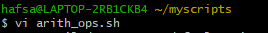

Program No: 01 Shell Program to Add Two Numbers
Code:
#!/bin/bash
echo "Enter the the fisrt number:"
read num1
echo "Enter the 2nd number:"
read num2
sum=$((num1+num2))
echo "the sum is: $sum"
Output:
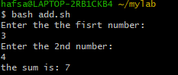
Program No: 02 Shell Program to Multiply Two Numbers
Program No: 03 Shell Program to find Average of Three Numbers

