Lab Session 06
Objective:
Create and demonstrate with an IBM cloud trail account using feature code.
IBM Cloud:
IBM Cloud is a cloud computing platform and infrastructure offered by IBM. It provides a range of cloud-based services, including infrastructure as a service (IaaS), platform as a service (PaaS), and software as a service (SaaS). IBM Cloud offers a variety of tools and services for developers, data scientists, and other IT professionals to build, deploy, and manage applications and services in the cloud.
IBM Cloud also includes a range of services that leverage artificial intelligence (AI), machine learning (ML), and other advanced technologies to help organizations gain insights and make better decisions. These services include IBM Watson, which offers a suite of AI-powered tools for language understanding, computer vision, and natural language processing (NLP), among others.
Overall, IBM Cloud offers a robust set of cloud-based services and tools to help businesses of all sizes and industries accelerate their digital transformation journey and drive innovation.
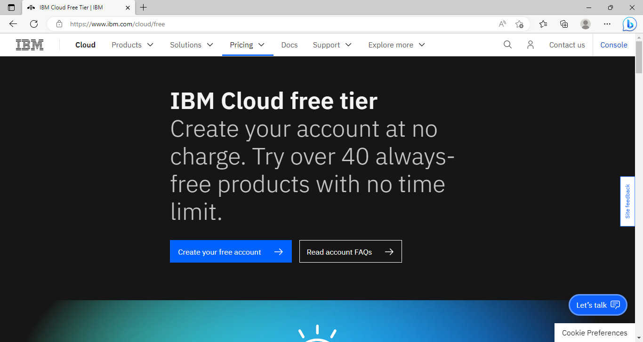
To access the resources and services that the IBM Cloud provides, you need an IBM Cloud account.

- Once you are on the account creation page, follow the below instructions to create an IBM cloud trial account.
- Enter your Email address and a strong Password, as per criteria and then click the Next button.
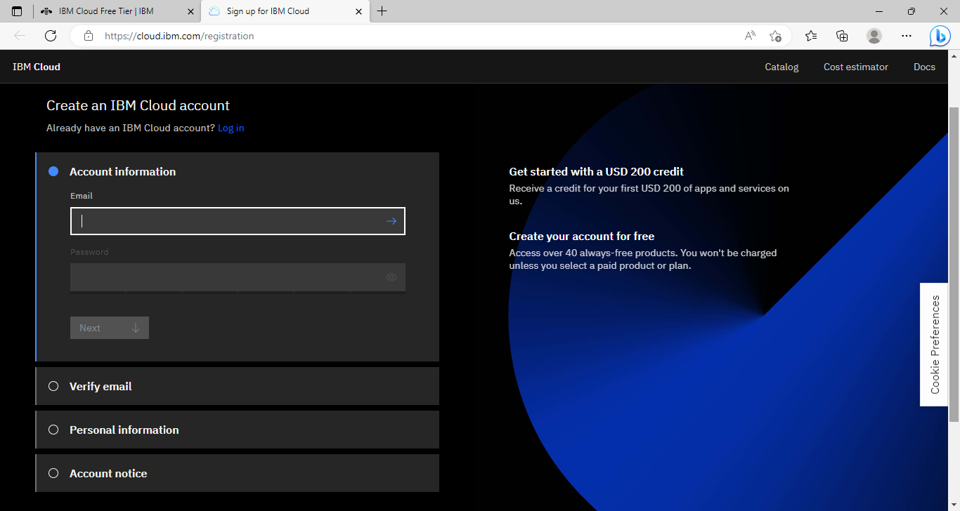
- An email is sent to the address that you signed up with to confirm your email address. Check your email and copy and paste Verification code. Then click Next.
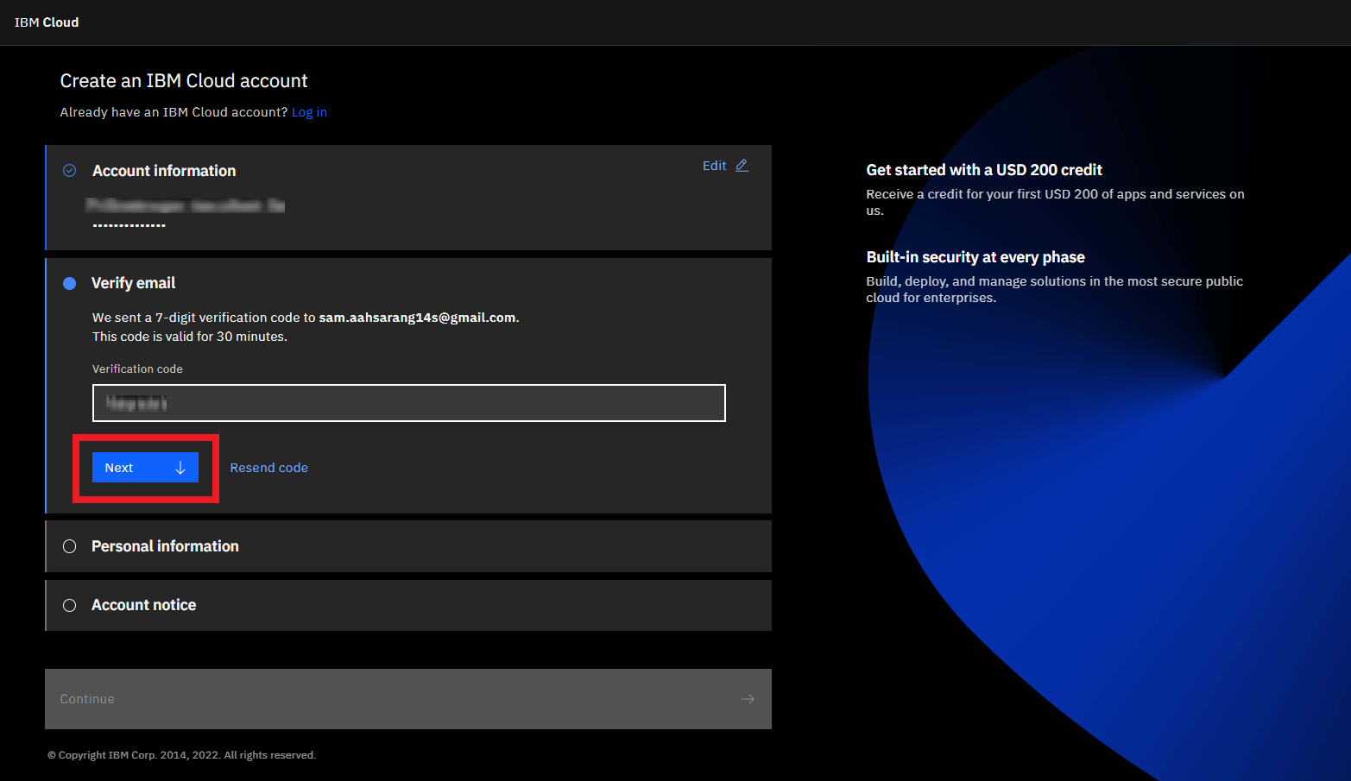
- Once your email is successfully verified, enter your First name, Last name, and preferably select United States under Country or region then click Next.

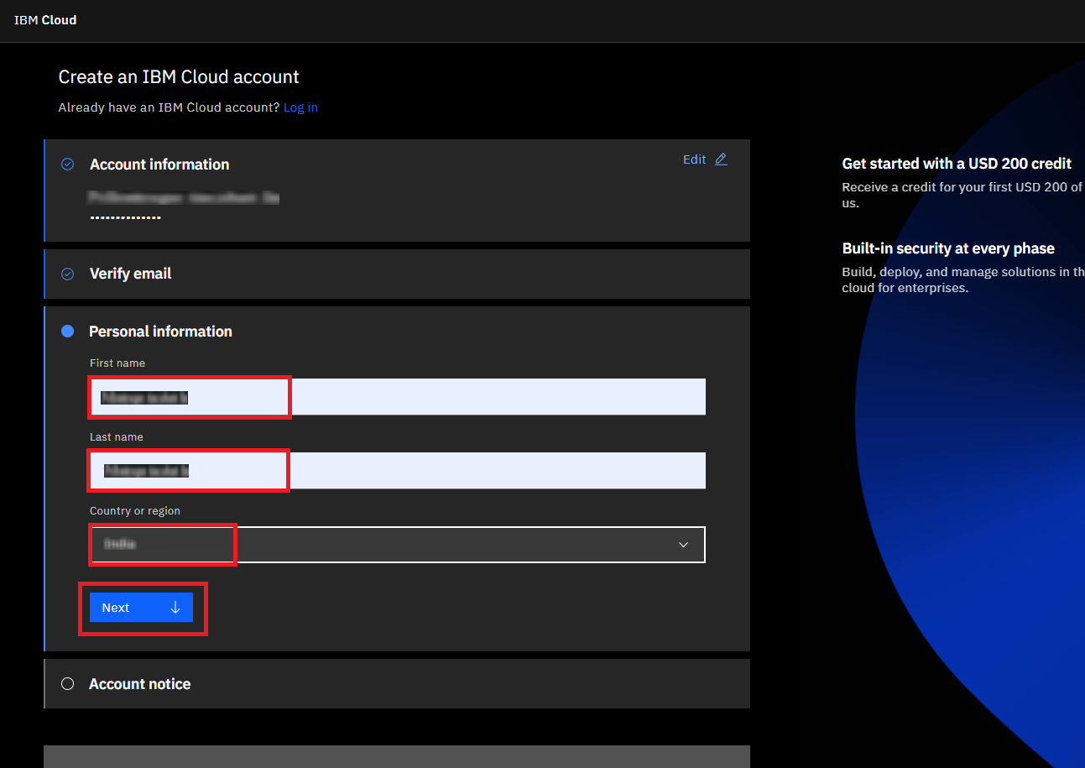
- Go through the Account Notice and opt for email updates if you desire, accept the terms and conditions and click on Continue.

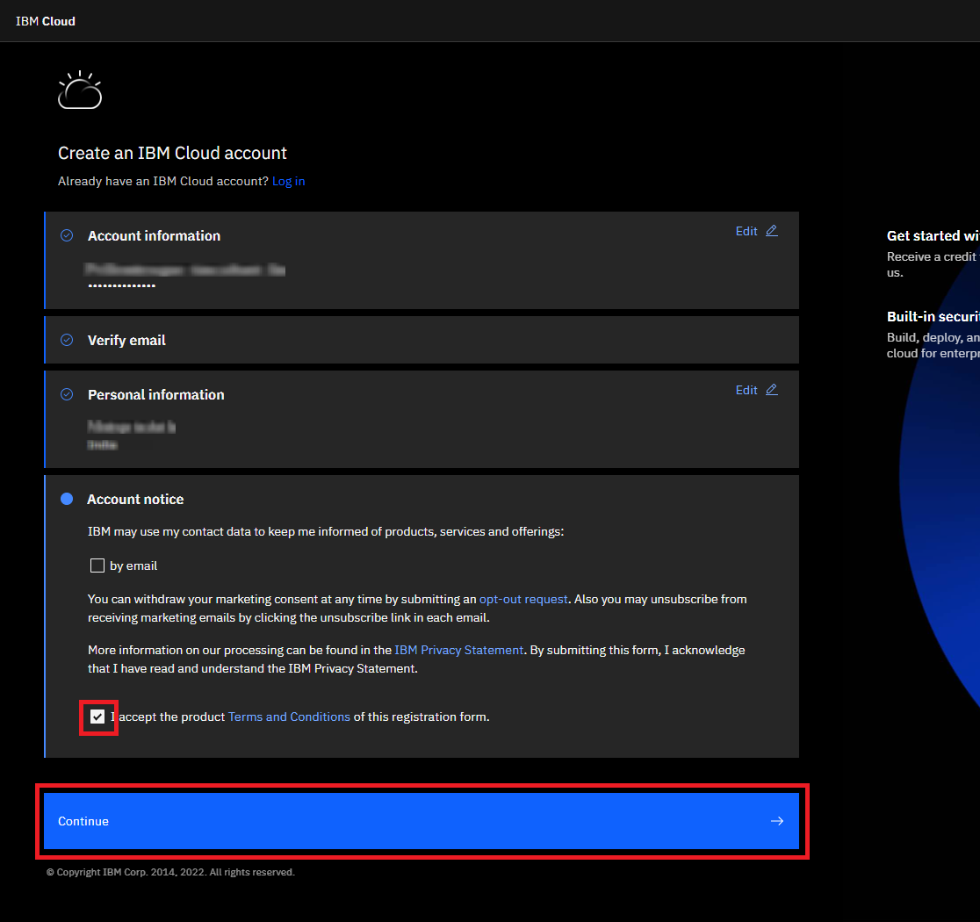
- Before creating your account, review the account privacy notice and acknowledge that you have read and understood by checking the checkbox and click on Continue.

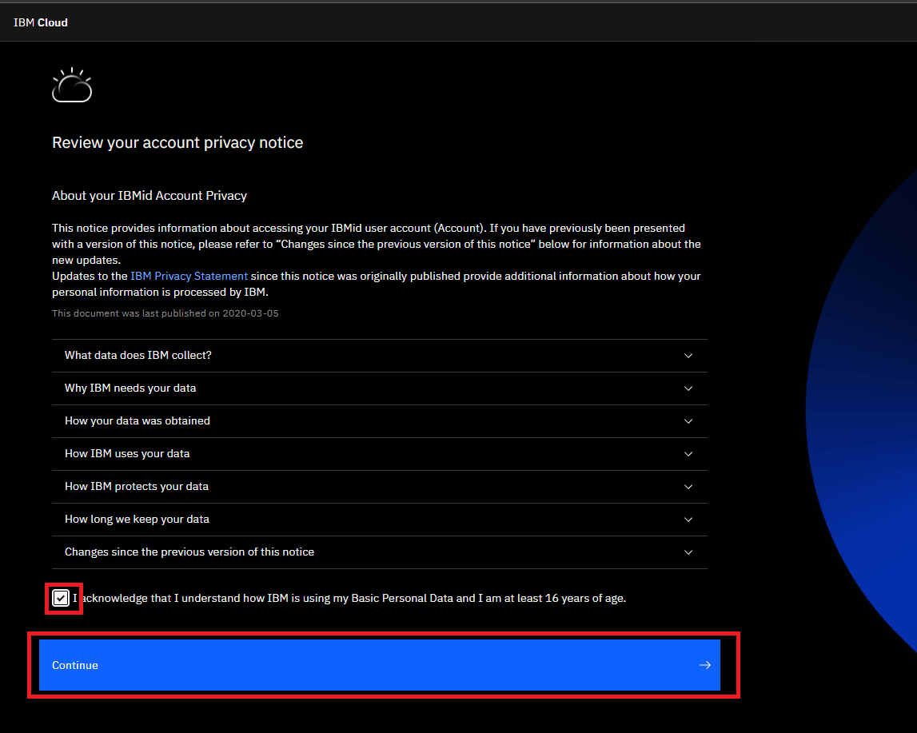
It takes a few seconds to create and set up your account.

Note: It might take a couple of minutes to create your account.
Note: Please ensure you should not use the Credit Card option to verify your account for course work as that can result in unnecessary charges and delays in activating your account.
- Once you’ve successfully created your IBM Cloud account, you should see the dashboard.
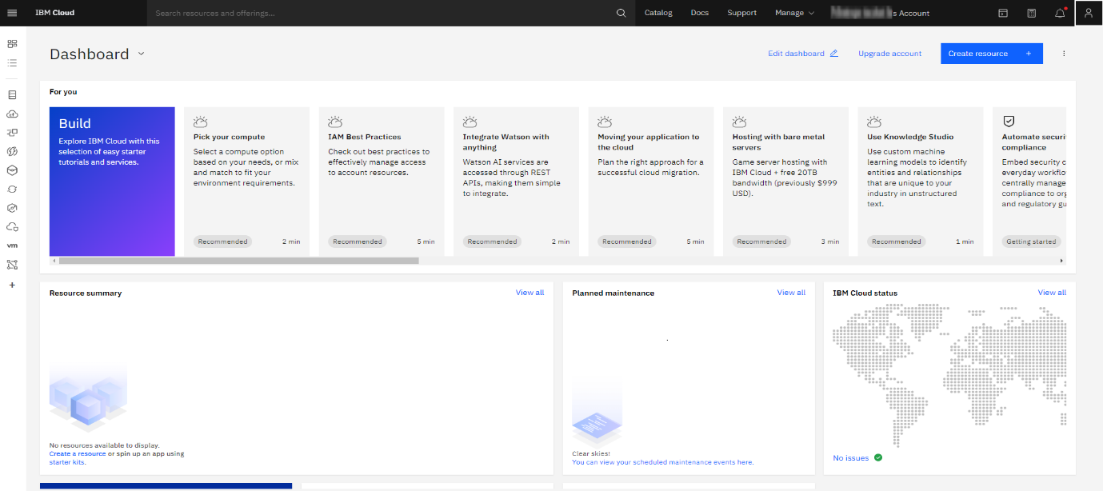
- Now you may explore the IBM Catalog for exploring the services and resources offered by IBM Cloud.

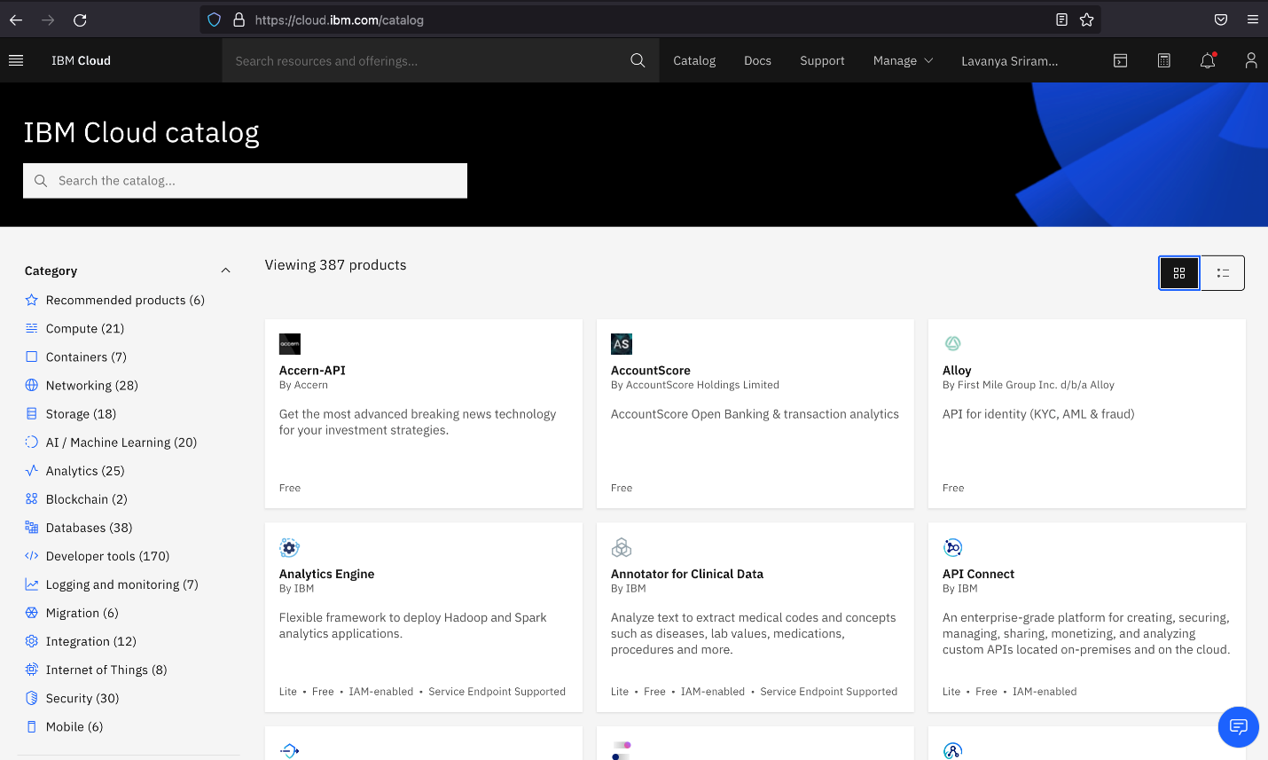

Department of Software Engineering
BS (Software Engineering)
Semester: 5th
Course: Cloud Computing
Course Code:
Credit Hours: 3+1
Lab Credit Hours: 01
Lab CLO: Demonstrate the basic service delivery models of cloud and distributed computing: Software as a Service (SaaS), Platform as a Service (PaaS), Infrastructure as a service (IaaS)
Bloom’s Taxonomy Level: C3
Linked PLO: 05 (Modern Tool Usage)
Max Marks: 20
Marks Distribution
Semester Work: 10
Final Lab Examination: 10
Lab Examination Rubrics

Attribute | Attainment Extent (Marks) |  |  |  |  | Marks Obtained (out of 2)
 | 0 | 0.5 | 1 | 1.5 | 2
Software Installation and configuration  (Knowledge about how to access Cloud /Distributed software) | Not able to recognize cloud/Distributed computing-based software | Knows a little bit about software but unable to access | Knows about software but cannot access it without detailed help | Knows about cloud based /Distribution computing software and able to access it with minor help | Able to recognize cloud based /distributed computing-based software and access it independently
Use of Software Knowledge and environment setting  (Knowledge about using Cloud based /distributed computing-based software and its environment) | Not able to work on cloud based /distributed computing-based software | Very limited work on Cloud based /distributed computing-based software with complete dependance on external help | Able to use Cloud based /distributed computing-based software with major external support | Able to use Cloud based /distributed computing-based software components with minor errors | Able to use Cloud based /distributed computing-based software properly with no errors
Procedural Skills  (Procedural skills of students using programming codes for the lab/or algorithm given is assessed) | Not able to follow procedure given to perform lab | Rarely follows procedure and mainly asks others | Follows procedure on large parts with some errors | Follows procedures as given with minimal errors | Follow correct procedure as provided independently
Accuracy of Completion of task  (Student assessment of completing the given task as per requirement is assessed) | Completely wrong or fundamental level errors indicating student is completely unaware about completion of task | Very few things of task as per requirement correct | Some tasks completed correctly but major portion inaccurate | Major parts of task completely accurate with minor mistakes | Accurate completion of tasks with no errors
Responding to questions about Lab work  (Student will be assessed for having confidence while answering questions asked about cloud based/distributed computing-based software and given task) | Completely confused and not able to respond | Confused but able to respond a few questions | Middle level confidence and able to respond | Good confidence except minor level confusion and ability to respond | Completely confident and responding well to questions asked
CLO Score in Lab Examination (Out of 10)
Notes:
- There shall be a 10 marks final examination on Rubrics
- Students not getting 50% KPI shall be given additional chance to repeat and improve in CQI

