Lab Session 10
Objective:
Demonstrate the CRM using Salesforce and use Salesforce as a SaaS, PaaS and IaaS.
Theory:
CRM:
CRM (Customer Relationship Management) is a kind of software that stores customer contact information like name, address, age, phone number. It also keeps tracks of customer activity like website visits, numbers of outgoing and incoming phone calls, email, and more.
Salesforce:
Salesforce is a cloud-based Customer Relationship Management (CRM) software for managing customer relationships and integration with other systems. This SaaS tool helps to create custom solutions for marketing, sales, services and ecommerce as per business requirements. Salesforce has now expanded from just CRM to offer multiple products.
History of salesforce:
- It was founded in March 1999 by ex-Oracle employee Marc Benioff, Frank Dominguez, and Parker Harris
- In June 2004, the company’s IPO was listed on the New York Stock Exchange under the stock symbol CRM and raised US$110 million.
- In October 2014, Salesforce announced the development of its Customer Success Platform to merge all the Salesforce’s services like sales, service, marketing, analytics, etc.
- In 2017, Sales force launched a Facebook Analytics tool.
- In 2018, Sales force partnered with Apple for improving apps for businesses.
- Salesforce.com translated its services into 16 different languages. It currently has 82,400 regular customers and over 2,100,000 subscribers.
Benefits:
- It is a complete feature-rich solution for marketing, sales, service, partner management, and community management.
- Salesforce data is stored in the cloud so your team can use it from anywhere in the world with the help of an Internet connection.
- It caters to the needs of small as well as medium to large organizations.
- Salesforce works on a pay as you go, model so there are no overhead costs.
- Increase customer loyalty, retention, and satisfaction
- Accelerates sales productivity
- Salesforce can easily integrate with 3rd party apps.
- Increase the growth of your business
- Continuous optimization of campaigns can be done based on the market response and closure interaction with channel partners.
Salesforce Architecture:

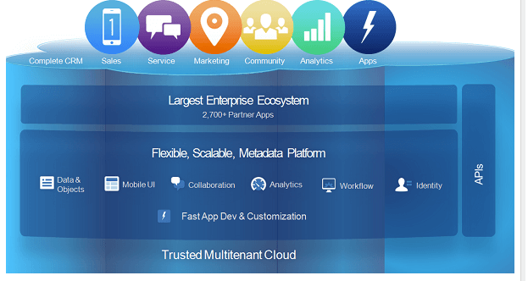
Trusted multitenant Cloud
- In this component, multiple instances of one or more application operate separately in a shared environment. The instances are known as tenants which separate from each other. Although, there are physically remain in the same hardware. It is called trusted as it offers a high level of security.
Scalable Metadata Platform
- This component helps you to customizations. It also allows you to increase the amount of data or concurrent user instances.
Enterprise Ecosystem
- The enterprise Ecosystem of Salesforce is quite big as many partners contribute by creating and maintaining in this platform. To ensure the quality of your Salesforce implementation, it’s essential to learn about Salesforce testing techniques and best practices.
APIs
- Salesforce offers a powerful suite of APIs to develop the Mobile App.
CRM and Related Functionality
- Salesforce includes all features of CRM and also offers features for the creation of apps
Service Nature of Salesforce
- Salesforce as SaaS (Software as a Service): No installations, setup or download required. Just Log in and use software across the Cloud.
- Salesforce as PaaS (Platform as a service): In this kind of software service, no separate platform is required. You can use the developer’s code to create and deploy applications.
- Salesforce as laaS (Infrastructure as a service): No hardware or software installations needed as your data and applications are stored securely on the Salesforce cloud.
Features of Salesforce
- Marketing and sales lead: Helps you to measure customer engagement by tracking email activities and convert them to customers.
- Contact management: With the help of this feature you can pull your customer’s data like activity history, frequent contacts, customer communications, etc.
- Opportunities and quotes: Helps vendor to create opportunity and quote.
- Build and run innovative apps: You can build, scale and manage apps
- Analytics: It allows you to access the data, create dashboards and perform analysis
- Email integration: It provides integrations devoted to customer service, support and customer experience
- Communities for sales:– Online community software that enables companies to connect customers, partners and employees with each other
- Salesforce Engine: This feature focuses on making personalized contact with a customer for various campaigns designed by the marketing team
- Sales Collaboration: This feature helps you to address customer queries and feedback
- Sales Performance Management: It offers a metric-based goal setting and helps you to get feedback & rewards for the sales team.
- Lead Management: This feature helps you to tracks the leads that are in progress
- Territory Management: This feature allows you to create multiple territory models. You can also preview them before rollout, and helps you to optimize and balance territories
- Partnership management: This feature allows you to build communities with partners and help them to share objectives, goals, and activities
- Workflow and Approvals: The interface provides simple drag and drops option
- Files Sync and Share: This feature provide the sales team the power to share various files and update them instantly
- Reports and Dashboards: Dashboards and reporting feature offers a real-time picture of the business at a glance
- Sales Forecasting: This feature allows you are getting a real time view of the forecast of a sales team

Salesforce Products

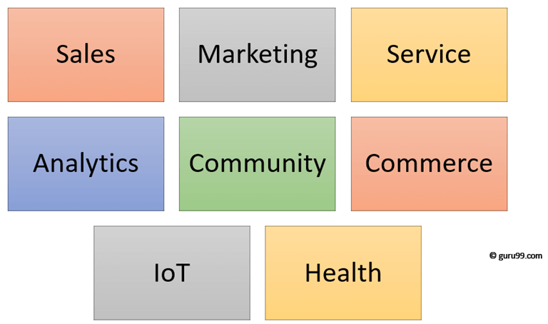

Lab task:
Differentiate between traditional CRM and salesforce CRM.
Briefly describe the salesforce products.

Department of Software Engineering
B.E (Software Engineering)
Semester: 5th
Course: Cloud Computing
Course Code: SWE-313
Credit Hours: 3+1
Lab Credit Hours: 01
Lab CLO: Demonstrate the basic service delivery models of cloud and distributed computing: Software as a Service (SaaS), Platform as a Service (PaaS), Infrastructure as a service (IaaS)
Bloom’s Taxonomy Level: C3
Linked PLO: 05 (Modern Tool Usage)
Max Marks: 20
Marks Distribution
Semester Work: 10
Final Lab Examination: 10
Lab Examination Rubrics

Attribute | Attainment Extent (Marks) |  |  |  |  | Marks Obtained (out of 2)
 | 0 | 0.5 | 1 | 1.5 | 2
Software Installation and configuration  (Knowledge about how to access Cloud /Distributed software) | Not able to recognize cloud/Distributed computing-based software | Knows a little bit about software but unable to access | Knows about software but cannot access it without detailed help | Knows about cloud based /Distribution computing software and able to access it with minor help | Able to recognize cloud based /distributed computing-based software and access it independently
Use of Software Knowledge and environment setting  (Knowledge about using Cloud based /distributed computing-based software and its environment) | Not able to work on cloud based /distributed computing-based software | Very limited work on Cloud based /distributed computing-based software with complete dependance on external help | Able to use Cloud based /distributed computing-based software with major external support | Able to use Cloud based /distributed computing-based software components with minor errors | Able to use Cloud based /distributed computing-based software properly with no errors
Procedural Skills  (Procedural skills of students using programming codes for the lab/or algorithm given is assessed) | Not able to follow procedure given to perform lab | Rarely follows procedure and mainly asks others | Follows procedure on large parts with some errors | Follows procedures as given with minimal errors | Follow correct procedure as provided independently
Accuracy of Completion of task  (Student assessment of completing the given task as per requirement is assessed) | Completely wrong or fundamental level errors indicating student is completely unaware about completion of task | Very few things of task as per requirement correct | Some tasks completed correctly but major portion inaccurate | Major parts of task completely accurate with minor mistakes | Accurate completion of tasks with no errors
Responding to questions about Lab work  (Student will be assessed for having confidence while answering questions asked about cloud based/distributed computing-based software and given task) | Completely confused and not able to respond | Confused but able to respond a few questions | Middle level confidence and able to respond | Good confidence except minor level confusion and ability to respond | Completely confident and responding well to questions asked
CLO Score in Lab Examination (Out of 10)
Notes:
- There shall be a 10 marks final examination on Rubrics
- Students not getting 50% KPI shall be given additional chance to repeat and improve in CQI

