Lab Session 11
Objective:
Demonstrate with Salesforce lightning account to explore the basic CRM functions.
Theory:
Salesforce:
Salesforce.com Inc. is an American cloud-based software company headquartered in San Francisco, California. Though the bulk of its revenue comes from a customer relationship management (CRM) product, Salesforce also sells a complementary suite of enterprise applications focused on customer service, marketing automation, analytics and application development.
Salesforce is the primary enterprise offering within the Salesforce platform. It provides companies with an interface for case management and task management, and a system for automatically routing and escalating important events. The Salesforce customer portal provides customers the ability to track their own cases, includes a social networking plug-in that enables the user to join the conversation about their company on social networking websites, provides analytical tools and other services including email alert, Google search, and access to customers' entitlement and contracts.
Lightning Platform:
Lightning Platform (also known as Force.com) is a platform as a service (PaaS) that allows developers to create add-on applications that integrate into the main Salesforce.com application. These third-party applications are hosted on Salesforce.com's infrastructure.
Force.com applications are built using declarative tools, backed by Lightning and Apex (a proprietary Java-like programming language for Force.com) and Lightning and Visual force (a framework that includes an XML syntax typically used to generate HTML). The Force.com platform typically receives three complete releases a year. As the platform is provided as a service to its developers, every single development instance also receives all these updates.
Community Cloud:
Community Cloud provides Salesforce customers the ability to create online web properties for external collaboration, customer service, channel sales, and other custom portals in their instance of Salesforce. Tightly integrated to Sales Cloud, Service Cloud, and App Cloud, Community Cloud can be quickly customized to provide a wide variety of web properties
Salesforce Sales Cloud:
Salesforce Sales Cloud is a customer relationship management (CRM) platform designed to support sales, marketing and customer support in both business-to-business (B2B) and business-to-customer (B2C) contexts. Sales Cloud is a fully customizable product that brings all the customer information together in an integrated platform that incorporates marketing, lead generation, sales, customer service and business analytics and provides access to thousands of applications through the AppExchange. The platform is provided as Software as a Service (SaaS) for browser-based access; a mobile app is also available. A realtime social feed for collaboration allows users to share information or ask questions of the user community.Salesforce.com offers five versions of Sales Cloud on a per-user, per month basis, from lowest to highest: Group, Professional, Enterprise, Unlimited and Performance. The company offers three levels of support contracts: Standard Success Plan, Premier Success Plan and Premier+ Success Plan.
Step1:
Search for developer salesforce.
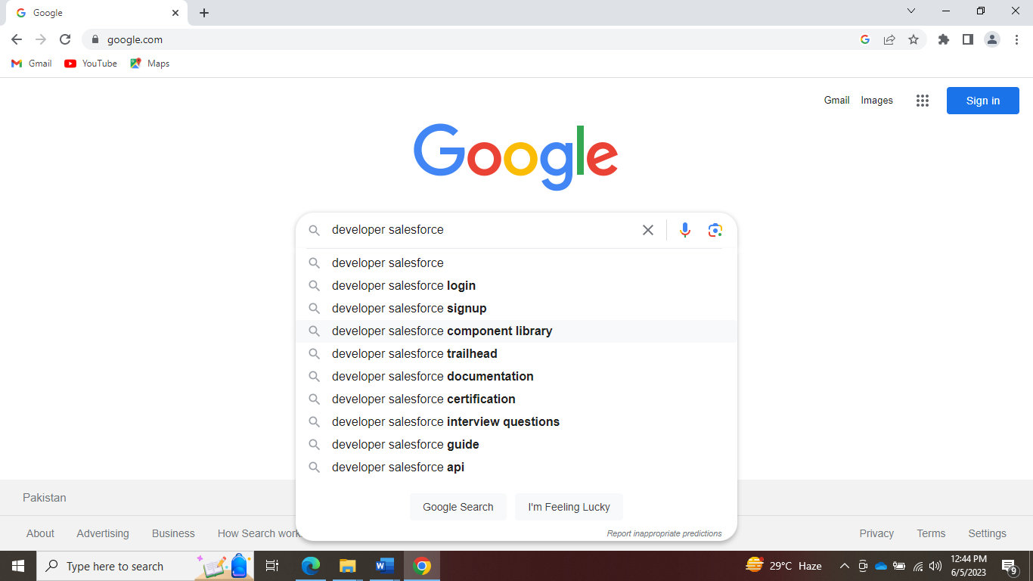

Step2:
Select developer edition.
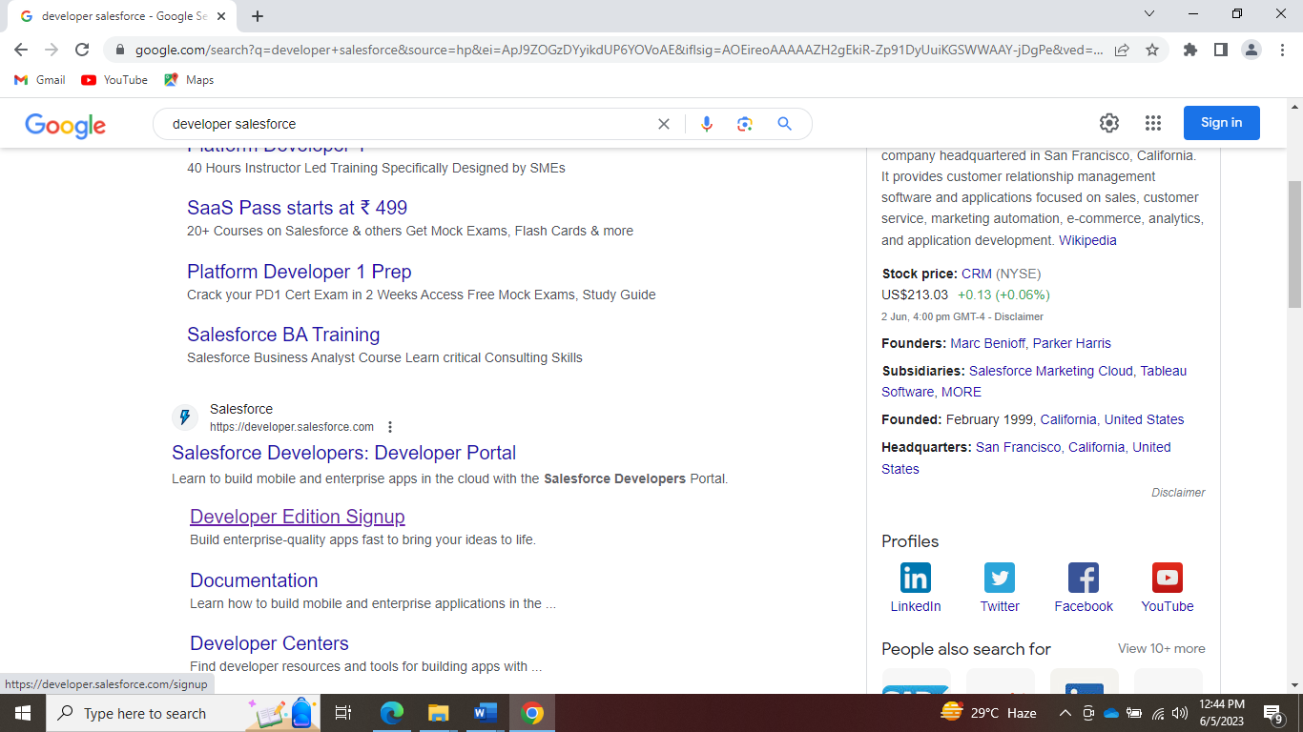
Step3:
Fill out the form.
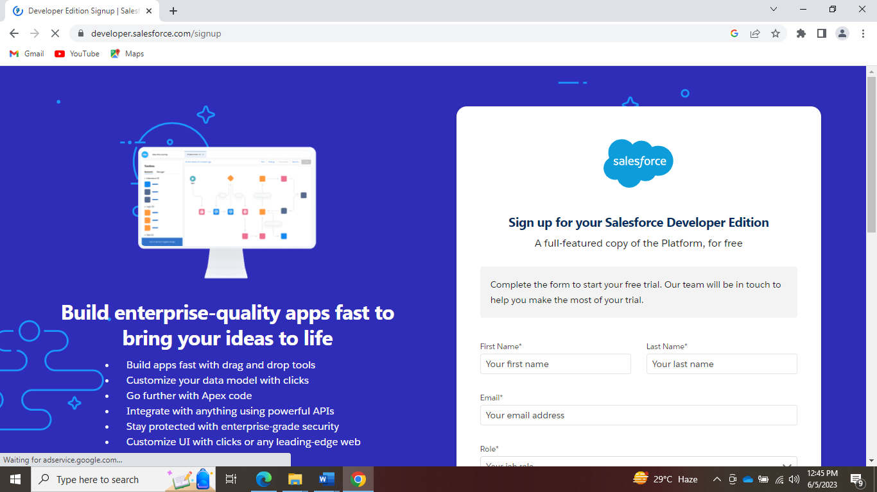

Step4:
Verify with your email account.
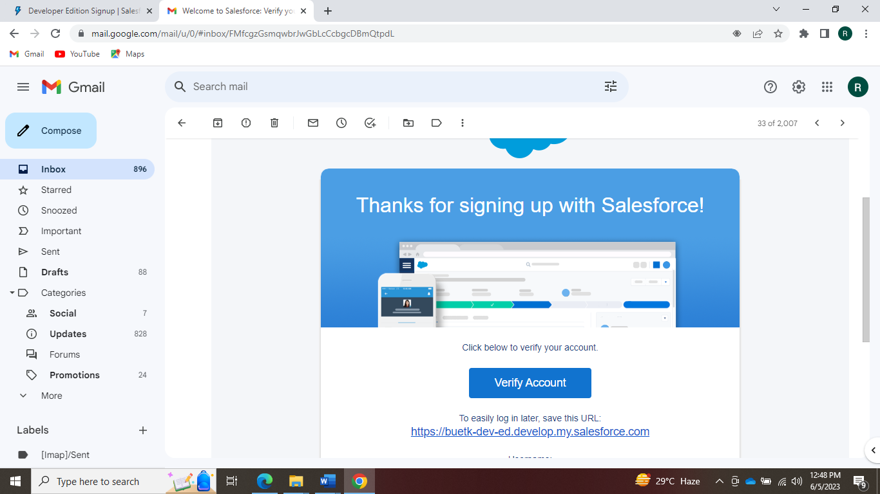

Step5:
Change the password for first use.
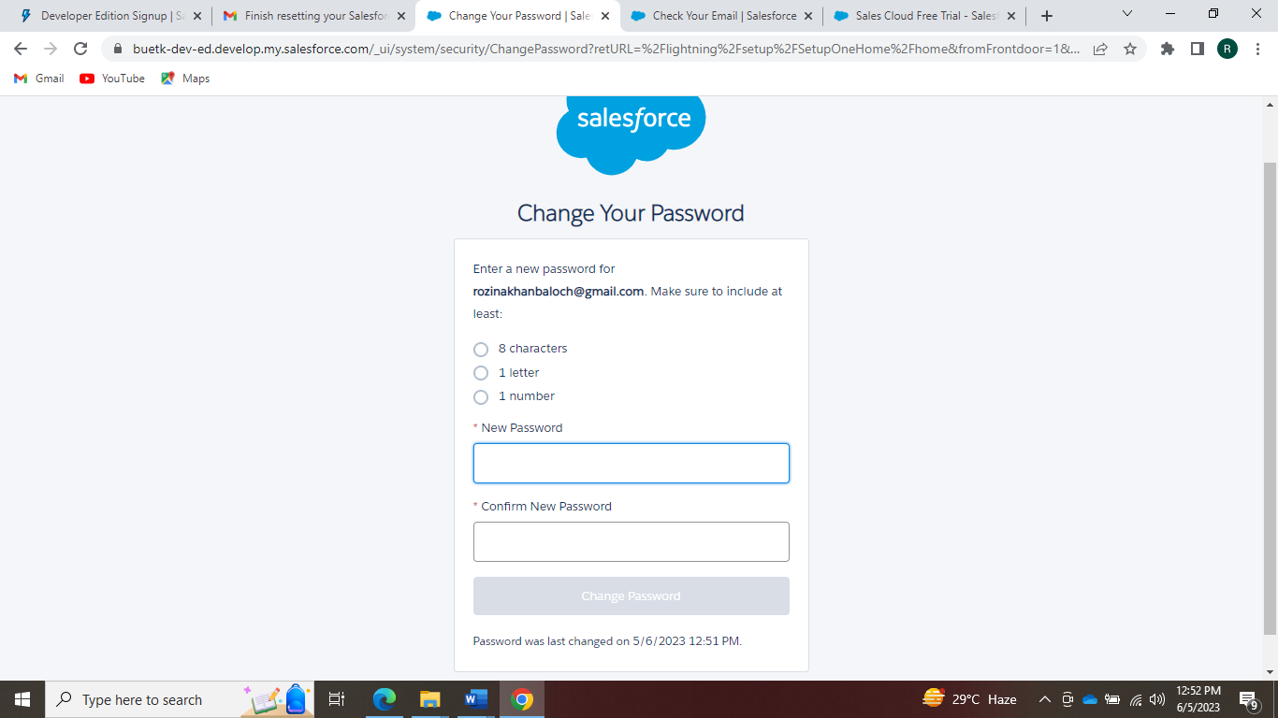

Step6:
Your account has been created.
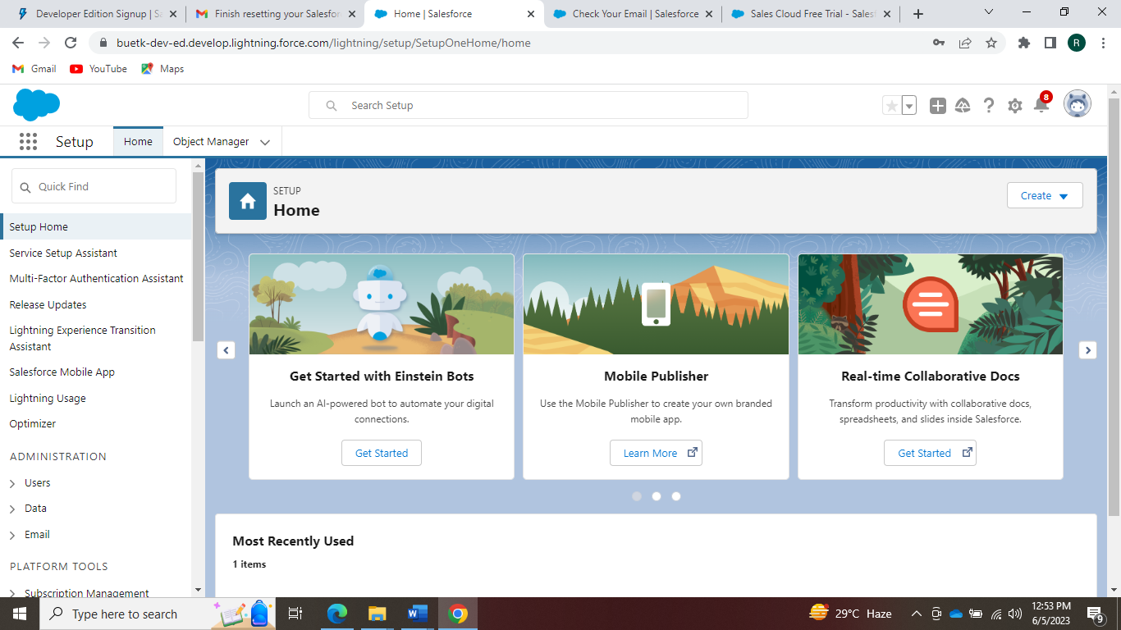
Lab task:
Create your salesforce lightning account and explore the basic functions of salesforce.

Department of Software Engineering
B.E (Software Engineering)
Semester: 5th
Course: Cloud and Distributed Computing
Course Code: SWE-313
Credit Hours: 3+1
Lab Credit Hours: 01
Lab CLO: Demonstrate the basic service delivery models of cloud and distributed computing: Software as a Service (SaaS), Platform as a Service (PaaS), Infrastructure as a service (IaaS)
Bloom’s Taxonomy Level: C3
Linked PLO: 05 (Modern Tool Usage)
Max Marks: 20
Marks Distribution
Semester Work: 10
Final Lab Examination: 10
Lab Examination Rubrics

Attribute | Attainment Extent (Marks) |  |  |  |  | Marks Obtained (out of 2)
 | 0 | 0.5 | 1 | 1.5 | 2
Software Installation and configuration  (Knowledge about how to access Cloud /Distributed software) | Not able to recognize cloud/Distributed computing-based software | Knows a little bit about software but unable to access | Knows about software but cannot access it without detailed help | Knows about cloud based /Distribution computing software and able to access it with minor help | Able to recognize cloud based /distributed computing-based software and access it independently
Use of Software Knowledge and environment setting  (Knowledge about using Cloud based /distributed computing-based software and its environment) | Not able to work on cloud based /distributed computing-based software | Very limited work on Cloud based /distributed computing-based software with complete dependance on external help | Able to use Cloud based /distributed computing-based software with major external support | Able to use Cloud based /distributed computing-based software components with minor errors | Able to use Cloud based /distributed computing-based software properly with no errors
Procedural Skills  (Procedural skills of students using programming codes for the lab/or algorithm given is assessed) | Not able to follow procedure given to perform lab | Rarely follows procedure and mainly asks others | Follows procedure on large parts with some errors | Follows procedures as given with minimal errors | Follow correct procedure as provided independently
Accuracy of Completion of task  (Student assessment of completing the given task as per requirement is assessed) | Completely wrong or fundamental level errors indicating student is completely unaware about completion of task | Very few things of task as per requirement correct | Some tasks completed correctly but major portion inaccurate | Major parts of task completely accurate with minor mistakes | Accurate completion of tasks with no errors
Responding to questions about Lab work  (Student will be assessed for having confidence while answering questions asked about cloud based/distributed computing-based software and given task) | Completely confused and not able to respond | Confused but able to respond a few questions | Middle level confidence and able to respond | Good confidence except minor level confusion and ability to respond | Completely confident and responding well to questions asked
CLO Score in Lab Examination (Out of 10)
Notes:
- There shall be a 10 marks final examination on Rubrics
- Students not getting 50% KPI shall be given additional chance to repeat and improve in CQI

