Computer Science NEA
Hafsa Aftab

Contents:
Section 1 - Analysis
Description

Section 1 – Analysis
Description
Tower defence games are defined by a territory/base that must be defended by the placement of ‘tower’ elements or obstructions against waves of incoming enemies. Using Python 3.15, I am going to develop a game in this genre.
In most tower defence games, the game ends when a certain number of enemies breach the player’s ‘base’, or the player’s HP depletes to zero. The objective of the game is to survive as many waves of enemies as possible, with waves becoming increasingly more difficult to defend against as the player progresses. Between waves, players are given the opportunity to build defences and ‘towers’ to block and attack the enemy respectively.
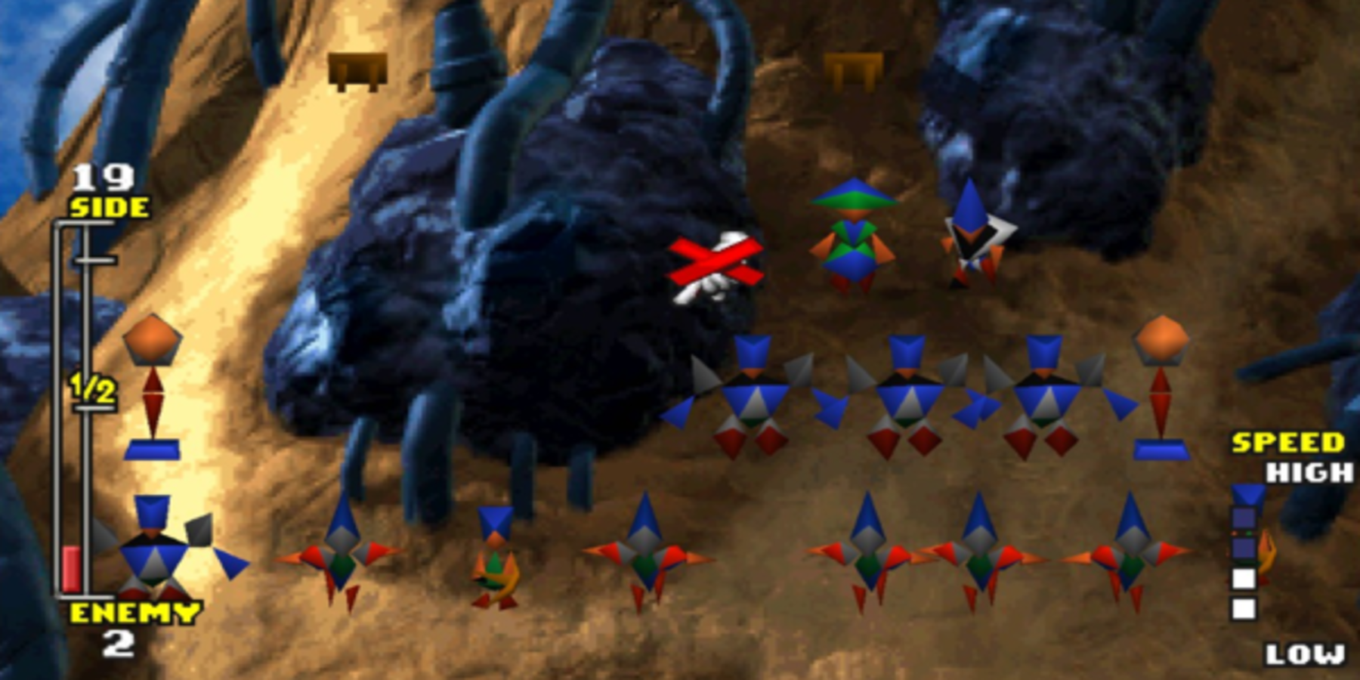
The 1990 Atari game Rampart is widely considered the first game in this genre, introducing a two-phase system, where the first building phase consists of the player attempting to expand their territory and repair any combat damage, and where the second combat phase consists of the player attacking the enemy with their canons. These are now staple elements of gameplay in any modern game of this genre, whether it be the popular 2009 game Plants vs. Zombies or the tower defence minigame in the 1997 Final Fantasy VII.
Final Fantasy VII tower defence minigame
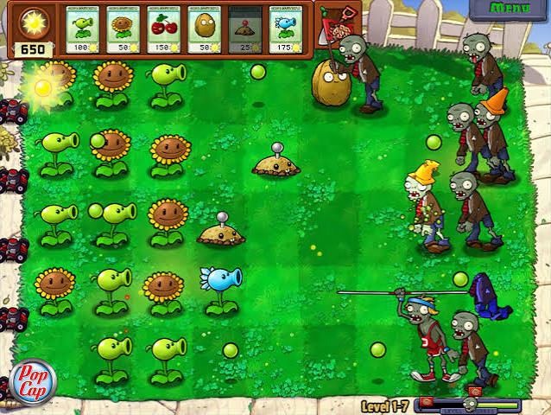
2009 Plants vs. Zombies
Many modern tower defence games include currency which is used to build obstructions, ‘towers’ and upgrade or repair both (as enemies can usually destroy them over time), waves with different types of enemies, an ability to unlock new maps and levels, and towers that have the ability to move. These features are all showcased in the 2018 mobile game Bloons TD 6. 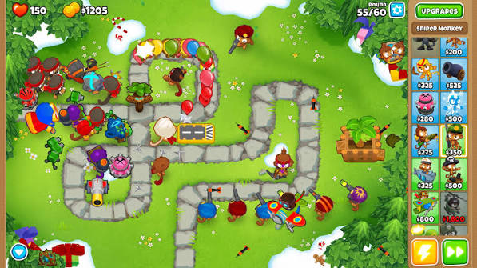
2018 Bloons TD 6

