**Terraform**

Step 1:

Download Terraform file and extract and unzip it to your workspace

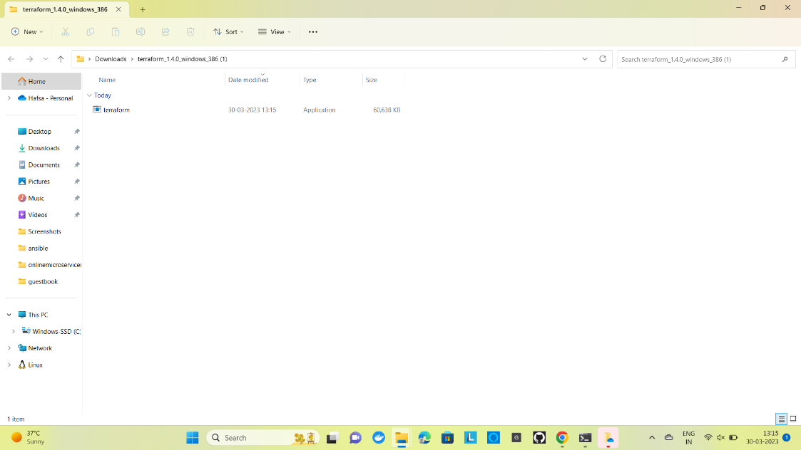

Step 2:

Copy the file location 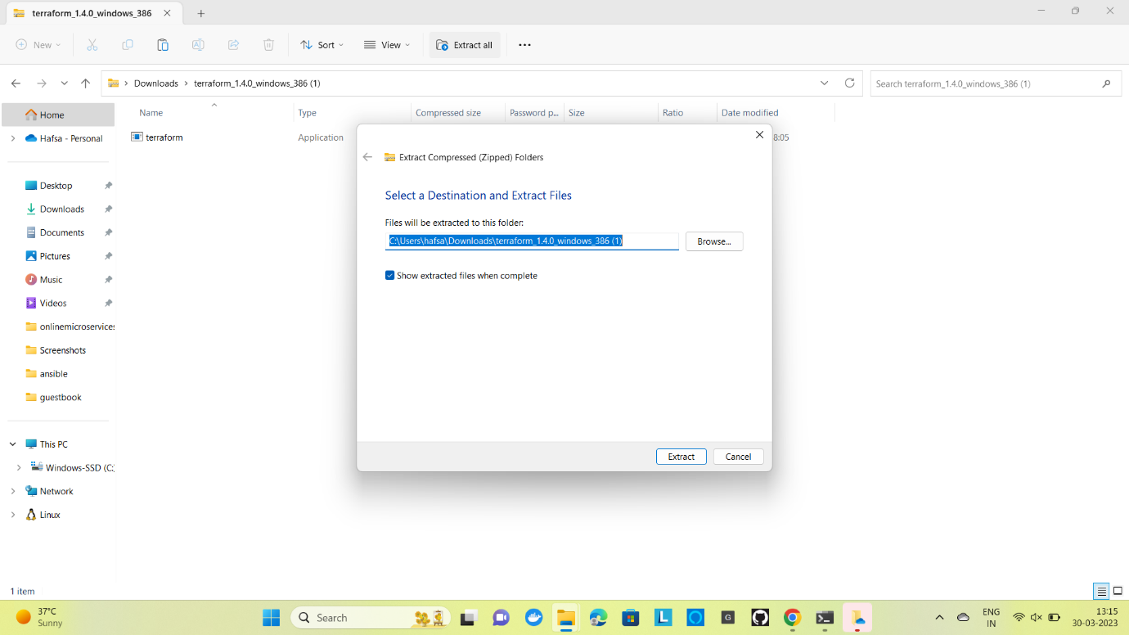

Step 3 :

Open settings-Open about-Open view advanced system settings- Open environment variables-Open path-Paste your terraform file location

C:\Workspace\terraform_1.4.0_windows_386

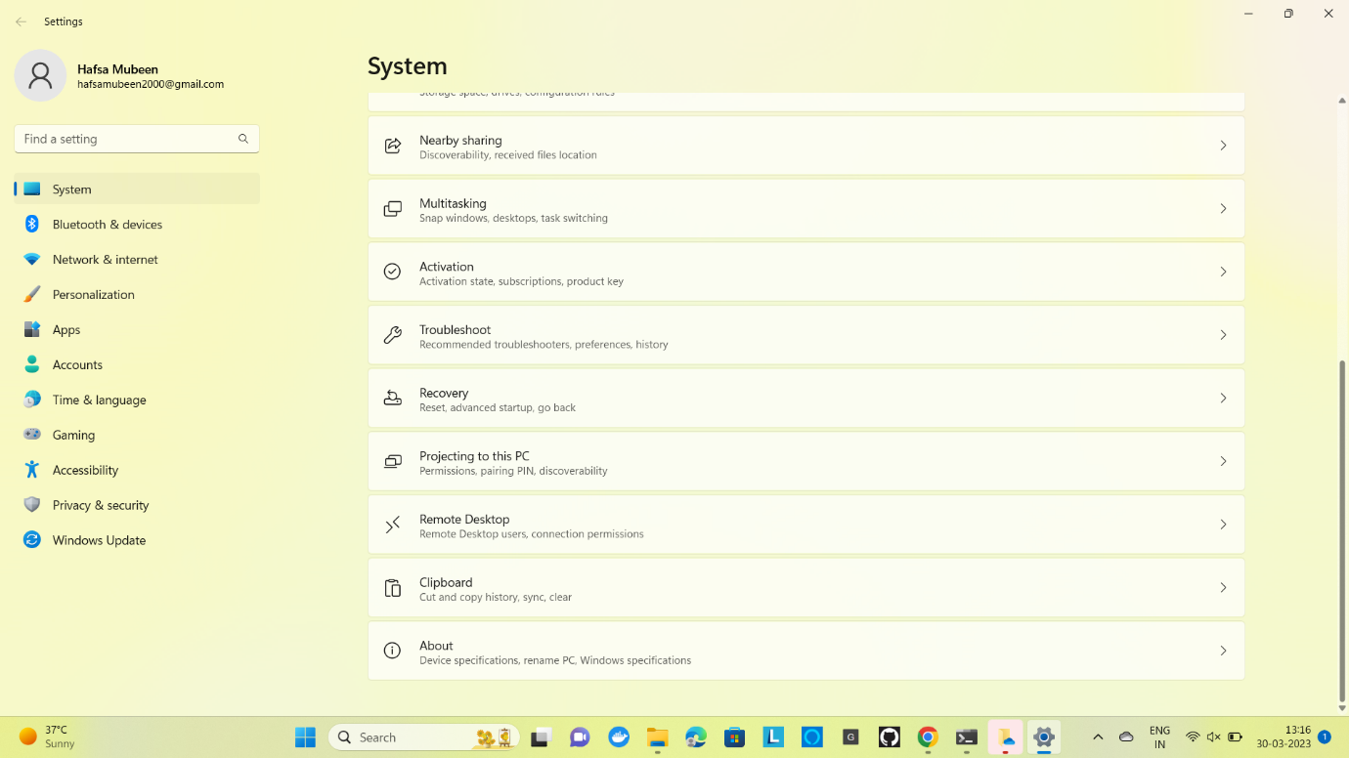

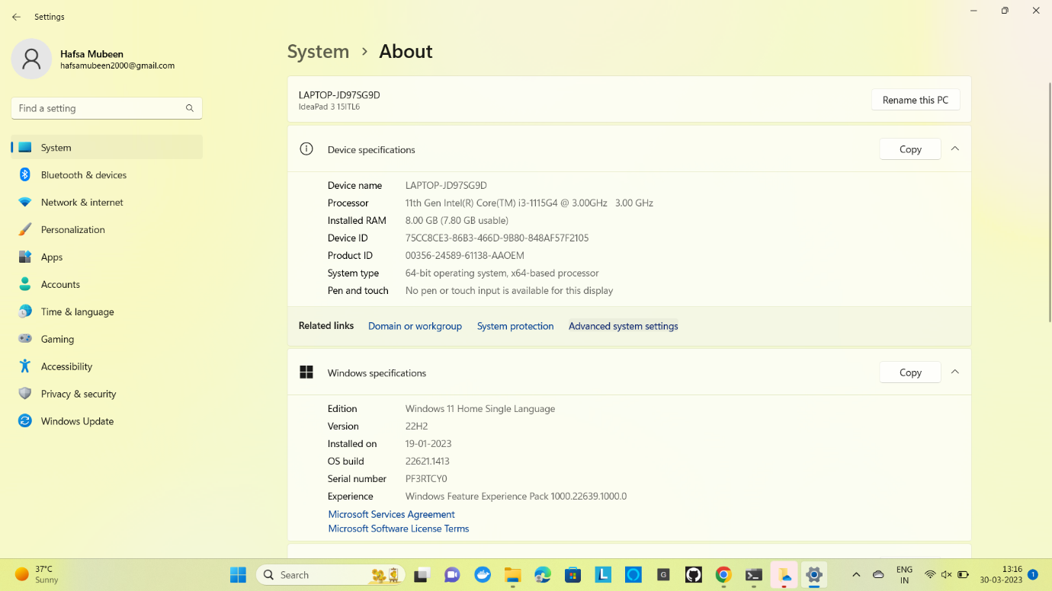

Step 4 :

Open Terraform file in your Command prompt

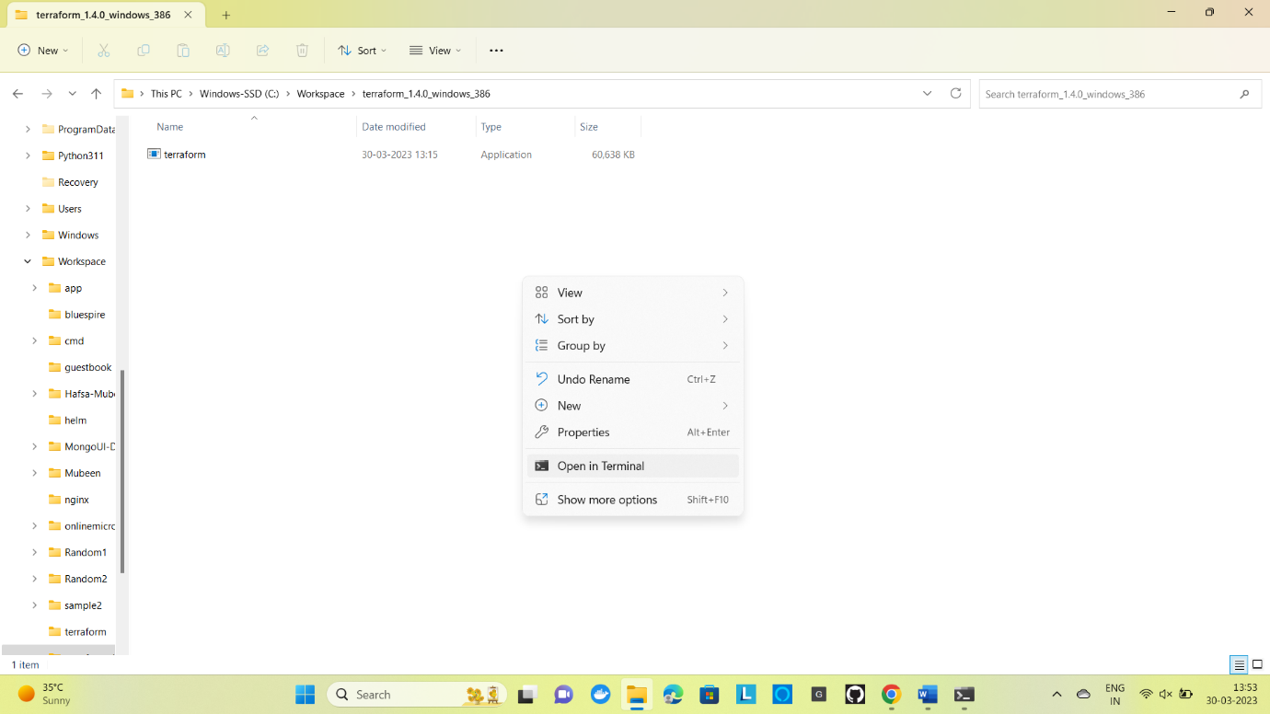

It displays the commands of terraform

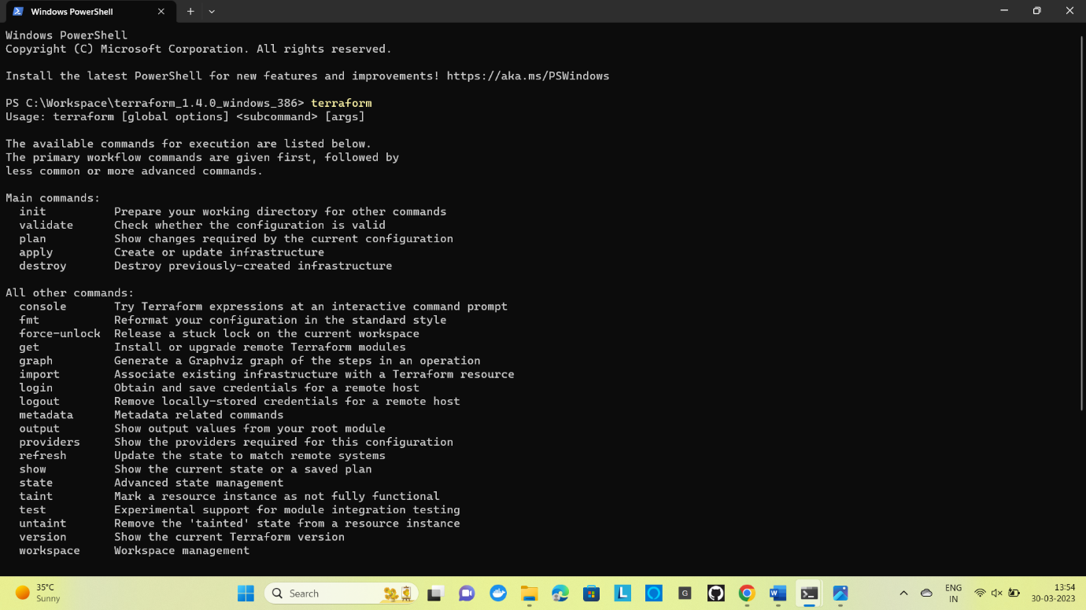

Step 5:

Open visual studio code and use command

PS C:\Users\hafsa\Downloads\terraform_1.4.0_windows_386 (1)> terraform init

The terraform init command initializes a working directory containing Terraform configuration files.

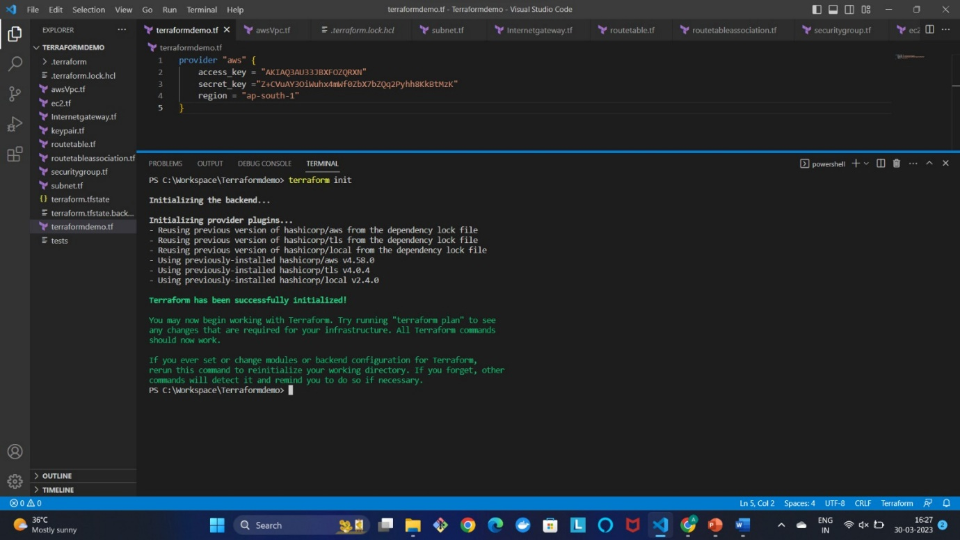

Step 6:

PS C:\Users\hafsa\Downloads\terraform_1.4.0_windows_386 (1)> terraform plan

The **terraform plan** command creates an execution plan, which lets you preview the changes that **Terraform plans** to make to your infrastructure.

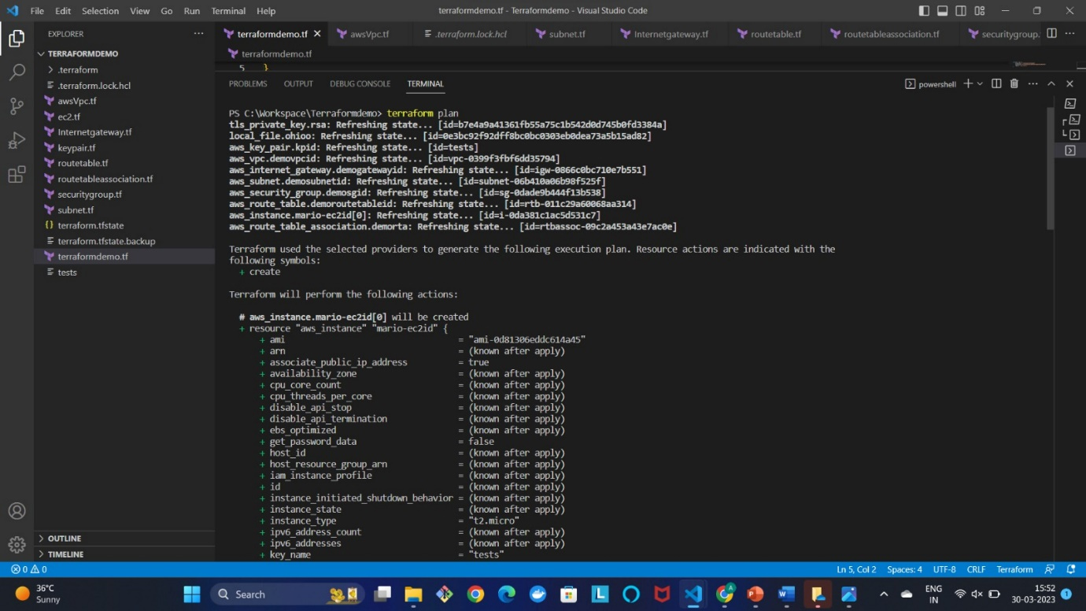

Step 7:

PS C:\Users\hafsa\Downloads\terraform_1.4.0_windows_386 (1)> terraform apply

The terraform apply command performs a plan just like terraform plan does, but then actually carries out the planned changes to each resource using the relevant infrastructure provider's API.

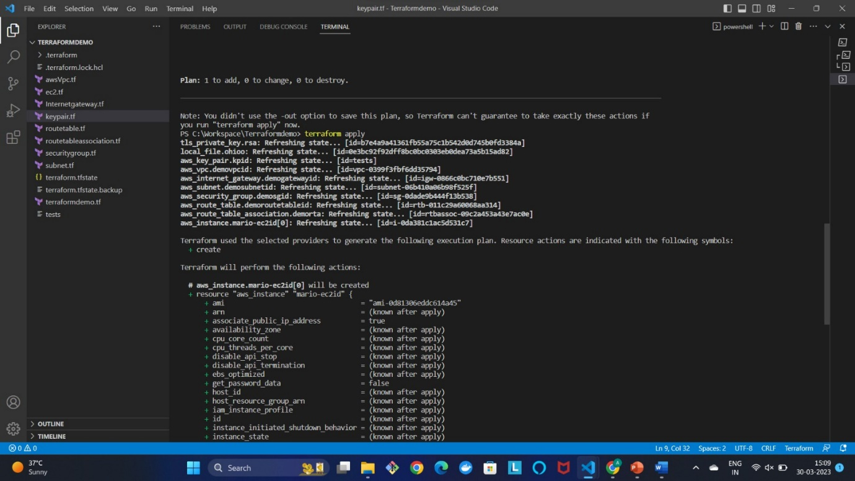

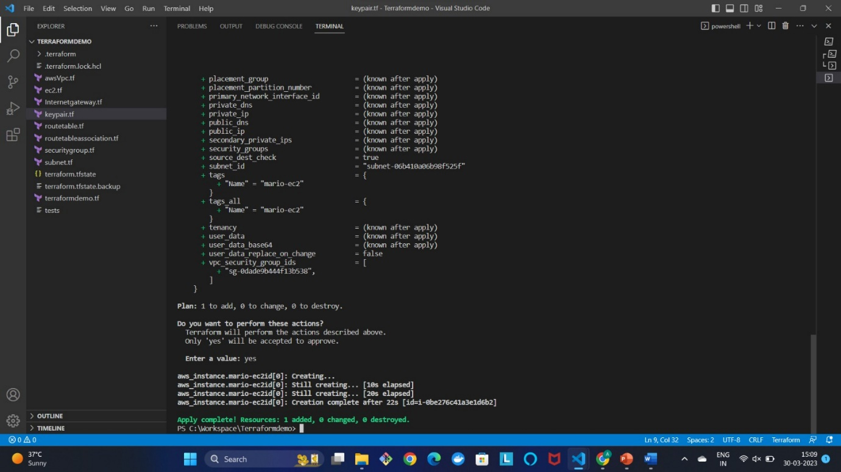

Step 8:

Terraform creates a Ec2 instance in AWS infrastructure.

