Docker file :

Step 1:

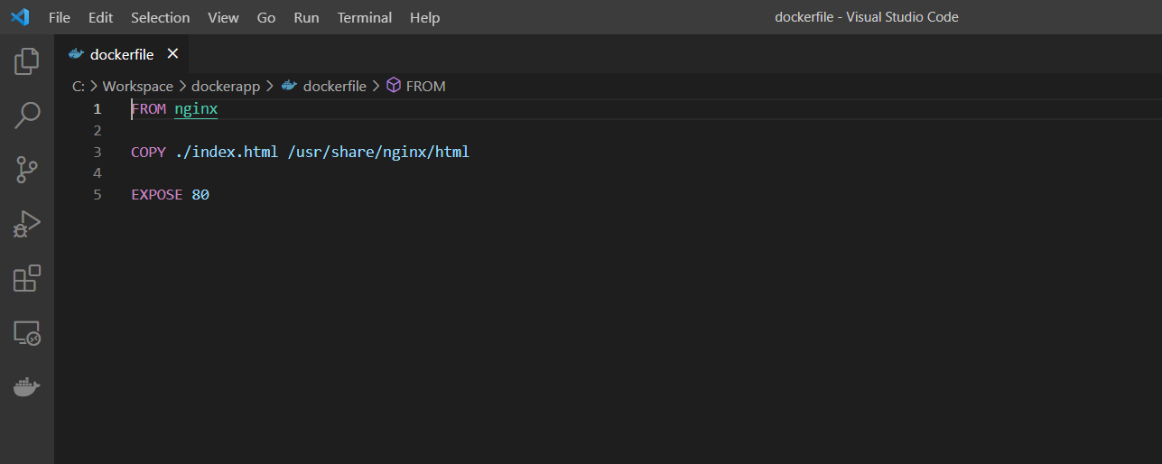

Build an image from a Dockerfile

PS C:\Users\hafsa\OneDrive\Desktop\Docker -qno3> docker build -t 191918/dockerfinal:dockernodejs .

PS C:\Users\hafsa\OneDrive\Desktop\Docker -qno3> docker images

REPOSITORY TAG IMAGE ID CREATED SIZE

191918/dockerfinal dockernodejs bd3a4d0bad6d 15 seconds ago 142MB

PS C:\Users\hafsa\OneDrive\Desktop\Docker -qno3> docker run -d --name dockerassesment -p 8080:80 191918/dockerfinal:dockernodejs

01cbf67ffa3eb63ed7d9e165057e1321ec3c3e728a0bc103730005560e659485

PS C:\Users\hafsa\OneDrive\Desktop\Docker -qno3> docker push 191918/dockerfinal:dockernodejs

PS C:\Users\hafsa\OneDrive\Desktop\Docker -qno3> minikube start

😄 minikube v1.29.0 on Microsoft Windows 11 Home Single Language 10.0.22621.1635 Build 22621.1635

PS C:\Users\hafsa\OneDrive\Desktop\Docker -qno3> minikube status

Deploying docker file in kubernetes :

PS C:\Users\hafsa\OneDrive\Desktop\Docker -qno3> kubectl create deployment dockerassesment --image=191918/dockerfinal:dockernodejs

deployment.apps/dockerassesment created

PS C:\Users\hafsa\OneDrive\Desktop\Docker -qno3> kubectl expose deployment dockerassesment --type="NodePort" --port 80

service/dockerassesment exposed

PS C:\Users\hafsa\OneDrive\Desktop\Docker -qno3> kubectl get pods

NAME READY STATUS RESTARTS AGE

dockerassesment-6bb5677fcf-sbj48 1/1 Running 0 33s

dockerpractice-6d56485797-vhjh4 1/1 Running 5 (2m55s ago) 2d3h

step 3:

To check services

PS C:\Users\hafsa\OneDrive\Desktop\Docker -qno3> kubectl get service

NAME TYPE CLUSTER-IP EXTERNAL-IP PORT(S) AGE

appsample NodePort 10.96.221.139 <none> 80:32086/TCP 4d4h

bsdatadog ClusterIP 10.111.190.95 <none> 8125/UDP 61d

bsdatadog-cluster-agent ClusterIP 10.105.136.8 <none> 5005/TCP 61d

bsdatadog-cluster-agent-admission-controller ClusterIP 10.102.169.5 <none> 443/TCP 61d

bspiredatadog ClusterIP 10.97.198.222 <none> 8125/UDP 28d

bspiredatadog-cluster-agent ClusterIP 10.107.216.11 <none> 5005/TCP 28d

bspiredatadog-cluster-agent-admission-controller ClusterIP 10.98.251.116 <none> 443/TCP 28d

bssdatadog ClusterIP 10.106.71.91 <none> 8125/UDP 28d

bssdatadog-cluster-agent ClusterIP 10.105.126.15 <none> 5005/TCP 28d

bssdatadog-cluster-agent-admission-controller ClusterIP 10.102.75.87 <none> 443/TCP 28d

datadog ClusterIP 10.102.252.183 <none> 8125/UDP 4d4h

datadog-cluster-agent ClusterIP 10.102.42.149 <none> 5005/TCP 4d4h

datadog-cluster-agent-admission-controller ClusterIP 10.98.193.203 <none> 443/TCP 4d4h

dockerapp NodePort 10.109.58.249 <none> 80:31241/TCP 10d

dockerassesment NodePort 10.104.11.222 <none> 80:32650/TCP 27s

dockerpractice NodePort 10.101.181.111 <none> 80:30749/TCP 2d3h

kubernetes ClusterIP 10.96.0.1 <none> 443/TCP 74d

mongo-express-service LoadBalancer 10.97.252.128 <pending> 8081:30000/TCP 67d

mongo-service ClusterIP 10.108.225.212 <none> 80/TCP 44h

mongodb-service ClusterIP 10.102.219.123 <none> 27017/TCP 67d

nginx ClusterIP 10.101.66.221 <none> 80/TCP 63d

nginx-service ClusterIP 10.104.241.96 <none> 80/TCP 3d4h

redis-follower ClusterIP 10.103.108.109 <none> 6379/TCP 56d

redis-leader ClusterIP 10.105.69.140 <none> 6379/TCP 56d

PS C:\Users\hafsa\OneDrive\Desktop\Docker -qno3> minikube service dockerassesment

|-----------|-----------------|-------------|---------------------------|

| NAMESPACE | NAME | TARGET PORT | URL |

|-----------|-----------------|-------------|---------------------------|

| default | dockerassesment | 80 | http://192.168.49.2:32650 |

|-----------|-----------------|-------------|---------------------------|

🏃 Starting tunnel for service dockerassesment.

|-----------|-----------------|-------------|------------------------|

| NAMESPACE | NAME | TARGET PORT | URL |

|-----------|-----------------|-------------|------------------------|

| default | dockerassesment | | http://127.0.0.1:54867 |

|-----------|-----------------|-------------|------------------------|

🎉 Opening service default/dockerassesment in default browser...

❗ Because you are using a Docker driver on windows, the terminal needs to be open to run it.

✋ Stopping tunnel for service dockerassesment.

PS C:\Users\hafsa\OneDrive\Desktop\Docker -qno3> helm repo update

Hang tight while we grab the latest from your chart repositories...

...Successfully got an update from the "datadog" chart repository

...Successfully got an update from the "bitnami" chart repository

...Successfully got an update from the "bitnami1" chart repository

Update Complete. ⎈Happy Helming!⎈

Step 6:

Datadog installed

PS C:\Users\hafsa\OneDrive\Desktop\Docker -qno3> helm install datadogfinal --set datadog.site='us5.datadoghq.com' --set datadog.apiKey=02b96ef753ea86e4102914ab04075ec6 datadog/datadog

NAME: datadogfinal

* set `clusterAgent.createPodDisruptionBudget` to `true`.

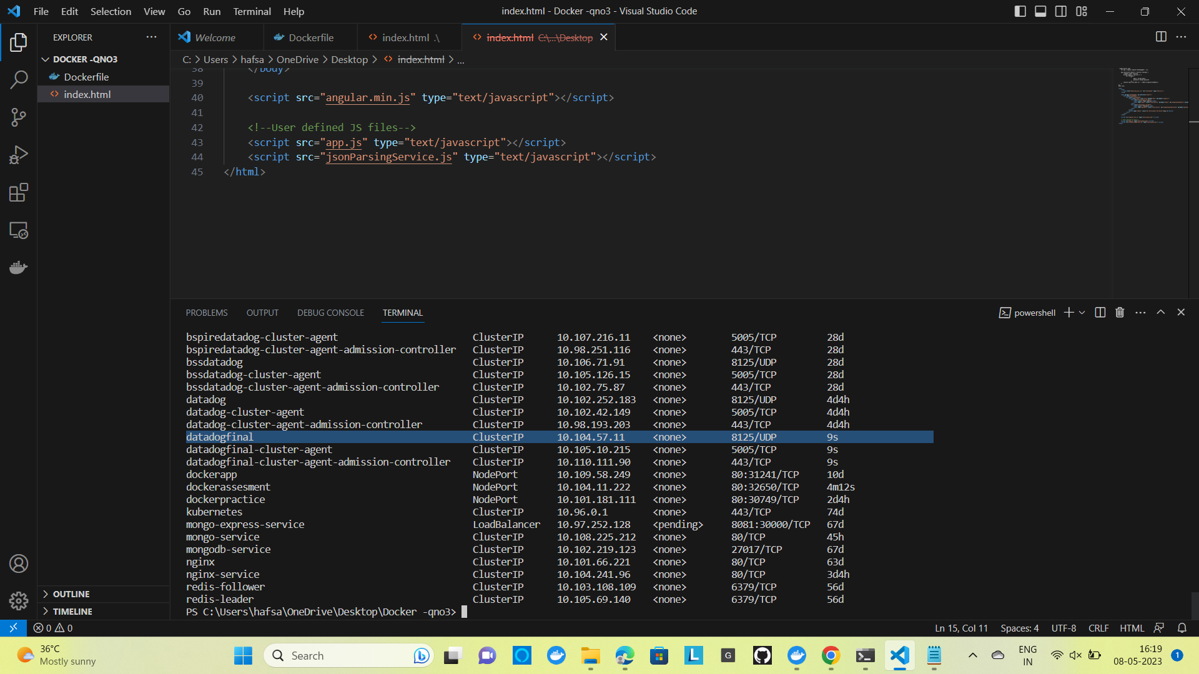

PS C:\Users\hafsa\OneDrive\Desktop\Docker -qno3> kubectl get service

NAME TYPE CLUSTER-IP EXTERNAL-IP PORT(S) AGE

appsample NodePort 10.96.221.139 <none> 80:32086/TCP 4d4h

bsdatadog ClusterIP 10.111.190.95 <none> 8125/UDP 61d

bsdatadog-cluster-agent ClusterIP 10.105.136.8 <none> 5005/TCP 61d

bsdatadog-cluster-agent-admission-controller ClusterIP 10.102.169.5 <none> 443/TCP 61d

bspiredatadog ClusterIP 10.97.198.222 <none> 8125/UDP 28d

bspiredatadog-cluster-agent ClusterIP 10.107.216.11 <none> 5005/TCP 28d

bspiredatadog-cluster-agent-admission-controller ClusterIP 10.98.251.116 <none> 443/TCP 28d

bssdatadog ClusterIP 10.106.71.91 <none> 8125/UDP 28d

bssdatadog-cluster-agent ClusterIP 10.105.126.15 <none> 5005/TCP 28d

bssdatadog-cluster-agent-admission-controller ClusterIP 10.102.75.87 <none> 443/TCP 28d

datadog ClusterIP 10.102.252.183 <none> 8125/UDP 4d4h

datadog-cluster-agent ClusterIP 10.102.42.149 <none> 5005/TCP 4d4h

datadog-cluster-agent-admission-controller ClusterIP 10.98.193.203 <none> 443/TCP 4d4h

datadogfinal ClusterIP 10.104.57.11 <none> 8125/UDP 9s

datadogfinal-cluster-agent ClusterIP 10.105.10.215 <none> 5005/TCP 9s

datadogfinal-cluster-agent-admission-controller ClusterIP 10.110.111.90 <none> 443/TCP 9s

dockerapp NodePort 10.109.58.249 <none> 80:31241/TCP 10d

dockerassesment NodePort 10.104.11.222 <none> 80:32650/TCP 4m12s

dockerpractice NodePort 10.101.181.111 <none> 80:30749/TCP 2d4h

kubernetes ClusterIP 10.96.0.1 <none> 443/TCP 74d

mongo-express-service LoadBalancer 10.97.252.128 <pending> 8081:30000/TCP 67d

mongo-service ClusterIP 10.108.225.212 <none> 80/TCP 45h

mongodb-service ClusterIP 10.102.219.123 <none> 27017/TCP 67d

nginx ClusterIP 10.101.66.221 <none> 80/TCP 63d

nginx-service ClusterIP 10.104.241.96 <none> 80/TCP 3d4h

redis-follower ClusterIP 10.103.108.109 <none> 6379/TCP 56d

redis-leader ClusterIP 10.105.69.140 <none> 6379/TCP 56d

PS C:\Users\hafsa\OneDrive\Desktop\Docker -qno3> minikube service dockerassesment

|-----------|-----------------|-------------|---------------------------|

| NAMESPACE | NAME | TARGET PORT | URL |

|-----------|-----------------|-------------|---------------------------|

| default | dockerassesment | 80 | http://192.168.49.2:32650 |

|-----------|-----------------|-------------|---------------------------|

🏃 Starting tunnel for service dockerassesment.

|-----------|-----------------|-------------|------------------------|

| NAMESPACE | NAME | TARGET PORT | URL |

|-----------|-----------------|-------------|------------------------|

| default | dockerassesment | | http://127.0.0.1:55233 |

|-----------|-----------------|-------------|------------------------|

🎉 Opening service default/dockerassesment in default browser.. 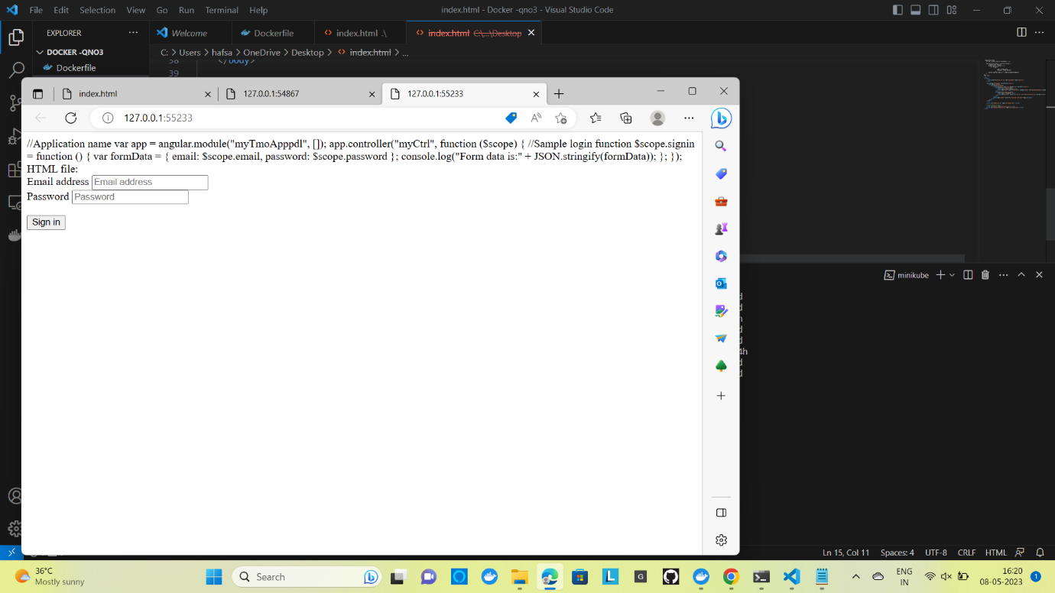

Deployment in datadog :

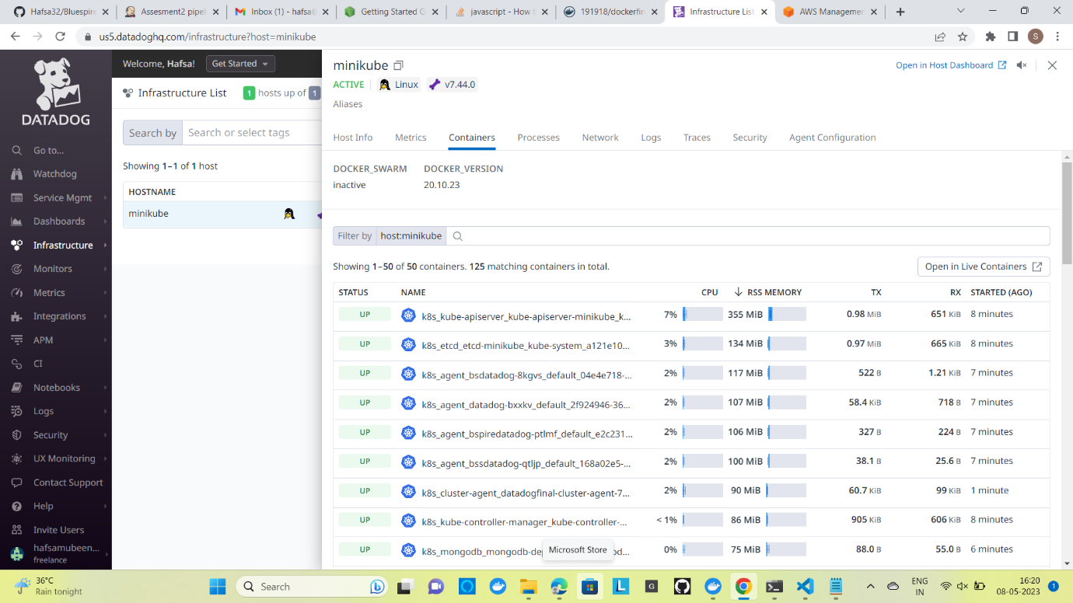

Select any container which is up we can see the metrics in datadog

