Final Project Report

<< NLP Chatbot Development using Dialogflow >>



Project Supervisor
<< Abdullah Qamar >>

Submitted By

Group Id: F24PROJECTF99DD

Software Projects & Research Section,
Department of Computer Sciences
Virtual University of Pakistan


CERTIFICATE

This is to certify that <<l>> (<<>>), <<>> (<< >>) have worked on and completed their Software Project at Software & Research Projects Section, Department of Computer Sciences, Virtual University of Pakistan in partial fulfillment of the requirement for the degree of BS in Computer Sciences under my guidance and supervision.

In our opinion, it is satisfactory and up to the mark and therefore fulfills the requirements of BS in Computer Sciences.

Supervisor / Internal Examiner

<<Project Supervisor Name>>
Supervisor,
Software Projects & Research Section,
Department of Computer Sciences
Virtual University of Pakistan

___________________
(Signature)

External Examiner/Subject Specialist
<<External Supervisor Name>>

___________________
(Signature)

Accepted By:

_____________
(For office use)

EXORDIUM

In the name of Allah, the Compassionate, the Merciful.

Praise be to Allah, Lord of Creation,
The Compassionate, the Merciful,
King of Judgment-day!

You alone we worship, and to You alone we pray for help,
Guide us to the straight path

The path of those who You have favored,

Not of those who have incurred Your wrath,
Nor of those who have gone astray.

DEDICATION

ACKNOWLEDGEMENT
PREFACE
TABLE OF CONTENTS

CHAPTER NO. 1
gathering & Analyzing info 10

1.1 Introduction

1.2 purpose

1.3 scope

1.4 definitions, acronyms and abbreviations

1.5 use cases and usage scenarios

1.5.1 Use Case Diagrams

1.5.2 Usage Scenarios

1.6 supplementary requirements

1.6.1 Usability

1.6.2 Reliability

1.6.3 Supportability

1.6.4 System Requirements

CHAPTER NO. 2
planning the project 11
2.1 Introduction

2.2 Methodology

  - Available Methodologies

  - Chosen Methodology

  - Reasons for Chosen Methodology

  - Work Plan
  - Project Structure

    - Team Structure

    - Project Schedule (Submission Calendar)

CHAPTER NO. 3
designing the project 12

3.1 Introduction

3.2 purpose

3.3 scope

  - definitions, acronyms and abbreviations

  - Architectural Representation (Architecture Diagram)

  - Dynamic Model: Sequence Diagrams

  - Object Model/Logical Model: Class Diagram

  - Database Model (Database Diagram)

  - Graphical User Interfaces

Chapter no.4
DEvelopment 13
4.1 Development plan (Architecture Diagram)

CHAPTER 1
Gathering & Analyzing Info
1.1 Introduction:
Gathering & Analyzing info is the basic step in project development in which we gather information from different resources and analyze them in such way that it is helpful in our project development and also the project success is also depends upon these resources
1.2 Purpose:
The basic purpose of the above step we should collect required information from the resources about the project or the company or firm for which we are developing the project
1.3 Scope:
Punjab College in which student can enroll in different type of exam and take it by home with internet connection
1.4 Definitions, Acronyms and Abbreviations
This step involve all the definitions terms, Acronyms and abbreviations which we use in our project development

1.5 USE CASES AND USAGE SCENARIOS

1.5.1 USE CASE DIAGRAM Updated

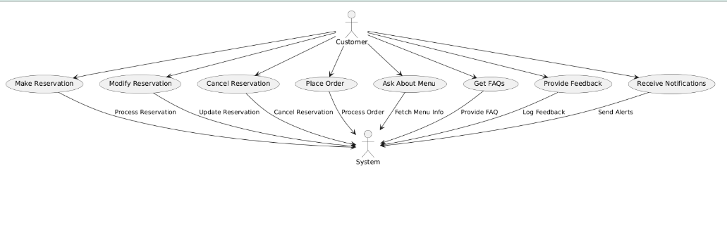

1.5.2 Usage Scenarios

Use case title | Use case ID | Actions | Description | Alternatives path | Pre-condition | Post-condition | Author | Exceptions
Make reservation | UC-001 | 1.initiate  2.input  Date/time  3.confirm | Customer books a table for a specific time. | Suggests alternatives if unavailable. | Customer knows reservation policy. | Reservation confirmed | Team project | Network issues may hinder confirmation.
Modify reservation | UC-002 | 1.Request modify  2.input new date/time | Customer changes an existing reservation. | suggests alternatives if new time is full | Existing reservation must exist. | Reservation updated |  | Invalid data entered during modification.
Cancel reservation | UC-003 | 1. Request cancel 2. Confirm cancellation | Customer cancels an existing reservation. | Inform if reservation not found. | Existing reservation must exist. | Reservation successfully canceled. |  | Network issues may hinder cancellation.
Place order | UC-004 | 1. Start order 2. Select items 3. Confirm | Customer places an order from the menu | Suggests  Alternatives if an item is out. | Menu should e available. | Order successfully placed. |  | Invalid item selection or unavailability.
Ask about menu | UC-005 | 1. Ask about menu 2. Retrieve details | Customer inquires about menu items. | Inform about specials or unavailability. | Menu must be up-to-date. | Accurate menu info provided. |  | Database retrieval error.
Get FAQs | UC-006 | 1. Ask question 2. Retrieve answer | Customer asks general questions. | Refer to support if not found. | FAQs must be defined | Satisfactory answer given. |  | FAQ database retrieval issue.
Provide feedback | UC-007 | 1. Start feedback 2. Input feedback | Customer submits feedback about their dining. | Prompt for missing info if incomplete. | Recent dining experience required. | Feedback logged successfully. |  | Inappropriate content or format issues.
Receive notifications | UC-008 | 1. Subscribe to alerts 2. Send notifications | Customer receives updates related to reservations. | Opt-out available. | Permission granted for notifications. | User informed about updates. |  | Settings may fail to save.

1.6 supplementary requirements

1.6.1 Usability:
The usability requirement of the project depicts about the usage of project our project is easy to use its UI’s are design dynamic and can be easily use
1.6.2 Reliability:
The reliability requirement of project depicts about how the system will work in critical condition and how can bug handling can be done by the system.
1.6.3 Supportability
The supportability requirement is necessary to any project regarding its fine working like compatibility with different browser

1.6.4 System Requirements
System requirements are those requirements which tells about the on which system our project is able to run and work fine
The salon management system some basic system requirement for its working 2 GB RAM and 50 GB ROM is enough for its working

CHAPTER 2
Planning the Project
2.1 Introduction:
Project Planning is to do everything you need to get your project successful
2.2 Methodology:
Software development methodologies are also known as system development methodologies. Actually it is a system development life cycle, or it can be called System Development Process.
2. Available Methodologies:

There are the following methodologies:
• Build-and-fix model
• Waterfall model
• Rapid prototyping model
• Incremental model
• Extreme programming
• Synchronize-and-stabilize model
• Spiral model
• Object-oriented life-cycle models

CHOSEN METHODOLOGY:

Different methodologies and models are used by the people according to their work and planning. We will use “VU process model” It is combination of two models Water Fall and Spiral methodologies.

Waterfall Model:

This model is also known as linear sequential model. This model is depicted in the following diagram.
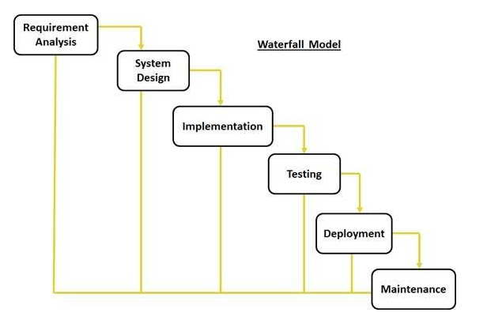

It suggests a systematic, sequential approach to software development that begins at the system level and progresses through the analysis, design, coding, testing, and maintenance.
Real projects rarely follow the sequential flow that the model proposes. In general these phases overlap and feed information to each other. Hence there should be an element of iteration and feedback. A mistake caught any stage should be referred back to the source and all the subsequent stages need to be revisited and corresponding documents should be updated accordingly. This feedback path is shown in the following diagram.

Implementation

Maintenance

Testing

Requirement Analysis
System Design

Conclusion:
The Waterfall Model is a documentation-driven model. It therefore generates complete and comprehensive documentation and hence makes the maintenance task much easier. It however suffers from the fact that the client feedback is received when the product is finally delivered and hence any errors in the requirement specification are not discovered until the product is sent to the client after completion. This therefore has major time and cost related consequences.

Spiral Model:

This model was developed by Barry Boehm. The main idea of this model is to avert risk as there is always an element of risk in development of software. For example, key personnel may resign at a critical juncture, the manufacturer of the software development may go bankrupt, etc.

Rapid Prototype
Specification
Design
Implementation
Risk Analysis
Verify

In its simplified form, the Spiral Model is Waterfall model plus risk analysis. In this case each stage is preceded by identification of alternatives and risk analysis and is then followed by evaluation and planning for the next phase. If risks cannot be resolved, project is immediately terminated.

Plan Next Phase
Determine objectives, alternatives, constraints
Identify and resolve risks
Develop and verify next-level product

Conclusion:

As can be seen, a Spiral Model has two dimensions. Radial dimension represents the cumulative cost to date and the angular dimension represents the progress through the spiral. Each phase begins by determining objectives of that phase and at each phase a new process model may be followed. The main strength of the Spiral Model comes from the fact that it is very sensitive to the risk. Because of the spiral nature of development, it is easy to judge how much to test and there is no distinction between development and maintenance. It however can only be used for large-scale software development and that too for internal (in-house) software only.

VU Process Model which is the combination of Waterfall and Spiral model. In this model each stage of waterfall is preceded by identification of alternatives and risk analysis and is then followed by evaluation and planning for the next phase.

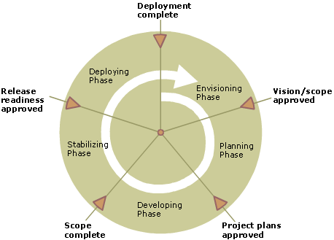

Reasons for choosing the Methodology

It derives the benefits of predictability from the milestone-based planning of the waterfall model, as well as the benefits of feedback and creativity from the spiral model.

- The VU Process Model is a documentation-driven model. It therefore generates complete and comprehensive documentation and hence makes the maintenance task much easier because the feedback of user must fulfil on each phase of development.
- .VU Process Model is heavily dependent on risk analysis and evaluation in each phase.
- Progress Tracking and Risk management is easy in this process.
- Project can be divided into small units and thus the Object-Oriented Approach for web based application can easily be implemented.
- Iterations are easily manageable.
- Application Quality Assurance can easily be managed by testing the developed modules individually.
- The modules or prototypes which are successfully developed can be implemented independently and can be easily integrated.
- The deadline for the given project is good enough to be build. So we can easily choose selected methodology to work upon.

2.6 work Plan
Work plan is given below Updated

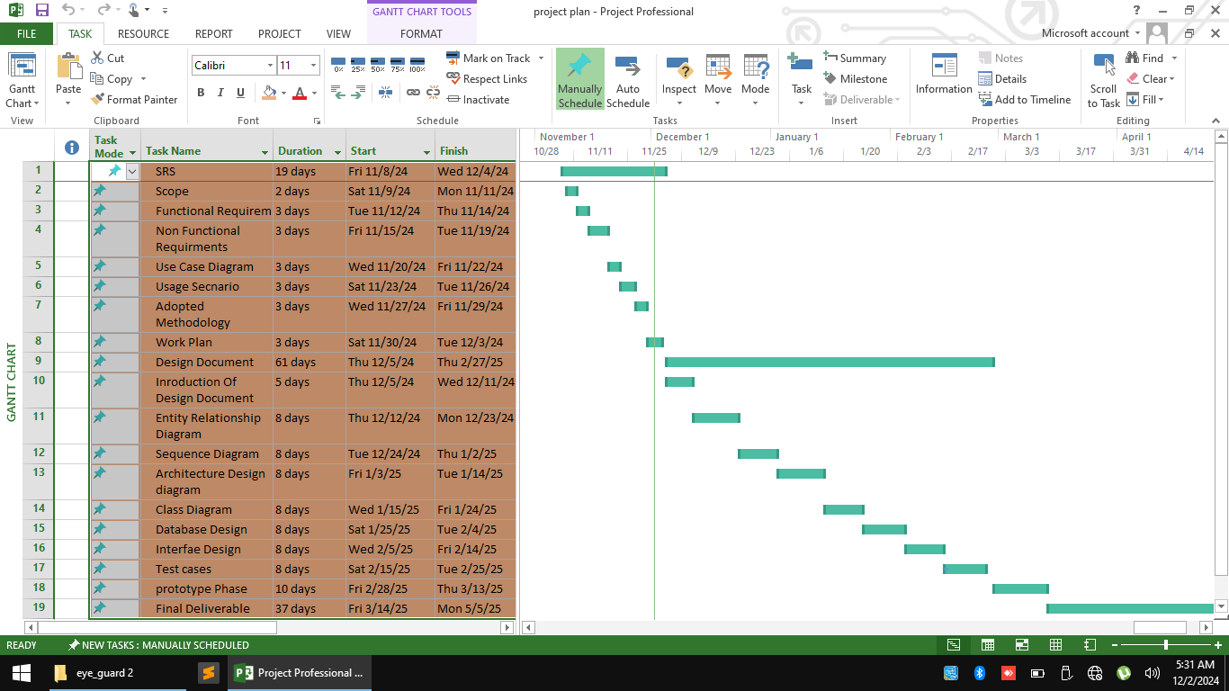

2.7 Project Structure
2.7.1 Team Structure:

F24PROJECTF99DD

CHAPTER 3
Designing the Project

3.1 Introduction:
In the design phase, one or more designs are developed, with which the project result can apparently be achieved.
3.2 Purpose:
A project design is a strategic organization of ideas, materials and processes for the purpose of achieving a goal. .
3.3 Scope:
The scope of design phase of project is that how can we design the prototype of projects different modules in how much duration
3.4 Definitions, Acronyms and Abbreviation
These includes different terms definitions, Acronyms and abbreviation

3.5: Architectural Representation
Front End programming language: HTML, CSS, JQUERY
Back End programming language : PHP
The Architectural Representation diagram is given below
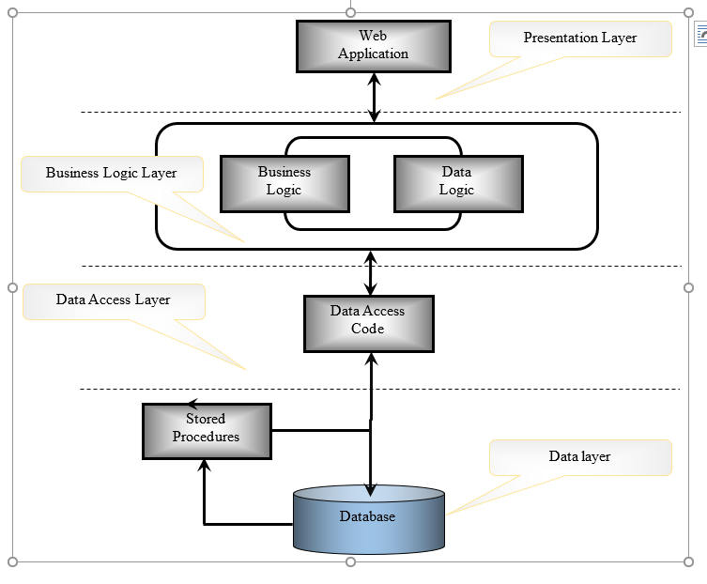

  - Dynamic Modal: Sequence Diagram:
Sequence Diagrams

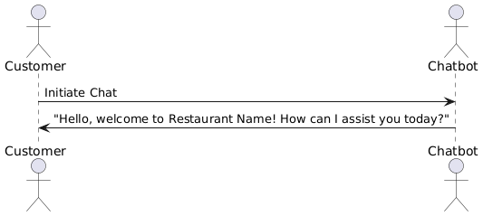
Make reservation 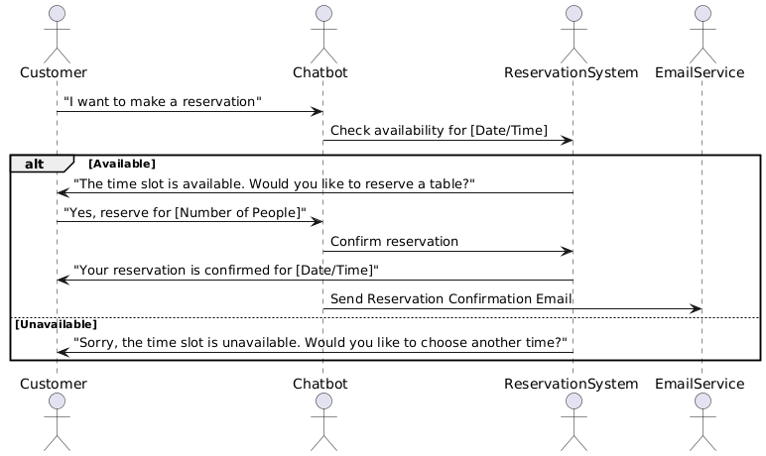Modify reservation 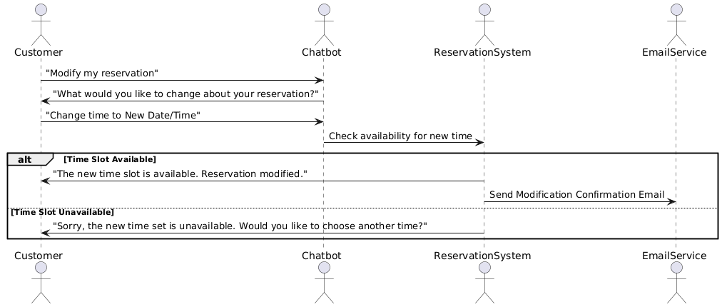Cancel reservation 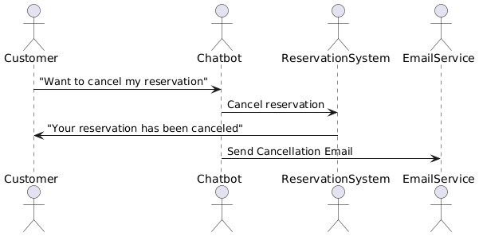
Ask about menu
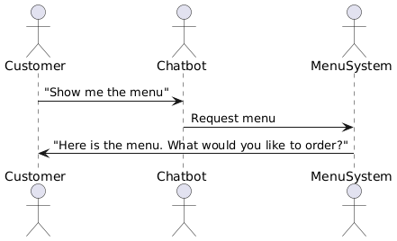
Confirm order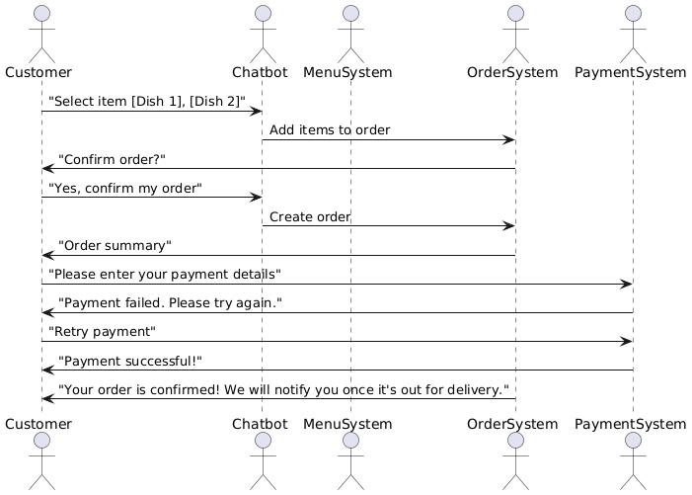Get FAQ’s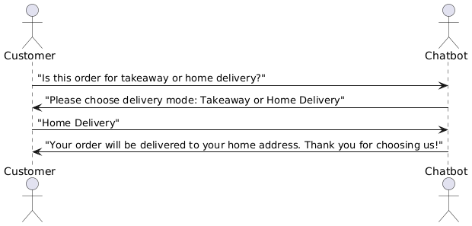
Cancel order
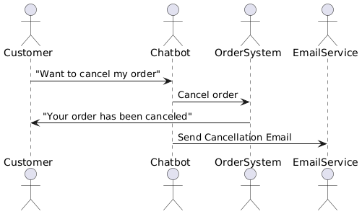
Feedback

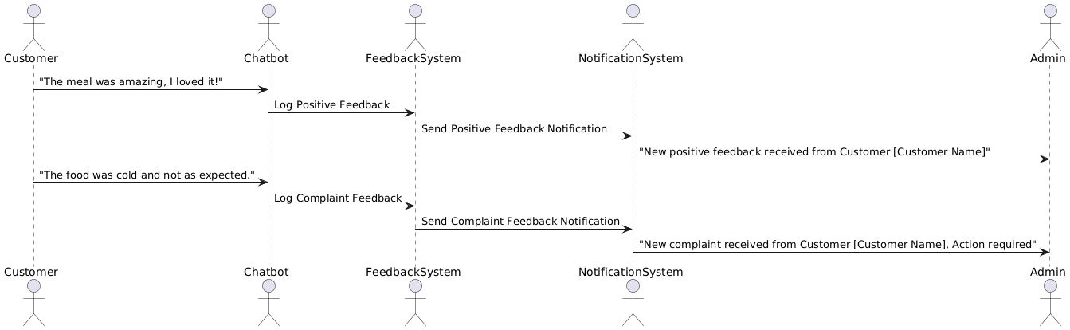
Notification system 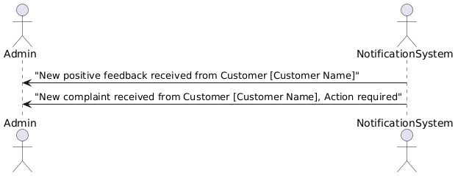

- Class Diagram

Brief overview
A class diagram is a type of static structure diagram in Unified Modeling Language (UML) that shows the structure of a system by depicting its classes, attributes, operations, and relationships among objects. Here’s a breakdown of the main components and how they work together:
- Classes: Represented by rectangles divided into three sections for the class name, attributes, and methods (operations). Classes define objects, including their properties (attributes) and behaviors (methods).
- Attributes: Characteristics of the class. These are usually variables, like name, age, or address, and can have specific data types (e.g., String, Integer).
- Methods (Operations): Functions or actions that an object of the class can perform. Examples include calculateSalary(), getName(), etc.
- Relationships:
  - Association: A link between two classes, indicating a relationship. It’s depicted with a simple line and can include multiplicities, such as one-to-many or many-to-many.
  - Aggregation: A "whole-part" relationship, where one class is a collection or part of another. Represented by an empty diamond.
  - Composition: A stronger form of aggregation where the part cannot exist independently of the whole. Represented by a filled diamond.
  - Inheritance (Generalization): Shows a "is-a" relationship where one class inherits attributes and methods from another. Represented by a solid line with an empty arrowhead.
  - Dependency: Indicates that a class uses another class. Represented by a dashed line with an arrow.
- Multiplicity: Specifies the number of instances of one class related to one instance of another class (e.g., "1", "0..", or "1..").
Class diagrams provide a visual model of a system's structure, helping developers and stakeholders understand how different parts of a system interact and organize their code effectively.
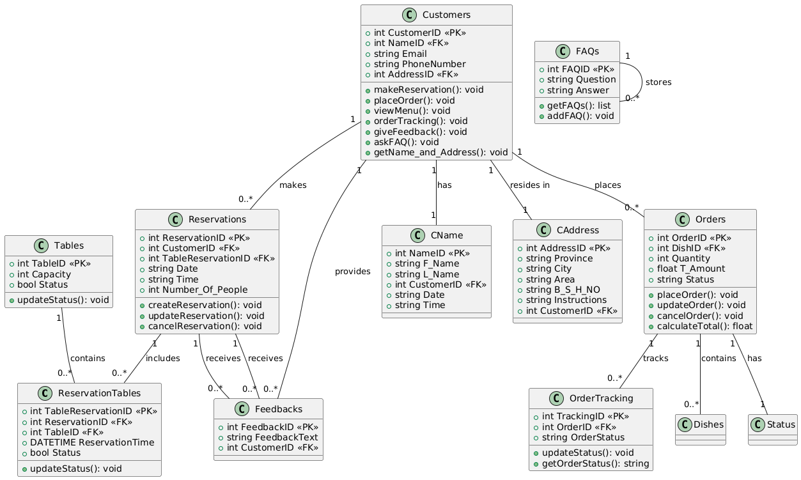

3.8 Database Modal:

Brief overview

A database diagram is a visual representation of the structure of a database. It shows how different entities (such as tables) are related to each other, including the fields (columns) within each table and the relationships between them. Here’s a quick breakdown of key components:
- Entities (Tables): Each table represents a specific object or category of data, like Customers, Orders, or Products. Each entity typically has multiple fields (columns) describing its properties.
- Attributes (Columns): Attributes represent the specific data points within a table. For example, a Customer table might have attributes like CustomerID, Name, Email, and Address.
- Primary Keys: A primary key is a unique identifier for each record in a table. It ensures that each row can be uniquely identified. For example, CustomerID might be the primary key for the Customers table.
- Foreign Keys: Foreign keys establish relationships between tables. They reference the primary key of another table, linking records across tables. For example, an Order table might have a CustomerID foreign key that links to the CustomerID primary key in the Customers table.
- Relationships: Relationships show how tables are connected. Common types include:
  - One-to-One (1:1): Each record in one table links to a single record in another.
  - One-to-Many (1
): One record in a table links to multiple records in another (e.g., one customer with multiple orders).
  - Many-to-Many (M
    - ): Each record in a table can link to multiple records in another, and vice versa, often requiring a junction table to manage this relationship.
- Database diagrams help in designing, understanding, and managing database structures, making it easier to visualize how data flows and is organized

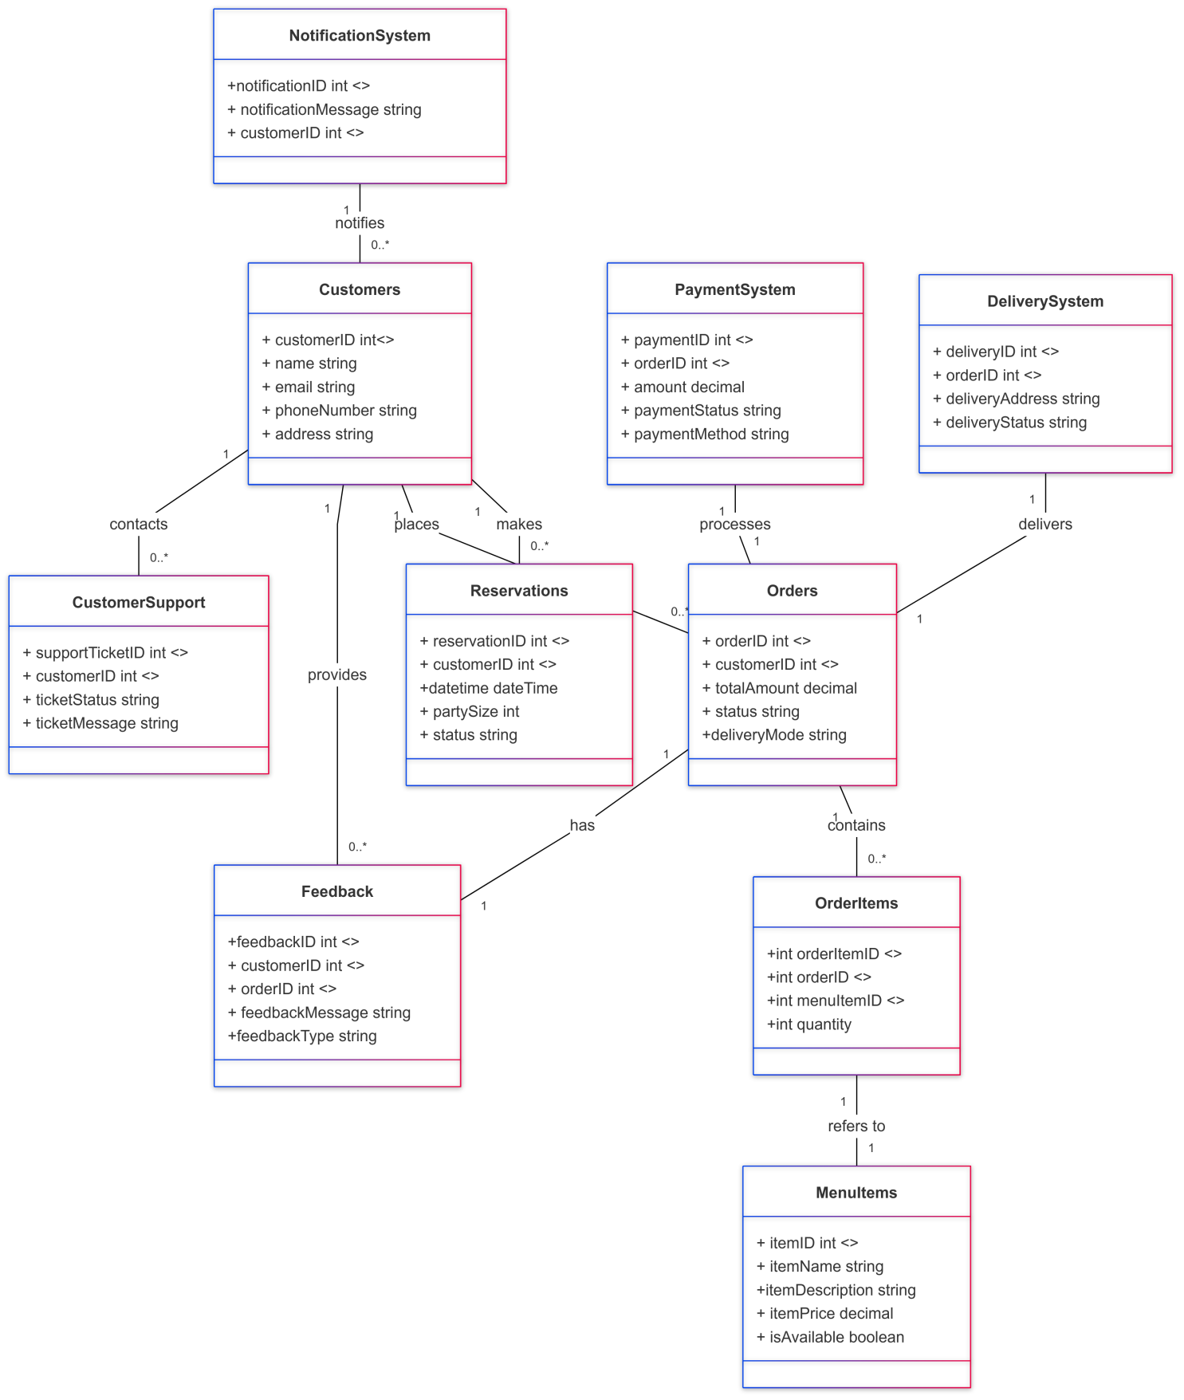

3.9
Graphical user Interfaces: original application

Main Landing Page:

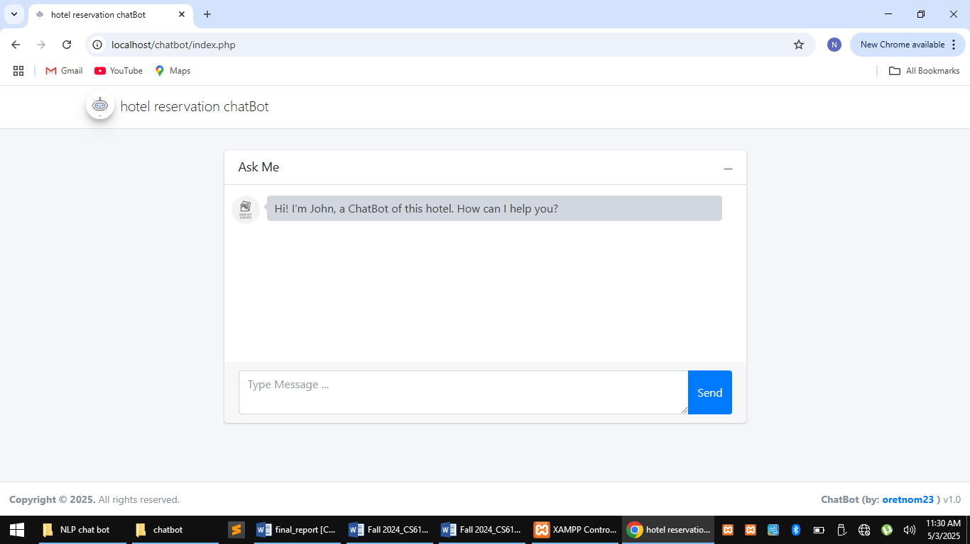

Admin login
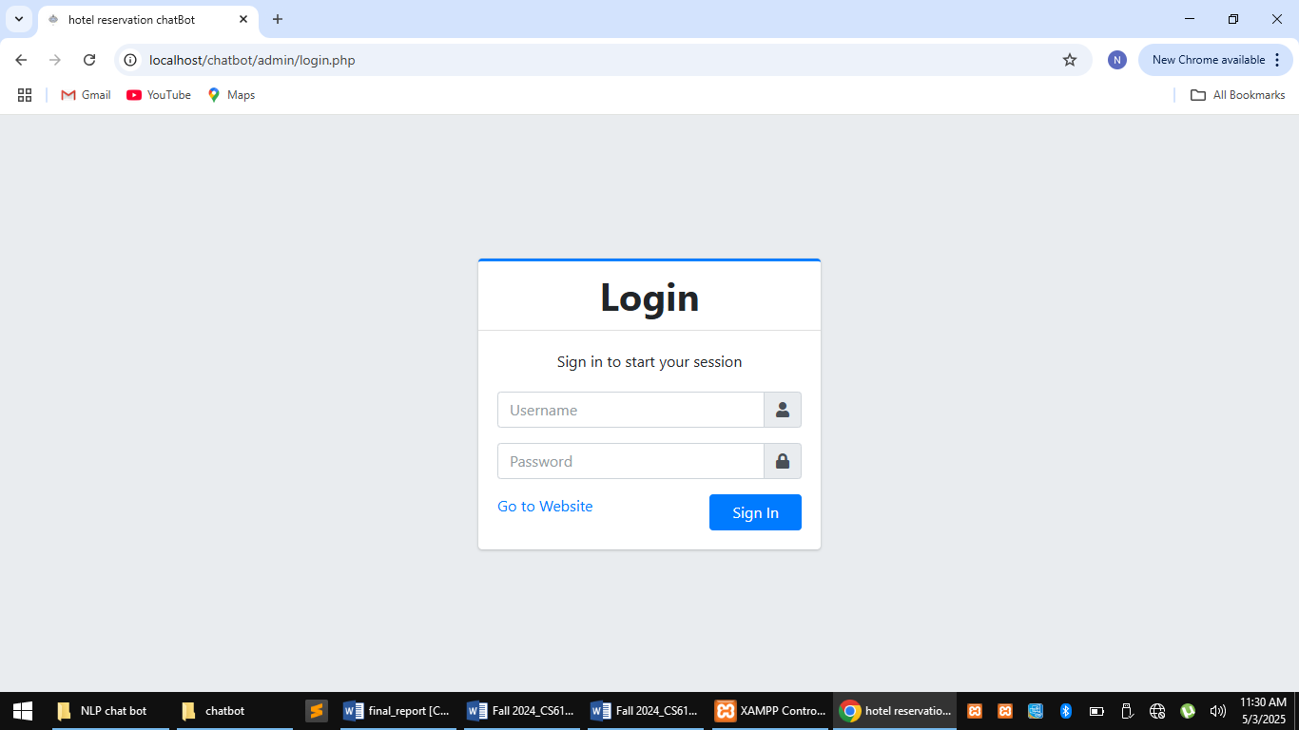

Admin dashboard

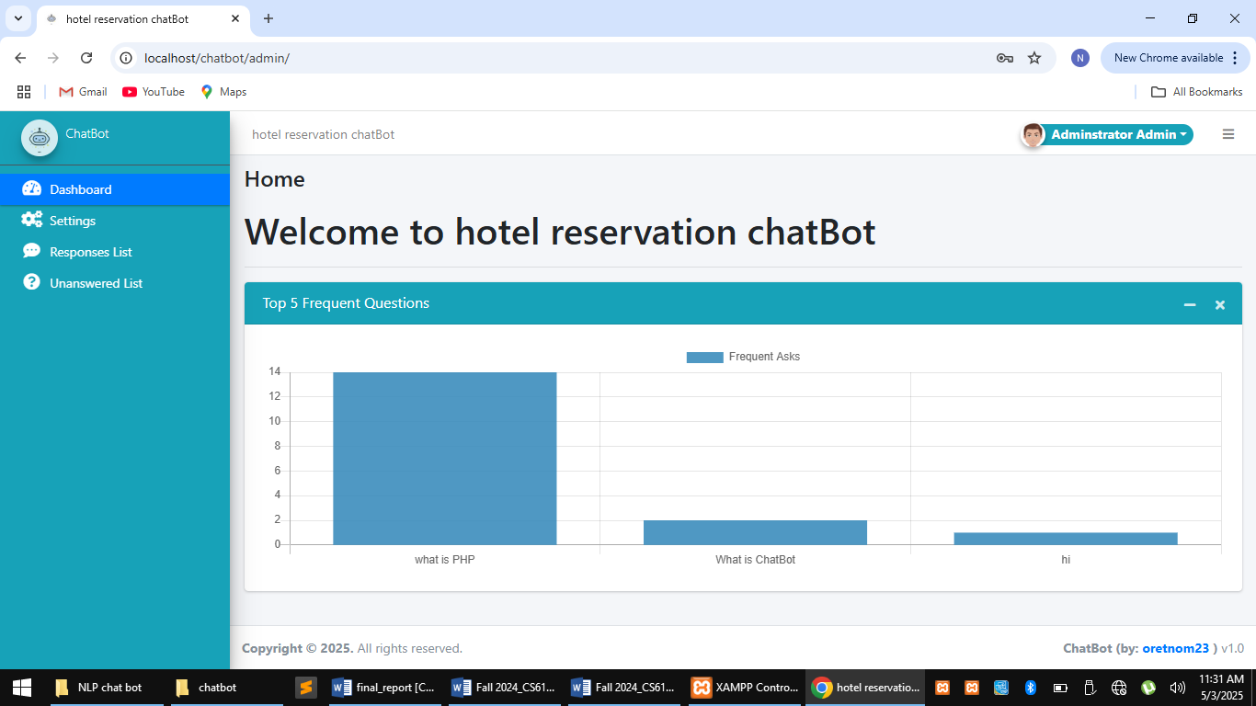

CHAPTER 4
Development4.1
Development plan (Architecture Diagram)

