FOODSCOPE
Discover, Review & Explore Restaurants Near You
Course  Advanced Web Technologies | Assessment  Lab Terminal — MERN Stack Application (CLO5)
Technology Stack  MongoDB · Express · React · Node.js | Maximum Marks  50

Project Document · FoodScope Web Application

Table of Contents
1. Problem Statement
2. Proposed Solution
3. Scope Statement
4. System Actors
5. Functional Requirements
6. Technology Stack
7. REST API Design
8. Data Design — Mongoose Schemas
9. UI Screenshots

SECTION 01
1. Problem Statement
Pakistan's food and dining industry is expansive and rapidly growing, yet restaurant discovery remains fragmented and inefficient. Diners rely on informal word-of-mouth, outdated social media posts, or generic global platforms that have limited local coverage and no real community engagement for Pakistani cities such as Karachi, Lahore, and Islamabad.
Restaurant owners — particularly independent and small-scale operators — have no dedicated, structured platform to list their establishments, manage their profiles, and receive credible feedback from a genuine user base. Existing solutions either require expensive subscriptions, are cluttered with advertisements, or simply do not reflect the local dining landscape accurately.
From the Customer's Perspective
- No centralised platform to browse, filter and compare restaurants by cuisine, price range or rating.
- Inability to read and contribute authentic, community-driven reviews.
- No reliable geospatial restaurant discovery ("find restaurants near me").
- Difficulty identifying dietary options (Halal, Vegetarian, Gluten-Free) when searching.
From the Restaurant Owner's Perspective
- No self-service portal to create and maintain a digital presence for their restaurant.
- No structured way to receive and respond to genuine customer feedback.
- Limited visibility to reach new customers beyond their existing social media following.
────────────────────────────────────────────────────────────────────────────────
SECTION 02
2. Proposed Solution
FoodScope is a full-stack MERN (MongoDB, Express, React, Node.js) web application that serves as a community-driven restaurant discovery and review platform tailored for Pakistani cities. It provides a Single Page Application (SPA) front-end with high interactivity and a robust RESTful back-end API with clearly defined business logic, JWT authentication, and Role-Based Access Control (RBAC).
Key Pillars of the Solution
Restaurant Discovery: Browse restaurants with multi-criteria filtering (cuisine, price, rating, tags). Geospatial "nearby" search using MongoDB 2dsphere indexes.
Community Reviews: Authenticated users post reviews with star ratings and written feedback. A helpful/not-helpful voting system surfaces quality content.
Restaurant Owner Portal: Restaurant owners can register and list their establishments with full details — location, cuisine, price range, and menu items.
Role-Based Access Control: Three distinct roles (Admin, Restaurant Owner, Customer) with clearly scoped permissions enforced on the API via middleware.
Secure Authentication: JWT access + refresh tokens, argon2id password hashing, per-route rate limiting, and account lockout after repeated failed logins.
Admin Dashboard: Administrators approve restaurant listings, moderate reviews, manage users, and view platform-wide analytics.
────────────────────────────────────────────────────────────────────────────────
SECTION 03
3. Scope Statement
Business Name & Purpose
FoodScope — the name reflects the platform's purpose: a wide-angle lens for exploring the food landscape. FoodScope's online presence exists to connect food lovers with great restaurants and give restaurant owners a credible, structured digital presence within their local community.
Target Market
Diners and food enthusiasts in Pakistani cities (initial focus: Karachi, Lahore, Islamabad) and independent restaurant owners seeking online visibility without the cost of large enterprise platforms.
Services Offered
- Restaurant browsing with multi-criteria filtering (cuisine, price, rating, tags)
- Geospatial "nearby restaurants" discovery using GPS coordinates
- User account registration, login, and profile management
- Review and rating submission with helpful/not-helpful voting
- Comment threads on reviews for community discussion
- Restaurant bookmarking / favourites for logged-in users
- Restaurant owner portal: create and manage listings and dish menus
- Tag-based classification (cuisine type, dietary requirements, features)
- Admin control panel for content moderation and platform management
- In-app notification system for relevant user activity
Out of Scope (Current Version)
Note: The following features are planned for future iterations and are not part of the current submission: online reservation/booking system, payment integration, real-time chat between owners and customers, and a dedicated mobile application.
────────────────────────────────────────────────────────────────────────────────
SECTION 04
4. System Actors
FoodScope has three distinct user roles, each with specific permissions enforced through Role-Based Access Control (RBAC) middleware on the API layer.
Customer (User)
Registered members of the public who use FoodScope to find and review restaurants.
- Browse and search restaurant listings
- Read reviews, ratings and comments
- Post, edit and delete their own reviews
- Comment on reviews (threaded replies)
- Vote reviews helpful or not helpful
- Bookmark favourite restaurants
- Manage their own profile and avatar
Restaurant Owner [role: reviewer]
Verified businesses who list and manage their restaurant(s) on the platform.
- All Customer permissions
- Create new restaurant listings
- Edit and update own restaurant details
- Add, edit and remove menu dishes
- Manage restaurant tags and photos
- View restaurant review statistics
Administrator
Platform superusers with full control over all content and user accounts.
- All Restaurant Owner permissions
- Approve, reject or suspend restaurant listings
- Suspend or delete any user account
- Moderate any review (hide / archive)
- Manage the tag taxonomy system-wide
- View platform-wide analytics dashboard
────────────────────────────────────────────────────────────────────────────────
SECTION 05
5. Functional Requirements
FR-1: User Authentication & Accounts
- Users can register with name, email, and password
- Email verification is required before account activation
- Users can log in and receive JWT access and refresh tokens
- Forgot password and reset password flows via secure email token
- Users can update their profile information and avatar
- Account lockout after repeated failed login attempts (brute-force protection)
FR-2: Restaurant Listings
- Restaurant owners can create listings with name, description, cuisine type, price range, address, and geolocation
- New listings are submitted as pending and require admin approval before going live
- Restaurants can be filtered by cuisine, price range, minimum rating, and tags
- Full-text search across restaurant name and description
- Geospatial "nearby" search returns restaurants within a configurable kilometre radius
FR-3: Reviews & Ratings
- Authenticated users can submit one review per restaurant (1–5 stars with written body)
- Users can edit or delete their own reviews
- Other users can vote a review as helpful or not helpful (one vote per user)
- Admins can hide or archive inappropriate reviews
- Restaurant average rating is automatically recalculated from all active reviews
FR-4: Comments
- Authenticated users can comment on any review
- Threaded replies supported up to depth 2
- Users can delete their own comments
FR-5: Tags & Classification
- Tags are categorised as cuisine type, dietary requirement, or restaurant feature
- Restaurant owners can propose new tags; admins approve or reject them
- Tags are used as filters on the restaurant listing page
FR-6: Bookmarks & Notifications
- Logged-in users can bookmark restaurants and view their saved list
- In-app notifications for relevant user activity (review responses, etc.)
FR-7: Admin Dashboard
- View and manage all registered users with search and filtering
- Approve, reject, or suspend restaurant listings
- Moderate reviews (hide/archive with reason)
- View platform-wide analytics (user counts, restaurant counts, review counts)
────────────────────────────────────────────────────────────────────────────────
SECTION 06
6. Technology Stack
Layer | Technology | Purpose
Database | MongoDB Atlas | NoSQL document store with 2dsphere geospatial indexes
ODM | Mongoose | Schema definition, validation, and query building
Backend | Node.js + Express v5 | RESTful API server with middleware pipeline
Frontend | React 18 | Component-based Single Page Application (SPA)
Routing | React Router v6 | Client-side navigation with protected routes
Build Tool | Vite | Frontend bundler with Hot Module Replacement
Auth | JWT (access + refresh) | Stateless authentication with token rotation
Password | argon2id | Industry-standard password hashing algorithm
Validation | Joi | Request schema validation on all API routes
HTTP Client | Axios | Fetch API wrapper with request/response interceptors
Security | Helmet + CORS | HTTP security headers and cross-origin policy
Rate Limiting | rate-limiter-flexible | Per-route rate limiting with in-memory fallback
Logging | Pino | Structured JSON request and error logging
Email | Nodemailer | Transactional email (password reset, verification)
────────────────────────────────────────────────────────────────────────────────

SECTION 07
7. REST API Design
All API endpoints are versioned under the base path /api/v1. Authentication is enforced via Bearer token in the Authorization header. AUTH denotes endpoints requiring a valid JWT access token.
Authentication — /api/v1/auth
Method | Endpoint | Description | Access
POST | /register | Register a new user account | Public
POST | /login | Authenticate user, return access + refresh tokens | Public
POST | /logout | Revoke refresh token and clear session | AUTH
POST | /refresh | Issue a new access token using refresh token | Public
GET | /me | Get authenticated user's profile | AUTH
PUT | /me | Update authenticated user's profile | AUTH
POST | /forgot-password | Send password reset link to email | Public
POST | /reset-password | Reset password using valid token | Public

Restaurants — /api/v1/restaurants
Method | Endpoint | Description | Access
GET | / | List all approved restaurants (with filters & pagination) | Public
GET | /:id | Get a single restaurant by ID | Public
POST | / | Create a new restaurant listing | OWNER
PUT | /:id | Update restaurant details | OWNER
DELETE | /:id | Soft-delete a restaurant | ADMIN
POST | /:id/bookmark | Bookmark / un-bookmark a restaurant | AUTH
GET | /me/bookmarks | Get current user's bookmarked restaurants | AUTH

Reviews — /api/v1/reviews
Method | Endpoint | Description | Access
GET | / | List reviews (filterable by restaurant) | Public
POST | / | Submit a new review for a restaurant | AUTH
PUT | /:id | Edit own review | AUTH
DELETE | /:id | Delete own review | AUTH
POST | /:id/vote | Vote a review helpful or not helpful | AUTH
GET | /:id/comments | Get comments on a review | Public
POST | /:id/comments | Add a comment to a review | AUTH

Search & Geo — /api/v1/search & /api/v1/geo
Method | Endpoint | Description | Access
GET | /search | Full-text search across restaurants | Public
GET | /geo/nearby | Find restaurants within a radius of coordinates | Public
GET | /geo/reverse | Reverse geocode coordinates to address | Public
GET | /geo/location/ip | Approximate user location from IP address | Public

Tags & Admin — /api/v1/tags & /api/v1/admin
Method | Endpoint | Description | Access
GET | /tags | List all approved tags (filterable by type) | Public
POST | /tags | Create a new tag (pending approval) | OWNER
GET | /admin/users | List all users with filters | ADMIN
PATCH | /admin/restaurants/:id/status | Approve / reject / suspend a restaurant | ADMIN
PATCH | /admin/reviews/:id/moderate | Hide or archive a review | ADMIN
GET | /admin/analytics | Platform statistics and analytics | ADMIN

────────────────────────────────────────────────────────────────────────────────

SECTION 08
8. Data Design — Mongoose Schemas
All data is stored in MongoDB. The following collections are defined using Mongoose schemas with validation, appropriate indexes, and document references.
User Collection
Field | Type | Notes
name | String | Required
email | String | Unique index
password | String | argon2id hash
role | String | enum: user | reviewer | admin
isVerified | Boolean
isSuspended | Boolean
failedLoginAttempts | Number | Brute-force protection
lockUntil | Date | Account lockout expiry
avatar_url | String
review_count | Number | Denormalised counter

Restaurant Collection
Field | Type | Notes
name | String | Required
description | String | Full-text indexed
cuisine_type | String
price_range | String | enum: $ | $$ | $$$
avg_rating | Number | 0–5, auto-updated
address | String
location | GeoJSON Point | 2dsphere index
tags | [String]
owner_id | ObjectId | Ref: User
status | String | enum: pending | approved | rejected
thumbnail | String | Image URL

Review Collection
Field | Type | Notes
user_id | ObjectId | Ref: User
restaurant_id | ObjectId | Ref: Restaurant
rating | Number | Required, 1–5
body | String | Max 3000 characters
helpful_count | Number
not_helpful_count | Number
status | String | enum: active | hidden | archived
photos | [String] | Image URLs

Comment Collection
Field | Type | Notes
review_id | ObjectId | Ref: Review
user_id | ObjectId | Ref: User
parent_comment_id | ObjectId | Ref: Comment (nullable)
depth | Number | Max 2 (threaded replies)
body | String | Max 2000 characters
status | String | enum: active | deleted

Dish Collection
Field | Type | Notes
name | String | Required
description | String
price | Number | In PKR
dietary_tags | [String] | vegan | halal | gluten-free | vegetarian
image_url | String
restaurant_id | ObjectId | Ref: Restaurant

Tag Collection
Field | Type | Notes
name | String | Unique
name_lower | String | Normalised for search
type | String | enum: cuisine | dietary | feature
status | String | enum: pending | approved
created_by | ObjectId | Ref: User
usage_count | Number | Denormalised counter

Key Database Indexes
- Restaurant: 2dsphere index on location field for geospatial queries
- Restaurant: Compound text index on name + description for full-text search
- Restaurant: Unique compound index on name_normalized + address_normalized to prevent duplicates
- Review: Unique compound index on user_id + restaurant_id (one review per user per restaurant)
- ReviewVote: Unique compound index on review_id + user_id (one vote per user per review)
- RefreshToken: TTL index on expiresAt field for automatic cleanup of expired tokens
────────────────────────────────────────────────────────────────────────────────

SECTION 09
9. UI Screenshots
The application is built as a Single Page Application (SPA) using React 18 with React Router v6 for client-side navigation. All pages are fully responsive and styled with custom CSS.
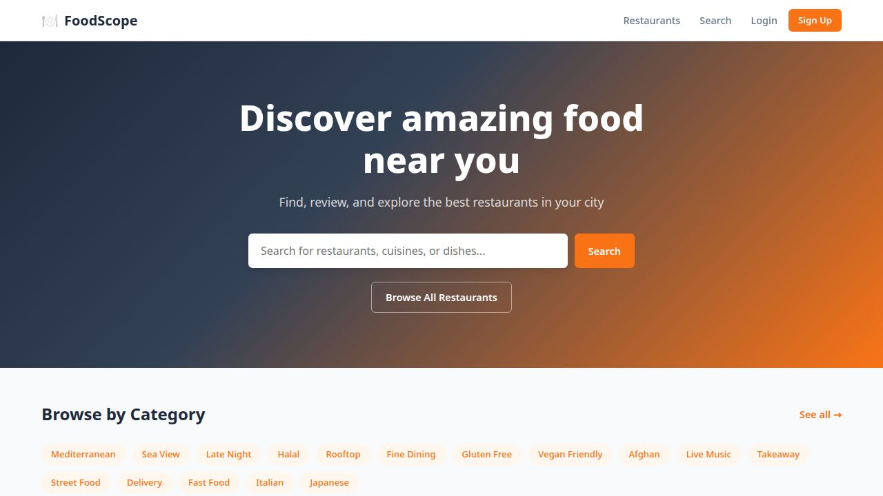
Fig 1 — Home Page: Hero search section with Browse by Category tags
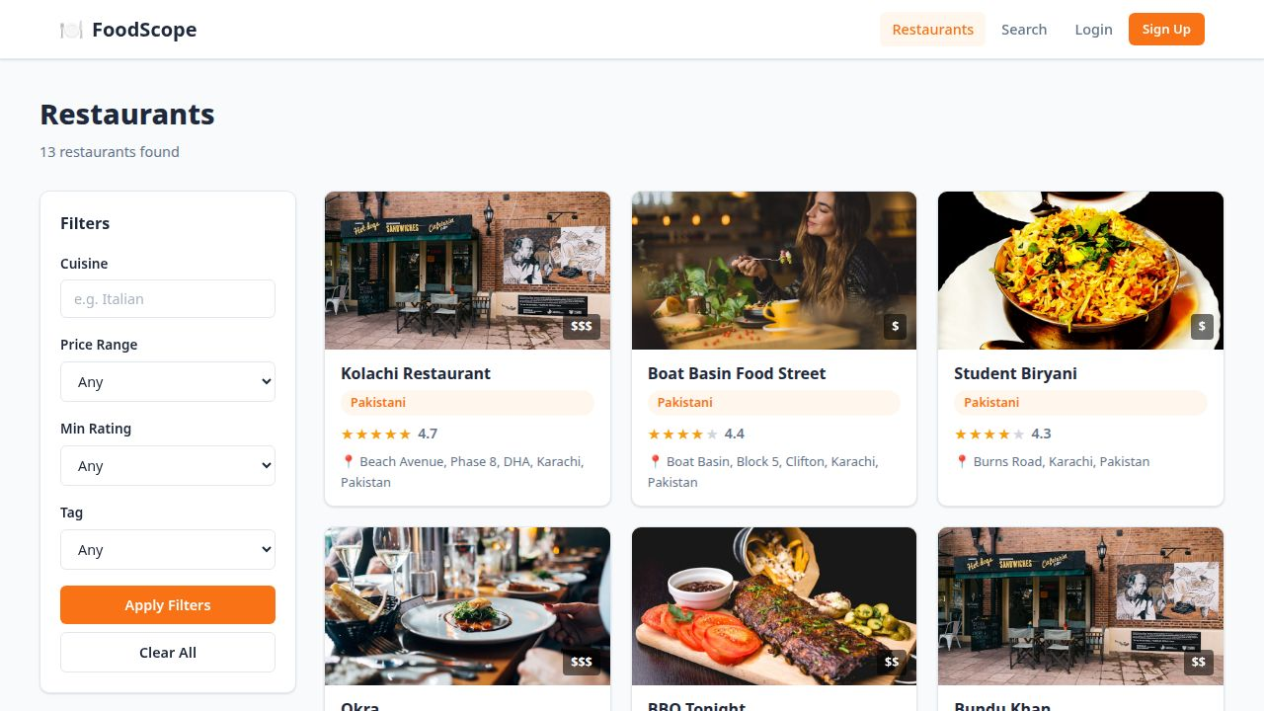
Fig 2 — Restaurant Listing: Filter panel with cuisine, price, rating and tag filters
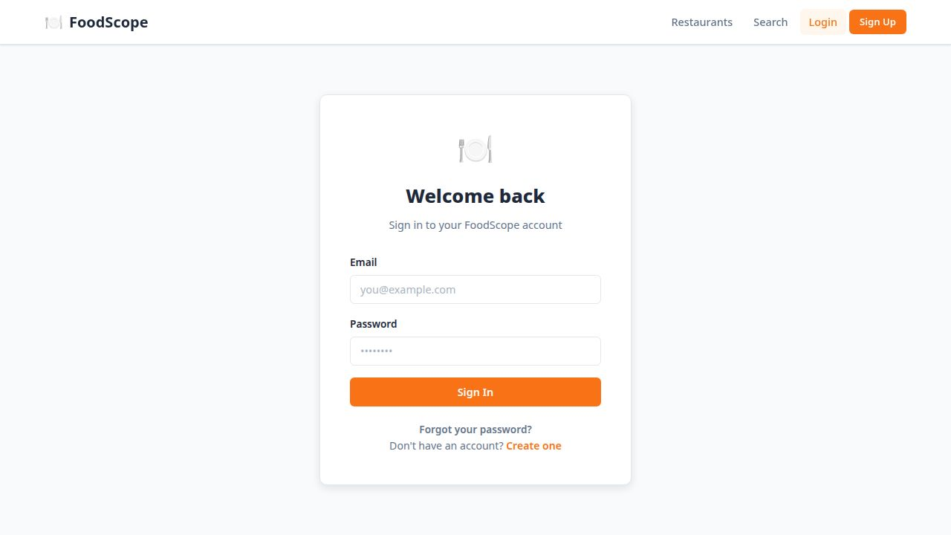
Fig 3 — Authentication: Login form with forgot password and sign-up links
────────────────────────────────────────────────────────────────────────────────
FoodScope · MERN Stack Web Application · Advanced Web Technologies Lab Terminal

