HOUSE PRICE PREDICTION
Using Linear Regression and Random Forest
A Project Report
Submitted as part of
CloudExify Summer Internship 2026
Data Science Track — Month 2, Project 3
Prepared by
Hafsa Chishti
August 2026

Declaration
I, Hafsa Chishti, hereby declare that this project report titled “House Price Prediction Using Linear Regression and Random Forest” is an original piece of work carried out by me as part of Month 2 (Data Science) of the CloudExify Summer Internship 2026. The analysis, code implementation, and results presented in this report are based on my own understanding and effort, guided by the learning material and mentorship provided during the internship. All external libraries, datasets, and references used have been duly acknowledged.

Name: Hafsa Chishti
Programme: CloudExify Summer Internship 2026 — Data Science Track
Project: Month 2, Project 3 — House Price Prediction
Date: August 2026

Acknowledgement
I would like to express my sincere gratitude to the mentors and coordinators of the CloudExify Summer Internship 2026 for their continuous guidance and support throughout Month 2 of the Data Science track. Their structured curriculum and hands-on project assignments made it possible to build a practical understanding of the end-to-end machine learning workflow, from raw data to a working predictive model.
I am also thankful to my peers in the internship cohort for the useful discussions during doubt-clearing sessions, which helped resolve several implementation challenges encountered while building this project. Finally, I would like to thank the open-source community behind tools such as pandas, scikit-learn, and Matplotlib, without which projects like this would not be possible.

Table of Contents
Abstract
1. Introduction
2. Problem Statement
3. Objectives
4. Tools and Technologies Used
5. Dataset Description
6. Related Work and Background
7. Methodology
8. Model Building
9. Results and Evaluation
10. Feature Importance Analysis
11. Exploratory Data Visualizations
12. Making Predictions on New Data
13. Notebook Walkthrough — Cell by Cell
14. Challenges Faced
15. Limitations of the Study
16. Ethical and Practical Considerations
17. Conclusion
18. Future Scope
19. References
Appendix A — Key Code Snippets
Appendix B — Glossary of Terms

Abstract
This report documents the design, implementation, and evaluation of a machine learning system that predicts residential house prices from four attributes: area (in square feet), number of bedrooms, age of the property, and location. Two supervised regression approaches — Linear Regression and Random Forest Regression — were built, trained, and compared on a real-valued housing dataset of 300 listings. Prior to modelling, the dataset was cleaned by removing missing values and statistical price outliers using the interquartile range (IQR) method, and the categorical Location feature was transformed using one-hot encoding.
On the held-out test set, the Random Forest model achieved an R² score of 0.970 compared to 0.860 for Linear Regression, along with a lower root mean squared error (RMSE) of Rs 2,34,784 versus Rs 5,10,928. Feature importance analysis showed that Area is overwhelmingly the strongest predictor of price, followed by location and age. The best-performing model was then used to generate price predictions for new, unseen house configurations, and an optional interactive widget-based interface was built for exploratory use inside Jupyter Notebook.

1. Introduction
Estimating the fair market value of a house is one of the most common and practically useful applications of predictive analytics. Buyers, sellers, real-estate agents, and financial institutions all rely on accurate price estimates to make informed decisions. Traditionally, house valuation has depended heavily on manual appraisal and comparison with recently sold properties in the same area. This approach, while intuitive, is time-consuming, inconsistent between appraisers, and does not scale well to large volumes of listings.
Machine learning offers an alternative: given a sufficiently large and representative dataset of historical sales, a model can learn the underlying relationship between a property's characteristics and its selling price, and then generalize that relationship to new, unseen properties. This project explores that idea using a structured dataset containing four commonly available features — area, number of bedrooms, age, and location — and evaluates two well-established regression techniques for the task.
This project was completed as Project 3 of Month 2 (Data Science) under the CloudExify Summer Internship 2026 programme. It builds on foundational concepts of data cleaning, feature engineering, model training, and evaluation that were introduced earlier in the internship.

2. Problem Statement
Given a dataset of historical house listings — each described by its area, number of bedrooms, age, and location — the objective is to build a regression model that can accurately predict the selling price of a house that is not present in the training data. The problem is framed as a supervised regression task: the input is a fixed-length feature vector describing a property, and the output is a single continuous value representing its predicted price in Rupees.
The core challenge lies in capturing the often non-linear and interacting effects of these features — for instance, an older house in a premium location may still be worth more than a newer house in a less desirable one — while keeping the model simple enough to train and interpret on a modestly sized dataset of 300 listings.

3. Objectives
The specific objectives of this project were as follows:
- To load, clean, and explore a real-valued housing dataset.
- To handle missing data and statistical outliers in a principled, repeatable way.
- To encode categorical variables so they can be used by machine learning algorithms.
- To train and evaluate a Linear Regression model as a baseline.
- To train a Random Forest Regressor and compare its performance against the baseline.
- To identify which features most strongly influence house prices.
- To use the best-performing model to predict prices for new house configurations.
- To visualize model performance and feature importance for interpretability.

4. Tools and Technologies Used
The project was implemented entirely in Python, using the following libraries and tools:
- Python 3.10 — core programming language
- Jupyter Notebook — interactive development environment
- pandas & NumPy — data loading, cleaning, and numerical computation
- scikit-learn — machine learning models, train/test splitting, and evaluation metrics
- Matplotlib — data visualization
- ipywidgets (optional) — interactive slider-based prediction interface
The notebook was designed to run seamlessly in both a local Jupyter environment and Google Colab, with an automatic file-upload prompt included for the Colab case.

5. Dataset Description
The dataset used in this project, sample_data.csv, contains 300 house listings, each described by five columns: Area, Bedrooms, Age, Location, and Price. Location is a categorical variable with three possible values — North, South, and East — while the remaining columns are numeric. Price, in Pakistani Rupees (Rs), is the target variable that the models were trained to predict.
Property | Value
Total records (raw) | 300
Missing values (Age column) | 8
Records after removing missing values | 292
Records after outlier removal | 289
Training set size | 231
Test set size | 58
Price range | Rs 87,000 – Rs 54,60,000
Average price | Rs 22,64,281
Area range (sqft) | 50 – 498
Table 1: Summary of dataset characteristics before and after preprocessing.

5.1 Location Distribution
The dataset's listings are distributed across the three location categories as follows:
Location | Number of Listings
North | 116
South | 100
East | 73
Table 2: Number of listings per location category (after cleaning).

5.2 Descriptive Statistics
Table 3 below summarizes the central tendency and spread of each numeric column after missing-value removal but before outlier filtering, giving a sense of the overall scale and variability of the data.
Statistic | Area | Bedrooms | Age | Price
mean | 272.04 | 2.82 | 18.63 | 23,39,444
std | 129.3 | 1.39 | 11.24 | 15,75,108
min | 50 | 1 | 0 | 87,000
25% | 156.75 | 2 | 8 | 10,80,750
50% | 276 | 3 | 19 | 18,66,500
75% | 383 | 4 | 28 | 34,39,000
max | 498 | 5 | 39 | 1,33,70,000
Table 3: Descriptive statistics for numeric columns (Area, Bedrooms, Age, Price).
Notably, Price has a much larger standard deviation relative to its mean than the other columns, confirming visually what the box-plot-based IQR method later detects numerically: a right-skewed distribution with a handful of high-value listings pulling the average upward.

6. Related Work and Background
House price prediction is a widely studied problem in applied machine learning, largely because structured, tabular real-estate data is both plentiful and economically meaningful. Historically, price estimation relied on the hedonic pricing model from economics, which assumes that a good's price can be decomposed into the value of its individual characteristics — in the case of housing, this typically includes size, location, age, and amenities. Statistical regression techniques were a natural fit for estimating the hedonic pricing model's parameters, which is precisely what Linear Regression does in this project.
More recently, tree-based ensemble methods such as Random Forest and Gradient Boosting have become the de-facto standard for structured/tabular prediction tasks, including housing datasets like the well-known Boston Housing and Ames Housing datasets. These methods consistently outperform plain linear models because real-world price relationships are rarely perfectly linear — for example, the marginal value of an additional bedroom may differ substantially between a small apartment and a large house. This project's own results, discussed in Section 9, are consistent with that broader trend in the literature.

7. Methodology
The overall workflow followed a standard supervised machine learning pipeline: data loading, cleaning, feature preparation, model training, evaluation, and prediction. Each stage is described below.

7.1 Handling Missing Values
On inspection, the Age column was found to contain 8 missing entries, while all other columns were complete. Rows with missing values were removed using pandas' dropna() function, reducing the dataset from 300 to 292 rows. Given the relatively small proportion of missing data, row deletion was preferred over imputation to avoid introducing artificial bias into the Age feature.

7.2 Outlier Removal
A small number of listings had unusually high or low prices, which could distort the fitted regression line and lead to a model that generalizes poorly. These were identified and removed using the interquartile range (IQR) method — a standard, non-subjective statistical technique. The first quartile (Q1) and third quartile (Q3) of the Price column were computed, and any listing outside the range [Q1 − 1.5×IQR, Q3 + 1.5×IQR] was treated as an outlier and discarded. This process removed 3 row(s), leaving 289 listings for modelling.
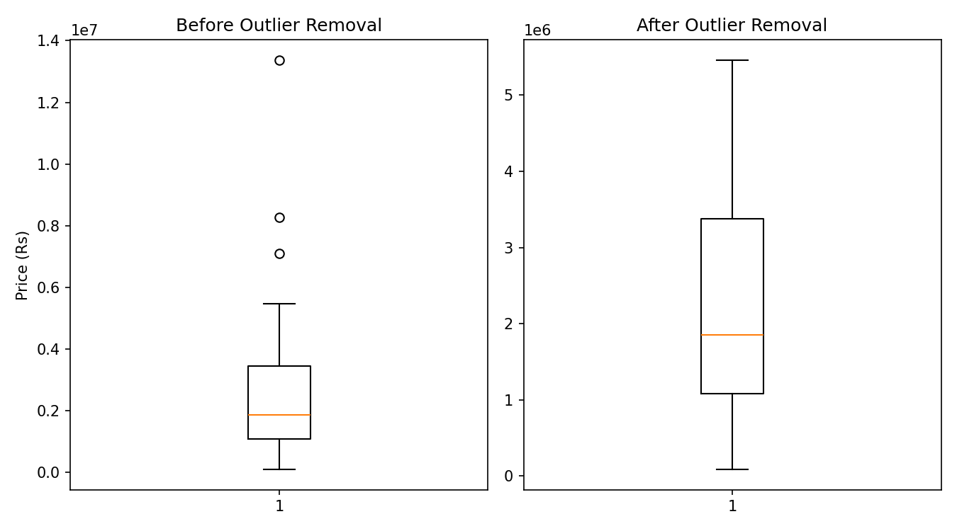
Figure A: Box plot of Price distribution before and after IQR-based outlier removal.
As shown above, the box plot after cleaning is noticeably more compact, with the extreme high-value listings that were stretching the whiskers now removed. This gives both models a more consistent, representative price range to learn from.

7.3 Correlation Analysis
Before modelling, a correlation matrix was computed between the numeric features and the target variable to get an early signal of which features might matter most.
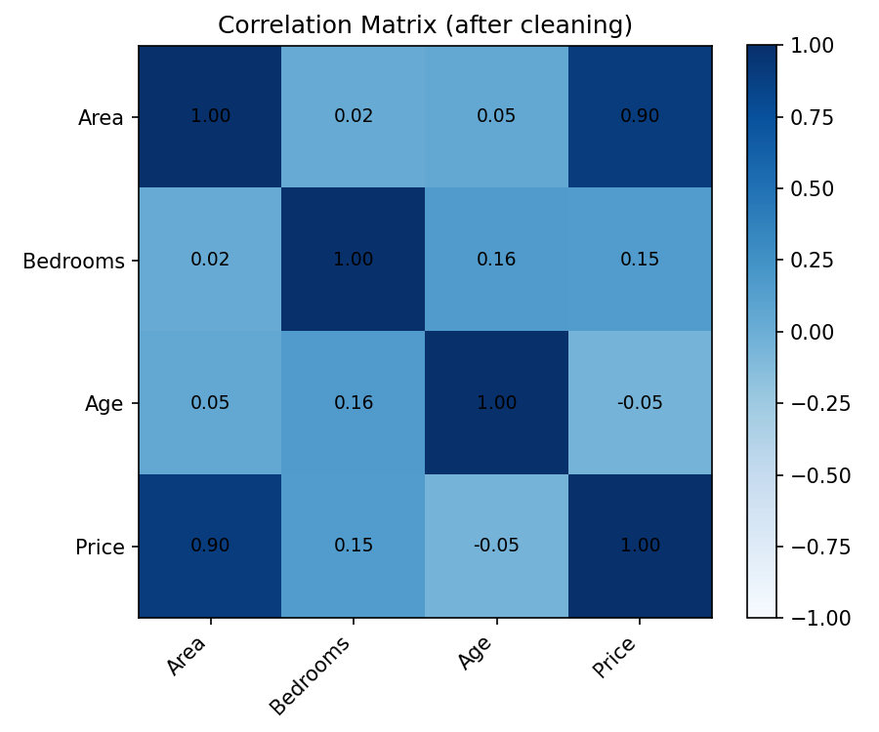
Figure B: Correlation matrix between Area, Bedrooms, Age, and Price.
The matrix confirms a strong positive correlation between Area and Price, a much weaker positive correlation for Bedrooms, and a negligible correlation for Age — a pattern that is later echoed almost exactly in the Random Forest feature importance scores discussed in Section 10.

7.4 Encoding Categorical Features
The Location column, being categorical, was converted into a numeric form using one-hot encoding via pandas.get_dummies(). This created three binary indicator columns — Location_North, Location_South, and Location_East — each representing the presence or absence of that location for a given listing. One-hot encoding was chosen over ordinal encoding because location categories have no inherent order or ranking.

7.5 Train-Test Split
The cleaned and encoded dataset was split into training and test sets using an 80/20 split, resulting in 231 training samples and 58 test samples. A fixed random_state of 42 was used to ensure the split — and therefore the reported results — are reproducible.

8. Model Building

8.1 Linear Regression
Linear Regression was used as the baseline model. It assumes a linear relationship between the input features and the target variable, fitting a straight-line (or hyperplane, in multiple dimensions) equation that minimizes the sum of squared errors between predicted and actual prices. Its main advantages are simplicity, speed, and interpretability — the fitted coefficients directly indicate how much each feature contributes to the predicted price.

8.2 Random Forest Regressor
Random Forest is an ensemble learning method that builds a large number of decision trees during training (100 trees were used in this project) and averages their individual predictions to produce a final output. Because it builds multiple trees on different random subsets of the data and features, Random Forest is generally more robust to noise and can capture non-linear relationships that a single linear model cannot. This makes it well-suited to housing data, where price does not always scale linearly with features such as area or age.

8.3 Model Configuration
The following configuration was used for training both models:
- Linear Regression: default scikit-learn parameters (ordinary least squares).
- Random Forest Regressor: n_estimators = 100, random_state = 42.
- Input features: Area, Bedrooms, Age, Location_North, Location_South, Location_East.
- Target variable: Price.

9. Results and Evaluation
Both models were evaluated on the same held-out test set using three standard regression metrics: R² (coefficient of determination), Root Mean Squared Error (RMSE), and Mean Absolute Error (MAE). R² measures how much of the variance in house prices is explained by the model (closer to 1 is better), while RMSE and MAE quantify the average prediction error in Rupees (lower is better).
Metric | Linear Regression | Random Forest
R² (Test) | 0.860 | 0.970
RMSE | Rs 5,10,928 | Rs 2,34,784
MAE | Rs 4,17,013 | Rs 1,69,783
Table 3: Test-set performance comparison between Linear Regression and Random Forest.
The Random Forest model clearly outperformed Linear Regression across every metric, improving R² from 0.860 to 0.970 and reducing RMSE by approximately Rs 2,76,145. This suggests that the relationship between house features and price in this dataset is not purely linear, and that Random Forest's ability to model non-linear interactions between features gives it a meaningful advantage. Based on these results, the Random Forest model was selected as the final "best_model" used for downstream predictions.

9.1 Actual vs Predicted Prices
To visually assess prediction quality, actual test-set prices were plotted against the Random Forest model's predicted prices. Points lying close to the red dashed diagonal line represent accurate predictions, while points further away represent larger errors.
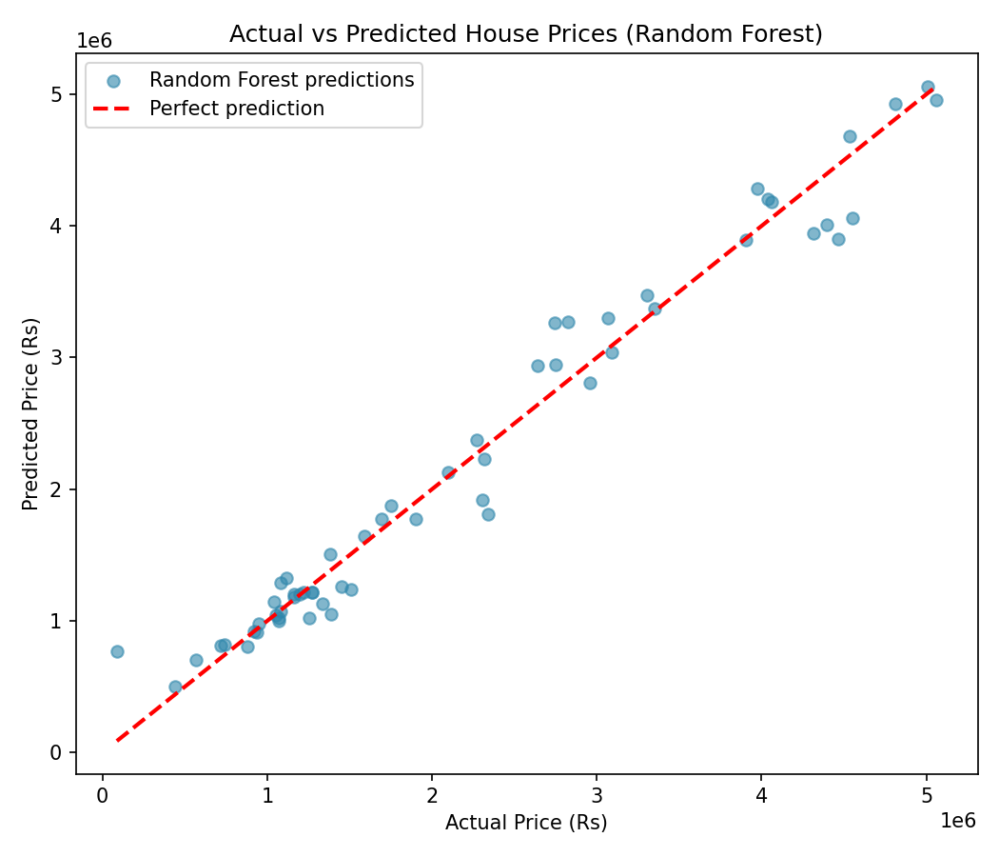
Figure 1: Actual vs. predicted house prices on the test set (Random Forest model).
The plot shows that the majority of predictions cluster tightly around the diagonal, particularly for lower and mid-range prices, with slightly more spread appearing at the higher end of the price range — a common pattern, since fewer high-value listings are available for the model to learn from.

9.2 Residual Analysis
To further diagnose model behaviour, residuals (the difference between actual and predicted price) were plotted against the predicted price. Ideally, residuals should be randomly scattered around zero with no obvious pattern, which would indicate the model is not systematically over- or under-predicting for any particular price range.
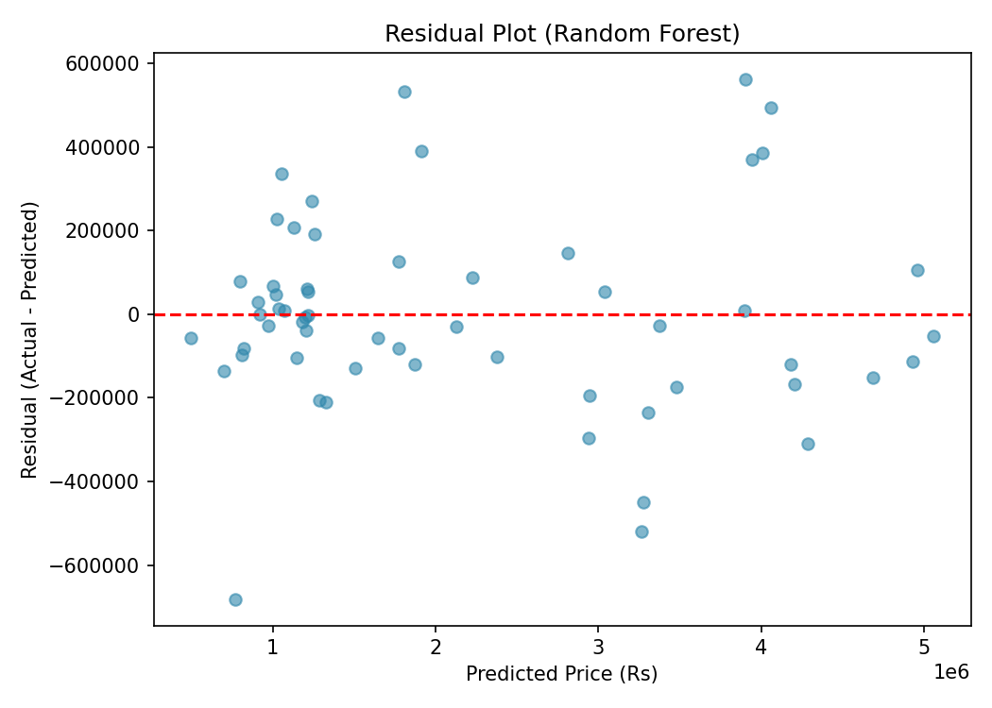
Figure C: Residual plot for the Random Forest model on the test set.
The residuals here are broadly centred around zero across most of the predicted price range, with a slight increase in spread at higher predicted prices. This is consistent with the earlier observation that high-value properties are less well represented in the dataset, giving the model fewer examples to learn precise pricing behaviour at that end of the market.

10. Feature Importance Analysis
One advantage of Random Forest over Linear Regression is that it naturally produces a feature importance score for each input variable, indicating how much that feature contributed to reducing prediction error across all trees in the forest.
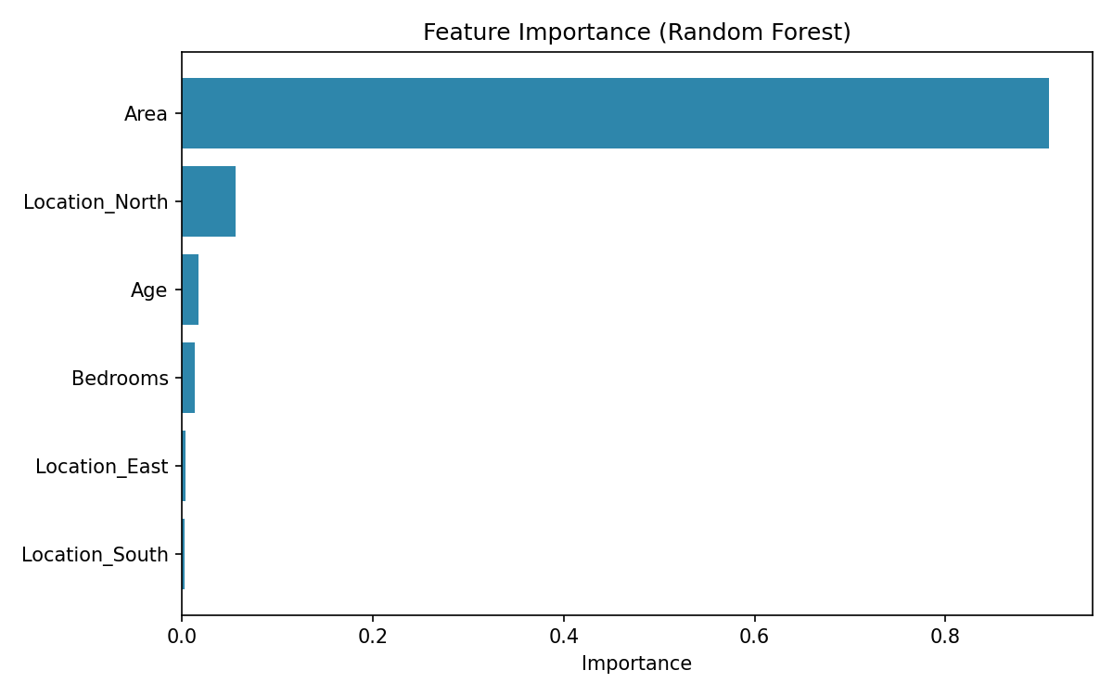
Figure 2: Relative feature importance scores from the Random Forest model.
Feature | Importance Score
Area | 0.9083
Location_North | 0.0558
Age | 0.0169
Bedrooms | 0.0132
Location_East | 0.0035
Location_South | 0.0022
Table 4: Exact feature importance values.
Area emerged as the dominant predictor, accounting for roughly 90.8% of the model's total decision-making weight — a result that aligns with real-world intuition, since larger properties command higher prices almost universally. Location and Age contributed more modestly, while the number of Bedrooms had comparatively little independent influence once Area was already accounted for.

11. Exploratory Data Visualizations

11.1 Price Distribution
After cleaning, the distribution of house prices was examined to understand the overall spread of the target variable.
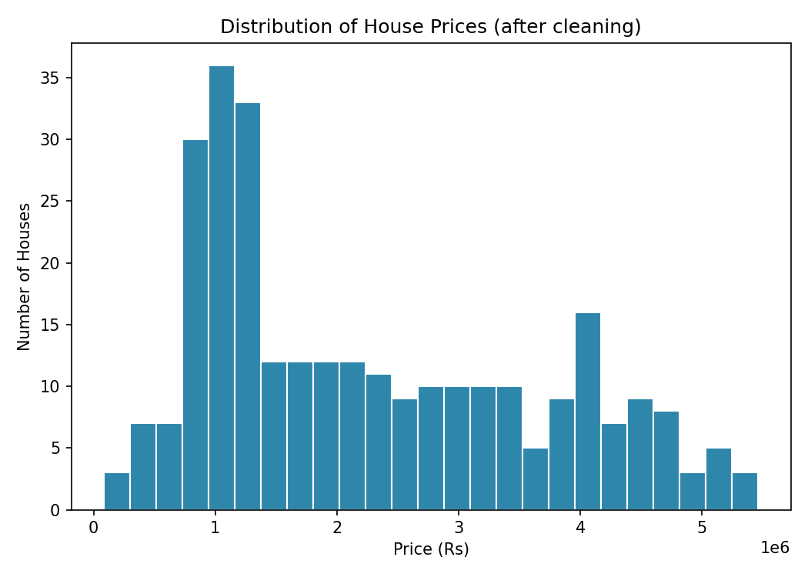
Figure 3: Distribution of house prices after cleaning and outlier removal.

11.2 Price vs. Area
A scatter plot of Price against Area was generated to visually confirm the strong positive relationship identified by the feature importance analysis.
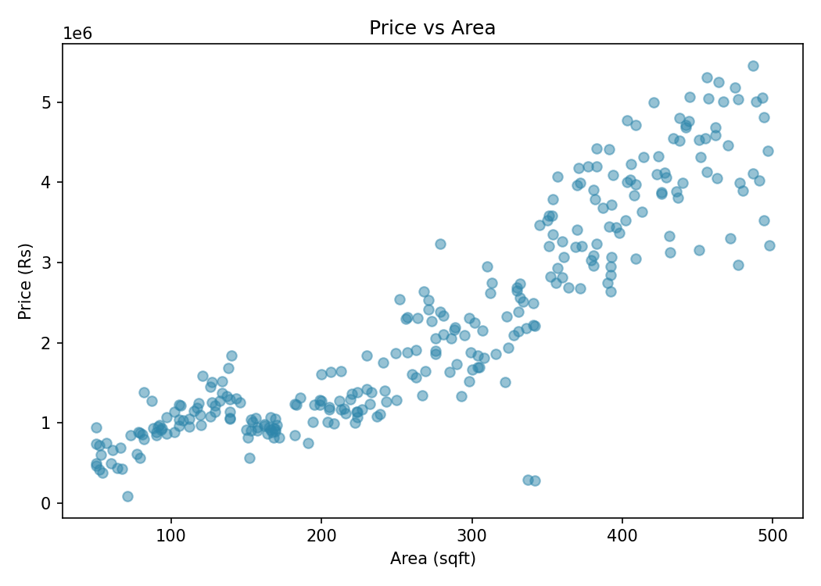
Figure 4: Relationship between house area and price.

12. Making Predictions on New Data
Once trained, the best-performing model (Random Forest) was used to predict the price of new, unseen house configurations. For example, a house with the following characteristics can be evaluated by encoding it in the same format as the training data:
- Area: 350 sqft
- Bedrooms: 4
- Age: 10 years
- Location: North
It is important that the one-hot encoded columns for any new input exactly match the column order and naming used during training, otherwise the model will misinterpret the input. The notebook also includes a simple, editable cell where users can plug in their own values for Area, Bedrooms, Age, and Location to obtain an instant price prediction, along with an optional ipywidgets-based interface featuring sliders and a dropdown for a more interactive experience.

13. Notebook Walkthrough — Cell by Cell
This section summarizes what each major cell of the accompanying Jupyter Notebook (house_price_prediction.ipynb) does, to serve as a quick reference when reading or re-running the code.

13.1 Step 0 — Upload Data (Colab only)
Checks whether the notebook is running inside Google Colab. If so, it prompts the user to upload sample_data.csv directly through the browser. If running locally in Jupyter, this cell does nothing and simply reminds the user to keep the CSV file in the same folder as the notebook.

13.2 Step 1 — Load and Explore Data
Imports all required libraries (pandas, NumPy, scikit-learn modules, Matplotlib), loads sample_data.csv into a DataFrame, and prints the first few rows, summary statistics, missing-value counts, and column names to get an initial feel for the data.

13.3 Step 2 — Prepare Data
Drops rows with missing values (specifically in the Age column), then computes the IQR-based lower and upper price bounds and removes any listing outside that range. Finally, it selects the four input features and target column, applies one-hot encoding to Location, and performs an 80/20 train-test split.

13.4 Step 3 — Train Linear Regression
Fits a LinearRegression model on the training data, generates predictions on both the training and test sets, and prints R², RMSE, and MAE for the test set.

13.5 Step 4 — Random Forest
Fits a RandomForestRegressor with 100 trees, evaluates it on the same test set, and compares its R² score against the Linear Regression model to automatically select the better-performing model as best_model.

13.6 Step 5 — Feature Importance
Extracts feature_importances_ from the trained Random Forest model, sorts them in descending order, prints the ranked list, and renders a horizontal bar chart for easy visual comparison.

13.7 Step 6 — Predictions on New Data
Demonstrates how to construct a single-row DataFrame representing a new house (matching the exact one-hot encoded column structure used in training) and passes it to best_model.predict() to obtain a price estimate. A follow-up cell lets the user edit plain variables (area, bedrooms, age, location) directly, and an optional cell provides an ipywidgets-based interface with sliders, a dropdown, and a “Predict Price” button for interactive experimentation.

14. Challenges Faced
- Deciding on a principled, non-arbitrary method for outlier removal rather than manually inspecting and dropping rows.
- Ensuring that one-hot encoded columns for new prediction inputs matched the training data's column order exactly.
- Balancing model interpretability (Linear Regression) against predictive accuracy (Random Forest).
- Setting up ipywidgets correctly in a local Jupyter environment, which required an extra installation and configuration step.
- Making the notebook portable enough to run unmodified in both local Jupyter and Google Colab.

15. Limitations of the Study
While the results obtained are encouraging, several limitations should be kept in mind when interpreting them. First, the dataset contains only 300 listings (289 after cleaning), which is small by machine learning standards; a model trained on such a limited sample may not generalize well to houses with feature combinations not well represented in the data, such as very large or very old properties.
Second, only four features — Area, Bedrooms, Age, and Location — were available. Real-world house prices are also influenced by factors such as number of bathrooms, proximity to schools and hospitals, floor level, parking availability, and overall condition of the property, none of which were captured in this dataset. As a result, some of the unexplained variance in price (visible as scatter around the diagonal in Figure 1) is likely attributable to missing features rather than model error alone.
Third, Location was represented only as three broad categories (North, South, East) rather than precise coordinates or neighbourhood-level detail, which limits how finely the model can capture location-based price variation. Finally, the Random Forest model, while more accurate, is less interpretable than Linear Regression — it does not provide simple coefficients that explain exactly how much each feature contributes to a specific prediction, which may matter in contexts requiring explainable decisions, such as loan underwriting.

16. Ethical and Practical Considerations
Automated price prediction tools carry some responsibility, since they can influence real financial decisions. A few considerations are worth noting for any real-world deployment of a model like this one:
- Bias in historical data: if past listings systematically under- or over-value properties in certain areas, the model will learn and repeat that bias rather than correct it.
- Transparency: users relying on a predicted price for a real transaction should be informed that it is a statistical estimate, not a certified valuation, and should be encouraged to seek professional appraisal for high-stakes decisions.
- Data privacy: any production version of this system using real customer or transaction data would need to handle that data in compliance with applicable privacy regulations.
- Model drift: housing markets change over time due to inflation, interest rates, and local development, so a model trained on older data should be periodically retrained on fresh listings.

17. Conclusion
This project successfully demonstrated an end-to-end machine learning workflow for predicting house prices, from raw data cleaning through to model deployment for new predictions. Two models were compared, and Random Forest was found to substantially outperform Linear Regression on this dataset, achieving an R² of 0.970 against 0.860. Feature importance analysis confirmed that Area is by far the most influential factor in determining house price, followed by Location and Age, while the number of Bedrooms played a comparatively minor role.
The project reinforced practical data science skills including handling missing data, statistically justified outlier removal, categorical encoding, model comparison, and result interpretation — all of which are directly transferable to real-world regression problems beyond housing data.

17.1 Personal Reflection
Working through this project deepened my understanding of why data preprocessing decisions — such as how outliers are defined and removed — can meaningfully change model outcomes, and not just the choice of algorithm itself. Comparing a simple, interpretable model against a more complex ensemble model also made the accuracy-versus-interpretability trade-off concrete rather than theoretical. This is a lesson I intend to carry forward into future projects in the CloudExify internship, particularly when working with larger and messier real-world datasets.

18. Future Scope
- Incorporate additional features such as number of bathrooms, proximity to amenities, or floor level to improve prediction accuracy.
- Experiment with other algorithms such as Gradient Boosting (XGBoost/LightGBM) for potentially better performance.
- Apply hyperparameter tuning (e.g., GridSearchCV) to optimize the Random Forest model further.
- Deploy the trained model behind a simple web interface (e.g., using Streamlit or Flask) for broader accessibility.
- Collect a larger and more geographically diverse dataset to improve generalization.

18.1 Notes on Deployment
If this model were to move beyond a notebook prototype into a real application, a few practical steps would be needed: saving the trained model to disk using a serialization tool such as joblib or pickle, wrapping the prediction logic in a lightweight API (for example, using Flask or FastAPI), and adding input validation to reject malformed or out-of-range requests before they reach the model. Periodic retraining on newly collected listings would also be necessary to keep the model's predictions aligned with current market conditions.

19. References
- scikit-learn documentation — https://scikit-learn.org/stable/documentation.html
- pandas documentation — https://pandas.pydata.org/docs/
- Matplotlib documentation — https://matplotlib.org/stable/contents.html
- NumPy documentation — https://numpy.org/doc/
- Jupyter Project documentation — https://docs.jupyter.org/
- CloudExify Summer Internship 2026 — Data Science Track, Month 2, Project 3 guidelines.

Appendix A — Key Code Snippets
The following snippets, taken directly from the accompanying notebook, illustrate the core preprocessing and modelling steps discussed in this report.

A.1 Outlier Removal (IQR Method)
Q1 = df['Price'].quantile(0.25)
Q3 = df['Price'].quantile(0.75)
IQR = Q3 - Q1
lower_bound = Q1 - 1.5 * IQR
upper_bound = Q3 + 1.5 * IQR
df = df[(df['Price'] >= lower_bound) & (df['Price'] <= upper_bound)]

A.2 Encoding and Train-Test Split
X = df[['Area', 'Bedrooms', 'Age', 'Location']]
y = df['Price']
X = pd.get_dummies(X)
X_train, X_test, y_train, y_test = train_test_split(
X, y, test_size=0.2, random_state=42
)

A.3 Model Training and Evaluation
lr_model = LinearRegression()
lr_model.fit(X_train, y_train)
rf_model = RandomForestRegressor(n_estimators=100, random_state=42)
rf_model.fit(X_train, y_train)
r2_test = r2_score(y_test, lr_model.predict(X_test))
r2_rf = r2_score(y_test, rf_model.predict(X_test))

A.4 Predicting on a New House
new_house = pd.DataFrame({
'Area': [350], 'Bedrooms': [4], 'Age': [10],
'Location_East': [0], 'Location_North': [1], 'Location_South': [0]
})
new_house = new_house[X.columns]
predicted_price = best_model.predict(new_house)

Appendix B — Glossary of Terms
- R² (R-squared): A value between 0 and 1 indicating the proportion of variance in the target variable explained by the model; higher is better.
- RMSE (Root Mean Squared Error): The square root of the average squared difference between predicted and actual values, expressed in the same units as the target (Rupees here).
- MAE (Mean Absolute Error): The average absolute difference between predicted and actual values; less sensitive to large outlier errors than RMSE.
- IQR (Interquartile Range): The range between the 25th and 75th percentile of a distribution, used here to detect and remove price outliers.
- One-hot encoding: A technique for converting a categorical variable into multiple binary (0/1) columns, one per category.
- Train-test split: Dividing a dataset into a portion used to fit the model (training set) and a portion held back to evaluate it (test set).
- Random Forest: An ensemble machine learning model that combines the predictions of many decision trees to improve accuracy and reduce overfitting.
- Feature importance: A score indicating how much a given input feature contributed to a tree-based model's predictions.
- Overfitting: When a model learns patterns specific to the training data that do not generalize to new, unseen data.
- Hyperparameter: A configuration value (such as the number of trees in a Random Forest) set before training, rather than learned from the data.

