10 Insights to Check Does Covid-19 Stop Spread in Pakistan within a Several Months?

I am here with 10 Different visualizations related to spread of COVID-19 in Pakistan. I have used Tableau to create these insights. Tableau is very easy to use and creates professional visualization. This blog surely helps you very much to visualize the trends of covid-19 in Pakistan. I have taken data from [**https://www.kaggle.com/mesumraza/corona-virus-pakistan-dataset-2020**](https://www.kaggle.com/mesumraza/corona-virus-pakistan-dataset-2020)and clean it in MS Excel**.**

# Conditions of Hospitals in Overall Pakistan

The dashboard below helps you to visualize the current conditions of hospitals in all the provinces. It contains 3 insights. The first visual that has Pakistan’s map, shows the number of test performed and total positive results along with province name when you hover over it. You can simply use this insight for filtering other two insights by clicking specific region on map the data of other two visuals filters according to it. Second, insight shows how many patients are in hospitals and under what condition. Third visual demonstrate the status of available hospitals.

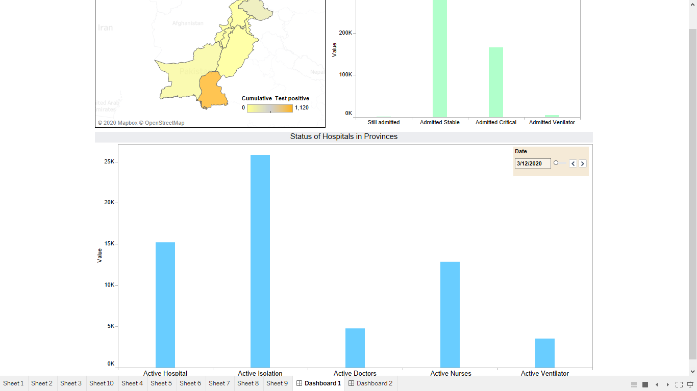

# Special Facilities available to COVID Patients:

The visual below shows how much each provincial Government had facilitate COVID-19 patients. This also helps you to visualize how many resources we are left with and how many more patients we could bear with.

# Suspected cases at Airports

The dashboard below is designed to view how many international passengers arrived and in second chart you can visualize total number of passengers screened and out of them how many got suspected.

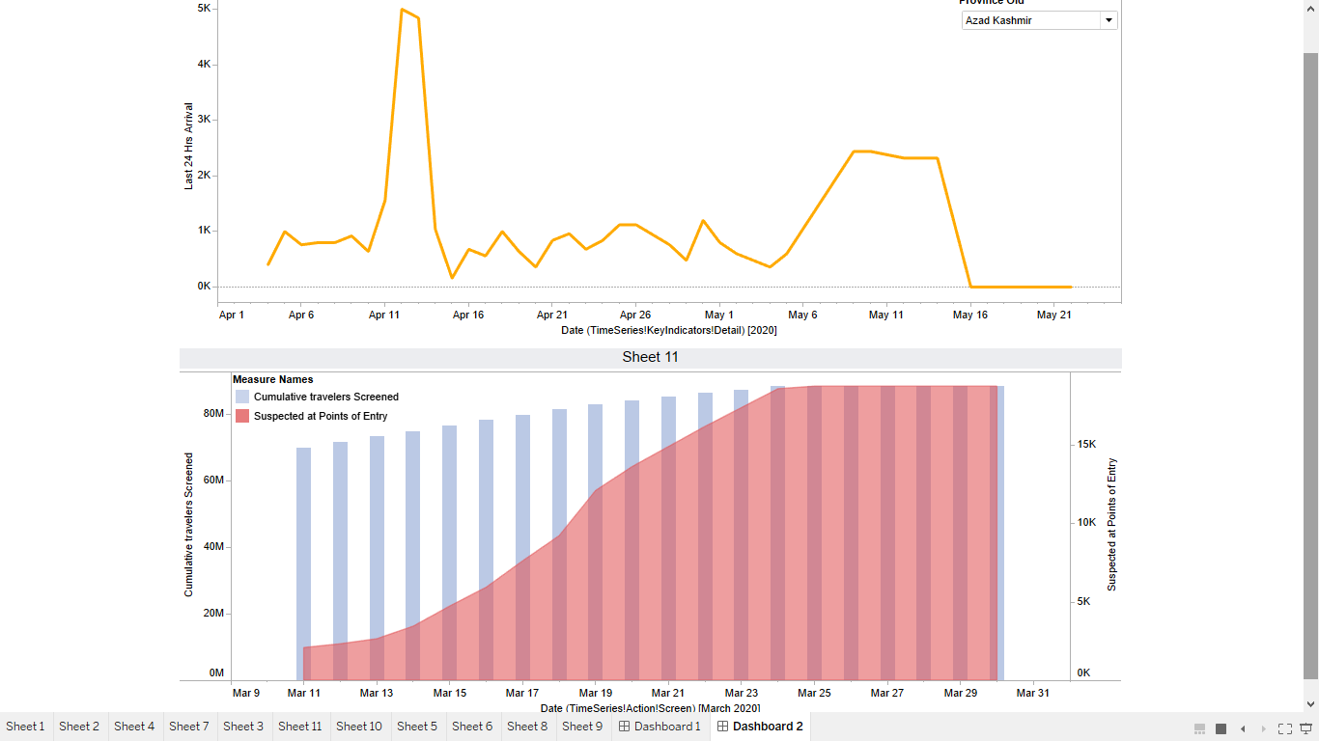

# Daily Positive Cases in all Regions:

This Visualization helps you to see the trend of daily increase in the number of COVID patients in all the regions of Pakistan. It clearly shows that there is a rapid increase in all regions except Azad Kashmir.

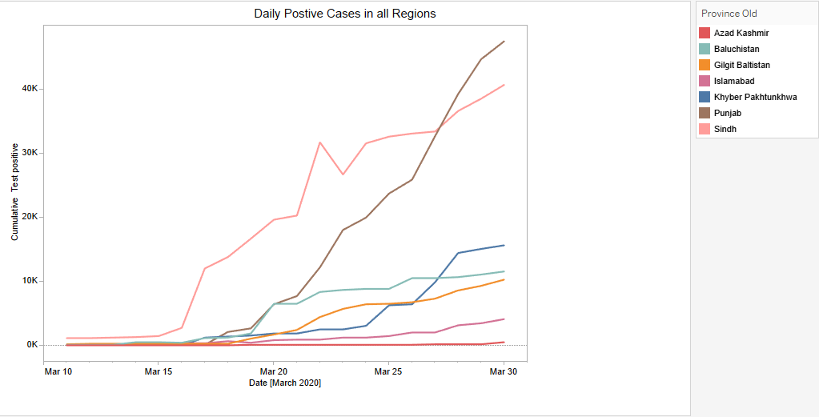

# Deaths and Recoveries in Pakistan

This graph help you to find the trend of deaths and recoveries from COVID-19 in all regions of Pakistan.

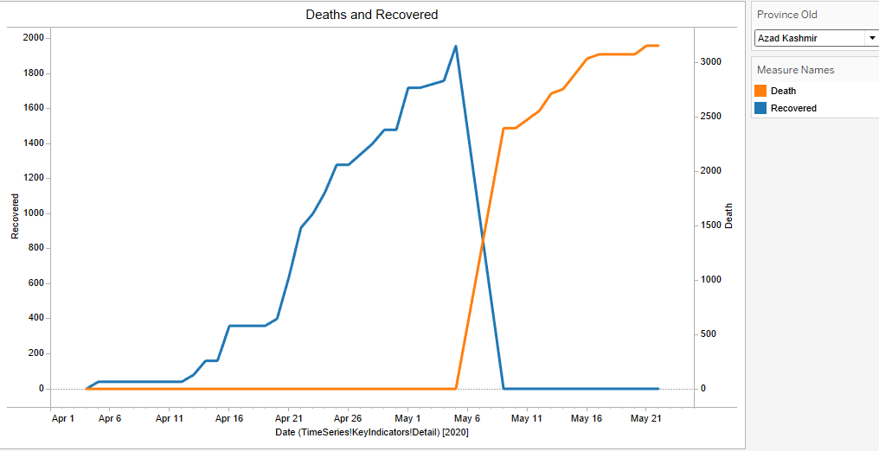

# Total Suspected Cases and those who didn’t Survived from Corona Virus

This visualization shows the number of total suspected cases and deaths in all over the Pakistan. This can be seen clearly the cases are rapidly increasing on a daily basis plus the death rate is also increasing.

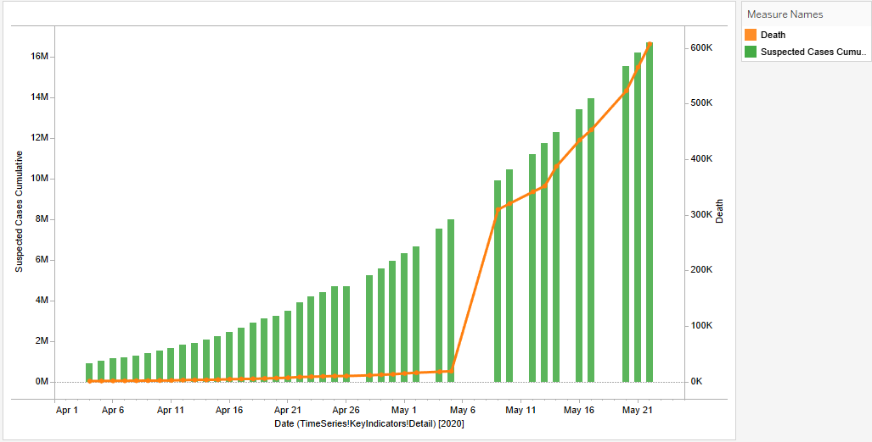

# Home Quarantined out of total

As corona virus is a contiguous disease the only thing that can prevent the increase of number of its patient is social distancing. Quarantine the patients of COVID-19 is the international practice to stop the spread of disease. As in one of the above chart you can view every regional government provide Quarantine facilities but as the rapid increase of patients these facilities will not be enough so the people that has facility of home quarantine they avail it to help those who have not. Government not only Quarantine those who got corona test positive but also those who had arrived from foreign countries.

# GitHub Repository:

Here you will find this Tableau workbook, Cleaned Excel File and Blog Document. Link is <https://github.com/HafsaSheikh/COVID-19-Pakistan-Visuals>