|  |  |  |
| --- | --- | --- |
| **Project Design Document** | |  | | --- | | *25/11/2021*  Hafsa Sheikh | |

|  |  |  |  |
| --- | --- | --- | --- |
| **Project Concept** | | | |
| **1** **Player Control** |  | You control an   |  | | --- | | *Avatar* | | in this   |  |  | | --- | --- | | *Side-view* | game | |
|  | where   |  | | --- | | *Arrow keys and space bar* | | makes the player   |  | | --- | | *Makes the player move and Attack (spell) respectively* | |

|  |  |  |  |  |  |  |
| --- | --- | --- | --- | --- | --- | --- |
| **2** **Basic**  **Gameplay** |  | During the game,   |  |  | | --- | --- | | *The user has to fight with enemies* | appear | | from   |  | | --- | | *right side* | |
|  | and the goal of the game is to   |  | | --- | | *find the broken pieces of Rocket and moon in each level and give them to the Astronauts.* | | |

|  |  |  |  |  |  |
| --- | --- | --- | --- | --- | --- |
| **3** **Sound**  **& Effects** |  | There will be sound effects   |  | | --- | | 1. *When attacking enemies.* 2. *When breaking items.* 3. *Collecting coin.* | | and particle effects   |  | | --- | | 1. *When item breaks.* 2. *Enemy died.* 3. *Jump* 4. *Item picked* | |
|  | [*optional*] There will also be   |  | | --- | | *Background music to make the game more interactive* | | |

|  |  |  |  |  |  |
| --- | --- | --- | --- | --- | --- |
| **4** **Gameplay**  **Mechanics** |  | In Start   |  | | --- | | *Player will find sword and then game process. For other enemies or in other levels the player* |   **As the game progresses,**    *The player has to find out the moon and rocket pieces.* | |  | | --- | | *Pass the level.* |   **making it** |
|  | [*optional*] There will also be   |  | | --- | | *Enemies will be difficult for every level. Will have different attacking power and style. When player kill enemies the coins or any powerup will appear.* | | |

|  |  |  |  |  |  |  |  |
| --- | --- | --- | --- | --- | --- | --- | --- |
| **5** **User**  **Interface** |  | The   |  | | --- | | *Moon, Coins, lives.* | | will   |  | | --- | | *Find pieces, increase and decrease respectively.* | | whenever   |  | | --- | | *Whenever player collides with moon pieces it will fill the moon with it. Whenever player collides coin they will increase the number. And lives will decrease when user hit by enemy spell. Or fall from land.* | |
|  | At the start of the game, the title   |  |  | | --- | --- | | *Dark Sight* | will appear | | | and the game will over when   |  | | --- | | *user has lost all his lives.* | |

|  |  |  |  |
| --- | --- | --- | --- |
| **6** **Other Features** |  | |  | | --- | | *In version 1 there will be only 4 levels.* | |

# **Project Timeline**

|  |  |  |
| --- | --- | --- |
| **Milestone** | **Description** | **Due** |
| **#1** | |  | | --- | | * *Finding Assets, Rig Player and set Animations* | | |  | | --- | | *25/11* | |
| **#2** | |  | | --- | | *shooting mechanics scripting and player movement* | | |  | | --- | | *27/11* | |
| **#3** | |  | | --- | | * *Pickups* | | |  | | --- | | *28/11* | |
| **#3** | |  | | --- | | * *enemies* | | |  | | --- | | *29/11* | |
| **#4** | |  | | --- | | * *Level Designing* | | |  | | --- | | *1/12* | |
| **#5** | |  | | --- | | *Implementation* | | |  | | --- | | *4/12* | |
| **#6** | |  | | --- | | * *Story and Dialogue System* | | |  | | --- | | *5/12* | |
| **#7** | |  | | --- | | * *Revise & Build* | | |  | | --- | | *6/12* | |

# **Project Sketch**

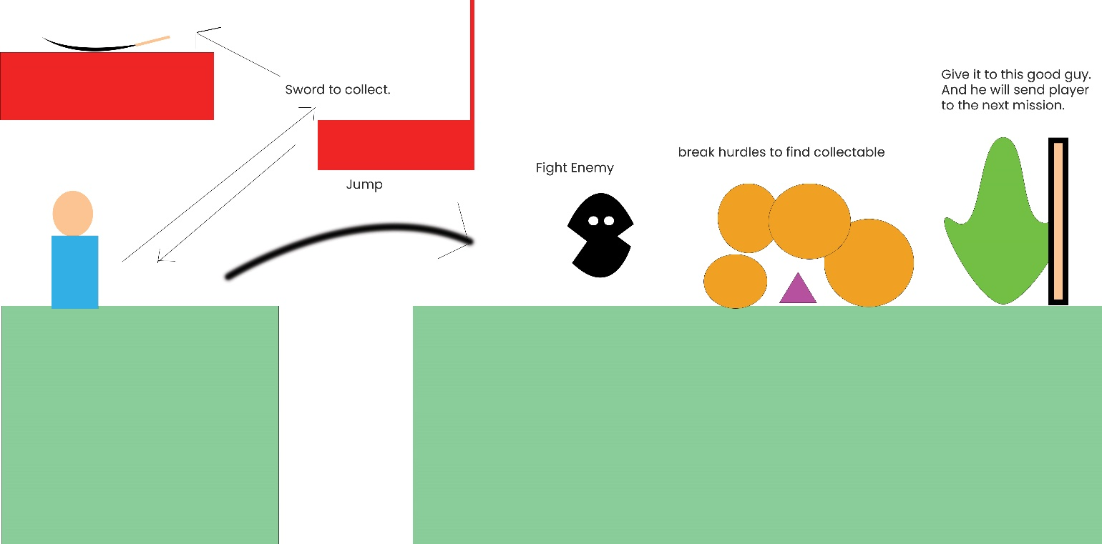

Player