**UNIVERSITY OF SINDH CAMPUS MIRPURKHAS**

# **Subject: python Deadline: 07/01/2022**

# **Assignment no#01**

# 

**Task 1: Create for loop, which count all the roll numbers from 1 to 48, but stops at your own roll number.**

**Code:**

for i in range(1,48):  
 if i==12:  
 print(i)  
 break  
  
 else:  
 print(i)

**Output:**

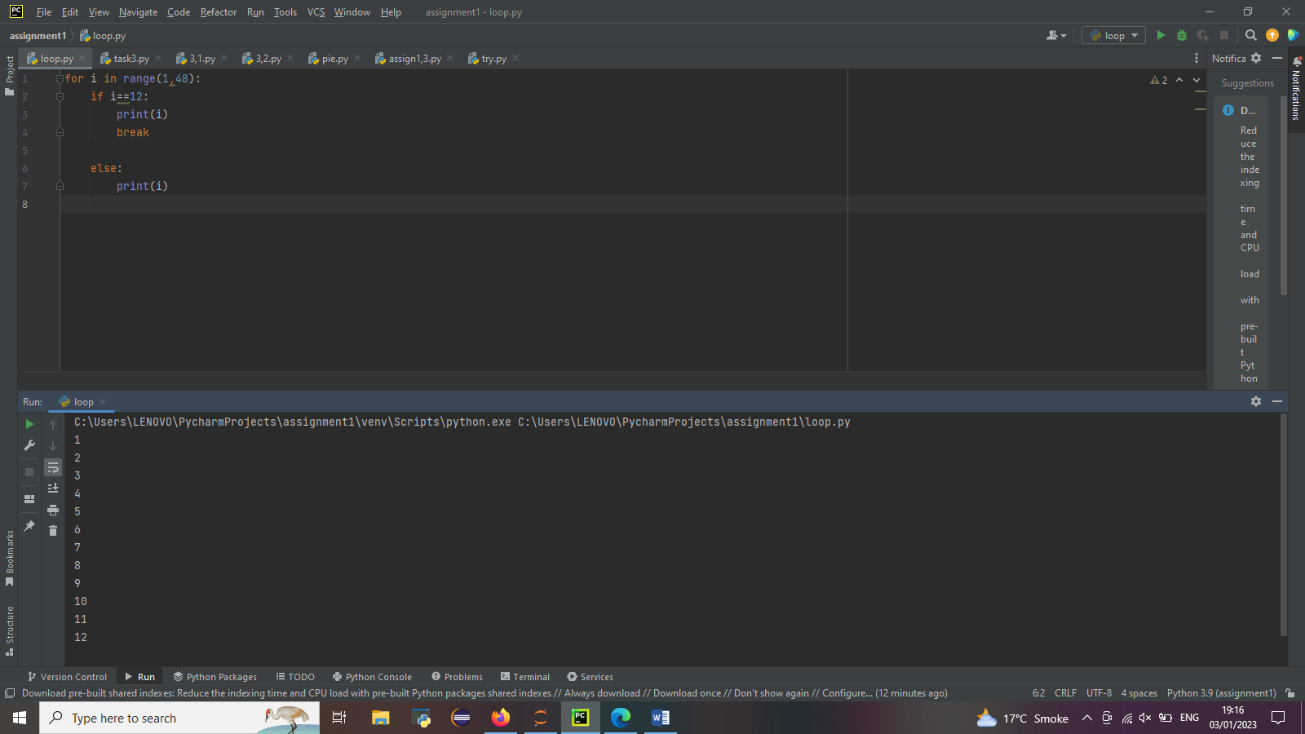

**Task 2: Create a loop which display all of the roll numbers from 1 to 48, but do not show five roll numbers of your friends.**

**Code:**

for i in range(1,48):  
 if i==5 or i==6 or i==12 or i==20 or i==36 :  
   
 continue  
  
 else:  
 print(i)

**output:**

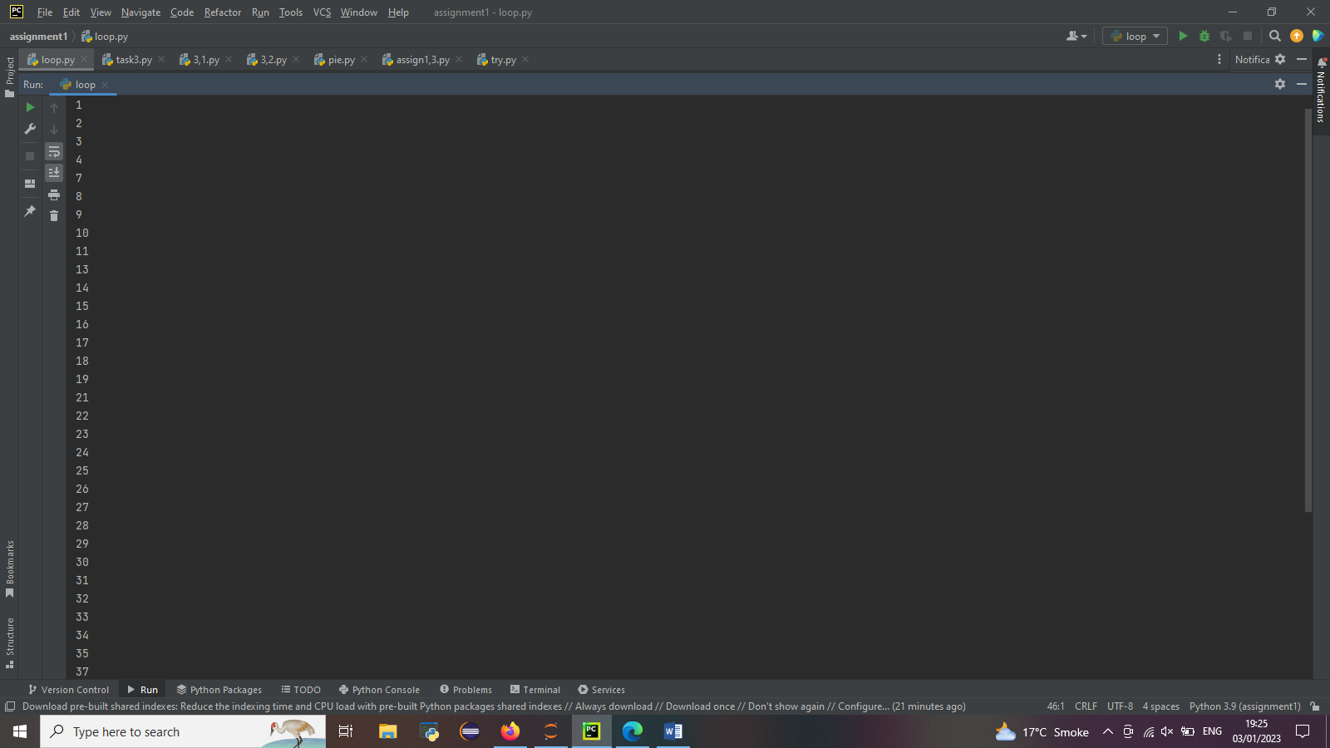

**Task 3: Create a program with following sequence:**

1. **Ask marks of 6 subjects from one student (use: input), student must have <49 marks in at least one subject.**
2. **Calculate percentage of student for only those subjects, having marks above 49.**

**Code:**

students={}  
student=input('ENTER YOR NAME: ')  
mark = []  
add = 0  
for i in range(0,6):  
 marks=int(input('ENTER YOUR MARKS: '))  
 add+=marks  
  
 if marks>=49:  
 mark.append(marks)  
 else:  
 continue  
 students[student]=mark  
  
total=((add/600)*100)  
print('MARKS: ',students,'PERCENTAGE',total)

**output:**

