**UNIVERSITY OF SINDH CAMPUS MIRPURKHAS**

## **Subject Python Deadline: 07/01/2023**

## **Assignment: 02**

Task 1: Create a dictionary of city and their respective zip codes. Then ask zip code from user and provide the name of city. (Hint: use input)

**Code:**

cities_data = {  
 '69000': 'MIRPURKHAS',  
 '17000': 'HYDERABAD',  
 '67450': 'NAWABSHAH'  
  
}  
  
user_input = input('ENTER ZIP CODE: ')  
print(cities_data[user_input])

**Output:**

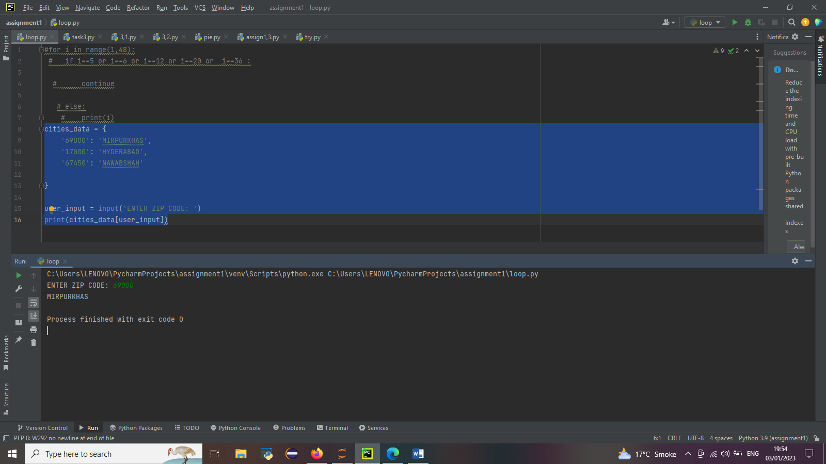

Task 2: (Dictionary): Create a marksheet of your class, having five student’s name and their marks, and apply following series of action:

A. Ask five names and their respective marks in first year

B. Calculate and print total marks of all students

C. Calculate and print average marks of all students

**Code:**

students={}  
  
no_students=int(input('Total No Of Students? '))  
for i in range(no_students):  
 student_name=input('Enter The Name Of Student: ')  
 marks=[]  
 total=0  
 sum=[]  
 for j in range(3):  
 student_marks=int(input('Enter Marks: '))  
 total+=student_marks  
  
 marks.append(student_marks)  
  
  
 print(student_name,marks,'percentage',int((total/300)*100),'average',int(total/3))

**output:**

