**UNIVERSITY OF SINDH CAMPUS MIRPURKHAS**

## **Subject Python Deadline: 07/01/2023**

## **Assignment: 03**

Task 01: Write down a code which convert following Dictionary to Series:

heading: name, DoB, RollNo,

marks values: ‘abc’, ‘2000-01-01’, ‘01’,63

**code:**

import pandas as pd  
#importlib pandas as pd  
  
dic={ 'name': 'abc',  
 'DOB':'2000-01-01',  
 'RollNo':'01',  
 'marks':'63'}  
print(dic)  
series=pd.Series(dic)  
  
print(series)

**output:**

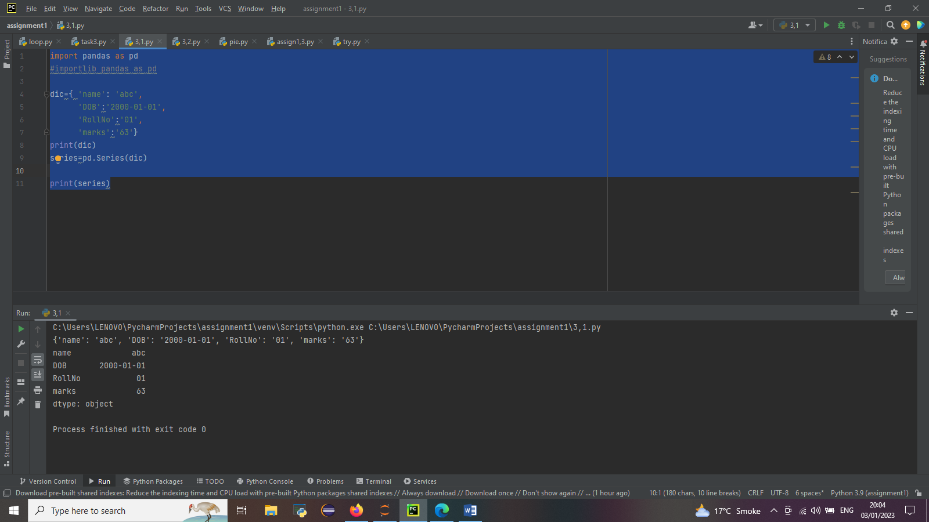

Task 02: Consider Dataframe1 and write following code:

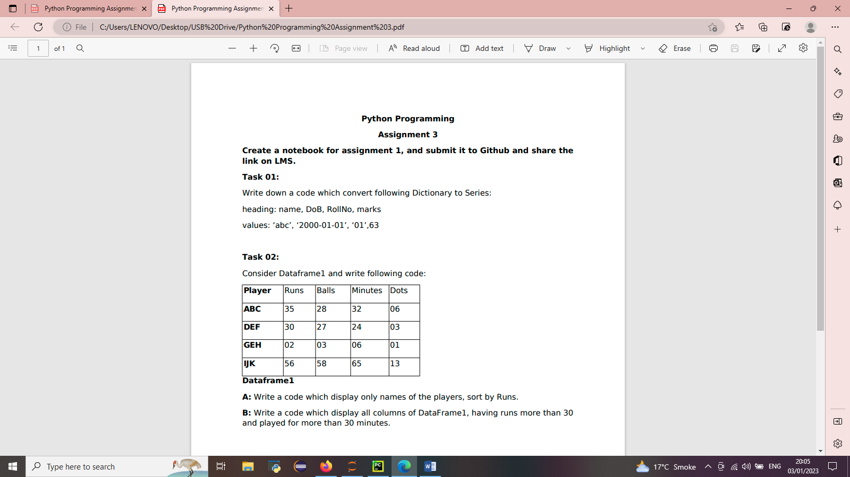

A: Write a code which display only names of the players, sort by Runs.

B: Write a code which display all columns of DataFrame1, having runs more than 30 and played for more than 30 minutes.

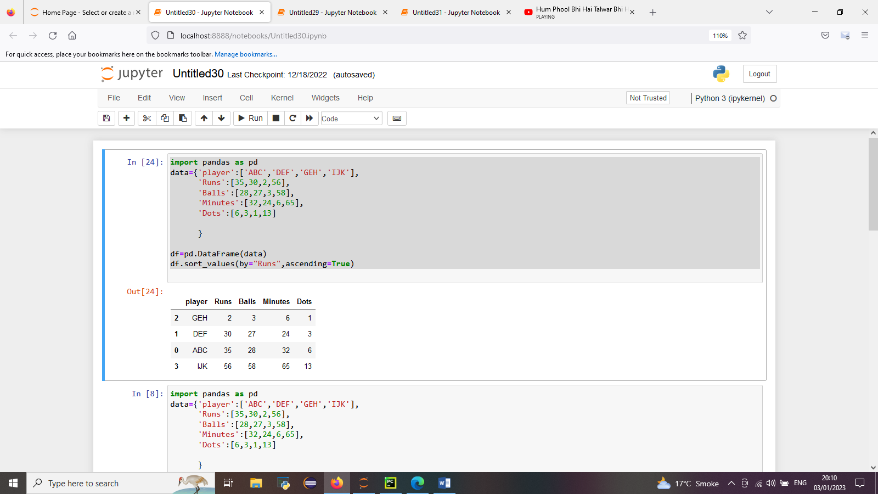**Code A:**

**Output:**



**Code B:**

import pandas as pd  
data={'player':['ABC','DEF','GEH','IJK'],  
 'Runs':[35,30,2,56],  
 'Balls':[28,27,3,58],  
 'Minutes':[32,24,6,65],  
 'Dots':[6,3,1,13]  
  
 }  
  
df=pd.DataFrame(data)  
print(df,'\n','\n Best players of the match \n')  
x=df[(df['Runs'] >= 30 )&(df['Minutes']>=30) ]  
print(x)

**Output:**

