**UNIVERSITY OF SINDH CAMPUS MIRPURKHAS**

## **Subject Python Deadline: 07/01/2023**

## **Assignment: 03**

Matplotlib: Write a code and provide screen shot of its output.

Write down your marks of first semester in following subjects. Draw a pie chart which represent your marks in percentage. Note: replace 00 by your own marks.

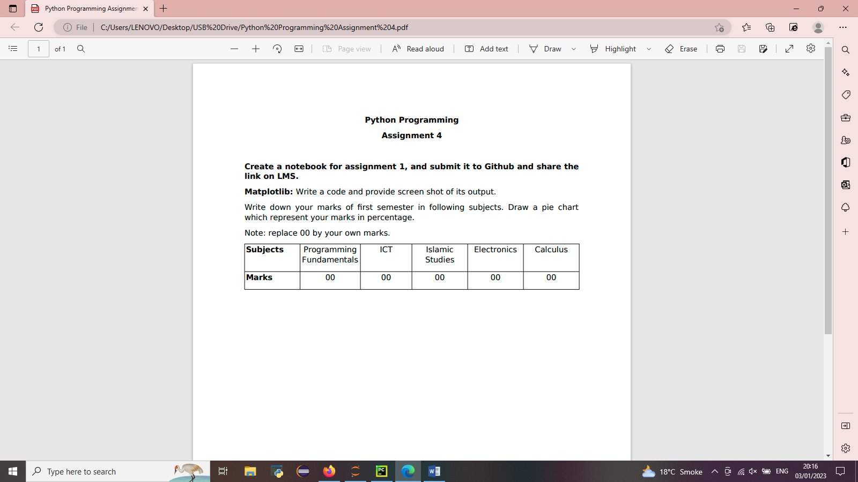

**Code:**

from matplotlib import pyplot as plt  
import numpy as np  
#importlib numpy as np  
  
subjects=['Programming fundamentals','ICT','Islamic Studies','Electronics','Calculus']  
marks=[91,82,86,65,85]  
plt.figure(figsize=(9,10))  
plt.pie(marks,labels=subjects,startangle=0,shadow=True,autopct='%1.2f%%')  
plt.legend(title='result')  
plt.show()

**output:**

