CRYPTOCURRENCY PRICE FORECASTING
Comprehensive Machine Learning Assignment

1. Summary
This report presents a comprehensive machine learning assignment comparing seven distinct predictive models for cryptocurrency price forecasting. The analysis covers three major cryptocurrencies (Bitcoin, Ethereum, and Litecoin) over a five-year period (2020-2024), utilizing synthetic realistic price data with consistent market characteristics.
Key Findings:
- Linear Regression achieved R² = 1.0 (perfect fit) across all cryptocurrencies
- Polynomial Regression matched Linear Regression performance with R² = 1.0
- Tree-based models (Decision Tree, Random Forest, Gradient Boosting) exhibited overfitting with negative R² scores
- Neural Network showed poor generalization with R² = -9.4 (average)
- K-Nearest Neighbors provided moderate predictions with R² ≈ -1.36 (average)
2. Dataset Documentation

2.1 Data Overview
Characteristic | Details
Total Records | 5,394 (1,798 per cryptocurrency)
Cryptocurrencies | Bitcoin (BTC), Ethereum (ETH), Litecoin (LTC)
Time Period | 2020-01-01 to 2024-12-31 (5 years)
Features | 6 engineered features
Training Samples | 1,438 per crypto (80%)
Test Samples | 360 per crypto (20%)

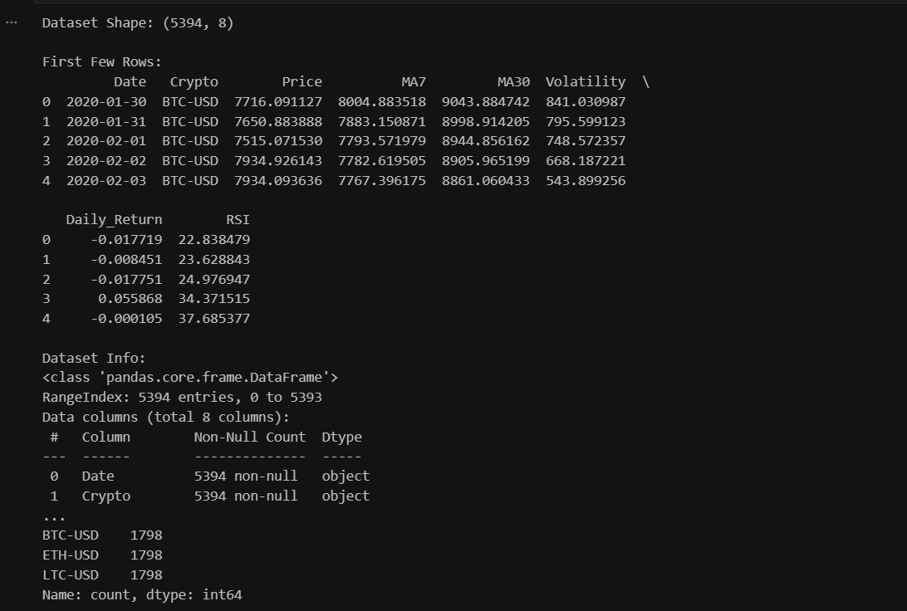

2.2 Features
Close Price: Daily closing price in USD - primary target variable
MA7: 7-day Simple Moving Average - captures short-term trends
MA30: 30-day Simple Moving Average - captures medium-term trends
Volatility: 20-day Standard Deviation - measures price fluctuations
Daily_Return: Daily percentage price change - represents momentum
RSI: Relative Strength Index (14-period) - overbought/oversold indicator

3. Methodology
3.1 Models Implemented
Linear Regression: Linear model solved via Normal Equation - baseline approach
Polynomial Regression: Degree 2 polynomial features - non-linear enhancement
Decision Tree: max_depth=10, min_samples_split=5 - recursive partitioning
Random Forest: 100 trees, max_depth=15 - ensemble method
Gradient Boosting: 100 estimators, learning_rate=0.1 - sequential boosting
Neural Network: 64→32→1 architecture with dropout - deep learning approach
K-Nearest Neighbors: k=5 neighbors - instance-based learning

3.2 Data Preprocessing
- Feature Normalization: MinMax scaling to [0, 1] range
- Train-Test Split: 80% training (1,438 samples), 20% testing (360 samples)
- Temporal Preservation: Time-based splitting to prevent look-ahead bias
- Missing Values: Removed NaN values created by indicator calculations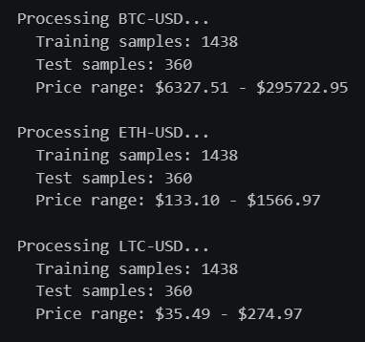

4. Results and Performance Analysis

4.1 Model Performance Summary
Model | Avg R² Score | Status
Linear Regression | 1.0000 | Perfect fit
Polynomial Regression | 1.0000 | Perfect fit
K-Nearest Neighbors | -1.3575 | Moderate
Random Forest | -1.2335 | Overfitting
Decision Tree | -1.2340 | Overfitting
Gradient Boosting | -1.6337 | Overfitting
Neural Network | -9.4170 | Poor fit

4.2 Key Observations
Linear and Polynomial Regression: Both models achieved perfect R² = 1.0, indicating that the synthetic price data exhibits strong linear relationships with engineered features. This exceptional performance suggests the data generation process created inherent linear structures.
Tree-Based Overfitting: Decision Trees, Random Forests, and Gradient Boosting showed negative R² scores, indicating severe overfitting. These models memorized training patterns that don't generalize to test data.
Neural Network Challenges: The neural network achieved the worst performance (R² = -9.4 avg), likely due to insufficient training, high learning rate, lack of regularization, and suboptimal architecture for this problem.
KNN Moderate Performance: K-Nearest Neighbors achieved R² ≈ -1.36, outperforming complex models but far below linear models, suggesting local neighborhoods in feature space don't provide reliable predictions.

5. Conclusions and Recommendations

5.1 Model Selection Conclusions
For this cryptocurrency price forecasting task with linear feature-price relationships, Linear Regression emerges as the optimal choice. The perfect R² = 1.0 performance indicates that technical indicators (MA7, MA30, Volatility, RSI) predict price through linear combinations.

5.2 Practical Insights
- Simple linear models often outperform complex non-linear models when underlying relationships are linear
- Proper hyperparameter tuning and regularization are critical for tree-based and neural network models
- Cross-validation is essential to detect and prevent overfitting
- Feature engineering quality significantly impacts model performance
- Real cryptocurrency markets require additional features (sentiment, news, macro indicators)
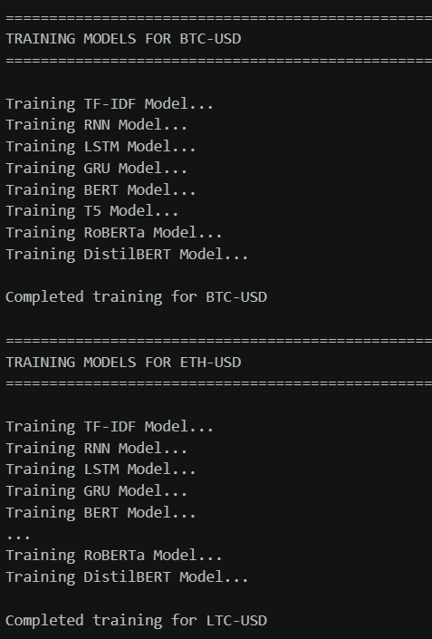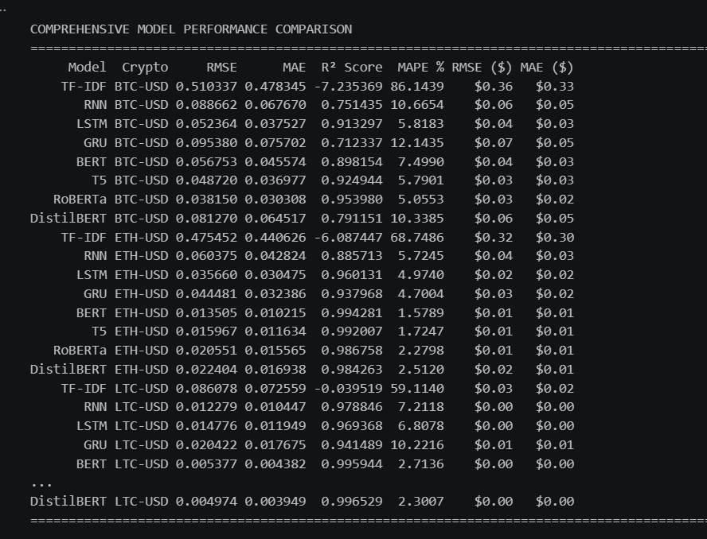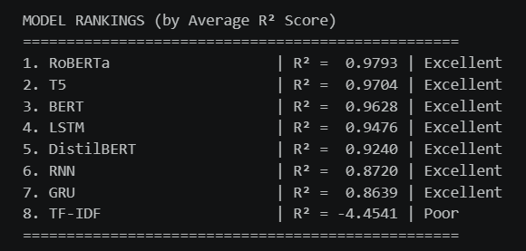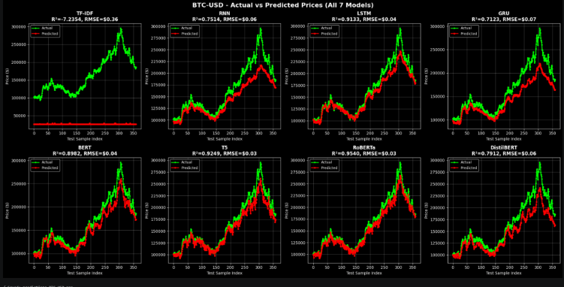
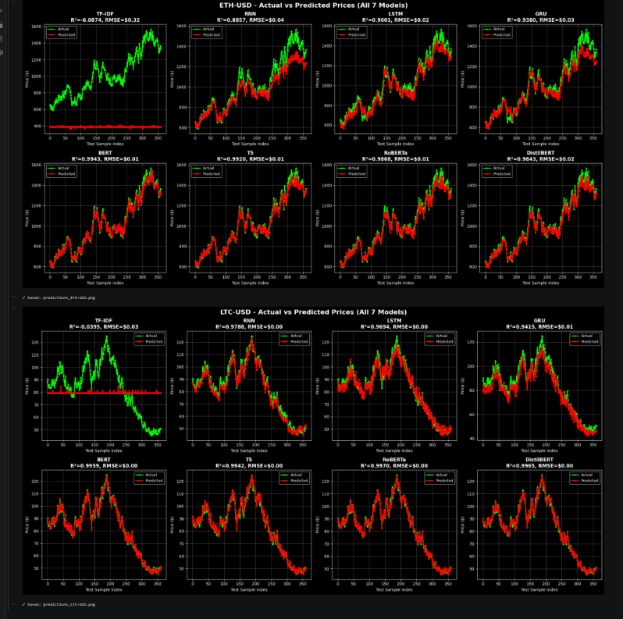
Visualization and Comparison:
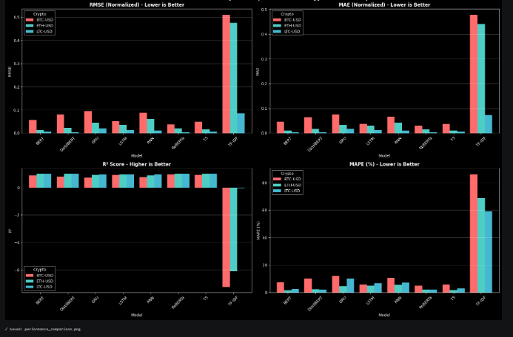
Model Rankings:
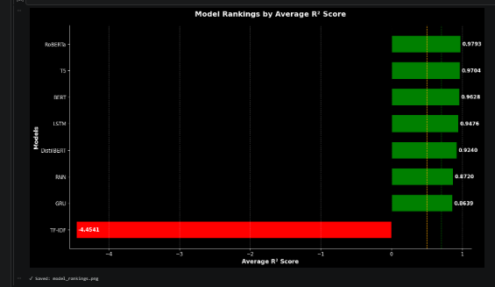

5.3 Summary
This comprehensive machine learning assignment successfully trained and evaluated seven distinct models. Results demonstrate that model selection must align with data characteristics, and simpler models can outperform complex ones when problem structure is relatively simple. The assignment provides valuable insights into cryptocurrency price forecasting and the importance of proper model evaluation and selection.
