1. CRUD IN Customer Detail

* Name, Code, Address Detail(Multiple)
  + Addr-1, Addr-2, City, State, PinCode(Validation), PhoneNo.

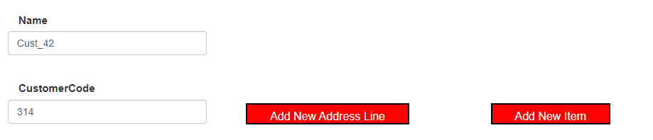

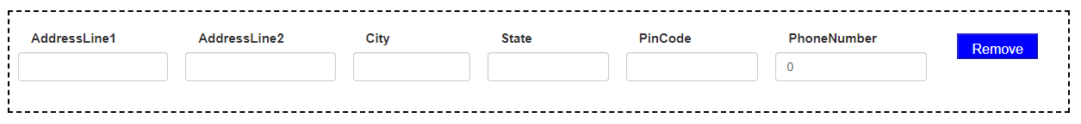

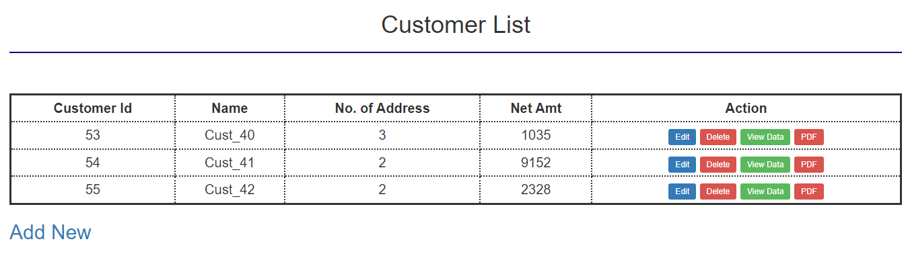

1. 1 AddressLine: Disable Delete Button

More AddressLine: Enable Delete of all Lines

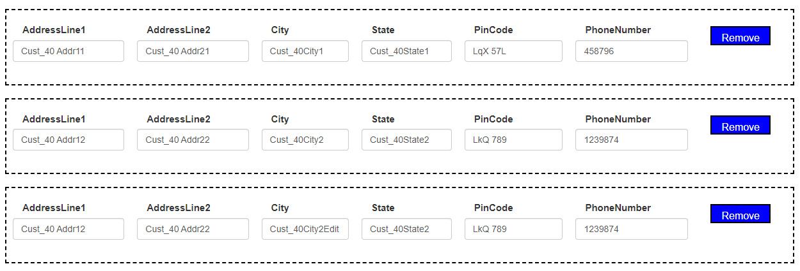

1. Item Detail(Multiple)

* ItemName, Qty, rate, Amt
  + - Horizontal & Vertical Total
    - Gross Amt, Disc(% and Rs.), Net Amt.

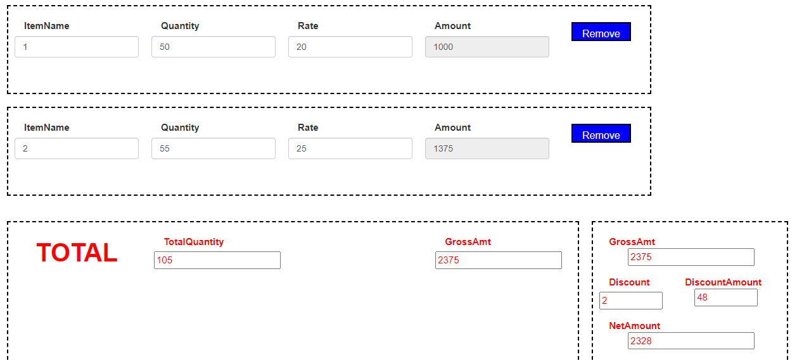

1. StartDate + Days = EndDate

StartDate, EndDate ⇒ Days

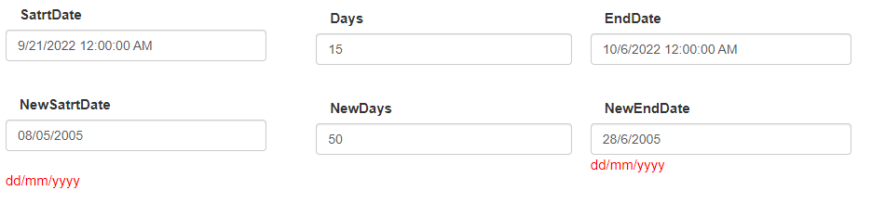

1. View Data as Pop-Up
2. Login-LogOut using Session
3. Remember Me(UserName & Password) using Cookie
4. ViewData as PDF