Data Visualization and Dashboard Development



NAMAL UNIVERSITY MIANWALI

DEPARTMENT OF MATHEMATICS

Semester Project
Name | Roll No.
Hafza Batool | NUM-BS Math-2022-01

Course: Data Visulaization
Supervisor: Mr. Muhammad Bilal
Due Date: 06th January, 2026

1. Introduction
The objective of this project is to analyze the Pakistan job market using a real-world dataset from Rozee.pk. The project focuses on applying Exploratory Data Analysis (EDA) and developing an interactive dashboard to extract meaningful insights about jobs across cities, experience levels, salaries, job types, functional areas, and skills.

2. Dataset Selection
For this project I used the Following dataset:
- Name: Pakistan Job Market Dataset (RozeePk-jobs-2024)
- Data Source: Kaggle (https://www.kaggle.com/datasets/zincly/pakistan-job-market-dataset-rozee-pk)
- Dataset Feature: My selected dataset has 1K+ job postings from 14 different cities of Pakistan and have columns such as: Title, Job location, Salary, Minimum required experience, Job Type, Minimum Education, Area of work, Required skills etc.

3. Project Theme
Analyzing Pakistan’s Job Market: City, Salary, Experience, and Skills Insights

Objective Questions:
- Which cities have the highest number of job postings?
- How do salary ranges vary across functional area and experience levels?
- What are the most common job types in different cities?
- Which skills are most in-demand for each functional area?
- Are certain experience levels associated with specific jobs?

4. Cleaning Steps Summary
While Cleaning my datset for Developing Dashboard I perfomed following steps:
- Removed irrelevant columns (apply before, gender,age etc.)
- Standardized column names (Age age )
- Removed null rows from Title and Job Location using dropna as these are leading columns.
- Handled missing values in functional Area, career level, skills.
- Converted salary to numeric mean value by using regex as it was mentioned as
(PKR. 30,000 - 60,000/Month) and replaced null with mean salary of overall.
- Standardized Job Type column.
- Extracted valid cities from job_location as this column was given as (Bahria Town Rawalpindi, Rawalpindi, Pakistan) using regex.
- Converted minimum experience to numeric and derived experience_level as this column was given as (2 Years, Less than 1 Year)
- Normalized skills into lists as skills column was given as (PHP, MySQL, Javascript, Laravel, HTML, CSS, Git, RESTful Api, Responsive Design, CSS3, React JS)
After all cleaning all relevant columns were stored in as separate csv file.

5. Exploratory Data Analysis (EDA)

5.1. Univariate Analysis

5.1.1 Salary Distribution:
- Average salary: PKR 82,640
- Minimum salary: PKR 7,500
- Maximum salary: PKR 900,000
- The wide salary range shows high variability, indicating the presence of both entry-level and senior executive roles.
- Salary distribution is right-skewed, with a small number of very high-paying jobs.
import pandas as pd
import seaborn as sns
import matplotlib.pyplot as plt
# Load Dataset
df = pd.read_csv("RozeePk-2024.csv")
plt.figure(figsize=(10,6))
sns.histplot(df["Salary"], bins=40, kde=True)
plt.title("Salary Distribution with KDE")
plt.xlabel("Salary (PKR)")
plt.ylabel("Frequency")
plt.tight_layout()
plt.show()
OUTPUT
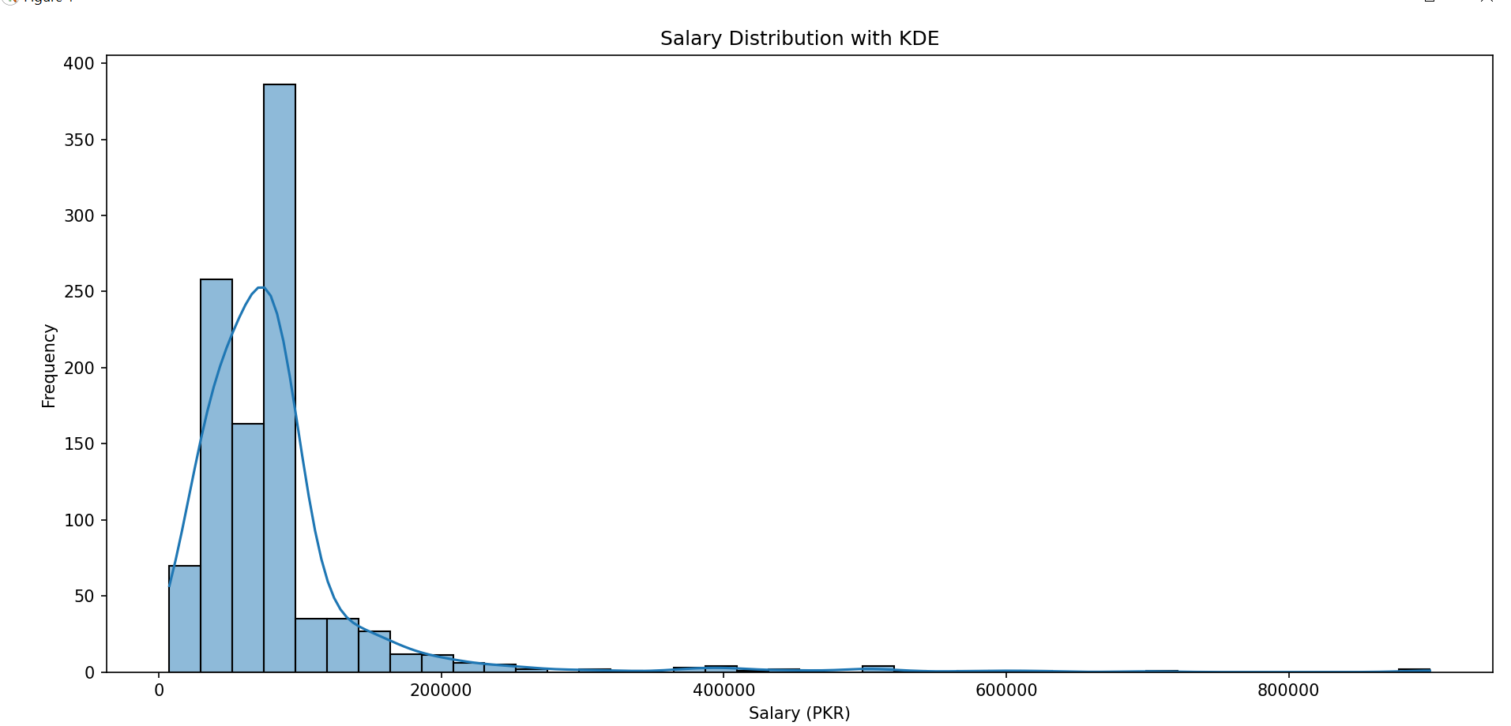

5.1.2 Job Type Distribution:
- Full-time jobs dominate the dataset.
- Part-time and “Other” job types appear very rarely.
These results show that the Pakistani job market is primarily full-time oriented.
job_type_counts = df["Job Type"].value_counts()
plt.figure(figsize=(6,6))
plt.pie(job_type_counts, labels=job_type_counts.index,autopct="%1.1f%%",startangle=90)
plt.title("Job Type Distribution")
plt.tight_layout()
plt.show()
OUTPUT
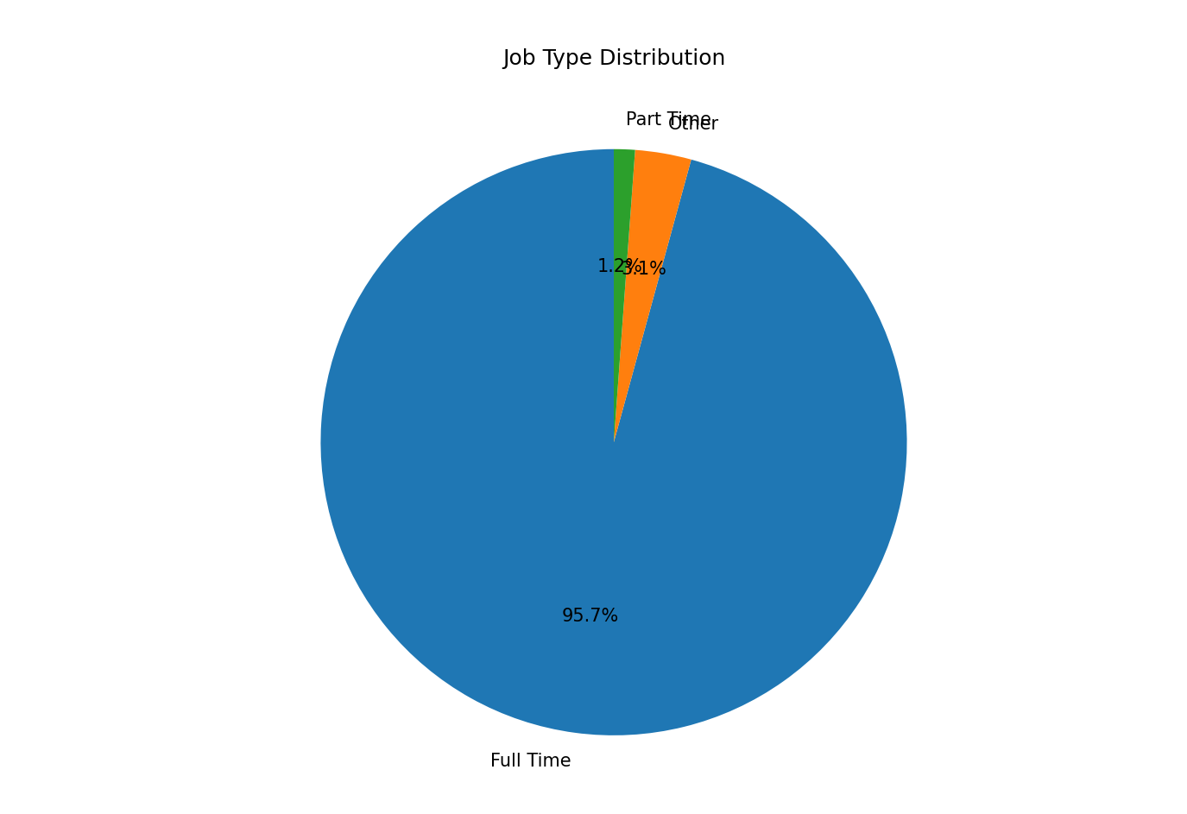

5.1.3 Functional Areas:
- The dataset includes 48 functional areas, with IT, Sales, Management, and Administration being the most frequent.
# Get top functional areas
fa_counts = df["functional_area"].value_counts().head(6)
plt.figure(figsize=(7,7))
plt.pie(
fa_counts,
labels=fa_counts.index,
autopct="%1.1f%%",
startangle=90)
plt.title("Distribution of Job Postings by Functional Area (Top 6)")
plt.tight_layout()
plt.show()
OUTPUT
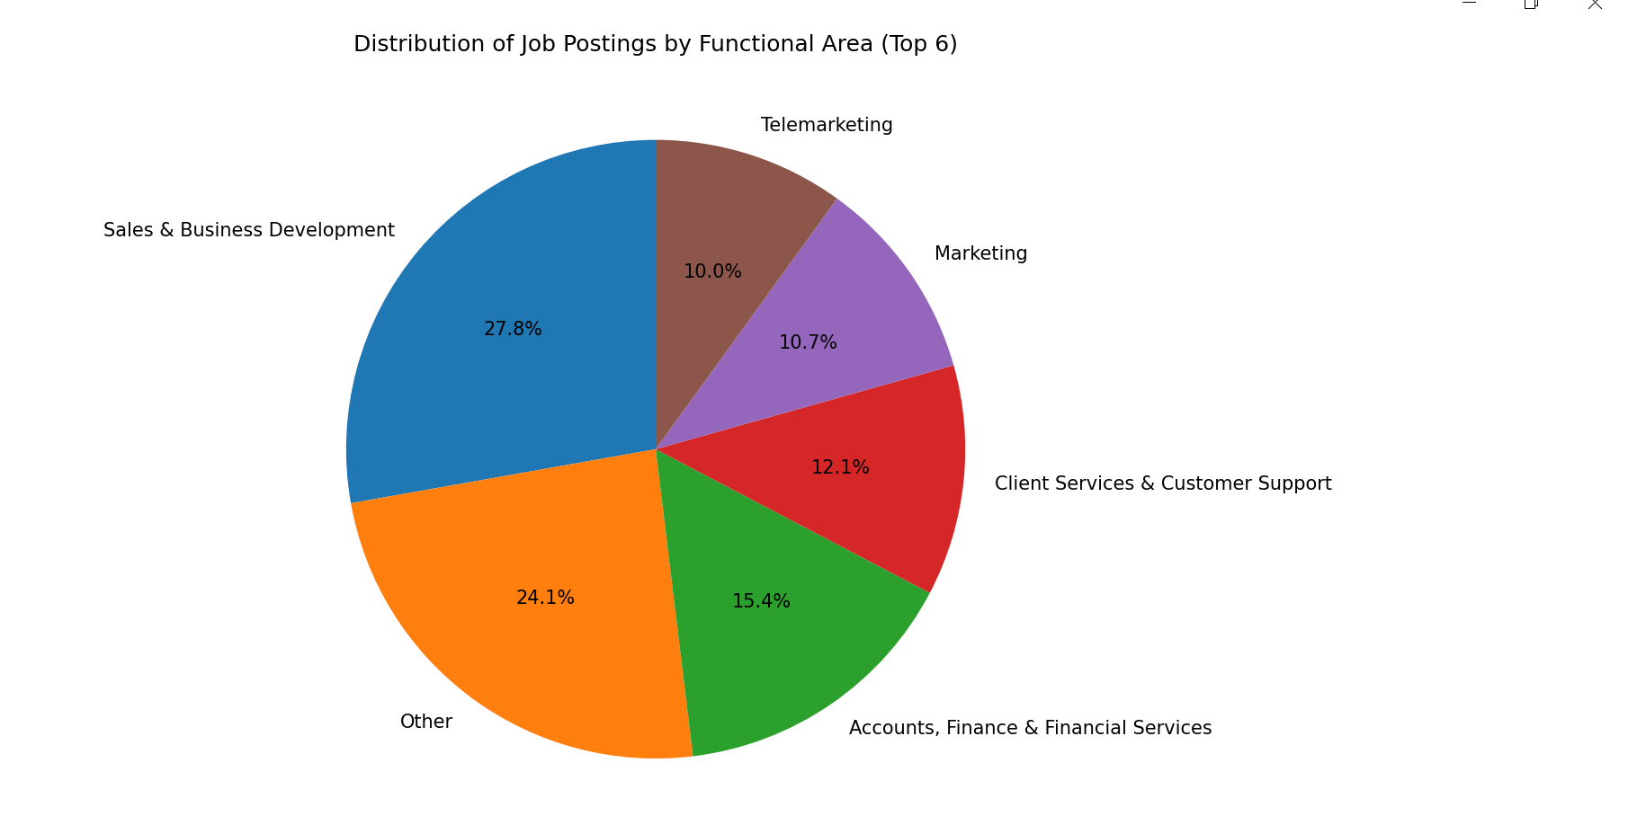

5.1.4 Skills
- Skills are highly diverse (over 900 unique skills), indicating role-specific skill requirements.
- Commonly occurring skills include communication, sales, programming, and management-related skills.
from collections import Counter
# Split skills
skills_series = df["skills"].dropna().str.split(",")
skills_list = [skill.strip().lower() for sublist in skills_series for skill in sublist]
top_skills = Counter(skills_list).most_common(10)
skills_df = pd.DataFrame(top_skills, columns=["Skill", "Count"])
plt.figure(figsize=(10,6))
sns.barplot(data=skills_df, x="Count", y="Skill")
plt.title("Top 10 In-Demand Skills")
plt.xlabel("Count")
plt.ylabel("Skill")
plt.tight_layout()
plt.show()
OUTPUT
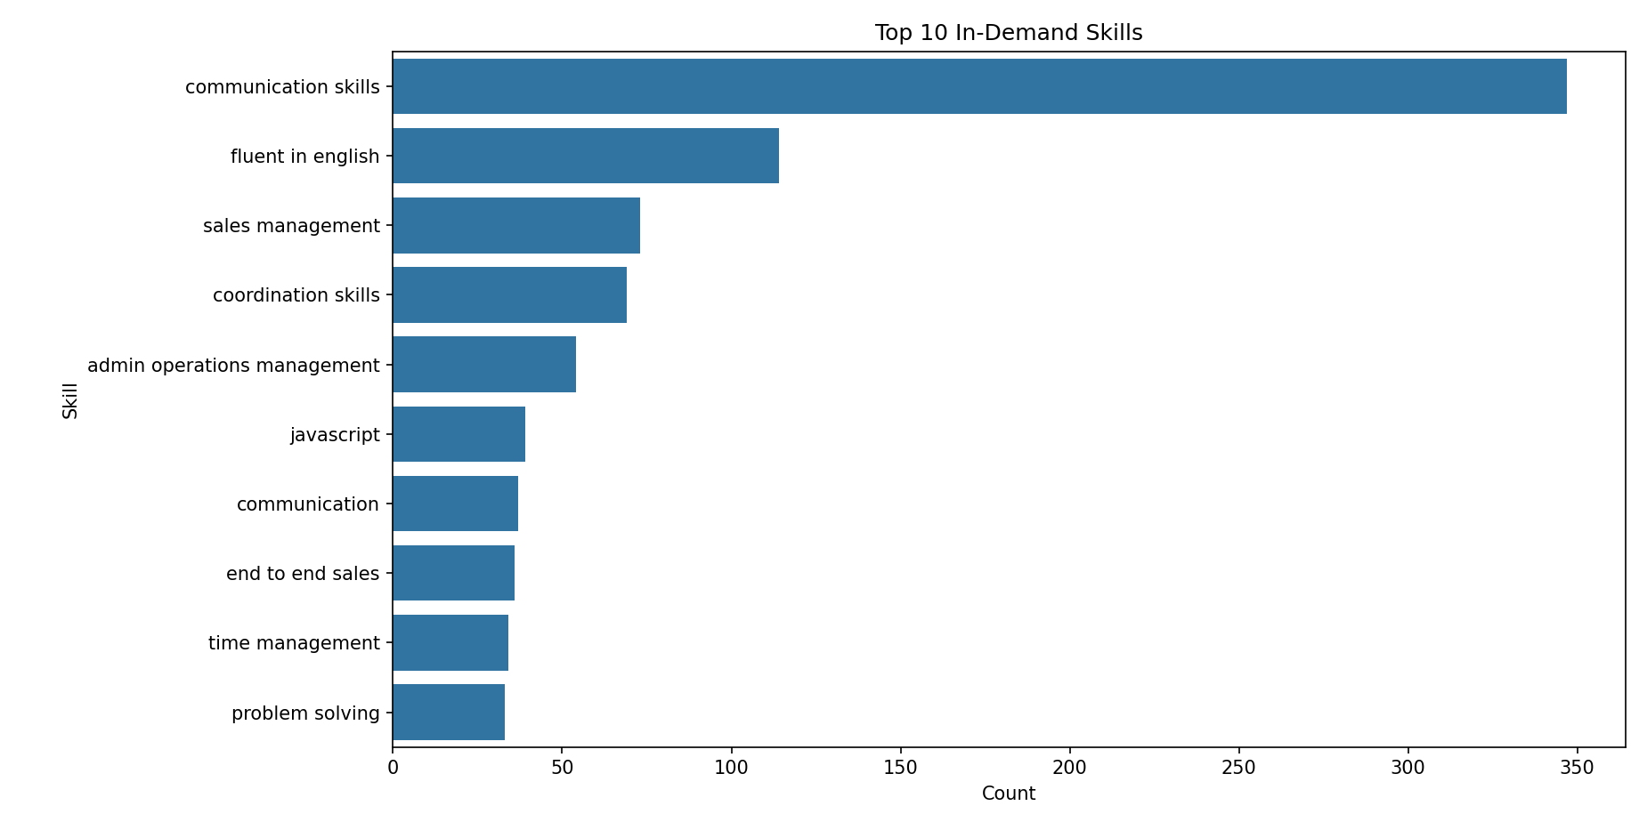

5.2. Bivariate Analysis

5.2.1 City vs Job Postings
- The dataset contains 1,034 job postings across 17 cities.
- Lahore has the highest number of job postings (431 jobs), followed by Karachi (210 jobs) and Islamabad (191 jobs)
- Smaller cities such as Rawalpindi and Faisalabad show comparatively fewer postings.
This indicates that major metropolitan cities dominate Pakistan’s job market, offering more employment opportunities.
plt.figure(figsize=(12,6))
sns.countplot(data=df,x="City",order=df["City"].value_counts().index)
plt.title("Number of Job Postings by City")
plt.xlabel("City")
plt.ylabel("Job Count")
plt.xticks(rotation=45)
plt.tight_layout()
plt.show()
OUTPUT
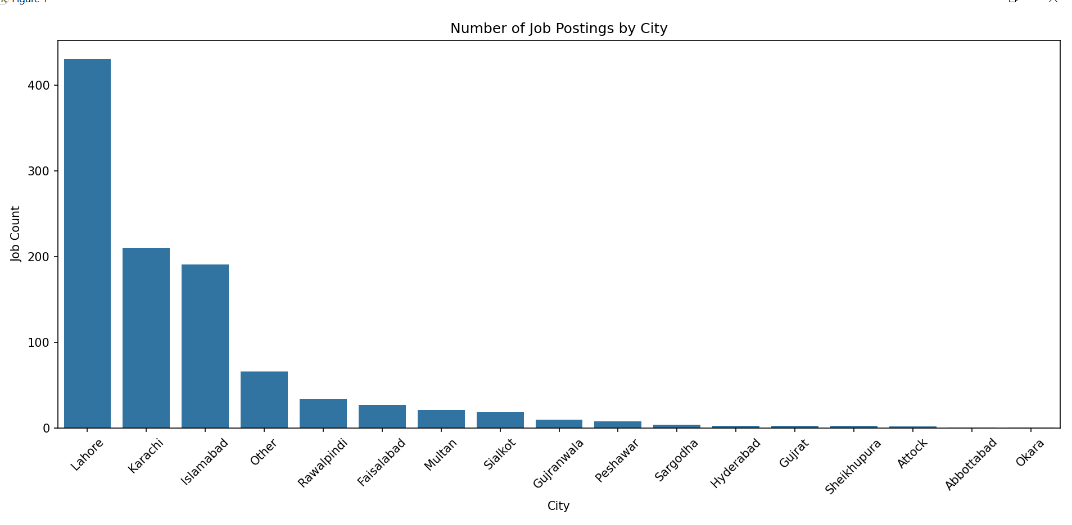

5.2.2 Salary vs Experience Level
- To avoid misleading interpretation caused by extreme values (e.g., 15–20 years), experience was better analyzed using experience levels instead of raw numeric years. Average salary increases clearly with experience level:

Experience Level | Average Salary (PKR)
Entry | ~66,800
Junior | ~76,100
Mid | ~113,200
Senior | ~192,000

- This confirms a strong positive relationship between experience and salary.
- Senior-level roles command almost higher salaries than entry-level roles/
- Some lower-experience roles offer high salaries, likely due to specialized skills or technical roles.
plt.figure(figsize=(10,6))
sns.boxplot(
data=df,
x="experience_level",
y="Salary"
)
plt.title("Salary Distribution by Experience Level")
plt.xlabel("Experience Level")
plt.ylabel("Salary (PKR)")
plt.tight_layout()
plt.show()
OUTPUT
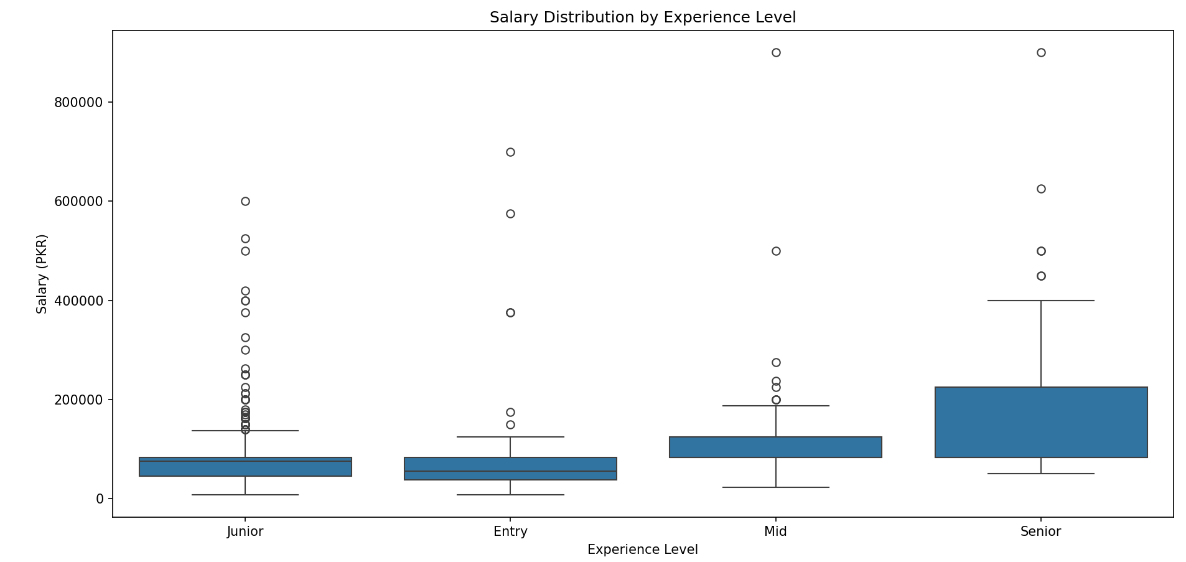

5.2.3 Functional Area vs Skills
- Each functional area shows distinct skill demand:
IT: Programming languages, databases, frameworks
Sales: Communication, negotiation, customer handling
Management: Leadership, planning, coordination
This highlights the alignment between functional area and skill requirements.

5.3. EDA Conclusion:
The EDA reveals clear trends in city-wise job distribution, experience-based salary growth, and functional-area-specific skill demand. These findings provide a strong foundation for the interactive dashboard and support data-driven insights into Pakistan’s job market.

6. Dashboard Development

6.1. Tool Used: Streamlit (Python)

6.2. Components of Dashboard:
The interactive dashboard includes:
import streamlit as st
import pandas as pd
import plotly.express as px
# Load Dataset
df = pd.read_csv("RozeePk-2024.csv")
# ------------------------------
# Streamlit Page Config
st.set_page_config(page_title="Pakistan Job Market Dashboard",layout="wide",initial_sidebar_state="expanded")

6.2.1. Title() &KPIs
st.title("Pakistan Job Market Insights Dashboard")
# KPI Cards
total_jobs = len(df)
avg_salary = df["functional_area"].nunique()
unique_cities = df["City"].nunique()
unique_skills = df["title"].nunique()
col1, col2, col3, col4 = st.columns(4)
col1.metric("Total Jobs", total_jobs)
col2.metric("Functional Areas", avg_salary)
col3.metric("Cities Covered", unique_cities)
col4.metric("Unique Job Title", unique_skills)
OUTPUT
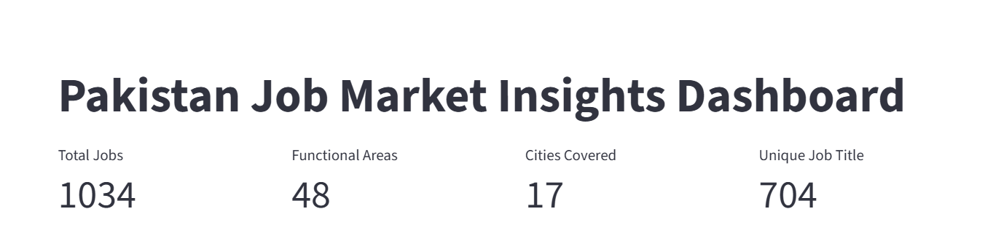

6.2.2. Filters
# Sidebar Filters
st.sidebar.header("Filters")
# Job Type Filter (for city chart)
job_type_options = ["None"] + df["Job Type"].unique().tolist()
selected_job_type = st.sidebar.selectbox("Select Job Type (City-wise Jobs)", job_type_options)
# Functional Area Filter (for salary and skills)
functional_area_options = ["All"] + df["functional_area"].unique().tolist()
selected_functional_area = st.sidebar.selectbox("Select Functional Area", functional_area_options)
# City Filter (for salary scatter)
city_options = ["All"] + df["City"].unique().tolist()
selected_cities = st.sidebar.multiselect("Select Cities (Salary Scatter)", city_options, default=["All"])
# Job Title Filter (for experience vs job type)
job_title_options = ["All"] + df["title"].unique().tolist()
selected_job_title = st.sidebar.selectbox("Select Job Title (Experience vs Job Type)", job_title_options)
OUTPUT
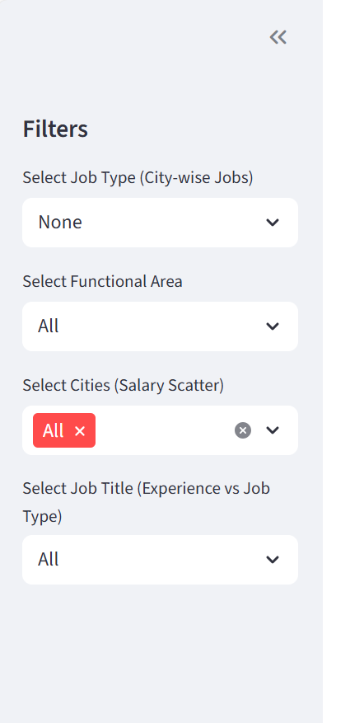

6.2.3 Bar chart to show Job Postings by City
# 1. Cities with Highest Number of Job Postings
st.subheader("1. Job Postings by City")
city_df = df.copy()
if selected_job_type != "None":
city_df = city_df[city_df["Job Type"] == selected_job_type]

city_count = city_df["City"].value_counts().reset_index()
city_count.columns = ["City", "Number of Jobs"]
fig1 = px.bar(city_count, x="City", y="Number of Jobs", color="City", text="Number of Jobs")
st.plotly_chart(fig1, use_container_width=True)
OUTPUT
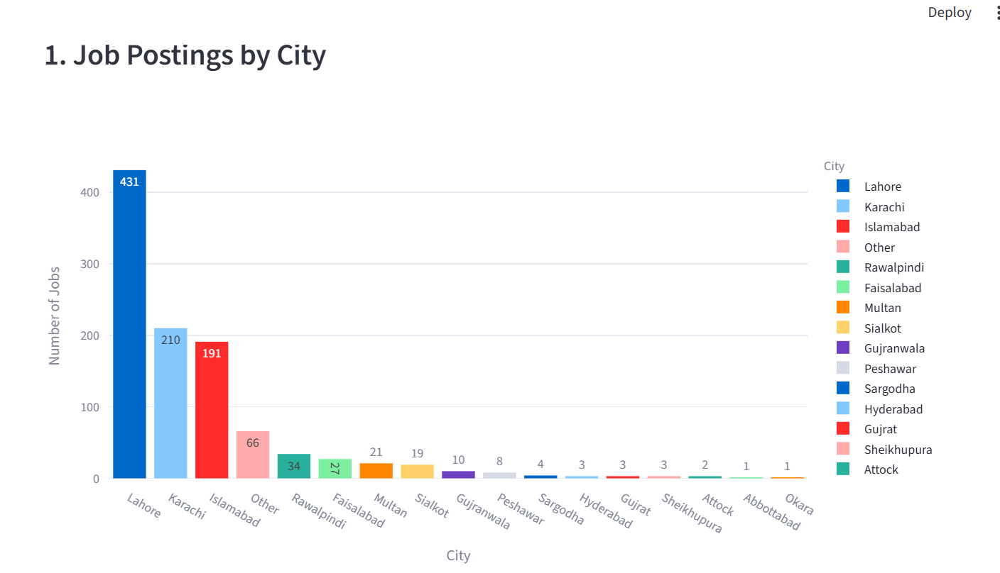

6.2.4 Scatter plot to show Salary vs Experience
st.subheader("2. Salary Ranges by Experience and Functional Area")
salary_df = df.copy()
if "All" not in selected_cities:
salary_df = salary_df[salary_df["City"].isin(selected_cities)]
if selected_functional_area != "All":
salary_df = salary_df[salary_df["functional_area"] == selected_functional_area]
salary_df["Experience_Capped"] = salary_df["Experience"].clip(lower=0, upper=10)
fig2 = px.scatter(
salary_df,
x="Experience_Capped",
y="Salary",
color="experience_level",
hover_data=["title", "City","functional_area"],
labels={"Experience_Capped": "Experience (Years)"},title="Salary vs Experience")
st.plotly_chart(fig2, use_container_width=True)
OUTPUT
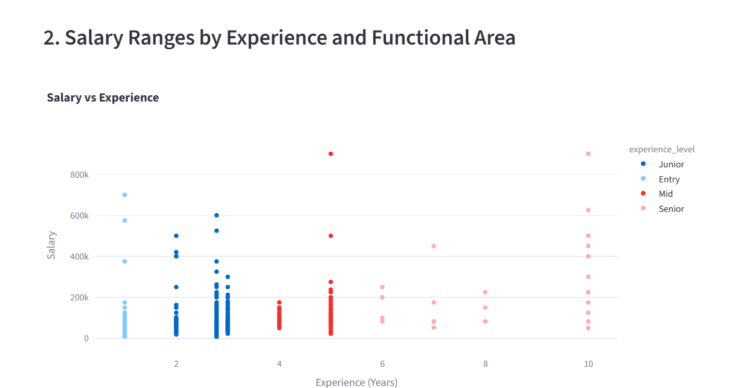

6.2.5 Bar chart to show Most Demanded Skills by Functional Area
st.subheader("3. Most In-Demand Skills")
skills_df = df.copy()
if selected_functional_area != "All":
skills_df = skills_df[skills_df["functional_area"] == selected_functional_area]
# Explode skills column
skills_df = skills_df.assign(skill=skills_df["skills"].str.split(",")).explode("skill")
skills_df["skill"] = skills_df["skill"].str.strip().str.lower()
top_skills = skills_df.groupby("skill").size().reset_index(name="Count").sort_values("Count", ascending=False).head(10)
fig3 = px.bar(top_skills, x="skill", y="Count", text="Count", title="Top 10 Skills")
st.plotly_chart(fig3, use_container_width=True)
OUTPUT
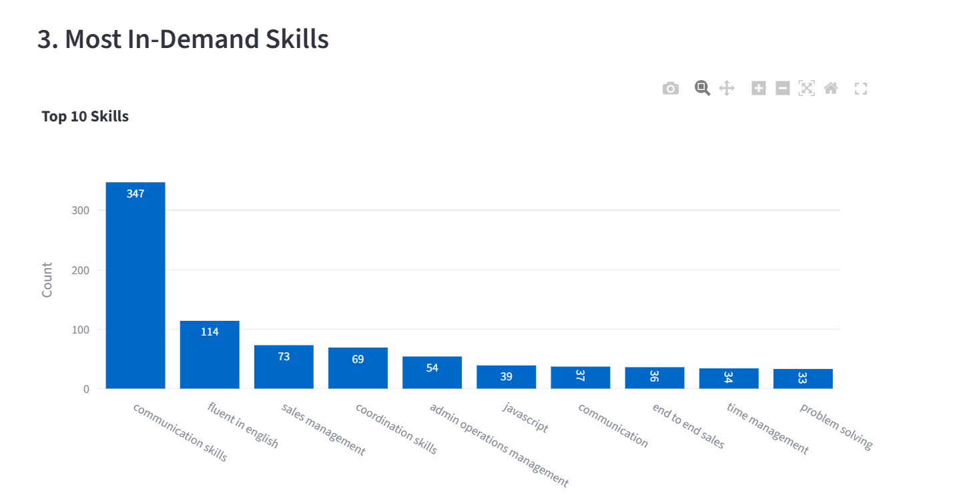

6.2.6 Bar chart to show Experience Level vs Job Posting Count
st.subheader("4. Experience Level vs Job Posting Count")
exp_df = df.copy()
if selected_job_title != "All":
exp_df = exp_df[exp_df["title"] == selected_job_title]

exp_count = exp_df.groupby("experience_level").size().reset_index(name="Count")
fig4 = px.bar(exp_count, x="experience_level", y="Count", text="Count", color="experience_level")
st.plotly_chart(fig4, use_container_width=True)
OUTPUT
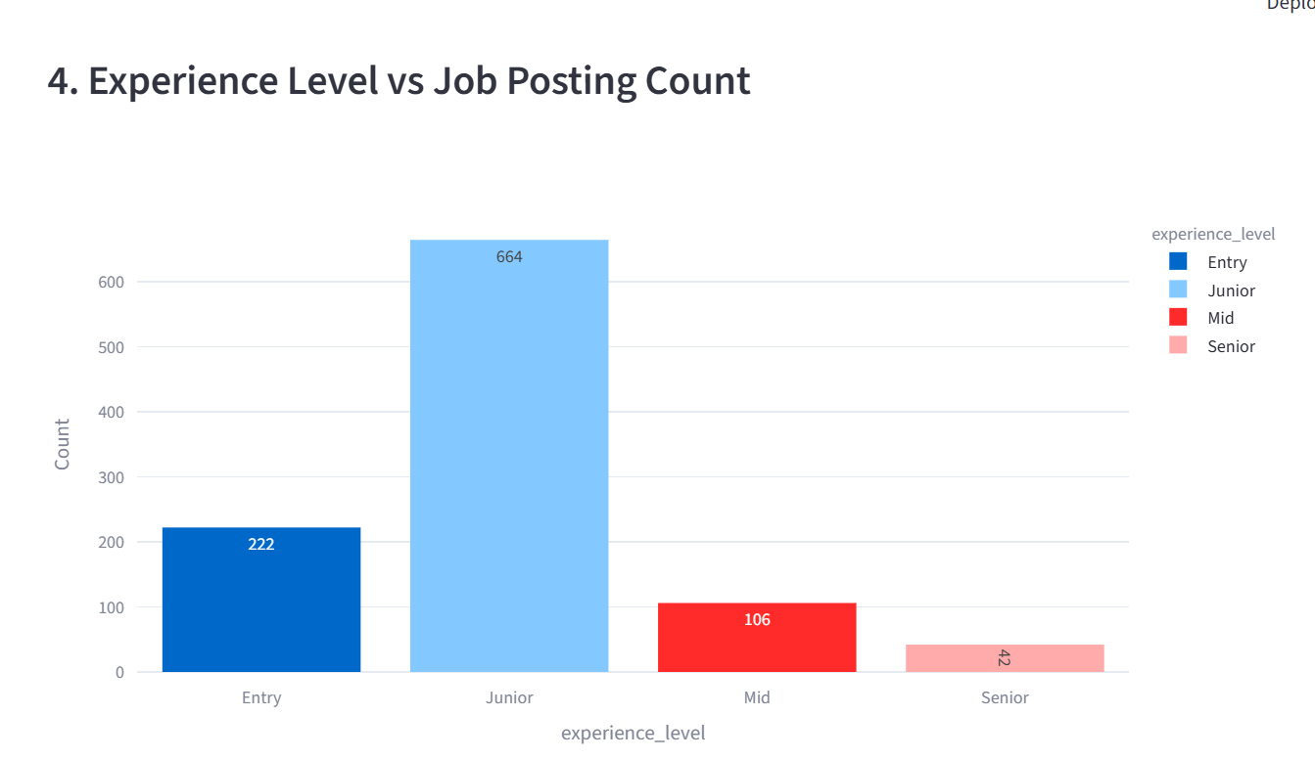

Overall Dashboard look like as below:
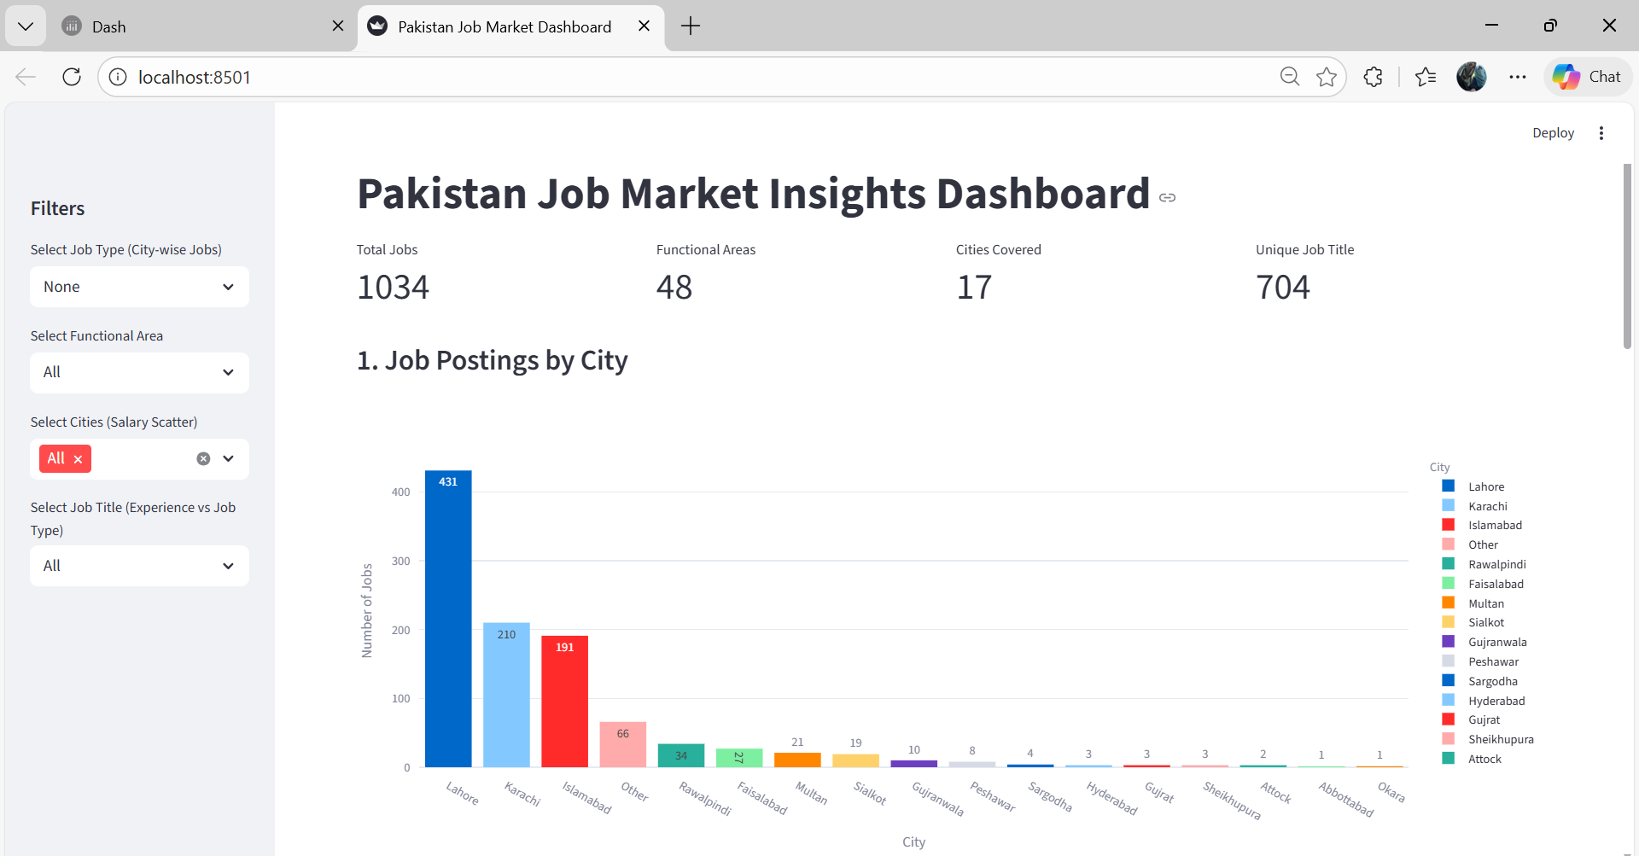

Interpretation and Insights
- Karachi and Lahore lead in job postings.
- Senior and mid-level roles attract higher salaries, particularly in IT and Engineering.
- Full-time roles dominate all major cities; part-time roles are limited to Karachi and Lahore.
- Skills in demand include Python, SQL, Java, and MS Office, varying by functional area.
- Entry-level jobs are mostly in IT, Sales, and Customer Service. Senior roles dominate Management and Technical functions.

8. Conclusion:
The analysis provides a comprehensive view of Pakistan’s job market, highlighting city-wise trends, salary distribution, skill demand, and career progression patterns. The interactive dashboard allows dynamic exploration of the data, aiding HR professionals, job seekers, and researchers in making data-driven decisions.

