Name: Hagos Chekole ID:GSE0224/17 Course :SVVT

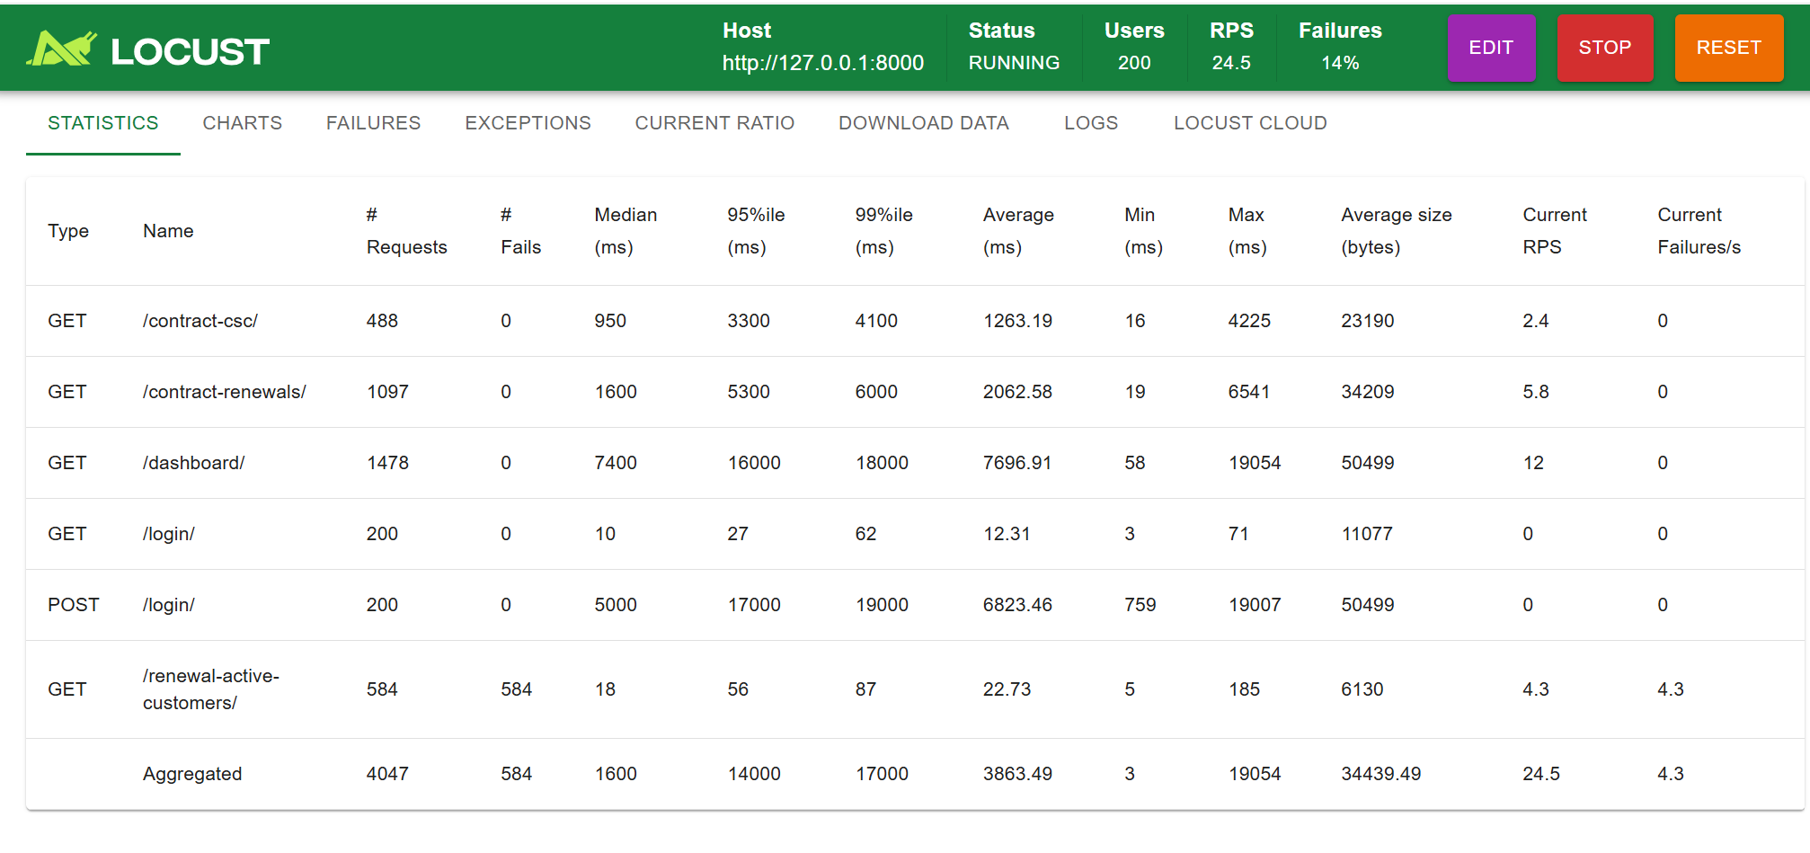

**Summary: Non Functional Testing from Locust**

1. **About Fails:**

The last two **Aggregated** and **renewal_active_customers** are not available on the system. Renewal-active-customers is found on the system “URL” only. In case of that high fails numbers are displayed.

**2, Average(ms):**

**Login** is fastest in case of less access of other modules .It directly check the user role since the application is role based so at the very beginning role of the user is identified which is the first action the system.it means no need of accessing other modules to check(get) username and password in case of this it is fast. **Whereas Post /login** requires more time to check whose username and password is asked from 200 users.

**Dashboard** took huge amount of time because the output on the dashboard are collected from different models of the system and uses different logics from different views, so to access these all it requires more time .

**Contract_renewals:** this module is the second from the modules took large time to load.The reason is this module is accessible by region and head office label that means many csc(branches) are linked with this module .It this the summary of csc .

The over the system performance with 200 is good.

**Challenges:**

I tried to test by using ZAP other systems built by django and reactjs, php angular all of them worked properly but the django frame work with python and bootstrap frontend is big challenge to test by using Zap.

**Summary of Functional Testing:**

**Functional Testing By using Selenium**

**Login is properly tested by using valid input automatic through selenium**

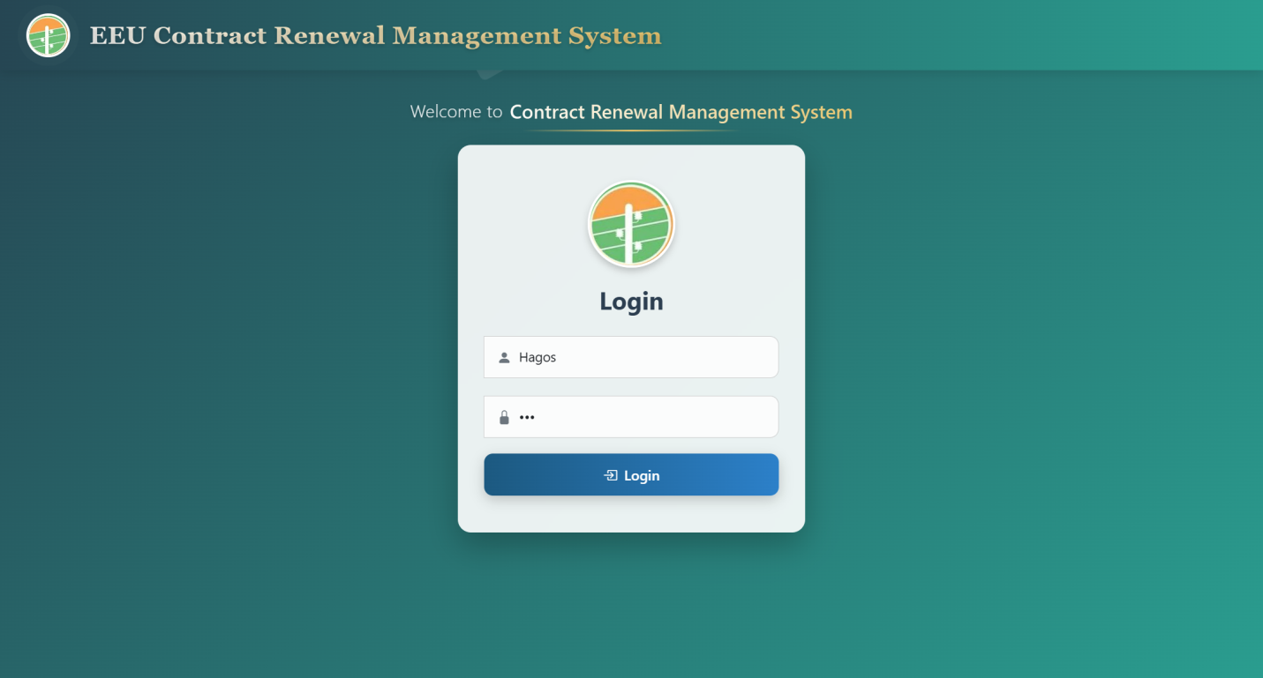

**Invalid login:**

**Invalid login is tested as it is expected**

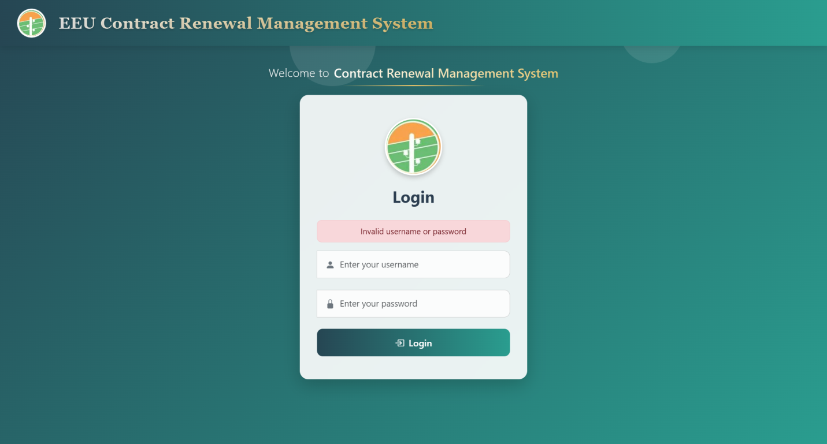

**Form Input validation is done:**

**BV: Border values the minimum, maximum, lower minimum, upper maximum ,between lower and maximum value are tested properly**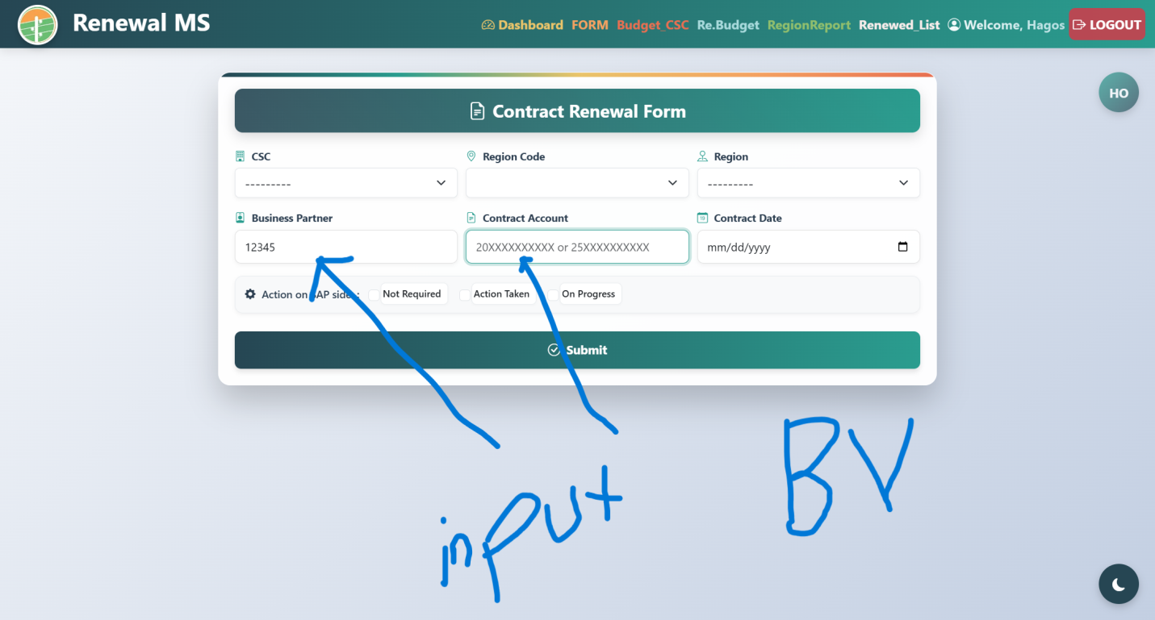

**Navigation Menu are Tested:**

**One from the navigation menu is the above Form**

**Another Dashboard and the logics including with dashboard are tested:**

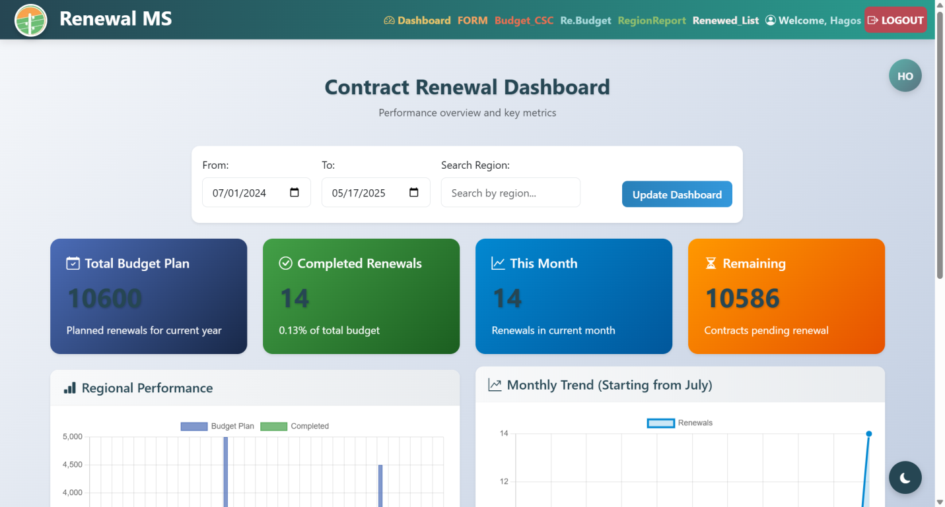

**Pagination : The pagination pages and report is tested**

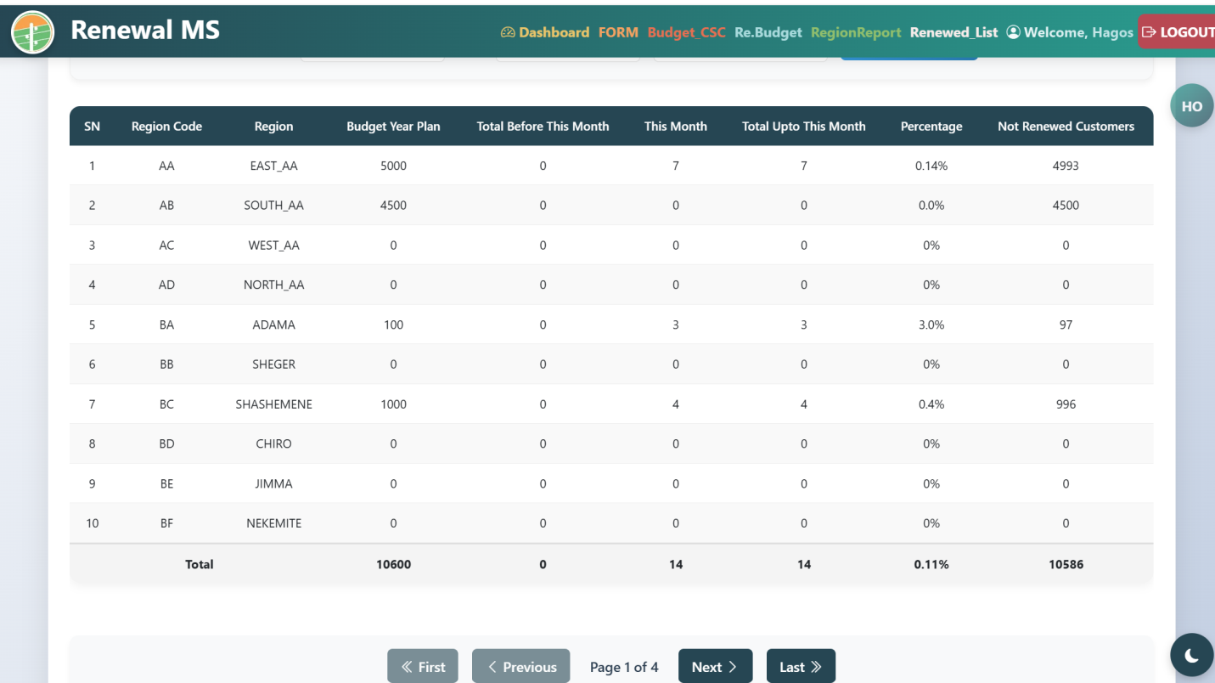

**This one also tested most of the are passed. But one list of customer renewal was developed without pagination**

**Logout:**

**On each testing navigation menu logout is repeatedly tested.**

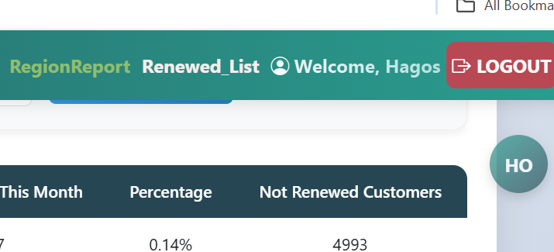

**Customers list**

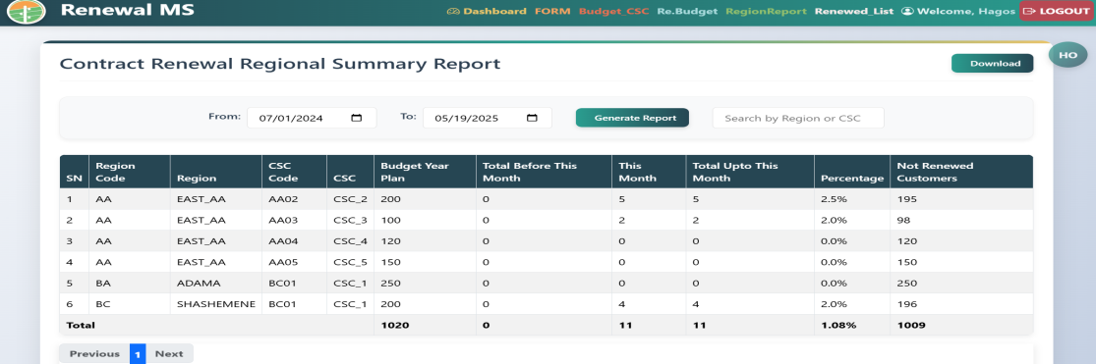

This view is accessible by selenium but the filtration as well generate report on this page is not working.

**Cause:** I think this view is the combination of three models that are csc, region,contrct_renewal form,so clear logic of reading this page is not offered .i put this as cause.