



Alify Application

Version 9

Hagar Naga lujain Alkinany

Supervisor: Mona Alofy

October 24,2024

**Content Table**

**Abstract………….…….………………………………………………………………………………2**

1 Introduction 3

2 Analysis 3

2.1 Application Purpose 3

2.2 Problem Definition 3

2.3 proposed Audience 3

2.4 Application Requirements 4

2.4.1 Functional Requirements 4

2.4.2 Non Functional Requirements 4

2.4 3 Requirements refining 5

2.5 pet care applications Comparison 6

2.5.1 Advantages and Disadvantages of Watch Pet Application 6

3 Design 7

3.1 System Architecture 7

3.2 UI Prototype 8

3.3 Data Models 12

3.3.1 Use Case Diagram for Alify Application 12

3.3.2 Class Diagram 13

**3.4** **System technical specifications 15**

4 Conclusion 15

5 Appendices 16

6 References 17

**Abstract**

In this document we present an overview of **Alify** pet care application .The document Introduces the analysis phase, explaining the purpose of developing **Alify** and highlighting its strengths over other similar competing applications .Next, the multiple functions and services provided by **Alify** to enhance the user experience raising pets . Next, the application design phase including **Alify** system architecture to show the constituent components and their relationships , and providing UML models to enhance illustrating the application .Next, it provide User Interfaces to ensure users have a comprehensive idea about **Alify** .Finally conclude with predictive technical specifications essential to run the **application**.

**Key Terms**

Client-Server Model, Pet Profile, Veterinarian ,UI

**1. Introduction**

Lots of applications are developed daily. But not every application serves its users properly. Only useful application are needed by users. Useful applications are characterized by their ability to solve daily problems faced by several people and make their life easier. From this standpoint our team focused on developing an application (Alify)that solves a common problem faced by many people.

**2. Analysis**

This section will talk about a general analysis of the application in- cluding the purpose of developing and creating it, the problems that the application is meant to solve, and the proposed audience that will use the application. In addition to the necessary requirements must exist, and a com- parison between Alify and other similar applications.

# 2.1 Application Purpose

Alify application is made to ease the life of pet owners, which helps them take care and raise their pets properly by giving appropriate information about their lifestyle.

# Problem Definition

Contributes to solve the problems faced by pet lovers raising pets and provides them sufficient expertise and knowledge to care of them, especially in areas lacking veterinary centers.

# 2.3 proposed Audience

Alify is made for pet owners , people interested in pets in general and for the contributed vets.

# 2.4 Application Requirements

A study was conducted to determine the basic requirements needed to exist in the application-see in **Table 1** bellow for study results-. So it includes a set of functional and non functional requirements that make it achieve the purpose it was created for.

|  |  |
| --- | --- |
| **Description** | **Study results** |
| The results show that 59.3% of respondents have previous experience in pet care. Meanwhile, 29.6% interact with pets only at friends' places, and 11.1% have never dealt with pets. This suggests a diverse audience with varying levels of pet care knowledge and needs |  |
| The results show that most respondents 38.5% find pet care challenging, especially when pets get sick. Only 23.1% feel confident in their experience, highlighting the need for more support and resources for pet owners. |  |

|  |  |
| --- | --- |
| The results show a mixed availability of veterinary clinics in the respondents' areas. Only 29.6% report having many nearby clinics, while 33.3% have none close by, and 37% say some clinics exist but are hard to reach. This suggests varying access to veterinary care among pet owners. |  |
| The results revealed that many pet owners struggle with feeding schedules and quantities. About 40.7% are unsure about the right amounts, 22.2% find it difficult to determine and remember feeding times, while 37% have no issues. This highlights a need for better guidance to ensure pets' dietary needs are met. |  |
| The results show that 51.9%of respondents go to the veterinary clinic immediately when their pet gets sick, while 40.7% ask someone with pet-raising experience, and 7.4% do nothing and wait for the pet to recover." This reflects the varied approaches pet owners take when dealing with illnesses |  |

|  |  |
| --- | --- |
| The results show that 85.2% of respondents prefer having an app that provides information on pet care, 11.1% think it is not very useful currently, and 3.7% believe there is no need for such an app given the abundance of information available online." This highlights a strong desire among most respondents for additional resources to care for their pets |  |
| The results show that , 63% of respondents prefer a remote veterinary communication service because they cannot go to a veterinary clinic, 33.3% think it might be a good idea, and 3.7% do not prefer it. This indicates a strong interest in remote vet services among users. |  |

**Table 1**, study results for Alify requirements

## 2.4.1 Functional Requirements

These are services the application should provide based on user needs ,which specify the different actions taken by the application to make users interact with . including:

* + - * The application should allow the creation of a new account for each user containing his or her personal information: name, email, and password.
      * The application should allow users to search for the type of pet and information related to the specific pet.
      * The application should allow information about the animals to be pro- vided.
      * The application should allow the creation of sub-accounts for each pet the user owns, including detailed pet data.
      * The application should allow a special interface to be provided to the administrator.
      * The application should allow users to create reminders for various pet care activities.
      * The application should allow a communication with veterinarians.

## 2.4.2 Non Functional Requirements

These are the functions that have to be in the application by default to ease the process of using the application and give users a seamless experience. Including :

* + - * The application should be compatible with android and iOS operating systems.
      * The application should make noise when sending notification
      * The application should work on the internet.
      * The application information should be edited only by the admin.
      * The application should respond quickly (5 sec max).

These requirements will ensure the application will work consistently and ensure a great user experience.

## 2.4.3 Requirements refining

In addition to previous requirements and to make sure being in touch with user real needs, a survey was conducted to gather other requirement users want to be in the application-see the conducted survey on **p 15** . and based on the responses -see in **figure 1** below for responses – a requirements were refined to include the following:

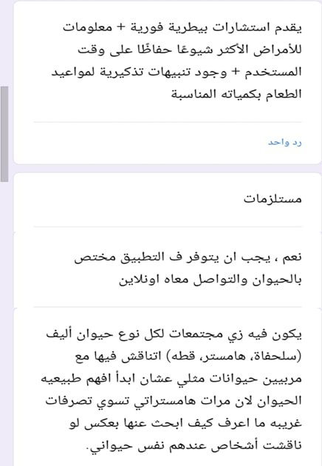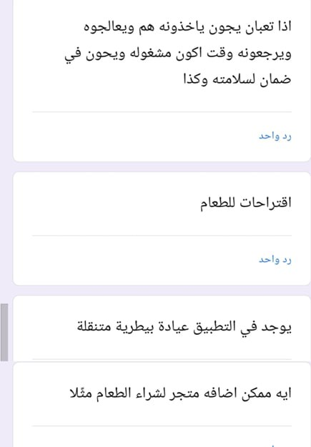

**figure 1**, Responses to the conducted survey.

* + - * Adding an online store to buy various pet cosmetics.
      * Adding a chat group for people who own the same pet.
      * Providing information about the most common pet diseases.
      * Linking the application to comprehensive pet clinics.
      * Set notifications for sending funny information about pets

# 2.5 Pet Care Applications Comparison

After refining the functional and non-functional requirements of the Alify application, and incorporating valuable feedback from the conducted user survey, it is important to contextualize these features within the existing landscape of similar applications. By comparing Alify with other pet care applications , we can better understand the unique strengths in Alify design.

**Watch Pet** is a pet care application that Focuses on providing a virtual pet care experience and used by people who enjoy raising virtual pets on their smartphones. Providing a fun interactive experience related to caring for a virtual pet.

## 2.5.1 Advantages and Disadvantages of Watch Pet Application

|  |  |
| --- | --- |
| **Advantages** | Disadvantages |
| It allows users to have an entertaining interactive experience of caring, feeding and playing with pets. | May not provide a deep realistic experience. |
| Those who cannot have pets and would like to have one can get a virtual one. | Requires constant interaction with the pet via the screen, which affects the user’s health. |
| It offers fun challenges of caring a pet and keeping it healthy and happy. | It is fun, but does not provide many benefits about raising a pet in real life. |

Alify addresses these disadvantages by aiming to provide assistance in raising real pets, and offering the user all essential information- including practical tips and solutions on how to take care of pets- ensuring a more interactive and enjoyable experience for pet owners.

**3. Design**

This section will include the developed design of Alify. This is an im- portant step in translating the functional requirements into a well structured architecture . Alify is designed to adopt the client-server methodology since it has users (clients) interacting with a central server , and will consist of multiple components interacting with each other to provide a smooth experience for pet owners and vets. In this phase our team focuses on establishing the overall system architecture ,data models and technical specifications.

# 3.1 System Architecture

System Architecture refers to high level of the application .It defines the components and how they interact with each other to form the entire system. And the building blocks (components) in Alify application are:

* + - * **User Interface(UI)** The front end where users (pet owner and vets

) interact with the application. This includes screens for log in ,pet information , search, reminders and chat .

* + - * **Admin Interface** A special interface for admins to make them able to monitor and manage the application data ,like (user profiles , pet information ,..etc).
      * **Application Server** The back end components that processes and deals with user requests, like (searching for pets, creating reminders,..etc.)

.it will handle business logic and communicate to database.

* + - * **Database** where all the application data (including user, vet, admin and pet information, vet chat content ,. . . etc) stored and retrieved.

Now that the components are defined, the interactions between them can be grouped in:

* + - * **Users Interactions with UI** Different users will use UI in different manners to meet their needs ,like (pet owners will log in ,search and create reminders, vets will chat with different pet owners and admins will manage the whole information in the application).
      * **The UI Communications with The Application Server** It is whenever the users performs an action ,the UI sends the request to the server .
      * **Mutual Chatting** The chat functionality between pet owners and vets can be real-time (WebSocket) or message-based (stored in a database).
      * **The application Server Interactions with Database** The server stores or retrieves the data from Database .

High security , communication protocol types and data management have to be considered To achieve the best architecture .

# 3.2 UI Prototype

Prototypes are an optimal way to present a high abstracted view of systems . our team considered the importance of it and some User Interfaces were deigned to show how the application looks like-see in next **figures 2,3,4** below.

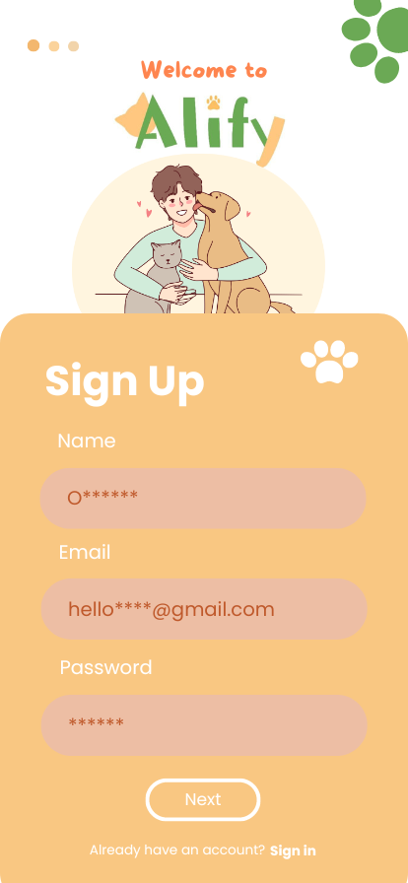

**Figure 2,** Sign up interface allows users to create new accounts.

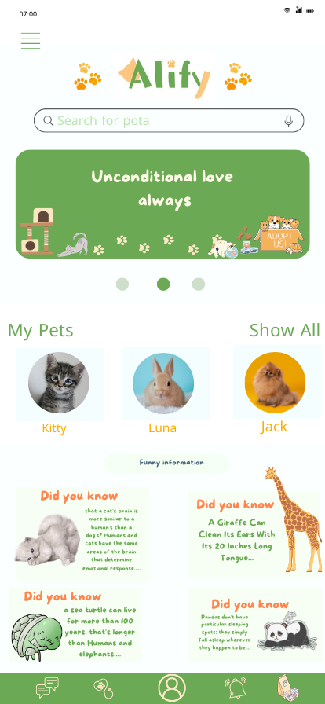

**Figure 3**, Home interface shows pet information.

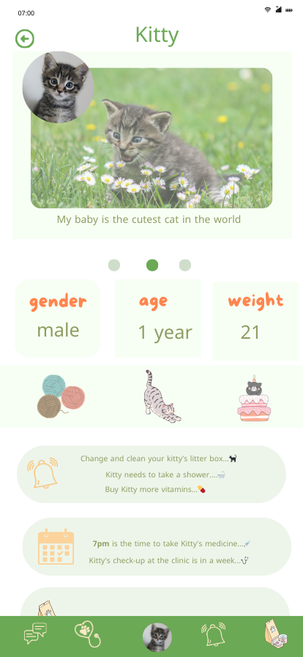

**Figure 4**, pet account interface shows information for each owned pet.

# Data Models

Now that the basic components of the system and how they interact with each other are defined , a set of models -that explain how Alify works- will be illustrated.

## 3.3.1 Use Case Diagram for Alify Application

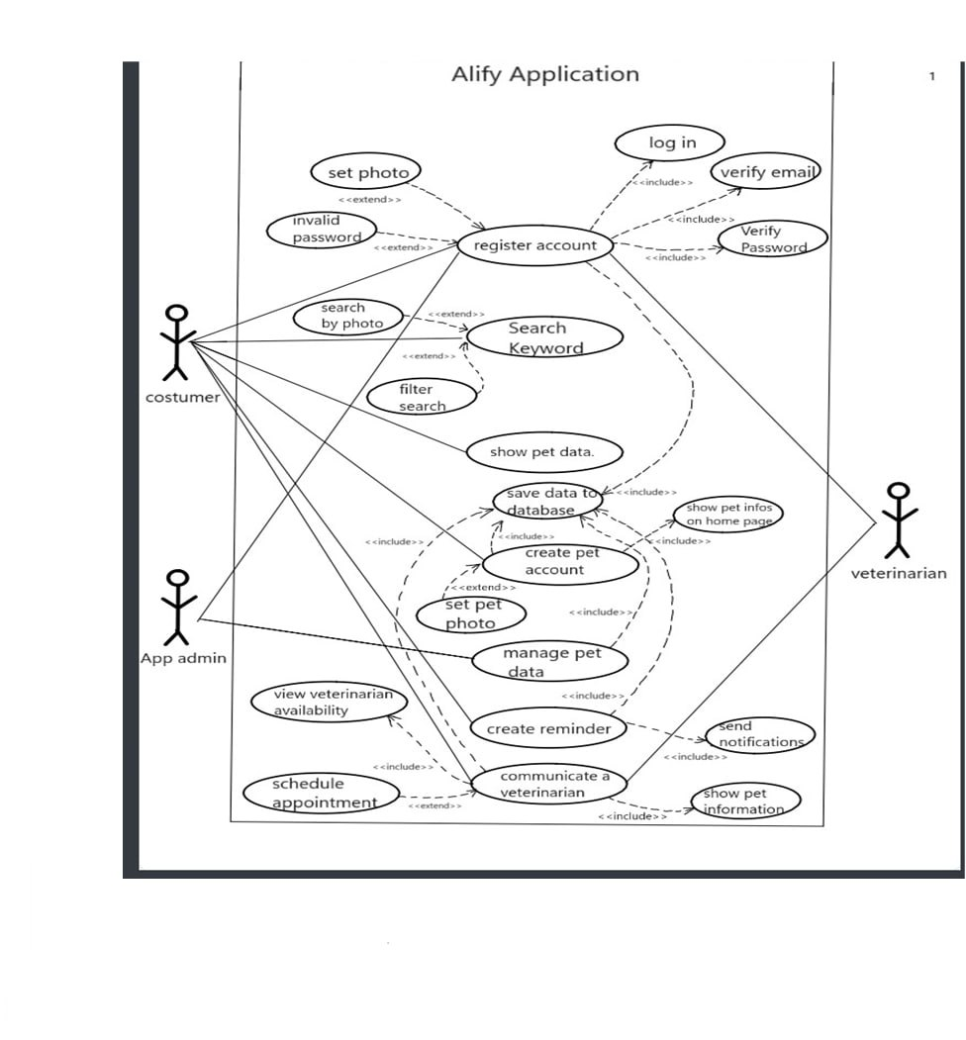Here we will provide an overview of the interactions between different users (customer, app administrator, and veterinarian) and the different functions they can perform within the app. These functions include : Account registration, pet search, pet data management, creating reminders, communicating with veterinarians, and more shown in **figure 5** below.

**Figure 5**, Alify use case shows the main functions performed by Alify.

## 3.3.2 Class Diagram for Alify Application

Class Diagram will be used to show the integrated components consisting the application and their relationships as follows:

* **App User** This class manages user account functions like registration and log in.
* **Customer** Controls creation, update and deletion of pet data. So pet owners can create ,modify, and remove pet profiles.
* **Pet Account** Contains details of pet accounts and linked to the its owner's profile for easy access and management.
* **Pet Data** Manages the pet shown information such as gender and Preferences.
* **Veterinarian** Manages medical history and appointments by viewing and modifying medical records and schedules.
* **Admin** Manages pet data in general ,he has the access to all parts of the system.
* **Database** manages connecting, disconnecting and data backup.
* **Search** Searches data and photos of pets.
* **Reminder** Creates, edits and deletes reminders for each pet.
* **Appointment** Manages and schedules appointments between vets and pet owners.

-See the structured class diagram in **figure 6** below-

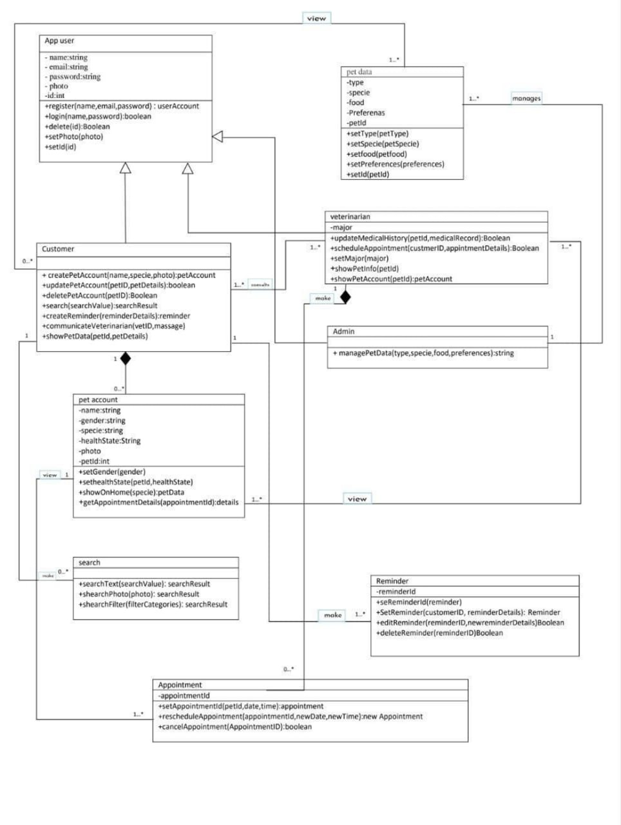**Figure 6**, Alify class diagram shows the application components.

## 3.4 System technical specifications

The technical specifications of Alify application outline the key tech- nologies, tools and configurations required for the successful development and deployment of the system. These specifications ensure that the application meets the functional requirements and operates in a professional manner. This section covers the necessary hardware, software, and network requirements, as well as scalability options.

* **Hardware requirements** Including: 1.5 GHz or higher processor, minimum 8 GB RAM and 100-200 MB for Disk Space.
* **Software requirements** Including: Windows 10 operating system or later version, Java or C programming language and MySQL for relational Database.
* **Network and communication** Including: TCP/IP communication protocols for reliable communication, HTTPS for secure communica- tion and SSL/TLS for encrypting transferred data to maintain security

.

* **Scalability** Including: Adding more servers to distribute the load and Uses indexing to handle growing data volume.

The detailed hardware, software, and network specifications outlined in this section ensure that Alify is built on a solid foundation capable of delivering optimal performance and reliability.

**4. Conclusion**

In conclusion, Alify represents a comprehensive solution for pet owners and veterinarians, by offering features that ease pet care, enhance communi- cation between users, and provide a user-friendly experience. From gathering and refining functional requirements to designing a robust reliable system architecture and user interfaces, the development of Alify has been designed with a focus on practicality, user satisfaction, and scalability. By addressing gaps in existing applications, Alify stands out as a valuable tool that simplifies the responsibilities of pet ownership while ensuring pets receive the care they need. Moving forward, this foundation sets the stage for future iterations and improvements, keeping the needs of both pets and their owners at the heart of its evolution.

**5. Future Work**

Adding future work helps maintaining the quality and reusability of the application, taking into account staying updated. That is why our team considers the importance of future work by adding Artificial Intelligence(AI) services to improve the user experience. Via providing suggestions about pets information, sending notifications based on user preferences, and reminding users of their pets activities.

**5. Appendices**

Appendix A: The conducted survey

<https://docs.google.com/forms/d/1knzKI0j-MDYWSEWGQjm2EkJWuGr_awBlLeHSVaJvKsk/edit?chromeless=1>

Appendix B: GitHub link

<https://github.com/Hagar-24/alifyCopies/tree/main>

Appendix C: Microsoft Style Guide

<https://learn.microsoft.com/en-us/style-guide/welcome/>

Appendix D: Canva

Appendix E: Visual Paradigm

Appendix F: Word

Appendix G: Latex

**6. References**

1.Lucid Software. (n.d.). *[YouTube channel]*. Retrieved from <https://youtube.com/@lucid_software?si=6EEyedCNMDYqoQGJ>

2. Visual Paradigm. (n.d.). *Visual Paradigm*. Retrieved from <https://www.visual-paradigm.com/>

3. Global App Testing. (2022, November 10). Mobile app development statistics and facts. *Global App Testing Blog.* Retrieved from <https://www.globalapptesting.com/blog/mobile-app-development-statistics-and-facts>

4. Queen Creek Veterinary Clinic. (2024, May 17). The joy & challenges of pet ownership. *Queen Creek Vet Blog.* Retrieved from <https://www.queencreekvet.care/2024/05/17/the-joy-challenges-of-pet-ownership/>

5. GeeksforGeeks. (2021, December 14). Functional vs non-functional requirements. *GeeksforGeeks.* Retrieved from <https://www.geeksforgeeks.org/functional-vs-non-functional-requirements/>

6. GeeksforGeeks. (2023, January 5). Software engineering | software design process. *GeeksforGeeks.* Retrieved from <https://www.geeksforgeeks.org/software-engineering-software-design-process/>