

Business Requirements Document (BRD)

Project Title: Integrated AI Cardiac Monitoring System
Supervisor: Prof. Sobh & Eng. Yara
Team Members:
Hager Abdelkader (Network & Cyber Security)
Sama Abdelwahab (Network & Cyber Security)
Hager Abdel Naser (Computer Science)
Al Shimaa Abdulhamid (Data Science & AI)
Jana Ahmed (Data Science & AI)
Date: October 2025
1. Project Overview
The Integrated AI Cardiac Monitoring System is a comprehensive solution combining hardware and software to monitor post-operative cardiac patients. The system continuously collects and analyzes patients’ medical data using AI, creating a customized medical modelfor each individual to detect early warning signs of potential complications. This ensures timely interventions and enhances patient outcomes.
2. Business Objectives
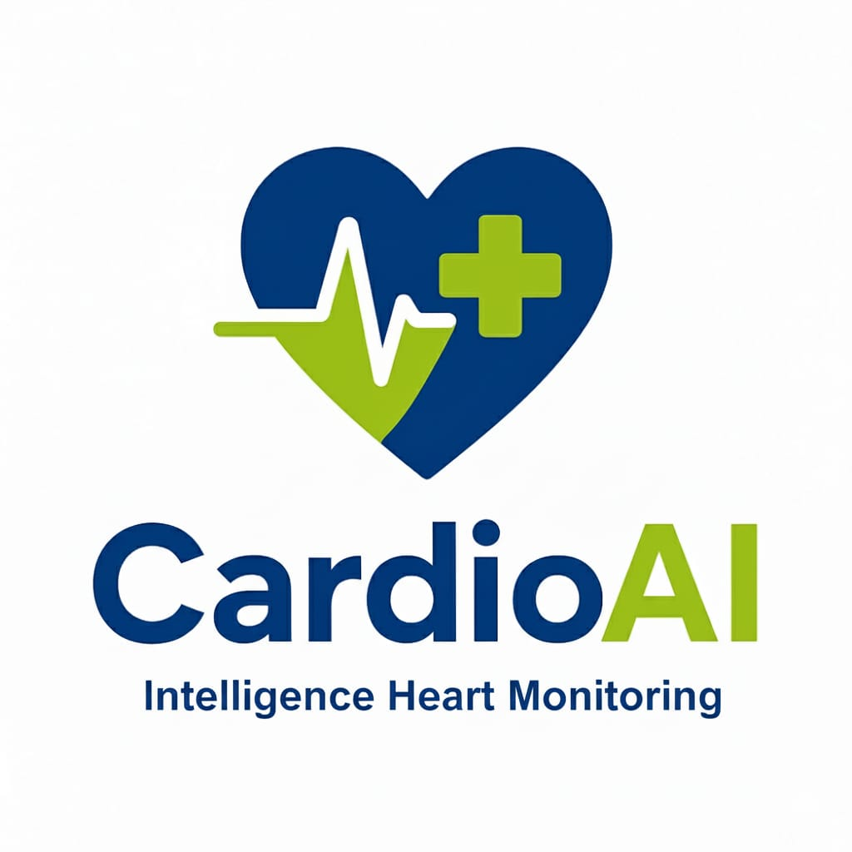

Reduce post-operative complications: Minimize the risk of cardiac complications through continuous monitoring.
Support clinical decision-making: Provide physicians with AI-driven insights based on patients’ medical history.
Enhance patient quality of life: Offer patients security and confidence through proactive care.
Generate new revenue streams: Provide SaaS subscriptions or integrate with Siemens Healthineers’ medical devices.
3. Scope
In-Scope:
- Continuous monitoring via wearable biometric sensors (HR, BP, SpO₂, Temperature).
-AI-powered predictive analytics to identify potential health risks.
-Secure, interactive web-based dashboard for physicians and patients.
-Intelligent alerts and visualized reports of patient conditions.
Out-of-Scope:
- Emergency interventions or acute treatment outside the monitoring system.
-Non-integrated medical devices or sensors.
4. Functional Requirements
1. Collect and record vital signs from wearable sensors.
2. Input and track periodic lab tests and patient examinations.
3. Analyze medical data in the context of each patient’s history and surgery type.
4. Generate intelligent alerts for abnormal trends or predicted complications.
5. Provide real-time dashboards for physicians and patients.
6. Produce reports and data visualizations for patient monitoring over time.
5. Non-Functional Requirements
Data Security: Ensure compliance with patient privacy regulations.
Usability: User-friendly interface with clear visualization.
Performance: Low latency for real-time monitoring and alerts.
Scalability: Support increasing numbers of patients and devices.
Reliability: System uptime and accuracy of AI predictions.
6. Stakeholders
Technical Team: AI developers, Data Scientists, Network & Cyber Security, Software Engineers.
Medical Team: Cardiologists, cardiac surgeons, hospital staff.
Partners: Siemens Healthineers for device integration and support.
End Users: Post-operative cardiac patients.

7. Assumptions & Constraints
Assumptions:
-Patients wear and maintain biometric sensors correctly.
-Hospitals provide access to historical medical data.
-Physicians actively engage with the dashboard and alerts.
Constraints:
-Compliance with legal and regulatory medical data standards.
-Availability and accuracy of sensors and devices.
-System must integrate with existing Siemens medical devices.
8. Acceptance Criteria
- The system continuously monitors patient vitals and generates accurate alerts.
-AI predictions align with clinical expectations and patient history.
-Dashboard presents real-time updates, visualizations, and reports clearly.
-Physicians can make informed decisions based on AI insights.
9. Optional: System Architecture (Visual Suggestion)
Hardware Layer: Biometric sensors (HR, BP, SpO₂, Temp) connected via IoT to cloud.
Software Layer: Web-based dashboard for visualization and interaction.
AI Layer: Predictive analytics engine analyzing historical and real-time data to generate alerts.

