Maternal Health Hub - Application Prototypes
Based on the frontend code structure and styling, here are the high-fidelity UI prototypes representing all key screens of the application as outlined in the TrackERB Software Documentation.

7.1 Login Page
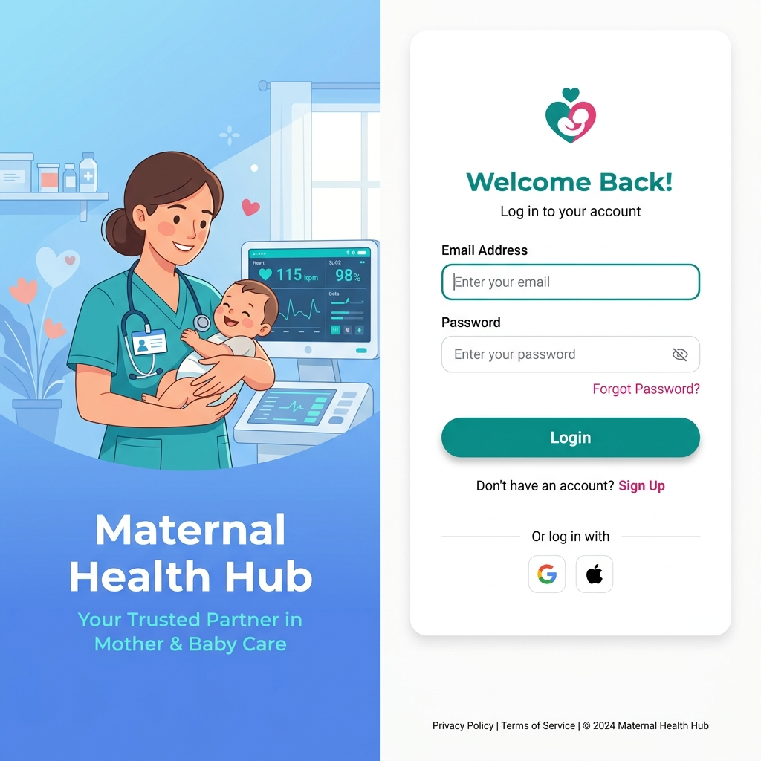
Login Page Prototype

7.2 Admin Dashboard Page
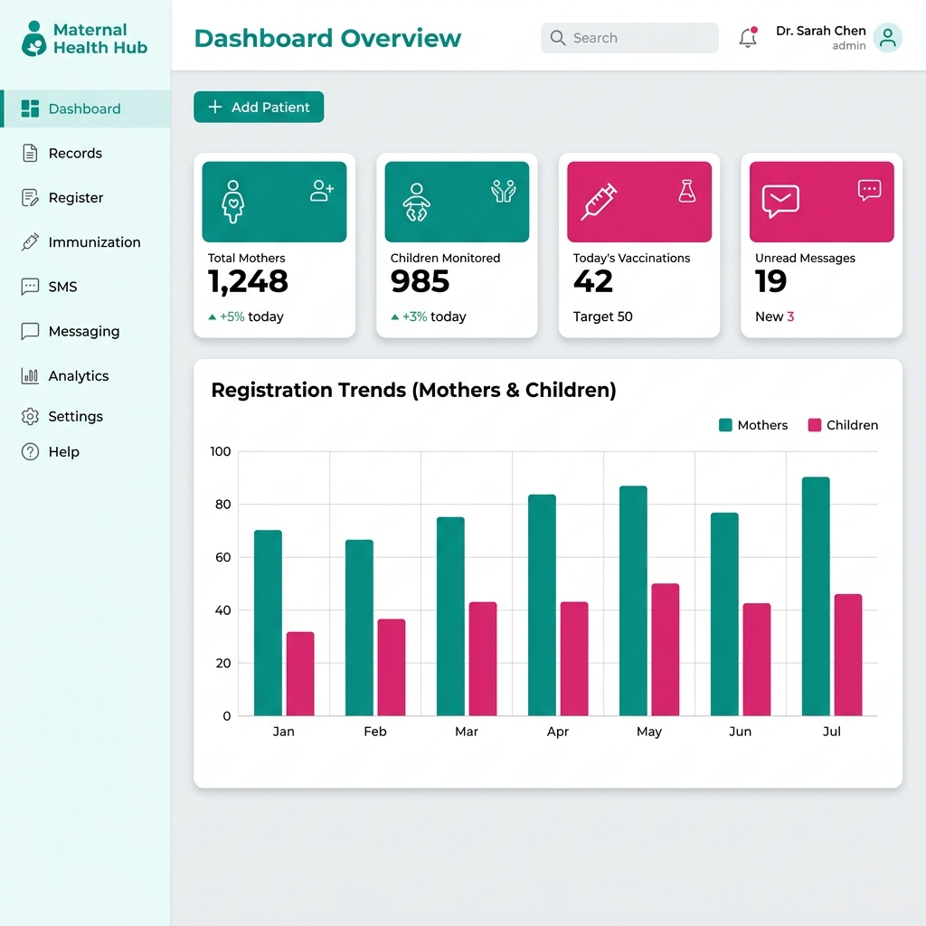
Admin Dashboard Prototype

7.3 Patient Records Table Page
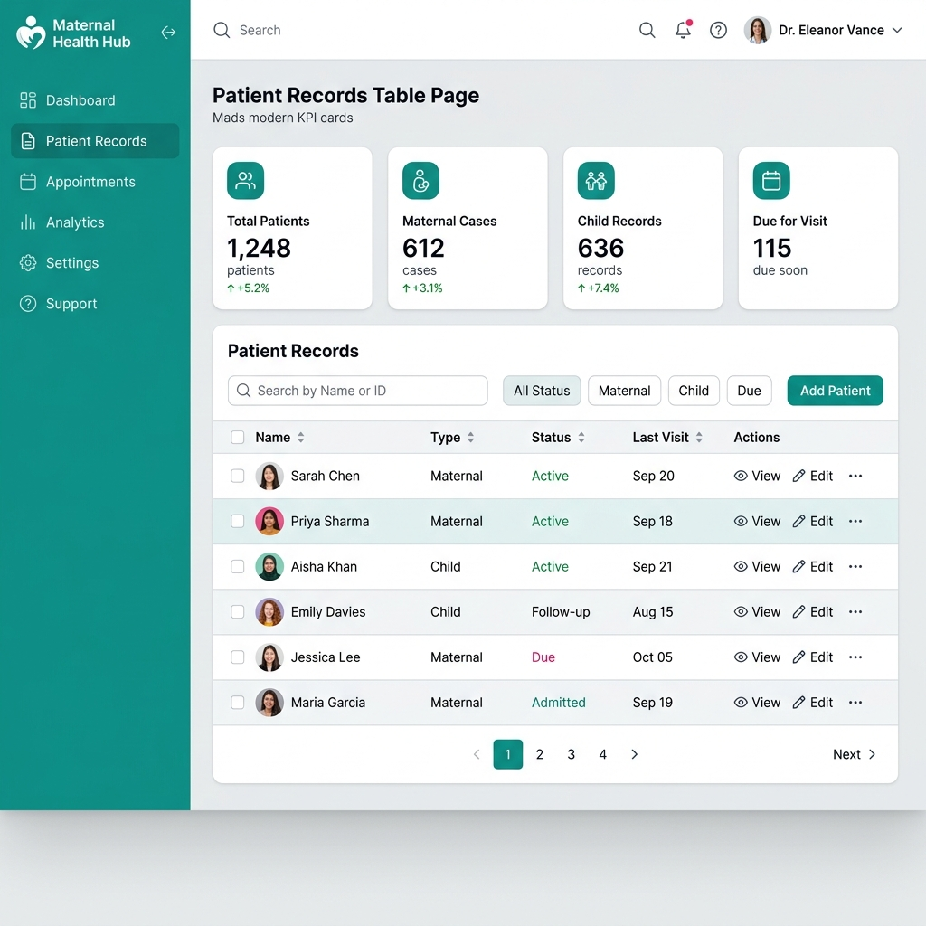
Patient Records Table Prototype

7.4 Patient Registration Form
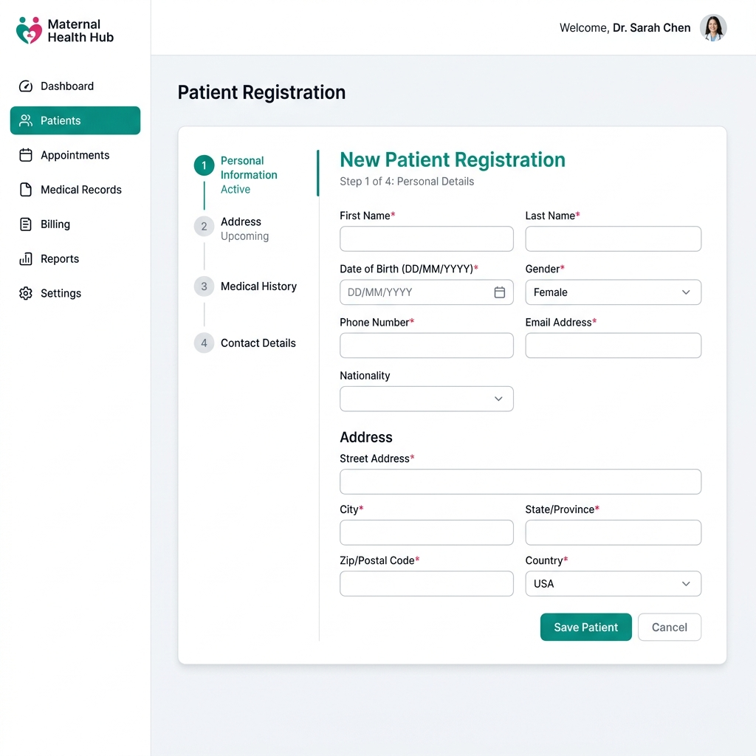
Patient Registration Prototype

7.5 Maternal Health Monitoring Page
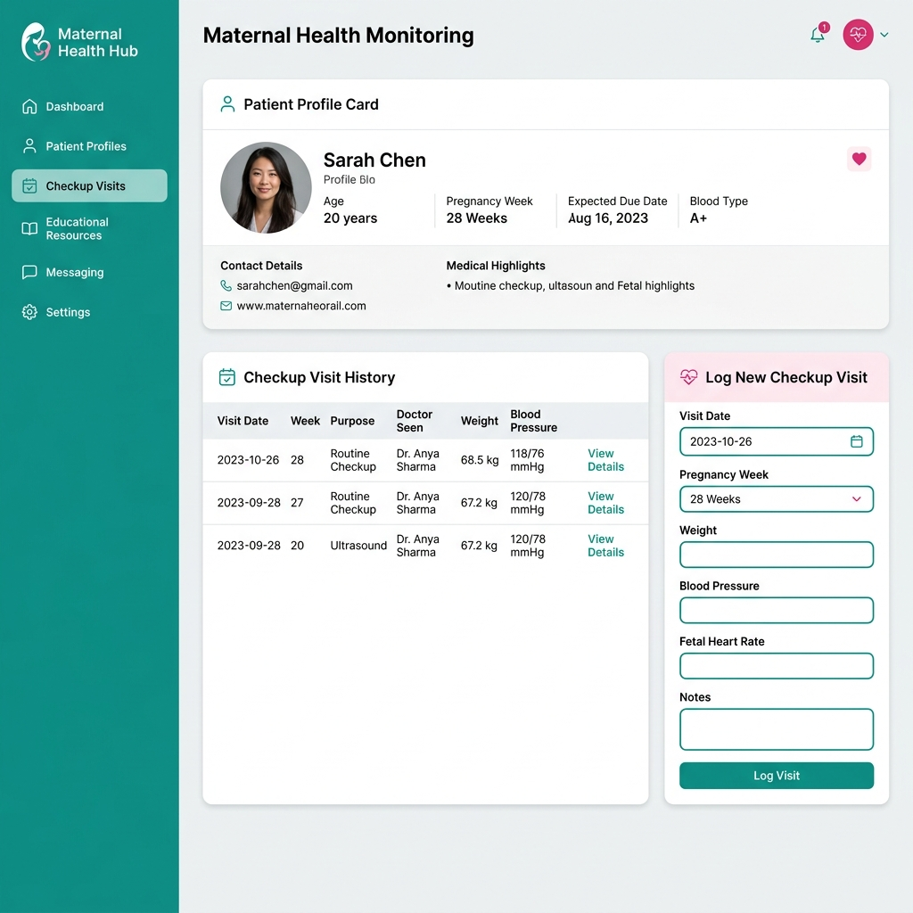
Maternal Health Monitoring Prototype

7.6 Immunization Tracking Page
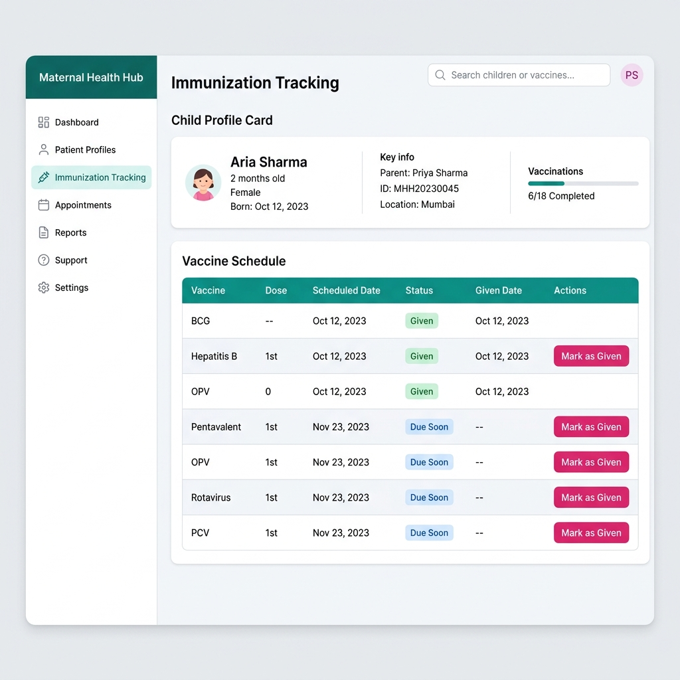
Immunization Tracking Prototype

7.7 Growth Monitoring Page
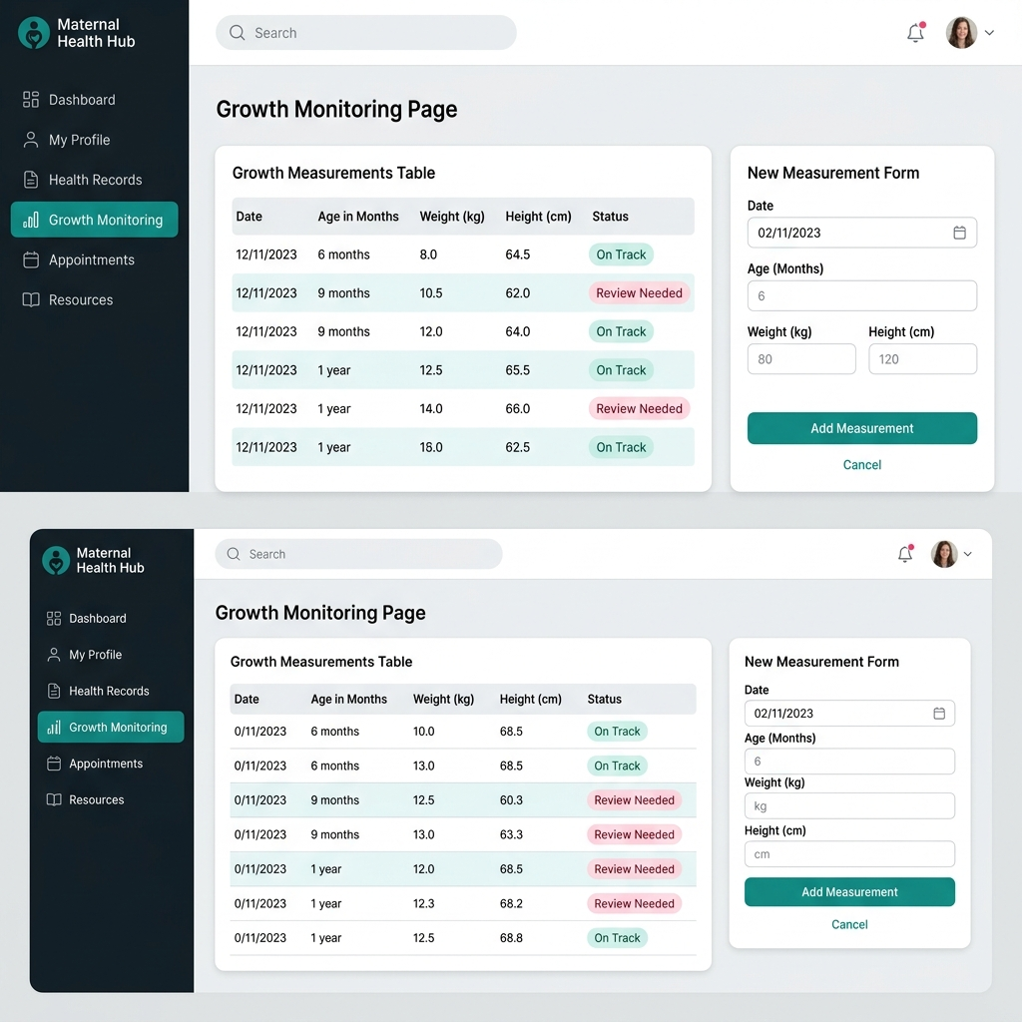
Growth Monitoring Prototype

7.8 SMS Management Page
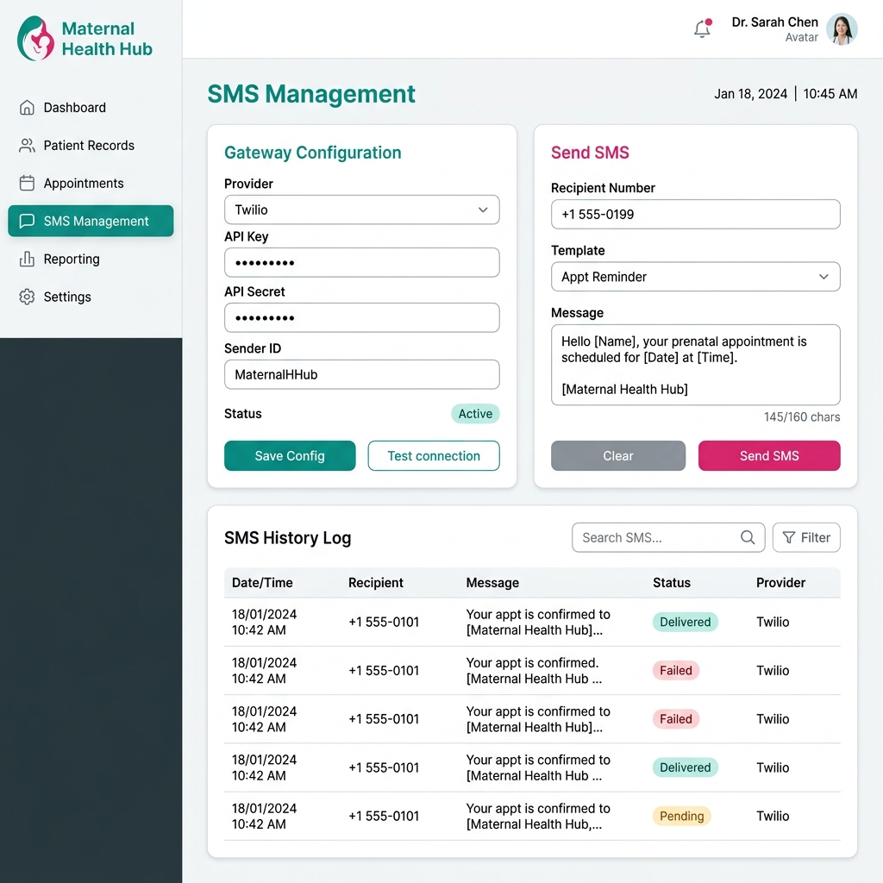
SMS Management Prototype

7.9 Messaging Page
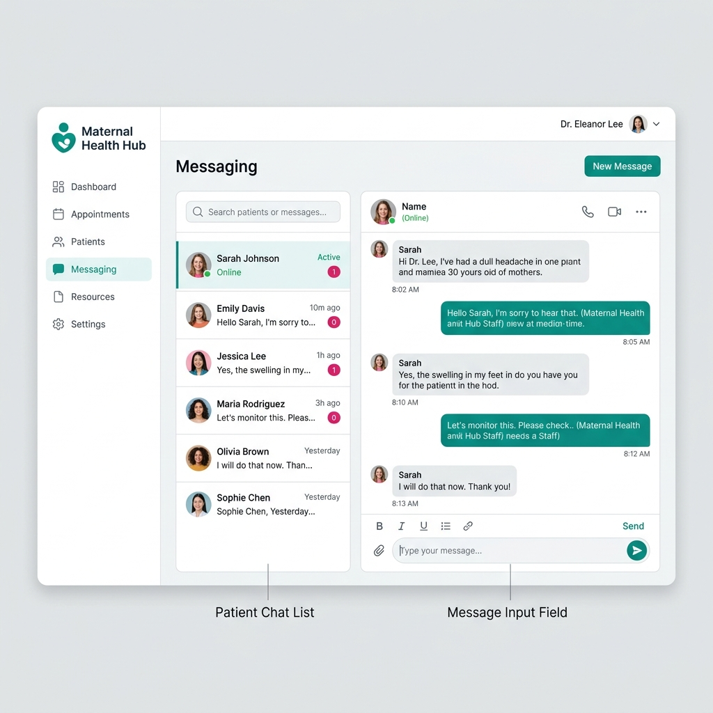
Messaging Prototype

7.10 Reports Page
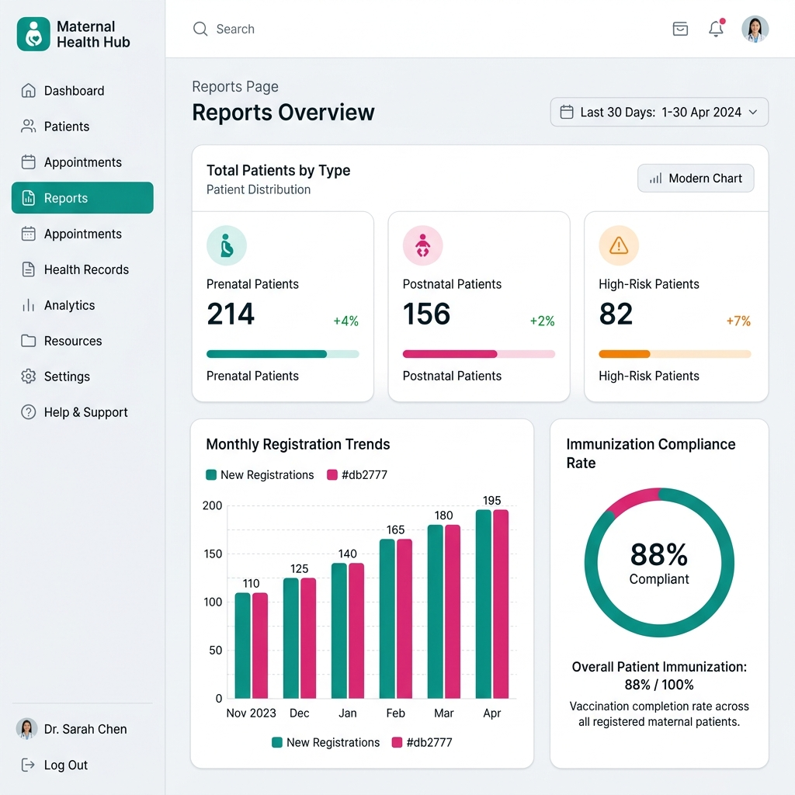
Reports Prototype

7.11 Patient Portal Page
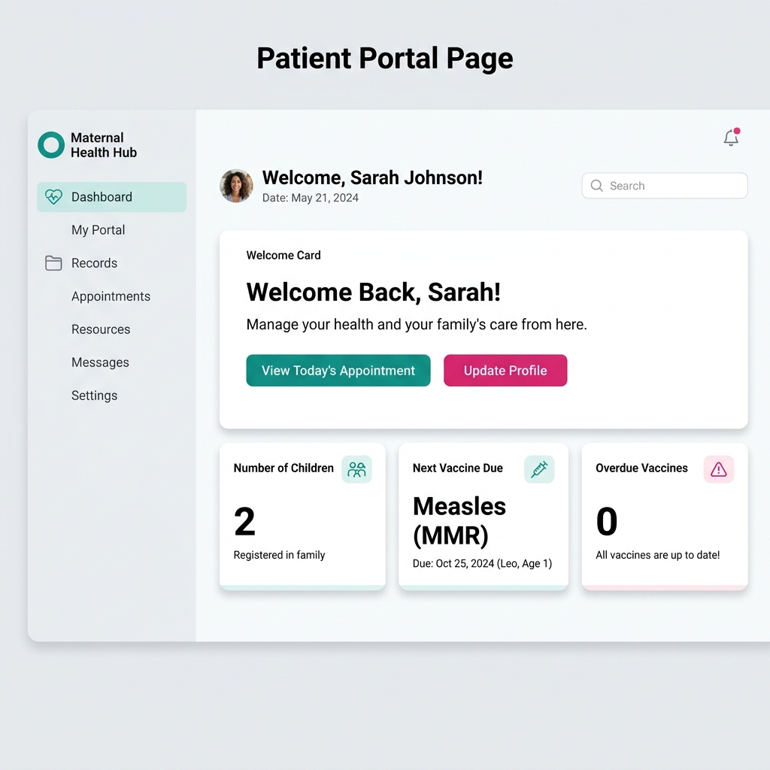
Patient Portal Prototype

7.12 Admin User Management Page
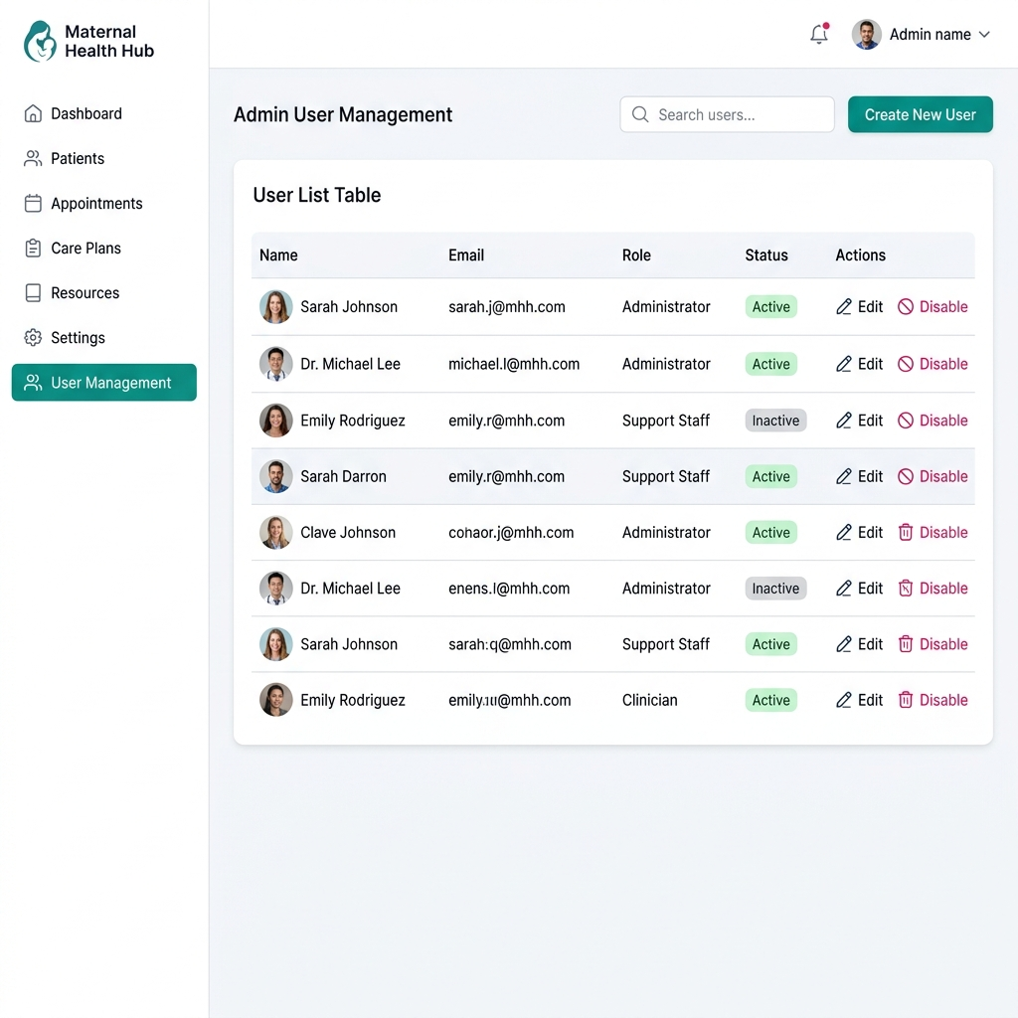
Admin User Management Prototype

