**Data 1**

**Environmental_dataset.csv**

[**https://erddap.bco-dmo.org/erddap/index.html**](https://erddap.bco-dmo.org/erddap/index.html)

ERDDAP (the Environmental Research Division's Data Access Program) is a data server that gives you a simple, consistent way to download subsets of scientific datasets in common file formats and make graphs and maps. This particular ERDDAP installation has oceanographic data

**Years 2017-2018**

**Data structure:**

|  |  |
| --- | --- |
| Station | unitless |
| Date | unitless |
| Julian_Day | days |
| time | UTC |
| Pressure | decibars (db) |
| depth | m |
| Temperature | degrees Celsius (C) |
| Temperature_2 | degrees Celsius |
| Conductivity | milliSiemens per centimeter (mS/cm) |
| Conductivity_2 | milliSiemens per centimeter (mS/cm) |
| Oxygen | millileters per liter (mL/L) |
| Oxygen_2 | millileters per liter (mL/L) |
| Fluorescence | micrograms per cubic meter (mg/m^3) |
| Beam_Transmission | percent (%) |
| PAR_Irradiance | micromoles photons per meters squared per second (umol photons/m^2/s) |
| latitude | degrees_north |
| longitude | degrees_east |
| Altimeter | meters (m) |
| SPAR_Surface_Irradiance | micromoles photons per meters squared per second (umol photons/m^2/s) |
| Time_Elapsed | seconds |
| Scan_Count | unitless |
| Salinity | PSU |
| Salinity_2 | PSU |
| Oxygen_Saturation | millileters per liter (mL/L) |
| Scans_bin | count |
| Flag | Unitless |

**Data 2**

**country_population-density.csv**

|  |  |
| --- | --- |
| Entity | Country |
| Country_Code |  |
| Year |  |
| Population density | people per sq. km of land area |

**Data 3 - FloodArchive.csv**

|  |  |
| --- | --- |
| **Key** |  |
| **GlideNumber** | **GLobal IDEntifier Number** |
| **Country** | **Primary country of flooding.** |
| **OtherCountry** | **Other affected countries** |
| **Long** | **Longitude is a geographic coordinate that specifies the east–west position of a point on the Earth's surface, or the surface of a celestial body. It is an angular measurement, usually expressed in degrees** |
| **Lat** | **latitude is a geographic coordinate that specifies the north–south position of a point on the Earth's surface. Latitude is an angle (defined below) which ranges from 0° at the Equator to 90°** |
| **Area** | **geographical area. Geographers use the term "area" to refer to any particular portion of the Earths surface. ... For example, the U.S. state of California has a land area of 403,932 square kilometers (155,959 square miles).** |
| **Began** | **Begin date** |
| **Ended** | **End date** |
| **Validation** | **Data origin** |
| **Dead** | **News reports are usually specific about this, but occasionally there is only mention of 'hundreds' or 'scores' killed; in this case we estimate as follows: "hundreds"=300; "scores"=30; "more than a hundred =110 (number given plus 10%). If there is information on the number of people 'missing', the DFO does not include them in the total of deaths. We require an exact number for analytical purposes, but caution that our numbers are never more than estimates.** |
| **Displaced** | **This number is sometimes the total number of people left homeless after the incident, and sometimes it is the number evacuated during the flood. News reports will often mention a number of people that are 'affected', but we do not use this. If the only information is the number of houses destroyed or damaged, then DFO assumes that 4 people live in each house. If the news report only mentions that "thousands were evacuated", the number is estimated at 3000. If the news reports mention that "more than 10,000" were displaced then the DFO number is 11,000 (number plus 10%). If the only information is the number of families left homeless, then DFO assumes that there are 4 people in each family** |
| **MainCause** | **One of eleven main causes is selected: Heavy rain, Tropical cyclone, Extra-tropical cyclone, Monsoonal rain, Snowmelt, Rain and snowmelt, Ice jam/break-up, Dam/Levy, break or release, Brief torrential rain, Tidal surge, Avalanche related. Information about secondary causes is in the Notes and Comments section of the table.** |
| **Severity** | **Class - Assessment is on 1-2 scale. These floods are then divided into three classes. Class 1: large flood events: significant damage to structures or agriculture; fatalities; and/or 1-2 decades-long reported interval since the last similar event. Class 1.5: very large events: with a greater than 2 decades but less than 100 year estimated recurrence interval, and/or a local recurrence interval of at 1-2 decades and affecting a large geographic region (> 5000 sq. km). Class 2: Extreme events: with an estimated recurrence interval greater than 100 years.** |

**World Data**

World government indications

WGI_Data.csv – social data

**https://ourworldindata.org/**

population-density-by-city.csv

population-density.csv

Each entry in the table and related shape file represents a discrete flood event. The listing is comprehensive and global in scope. Deaths and damage estimates for tropical storms are totals from all causes, but tropical storms without significant river flooding are not included.

Dartmouth Flood Observatory, University of Colorado

<https://data.humdata.org/dataset/global-active-archive-of-large-flood-events>

Article:\

<http://floodobservatory.colorado.edu/Publications/Kundzewicz.pdf>

**city Temp:**

https://www.kaggle.com/sudalairajkumar/daily-temperature-of-major-cities?select=city_temperature.csv

**Geographical cities location:**

https://simplemaps.com/data/world-cities

food:

# **The Humanitarian Data Exchange**

https://data.humdata.org/

<https://data.humdata.org/dataset/wfp-food-prices>

[**http://floodobservatory.colorado.edu/archiveatlas/index.htm**](http://floodobservatory.colorado.edu/archiveatlas/index.htm)

[**http://www.dartmouth.edu/~floods/archiveatlas/cause.htm**](http://www.dartmouth.edu/~floods/archiveatlas/cause.htm)

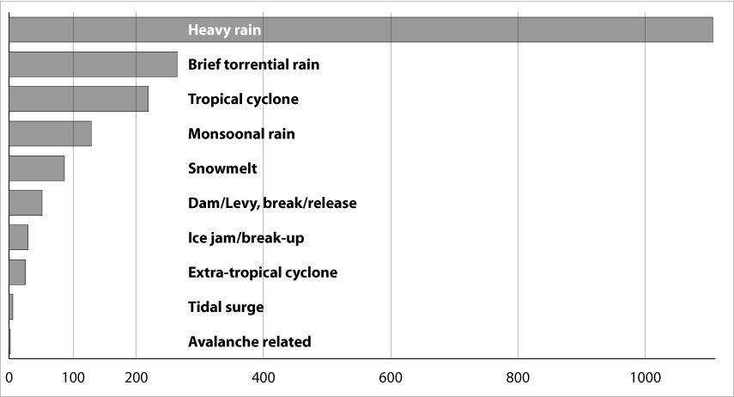

**Background**

Temperature is a fundamental measurement for describing the climate, and the temperature in particular places can have wide-ranging effects on human life and ecosystems. For example, increases in air temperature can lead to more intense heat waves, which can cause illness and death, especially in vulnerable populations. Annual and seasonal temperature patterns also determine the types of animals and plants that can survive in particular locations. Changes in temperature can disrupt a wide range of natural processes, particularly if these changes occur more quickly than plant and animal species can adapt.

Concentrations of heat-trapping greenhouse gases are increasing in the Earth’s atmosphere (see the [Atmospheric Concentrations of Greenhouse Gases](https://www.epa.gov/climate-indicators/climate-change-indicators-atmospheric-concentrations-greenhouse-gases) indicator). In response, average temperatures at the Earth’s surface are increasing and are expected to continue rising. Because climate change can shift the wind patterns and ocean currents that drive the world’s climate system, some areas are warming more than others, and some have experienced cooling.

**About the Indicator**

This indicator examines U.S. and global surface temperature patterns over time. U.S. surface measurements come from weather stations on land, while global surface measurements also incorporate observations from buoys and ships on the ocean, thereby providing data from sites spanning much of the surface of the Earth. This indicator starts at 1901 except for the detailed map of Alaska, where reliable statewide records are available back to 1925. For comparison, this indicator also displays satellite measurements that can be used to estimate the temperature of the Earth’s lower atmosphere since 1979.