

**Software Requirements Specification**

**For**

**Fitness/Weather App**

**Prepared by Group G**

**Team Fitness**

**November 11, 2018**

***Copyright © 2002 by Karl E. Wiegers. Permission is granted to use, modify, and distribute this document.***

**Table of Contents**

|  |  |  |  |
| --- | --- | --- | --- |
| **Table of Contents ..........................................................................................................................** | | | **ii** |
| **Revision History ...........................................................................................................................** | | | **iii** |
| **1.** | **Introduction ..............................................................................................................................** | | **1** |
| 1.1 | | Purpose ............................................................................................................................................. | 1 |
| 1.2 | | Document Conventions .................................................................................................................... | 1 |
| 1.3 | | Intended Audience and Reading Suggestions .................................................................................. | 1 |
| 1.4 | | Project Scope ................................................................................................................................... | 1 |
| 1.5 | | References ........................................................................................................................................ | 1 |
| **2.** | **Overall Description ..................................................................................................................** | | **2** |
| 2.1 | | Product Perspective .......................................................................................................................... | 2 |
| 2.2 | | Product Features .............................................................................................................................. | 2 |
| 2.3 | | User Classes and Characteristics ..................................................................................................... | 3 |
| 2.4 | | Operating Environment .................................................................................................................... | 3 |
| 2.5 | | Design and Implementation Constraints .......................................................................................... | 3 |
| 2.6 | | User Documentation ........................................................................................................................ | 3 |
| 2.7 | | Assumptions and Dependencies ...................................................................................................... | 3 |
| 2.8 Budget……………………………………………………………………………………………...4 | | |  |
| **3.** | **System Features .......................................................................................................................** | | **4** |
| 3.1 | | Project Features ................................................................................................................................ | 4 |
| 3.2 | | Use Cases ......................................................................................................................................... | 7 |
| 3.3 | Architectural Style………………………………………………………………………………..15 | |  |
| **4.** | **External Interface Requirements .........................................................................................** | | **16** |
| 4.1 | | User Interfaces ............................................................................................................................... | 16 |
| 4.2 | | Hardware Interfaces ....................................................................................................................... | 16 |
| 4.3 | | Software Interfaces ........................................................................................................................ | 16 |
| 4.4 | | Communications Interfaces ........................................................................................................... | 16 |
| **5.** | **Other Nonfunctional Requirements .....................................................................................** | | **16** |
| 5.1 | | Performance Requirements ............................................................................................................ | 16 |
| 5.2 | | Safety Requirements ...................................................................................................................... | 16 |
| 5.3 | | Security Requirements ................................................................................................................... | 17 |
| 5.4 | | Software Quality Attributes ........................................................................................................... | 17 |
| **6.** | **Other Requirements ..............................................................................................................** | | **17** |
| **Appendix A: Glossary..................................................................................................................** | | | **17** |
| **Appendix B: Analysis Models .....................................................................................................** | | | **17** |
| **Appendix C: Issues List ...............................................................................................................** | | | **17** |

**Revision History**

|  |  |  |  |
| --- | --- | --- | --- |
| **Name** | **Date** | **Reason for Changes** | **Version** |
| Sameh Heinen | November 9 | Use Case 1 | 1.1 |
| Steven Moore-Vountas | Oct 14 | Use Case 2  Domain Model | 1.1 |
| Edouard Theoux |  | Use Case 3 | 1.1 |
| Hagop Avakian | November 11 | Use Case 4 | 1.1 |
| Anastasiia Drozdova | November 11 | Use Case 5 | 1.1 |

**1. Introduction**

**1.1 General**

This document puts together the software requirements specifications of Fitness app that is implemented for an Android device as a part of COMP 354: Introduction to Software Engineering. The goal of this fitness app is to be connected to Endomondo to be able to retrieve information and correlate it with some weather data. The main idea behind this application is to provide the user with the information about what days would be good to exercise, depending on the weather and the user’s past data.

**1.2 Deadlines**

|  |  |
| --- | --- |
| Date | Summary |
| 14/10/2018 | Data Extraction - approach |
| 4/11/2018 | Iteration # 1 - Fitness App |
| 3/12/2018 | Iteration #2 - Fitness/Weather App |

**1.3 General Constraints**

**Task 1 requirements (fitness)**

● Fitness is tracked with Endomondo (separate application)

● Fitness data is must be scraped from Endomondo’s JSON data (requires login info)

● Only activity is cycling

● Analyze average speed and/or total time

● Display data points as a chart

**Task 2 requirements (weather)**

● analyze temperature and wind speed

● Weather from April to October/November only

● Weather must be collect for Montreal or nearby region

● Display data points as a chart

**Task 3 requirements (integration)**

● Application login capabilities

● Analyze patterns between fitness and weather data

● Predict if today is a favorable day for fitness according to weather forecast

● Does performance go up or down after breaks?

**Eventual tasks**

● Documentation (follow given template/sample)

● Price estimation

**Notes**

● Preferably Android O

● Use of libraries/APIs allowed

● Data is stored on the device, not on the cloud

● No encryption required

● Use 10/20 days moving averages for data

**1.5 References**

**2. Overall Description**

**2.1 Product Perspective**

The product is being developed for Introduction To Software class given by Juergen Rilling, Concordia University. The FitnessApp will be an extension of Endomondo Application. The main goal of Fitness app is to analyze data correlation between the workout statistics and weather, and to predict the next workout day for a specific user. The FitnessApp will have the following features:

* Login: will ask the user for a username and password in order to view statistics.
* Statistics: will provide statistics for specific diagrams
* Constraints: diagrams will have to follow rules as outlined for UML diagrams

**2.2 Product Features**

**Login:** 1. Create new login

1. Login as existing user
2. Access statistics

**Statistics:** 1. Display pie chart showing size distribution of classes

1. Display pie chart showing number of outgoing messages per object
2. Calculate averages for statistics
3. Display window with all statistics from other groups
4. Display warnings

**Constraints:** 1. No empty activation bars in Sequence diagrams

1. No return messages from objects that have been called
2. Identify GRASP control pattern
3. Classes cannot have multiple different recursive relationships
4. No bi-directional composite or aggregation relationships between two classes
5. Notifications of problems
6. Login required to view statistics

**2.3 User Classes and Characteristics**

The users of the ProfitsFromUML drawing tool will vary from Software Engineering students to Software Engineering professionals. We will categorize the users of the UCM drawing tool as **Power Users, Intermediate Users** and **End Users**. The **Power User**is highly educated,experienced and has a high level of technical expertise. He/She is most likely a professional Software Engineer possibly a leader of a group of Software Engineers working on a project. He/She will have the highest security/privilege level and will use the product more than any other user. Therefore, the Software Engineer is the favored user class of the UCM drawing tool. The **Intermediate User**is educated, has some technical expertise and some experience. He/She is aworking Software Engineering professional or Graduate Student, and will have some privileged access. He/She will use the product some of the time. The **End User** has low or no technical expertise and low privileges. Possibly a student or customer, he/she will use the product very minimally and just for reference.

**2.4 Operating Environment**

The operating environment will be Microsoft Windows 10, running on the x64 hardware platform. Eclipse IDE Version 4.6.1 (Neon) will be used. Other software components include Eclipse Java Development Tools, Eclipse Plug-In development environment, etc.

**2.5 Design and Implementation Constraints**

Java will be used to implement ProfitsFromUML. For the visualization aspect of the project, the user will have the ability to read statistics, display pie charts showing size distribution of classes in the class model, and the ability to display pie charts showing the number of outgoing messages per object in the sequence diagram. The visualization will also calculate averages for statistics. A display window will also be shown with all statistics from other groups. Warnings will also be displayed: High CBO for the class model, and large number of outgoing messages from an object for the sequence diagram.

**2.6 User Documentation**

The user documentation standard we will use is **List or Reference**. For further documentation regarding the base software, the user can refer to software documentation for Violet UML Editor [2], which this software is based on.

1. <http://en.wikipedia.org/wiki/Software_documentation>

**2.7 Assumptions and Dependencies**

The Feature class is composed of 3 sub-classes. The User class is composed of 3 sub-classes.

The object oriented method of inheritance is assumed here.

Other assumptions and dependencies:

The class diagram contains all features present in Violet UML Editor.

The development requires the Microsoft Windows operating system.

There will be 3 user types: Power, Intermediate and End.

There will be limited access to the statistical results.

We will likely used swing/awt libraries to generate pie charts and tables.

**2.8 Budget**

2.8.1. Visualization Budget

We estimate our budget for the visualization part of the project will be **$7532.76**. We used constructive cost model to calculate the total cost during developing the fitness application. The estimation details are shown below.

Based on visualization part specification, we believe our responsible part is organic, the size of it is small with very little innovation, and the deadlines is not very tight. So, for the equation Effort = $A=a×{size}^{b}×c$, we pick = 2.4, = 1.05. We estimated the total lines of code will be around 1000 lines. We figured this out by estimating every single small function instead of the whole system that our domain model has, then add all the estimates up. For variable c, it based on the following 15 criteria/factors. After multiplying this criteria/factors together, we get c = 0.653885011. We also estimate that the visualization part of the project will be completed within two months. Thus, since the monthly salary is 4800, the total estimated cost for our responsible part is: 2.4 ∗ 11.5 ∗ 0.653885011 ∗4800= 7532.76.

|  |  |  |  |  |  |  |  |  |  |  |  |  |  |  |  |  |
| --- | --- | --- | --- | --- | --- | --- | --- | --- | --- | --- | --- | --- | --- | --- | --- | --- |
|  |  |  |  |  |  |  |  |  | Rating | | | |  |  |  |  |
| Cost Drivers |  | Very | | Low |  | Normal | | |  |  | High | |  | Very | | Extra |
|  |  | low | |  |  |  |  |  |  |  |  |  |  | High | | High |
| Product Attributes |  |  |  |  |  |  |  |  |  |  |  |  |  |  |  |  |
| Required software reliability | 0.75 | |  | 0.88 |  | 1.00 | |  |  | 1.15 | |  | 1.40 | |  | / |
| Database size | / | |  | 0.94 |  | 1 |  |  |  |  | 1.08 |  | 1.16 | |  | / |
| Product complexity |  | 0.70 |  | 0.85 | 1.00 | | |  |  |  | 1.15 |  | 1.30 | |  | 1.65 |
| Computer Attributes |  |  |  |  |  |  |  |  |  |  |  |  |  |  |  |  |
| Execution time constraint | / | |  | / |  | 1.00 | |  |  | 1.11 | |  | 1.13 | |  | 1.66 |
| Main storage constraint | / | |  | / |  | 1.00 | |  |  | 1.06 | |  | 1.21 | |  | 1.56 |
| Virtual machine Volatility | / | |  | 0.87 |  | 1.00 | |  |  | 1.55 | |  | 1.30 | |  | / |
| Computer turnaround time | / | |  | 087 |  | 1.00 | |  |  | 107 | |  | 1.15 | |  | / |
| Personnel Attributes |  |  |  |  |  |  |  |  |  |  |  |  |  |  |  |  |
| Analyst capabilities | 1.46 | |  | 1.99 |  | 1 |  |  |  | 0.86 | |  | 0.71 | |  | / |
| Applications experience | 1.29 | |  | 1.13 |  | 1 |  |  |  |  | 0.91 |  | 0.82 | |  | / |
| Programmer capability | 1.42 | |  | 1.17 |  | 1.00 | |  |  |  | 0.86 |  | 0.70 | |  | / |
| Virtual machine experience |  | 1.21 |  | 1.10 |  | 1.00 | |  |  | 0.90 | |  | / | |  | / |
| Programming language experience |  | 1.41 |  | 1.07 | 1.00 | | |  |  |  | 0.91 |  | 0.82 | |  | / |
| Project Attributes |  |  |  |  |  |  |  |  |  |  |  |  |  |  |  |  |
| Use of modern programming | 1.21 | |  | 1.10 |  | 1.00 | |  | 0.91 | | |  | 0.82 | |  | / |
| practices |  |  |  |  |  |  |  |  |  |  |  |  |  |  |  |  |
| Use of software tools | 1.21 | |  | 1.10 | 1.00 | | |  | 0.91 | | |  |  | 0.83 |  | / |
| Required development schedule | 1.23 | |  | 1.08 | 1.00 | | |  | 1.04 | | |  |  | 1.10 |  | / |

We used COCOMO and Bottom-up Cost Estimation methods.

**3. System Features**

FitnessApp has a central goal of offering its user(s) reliable and readable statistics. These statistics will be presented graphically for the user, in an intuitive manner.

**3.1 Project Features**

*3.1.1 System Domain Model*

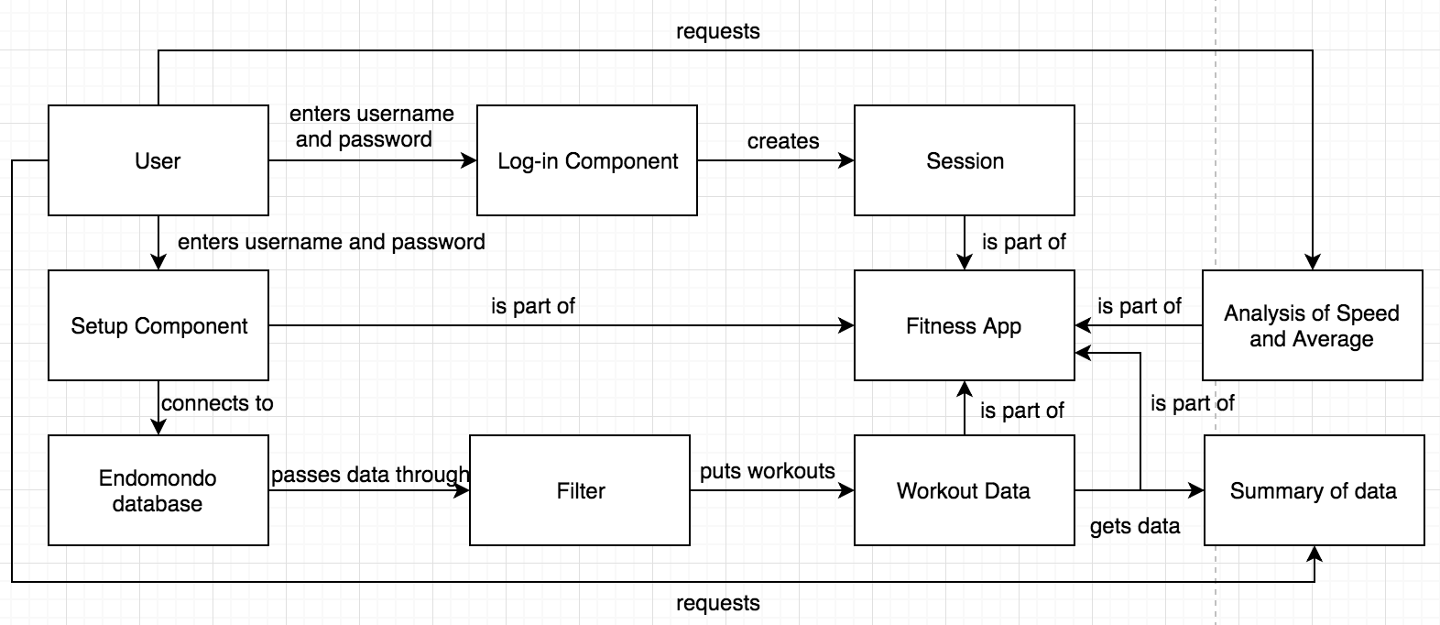

*3.1.3Use Case Diagram*

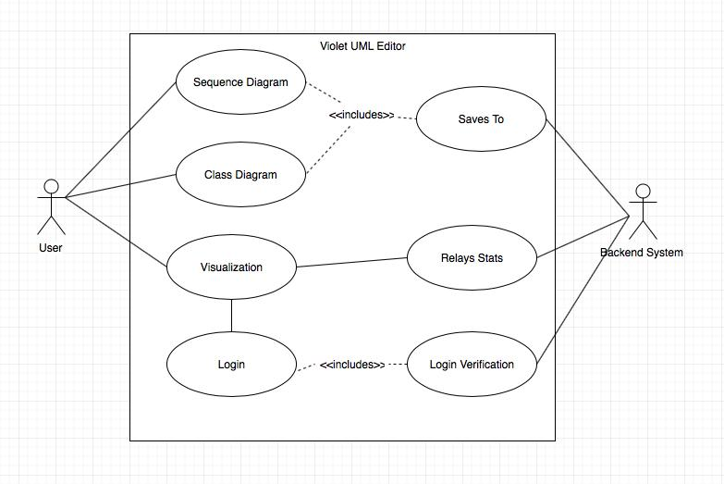

**3.2 Use Cases**

A few use case scenarios will be presented, each with a full dressed scenario, a system sequence diagram, and a diagram including GRASP patterns.

**3.2.1. Use Case 1 – Log-In**

Fully Dressed Scenario

|  |  |  |
| --- | --- | --- |
| **Number** | 1 | |
| **Name** | Login | |
| **Summary** | Enter the username and password and login into System | |
| **Priority** | High | |
| **Preconditions** | User has his user name and password | |
| **Post conditions** | User is logged into the system or the login button is disabled. | |
| **Primary Actor(s)** | User | |
| **Secondary Actor(s)** | Backend system | |
| **Trigger** | Login Button | |
| **Main Scenario** | **Step** | **Action** |
|  | 1 | User enters his username and password. |
|  | 2 | User presses the login button |
|  | 3 | The system starts validation. |
|  | 4 | The system opens a session for the user |
| **Extensions** | **Step** | **Branching Action** |
|  | 1 | User don’t have username or password |
|  | 2 | The number of attempts exceeds 3 times |
| **Open Issues** |  | None |
|  |  |  |

System Sequence Diagram

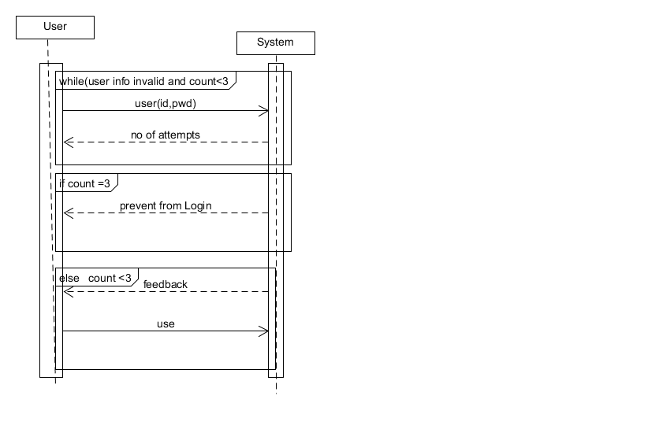

Sequence Diagram with GRASP Patterns

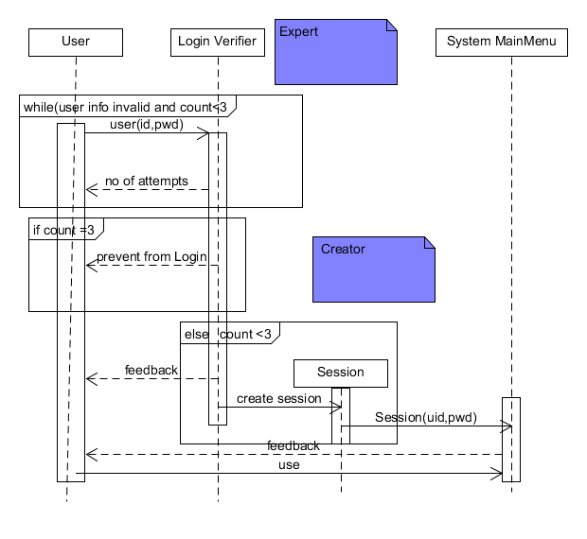

**3.2.2. Use Case 2 –Setup**

|  |  |  |
| --- | --- | --- |
| **Number** | 2 | |
| **Name** | Connect to Endomondo | |
| **Summary** | Enter the username and password and fetch information from the external database | |
| **Priority** | Very High | |
| **Preconditions** | User has logged into the Fitness application | |
| **Postconditions** | Application is connected to Endomondo and is ready to upload data | |
| **Primary Actor(s)** | User | |
| **Secondary Actor(s)** | Endomondo User Database | |
| **Trigger** | User wants to connect Endomondo account to Fitness Application | |
| **Main Scenario** | **Step** | **Action** |
|  | 1 | User logins to the Fitness Application |
|  | 2 | Selects the Endomondo Setup |
|  | 3 | Enters username and password |
|  | 5 | Clicks Enter to connect to Endomondo |
| **Extensions** | **Step** | **Branching Action** |
|  | 3.1 | No Endomondo account associated to username or password |
|  | 3.2 | Message shows: ‘Enter a valid username/password, or go to <https://www.endomondo.com/forgotpassword> if forgot password’ |
| **Open Issues** |  | none |
|  |  |  |

Fully Dressed Scenario

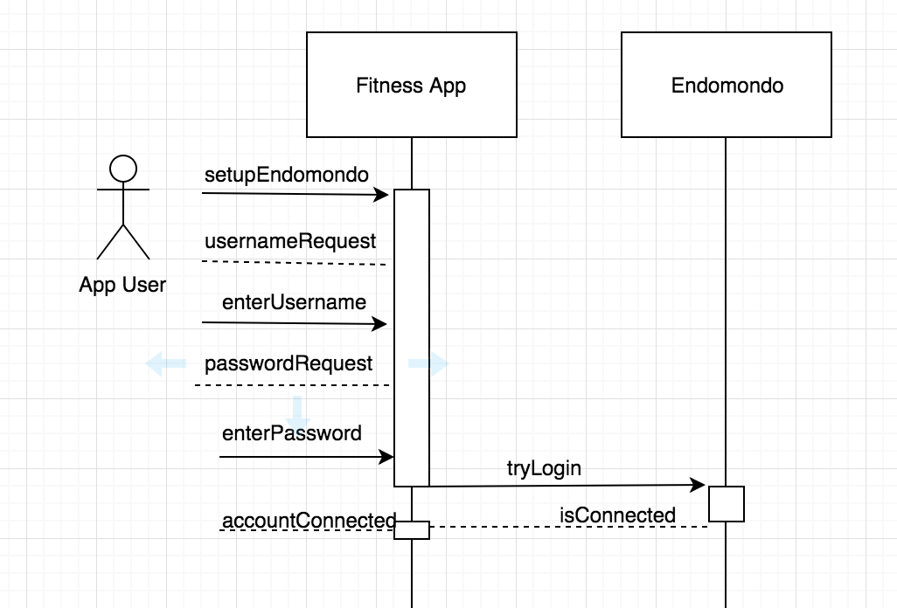System Sequence Diagram

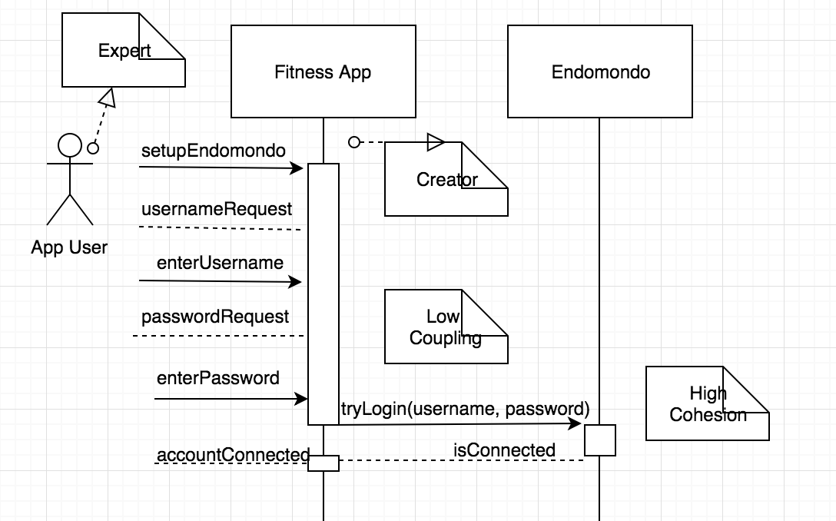Sequence Diagram With GRASP Pattern

**3.2.3. Use Case 3 – Filter**

Fully Dressed Scenario

System Sequence Diagram

Sequence Diagram with GRASP Patterns

**3.2.4. Use Case 4 – Summary**

Fully Dressed Scenario

|  |  |  |
| --- | --- | --- |
| **Number** | 4 | |
| **Name** | Graphing the data | |
| **Summary** | Extracting the data and plotting points on the graph, then displaying the graph | |
| **Priority** | High | |
| **Preconditions** | Synchronization with Endomondo. Extracting and storing the data in a data structure. | |
| **Postconditions** | Retrieving the data and displaying graphing it | |
| **Primary Actor(s)** | User | |
| **Secondary Actor(s)** | Workouts Database, GraphView library | |
| **Trigger** | User clicks on the “Fitness Graph” button to view the graph. | |
| **Main Scenario** | **Step** | **Action** |
|  | 1 | User logins to the Fitness Application |
|  | 2 | Selects “Fitness Graph” button |
|  | 3 | Graph displays the summary of workouts by plotting the average speed and the dates of the workouts. |
| **Extensions** | **Step** | **Branching Action** |
|  | 3.1 | No data available |
|  | 3.2 | Message shows: ‘No data available for analysis’ |
| **Open Issues** |  | none |

System Sequence Diagram

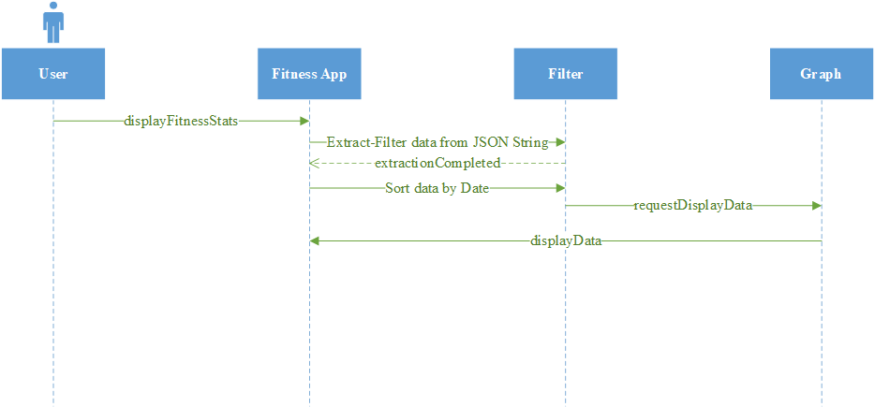

Sequence Diagram with GRASP Patterns

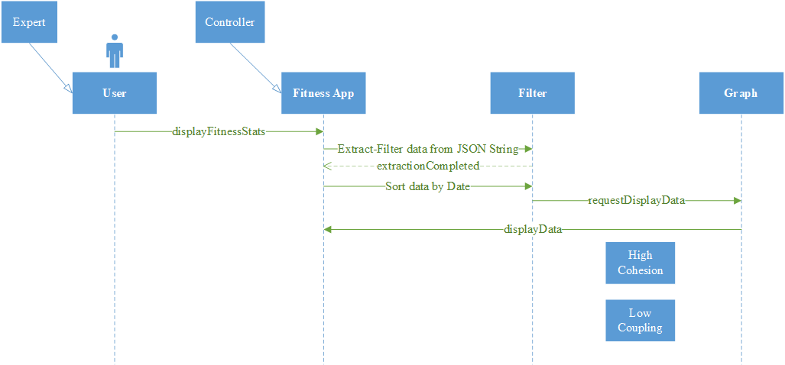

**3.2.5. Use Case5 – Statistics**

Fully Dressed Scenario

|  |  |  |
| --- | --- | --- |
| **Number** | 3 | |
| **Name** | Analysis of speed and average | |
| **Summary** | Simple statistics will be used to analyze the speed of the user | |
| **Priority** | High | |
| **Preconditions** | Synchronization with Endomondo workouts data is in place, and the Android Plot library is available. | |
| **Postconditions** | User obtains useful statistics about his performance | |
| **Primary Actor(s)** | User | |
| **Secondary Actor(s)** | Workouts Database, GraphView library | |
| **Trigger** | User wants to see the statistics of his workouts | |
| **Main Scenario** | **Step** | **Action** |
|  | 1 | User logins to the Fitness Application |
|  | 2 | Selects the Workout Statistics |
|  | 3 | Scrolls down to see the average speed(km/s) and distance (km) for all workouts |
|  | 4 | Scrolls down to see the best average speed(km/s) done in a workout from all workouts |
|  | 5 | Scrolls down to see the worst average speed(km/s) done in a workout from all workouts |
| **Extensions** | **Step** | **Branching Action** |
|  | 3.1 | No data available |
|  | 3.2 | Message shows: ‘No data available for analysis’ |
| **Open Issues** |  | none |

System Sequence Diagram

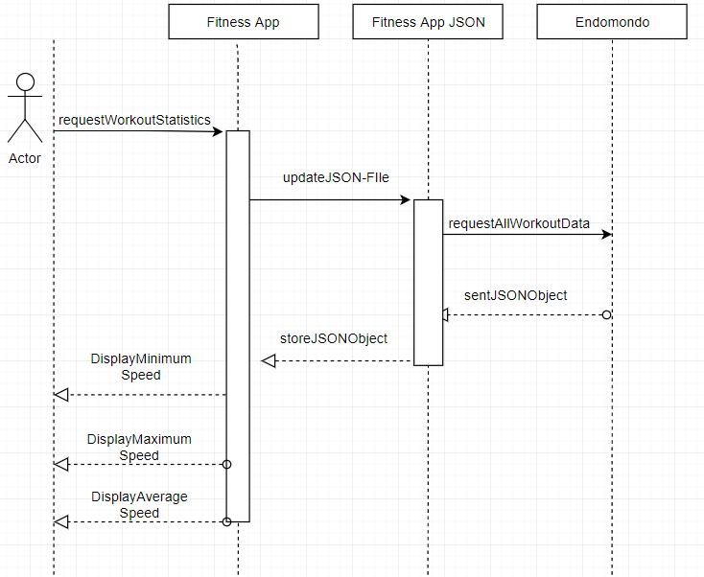

Sequence Diagram with GRASP Patterns

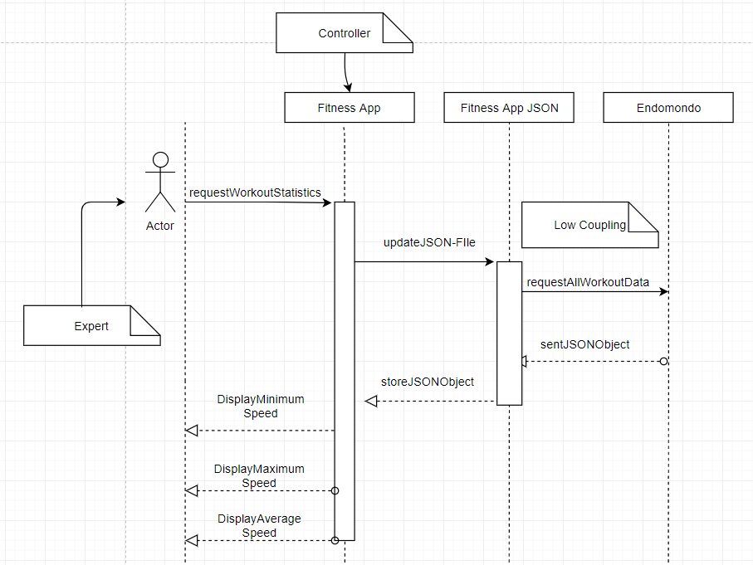

**3.3 Architectural Style**

The batch sequential system will be used for the Fitness app. In fact, for Fitness application to run successfully, each precedent step must be completed. For example, the user must first login, then enter the credential for Endomondo in a special form, then the Fitness app will make a copy of Endomondo database and this file will be then used to provide statistical analyses of the workouts to the user. During the statistical analysis the graph and the minimum and maximum average speed will be displayed. Consequently, each step will be done in a sequential manner.

To present the statistical analyses of the workouts to the user different libraries will be used to organize the data points in different libraries. GraphView library will be one of the libraries that will allow to plot the average speed time of the user with respect to time.

**4. External Interface Requirements**

**4.1 User Interfaces**

*<To be determined>*

**4.2 Hardware Interfaces**

ProfitFromUML will be Java based developed and will be cross platform supported under the Java Virtual Machine (JVM).

**4.3 Software Interfaces**

ProfitsFromUML wis developed under Java 8 and will require a compatible Java Runtime Environment (JRE) to be installed on the running machine.

The visualization will also feature an export to image file (.jpeg) which will create and image of the statistics visualization. An image viewer is required to open the images of the visuals.

**4.4 Communications Interfaces**

*<To be determined>*

**5. Other Nonfunctional Requirements**

**5.1 Performance Requirements**

ProfitFromUML is a real - time application, thus the computation needs to minimize response time. All features directly related to diagram such as the ones presented in the uses cases need to be performed instantly.

**5.2 Safety Requirements**

As a productivity software product, no special safety measure is necessary.

**5.3 Security Requirements**

Individual diagrams are tied to a specific account. The user must be logged in to access and edit files.

**5.4 Software Quality Attributes**

Software development focus will primarily be on the correctness of the product and if time allows, the ease of testing.

**6. Other Requirements**

No other requirements are to be noted for this project.

**Appendix A: Glossary**

*<To be determined>*

**Appendix B: Issues List**

No issues to report as of Now.