COS40007 Artificial Intelligence Engineering
Portfolio Assessment 1
Exploratory Data Analysis Report
Electrical Grid Stability Simulated Data (UCI Machine Learning Repository)
Student name | Hoang Huu Hoan
Student ID | 105732188
Unit | COS40007 Artificial Intelligence Engineering, Swinburne University of Technology
Task | Portfolio Assessment 1 — Exploratory Data Analysis (EDA) & Data Preparation
Dataset | Electrical Grid Stability Simulated Data — Arzamasov (2018), UCI ML Repository, https://doi.org/10.24432/C5PG66
Submission date | 4 October 2026
Github Repo

Contents
Generative AI Use Declaration 2
1. Dataset Overview 3
2. Data Quality Assessment 4
Target variable preparation 5
3. Key Findings from Univariate Analysis 6
4. Key Findings from Multivariate Analysis 7
Correlation heatmap and multicollinearity 8
Predictor relationships and patterns 9
5. Initial Insights for Modelling 10
6. Engineering Interpretation 11
What do the results mean in my discipline? 11
Unexpected patterns 11
Physical relationships reflected, and missing features 12
What type of model might suit this dataset? 12
7. Challenges Encountered 12
8. Reflection Questions 13
How might poor data quality affect model reliability? 13
What ethical or bias issues might exist in this dataset? 13
9. Next Steps 13
10. GenAI Declaration 13
References 14

1. Dataset Overview
Description and engineering relevance. The dataset comes from simulations of a four-node Decentral Smart Grid Control (DSGC) system: one producer (node 1) at the centre of a star network supplying three consumers (nodes 2–4). In DSGC the electricity price is tied to the local grid frequency, and every participant changes its power in response to that price after a reaction delay. Each participant is therefore part of a frequency-control feedback loop, and the question is whether the whole loop is stable. This is directly relevant to electrical and control engineering: demand response is one of the main tools for integrating variable renewables, and an operator must know which participant settings keep the grid stable. Each row is one simulated operating configuration, labelled by linear stability analysis.
Item | Value
Number of rows | 10,000 simulated configurations
Number of columns | 14 (13 numerical float64, 1 categorical text)
Target variable | stabf (stable / unstable)
Problem type | Binary classification
Class conversion | Not needed: the target is already categorical. The numerical stab (which defines stabf) is excluded as a predictor to avoid leakage.
Predictors (11) | tau1–tau4 reaction time (s); p2–p4 consumer power (s⁻², power normalised by inertia); g1–g4 price elasticity γ (s⁻¹)
Excluded columns | p1 (= |p2+p3+p4|, redundant) and stab (sign defines the label)

Required evidence. df.shape returns (10000, 14). The data types and the summary statistics (df.describe(): mean, std, min, max) are shown below. The first five rows, full describe() output and missing-value check are in Appendix B, Section 1.
Table 1. Data types (df.dtypes)
Column | dtype | Column | dtype
tau1 | float64 | p4 | float64
tau2 | float64 | g1 | float64
tau3 | float64 | g2 | float64
tau4 | float64 | g3 | float64
p1 | float64 | g4 | float64
p2 | float64 | stab | float64
p3 | float64 | stabf | str (text)

Table 2. Summary statistics of numerical variables (df.describe())
Variable | Mean | Std | Min | Max
tau1 | 5.2500 | 2.7425 | 0.5008 | 9.9995
tau2 | 5.2500 | 2.7425 | 0.5001 | 9.9998
tau3 | 5.2500 | 2.7425 | 0.5008 | 9.9995
tau4 | 5.2500 | 2.7426 | 0.5005 | 9.9994
p1 | 3.7500 | 0.7522 | 1.5826 | 5.8644
p2 | -1.2500 | 0.4330 | -1.9999 | -0.5001
p3 | -1.2500 | 0.4330 | -1.9999 | -0.5001
p4 | -1.2500 | 0.4330 | -1.9999 | -0.5000
g1 | 0.5250 | 0.2743 | 0.0500 | 0.9999
g2 | 0.5250 | 0.2743 | 0.0501 | 0.9999
g3 | 0.5250 | 0.2743 | 0.0501 | 1.0000
g4 | 0.5250 | 0.2743 | 0.0500 | 0.9999
stab | 0.0157 | 0.0369 | -0.0808 | 0.1094

Every input lies inside its documented simulation range, and each mean sits exactly at the centre of its range (tau 5.25 s, g 0.525 s⁻¹, p2–p4 −1.25 s⁻²). This is a first sign that the inputs were sampled evenly by design rather than observed on a real grid.

2. Data Quality Assessment
The raw file was kept unchanged (df_raw) and all checks were done on a working copy. Missing values, duplicates, outliers, documented ranges, physical consistency and data types were checked.
Check | Result | Handling and justification
Missing values | 0 of 140,000 cells; 0 % in every column (Figure 1) | No imputation needed; all 10,000 rows kept.
Duplicates | 0 exact duplicate rows; 0 duplicate input configurations | Nothing to remove; every row is a distinct scenario.
Outliers (1.5 × IQR) | Only one flag in all 13 columns: p1 = 1.583 (row 6273, 0.01 %) (Figure 2) | Retained. p1 is the sum of three uniform consumer powers, so it is bell-shaped and a low tail value is expected. The flagged case is simply all three consumers near their 0.5 s⁻² minimum: physically valid, and it satisfies the power balance. p1 is excluded from predictors anyway.
Documented ranges | All tau in [0.5, 10] s, g in [0.05, 1] s⁻¹, p2–p4 in [−2, −0.5] s⁻² | No invalid values.
Physical consistency | p1 = |p2+p3+p4| to machine precision; stabf = unstable exactly when stab > 0 (100 %) | Data is internally consistent. This proves p1 is redundant and stab leaks the label, so both are excluded.
Data types after cleaning | 13 × float64, stabf text — unchanged | Types are appropriate; the target is mapped to stable = 0, unstable = 1 only where a number is needed.

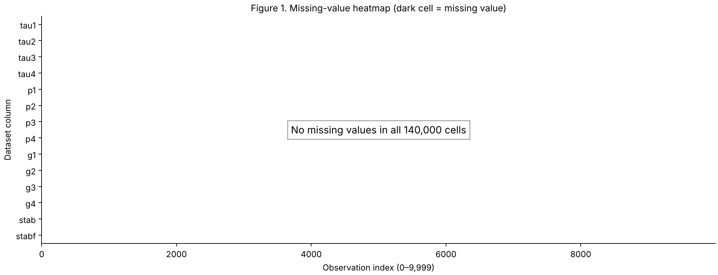
Figure 1. Missing-value heatmap: no missing values in any of the 140,000 cells.
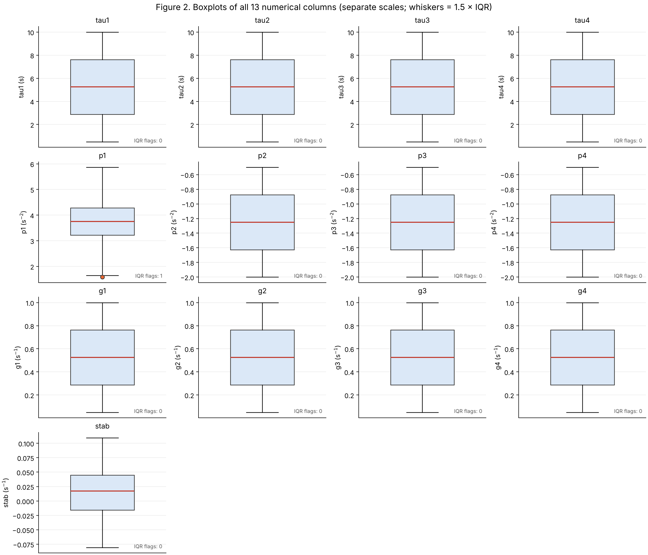
Figure 2. Boxplots of all 13 numerical columns (separate scales). The only IQR flag is one low p1 value.
Overall: data quality is very high, as expected for simulation output. The real quality risks are target leakage (stab) and redundancy (p1), not dirty data.

Target variable preparation
stabf is already categorical, so no 3–5 class discretisation is required (brief 1.2). The class balance is 3,620 stable (36.2 %) vs 6,380 unstable (63.8 %), a ratio of 1.76 : 1. No class exceeds 80 %, so there is no severe imbalance. It is still moderate: a model that always predicts "unstable" would score 63.8 % accuracy, so modelling must use a stratified split and report balanced accuracy, per-class recall and a confusion matrix. Figure 3b shows that the label is a hard threshold on stab (unstable ⇔ stab > 0). About 15 % of cases lie within ±0.01 s⁻¹ of this boundary; they will be the hardest to classify.
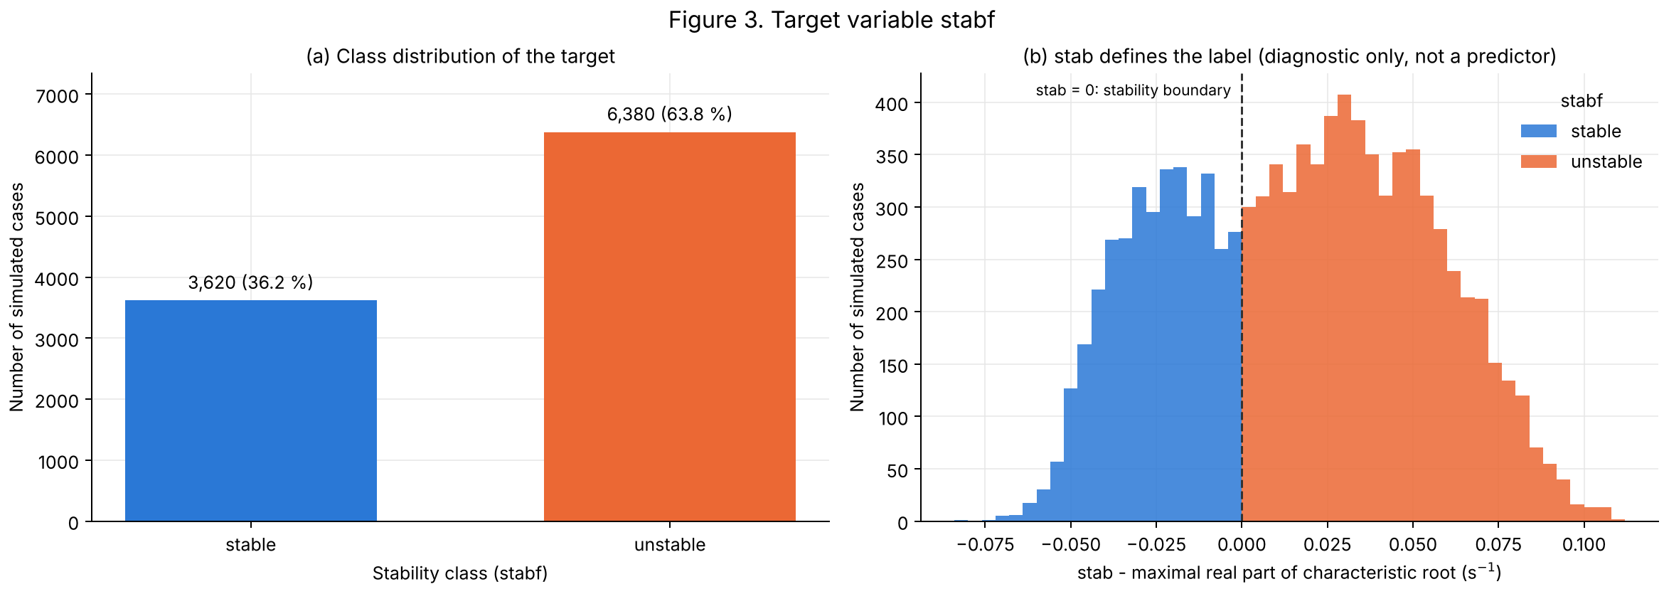
Figure 3. (a) Target class distribution; (b) stab by class, showing that the sign of stab defines the label.

3. Key Findings from Univariate Analysis
All 11 predictors were summarised (Appendix B, Section 4) and plotted (Figure 4). Their distribution type was tested against a uniform distribution on the documented range using skewness, excess kurtosis and the Kolmogorov–Smirnov distance D.
- All 11 predictors are uniformly distributed — none is normal or skewed. Skewness is 0.000 and excess kurtosis is −1.20 for every predictor, which are exactly the theoretical values for a uniform distribution (flat, no tails). Every 25-bin histogram contains exactly 400 cases per bin.
- The sampling is a designed experiment. D ≈ 0.0001 = 1/n, the smallest possible value (136 times below the 5 % critical value of 0.0136). Each of the 10,000 equal-width strata of every range contains exactly one value, which is the signature of Latin hypercube sampling. The histograms therefore describe the simulation design, not how often real grids operate at these settings.
- Scales differ by up to ~10× (tau std 2.74 s, p 0.43 s⁻², g 0.27 s⁻¹), so scale-sensitive models will need standardisation. There are no outliers, gaps or spikes, so no transformation (log, Box-Cox) is needed.
- p1 (excluded) is the only non-uniform input: as a sum of three uniforms it is bell-shaped, which explains its single IQR flag.
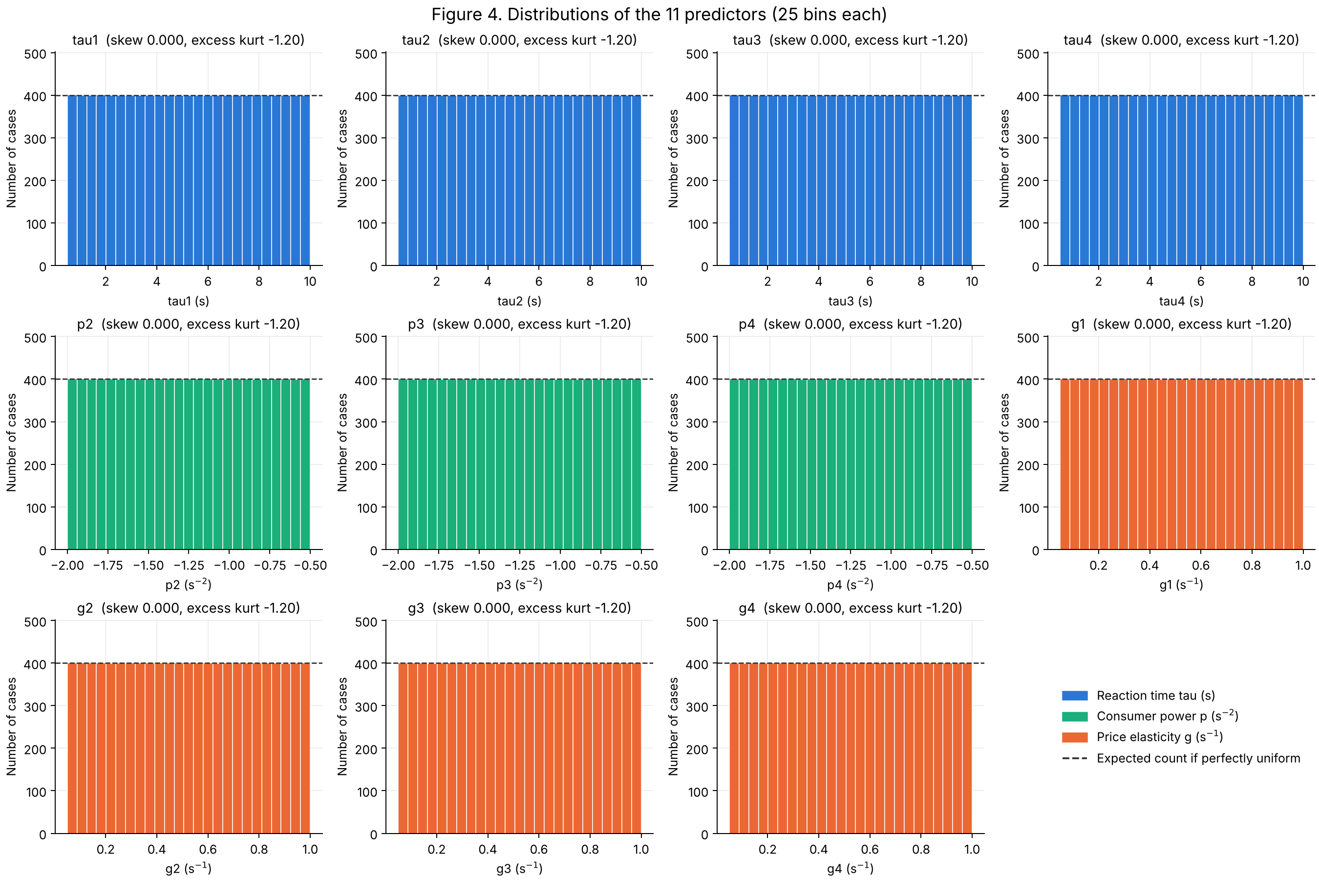
Figure 4. Histograms of the 11 predictors; the dashed line is the count expected for a perfectly uniform distribution.

4. Key Findings from Multivariate Analysis
Top 3 features correlated with the target (point-biserial r, i.e. Pearson r with stable = 0, unstable = 1):
- tau2 — r = +0.246
- tau4 — r = +0.239
- tau3 — r = +0.238
tau1 (+0.235) is close behind, followed by the four elasticities (g3 +0.232, g2 +0.217, g4 +0.205, g1 +0.198). All eight are positive: longer reaction times and stronger price elasticity go with instability. The consumer powers have |r| ≤ 0.02.

Correlation heatmap and multicollinearity
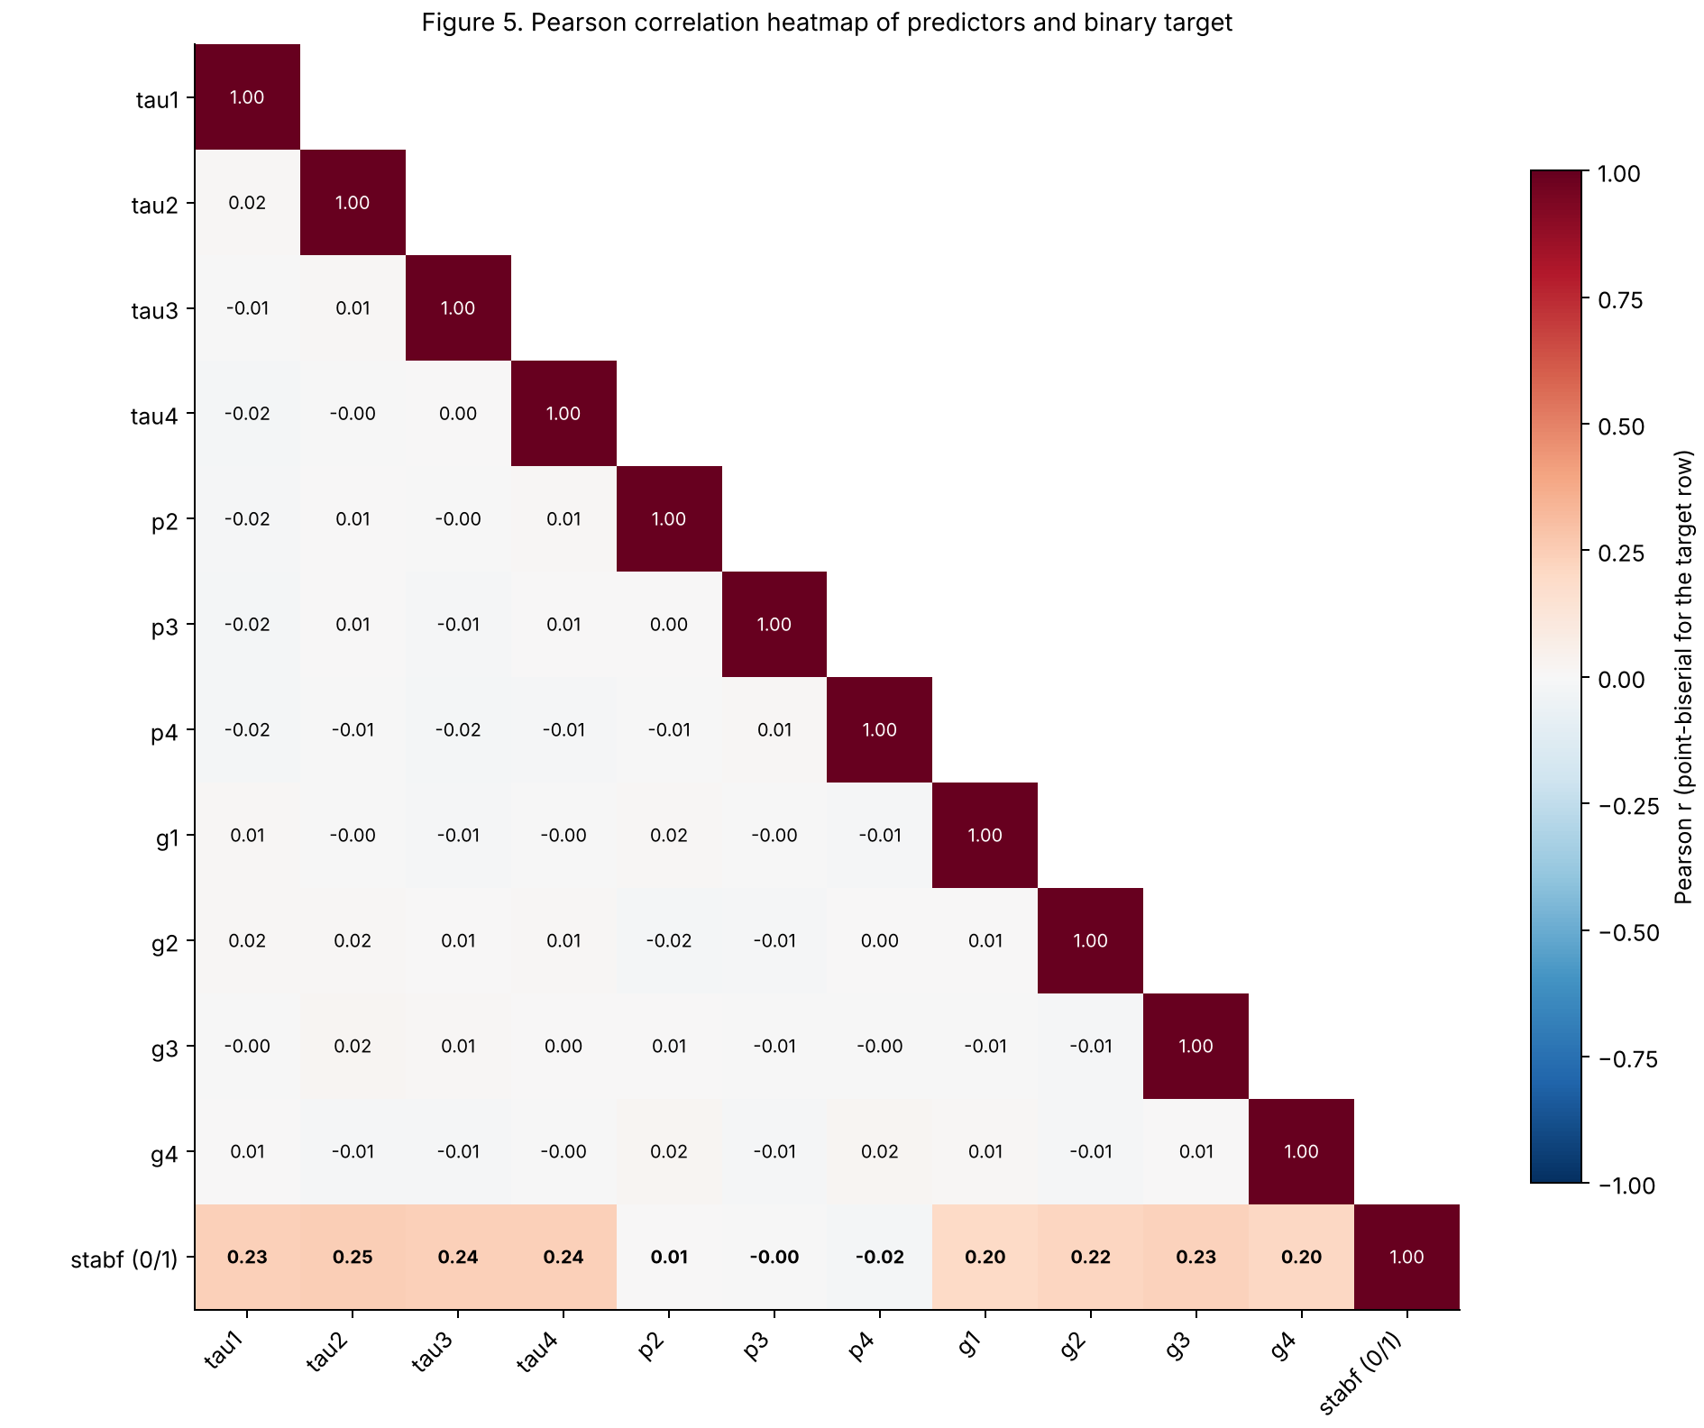
Figure 5. Pearson correlation heatmap of the 11 predictors and the binary target (bottom row = point-biserial r).
- No multicollinearity among the 11 predictors. The largest predictor–predictor |r| is 0.02, no pair reaches the |r| ≥ 0.80 screening threshold, and every VIF ≈ 1.00 (concern threshold 5–10). The inputs were varied independently by design.
- p1 would cause perfect multicollinearity. It correlates at r ≈ −0.58 with each of p2–p4 and p1 + p2 + p3 + p4 = 0 (the power matrix has rank 3 of 4), which makes linear-model coefficients undefined. This confirms excluding p1.

Predictor relationships and patterns
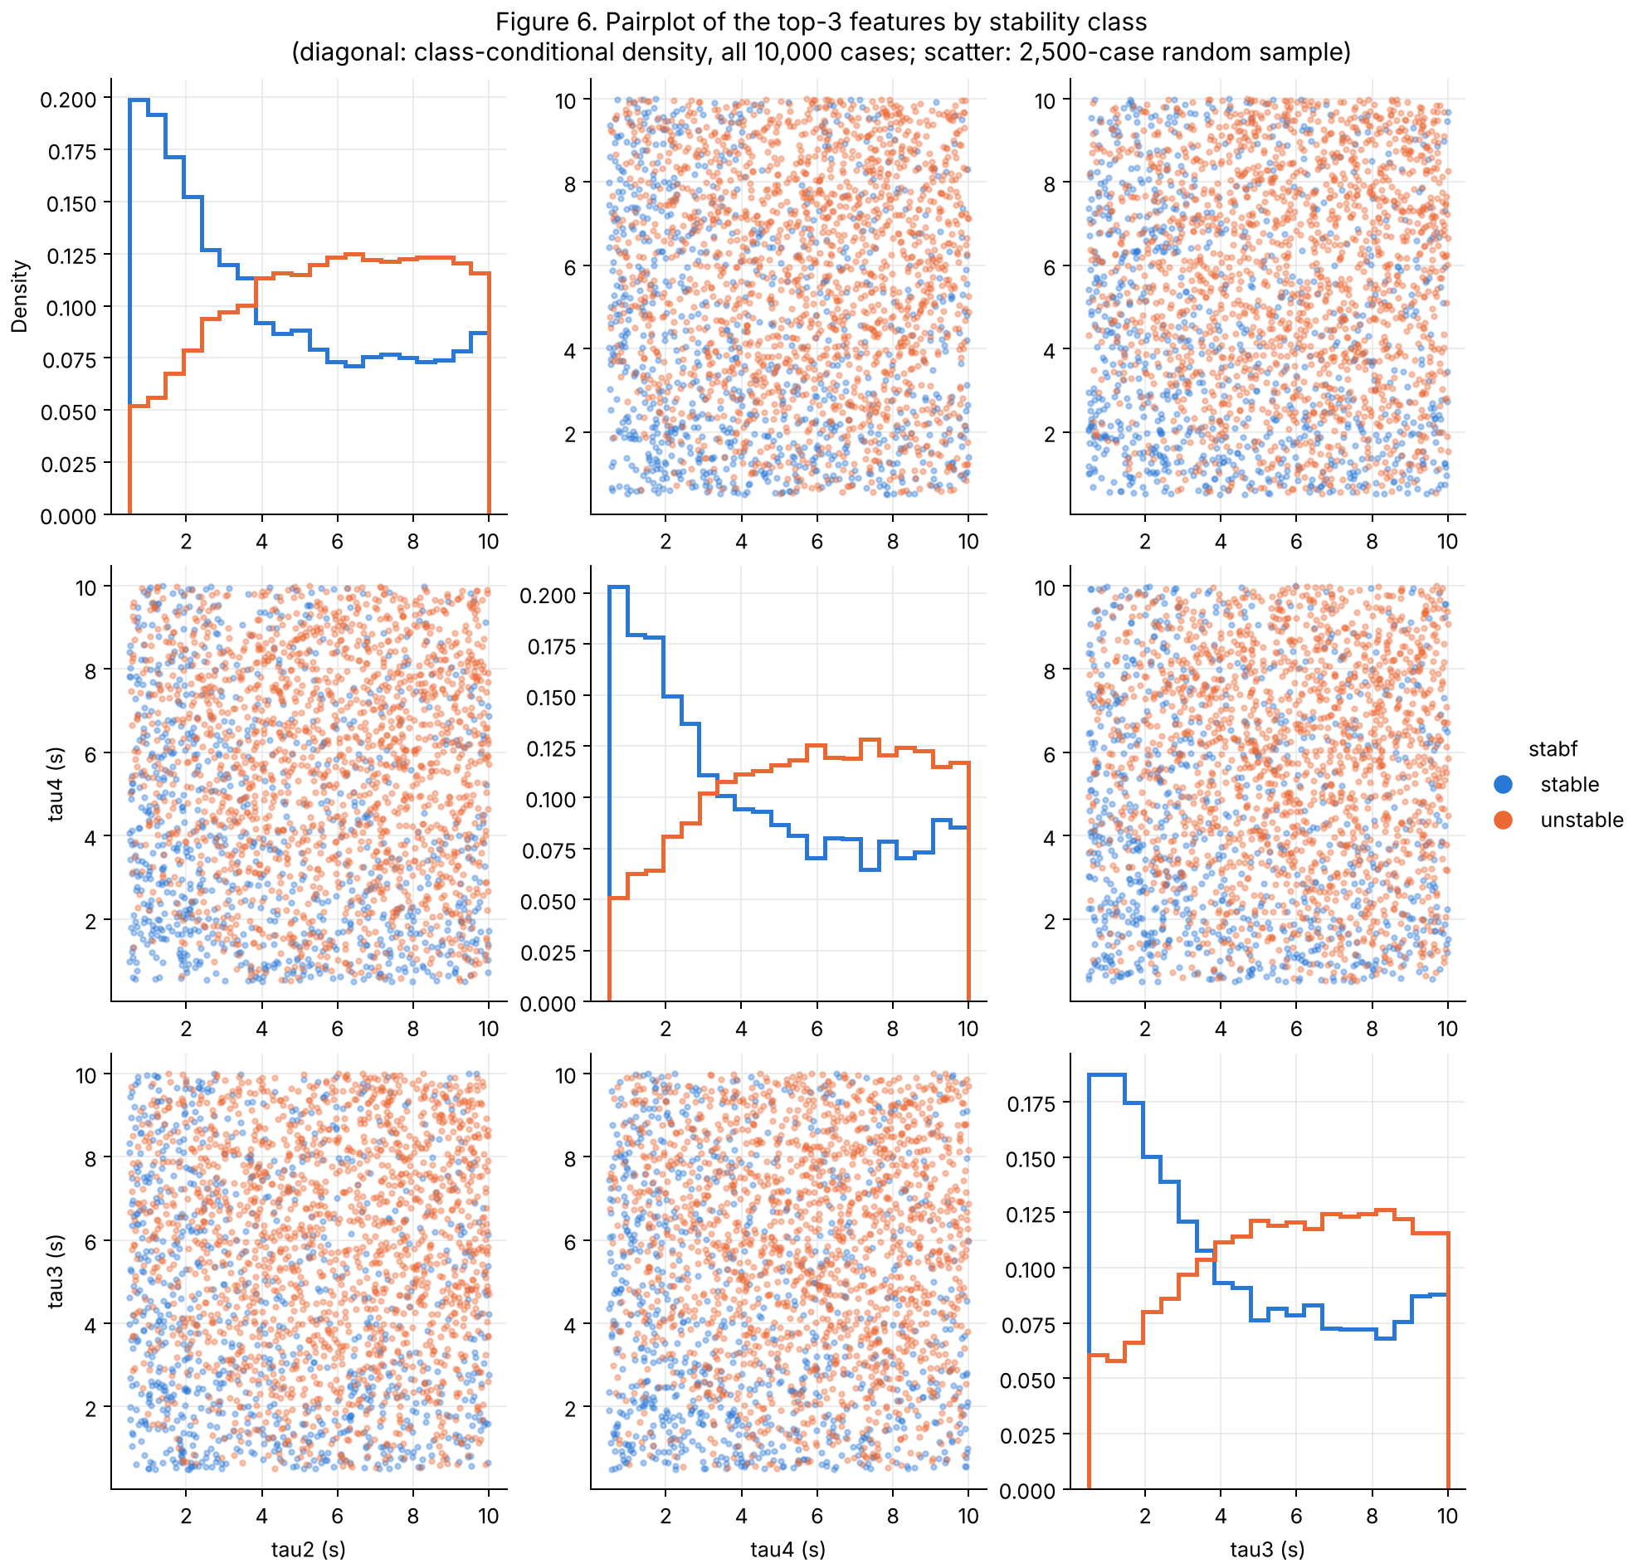
Figure 6. Pairplot of the top-3 features coloured by class (diagonal: class-conditional density, all cases; scatter: 2,500-case sample).
- Pairplot (Figure 6): the tau variables are independent of each other (uniform clouds), but stable cases cluster at low tau, especially when two reaction times are both small. The stable density is highest below ≈ 3 s, and the classes overlap heavily, so no single feature separates them.
- Non-linear threshold/saturation (Figure 7): for every tau the unstable rate rises steeply from ≈ 33–36 % in the lowest decile to ≈ 70 % by the 5th decile (≈ 5 s), then plateaus at ≈ 70–76 %. A single linear coefficient underestimates this. For g the rise is close to linear (≈ 47 % → 78–82 %). For p the lines are flat at the overall rate.
- Strong interaction / clusters (Figure 8): averaging over the four nodes doubles the association (tau_mean r = 0.48, g_mean r = 0.43 vs 0.25 for the best single feature). The unstable rate ranges from 1 % (fast reaction, low elasticity) to 100 % (slow reaction, high elasticity), so the effect of elasticity depends on the reaction time: the boundary is non-linear and interaction-driven.
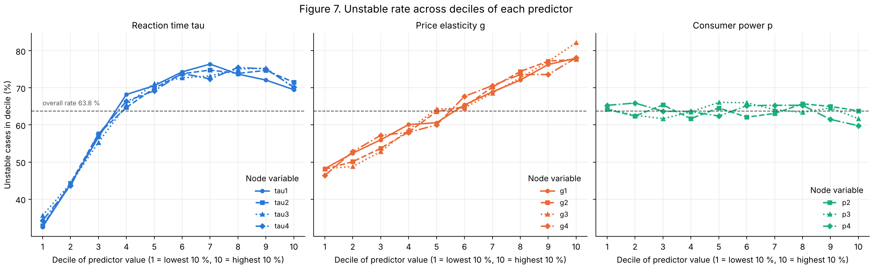
Figure 7. Unstable rate across deciles of each predictor (dashed line = overall rate 63.8 %).
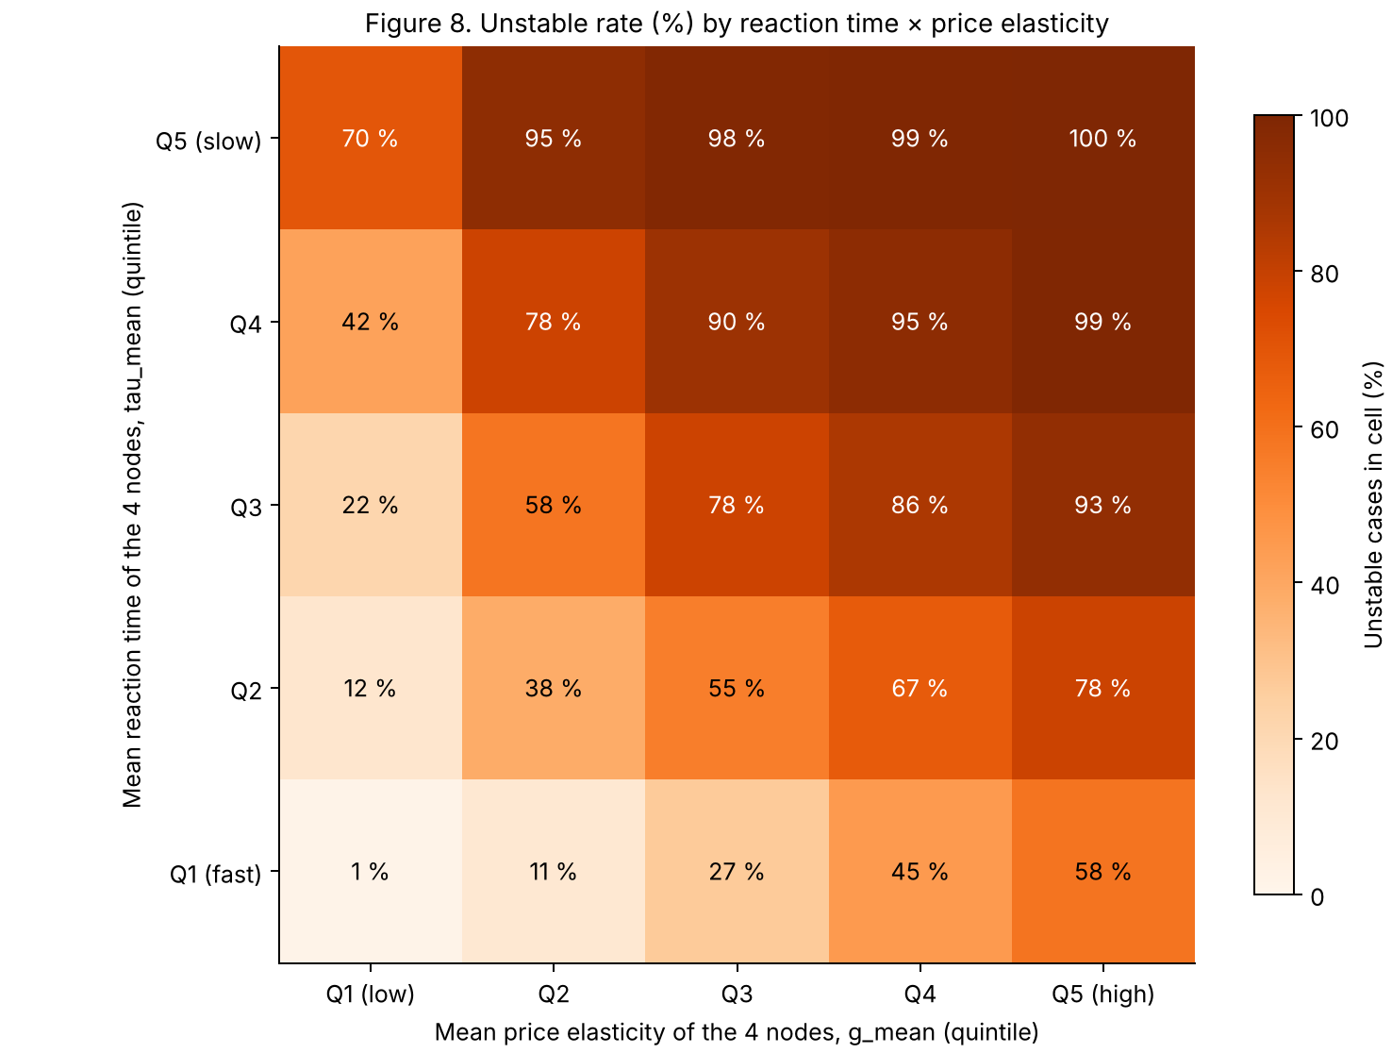
Figure 8. Unstable rate (%) by quintiles of node-averaged reaction time and price elasticity.
Implication: the modest linear correlations (≈ 0.25) understate how predictable stability is. Models that capture thresholds and interactions should perform much better than a linear model on the raw inputs.

5. Initial Insights for Modelling
Most promising features: tau1–tau4 (|r| 0.23–0.25) and g1–g4 (|r| 0.20–0.23), especially in combination (node averages and tau × g interaction). p2–p4 show no marginal effect, but they should be removed only after checking importance in a non-linear model.
Preprocessing needed:
Step | Decision
Scaling | Yes for logistic regression / SVM / MLP: standardise, fitted on the training split only, inside a pipeline. Not needed for tree models.
Encoding | No categorical predictors, so no input encoding. Encode the target as stable = 0, unstable = 1.
Feature selection | Drop stab (leakage) and p1 (perfect collinearity). Keep the other 11 initially, test engineered features (node-mean tau/g, per-node tau × g), and decide on p2–p4 with cross-validated importance.
Missing / duplicates / outliers | None to treat.
Class imbalance | Stratified split / stratified k-fold; optionally class_weight="balanced".

Modelling approaches likely to work: a tree-based ensemble (Random Forest or Gradient Boosting) as the main model, a logistic-regression baseline, and possibly a small MLP. Evaluate with balanced accuracy, per-class precision/recall/F1, ROC-AUC and a confusion matrix, with particular attention to false-stable errors.

6. Engineering Interpretation
Physical model. Each node follows the swing equation: rotor-angle acceleration is driven by the power imbalance p, damped (α = 0.1 s⁻¹) and coupled to neighbours through the lines (K = 8 s⁻²). In DSGC each participant measures frequency (averaged over T = 2 s), waits its reaction time τ, then changes its power in proportion to its elasticity γ (g). Every participant is therefore a delayed negative-feedback frequency controller with gain g and dead-time tau. stab is the largest real part of the eigenvalues of the linearised system (Schäfer et al., 2016).

What do the results mean in my discipline?
- Delay destabilises feedback (tau, top-3 features). A time delay adds phase lag to a control loop. When the delay becomes comparable to the period of the grid's power-angle oscillation, the corrective power change arrives out of phase and reinforces the oscillation, so negative feedback effectively becomes positive feedback. This is the classic loss of phase margin seen in Bode/Nyquist analysis. The saturation in Figure 7 is consistent with this: once the delay pushes the loop out of phase, extra delay changes little.
- High controller gain is risky with delay (g). Higher elasticity means a larger power response to the same frequency error, i.e. a higher loop gain. With dead-time present, higher gain reduces the gain margin and causes overshoot.
- Gain × delay trade-off (Figure 8). Fast reaction with low gain is almost always stable (1 % unstable); slow reaction with high gain is always unstable (100 %). The more aggressively participants respond, the faster they must react to keep the grid stable. This is a practical design rule for demand-response schemes.

Unexpected patterns
- Power level barely matters (r ≈ 0). Intuitively, a heavier load should stress the grid. Here each line carries at most |p| = 2 s⁻² against a coupling of K = 8 s⁻², so the lines run at ≤ 25 % of their transfer limit (sin Δθ ≤ 0.25). The synchronising stiffness K·cos Δθ therefore changes by only ≈ 3 % across all cases. Stability is dominated by the controller settings rather than the operating point; a heavily loaded grid could behave differently.
- More flexible consumers make the grid less stable. Demand response is usually seen as stabilising, but with delay a strong response becomes over-correction.
- The producer is not special: tau1/g1 have about the same influence as each consumer, again showing that controller dynamics, not power flow, drive stability.

Physical relationships reflected, and missing features
The data reflect energy conservation (p1 = −(p2+p3+p4) exactly, a lossless network), linear stability theory (label = sign of the dominant eigenvalue) and delayed feedback control (monotonic, saturating effect of delay and a gain–delay interaction). Important features that are missing include: the averaging time T, coupling K, damping α and inertia, all fixed here although inertia falls as renewables replace synchronous machines; network topology and size (only a 4-node star); line impedances and losses; voltage/reactive-power dynamics; stochastic renewable fluctuations; communication latency; and time-series frequency trajectories.

What type of model might suit this dataset?
The task is binary classification on 11 clean, continuous, independent inputs with a non-linear, interaction-driven boundary, so a tree-based ensemble (Random Forest / Gradient Boosting) is recommended. It captures the tau threshold and the tau × g interaction without manual feature engineering, needs no scaling, and its feature importances can be checked against the control-theory explanation above. Logistic regression (standardised, optionally with node-average and tau × g features) is the interpretable baseline. Alternatively, stab could be modelled as a regression target and thresholded at 0, giving operators a stability margin rather than only a label.

7. Challenges Encountered
- Choosing legitimate predictors. At first stab looked like the most useful column. Only after confirming that stabf equals the sign of stab in 100 % of rows did I realise it is the label. Similarly, p1 looked like an ordinary feature until the power-balance check showed it is an exact function of p2–p4.
- "Clean" data still needed evidence. With no missing values, duplicates or real outliers, the challenge was proving the data was fine (range, power-balance and label-consistency checks) rather than simply stating "no issues".
- Interpreting the single IQR outlier. I reasoned about the shape of p1 (a sum of uniforms) and its physical range before deciding to keep the flagged value, instead of deleting it automatically.
- Units and physical meaning. Power in s⁻² was confusing. Reading the source paper showed that power is normalised by inertia in the swing equation.
- Weak-looking correlations. A best |r| of 0.25 first suggested weak predictors. Binned plots and the interaction grid showed strong but non-linear relationships, so correlation alone was misleading.
- Practical issues. The 10,000-point pairplot was over-plotted, so a fixed random sample with transparency was used (statistics use all rows). A pandas 3 change (text dtype shown as str) needed noting for reproducibility.

8. Reflection Questions

How might poor data quality affect model reliability?
- Label noise near the boundary: ≈ 15 % of cases have |stab| < 0.01 s⁻¹, so small numerical or measurement errors could flip labels exactly where decisions matter most.
- Mis-scaled inputs (e.g. reaction times logged in ms instead of s) would shift the learned delay threshold and give confident but wrong predictions.
- Uneven or duplicated sampling would over-weight some operating regions. Here the uniform design means rare-but-realistic regimes are not emphasised.
- Leakage (keeping stab) would give near-perfect test accuracy that collapses in deployment, where stab is unknown.
- Simulation-to-reality gap: a small, lightly loaded model with fixed K, α and T may not represent real grids, so high accuracy here does not guarantee field reliability.

What ethical or bias issues might exist in this dataset?
- No personal or demographic data, so demographic bias cannot be measured. Bias appears instead as sampling/simulation bias: one topology, uniform ranges and fixed constants.
- Consumer equity: in a real scheme, g reflects how much a household can shift its usage. Using a model to label high-elasticity participants as "destabilising", for example to set tariffs or penalties, could unfairly burden some groups. Participants who cannot respond at all (e.g. medical-equipment users, households without smart devices) are not represented.
- Asymmetric harm: a false-stable prediction could contribute to blackouts affecting critical services; a false-unstable prediction could cause unnecessary curtailment or price spikes. Decision thresholds should reflect these costs.
- Accountability: stability decisions are safety-critical, so any model should be advisory, validated on independent scenarios, monitored for drift, and overseen by qualified engineers.

9. Next Steps
- Train and compare a logistic-regression baseline and a tree ensemble with a stratified split, train-only preprocessing and the metrics in Section 5.
- Test engineered features (node averages, tau × g) and check that model feature importances agree with the control-theory explanation.
- Model stab as a regression target (stability margin) and compare it with direct classification.
- Re-simulate with varied K, α, T, inertia, heavier line loading and other topologies to test whether the "power does not matter" finding generalises.

10. GenAI Declaration
I use GenAI to assist with structuring the analysis code, suggesting data-quality checks, debugging, improving code readability, and comments and plot labelling. All final code, interpretations, and conclusions are my own work after verification.

References
Arzamasov, V. (2018). Electrical Grid Stability Simulated Data [Dataset]. UCI Machine Learning Repository. https://doi.org/10.24432/C5PG66 (CC BY 4.0).
Schäfer, B., Grabow, C., Auer, S., Kurths, J., Witthaut, D., & Timme, M. (2016). Taming instabilities in power grid networks by decentralized control. The European Physical Journal Special Topics, 225, 569–582. https://doi.org/10.1140/epjst/e2015-50136-y
Swinburne University of Technology. (n.d.). Acknowledgement of Country. https://www.swinburne.edu.au/about/strategy-initiatives/moondani-toombadool-centre/acknowledgement

