MODULE CODE AND TITLE: SWDBD401 BACKEND APPLICATION DEVELOPMENT

Learning Outcome 1: Develop RESTFUL APIs with Node JS
Learning Outcome 2: Secure Backend Application
Learning Outcome 3: Test the Backend Application
Learning Outcome 4: Manage Backend Application

Learning Outcome 1: Develop RESTFUL APIs with Node JS
Indicative contents
1.1 Setup Node. Js Environment
1.2 Connection of Node Js to the ES5 or ES6 server
1.3 Establishment of database connection
1.4 Develop RESTFUL APIs

Learning Outcome 1: Develop RESTFUL APIs with Node JS
Indicative content 1.1: Setup Node. Js Environment
1. Node.js
- An open-source environment that runs JavaScript code outside the browser, specifically on servers.
- Key feature: Uses an event-driven, non-blocking I/O model, meaning it can handle many tasks simultaneously without waiting for one to finish before starting another.
- Why it matters: Ideal for building scalable, real-time applications like chat apps, live updates, or streaming services because it efficiently manages multiple connections at once.
- Example: A simple Node.js server might look like this in code:
const http = require('http');
const server = http.createServer((req, res) => {
res.end('Hello, World!');
});
server.listen(3000);
This creates a server that responds to requests on port 3000.
2. NPM (Node Package Manager): NPM is the built-in tool for managing JavaScript packages in Node.js projects. It's like a massive app store for code libraries, you search, install, and update them easily.
- How It Works: You run commands like npm install express to add packages. It reads from a global registry (npmjs.com) with millions of free packages.
- Key Files: It creates or updates a package.json file (your project's "shopping list" of dependencies) and a package-lock.json (to lock versions for consistency).
- Why It's Important: Saves time by reusing code. For instance, instead of writing your own HTTP server from scratch, install Express.js via NPM.
- Commands to Know: npm init (start a project), npm update (update packages), npm uninstall (remove them).
3. Dependencies
- Dependencies are external packages or libraries your application relies on to perform specific tasks. Example, if your app requires database connections, you might depend on a package like mongoose for MongoDB.
- Management: Listed in package.json file; installed and updated via NPM.
- Example: A package for handling HTTP requests, database access, or authentication.
- Best Practices: Keep them updated to avoid security vulnerabilities (use npm audit). Example: In a web app, you might depend on express for routing and body-parser for handling form data. Mismanaged dependencies can lead to "dependency hell" (version conflicts), so tools like NPM help automate this.
4. Backend Application
- Is the server-side part of a web application.
- Responsibilities: Processes user requests, interacts with databases, performs computations, and sends data or web pages back to the client. Processes HTTP requests (e.g., login attempts), queries databases, authenticates users, and sends responses (data or errors).
- Contrast with Frontend: Frontend is what users see (HTML/CSS/JS in browsers); backend is invisible but essential.
- Example: In an e-commerce site like Amazon, the backend checks inventory, processes payments, and updates your cart when you add items. Node.js excels here due to its speed.
- Architecture Tip: Often uses MVC (Model-View-Controller) pattern: Models for data, Views for UI (though in Node.js, views might be API responses), Controllers for logic.

5. Routes
- Definition: URL patterns that determine how your server responds to different HTTP requests. Routes are like address mappings in a web app, they tell the server what to do when a specific URL is requested via HTTP methods (GET, POST, etc.).
- Function: Map URLs to specific functions or controllers, enabling the server to handle various actions like showing a page, submitting data, or deleting records.
- How They Work: In Node.js (often with Express.js), you define routes like /users to fetch user data. Each route links to a function that handles the request.
- HTTP Methods: GET (read data), POST (create), PUT (update), DELETE (remove).
- Example in Express.js:
app.get('/home', (req, res) => {
res.send('Welcome to the home page!');
});
This responds to GET requests at /home.
- Importance: Enables organized, modular code. Without routes, your server couldn't differentiate between /login and /profile.
6. Class (in JavaScript)
- What it is: A blueprint to create objects with shared properties and behaviours.
- Purpose: Supports Object-Oriented Programming (OOP), promoting code reuse and organization.
- Syntax:
class Car {
constructor(make, model) {
this.make = make;
this.model = model;
}
drive() {
console.log('Vroom!');
}
}
- Inheritance: Classes can extend others (e.g., class ElectricCar extends Car).
7. Object
- Object is a collection of key-value pairs representing data and behaviour.
- Example: A user object might have properties like name and email, and methods like login().
8. Method
- Method is a function attached to an object that performs actions related to that object.
- Example: user.login() is a method that performs login functionality.

9. Properties: are the data attributes of an object, like variables inside it. They describe the object's state.
- Types: Can be primitives (strings, numbers) or complex (arrays, other objects).
- Access: Dot notation (user.name) or brackets (user['name']).
- In Practice: In a Node.js app, a request object might have properties like req.body (user-submitted data).
10. Express.js
- Express.js is a lightweight framework for Node.js that simplifies web app development.
- Features: Middleware (functions that process requests, e.g., logging), routing, template engines.
- Installation: npm install express.
- Example: Sets up a server faster than plain Node.js.
- It is popular because of its Flexibility, and used in millions of apps

11. Postman: is a GUI tool for API testing. It's like a simulator—send requests, view responses without writing code.
- Uses: Test endpoints, automate collections of tests, generate docs.
- Features: Supports variables, environments (dev/prod), scripting.
- Example: Test a GET /users route by entering the URL, headers, and clicking "Send".

12. Nodemon: is a development tool that auto-restarts your Node.js server on file changes.
- Function: Monitors your Node.js files, automatically restarting the server whenever code changes are detected, speeding up development workflow.
- How: Install via npm install -g nodemon, run with nodemon app.js.
- Benefit: Speeds up iteration no manual restarts. Ideal for local dev.
13. API (Application Programming Interface): A set of rules and protocols that enable different software systems to communicate.
- Function: Defines how to request data or actions from another program, often over the internet.
Types of APIs
Type | Description | Examples | Access Level
Open APIs (Public) | Freely available to anyone; promotes innovation. | Twitter API, Google Maps API | Public
Internal APIs (Private) | Used within a company for internal tools; not public. | Company's HR system API | Internal
Partner APIs | Shared with trusted partners under agreements. | Payment gateway like Stripe for partners | Restricted

• Advantages:
- Automation: Handles repetitive tasks, e.g., auto-syncing data between apps.
- Innovation: Reuse existing services, like embedding YouTube videos via API.
- Security: Adds layers like API keys or OAuth to control access.
- Cost Efficiency: Use third-party services (e.g., AWS APIs) instead of building everything.
• Common Use Cases:
- Integrating Systems: Link CRM (e.g., Salesforce) with email (e.g., Mailchimp) to auto-send welcomes. Salesforce is a cloud-based Customer Relationship Management (CRM) platform and software used by businesses to better manage and connect to their customers. It acts as a central hub for a business to manage things like customer interactions, sales activities, and marketing campaigns.
- Enhancing Functionality: Add maps to a ride-sharing app via Google Maps API.
- Connecting IoT: Smart home devices (e.g., Nest thermostat) use APIs to talk to apps or cloud.
- Scalable Systems: Microservices architecture, where small services (e.g., user auth, payments) communicate via APIs.
- Reducing Costs: Automate reports instead of manual work.
- Security & Governance: Enable SSO (Single Sign-on) (e.g., login with Google) or enforce policies like expense approvals.
• API Working Process:
- API Client: The application sending the request (e.g., a web browser, a mobile app, or Postman a tool specifically designed for testing APIs without needing a frontend).
- API Request: This is a package sent to the server containing:
Endpoint: The unique URL for the resource (e.g., https://api.myapp.com/users).
Method: The action to perform:
  - GET - Retrieve data.
  - POST - Create new data.
  - PUT/PATCH - Update existing data.
  - DELETE - Remove data.
Parameters: Parameters are the variables that are passed to an API endpoint to provide specific instructions for the API to process. For example, the /articles endpoint of a blogging API might accept a “topic” parameter, which it would use to access and return articles on a specific topic.
Request Headers: Request headers are key-value pairs that provide extra details about the request, such as its content type or authentication credentials.
Request Body: The actual data that is required to create, update, or delete a resource.
- API Server: The API client sends the request to the API server, which is responsible for handling authentication, validating input data, and retrieving or manipulating data.
- API Response: Finally, the API server sends a response to the client. Includes:
  - Status Code: HTTP status codes are three-digit codes that indicate the outcome of an API request.
  - Some of the most common status codes include:
1. Informational (1xx)
- 100 Continue: The server has received the request headers, and the client should proceed to send the request body (if any).
- 101 Switching Protocols: The server is switching protocols as requested by the client (e.g., switching from HTTP to WebSocket).
- 102 Processing: The server has received and is processing the request, but no response is available.
2. Successful (2xx)
These indicate that the request was successfully received, understood, and accepted by the server.
- 200 OK: The request was successful, and the server returned the requested data.
- 201 Created: The request was successful, and the server created a new resource (often used in POST requests).
- 202 Accepted: The request has been accepted for processing, but it has not yet been completed.
- 204 No Content: The request was successful, but there is no content to return (e.g., a successful DELETE request).
- 205 Reset Content: The request was successful, but the client should reset the document view.
- 206 Partial Content: The server returns a part of the resource (usually for range requests).
3. Redirection (3xx)
These codes indicate that further action is needed to fulfill the request, usually a URL redirect.
- 301 Moved Permanently: The resource has been permanently moved to a new URL, and future requests should use the new URL.
- 302 Found (Temporary Redirect): The resource has been temporarily moved to a different URL.
- 303 See Other: The response to the request can be found at another URL, often used after a POST request.
- 304 Not Modified: The resource has not been modified since the last request, and the client can use the cached version.
- 307 Temporary Redirect: The resource is temporarily available at another URL, and the client should use the same HTTP method.
- 308 Permanent Redirect: The resource has been permanently moved to a new URL, and the client should use the new URL with the same HTTP method.
4.Client Error (4xx)
These codes indicate that the client seems to have made an error in the request.
- 400 Bad Request: The request could not be understood or was malformed.
- 401 Unauthorized: The request requires authentication, but the client has not provided valid credentials.
- 402 Payment Required: Reserved for future use (though it’s rarely used).
- 403 Forbidden: The server understood the request, but it refuses to authorize it.
- 404 Not Found: The requested resource could not be found on the server.
- 405 Method Not Allowed: The HTTP method used is not allowed for the resource.
- 406 Not Acceptable: The server cannot produce a response that matches the client's requested content type.
- 407 Proxy Authentication Required: The client must authenticate with a proxy before proceeding.
- 408 Request Timeout: The server timed out waiting for the client to send the request.
- 409 Conflict: The request could not be completed due to a conflict with the current state of the resource (e.g., attempting to create a resource that already exists).
- 410 Gone: The resource is no longer available and will not be available again.
- 411 Length Required: The server requires the Content-Length header to be set.
- 412 Precondition Failed: One or more conditions in the request header fields were not met.
- 413 Payload Too Large: The request entity is too large to process.
- 414 URI Too Long: The request URI is too long for the server to process.
- 415 Unsupported Media Type: The server does not support the media type of the request.
- 416 Range Not Satisfiable: The range specified by the client cannot be fulfilled.
- 417 Expectation Failed: The server cannot meet the expectations set by the Expect header.
- 418 I'm a teapot: An April Fools' joke from the HTTP/1.1 specification. It's a humorous error.
- 422 Un-processable Entity: The server understands the request but cannot process it (often used for validation errors).
- 429 Too Many Requests: The client has sent too many requests in each amount of time (rate limiting).
5. Server Error (5xx)
These codes indicate that the server failed to fulfil a valid request due to an error on its part.
- 500 Internal Server Error: A generic error when the server encounters an unexpected condition.
- 501 Not Implemented: The server does not support the functionality required to fulfil the request.
- 502 Bad Gateway: The server, while acting as a gateway or proxy, received an invalid response from the upstream server.
- 503 Service Unavailable: The server is currently unable to handle the request, usually due to being overloaded or down for maintenance.
- 504 Gateway Timeout: The server, acting as a gateway, did not receive a timely response from the upstream server.
- 505 HTTP Version Not Supported: The server does not support the HTTP protocol version used in the request.
- 507 Insufficient Storage: The server is unable to store the representation needed to complete the request.
- 508 Loop Detected: The server detected an infinite loop while processing a request.
- 510 Not Extended: The server requires further extensions to fulfil the request.
- 511 Network Authentication Required: The client needs to authenticate to gain network access.
These status codes are essential for understanding how a server processes requests and helps developers troubleshoot and optimize their applications.
- Response headers: HTTP response headers are very similar to request headers; except they are used to provide additional information about the server's response.
- Response body: The response body includes the actual data or content the client asked for—or an error message if something went wrong.

15. Database Management Systems (DBMS)
- DBMS: is software for storing, managing, and retrieving data.
- Types:
  - SQL-based (Relational): Use structured schemas (tables). Examples: MySQL, PostgreSQL.
  - NoSQL-based (Non-relational): Flexible schemas, suitable for unstructured data. Examples: MongoDB, Redis.
Key Differences:
- SQL databases: Rigid schemas, ACID compliance for reliable transactions.
ACID is an acronym representing a set of four key properties that guarantee the reliability and consistency of database transactions. These properties are:
Atomicity:
This property ensures that a transaction is treated as a single, indivisible unit of work.
Consistency:
This property guarantees that a transaction brings the database from one valid state to another.
Isolation:
This property ensures that concurrent transactions do not interfere with each other.
Durability:
This property guarantees that once a transaction has been committed, its changes are permanent and will survive any subsequent system failures, such as power outages or crashes.
- NoSQL databases: Flexible, scalable, suitable for large, distributed systems.
  - Flexible: They can handle various data types and structures without rigid schemas, allowing for easy adaptation to different data needs.
  - Scalable: They can efficiently grow to accommodate increasing amounts of data and traffic, often by adding more servers or resources.
  - Suitable for large, distributed systems: They are well-designed to operate across multiple servers or locations, making them ideal for big, complex systems that require data to be stored and accessed across different regions or data centers.
SQL vs. NoSQL Comparison Table
Aspect | SQL-Based (Relational) | NoSQL-Based (Non-Relational)
Schema | Fixed (tables, columns predefined). | Flexible (no strict schema; add fields anytime).
ACID/BASE | ACID (reliable transactions: Atomicity, Consistency, etc.). | BASE (available, eventual consistency for distributed apps).
Structure | Tables with rows/columns; normalized to avoid duplicates. | Varied: Documents (JSON-like), key-value, graphs.
Query Language | SQL (e.g., SELECT * FROM users). | Varies (e.g., MongoDB's query objects).
Scalability | Vertical (bigger servers); good for complex queries. | Horizontal (add servers); handles big data/unstructured.
Data Types | Structured (e.g., numbers, strings). | Flexible (structured, semi-, unstructured like JSON).
Examples | MySQL, PostgreSQL, Oracle, SQL Server, Access. | MongoDB (documents), Redis (key-value), Cassandra (wide-column).
Use Cases | Banking (needs transactions), e-commerce inventories. | Social media (user posts), IoT (sensor data), big data apps.

Why Choose?: SQL for data integrity (e.g., financial apps); NoSQL for speed/flexibility (e.g., real-time analytics). In Node.js, connect via ORM (Object-Relational Mapping) tools for easier queries.

1.1.2: Installation of Node Js Modules and packages
1. Install node js
✓ Visit the Node.js official website (https://nodejs.org/en) or install it from external
driver such as flash disk.
✓ Download the installer for your operating system (Windows, macOS, Linux).
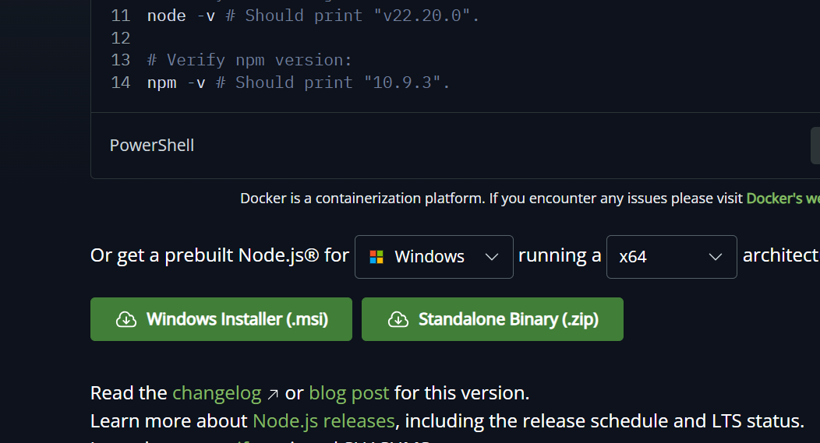
✓ Run the installer and follow the prompts to install Node.js.
2. Check if node and npm are installed
✓ Open a terminal or command prompt.
✓ To check Node.js installation, run in CMD or BASH:
node –v
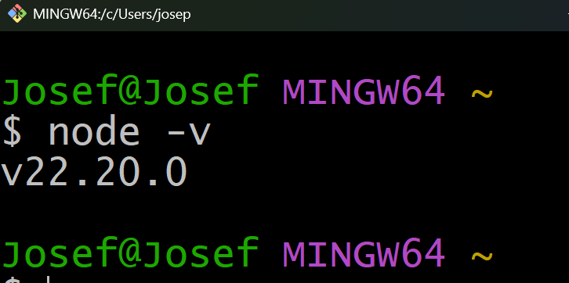
This command should output the version of Node.js installed.
✓ To check npm installation, run:
npm –v
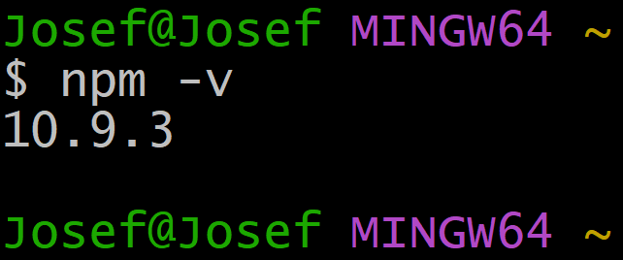
This command should output the version of npm installed.
3. Make a directory
✓ Open your terminal or command prompt.
✓ Navigate to the directory where you want to create your project, for example:
D: then press Enter will move you to local disk D of your computer
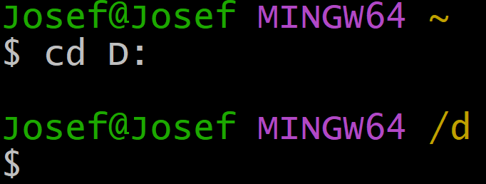
Or Use this in CMD

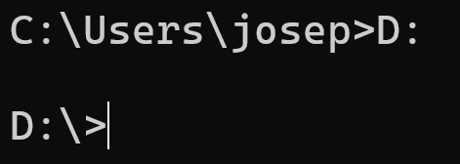
✓ Create a new directory (replace project-name with your desired project name):
mkdir project-name
Example: Let us create a project called StudentRegistartion
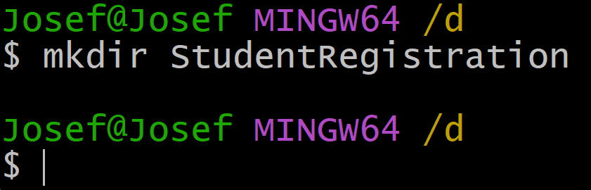
4. Navigate to created directory
After creating the directory, navigate into it:
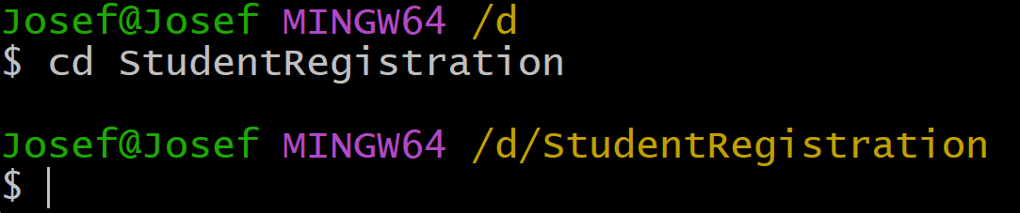
Or Use CMD and this is what you will get
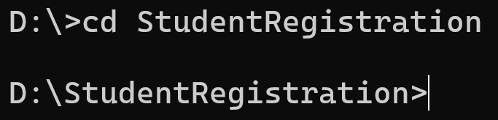
5. Initialise npm
Once inside your project directory, initialize npm (Node Package Manager) by using npm init or npm init –y which creates a package. json file:
npm init is interactive and allows customization, while npm init -y is noninteractive and uses default values to quickly create a package. json file.
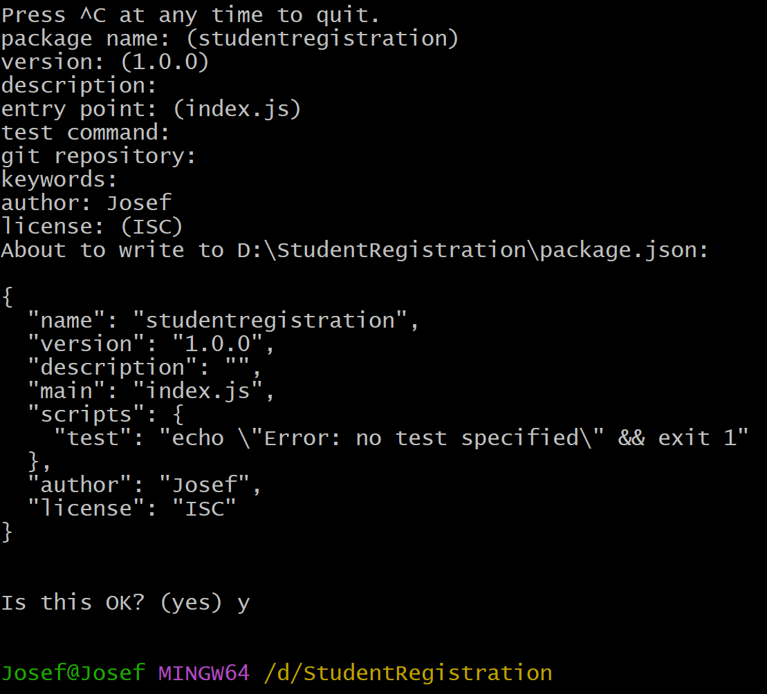
6. Install express and Nodemon
Install Express (a web framework for Node.js) and Nodemon (a utility that monitors for changes in your source code and restarts your server):
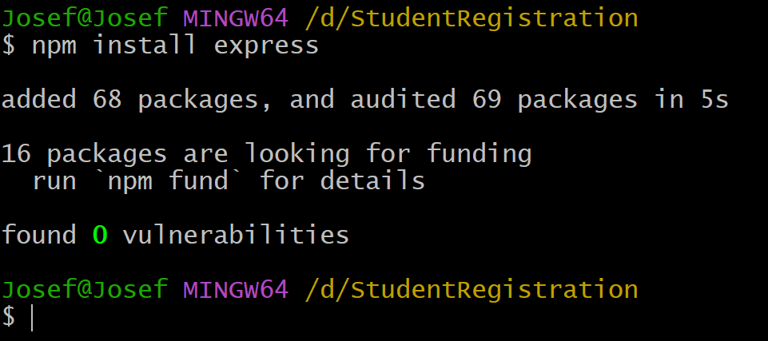
For installing nodemon replace the code by npm install nodemon
NB: You can install all necessary packages at the same time by writing them in single line of code
Ex: npm install express nodemon mysql2
For that case it will insatall express, nodemon and mysql2.
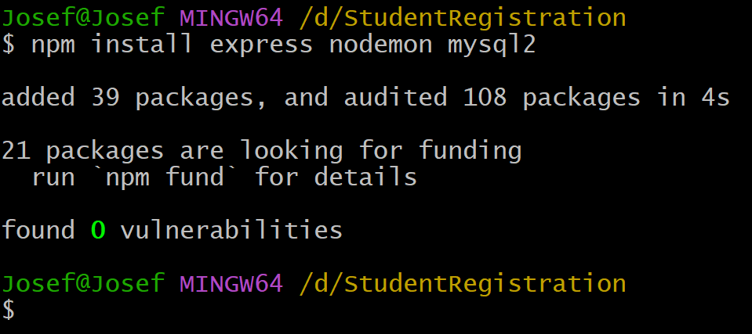
Once you install express js in your project folder it come up with a new folder called node_modules.
7. Open the created project in vs code.
Open Visual Studio Code (ensure it's installed on your system). Navigate to your project directory in VS Code.
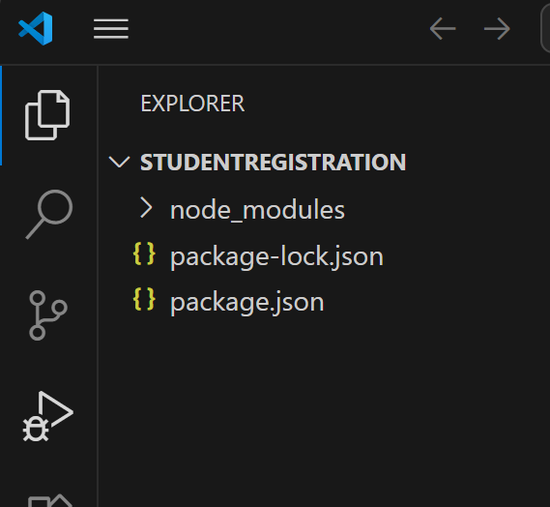

1.1.3: Installation and configuration of Postman
To install and configure postman you follow the following steps:
1. Download the Installer from official website or use it installer file on external device
Go to the official Postman website (https://www.postman.com/downloads/)
and download the installer suitable for your operating system (Windows, macOS, Linux).
2. Run the Installer
Once the download is complete, run the installer file. Follow the installation prompts to complete the installation process.
3. Launch Postman
After installation, launch Postman from your desktop or applications folder.
4. Configure the basic settings like user account (Email, Username and password) or sign up using google or sign in with SSO(Single Sign On).
✓ Upon launching Postman for the first time, you'll be prompted to sign in or sign up.
✓ If you have an existing Postman account, enter your email and password to sign in.
✓ If you don't have an account, you can sign up using your email address or sign in with Google or a Single Sign-On (SSO) provider.
✓ Follow the on-screen instructions to complete the sign-up or sign-in process.
✓ Once signed in, you can configure basic settings such as default environments, workspace preferences, and more from the Postman interface.
✓ Postman is now installed and configured. You can start using it to create, test, and manage APIs.

1.1.4: Configuration of MySQL Server
To configure MySQL Server on Windows, follow these steps:

